VM consumption of run-time dynamic linking

Background
A process can use the same DLL file in both load-time and run-time dynamic linking. This article will talk about the VM (virtual memory) consumption of run-time dynamic linking. When a process dynamically loads one Dll file directly or indirectly using LoadLibrary/LoadLibraryEx the first time, it needs a certain size of continuous VM.

VM consumption of a Dll file
Dumpbin.exe which locates in Visual Studio installation folder can help us get the exactly size of continuous VM when we load a Dll file the first time.

We can use /header option and check “size of image” field as shown in following figure:
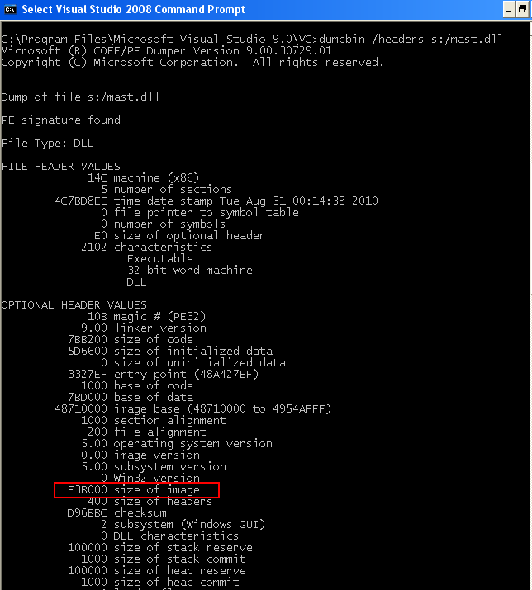

The above case, we need about 14.9M (E3B00 in Hex) continuous VM when we load mast.dll file the first time.

The global or static variables will contribute to the size of “size of image”. In addition, incremental linking option also will contribute to it. That is to say usually debug version Dll needs more continuous VM than release one.

Check VM layout of a process
VMMap is a process virtual and physical memory analysis utility.
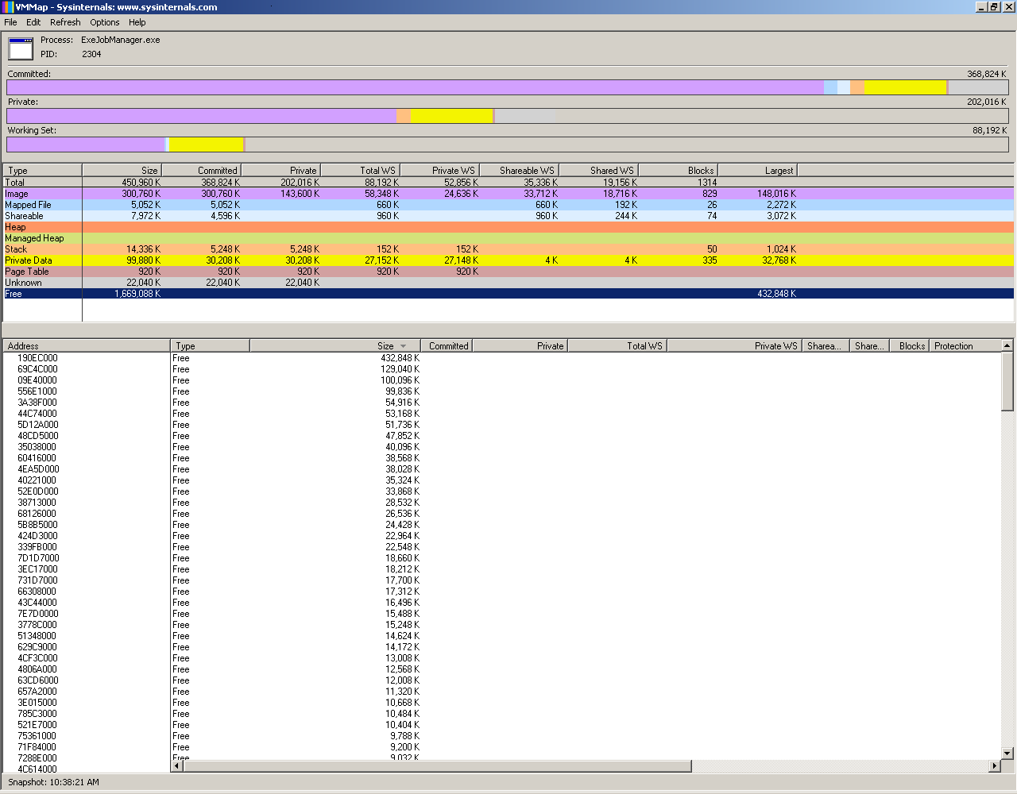

As you can see at the figure, it is easy to find the largest continuous VM size for a specific process by sorting the free VM blocks.

Potential problem
Since run-time dynamic linking can happen at any stage during process running, we should be very cautious to this kind of issues especially for “Huge” Dll files.
While process running, the free VM becomes less and memory fragment becomes more. It is more likely failed to load a Dll file due to lack of continuous VM if the Dll file has large “size of image” size.
Trickier thing happens in COM application. As CoCreateInstance calls LoadLibraryEx internally, it may fail due to lack of continuous VM as well. Even more badly, the error message returned by CoCreateInstance is something like “Class not registered” for this situation.

Best practice
- Avoid declaring large size of global or static variable as much as possible. In one word, change the initialization of variable from loading time to run time.
- Turn off the “incremental linking” build option which is already disabled in default configuration of release build.
- If we have to load large “size of image” size Dll file as run-time dynamic linking manner, move the Dll loading as earlier as possible.

Reference
http://msdn.microsoft.com/en-us/magazine/cc301727.aspx
http://www.microsoft.com/msj/0698/hood0698.aspx
http://www.microsoft.com/msj/0999/hood/hood0999.aspx
http://msdn.microsoft.com/en-us/magazine/bb985992.aspx
http://msdn.microsoft.com/en-us/magazine/bb985994.aspx

