**软件测试上机报告**



第一次上机作业

**学 院___智能与计算学部__**

**专 业___软件工程________**

**姓 名___陶柏安__________**

**学 号___3017218070______**

**年 级___2017级__________**

**班 级___1班________ __**

# 一、实验要求

1. Install Junit(4.12), Hamcrest(1.3) with Eclipse/IDEA
2. Install Eclemma with Eclipse
3. Write a java program for the given problem and test the program with Junit.
   1. Description of the problem:

There is one 50 yuan, one 20 yuan, one 10 yuan, two 5 yuan bills and three 1 yuan coins in your pocket. Write a program to find out whether you can take out a given number (x) yuan.

# 二、源代码

**zhaoqian.java:**

**package** org.tju.cn;

**public** **class** Money {

**public** **static** String IsCoincident(**int** money) {

**int** temp = 0;

**if**(money >= 0) {

**int** money_div_50 = money / 50;

money = money % 50;

**int** money_div_20 = money / 20;

money = money % 20;

**int** money_div_10 = money / 10;

money = money % 10;

**int** money_div_5 = money / 5;

money = money % 5;

**int** money_div_1 = money / 1;

**if**(money_div_50 < 2 && money_div_20 < 2 && money_div_10 < 2 && money_div_5 < 3 && money_div_1 < 4) {

temp = 1;

}

**else** {

temp = 0;

}

}

**else** {

temp = -1;

}

**if**(temp == 1) {

**return** "Coincident";

}

**else** **if**(temp == 0){

**return** "Not Coincident";

}

**else** {

**return** "Not existed";

}

}

}

**zhaoqiantest.java:**

**package** org.tju.cn;

**import** java.util.Arrays;

**import** java.util.Collection;

**import** **static** org.junit.Assert.*;

**import** **static** org.hamcrest.Matchers.*;

**import** org.junit.Test;

**import** org.junit.Before;

**import** org.junit.runner.RunWith;

**import** org.junit.runners.Parameterized;

**import** org.junit.runners.Parameterized.Parameters;

**import** org.tju.cn.Money;

@RunWith(Parameterized.**class**)

**public** **class** TestMoney {

**private** Money mon;

**private** **int** a;

**private** String expected;

**public** TestMoney(**int** a , String expected){

**this**.a = a;

**this**.expected = expected;

}

@Before

**public** **void** setUp(){

mon = **new** Money();

}

@Parameters

**public** **static** Collection<Object[]> getData(){

**return** Arrays.*asList*(**new** Object[][]{

{-1,"Not existed"},//NOT EXISTED

{0,"Coincident"},//Specify 0 as the default

{3,"Coincident"},//3 one yuan coins

{4,"Not Coincident"},//Failure

{8,"Coincident"},//3 one yuan coins and 1 five yuan bill

{9,"Not Coincident"},//Failure

{13,"Coincident"},//3 one yuan coins and 2 five yuan bills

{14,"Not Coincident"},//Failure

{23,"Coincident"},//3 one yuan coins and 1 ten yuan， 2 five yuan bills

{24,"Not Coincident"},//Failure

{43,"Coincident"},//3 one yuan coins and 1 twenty yuan，1 ten yuan， 2 five yuan bills

{44,"Not Coincident"},//Failure

{93,"Coincident"},//3 one yuan coins and 1 50 yuan，1 twenty yuan，1 ten yuan， 2 five yuan bills

});

}

@Test

**public** **void** test() {

*assertEquals*(**this**.expected,mon.*IsCoincident*(a));

}

}

# 运行结果

Right-click on the project name to use Junit, click properties——Java Build Path——Libraries, select Add External JARs:

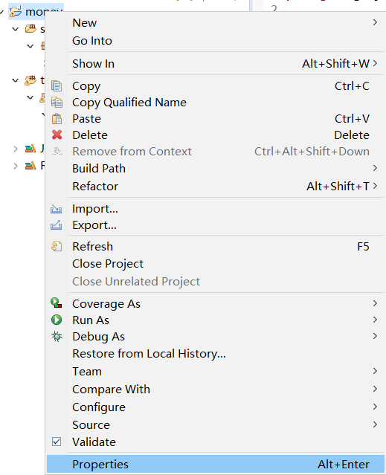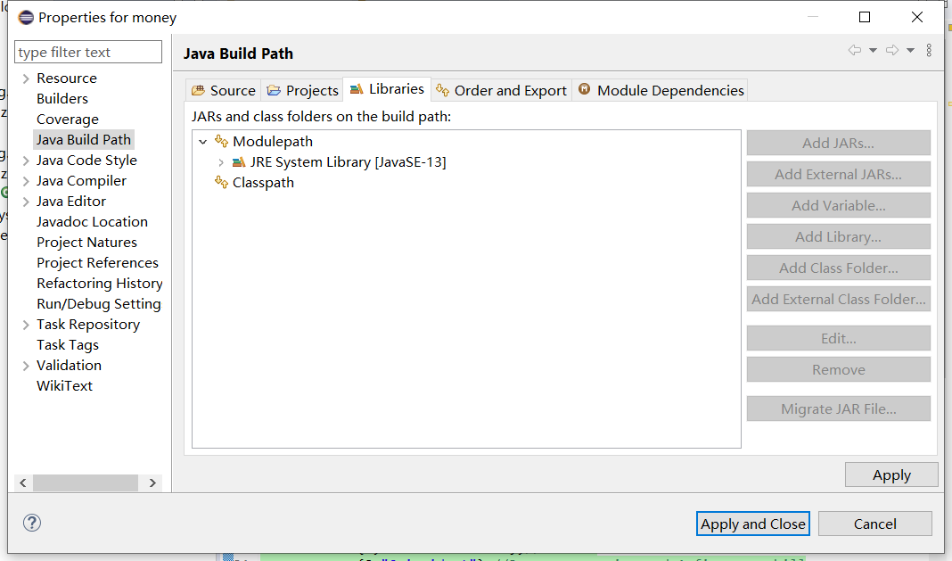

Find the Junit-4.12 package and hamcrest-all-1.3 package on your desktop:

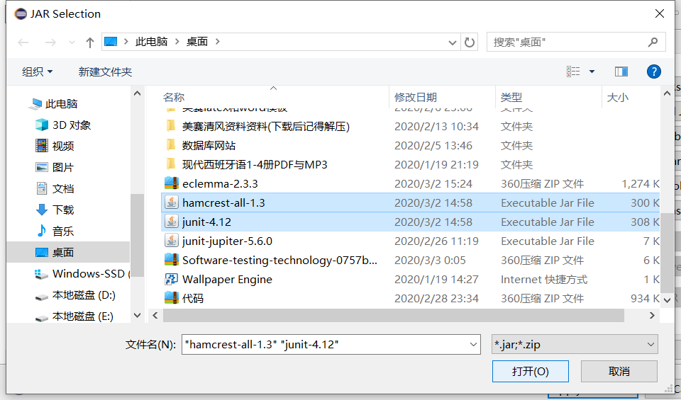

The effect diagram is as follows:

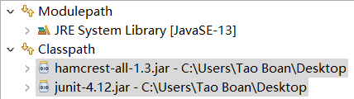

Download the eclemma-2.3.3 compressed package, decompress it to the dropins path of the Eclipse local directory, and restart Eclipse:

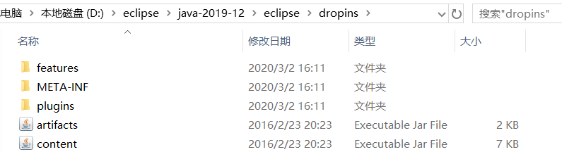

The result of **"coverage as**" is as follows:

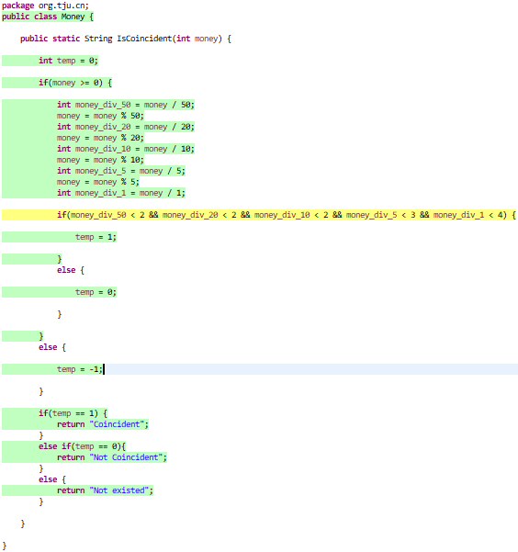

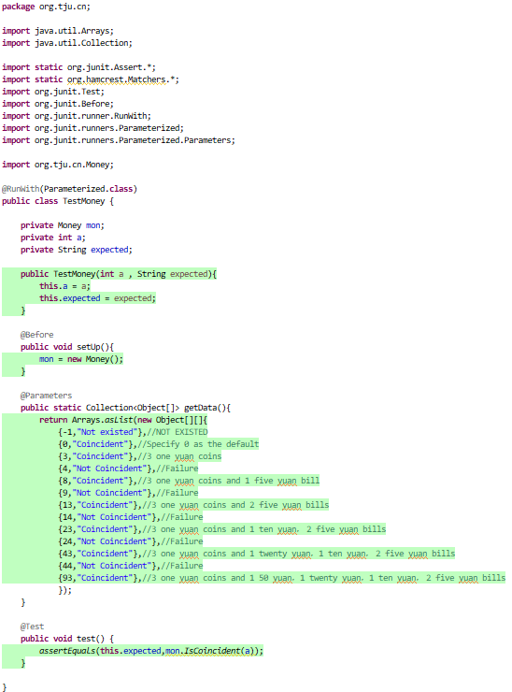

The result is as follows:

