CM5235 - Homework Gaussian (2026)
Exercise 1 - Study of the ground state HCl diatomic molecule with different computational methods
Full Name | Zhang Xubo
Student Number | A0359670R
E-mail | zhangxubo@u.nus.edu
Date | 13 September 2026
Signature

Single-point RHF/STO-3G at R(H-Cl) = 1.275 A
SCF energy: E(RHF) = -455.134835 Hartree
Electric dipole moment: 1.7343 Debye (components X = 0, Y = 0, Z = -1.7343; along the bond axis)
Molecular orbitals: 10 in total = 9 occupied + 1 virtual. Orbital energies (Hartree):
MO | 1 | 2 | 3 | 4 | 5 | 6 | 7 | 8 (HOMO) | 9 (HOMO) | 10 (LUMO)
E / Ha | -103.72252 | -10.40401 | -7.84887 | -7.84216 | -7.84216 | -1.04362 | -0.56448 | -0.42315 | -0.42315 | +0.40398
Mulliken charges:
Atom | Cl | H
Charge | -0.171761 | +0.171761

1) Optimisation + frequency with six basis sets
Route for each: #p hf/<basis> opt=tight freq.

Comparison table
Basis set | Optimal bond length / A | Vib. frequency / cm-1 | Number of orbitals | Number of basis functions | Total energy / Hartree | HOMO-LUMO gap / eV
STO-3G | 1.3133 | 3372.5 | 10 | 10 | -455.136012 | 21.72
6-31G | 1.2953 | 2924.8 | 15 | 15 | -460.037173 | 17.21
cc-pVDZ | 1.2773 | 3149.2 | 23 | 23 | -460.089450 | 16.87
6-311+G(d) | 1.2714 | 3106.6 | 33 | 33 | -460.087170 | 15.48
cc-pVTZ | 1.2673 | 3138.3 | 48 | 48 | -460.106851 | 16.37
cc-pVQZ | 1.2656 | 3138.7 | 89 | 89 | -460.111272 | 15.89
Experiment (NIST) | 1.2746 | 2990.9 (ωₑ) | - | - | - | -

Comparison with experimental values
Experimental data from NIST CCCBDB (cccbdb.nist.gov/exp2x.asp, species HCl).
Quantity | STO-3G | 6-31G | cc-pVDZ | 6-311+G(d) | cc-pVTZ | cc-pVQZ | Experiment
Bond length R_e / A | 1.3133 | 1.2953 | 1.2773 | 1.2714 | 1.2673 | 1.2656 | 1.2746
Vibrational frequency / cm-1 | 3372.5 | 2924.8 | 3149.2 | 3106.6 | 3138.3 | 3138.7 | 2990.9
Moment of inertia / 1e-47 kg m2 | 2.806 | 2.729 | 2.654 | 2.629 | 2.612 | 2.605 | 2.642
Zero-point energy / kJ mol-1 | 20.17 | 17.49 | 18.83 | 18.58 | 18.77 | 18.78 | 17.73
Enthalpy H(298)-H(0) / kJ mol-1 | 8.68 | 8.68 | 8.68 | 8.68 | 8.68 | 8.68 | 8.64
Entropy S(298) / cal mol-1 K-1 | 44.686 | 44.631 | 44.576 | 44.557 | 44.544 | 44.539 | 44.67
The calculated bond length, vibrational frequency and moment of inertia converge as the basis set is enlarged; at cc-pVQZ they differ from experiment by -0.009 A, +148 cm-1 and -0.037e-47 kg m2 respectively, whereas the enthalpy H(298)-H(0) and the entropy agree with experiment to within 1%.

2) Orbital energy diagram and occupied MOs (RHF/6-311+G(d))

Orbital energy diagram
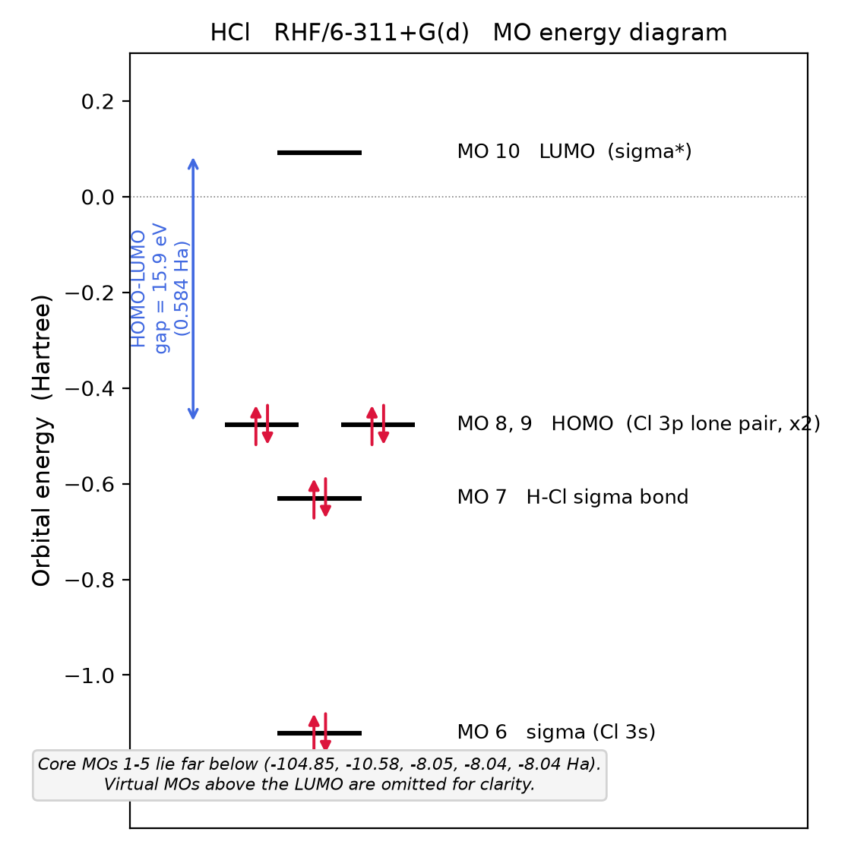
Orbital energy diagram of HCl, RHF/6-311+G(d). Core MOs 1-5 (-104.85 to -8.04 Ha) are off scale; virtual MOs above the LUMO are not shown.
MO | 1 | 2 | 3 | 4 | 5 | 6 | 7 | 8 (HOMO) | 9 (HOMO) | 10 (LUMO)
E / Ha | -104.84972 | -10.57650 | -8.04538 | -8.04148 | -8.04148 | -1.12190 | -0.63065 | -0.47730 | -0.47730 | +0.09172
HOMO-LUMO gap = 0.09172 - (-0.47730) = 0.56902 Ha = 15.48 eV.

Occupied molecular orbitals (MO 1-9)
GaussView, isosurface value 0.02; red / green = the two phases of the wavefunction.
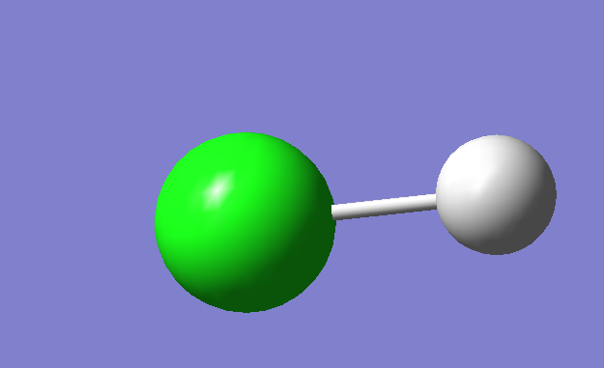
MO 1 (E = -104.85 Ha): Cl 1s core (too contracted to show an isosurface at 0.02).
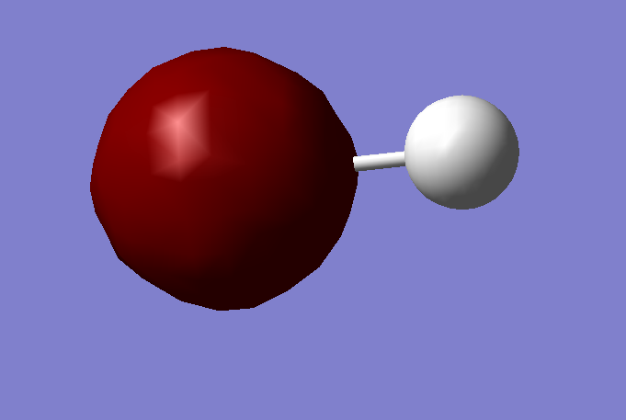
MO 2 (E = -10.58 Ha): Cl 2s core.
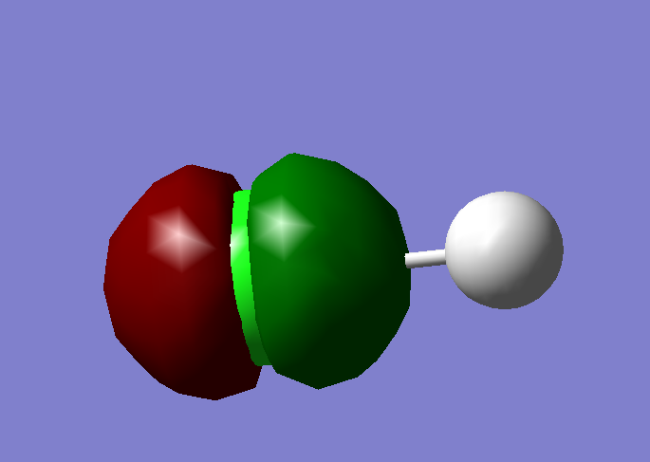
MO 3 (E = -8.05 Ha): Cl 2p core (along the bond axis).
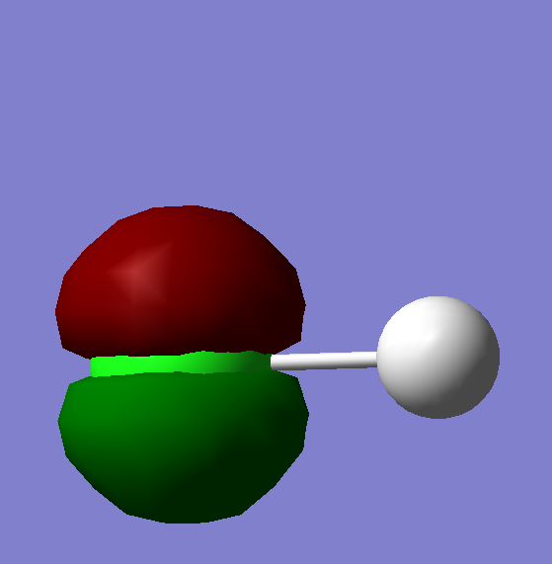
MO 4 (E = -8.04 Ha): Cl 2p core.
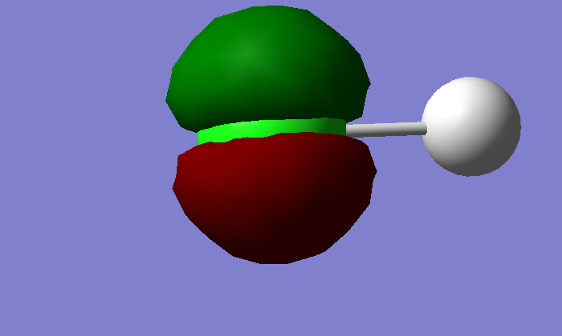
MO 5 (E = -8.04 Ha): Cl 2p core (degenerate with MO 4).
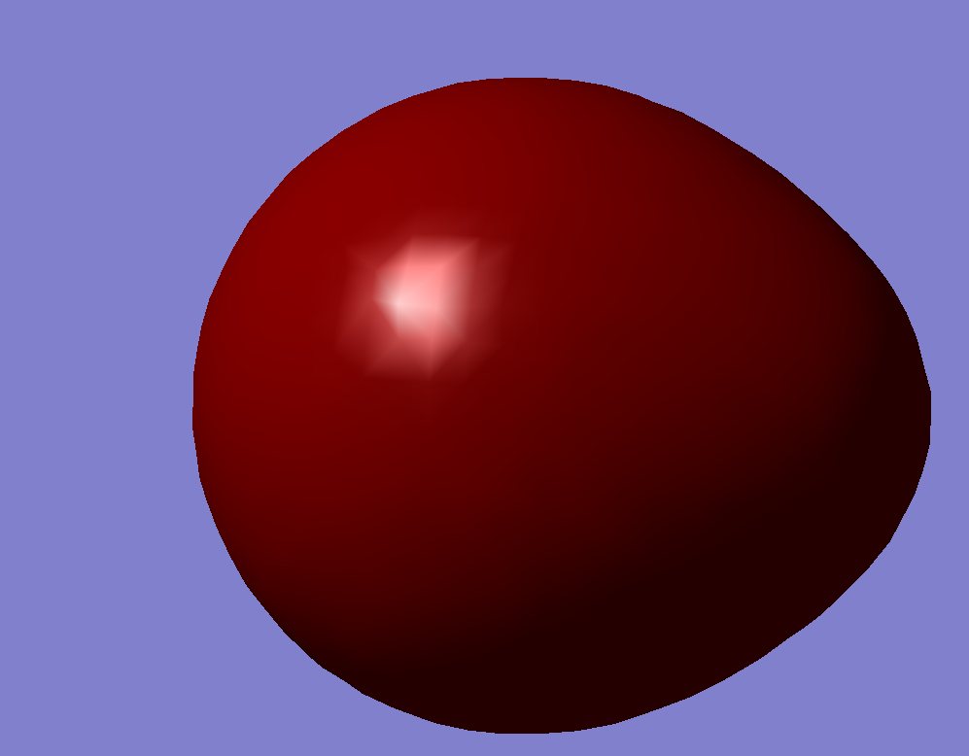
MO 6 (E = -1.12 Ha): sigma, dominated by Cl 3s.
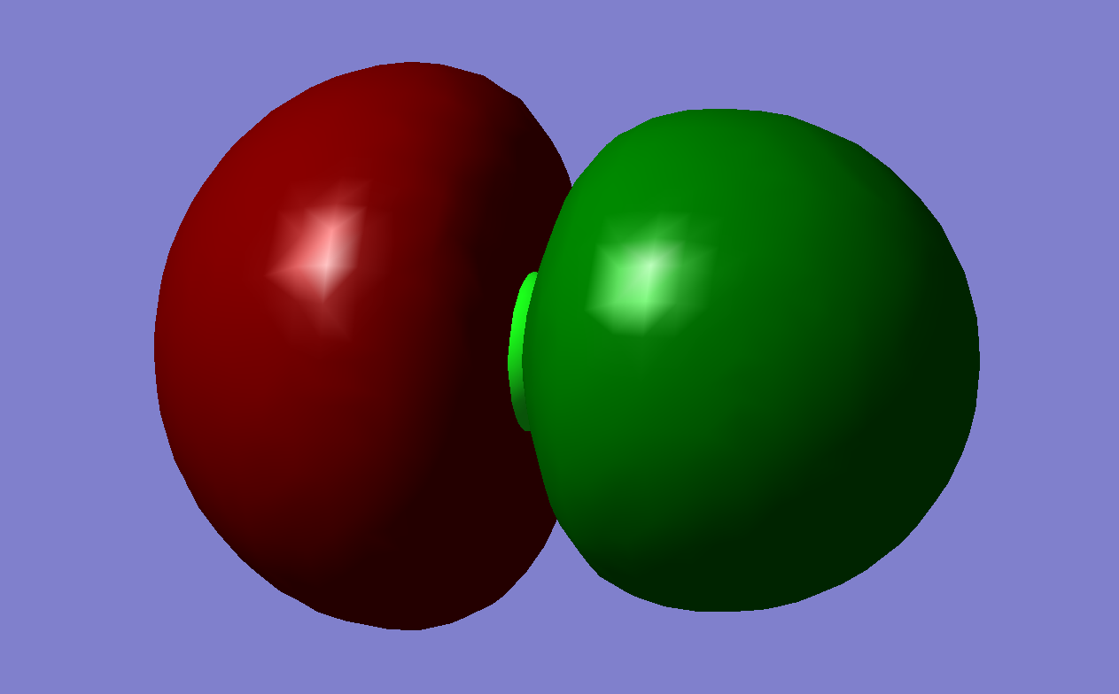
MO 7 (E = -0.63 Ha): H-Cl sigma bond (Cl 3p_z + H 1s).
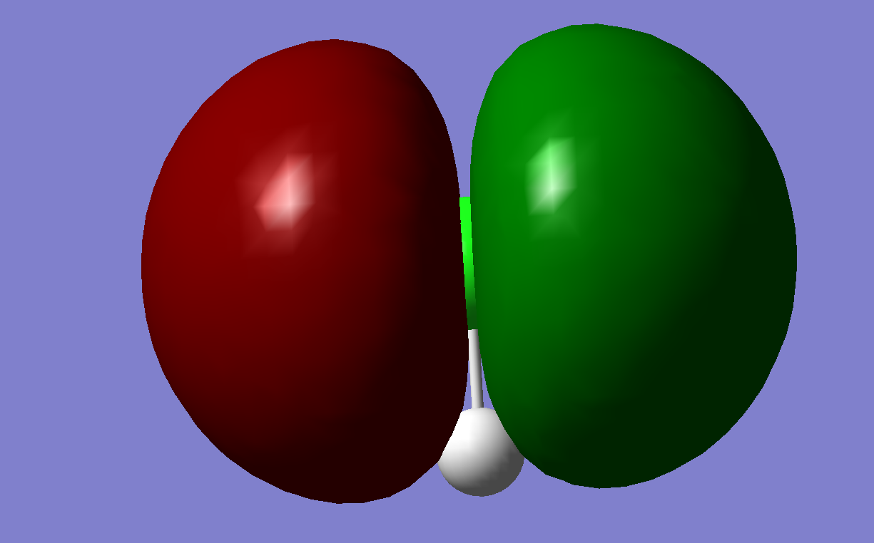
MO 8 (E = -0.48 Ha): HOMO - Cl 3p lone pair, perpendicular to the bond.
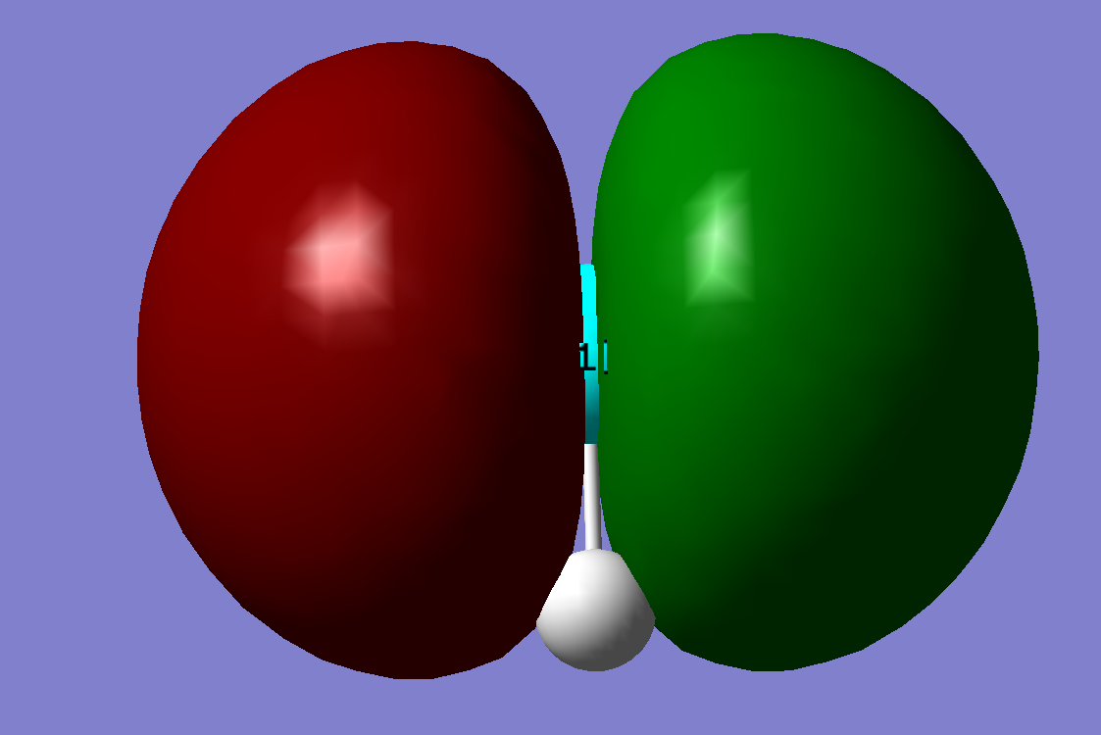
MO 9 (E = -0.48 Ha): HOMO - Cl 3p lone pair, degenerate with MO 8.

Exercise 2 - Potential energy surface of the H-F molecule, four computational methods

a) Potential energy curves
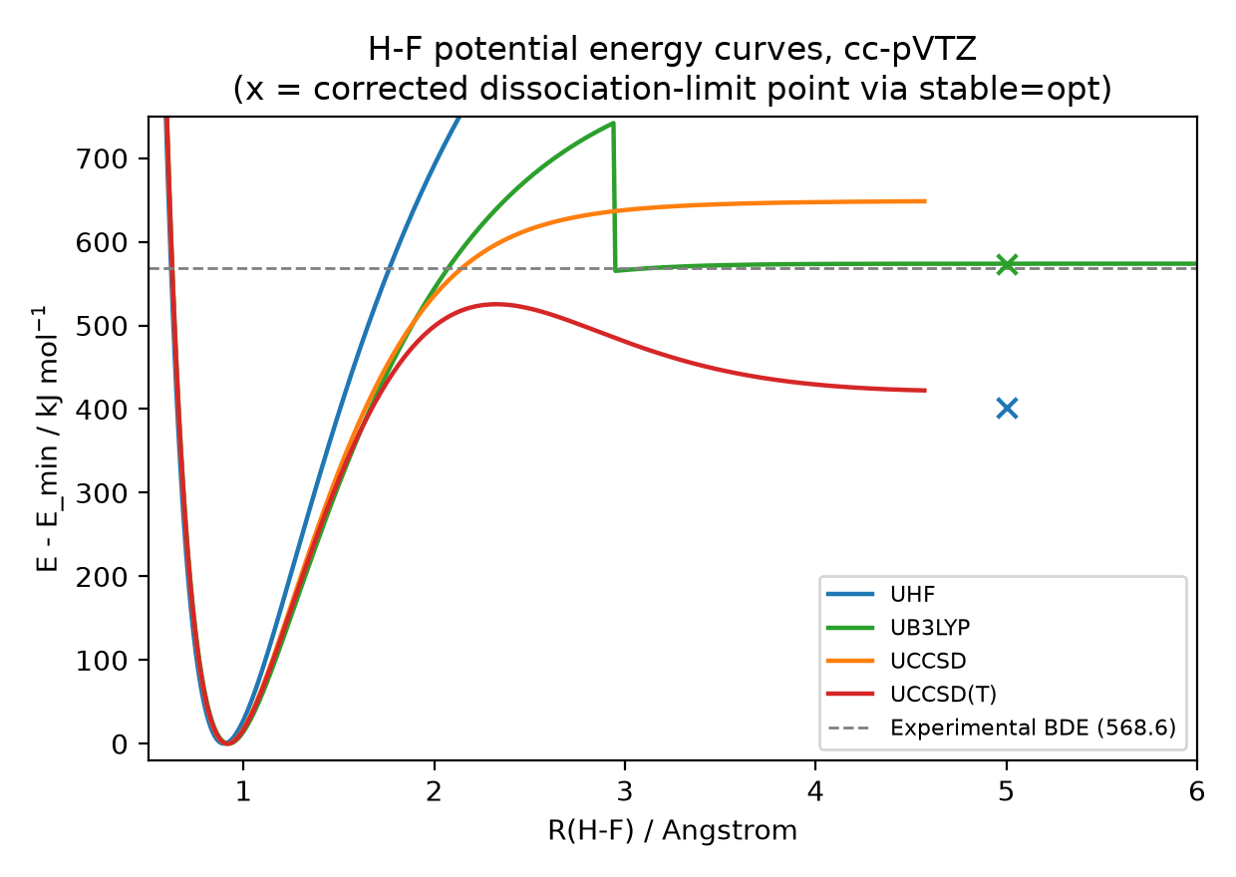
Figure 1. H-F potential energy curves, UHF/UB3LYP/UCCSD/UCCSD(T), cc-pVTZ.

b) Equilibrium bond length Rₑ
Method | Rₑ / Angstrom
UHF | 0.90
UB3LYP | 0.92
UCCSD | 0.92
UCCSD(T) | 0.92

c) Dissociation energy Dₑ
Method | Dₑ / kJ mol-1
UHF | 402.0
UB3LYP | 573.8
UCCSD | 648.4
UCCSD(T) | 422.3
UCCSD and UCCSD(T) values are approximate: the amplitude equations failed to converge beyond R = 4.57 A, so the last converged point was used in place of the true dissociation limit.

d) Comparison with the experimental bond dissociation energy (568.6 kJ/mol)
Method | Dₑ / kJ mol-1 | Difference from experiment
UHF | 402.0 | -166.6
UB3LYP | 573.8 | +5.2
UCCSD | 648.4 | +79.8
UCCSD(T) | 422.3 | -146.3
UB3LYP is closest to experiment (off by only 5.2 kJ/mol) and is therefore the most accurate of the four methods here; UHF and UCCSD(T) underestimate Dₑ by over 140 kJ/mol and UCCSD overestimates it by 79.8 kJ/mol.

Exercise 3 - CH2FCl bond dissociation energy

1) Total energy comparison, three methods
Method | Basis | E_total / Hartree
HF | STO-3G | -591.172393
B3LYP | cc-pVDZ | -599.362053
CCSD | cc-pVTZ | -598.670494

2) Electron density and electrostatic potential map (B3LYP/cc-pVDZ)
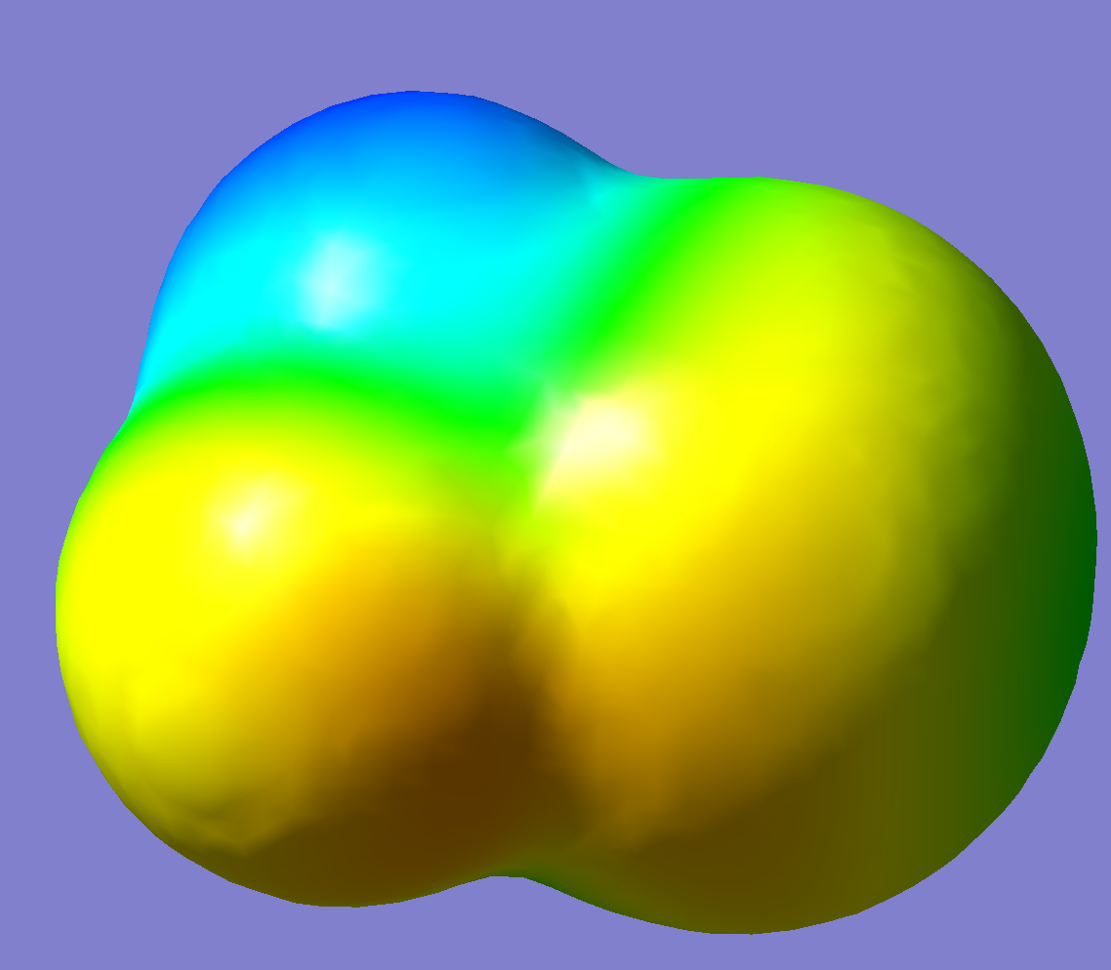
Figure 1. Total electron density surface (isovalue 0.0004) of CH2FCl, mapped with the electrostatic potential (GaussView, B3LYP/cc-pVDZ). Blue = more positive potential, yellow/orange = more negative potential.
The surface itself is a total electron density isosurface (isovalue 0.0004), so its shape traces the outer envelope of the electron cloud: it bulges out furthest around Cl, which has the most electrons and the most diffuse (largest) electron cloud of the four elements present, and is noticeably tighter around the H atoms, which contribute only a single 1s electron each. Mapping the electrostatic potential onto this surface then shows where that density sits relative to the nuclear charges: the H atoms (blue) carry the most positive potential, while F and Cl (yellow/orange) are more negative, since both pull electron density toward themselves more strongly than C or H.

3) C-H and C-F bond dissociation energies
Strategy: homolytic bond cleavage; each radical/atom fragment is separately optimised (with frequencies, for ZPE) at UB3LYP/cc-pVDZ.
BDE = [E(radical) + ZPE(radical) + E(atom)] - [E(parent) + ZPE(parent)]

C-H bond, B3LYP/cc-pVDZ: CH2FCl -> CHFCl. + H.
Species | E / Hartree | ZPE / Hartree
CH2FCl (parent) | -599.362053 | 0.030710
CHFCl. radical | -598.698761 | 0.017241
H atom | -0.501258 | 0 (atom, no vibration)
BDE(C-H) = 0.148565 Hartree = 390.1 kJ/mol

C-F bond, B3LYP/cc-pVDZ: CH2FCl -> CH2Cl. + F.
Species | E / Hartree | ZPE / Hartree
CH2FCl (parent) | -599.362053 | 0.030710
CH2Cl. radical | -499.461337 | 0.022429
F atom | -99.726601 | 0 (atom, no vibration)
BDE(C-F) = 0.165834 Hartree = 435.2 kJ/mol
The C-F bond is the stronger of the two (435.2 vs 390.1 kJ/mol); the H atom is the easier of the two to remove from CH2FCl.

Exercises 4 and 5 - Theoretical questions

Exercise 4 - Theoretical question 1
Describe the basic approximations used in the Hartree-Fock Self Consistent Field Method: Born-Oppenheimer Approximation, Orbital Approximation, Mean Field Approximation. How do these approximations simplify the computational problem?
Born-Oppenheimer. Nuclei are about 1836 times heavier than an electron, so on the timescale of nuclear motion the electrons relax essentially instantly to their ground state at any fixed nuclear geometry. The total wavefunction is then separated as Ψ = Ψ_{el}(r;R)·χ_{nuc}(R), with R entering the electronic problem only as a parameter. Solving Ĥ_{el}Ψ_{el} = E_{el}(R)Ψ_{el} once per fixed geometry, instead of together with the nuclei, turns one coupled problem into a 3N-electron electronic problem plus a potential energy surface E_{el}(R) + V_{nn}(R) that can be optimised, scanned or differentiated afterwards.
Orbital approximation. The N-electron wavefunction is approximated by a single Slater determinant of N one-electron spin orbitals, Ψ = (1/√N!)·det[χ₁(x₁) ... χ_{N}(x₁); ...; χ₁(x_{N}) ... χ_{N}(x_{N})], which builds in the Pauli principle automatically (swapping two electrons flips the sign; two electrons in the same spin orbital give a zero determinant). One unknown function of 3N coordinates becomes N unknown one-electron functions of 3 coordinates each, and each of those can be expanded in a finite atomic-orbital basis - so finding the orbitals is now a linear-algebra (matrix diagonalisation) problem rather than a differential equation.
Mean-field approximation. Each electron is treated as moving in the time-averaged charge distribution of the others rather than reacting to their instantaneous positions. This turns the electron-electron repulsion into an effective one-electron Fock operator, f(1) = h(1) + Σ_{j}[J_{j}(1) − K_{j}(1)], fφ_{i} = ε_{i}φ_{i}, so the N-electron problem is replaced by N one-electron eigenvalue problems, solved iteratively until self-consistent (SCF) because f depends on the orbitals it produces. This is far cheaper than the exact many-body problem, at the price of leaving out electron correlation - the instantaneous part of the electron-electron interaction.

Exercise 5 - Theoretical question 2
Describe the covalent chemical bonding on the example of the H2 molecule. Write down the Slater Determinant for the ground state and give an estimate of the total energy using the method explained in Lecture 3 (with h, J, K). Write down the energies of all excited Slater Determinants that can be formed using the minimal basis set on each of the H atoms. Explain the Coulomb and Exchange integrals.
Bonding picture. Each H atom contributes one 1s orbital, a on atom A and b on atom B, with overlap S = ⟨a|b⟩. Symmetry gives a bonding and an antibonding combination:
$σ_{g} = \frac{a + b}{\sqrt{2(1 + S)}} σ_{u} = \frac{a − b}{\sqrt{2(1 − S)}}$
σ_{g} piles electron density up between the nuclei (lowering the energy - the covalent bond); σ_{u} has a node there and lies higher in energy.
Ground-state determinant and energy. Both electrons occupy σ_{g} with opposite spin:
$Ψ_{0} = \frac{|σ_{g}(α) σ_{g}(β)|}{\sqrt{2}}$
With E = Σ_{i}h_{ii} + Σ_{i<j}(J_{ij} − K_{ij}) + V_{nn} and only one opposite-spin pair (K = 0):
E₀ = 2h_{gg} + J_{gg} + V_{nn}
h_{gg} = (h_{aa} + h_{ab})/(1+S) and J_{gg} is the Coulomb self-repulsion of the σ_{g} charge cloud. The resonance integral h_{ab} = ⟨a|ĥ|b⟩ is negative and sizeable - it is what pulls E₀ below the energy of two separated atoms (2h_{aa}) and gives the covalent bond.
Excited determinants. With 2 spatial orbitals (σ_{g}, σ_{u}) there are 4 spin orbitals, so besides the ground configuration there are 5 more determinants:
Determinant | M_S | Energy
σ_{g}(α) σ_{g}(β) (ground state) | 0 | 2h_{gg} + J_{gg} + V_{nn}
σ_{g}(α) σ_{u}(α) | +1 | h_{gg} + h_{uu} + J_{gu} − K_{gu} + V_{nn}
σ_{g}(β) σ_{u}(β) | −1 | h_{gg} + h_{uu} + J_{gu} − K_{gu} + V_{nn}
σ_{g}(α) σ_{u}(β) | 0 | h_{gg} + h_{uu} + J_{gu} + V_{nn}
σ_{g}(β) σ_{u}(α) | 0 | h_{gg} + h_{uu} + J_{gu} + V_{nn}
σ_{u}(α) σ_{u}(β) (doubly excited) | 0 | 2h_{uu} + J_{uu} + V_{nn}
The two M_S = 0 singly-excited determinants are not eigenstates by themselves; their symmetric and antisymmetric combinations give the spin-adapted triplet (energy h_{gg}+h_{uu}+J_{gu}−K_{gu}+V_{nn}) and singlet (h_{gg}+h_{uu}+J_{gu}+K_{gu}+V_{nn}) excited states.
Coulomb and exchange integrals. Coulomb integral:
J_{ij} = (ii|jj) = ∬ φ_{i}(1)² (1/r₁₂) φ_{j}(2)² dτ
This is the classical electrostatic repulsion between the charge clouds |φ_{i}|² and |φ_{j}|²: always positive, and independent of the relative spin of the two electrons.
Exchange integral:
K_{ij} = (ij|ji) = ∬ φ_{i}(1)φ_{j}(1) (1/r₁₂) φ_{j}(2)φ_{i}(2) dτ
This term has no classical counterpart - it comes purely from the antisymmetry of the Slater determinant. It is non-zero only between same-spin electrons and enters the energy with a minus sign, which is why same-spin (triplet) configurations sit lower than opposite-spin ones: the quantum origin of Hund's rule.

Exercise 6 - Excited states and spectra of CFH2-OH (fluoromethanol)

Comparison table
State | TDA E / eV | TDA λ / nm | TDA f | CIS E / eV | CIS λ / nm | CIS f
S1 | 8.10 | 153.1 | 0.0087 | 9.81 | 126.4 | 0.0082
S2 | 8.90 | 139.2 | 0.0193 | 11.05 | 112.2 | 0.0444
S3 | 9.43 | 131.5 | 0.0456 | 11.86 | 104.5 | 0.1865
S4 | 9.93 | 124.8 | 0.0144 | 12.43 | 99.7 | 0.0165
S5 | 10.10 | 122.8 | 0.0586 | 13.03 | 95.2 | 0.2335

UV/Vis spectrum
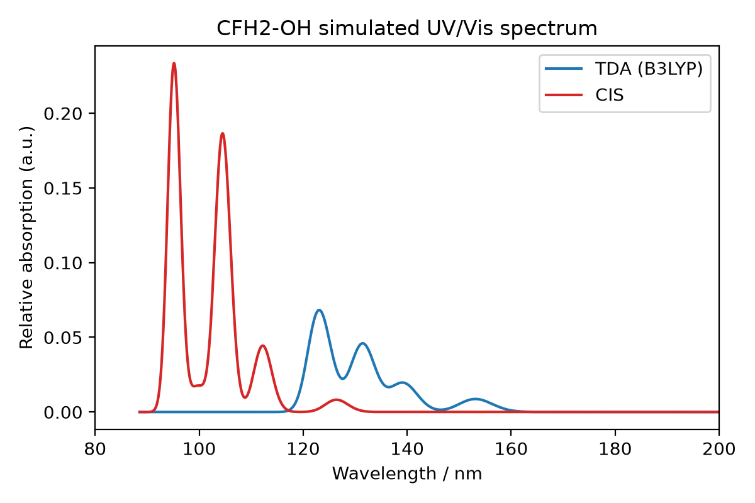
Figure 1. Simulated UV/Vis spectrum (Gaussian broadening, FWHM = 0.4 eV) from the TDA and CIS excitation energies and oscillator strengths above.
CIS gives systematically higher excitation energies than TDA/B3LYP across all five states (by roughly 1.7-3.0 eV), consistent with CIS lacking electron correlation.

