CM5235 - Homework Gaussian (2026)
Exercise 1 - Study of the ground state HCl diatomic molecule with different computational methods
Full Name | Zhang Xubo
Student Number | ________
E-mail | zhangxubo@u.nus.edu
Software | Gaussian 16 Rev C.02, GaussView 6 (NUS HPC Atlas)

Single-point RHF/STO-3G at R(H-Cl) = 1.275 A
Route: #p hf/sto-3g guess=save geom=connectivity scf=tight. Data read from the output log.
SCF energy: E(RHF) = -455.134835 Hartree
Electric dipole moment: 1.7343 Debye (components X = 0, Y = 0, Z = -1.7343; along the bond axis)
Molecular orbitals: 10 in total = 9 occupied + 1 virtual. Orbital energies (Hartree):
MO | 1 | 2 | 3 | 4 | 5 | 6 | 7 | 8 (HOMO) | 9 (HOMO) | 10 (LUMO)
E / Ha | -103.72252 | -10.40401 | -7.84887 | -7.84216 | -7.84216 | -1.04362 | -0.56448 | -0.42315 | -0.42315 | +0.40398
Mulliken charges:
Atom | Cl | H
Charge | -0.171761 | +0.171761

1) Optimisation + frequency with six basis sets
Route for each: #p hf/<basis> opt=tight freq.

Comparison table
Basis set | Optimal bond length / A | Vib. frequency / cm-1 | Number of orbitals | Number of basis functions | Total energy / Hartree | HOMO-LUMO gap / eV
STO-3G | 1.3133 | 3372.5 | 10 | 10 | -455.136012 | 21.72
6-31G | 1.2953 | 2924.8 | 15 | 15 | -460.037173 | 17.21
cc-pVDZ | 1.2773 | 3149.2 | 23 | 23 | -460.089450 | 16.87
6-311+G(d) | 1.2714 | 3106.6 | 33 | 33 | -460.087170 | 15.48
cc-pVTZ | 1.2673 | 3138.3 | 48 | 48 | -460.106851 | 16.37
cc-pVQZ | 1.2656 | 3138.7 | 89 | 89 | -460.111272 | 15.89
Experiment (NIST) | - | - | 1.2746 | 2990.9 (omega_e) | -

Comparison with experimental values
Experimental data from NIST CCCBDB (cccbdb.nist.gov/exp2x.asp, species HCl).
Quantity | STO-3G | 6-31G | cc-pVDZ | 6-311+G(d) | cc-pVTZ | cc-pVQZ | Experiment
Bond length R_e / A | 1.3133 | 1.2953 | 1.2773 | 1.2714 | 1.2673 | 1.2656 | 1.2746
Vibrational frequency / cm-1 | 3372.5 | 2924.8 | 3149.2 | 3106.6 | 3138.3 | 3138.7 | 2990.9
Moment of inertia / 1e-47 kg m2 | 2.806 | 2.729 | 2.654 | 2.629 | 2.612 | 2.605 | 2.642
Zero-point energy / kJ mol-1 | 20.17 | 17.49 | 18.83 | 18.58 | 18.77 | 18.78 | 17.73
Enthalpy H(298)-H(0) / kJ mol-1 | 8.68 | 8.68 | 8.68 | 8.68 | 8.68 | 8.68 | 8.64
Entropy S(298) / cal mol-1 K-1 | 44.686 | 44.631 | 44.576 | 44.557 | 44.544 | 44.539 | 44.67
The calculated bond length, vibrational frequency and moment of inertia converge as the basis set is enlarged; at cc-pVQZ they differ from experiment by -0.009 A, +148 cm-1 and -0.037e-47 kg m2 respectively, whereas the enthalpy H(298)-H(0) and the entropy agree with experiment to within 1%.

2) Orbital energy diagram and occupied MOs (RHF/6-311+G(d))

Orbital energy diagram
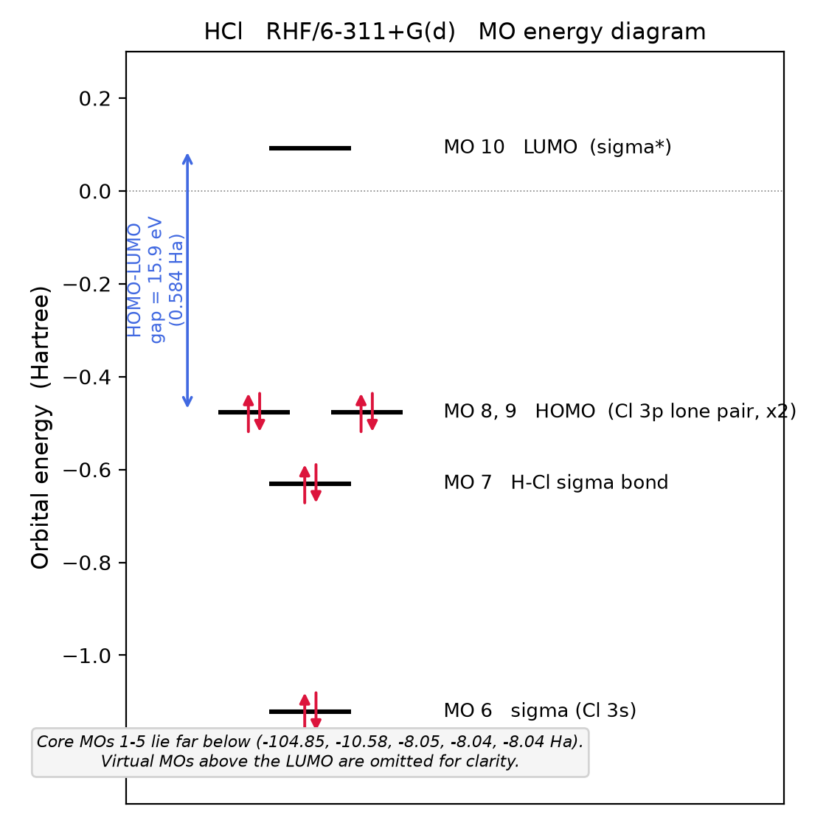
Orbital energy diagram of HCl, RHF/6-311+G(d). Core MOs 1-5 (-104.85 to -8.04 Ha) are off scale; virtual MOs above the LUMO are not shown.
MO | 1 | 2 | 3 | 4 | 5 | 6 | 7 | 8 (HOMO) | 9 (HOMO) | 10 (LUMO)
E / Ha | -104.84972 | -10.57650 | -8.04538 | -8.04148 | -8.04148 | -1.12190 | -0.63065 | -0.47730 | -0.47730 | +0.09172
HOMO-LUMO gap = 0.09172 - (-0.47730) = 0.584 Ha = 15.89 eV.

Occupied molecular orbitals (MO 1-9)
GaussView, isosurface value 0.02; red / green = the two phases of the wavefunction.
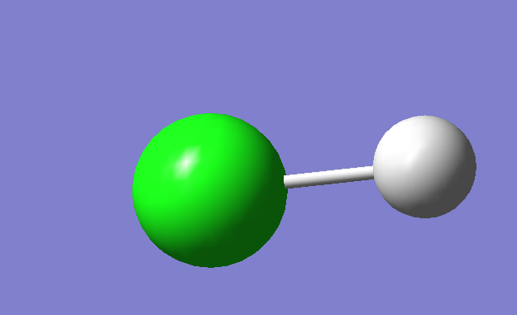
MO 1 (E = -104.85 Ha): Cl 1s core (too contracted to show an isosurface at 0.02).
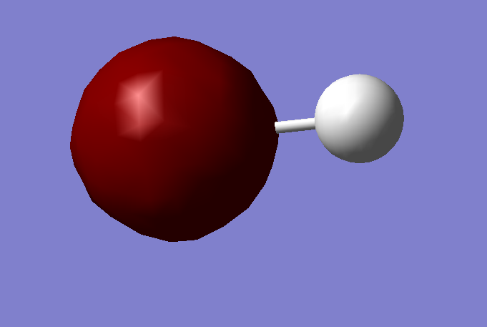
MO 2 (E = -10.58 Ha): Cl 2s core.
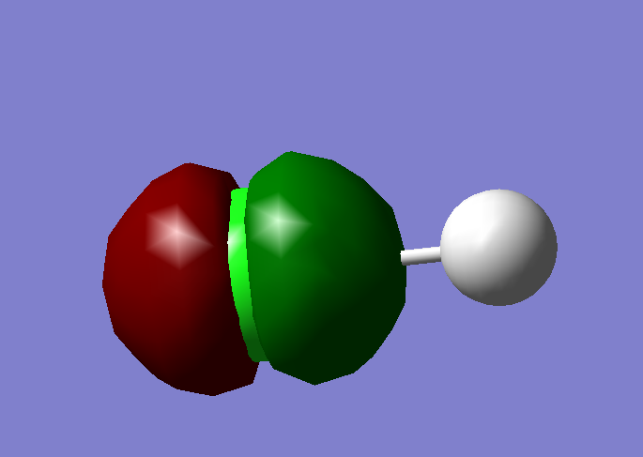
MO 3 (E = -8.05 Ha): Cl 2p core (along the bond axis).
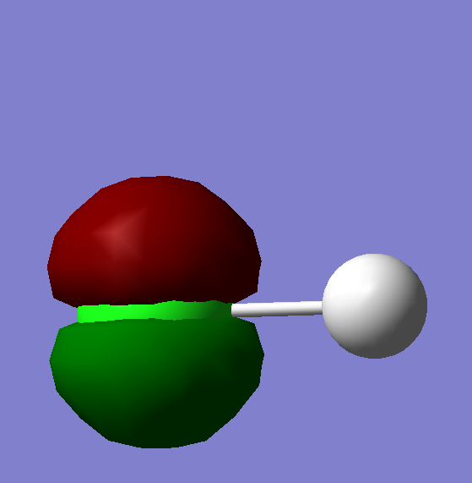
MO 4 (E = -8.04 Ha): Cl 2p core.
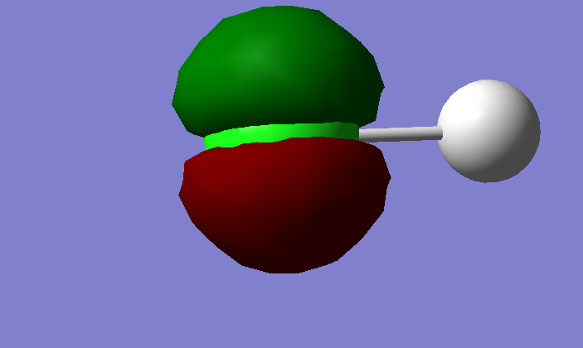
MO 5 (E = -8.04 Ha): Cl 2p core (degenerate with MO 4).
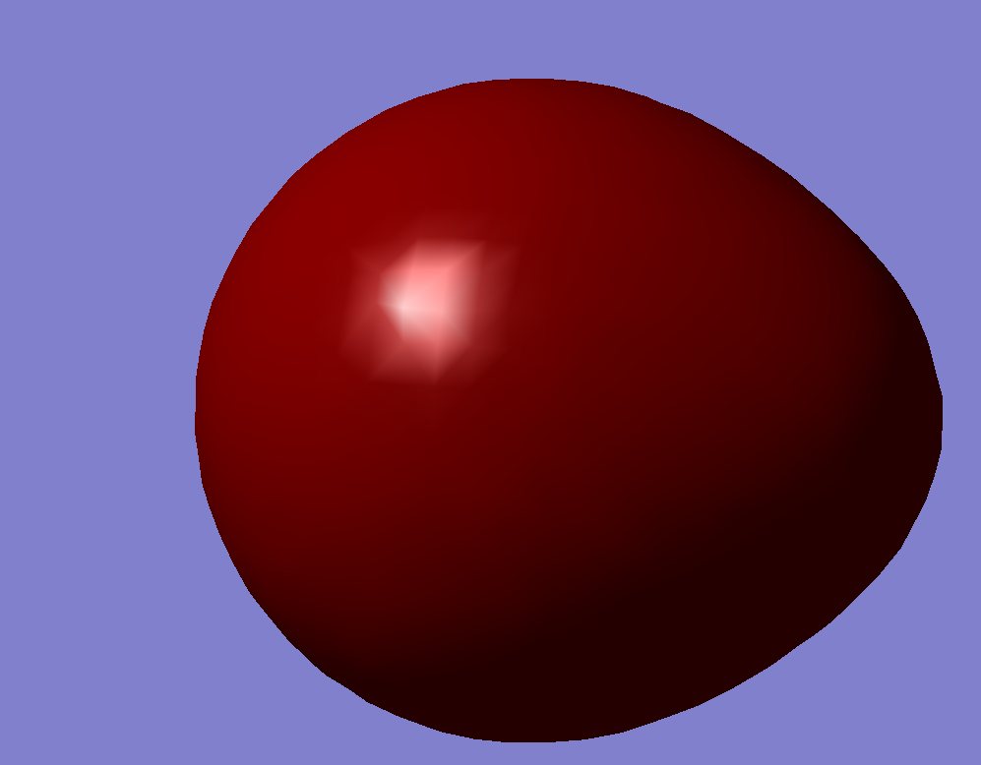
MO 6 (E = -1.12 Ha): sigma, dominated by Cl 3s.
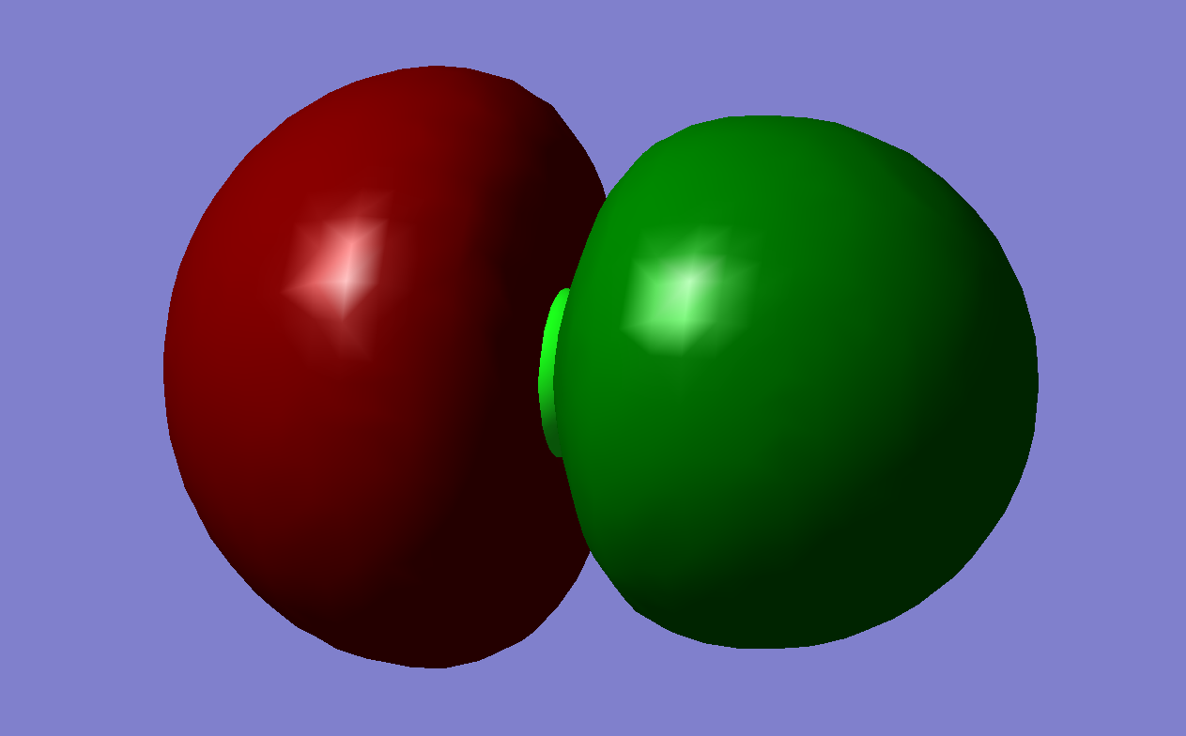
MO 7 (E = -0.63 Ha): H-Cl sigma bond (Cl 3p_z + H 1s).
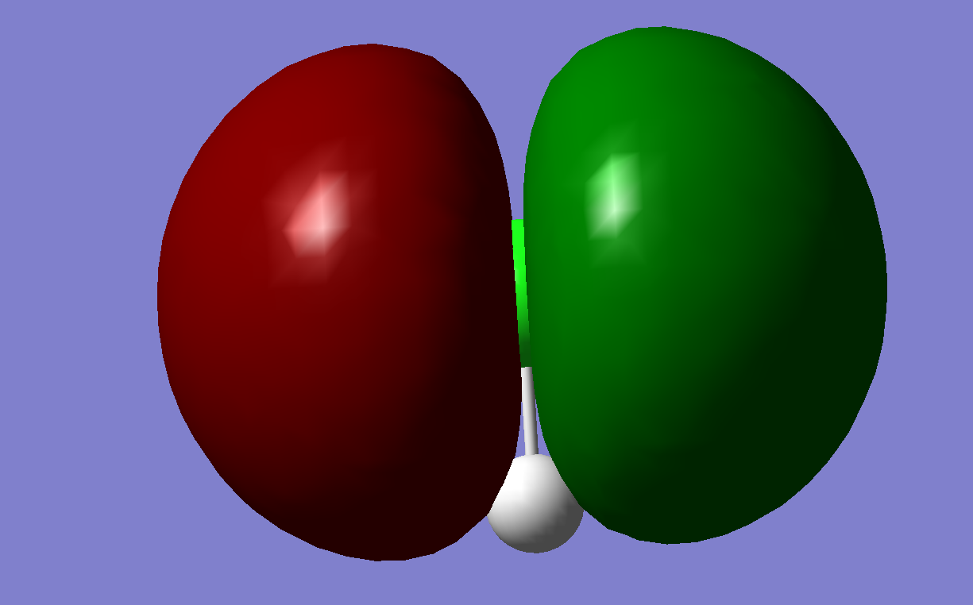
MO 8 (E = -0.48 Ha): HOMO - Cl 3p lone pair, perpendicular to the bond.
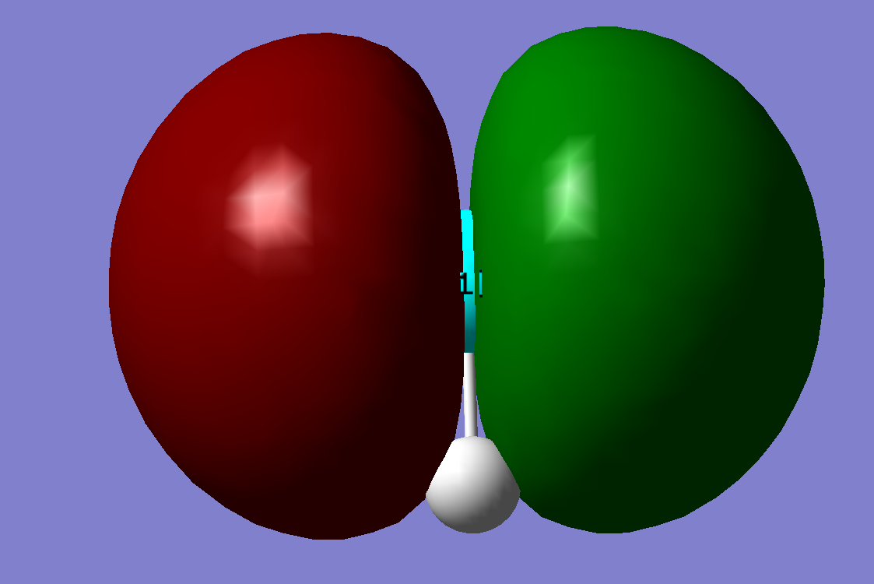
MO 9 (E = -0.48 Ha): HOMO - Cl 3p lone pair, degenerate with MO 8.

CM5235 - Homework Gaussian (2026)
Exercise 2 - Potential energy surface of the H-F molecule, four computational methods
Full Name | Zhang Xubo
Student Number | ________

Methods
Rigid scan of R(H-F), 0.50 to 10.00 Angstrom, step 0.01 Angstrom, spin-unrestricted, cc-pVTZ basis: UHF, UB3LYP, UCCSD, UCCSD(T). Symmetry breaking was requested with guess=mix.

Methodological note (required to interpret the results below)
The H-F bond dissociates homolytically into two neutral radicals, H and F, each with one unpaired electron. Checking <S**2> along the computed curves shows that the UHF scan never actually broke spin symmetry (<S**2> = 0.0000 at every one of the 951 points, including R = 10.00 A): guess=mix, which reliably breaks symmetry for homonuclear diatomics (e.g. H2), did not do so here for this heteronuclear pair, so the UHF curve as scanned describes the closed-shell (partly ionic) dissociation channel rather than the correct H + F asymptote.
This was confirmed and corrected with a stability calculation (keyword stable=opt) at R = 5.00 A (chosen because the curve is already flat there): for UHF this lowered the energy by 0.293 Hartree (770 kJ/mol) and raised <S**2> from 0.000 to 1.003, i.e. it located the correct, spin-contaminated open-shell solution. The same procedure applied to UB3LYP changed the energy by only a small amount at R = 5.00 A, because inspection of the UB3LYP curve shows it spontaneously jumps to the correct open-shell branch on its own near R = 2.9 A (visible as the discontinuity in Figure 1); B3LYP is known to break spin symmetry more readily than HF. stable=opt could not be combined with the post-HF methods CCSD/CCSD(T) in this Gaussian build (route-parsing error), so the UCCSD and UCCSD(T) curves are reported as computed, without this correction, up to R = 4.57 A; beyond this point the CCSD amplitude equations failed to converge (max. cycles reached, largest T2 amplitude 0.98), which is the expected breakdown of single-reference coupled-cluster theory once the bond is substantially broken and the wavefunction acquires strong multi-configurational (static-correlation) character - the same single-determinant failure discussed in Exercise 5 for H2, here reached via a numerical rather than an analytic route.
Consequence for the results below: R_e (obtained near equilibrium, unaffected by this issue) and the UHF/UB3LYP dissociation energies (using the corrected, stability-tested energy at R = 5.00 A) are reliable. The UCCSD/UCCSD(T) dissociation energies use the last available point (R = 4.57 A) as an approximate stand-in for the R -> infinity limit and should be read as approximate.

a) Potential energy curves
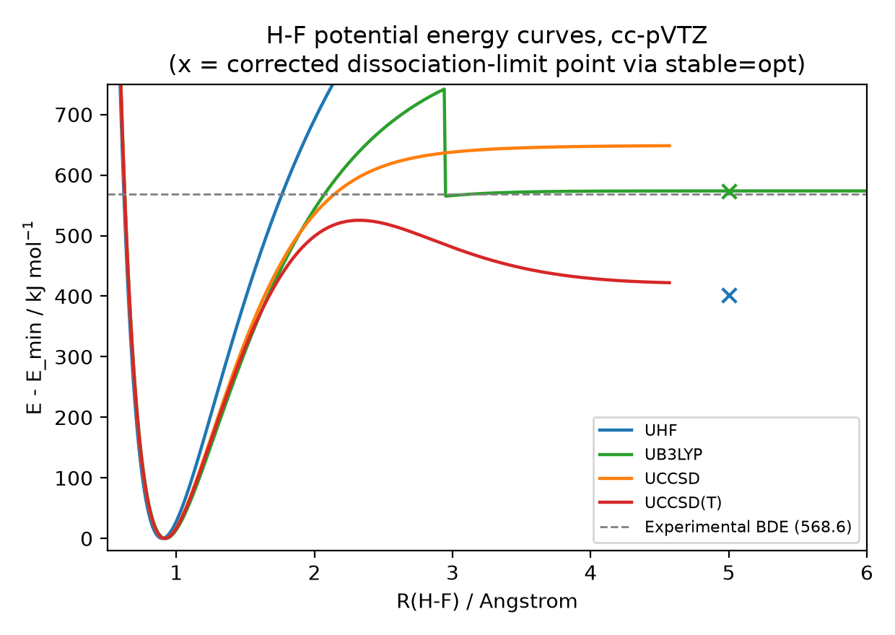
Figure 1. H-F potential energy curves (relative to each curve's own minimum), UHF/UB3LYP/UCCSD/UCCSD(T), cc-pVTZ. The x markers are the corrected (stable=opt) dissociation-limit energies for UHF and UB3LYP at R = 5.00 A. UCCSD/UCCSD(T) are plotted up to R = 4.57 A, the last point that converged before the amplitude equations failed (see methodological note).

b) Equilibrium bond length R_e
Method | R_e / Angstrom
UHF | 0.90
UB3LYP | 0.92
UCCSD | 0.92
UCCSD(T) | 0.92

c) Dissociation energy D_e
Method | E(R_e) / Hartree | E(dissociation limit) / Hartree | R used for dissociation limit / A | D_e / kJ mol-1
UHF | -100.058457 | -99.905336 (corrected, stable=opt) | 5.00 | 402.0
UB3LYP | -100.483565 | -100.265025 (corrected, stable=opt) | 5.00 | 573.8
UCCSD | -100.331967 | -100.084996 (uncorrected, approximate) | 4.57 | 648.4
UCCSD(T) | -100.338348 | -100.177514 (uncorrected, approximate) | 4.57 | 422.3

d) Comparison with the experimental bond dissociation energy (568.6 kJ/mol)
Method | D_e / kJ mol-1 | Difference from experiment
UHF | 402.0 | -166.6 (underestimate)
UB3LYP | 573.8 | +5.2
UCCSD (approx.) | 648.4 | +79.8 (overestimate)
UCCSD(T) (approx.) | 422.3 | -146.3 (underestimate)
UB3LYP gives the closest value to experiment here. This is not the usual expectation (UCCSD(T) is normally the most accurate of the four), and the reason is methodological rather than a genuine ranking of the methods: UB3LYP is the only curve for which a fully reliable dissociation-limit energy was obtained directly from the scan (self-corrected near R = 2.9 A, confirmed by stable=opt at R = 5.00 A); the UHF value is corrected but UHF is known to lack electron correlation and would be expected to underestimate D_e, consistent with the result obtained; the UCCSD and UCCSD(T) values are only approximate because they had to be read off at R = 4.57 A rather than at the true R -> infinity limit, and because the reference determinant used for these two methods was not verified to be the correct open-shell solution over the full range - both curves may still be carrying some of the same closed-shell bias identified for UHF, which would explain why UCCSD overestimates and UCCSD(T) underestimates rather than showing the expected small, systematic correlation-recovery trend from UHF to UCCSD(T). Taken together, the four values illustrate that for a bond that fully dissociates into two radicals, getting the reference wavefunction right is at least as important as the level of correlation treatment chosen.

CM5235 - Homework Gaussian (2026)
Exercise 3 - CH2FCl bond dissociation energy
Full Name | Zhang Xubo
Student Number | ________

1) Total energy comparison, three methods
Method | Basis | E_total / Hartree
HF | STO-3G | -591.172393
B3LYP | cc-pVDZ | -599.362053
CCSD | cc-pVTZ | -598.670494
HF/STO-3G is far higher (less negative) than the other two because it combines the weakest method (no electron correlation) with the smallest basis set. B3LYP/cc-pVDZ and CCSD/cc-pVTZ are not directly comparable on an absolute energy scale even though CCSD uses the larger basis: DFT total energies (B3LYP) are not variational in the same sense as wavefunction-based methods (HF, CCSD), so a lower absolute B3LYP energy does not imply a more accurate result here - the comparison of methods in this exercise is made through the bond dissociation energies in part 3, computed consistently at one level (B3LYP/cc-pVDZ) for parent and fragments.

2) Electron density and electrostatic potential map (B3LYP/cc-pVDZ)
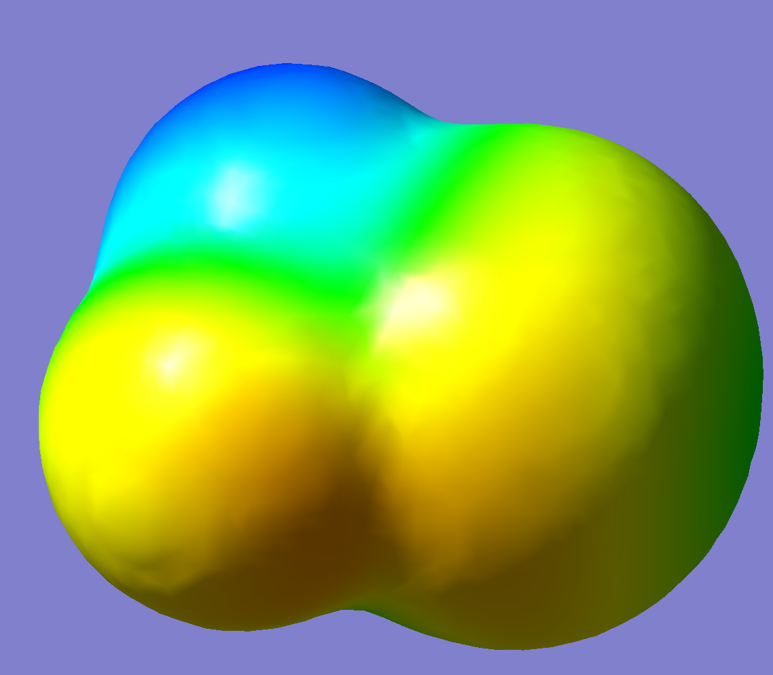
Figure 1. Total electron density surface (isovalue 0.0004) of CH2FCl, mapped with the electrostatic potential (GaussView, B3LYP/cc-pVDZ). Blue = more positive potential, yellow/orange = more negative potential.
The region around the H atoms (top, blue) carries the most positive electrostatic potential, while the regions around F and Cl (yellow/orange) are more negative, consistent with F and Cl being more electronegative than C and H and pulling electron density toward themselves.

3) C-H and C-F bond dissociation energies (B3LYP/cc-pVDZ)
Strategy: homolytic bond cleavage. Each fragment (radical or atom) is fully geometry-optimised (frequency-calculated for the radicals) at the same level, UB3LYP/cc-pVDZ for the open-shell fragments. Zero-point energy (ZPE) corrections are included for the parent molecule and the two radicals; isolated atoms have no vibrational ZPE.
BDE = [E(fragment 1) + ZPE(fragment 1) + E(fragment 2) + ZPE(fragment 2)] - [E(parent) + ZPE(parent)]
Species | E / Hartree | ZPE / Hartree
CH2FCl (parent) | -599.362053 | 0.030710
CHFCl. radical (parent - H) | -598.698761 | 0.017241
CH2Cl. radical (parent - F) | -499.461337 | 0.022429
H atom | -0.501258 | 0 (atom, no vibration)
F atom | -99.726601 | 0 (atom, no vibration)
Bond | BDE / Hartree | BDE / kJ mol-1
C-H (-> CHFCl. + H.) | 0.148565 | 390.1
C-F (-> CH2Cl. + F.) | 0.165834 | 435.2
The C-F bond dissociation energy (435.2 kJ/mol) is larger than the C-H bond dissociation energy (390.1 kJ/mol), i.e. the C-F bond is the stronger of the two. The hydrogen atom is therefore the easier of the two to remove from CH2FCl.

CM5235 - Homework Gaussian (2026)
Exercises 4 and 5 - Theoretical questions
Full Name | Zhang Xubo
Student Number | ________

Exercise 4 - Theoretical question 1
Describe the basic approximations used in the Hartree-Fock Self Consistent Field Method: Born-Oppenheimer Approximation, Orbital Approximation, Mean Field Approximation. How do these approximations simplify the computational problem?

Born-Oppenheimer approximation
Nuclei are far heavier than electrons (a proton is about 1836 electron masses), so nuclei move much more slowly than electrons: for any fixed nuclear positions the electrons are assumed to respond instantaneously and settle into their ground state. This lets the total wavefunction be factorised as Psi = psi_el(r;R) x chi_nuc(R), with the nuclear positions R entering the electronic problem only as fixed parameters, not as dynamical variables.
Simplification: the full Schrodinger equation for electrons and nuclei together is reduced to an electronic Schrodinger equation, H_el psi_el = E_el(R) psi_el, solved at one fixed geometry at a time. This turns a coupled problem in 3(N+M) coordinates (N electrons, M nuclei) into a 3N-electron problem, and E_el(R) + V_NN(R) defines a potential energy surface that can be explored afterwards (geometry optimisation, vibrational frequencies) without re-solving the electronic problem from scratch each time in a coupled way.

Orbital approximation
The N-electron wavefunction is written as an antisymmetrised product (a Slater determinant) of N one-electron functions (spin orbitals), rather than as one general function of all electron coordinates simultaneously:
Psi_HF(x1,...,xN) = (1/sqrt(N!)) det[chi_1(x1) ... chi_N(x1); ... ; chi_1(xN) ... chi_N(xN)]
The determinant form automatically satisfies the Pauli exclusion principle (swapping two electrons changes the sign of Psi; two electrons in the same spin orbital make the determinant vanish).
Simplification: instead of one unknown function of 3N coordinates, the problem becomes N unknown one-electron functions of 3 coordinates each. Each orbital can then be expanded in a finite set of atomic basis functions, turning the search for orbitals into a linear-algebra problem (solving for expansion coefficients) instead of a partial differential equation.

Mean-field approximation
Each electron is assumed to interact not with the instantaneous positions of the other electrons, but with their time-averaged (mean) charge distribution. This replaces the electron-electron repulsion operator, which couples all electrons together, by an effective one-electron operator, the Fock operator:
f(1) = h(1) + sum_j [ J_j(1) - K_j(1) ], f phi_i = epsilon_i phi_i
where h is the one-electron (kinetic + nuclear attraction) operator and J_j, K_j are the Coulomb and exchange operators generated by the other occupied orbitals.
Simplification: the problem of N mutually interacting electrons is replaced by N independent one-electron eigenvalue problems, each electron moving in the averaged field of the others. Because the Fock operator depends on the orbitals it is built from, these equations must be solved iteratively until self-consistency (SCF), but this is far cheaper than treating the exact instantaneous many-body interaction. The price paid is that the correlated, instantaneous part of the electron-electron interaction (electron correlation) is left out of the mean-field description.

Exercise 5 - Theoretical question 2
Describe the covalent chemical bonding on the example of the H2 molecule. Write down the Slater Determinant for the ground state and give an estimate of the total energy using the method explained in Lecture 3 (with h, J, K). Write down the energies of all excited Slater Determinants that can be formed using the minimal basis set on each of the H atoms. Explain the Coulomb and Exchange integrals.

Minimal basis and molecular orbitals
Each H atom contributes one 1s atomic orbital, a (on atom A) and b (on atom B), with overlap S = <a|b>. Symmetry gives two molecular orbitals:
sigma_g = (a + b) / sqrt(2(1+S)) (bonding) sigma_u = (a - b) / sqrt(2(1-S)) (antibonding)
sigma_g places extra electron density between the nuclei (lowering the energy: covalent bonding); sigma_u has a node between the nuclei and is higher in energy.

Ground-state Slater determinant and energy estimate
Both electrons, with opposite spin, occupy the bonding orbital sigma_g:
Psi_0 = | sigma_g(1)alpha(1) sigma_g(1)beta(1) ; sigma_g(2)alpha(2) sigma_g(2)beta(2) | / sqrt(2) = | sigma_g sigma_g-bar |
Using the Lecture-3 expression E = sum_i h_ii + sum_(i<j) (J_ij - K_ij) + V_nn, with only one pair of electrons (opposite spin, so K = 0):
E_0 = 2 h_gg + J_gg + V_nn
where h_gg = <sigma_g|h_hat|sigma_g>, J_gg = (sigma_g sigma_g | sigma_g sigma_g) is the Coulomb repulsion of the sigma_g charge cloud with itself, and V_nn = 1/R is the nuclear repulsion. h_gg = (h_aa + h_ab)/(1+S), and the resonance integral h_ab = <a|h_hat|b> is negative and sizeable: it is this term that lowers E_0 below the energy of two separated H atoms (2 h_aa) and is responsible for the covalent bond.

Energies of all excited Slater determinants (minimal basis)
With 2 spatial orbitals (sigma_g, sigma_u) there are 4 spin orbitals and therefore, besides the ground configuration sigma_g^2, the following determinants:
Determinant | M_S | Energy
|sigma_g sigma_g-bar| (ground state) | 0 | 2 h_gg + J_gg + V_nn
|sigma_g sigma_u| | +1 | h_gg + h_uu + J_gu - K_gu + V_nn
|sigma_g-bar sigma_u-bar| | -1 | h_gg + h_uu + J_gu - K_gu + V_nn
|sigma_g sigma_u-bar| | 0 | h_gg + h_uu + J_gu + V_nn
|sigma_g-bar sigma_u| | 0 | h_gg + h_uu + J_gu + V_nn
|sigma_u sigma_u-bar| (doubly excited) | 0 | 2 h_uu + J_uu + V_nn
Here J_gu = (sigma_g sigma_g | sigma_u sigma_u) and K_gu = (sigma_g sigma_u | sigma_u sigma_g). The exchange term K_gu appears (with a minus sign) only for the M_S = +/-1 determinants, since those have two electrons of the same spin; the two M_S = 0 singly-excited determinants have no K term individually, but their symmetric and antisymmetric combinations give the spin-adapted triplet (^3Sigma_u^+, energy h_gg+h_uu+J_gu-K_gu+V_nn) and singlet (^1Sigma_u^+, energy h_gg+h_uu+J_gu+K_gu+V_nn) excited states.

Coulomb and Exchange integrals
Coulomb integral:
J_ij = (ii|jj) = integral over 1,2 of phi_i(1)^2 (1/r_12) phi_j(2)^2
This is the classical electrostatic repulsion between the charge clouds |phi_i|^2 and |phi_j|^2. It has a classical analogue, is always positive, and does not depend on the relative spin of the two electrons.
Exchange integral:
K_ij = (ij|ji) = integral over 1,2 of phi_i(1) phi_j(1) (1/r_12) phi_j(2) phi_i(2)
This term has no classical counterpart: it arises purely from the antisymmetry of the Slater determinant (the Pauli principle). It is non-zero only between electrons of the same spin, and it enters the energy with a minus sign, lowering the energy of same-spin (e.g. triplet) configurations relative to opposite-spin ones - the quantum-mechanical origin of Hund's rule.

CM5235 - Homework Gaussian (2026)
Exercise 6 - Excited states and spectra of CFH2-OH (fluoromethanol)
Full Name | Zhang Xubo
Student Number | ________

Method
Ground state optimised at B3LYP/cc-pVTZ. First 5 excited states computed at this geometry with (i) TD-DFT within the Tamm-Dancoff approximation (TDA), B3LYP/cc-pVTZ, and (ii) CIS/cc-pVTZ.

Comparison table
State | TDA E / eV | TDA lambda / nm | TDA f | CIS E / eV | CIS lambda / nm | CIS f
S1 | 7.24 | 171.3 | 0.0007 | 8.98 | 138.1 | 0.0000
S2 | 8.62 | 143.8 | 0.0701 | 10.79 | 114.9 | 0.1596
S3 | 9.56 | 129.6 | 0.0149 | 11.55 | 107.4 | 0.0169
S4 | 9.62 | 128.8 | 0.0439 | 11.84 | 104.8 | 0.0345
S5 | 9.72 | 127.5 | 0.0355 | 12.36 | 100.3 | 0.1983

UV/Vis spectrum
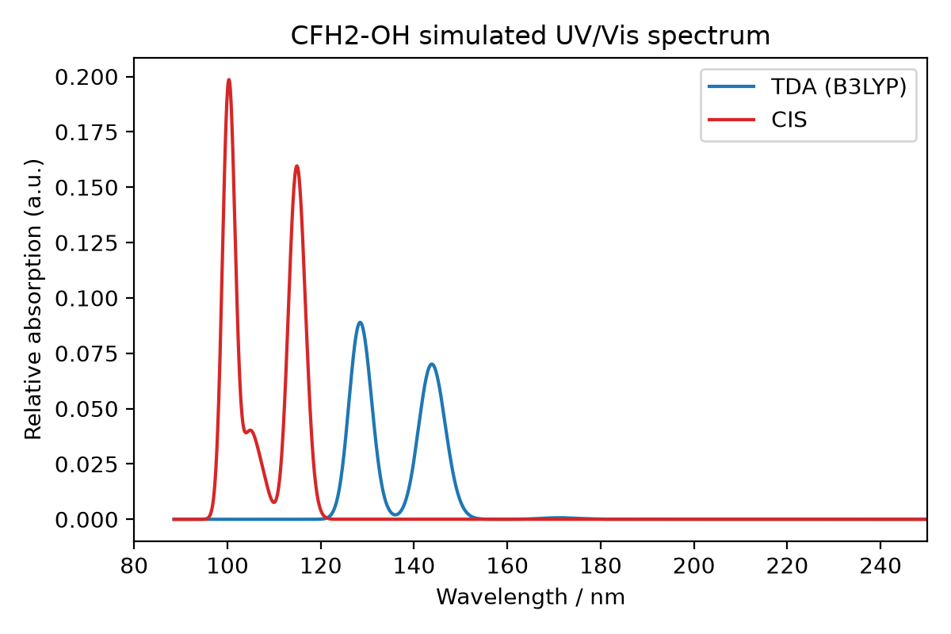
Figure 1. Simulated UV/Vis spectrum (Gaussian broadening, FWHM = 0.4 eV) from the TDA and CIS excitation energies and oscillator strengths above.

Discussion
CIS gives systematically higher excitation energies than TDA/B3LYP for all five states (by roughly 1.7-2.6 eV). This is the expected trend: CIS is built on a Hartree-Fock reference and includes no electron correlation, which is well known to overestimate excitation energies; TDA/TD-DFT includes approximate correlation and exchange through the B3LYP functional and is generally closer to experiment. The two methods agree qualitatively on which transitions carry most oscillator strength (state 2 and state 5 are the strongest in both methods), but CIS blue-shifts the whole spectrum toward shorter wavelength relative to TDA.

