CM5235 - Homework Gaussian (2026)
Exercise 1 - Study of the ground state HCl diatomic molecule with different computational methods
Full Name | Zhang Xubo
Student Number | A0359670R
E-mail | zhangxubo@u.nus.edu
Date | 13 September 2026
Signature

Single-point RHF/STO-3G at R(H-Cl) = 1.275 A
SCF energy: E(RHF) = -455.134835 Hartree
Electric dipole moment: 1.7343 Debye (components X = 0, Y = 0, Z = -1.7343; along the bond axis)
Molecular orbitals: 10 in total = 9 occupied + 1 virtual. Orbital energies (Hartree):
MO | 1 | 2 | 3 | 4 | 5 | 6 | 7 | 8 (HOMO) | 9 (HOMO) | 10 (LUMO)
E / Ha | -103.72252 | -10.40401 | -7.84887 | -7.84216 | -7.84216 | -1.04362 | -0.56448 | -0.42315 | -0.42315 | +0.40398
Mulliken charges:
Atom | Cl | H
Charge | -0.171761 | +0.171761

1) Optimisation + frequency with six basis sets
Route for each: #p hf/<basis> opt=tight freq.

Comparison table
Basis set | Optimal bond length / A | Vib. frequency / cm-1 | Number of orbitals | Number of basis functions | Total energy / Hartree | HOMO-LUMO gap / eV
STO-3G | 1.3133 | 3372.5 | 10 | 10 | -455.136012 | 21.72
6-31G | 1.2953 | 2924.8 | 15 | 15 | -460.037173 | 17.21
cc-pVDZ | 1.2773 | 3149.2 | 23 | 23 | -460.089450 | 16.87
6-311+G(d) | 1.2714 | 3106.6 | 33 | 33 | -460.087170 | 15.48
cc-pVTZ | 1.2673 | 3138.3 | 48 | 48 | -460.106851 | 16.37
cc-pVQZ | 1.2656 | 3138.7 | 89 | 89 | -460.111272 | 15.89
Experiment (NIST) | 1.2746 | 2990.9 (ωₑ) | - | - | - | -

Comparison with experimental values
Experimental data from NIST CCCBDB (cccbdb.nist.gov/exp2x.asp, species HCl).
Quantity | STO-3G | 6-31G | cc-pVDZ | 6-311+G(d) | cc-pVTZ | cc-pVQZ | Experiment
Bond length R_e / A | 1.3133 | 1.2953 | 1.2773 | 1.2714 | 1.2673 | 1.2656 | 1.2746
Vibrational frequency / cm-1 | 3372.5 | 2924.8 | 3149.2 | 3106.6 | 3138.3 | 3138.7 | 2990.9
Moment of inertia / 1e-47 kg m2 | 2.806 | 2.729 | 2.654 | 2.629 | 2.612 | 2.605 | 2.642
Zero-point energy / kJ mol-1 | 20.17 | 17.49 | 18.83 | 18.58 | 18.77 | 18.78 | 17.73
Enthalpy H(298)-H(0) / kJ mol-1 | 8.68 | 8.68 | 8.68 | 8.68 | 8.68 | 8.68 | 8.64
Entropy S(298) / cal mol-1 K-1 | 44.686 | 44.631 | 44.576 | 44.557 | 44.544 | 44.539 | 44.67
The calculated bond length, vibrational frequency and moment of inertia converge as the basis set is enlarged; at cc-pVQZ they differ from experiment by -0.009 A, +148 cm-1 and -0.037e-47 kg m2 respectively, whereas the enthalpy H(298)-H(0) and the entropy agree with experiment to within 1%.

2) Orbital energy diagram and occupied MOs (RHF/6-311+G(d))

Orbital energy diagram
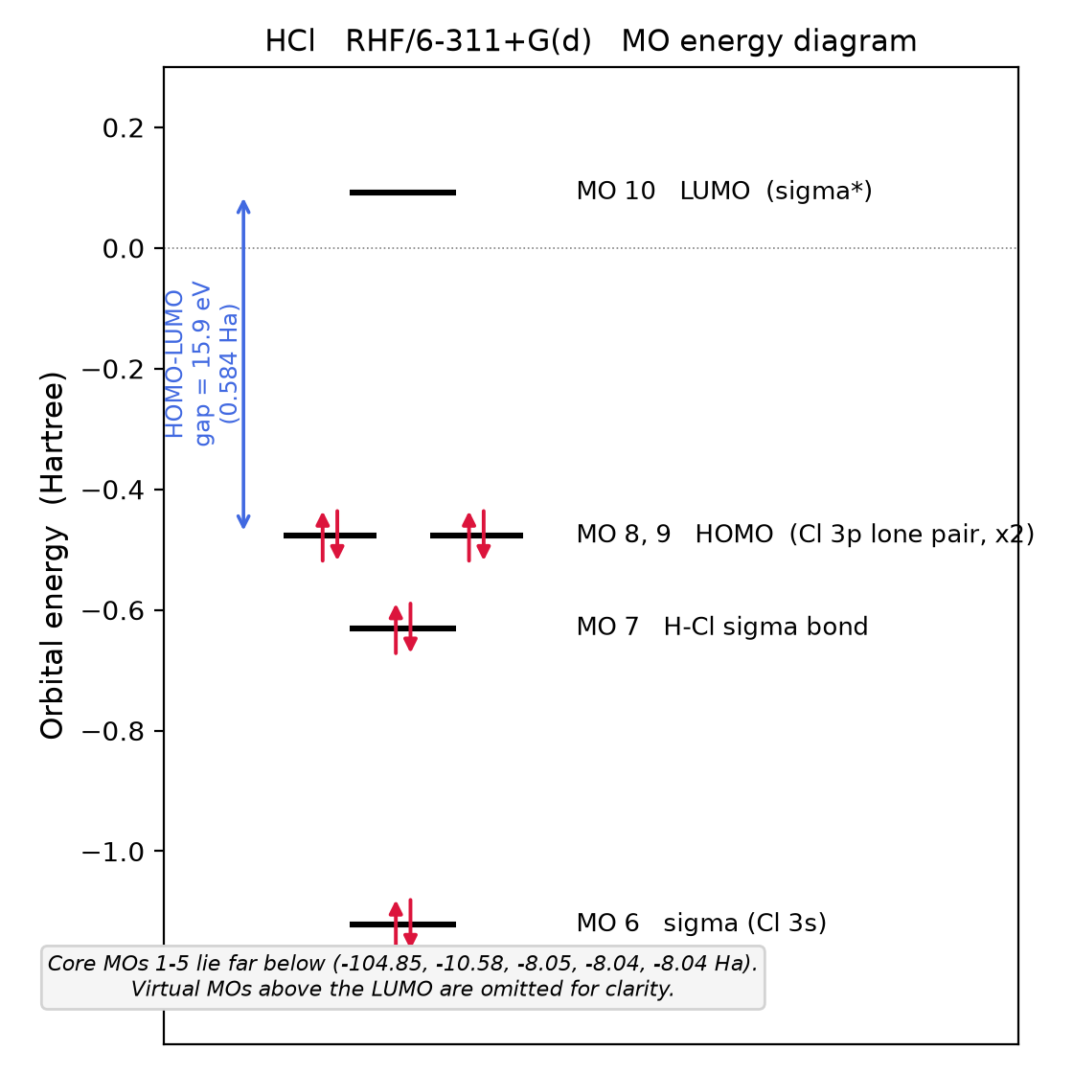
Orbital energy diagram of HCl, RHF/6-311+G(d). Core MOs 1-5 (-104.85 to -8.04 Ha) are off scale; virtual MOs above the LUMO are not shown.
MO | 1 | 2 | 3 | 4 | 5 | 6 | 7 | 8 (HOMO) | 9 (HOMO) | 10 (LUMO)
E / Ha | -104.84972 | -10.57650 | -8.04538 | -8.04148 | -8.04148 | -1.12190 | -0.63065 | -0.47730 | -0.47730 | +0.09172
HOMO-LUMO gap = 0.09172 - (-0.47730) = 0.56902 Ha = 15.48 eV.

Occupied molecular orbitals (MO 1-9)
GaussView, isosurface value 0.02; red / green = the two phases of the wavefunction.
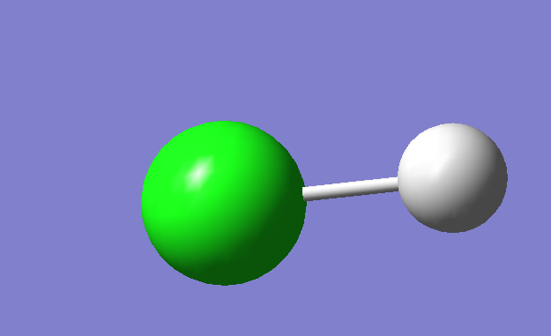
MO 1 (E = -104.85 Ha): Cl 1s core (too contracted to show an isosurface at 0.02).
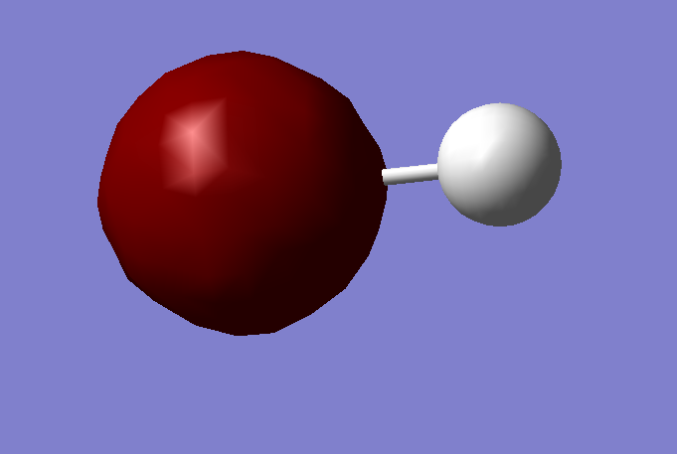
MO 2 (E = -10.58 Ha): Cl 2s core.
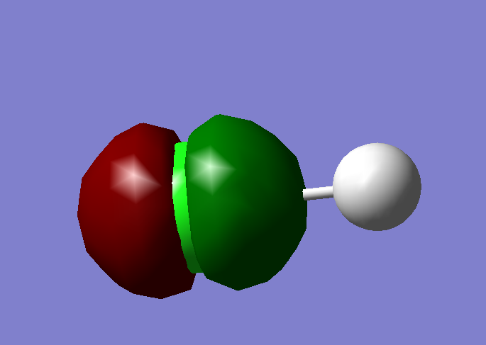
MO 3 (E = -8.05 Ha): Cl 2p core (along the bond axis).
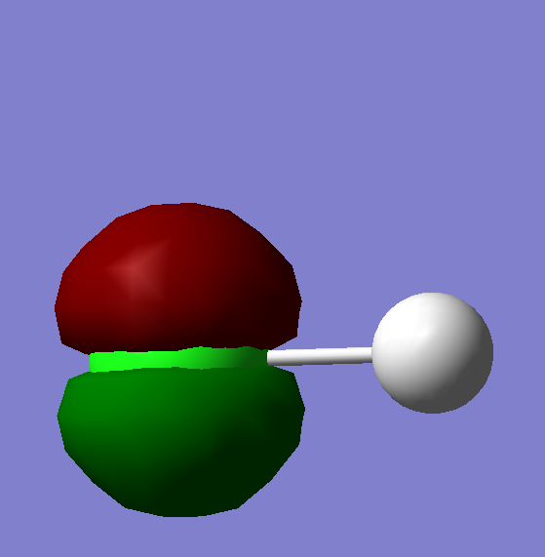
MO 4 (E = -8.04 Ha): Cl 2p core.
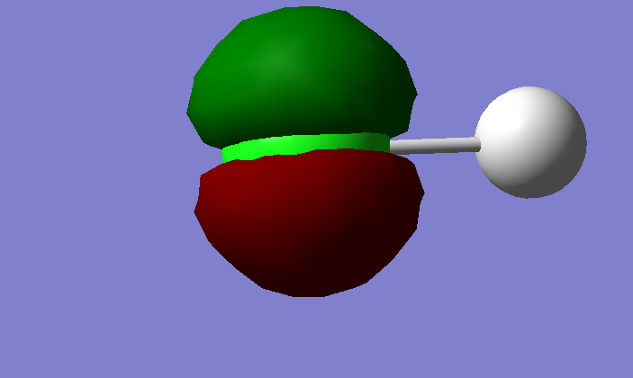
MO 5 (E = -8.04 Ha): Cl 2p core (degenerate with MO 4).
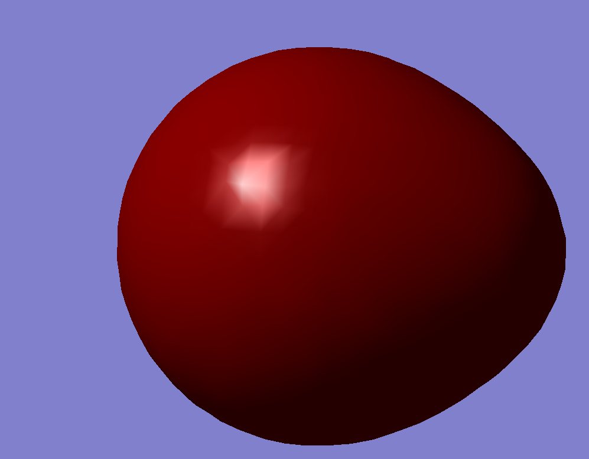
MO 6 (E = -1.12 Ha): sigma, dominated by Cl 3s.
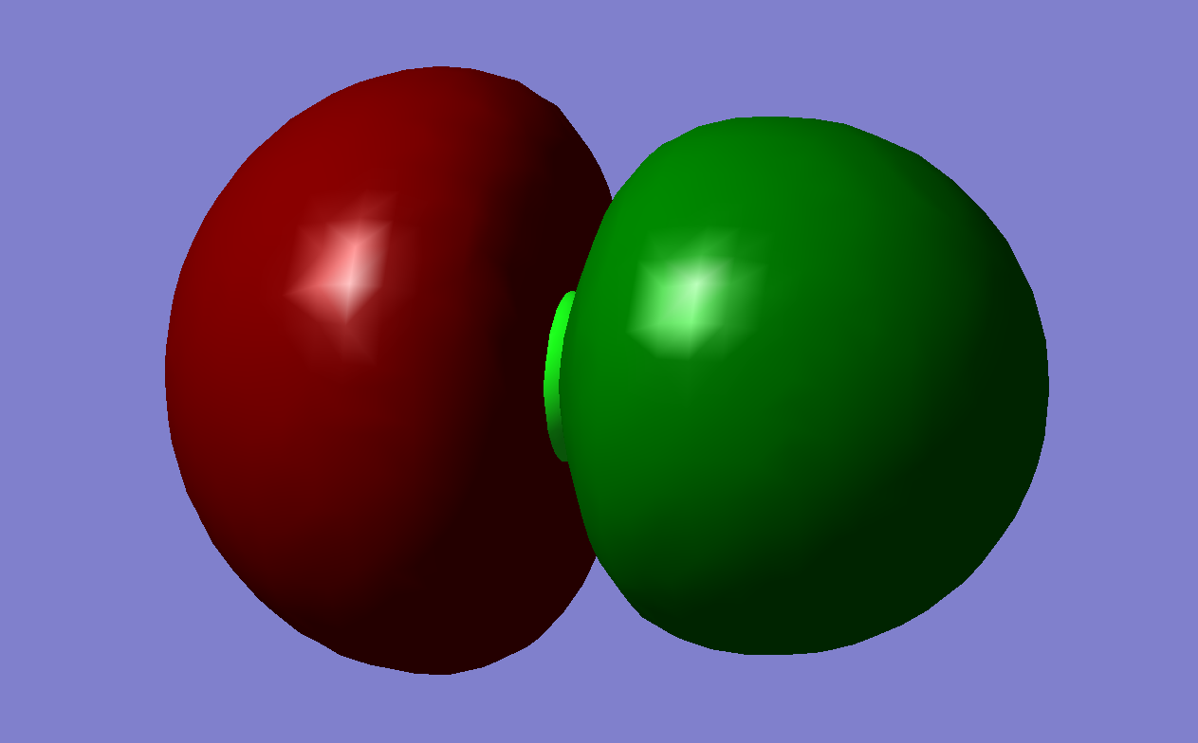
MO 7 (E = -0.63 Ha): H-Cl sigma bond (Cl 3p_z + H 1s).
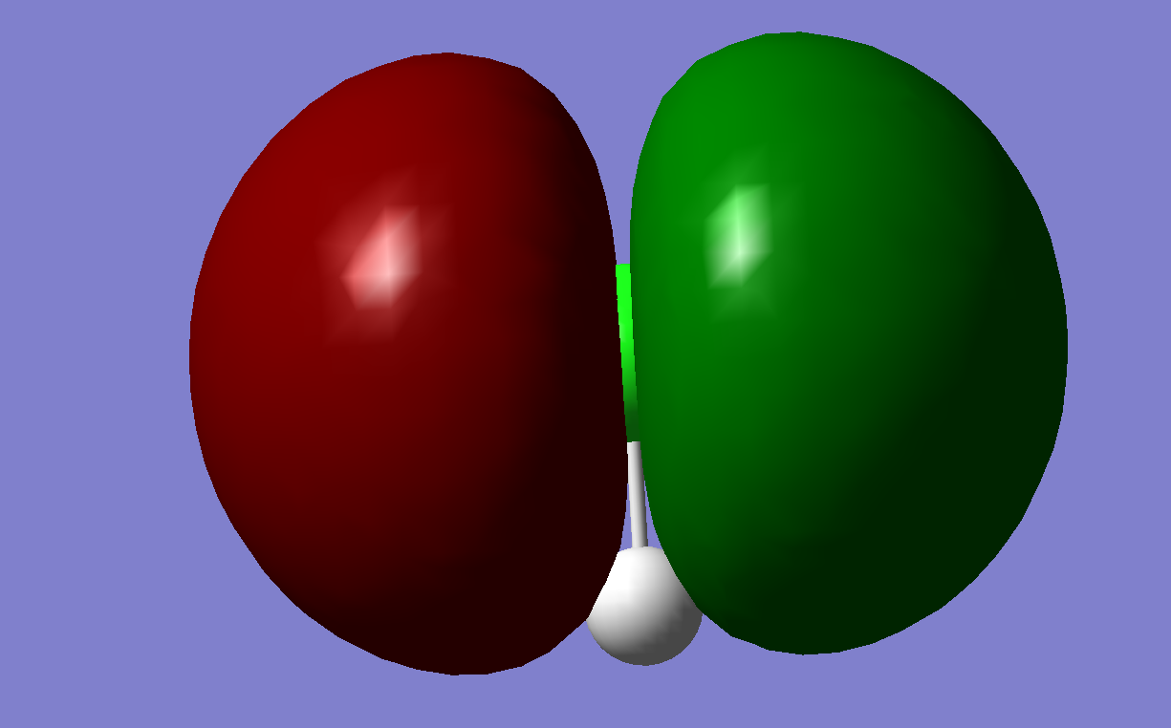
MO 8 (E = -0.48 Ha): HOMO - Cl 3p lone pair, perpendicular to the bond.
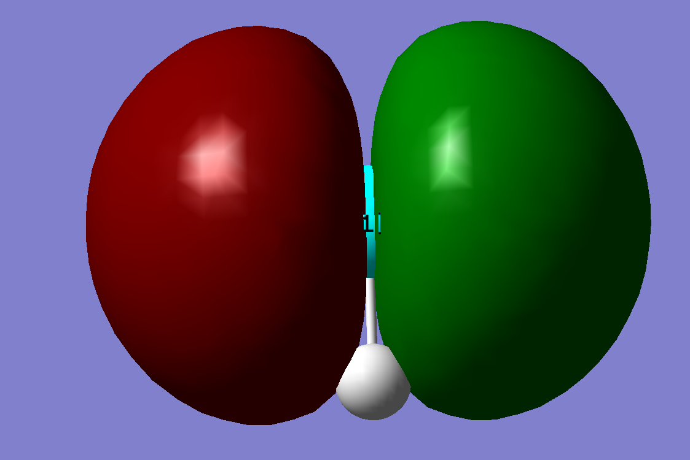
MO 9 (E = -0.48 Ha): HOMO - Cl 3p lone pair, degenerate with MO 8.

