Exercise 2 - Potential energy surface of the H-F molecule, four computational methods

a) Potential energy curves
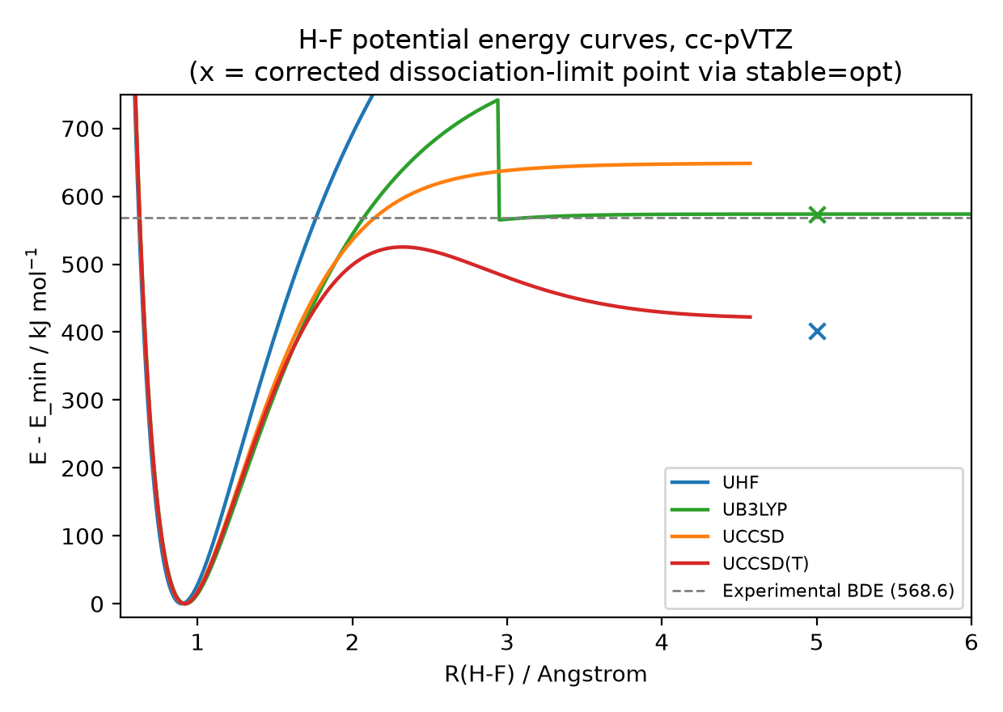
Figure 1. H-F potential energy curves, UHF/UB3LYP/UCCSD/UCCSD(T), cc-pVTZ.

b) Equilibrium bond length Rₑ
Method | Rₑ / Angstrom
UHF | 0.90
UB3LYP | 0.92
UCCSD | 0.92
UCCSD(T) | 0.92

c) Dissociation energy Dₑ
Method | Dₑ / kJ mol-1
UHF | 402.0
UB3LYP | 573.8
UCCSD | 648.4
UCCSD(T) | 422.3
UCCSD and UCCSD(T) values are approximate: the amplitude equations failed to converge beyond R = 4.57 A, so the last converged point was used in place of the true dissociation limit.

d) Comparison with the experimental bond dissociation energy (568.6 kJ/mol)
Method | Dₑ / kJ mol-1 | Difference from experiment
UHF | 402.0 | -166.6
UB3LYP | 573.8 | +5.2
UCCSD | 648.4 | +79.8
UCCSD(T) | 422.3 | -146.3
UB3LYP is closest to experiment (off by only 5.2 kJ/mol) and is therefore the most accurate of the four methods here; UHF and UCCSD(T) underestimate Dₑ by over 140 kJ/mol and UCCSD overestimates it by 79.8 kJ/mol.

