Exercise 3 - CH2FCl bond dissociation energy

1) Total energy comparison, three methods
Method | Basis | E_total / Hartree
HF | STO-3G | -591.172393
B3LYP | cc-pVDZ | -599.362053
CCSD | cc-pVTZ | -598.670494

2) Electron density and electrostatic potential map (B3LYP/cc-pVDZ)
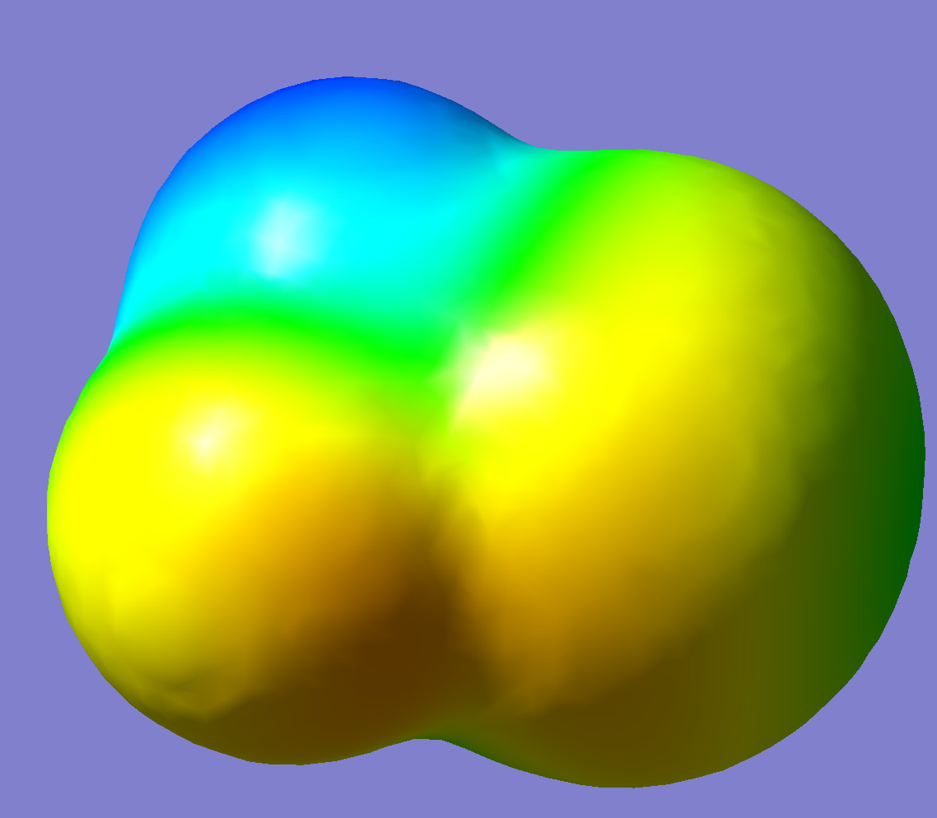
Figure 1. Total electron density surface (isovalue 0.0004) of CH2FCl, mapped with the electrostatic potential (GaussView, B3LYP/cc-pVDZ). Blue = more positive potential, yellow/orange = more negative potential.
The surface itself is a total electron density isosurface (isovalue 0.0004), so its shape traces the outer envelope of the electron cloud: it bulges out furthest around Cl, which has the most electrons and the most diffuse (largest) electron cloud of the four elements present, and is noticeably tighter around the H atoms, which contribute only a single 1s electron each. Mapping the electrostatic potential onto this surface then shows where that density sits relative to the nuclear charges: the H atoms (blue) carry the most positive potential, while F and Cl (yellow/orange) are more negative, since both pull electron density toward themselves more strongly than C or H.

3) C-H and C-F bond dissociation energies
Strategy: homolytic bond cleavage; each radical/atom fragment is separately optimised (with frequencies, for ZPE) at UB3LYP/cc-pVDZ.
BDE = [E(radical) + ZPE(radical) + E(atom)] - [E(parent) + ZPE(parent)]

C-H bond, B3LYP/cc-pVDZ: CH2FCl -> CHFCl. + H.
Species | E / Hartree | ZPE / Hartree
CH2FCl (parent) | -599.362053 | 0.030710
CHFCl. radical | -598.698761 | 0.017241
H atom | -0.501258 | 0 (atom, no vibration)
BDE(C-H) = 0.148565 Hartree = 390.1 kJ/mol

C-F bond, B3LYP/cc-pVDZ: CH2FCl -> CH2Cl. + F.
Species | E / Hartree | ZPE / Hartree
CH2FCl (parent) | -599.362053 | 0.030710
CH2Cl. radical | -499.461337 | 0.022429
F atom | -99.726601 | 0 (atom, no vibration)
BDE(C-F) = 0.165834 Hartree = 435.2 kJ/mol
The C-F bond is the stronger of the two (435.2 vs 390.1 kJ/mol); the H atom is the easier of the two to remove from CH2FCl.

