Exercise 6 - Excited states and spectra of CFH2-OH (fluoromethanol)

Comparison table
State | TDA E / eV | TDA λ / nm | TDA f | CIS E / eV | CIS λ / nm | CIS f
S1 | 8.10 | 153.1 | 0.0087 | 9.81 | 126.4 | 0.0082
S2 | 8.90 | 139.2 | 0.0193 | 11.05 | 112.2 | 0.0444
S3 | 9.43 | 131.5 | 0.0456 | 11.86 | 104.5 | 0.1865
S4 | 9.93 | 124.8 | 0.0144 | 12.43 | 99.7 | 0.0165
S5 | 10.10 | 122.8 | 0.0586 | 13.03 | 95.2 | 0.2335

UV/Vis spectrum
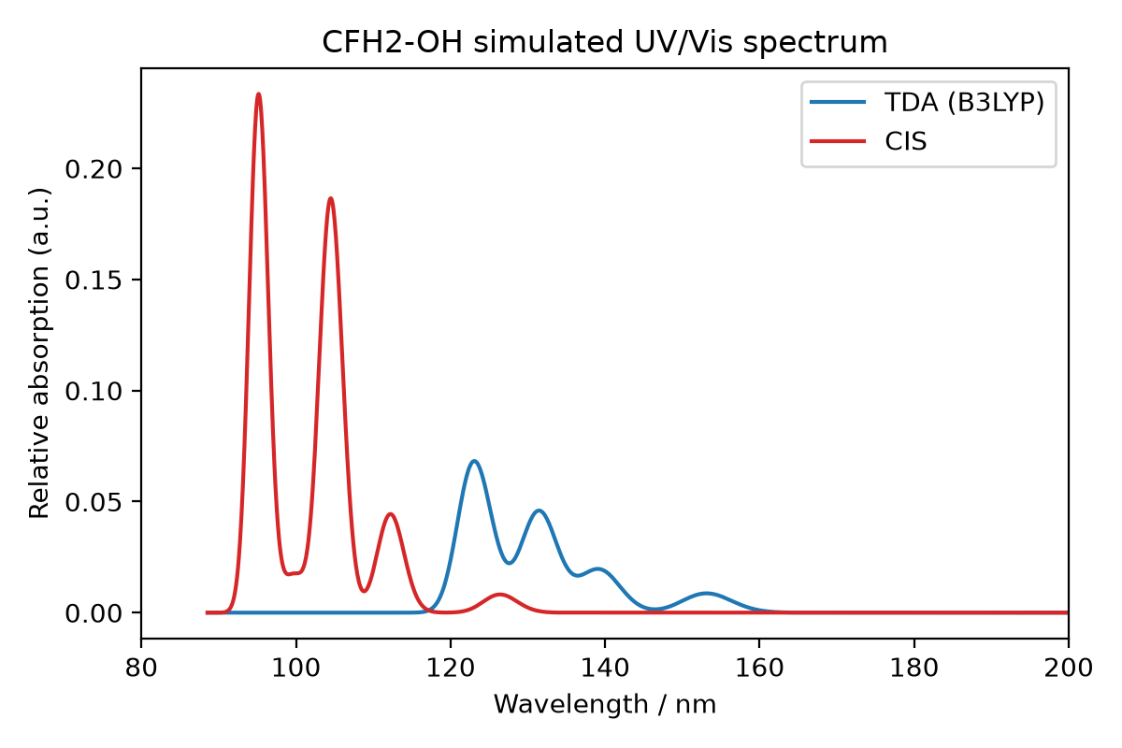
Figure 1. Simulated UV/Vis spectrum (Gaussian broadening, FWHM = 0.4 eV) from the TDA and CIS excitation energies and oscillator strengths above.
CIS gives systematically higher excitation energies than TDA/B3LYP across all five states (by roughly 1.7-3.0 eV), consistent with CIS lacking electron correlation.

