Exercise 4 - Excited states and spectra
TD-DFT for the first five singlet excited states at the four optimised structures of Exercise 1, with the same functional, basis and solvent model as the optimisation: ! RKS <PBE | B3LYP> def2-TZVP def2/J TightSCF (RIJCOSX for B3LYP, CPCM(Water) for the solvated runs) and %tddft NRoots 5 TDA false end, i.e. full linear-response TD-DFT rather than the Tamm–Dancoff approximation. The ground state is closed-shell, so a restricted reference was used; it gives the same ground state as the unrestricted one of Exercise 1 but pure singlet excited states.

Excitation energies of the first five excited states
Table 1. TD-DFT/def2-TZVP singlet excitations: energy E, wavelength λ, oscillator strength f and the orbital transitions with weight ≥ 0.15 (HOMO = orbital 32, LUMO = orbital 33).
Method | State | E (eV) | λ (nm) | f | Main transitions (weight)
PBE (gas) | S₁ | 4.656 | 266.3 | 0.0401 | HOMO→LUMO (0.81), HOMO−1→LUMO+1 (0.18)
 | S₂ | 5.175 | 239.6 | 0.0001 | HOMO→LUMO+2 (0.99)
 | S₃ | 5.478 | 226.3 | 0.0244 | HOMO→LUMO+1 (0.63), HOMO−1→LUMO (0.32)
 | S₄ | 5.865 | 211.4 | 0.0000 | HOMO−1→LUMO+2 (0.98)
 | S₅ | 6.129 | 202.3 | 0.2100 | HOMO−1→LUMO (0.43), HOMO−1→LUMO+1 (0.25)
B3LYP (gas) | S₁ | 4.985 | 248.7 | 0.0447 | HOMO→LUMO (0.79), HOMO−1→LUMO+1 (0.20)
 | S₂ | 5.690 | 217.9 | 0.0002 | HOMO→LUMO+2 (0.97)
 | S₃ | 5.749 | 215.7 | 0.0154 | HOMO→LUMO+1 (0.60), HOMO−1→LUMO (0.38)
 | S₄ | 6.339 | 195.6 | 0.0000 | HOMO−1→LUMO+2 (0.96)
 | S₅ | 6.667 | 186.0 | 0.0009 | HOMO→LUMO+3 (0.98)
PBE (water) | S₁ | 4.643 | 267.0 | 0.0585 | HOMO→LUMO (0.83), HOMO−1→LUMO+1 (0.16)
 | S₂ | 5.267 | 235.4 | 0.0002 | HOMO→LUMO+2 (0.99)
 | S₃ | 5.449 | 227.5 | 0.0377 | HOMO→LUMO+1 (0.64), HOMO−1→LUMO (0.31)
 | S₄ | 5.936 | 208.9 | 0.0000 | HOMO−1→LUMO+2 (0.98)
 | S₅ | 6.018 | 206.0 | 0.3226 | HOMO−1→LUMO (0.54), HOMO→LUMO+1 (0.19)
B3LYP (water) | S₁ | 4.974 | 249.3 | 0.0647 | HOMO→LUMO (0.81), HOMO−1→LUMO+1 (0.18)
 | S₂ | 5.720 | 216.7 | 0.0216 | HOMO→LUMO+1 (0.61), HOMO−1→LUMO (0.37)
 | S₃ | 5.762 | 215.2 | 0.0003 | HOMO→LUMO+2 (0.97)
 | S₄ | 6.390 | 194.0 | 0.5322 | HOMO−1→LUMO (0.58), HOMO→LUMO+1 (0.34)
 | S₅ | 6.395 | 193.9 | 0.0068 | HOMO−1→LUMO+2 (0.95)

Influence of the solvent
Table 2. Excitation energies (eV) in the gas phase and in water, matched by their main transition (the state number is given in brackets, because the order changes), and the solvent shift ΔE = E(water) − E(gas). “–”: not among the first five states.
Main transition | PBE gas | PBE water | ΔE | B3LYP gas | B3LYP water | ΔE
HOMO→LUMO | 4.656 (S₁) | 4.643 (S₁) | −0.013 | 4.985 (S₁) | 4.974 (S₁) | −0.011
HOMO→LUMO+2 | 5.175 (S₂) | 5.267 (S₂) | +0.092 | 5.690 (S₂) | 5.762 (S₃) | +0.072
HOMO→LUMO+1 | 5.478 (S₃) | 5.449 (S₃) | −0.029 | 5.749 (S₃) | 5.720 (S₂) | −0.029
HOMO−1→LUMO+2 | 5.865 (S₄) | 5.936 (S₄) | +0.071 | 6.339 (S₄) | 6.395 (S₅) | +0.056
HOMO−1→LUMO | 6.129 (S₅) | 6.018 (S₅) | −0.111 | – | 6.390 (S₄) | –
HOMO→LUMO+3 | – | – | – | 6.667 (S₅) | – | –

Water changes the excitation energies only slightly: by at most 0.11 eV for the states that appear in both phases. The lowest state, S₁, is the HOMO→LUMO excitation for all four methods and moves by only −0.013 eV with PBE and −0.011 eV with B3LYP (266.3 → 267.0 nm and 248.7 → 249.3 nm). The states dominated by the HOMO→LUMO+1 and HOMO−1→LUMO configurations are lowered by water, whereas the two states that excite into LUMO+2 are raised by 0.06–0.09 eV, so S₂ and S₃ swap order for B3LYP. The effect on the intensities is larger than on the energies: the oscillator strength of S₁ grows from 0.040 to 0.058 (PBE) and from 0.045 to 0.065 (B3LYP). The choice of functional matters much more than the solvent: B3LYP places every state 0.3–0.5 eV above PBE.

UV spectra
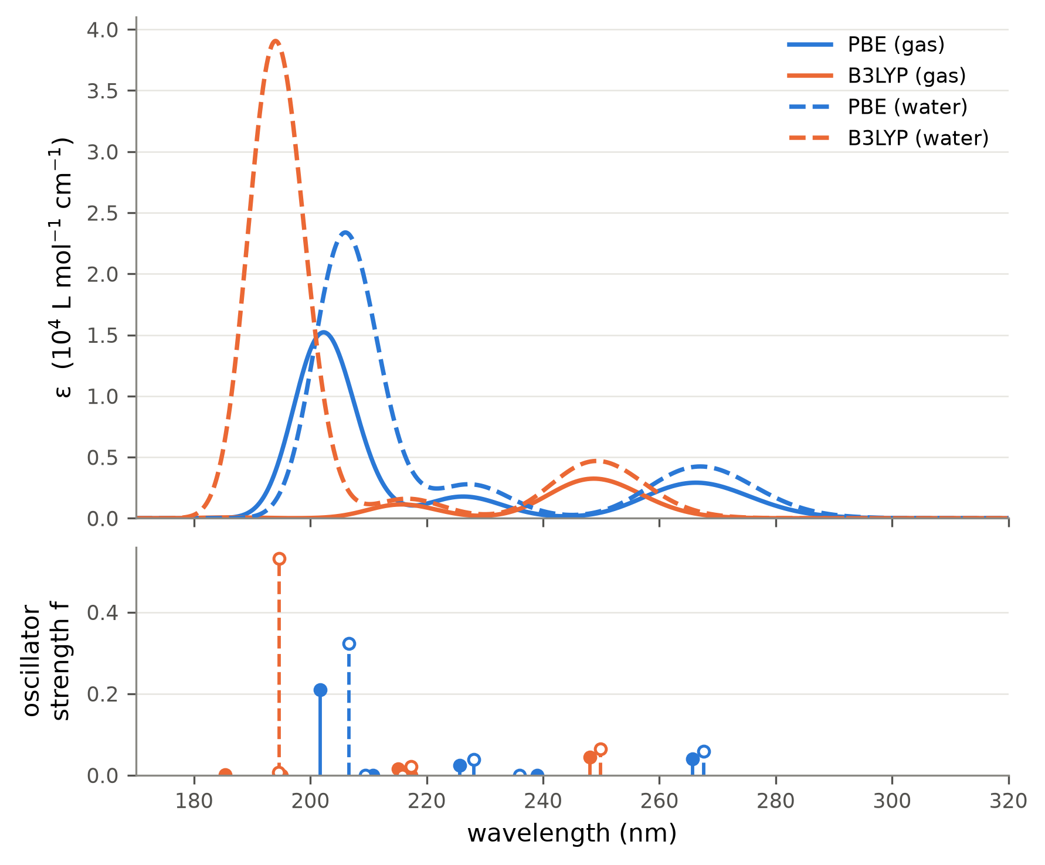
Figure 1. Simulated UV spectra of 2-chlorophenol. Top: each transition broadened by a Gaussian of FWHM 3000 cm⁻¹ (≈0.37 eV) in wavenumber, ε = Σ 2.174×10⁸ f_{i}/FWHM · exp[−2.773 (ν̃ − ν̃_{i})²/FWHM²]. Bottom: oscillator strengths (filled: gas, open: water; gas and water sticks are offset by ±0.6 nm for visibility). Only five states were computed, so the spectra are incomplete below about 200 nm.

