Exercise 6 - Ab initio and semi-empirical molecular dynamics of a water cluster
Both runs use the ORCA %md module on a cluster cut from an ice crystal, at 400 K with a Nosé–Hoover chain thermostat (time constant 10 fs) and a time step of 0.5 fs, which is the largest step the manual recommends for systems containing hydrogen. The exercise asks for a sphere of size 50 Å; this was read as a diameter, so the ORCA keyword Cell Sphere was given a radius of 25 Å, centred on the cluster (the input files are not centred on the origin). The sphere is a soft repulsive wall that keeps evaporated molecules from flying away; the clusters themselves have radii of only 6.4 Å (a) and 13.7 Å (b), so the wall never acts on the bulk of the cluster, and the results would be the same if the 50 Å were read as a radius. Keywords: ! MD PBE def2-SVP def2/J for (a) and ! MD XTB2 for (b).

Setup and cost
Table 1. The two simulations and what they cost on one core.
 | (a) PBE/def2-SVP | (b) GFN2-xTB
Water molecules | 20 | 128
Atoms | 60 | 384
Steps × 0.5 fs | 200 = 100 fs | 5000 = 2.5 ps
Wall time (1 core) | 4.8 h | 5.6 h
Time per step | 86 s | 4.1 s
Time per step and atom | 1436 ms | 10.6 ms

Structures at the beginning and at the end
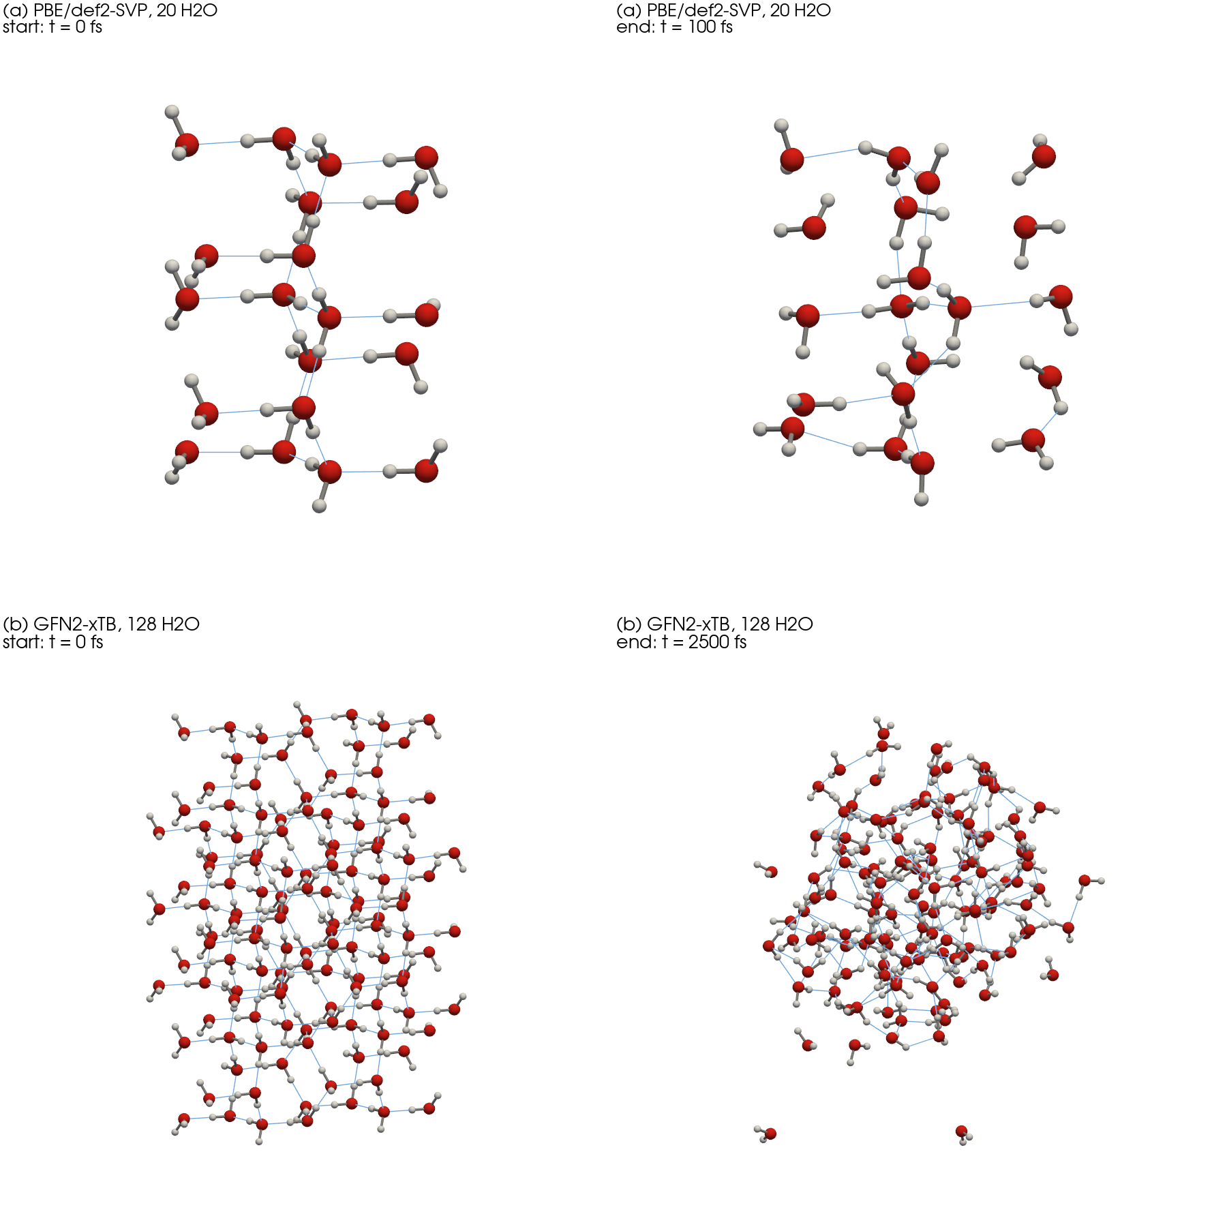
Figure 1. First and last frame of each trajectory. Red: O, white: H, grey sticks: covalent O–H bonds, thin blue lines: hydrogen bonds (H···O < 2.2 Å). Same viewing direction and scale within each row.

Temperature and structure along the trajectories
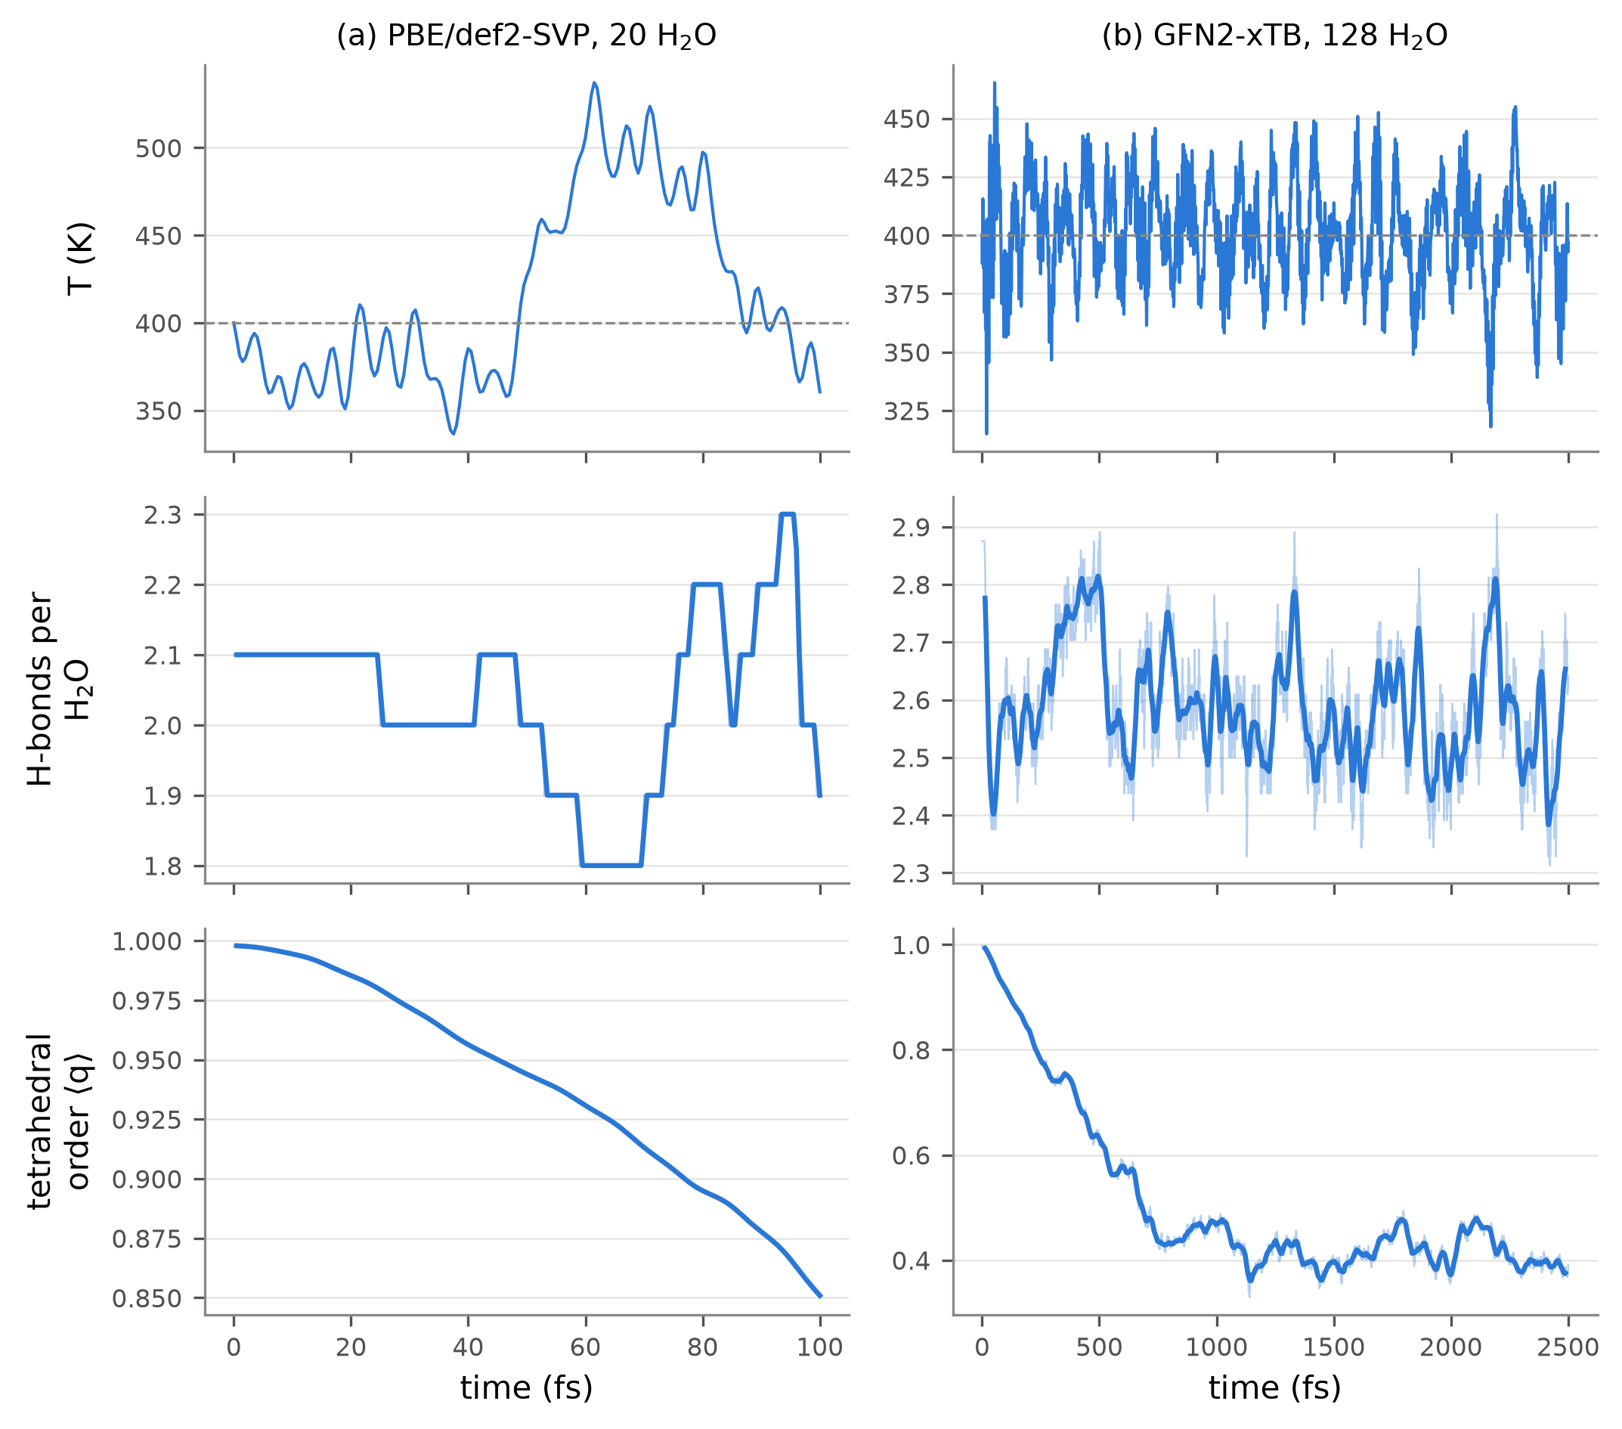
Figure 2. Top: instantaneous temperature (dashed line: the 400 K set point). Middle: hydrogen bonds per water molecule (O···O < 3.5 Å and ∠(H–O···O) < 30°). Bottom: tetrahedral order parameter q averaged over the molecules that start with four neighbours within 3.2 Å (2 of 20 and 48 of 128). Thin lines are per-step values, thick lines a running average.
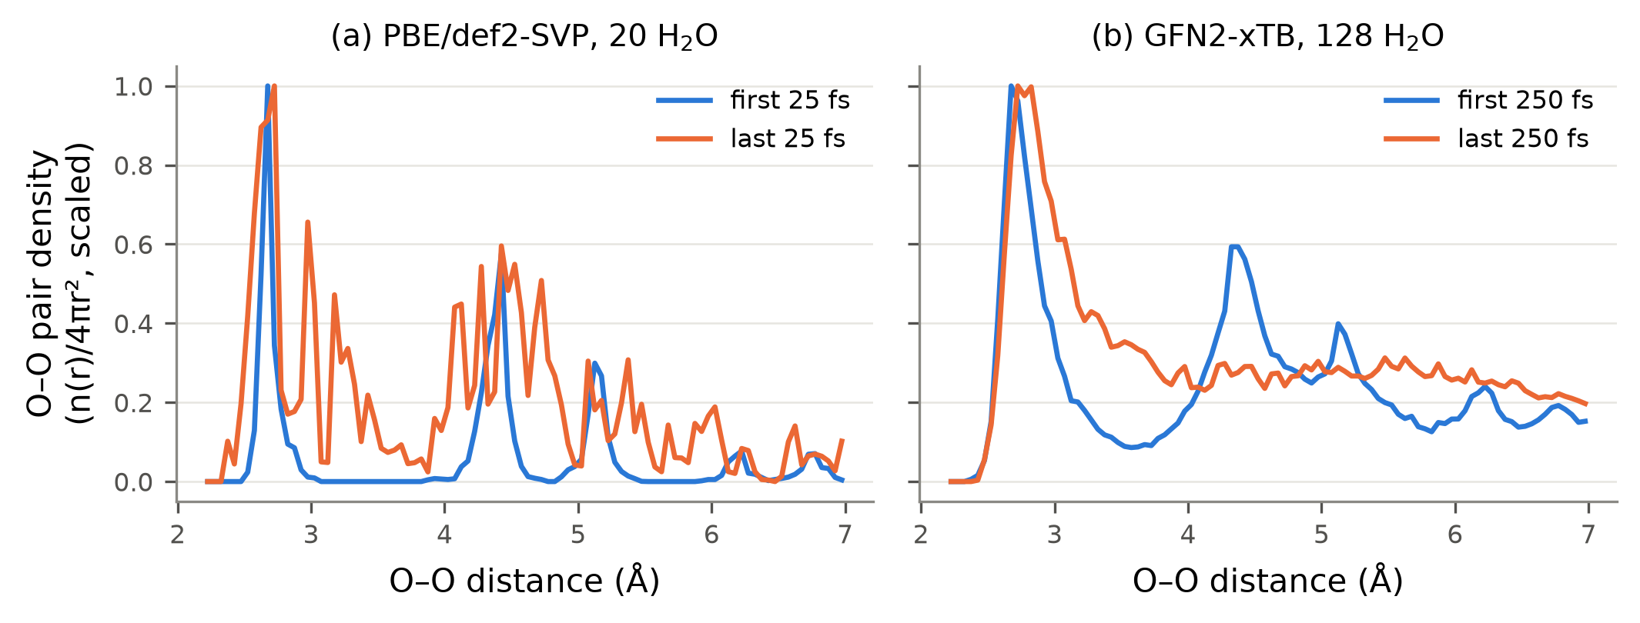
Figure 3. O–O pair distance distribution, n(r)/4πr², at the beginning and at the end of each run, scaled to the same maximum.

What the simulations show
The ice cluster melts, and the melting is visible in the structure, not in the temperature. In the xTB run the tetrahedral order of the interior molecules falls from 0.90 to 0.39 during the first ~800 fs and then stays there; the second-neighbour peak at 4.4 Å in the O–O distribution disappears and the minimum at 3.5 Å fills in (Figure 3b). That is the crystal-to-liquid change the exercise describes: the molecules keep their hydrogen bonds (2.56 → 2.53 per molecule) but lose the tetrahedral arrangement and the long-range order.
100 fs of ab initio MD is not enough to see it. In the DFT run q only falls from 0.99 to 0.88 and the pair distribution still shows the ice peaks. Hydrogen-bond rearrangement in water takes of the order of a picosecond, so a 100 fs trajectory only samples the vibrations around the initial structure.
Molecules evaporate, and the wall is needed. The largest O distance from the centre of the cluster grows from 13.0 Å to 23.6 Å in the xTB run: single molecules leave the hot surface and travel almost to the 25 Å wall. Without the confining sphere they would simply fly away and the cluster would slowly evaporate.
The thermostat works, but small clusters fluctuate strongly. Over the second half of the xTB run the mean temperature is 399 K with a standard deviation of 22 K. In the 60-atom DFT cluster the same thermostat gives swings of ±50 K around the set point, because the temperature of a small system is a strongly fluctuating quantity (the relative fluctuation goes as 1/√N).
Cost decides what is possible. One DFT step costs 86 s for 60 atoms, one xTB step 4.1 s for 384 atoms, i.e. about 136 times more expensive per atom and step. This is why the ab initio run is limited to a small cluster and 100 fs while the semi-empirical run reaches 128 molecules and 2.5 ps in a comparable wall time.

What else can be obtained from the trajectories
The stored trajectory (and the per-step energies in the .csv file that ORCA writes) contains much more than the melting itself:
Structure. Radial distribution functions g(r) for O–O, O–H and H–H and the coordination numbers obtained by integrating them; the distribution of hydrogen-bond distances and angles; the distribution of the tetrahedral order parameter; the size and shape of the cluster.
Dynamics. Mean square displacement and from it the diffusion coefficient; hydrogen-bond lifetimes and reorientation correlation times; velocity autocorrelation, whose Fourier transform gives the vibrational density of states; the dipole autocorrelation function, which gives the infrared spectrum including anharmonic and temperature effects, something a harmonic frequency calculation like Exercise 1 cannot provide.
Thermodynamics and quality control. The distributions of kinetic and potential energy (and from their fluctuations the heat capacity); the evaporation rate; and, as a check on the integration, the drift of the conserved quantity — here −3.2 kcal mol⁻¹ over 2.5 ps for xTB and +0.03 kcal mol⁻¹ over 100 fs for DFT.
Snapshots from the trajectory can also be used as starting structures for other calculations, for example to compute spectra of solvated molecules on configurations sampled by the dynamics.
The animation of the xTB trajectory (every 25th step, 201 frames) is supplied as ex6b_trajectory_animation_XTB.gif.

