CM5235 - Homework ORCA (2026)
Full Name | Zhang Xubo
Student Number | A0359670R
E-mail | zhangxubo@u.nus.edu
Date | 27 September 2026
Signature

Exercise 1 - Study of the ground state of 2-chlorophenol with different computational methods
ORCA 5.0.2, spin-unrestricted Kohn–Sham, def2-TZVP basis; geometry optimisation followed by an analytic frequency calculation: ! UKS <PBE | B3LYP> def2-TZVP def2/J TightSCF TightOpt Opt Freq, with RIJCOSX for B3LYP and CPCM(Water) for the two solvated runs.
In the supplied structure the hydroxyl hydrogen was perpendicular to the ring. Before optimisation it was rotated into the ring plane on the Cl side (cis conformer, intramolecular O–H···Cl contact); all other atoms were left as given. All four optimised structures have 33 real frequencies and no imaginary mode, so they are minima. This conformer was chosen because it is 3.3 kcal mol⁻¹ (3.0 kcal mol⁻¹ in G at 298 K) below the trans conformer, which is also a minimum (B3LYP/def2-TZVP, gas phase).

a) Mulliken and Löwdin atomic charges
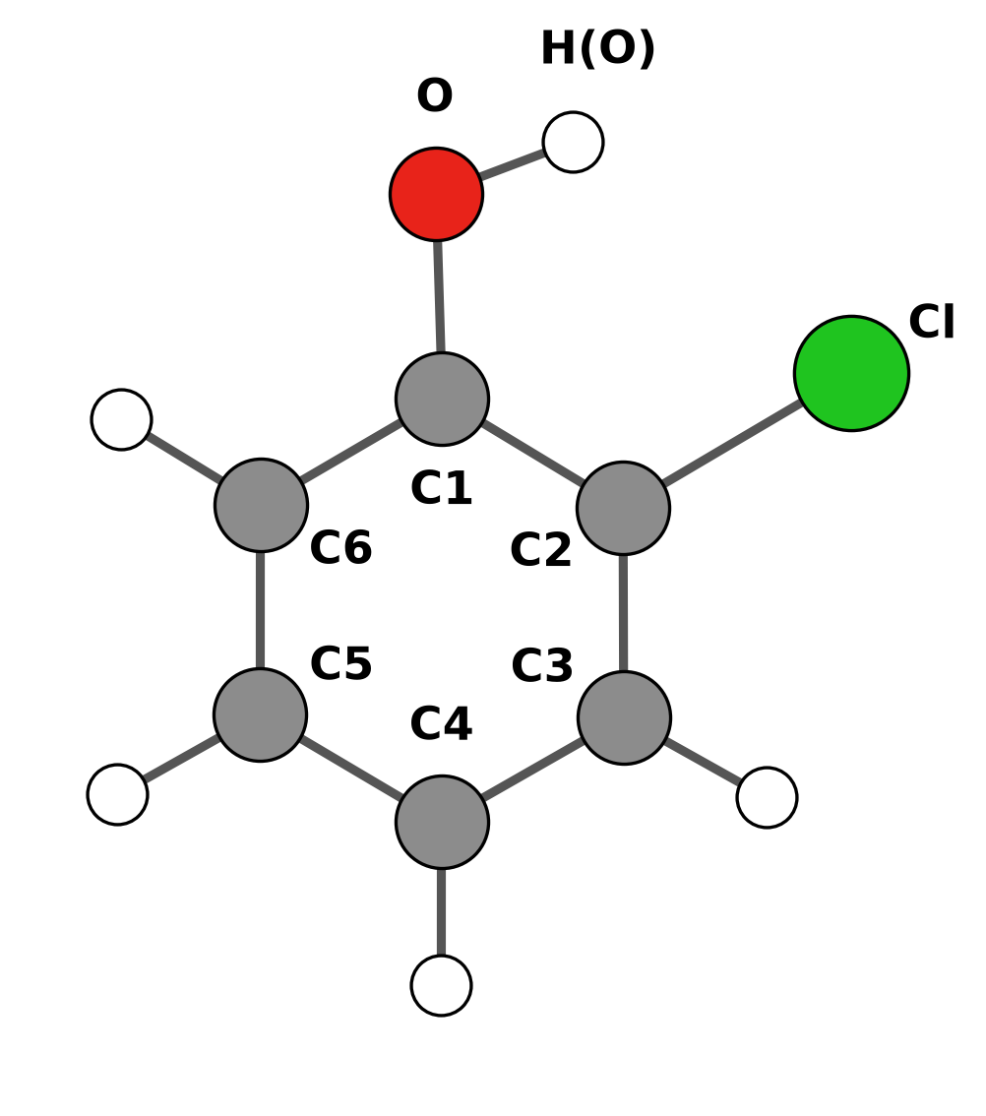
Figure 1. Atom numbering used in Table 1. H(Cn) is the hydrogen bonded to Cn; H(O) is the hydroxyl hydrogen.
Table 1. Atomic charges (e), UKS/def2-TZVP.
 | Mulliken |  |  |  | Löwdin
Atom | PBE gas | B3LYP gas | PBE water | B3LYP water | PBE gas | B3LYP gas | PBE water | B3LYP water
Cl | −0.1320 | −0.1390 | −0.1302 | −0.1399 | +0.3901 | +0.3753 | +0.3877 | +0.3711
O | −0.3215 | −0.3783 | −0.3568 | −0.4165 | +0.1091 | +0.0948 | +0.0963 | +0.0801
C1 | +0.1421 | +0.1795 | +0.1598 | +0.1996 | −0.2951 | −0.2832 | −0.3003 | −0.2879
C2 | +0.1463 | +0.1281 | +0.1257 | +0.1112 | −0.4167 | −0.4058 | −0.4220 | −0.4099
C3 | −0.1728 | −0.1632 | −0.1961 | −0.1845 | −0.1488 | −0.1433 | −0.1512 | −0.1448
C4 | −0.1165 | −0.1230 | −0.1557 | −0.1601 | −0.1545 | −0.1510 | −0.1589 | −0.1541
C5 | −0.0866 | −0.0898 | −0.1254 | −0.1268 | −0.1413 | −0.1351 | −0.1459 | −0.1383
C6 | −0.1931 | −0.1878 | −0.2251 | −0.2186 | −0.1181 | −0.1136 | −0.1258 | −0.1210
H(O) | +0.2975 | +0.3078 | +0.3358 | +0.3452 | +0.1768 | +0.1750 | +0.1919 | +0.1894
H(C3) | +0.1173 | +0.1245 | +0.1495 | +0.1549 | +0.1507 | +0.1478 | +0.1587 | +0.1554
H(C4) | +0.1052 | +0.1110 | +0.1415 | +0.1459 | +0.1467 | +0.1436 | +0.1546 | +0.1513
H(C5) | +0.1051 | +0.1125 | +0.1410 | +0.1471 | +0.1478 | +0.1450 | +0.1558 | +0.1528
H(C6) | +0.1090 | +0.1177 | +0.1359 | +0.1424 | +0.1533 | +0.1506 | +0.1592 | +0.1559

Water increases the charge separation in the hydroxyl group. The Mulliken charge on O goes from −0.322 to −0.357 (PBE) and from −0.378 to −0.417 (B3LYP), and the hydroxyl H goes from +0.297 to +0.336 and from +0.308 to +0.345. B3LYP puts more negative charge on O than PBE. The two partitioning schemes disagree most for the heteroatoms: Löwdin gives Cl a positive charge (+0.37 to +0.39) and O a small positive one, where Mulliken gives negative values. Atomic charges are not observables, and the two schemes divide the overlap density differently, so only the trends within one scheme should be compared.

b) Vibrational frequencies
Table 2. Harmonic vibrational frequencies (cm⁻¹), ORCA mode numbering (modes 0–5 are translations and rotations).
Mode | PBE gas | B3LYP gas | PBE water | B3LYP water
6 | 154.5 | 159.5 | 155.2 | 159.6
7 | 245.2 | 253.0 | 240.3 | 247.7
8 | 255.5 | 264.9 | 255.1 | 264.2
9 | 365.9 | 376.2 | 366.4 | 376.3
10 | 429.6 | 435.1 | 429.2 | 388.8
11 | 475.4 | 454.7 | 439.3 | 453.0
12 | 484.4 | 496.2 | 483.0 | 494.8
13 | 532.9 | 551.9 | 536.3 | 554.9
14 | 546.3 | 565.4 | 545.7 | 564.5
15 | 669.9 | 687.6 | 665.3 | 682.8
16 | 688.5 | 718.0 | 696.7 | 725.9
17 | 727.1 | 760.9 | 728.7 | 761.7
18 | 824.1 | 846.4 | 820.2 | 842.0
19 | 824.4 | 865.9 | 827.6 | 868.4
20 | 887.6 | 939.2 | 904.4 | 954.2
21 | 907.7 | 957.8 | 929.8 | 979.9
22 | 1020.9 | 1047.3 | 1016.0 | 1042.6
23 | 1033.5 | 1064.9 | 1031.1 | 1061.8
24 | 1111.8 | 1142.8 | 1104.3 | 1135.8
25 | 1143.2 | 1181.4 | 1132.2 | 1172.0
26 | 1185.4 | 1214.2 | 1170.2 | 1197.8
27 | 1248.8 | 1278.6 | 1233.4 | 1264.6
28 | 1303.6 | 1325.1 | 1298.1 | 1318.7
29 | 1364.6 | 1372.7 | 1355.7 | 1363.2
30 | 1451.2 | 1495.3 | 1444.5 | 1488.7
31 | 1468.4 | 1514.1 | 1458.4 | 1504.8
32 | 1583.5 | 1625.6 | 1576.7 | 1619.2
33 | 1593.0 | 1634.5 | 1583.2 | 1625.3
34 | 3109.7 | 3175.6 | 3110.2 | 3176.9
35 | 3121.9 | 3188.2 | 3120.0 | 3186.9
36 | 3128.9 | 3195.9 | 3126.4 | 3193.7
37 | 3137.0 | 3203.1 | 3135.5 | 3202.3
38 | 3567.0 | 3721.7 | 3561.5 | 3704.6

B3LYP gives higher frequencies than PBE for nearly every mode (on average by 2.8 % in the gas phase). The largest difference is the O–H stretch (mode 38): 3567 cm⁻¹ with PBE and 3722 cm⁻¹ with B3LYP. Water shifts most modes by only a few cm⁻¹; the O–H stretch is lowered by 6 cm⁻¹ (PBE) and 17 cm⁻¹ (B3LYP).

c)–e) Electric dipole moment, entropy at room temperature and HOMO–LUMO gap
Table 3. Dipole moment, entropy at 298.15 K and frontier orbital energies. S_{el} = 0 (closed-shell singlet); ORCA treats the low-frequency vibrations with Grimme's quasi-RRHO model. HOMO = orbital 32, LUMO = orbital 33 (α and β identical).
Quantity | PBE gas | B3LYP gas | PBE water | B3LYP water
Dipole moment μ (D) | 0.751 | 0.880 | 0.896 | 1.091
S_{vib} (cal mol⁻¹ K⁻¹) | 12.62 | 12.10 | 12.75 | 12.30
S_{rot} (cal mol⁻¹ K⁻¹) | 28.64 | 28.63 | 28.65 | 28.63
S_{trans} (cal mol⁻¹ K⁻¹) | 40.47 | 40.47 | 40.47 | 40.47
S total (cal mol⁻¹ K⁻¹) | 81.73 | 81.19 | 81.86 | 81.40
T·S (kcal mol⁻¹) | 24.37 | 24.21 | 24.41 | 24.27
E_{HOMO} (eV) | −5.676 | −6.449 | −5.666 | −6.429
E_{LUMO} (eV) | −1.490 | −0.690 | −1.463 | −0.647
HOMO–LUMO gap (eV) | 4.186 | 5.759 | 4.204 | 5.782

The dipole moment grows from PBE to B3LYP and from gas to water (0.75 D for PBE in the gas phase, 1.09 D for B3LYP in water): the continuum polarises the molecule. The entropy is almost method-independent (81.2–81.9 cal mol⁻¹ K⁻¹); the translational and rotational parts depend only on mass and geometry, and only the vibrational part changes a little through the low-frequency modes. The HOMO–LUMO gap is 1.6 eV larger with the hybrid functional (5.76 vs 4.19 eV in the gas phase), while water changes it by only 0.02 eV with both functionals.

Normal mode 12
ORCA numbers all 3N modes from 0, so modes 0–5 are translations and rotations and mode 12 is the seventh vibration. Avogadro and Chemcraft list only the 33 vibrations, starting from 1, so their twelfth entry is ORCA mode 17. Since the numbering in the question could mean either, both modes are shown.
Table 4. The two modes that “mode 12” can refer to, B3LYP/def2-TZVP gas phase.
 | ORCA mode 12 | ORCA mode 17
Position in the list | 12th of all modes (7th vibration) | 17th of all modes (12th vibration)
Frequency (cm⁻¹) | 496.2 | 760.9
IR intensity (km mol⁻¹) | 11.2 | 69.4
PBE gas / B3LYP gas / PBE water / B3LYP water (cm⁻¹) | 484.4 / 496.2 / 483.0 / 494.8 | 727.1 / 760.9 / 728.7 / 761.7

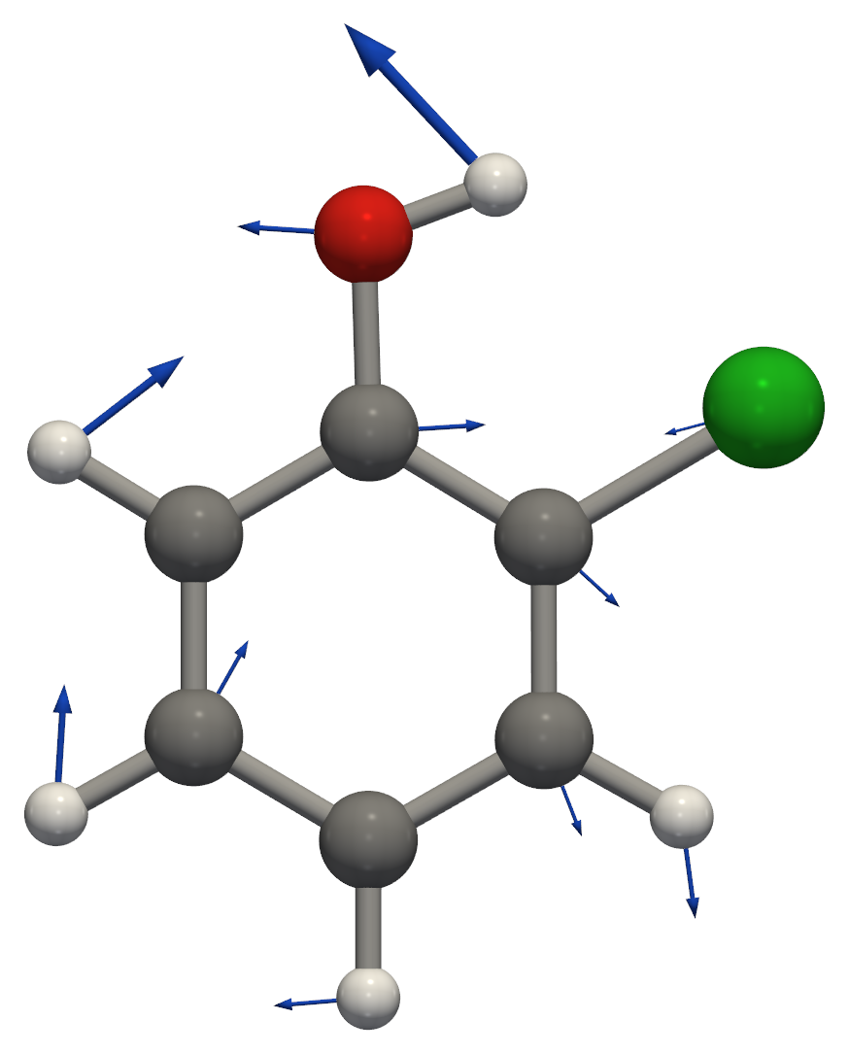
Figure 2a. ORCA mode 12 (7th vibration), 496.2 cm⁻¹, IR intensity 11.2 km mol⁻¹: in-plane ring deformation coupled to C–O–H bending; the hydroxyl H moves most. Arrows show the atomic displacements.
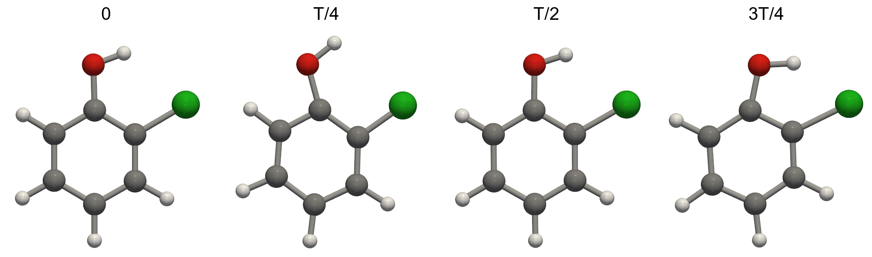
Figure 2b. ORCA mode 12 at four points of one vibrational period T. The animation is sent with this report as HW2_ZhangXubo_Ex1_mode12_ORCA-numbering.gif.
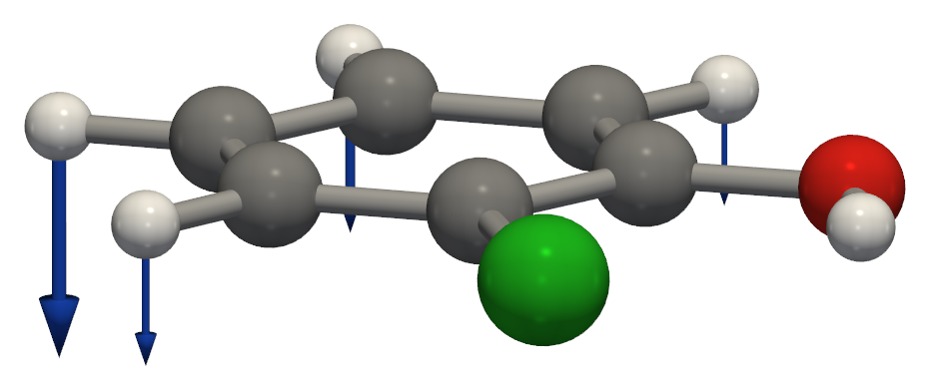
Figure 3. ORCA mode 17 (12th vibration in the Avogadro list), 760.9 cm⁻¹, IR intensity 69.4 km mol⁻¹: out-of-plane bending of the ring C–H bonds. The animation is sent as HW2_ZhangXubo_Ex1_mode12_Avogadro-numbering.gif.
The frames of both modes were generated with orca_pltvib and rendered with Python (PyVista), since the movie export of Avogadro does not work.

HOMO and LUMO (B3LYP/def2-TZVP, gas phase)
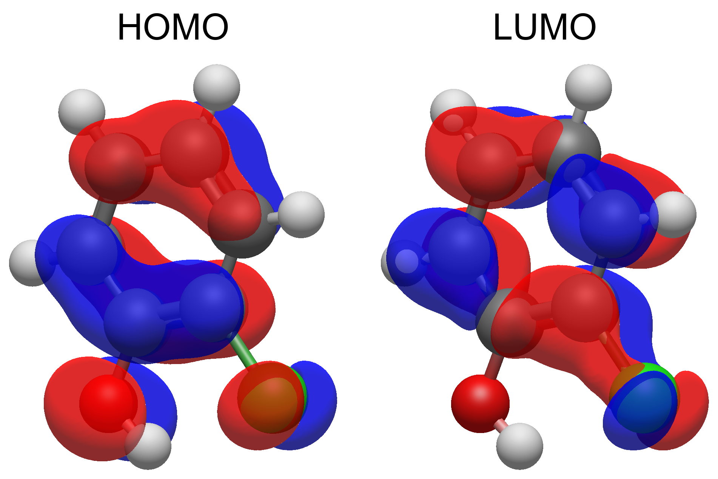
Figure 4. HOMO (orbital 32, −6.45 eV) and LUMO (orbital 33, −0.69 eV), isovalue ±0.02 a.u.; the two colours are the two phases of the orbital. Plotted with Avogadro 2 directly from the ORCA wavefunction (Molden file); Avogadro numbers the same orbitals 33 and 34, because it counts from 1 and ORCA from 0.
Both frontier orbitals are π orbitals. The HOMO is a ring π orbital with one nodal plane across the ring and antibonding contributions from the p lone pairs of O and Cl. The LUMO is a ring π* orbital with a small Cl contribution and almost none on O. The HOMO→LUMO excitation is the main component of the lowest excited state in Exercise 4.

Electron density and electrostatic potential (B3LYP/def2-TZVP, gas phase)
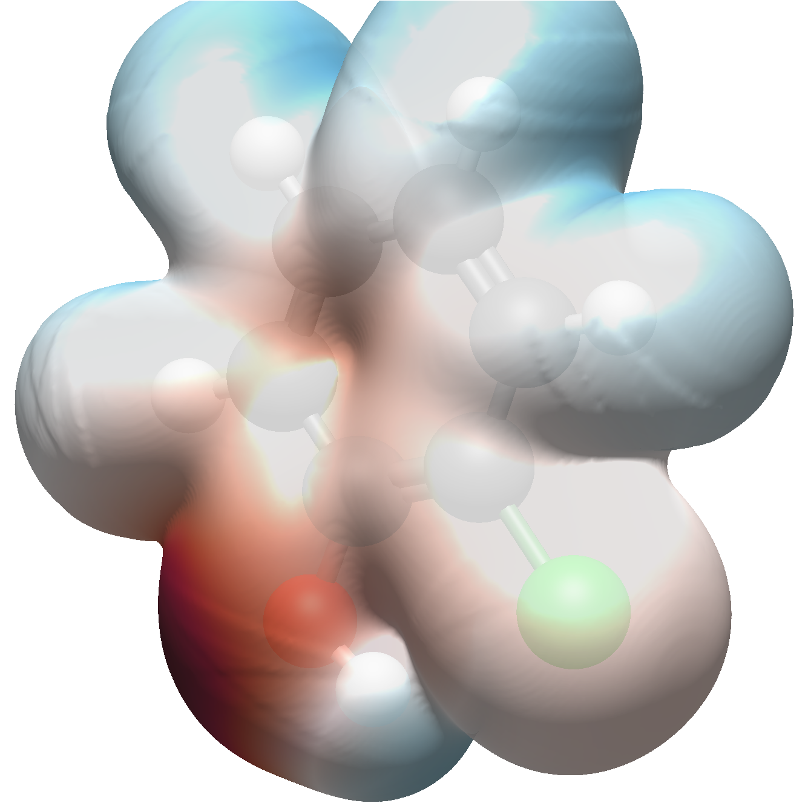
Figure 5. Electron density isosurface (0.001 a.u.) coloured by the electrostatic potential: red = negative, blue = positive. Plotted with Avogadro 2 from the ORCA wavefunction (Molden file). The surface is the B3LYP density; the colours come from Avogadro's point-charge (EEM) potential.
On the 0.001 a.u. density surface the potential calculated from the wavefunction with orca_vpot ranges from −0.035 to +0.061 a.u. The most negative region is the oxygen lone pair on the side away from Cl, and the π face of the ring is also negative. The most positive region is the hydroxyl hydrogen, which points towards Cl (intramolecular O–H···Cl contact); the ring hydrogens are moderately positive. Because Avogadro's colouring uses atom-centred point charges, it misses the negative π region above and below the ring, so the values above are taken from orca_vpot.

Exercise 2 - Theoretical question #1: solvent effects

How the solvent was included in Exercise 1
The water calculations in Exercise 1 used the conductor-like polarizable continuum model, CPCM(Water). This is an implicit model: there are no water molecules in the calculation. Instead, the molecule is placed in a cavity inside a uniform dielectric that has the bulk properties of water, ε = 80.4 and refractive index n = 1.33.
The cavity is built from overlapping spheres on the atoms. ORCA 5 takes 1.2 times the van der Waals radius of each element (C 1.70, H 1.10, O 1.52, Cl 1.75 Å), which gives C 2.04, H 1.32, O 1.824 and Cl 2.1 Å for 2-chlorophenol. The cavity surface is divided into small elements, 755 Lebedev points in this case, and each element carries one charge.
These surface charges q_{i} represent the polarisation of the solvent by the solute. If the surrounding medium were a perfect conductor (ε → ∞), the total electrostatic potential on the surface would be zero. Written for all surface points this gives the linear equations A q = −V, where V_{i} is the potential of the solute (electrons and nuclei) at point i and A contains the Coulomb interactions between the surface charges. Water is not a conductor, so the charges are scaled by f(ε) = (ε − 1)/(ε + x): A q = −f(ε) V. CPCM uses x = 0 (f = 0.9876 for water), while the original COSMO model uses x = 0.5.
In ORCA 5 each surface charge is a small Gaussian rather than a point charge, A_{ii} = ζ_{i} (2/π)^{1/2}/F_{i} and A_{ij} = erf(ζ_{ij} r_{ij})/r_{ij}, where the switching function F_{i} gradually removes a charge when it moves into a neighbouring sphere. With point charges, surface points would appear and disappear as the atoms move and the energy would jump. The Gaussian charges keep the energy and its derivatives smooth, which is needed for the analytic gradients and Hessians used in the Opt and Freq runs.
The surface charges and the electron density depend on each other, so they are solved together in the SCF (self-consistent reaction field). In each iteration the potential of the charges, V_{solv}(r) = Σ_{i} q_{i}/|r − r_{i}|, is added to the one-electron part of the Kohn–Sham operator, the new density gives new charges, and this is repeated until both are converged. The quantity minimised is the free energy G = ⟨Ψ|Ĥ⁰|Ψ⟩ + ½⟨Ψ|V̂|Ψ⟩, where the factor ½ accounts for the work needed to polarise the solvent. All properties in Exercise 1 (orbitals, charges, dipole moment, frequencies) therefore belong to the polarised molecule in solution, which explains the larger dipole moment and the larger O–H charge separation in water.
The “CPCM Dielectric” energy in the output is the electrostatic part of the solvation free energy: −0.00746 Eh (−4.68 kcal mol⁻¹) with PBE and −0.00763 Eh (−4.79 kcal mol⁻¹) with B3LYP. Plain CPCM in ORCA 5 does not include the non-electrostatic terms (cavity formation, dispersion and repulsion), as the output also states.

Other ways to treat solvent effects in ORCA
SMD (Marenich, Cramer and Truhlar) uses the same CPCM electrostatics with its own atomic radii and adds a non-electrostatic term for cavitation, dispersion and solvent structure, calculated from atomic surface tensions and solvent parameters. It is fitted to experimental solvation free energies, so it is the better choice when ΔG_{solv} itself is needed (%cpcm smd true end in ORCA 5, ! SMD(solvent) in ORCA 6).
openCOSMO-RS (ORCA 6) starts from the screening charges of a conductor calculation and treats the contacts between surface segments of solute and solvent with statistical thermodynamics. It gives solvation free energies in pure solvents and mixtures, including their temperature dependence.
A continuum cannot describe specific interactions such as a hydrogen bond between a water molecule and the OH group of 2-chlorophenol. For this, a few explicit water molecules can be added around the solute, by hand or with the SOLVATOR tool in ORCA 6, and the whole cluster can then be placed in CPCM (cluster–continuum model).
For a larger explicit solvent shell, ORCA offers QM/MM, where the solute is treated quantum mechanically and the solvent with a force field. Molecular dynamics with explicit solvent, as in Exercise 6, samples many solvent configurations instead of a single averaged one.

Exercise 3 - Theoretical question #2: the resolution of the identity (density fitting)

The bottleneck
In HF and DFT the Coulomb and exchange matrices are built from four-centre two-electron integrals:
J_{μν} = Σ_{λσ} P_{λσ} (μν|λσ), K_{μν} = Σ_{λσ} P_{λσ} (μλ|νσ), (μν|λσ) = ∫∫ φ_{μ}(1) φ_{ν}(1) r₁₂⁻¹ φ_{λ}(2) φ_{σ}(2) dr₁ dr₂.
The number of these integrals grows as N⁴, where N is the number of basis functions. For 2-chlorophenol with def2-TZVP (N = 284, Exercise 1) there are about 8.1 × 10⁸ unique integrals, roughly 6.5 GB, and they must be recalculated in every SCF iteration or read back from disk. Correlated methods such as MP2 and coupled cluster also have to transform them to the molecular orbital basis, which scales as N⁵.

The idea
A four-centre integral is the Coulomb repulsion between two charge distributions, the orbital products ρ_{μν}(r) = φ_{μ}(r) φ_{ν}(r) and ρ_{λσ}(r). In the resolution of the identity (RI), also called density fitting, each product is expanded in an auxiliary basis of atom-centred functions χ_{P}:
ρ_{μν}(r) ≈ Σ_{P} c^{P}_{μν} χ_{P}(r).
The coefficients are found by minimising the Coulomb self-repulsion of the fitting error. This gives c_{μν} = V⁻¹ (P|μν) with the Coulomb metric V_{PQ} = (P|Q), and the error in the energy is then only second order in the error of the fitted density. The four-index integral splits into three- and two-index integrals:
(μν|λσ) ≈ Σ_{PQ} (μν|P) [V⁻¹]_{PQ} (Q|λσ).
This is the same as inserting an approximate identity operator, 1 ≈ Σ_{PQ} |P) [V⁻¹]_{PQ} (Q|, between the two charge distributions, which is where the name comes from. The accuracy depends on the auxiliary basis. ORCA has matched auxiliary sets for different purposes, for example def2/J for Coulomb, def2/JK for Coulomb and exchange, def2-TZVP/C for correlation and SARC/J for relativistic basis sets, and AutoAux can generate one automatically.

Where the speed-up comes from
First, far fewer integrals are needed. Only three-centre (μν|P) and two-centre (P|Q) integrals appear, and the auxiliary basis is only 1.5–3 times larger than the orbital basis (def2/J: N_{aux} = 449 for 2-chlorophenol). The number of integrals drops from about N⁴/8 = 8.1 × 10⁸ to N²N_{aux}/2 = 1.8 × 10⁷, around 45 times fewer. At about 145 MB they fit in memory, so they do not have to be recalculated or read from disk.
Second, the Coulomb matrix is obtained in two cheap steps (RI-J). The density is fitted first, d = V⁻¹ g with g_{Q} = Σ_{λσ} (Q|λσ) P_{λσ}, and then J_{μν} = Σ_{P} (μν|P) d_{P}. Both steps cost N²N_{aux} instead of N⁴ and are dense matrix operations that run fast on modern processors. For a GGA functional like PBE, J is the only two-electron term, so RI-J removes the main bottleneck. The fitting error is small and systematic and largely cancels in energy differences.
The exchange matrix couples the indices crosswise and does not factorise as well. ORCA either fits it too (RIJK, with a /JK auxiliary basis) or uses RIJCOSX, which is RI for J and the chain-of-spheres method for K. In COSX one electron coordinate is integrated analytically and the other on a numerical grid, K_{μν} ≈ Σ_{g} w_{g} φ_{μ}(r_{g}) Σ_{λσ} A_{νλ}(r_{g}) P_{λσ} φ_{σ}(r_{g}) with A_{νλ}(r_{g}) = ∫ φ_{ν}(r) φ_{λ}(r) |r − r_{g}|⁻¹ dr, and the cost grows almost linearly for large molecules. In Exercise 1 the PBE runs used RI-J (def2/J) and the B3LYP runs RIJCOSX (def2/J).
The same factorisation speeds up correlated methods. In RI-MP2 the MO integrals are written as (ia|jb) ≈ Σ_{P} B^{P}_{ia} B^{P}_{jb}, which avoids the expensive four-index transformation and makes the calculation an order of magnitude or more faster. ORCA's DLPNO methods are also built on it.

Exercise 4 - Excited states and spectra
TD-DFT for the first five singlet excited states at the four optimised structures of Exercise 1, with the same functional, basis and solvent model as the optimisation: ! RKS <PBE | B3LYP> def2-TZVP def2/J TightSCF (RIJCOSX for B3LYP, CPCM(Water) for the solvated runs) and %tddft NRoots 5 TDA false end (full linear-response TD-DFT, not the Tamm–Dancoff approximation). The ground state is closed-shell, so a restricted reference was used. It gives the same ground state as the unrestricted calculation in Exercise 1, but the excited states are pure singlets.

Excitation energies of the first five excited states
Table 1. TD-DFT/def2-TZVP singlet excitations: energy E, wavelength λ, oscillator strength f and the orbital transitions with weight ≥ 0.15 (HOMO = orbital 32, LUMO = orbital 33).
Method | State | E (eV) | λ (nm) | f | Main transitions (weight)
PBE (gas) | S₁ | 4.656 | 266.3 | 0.0401 | HOMO→LUMO (0.81), HOMO−1→LUMO+1 (0.18)
 | S₂ | 5.175 | 239.6 | 0.0001 | HOMO→LUMO+2 (0.99)
 | S₃ | 5.478 | 226.3 | 0.0244 | HOMO→LUMO+1 (0.63), HOMO−1→LUMO (0.32)
 | S₄ | 5.865 | 211.4 | 0.0000 | HOMO−1→LUMO+2 (0.98)
 | S₅ | 6.129 | 202.3 | 0.2100 | HOMO−1→LUMO (0.43), HOMO−1→LUMO+1 (0.25)
B3LYP (gas) | S₁ | 4.985 | 248.7 | 0.0447 | HOMO→LUMO (0.79), HOMO−1→LUMO+1 (0.20)
 | S₂ | 5.690 | 217.9 | 0.0002 | HOMO→LUMO+2 (0.97)
 | S₃ | 5.749 | 215.7 | 0.0154 | HOMO→LUMO+1 (0.60), HOMO−1→LUMO (0.38)
 | S₄ | 6.339 | 195.6 | 0.0000 | HOMO−1→LUMO+2 (0.96)
 | S₅ | 6.667 | 186.0 | 0.0009 | HOMO→LUMO+3 (0.98)
PBE (water) | S₁ | 4.643 | 267.0 | 0.0585 | HOMO→LUMO (0.83), HOMO−1→LUMO+1 (0.16)
 | S₂ | 5.267 | 235.4 | 0.0002 | HOMO→LUMO+2 (0.99)
 | S₃ | 5.449 | 227.5 | 0.0377 | HOMO→LUMO+1 (0.64), HOMO−1→LUMO (0.31)
 | S₄ | 5.936 | 208.9 | 0.0000 | HOMO−1→LUMO+2 (0.98)
 | S₅ | 6.018 | 206.0 | 0.3226 | HOMO−1→LUMO (0.54), HOMO→LUMO+1 (0.19)
B3LYP (water) | S₁ | 4.974 | 249.3 | 0.0647 | HOMO→LUMO (0.81), HOMO−1→LUMO+1 (0.18)
 | S₂ | 5.720 | 216.7 | 0.0216 | HOMO→LUMO+1 (0.61), HOMO−1→LUMO (0.37)
 | S₃ | 5.762 | 215.2 | 0.0003 | HOMO→LUMO+2 (0.97)
 | S₄ | 6.390 | 194.0 | 0.5322 | HOMO−1→LUMO (0.58), HOMO→LUMO+1 (0.34)
 | S₅ | 6.395 | 193.9 | 0.0068 | HOMO−1→LUMO+2 (0.95)

Influence of the solvent
Table 2. Excitation energies (eV) in the gas phase and in water, matched by their main transition (the state number is given in brackets, because the order changes), and the solvent shift ΔE = E(water) − E(gas). “–”: not among the first five states.
Main transition | PBE gas | PBE water | ΔE | B3LYP gas | B3LYP water | ΔE
HOMO→LUMO | 4.656 (S₁) | 4.643 (S₁) | −0.013 | 4.985 (S₁) | 4.974 (S₁) | −0.011
HOMO→LUMO+2 | 5.175 (S₂) | 5.267 (S₂) | +0.092 | 5.690 (S₂) | 5.762 (S₃) | +0.072
HOMO→LUMO+1 | 5.478 (S₃) | 5.449 (S₃) | −0.029 | 5.749 (S₃) | 5.720 (S₂) | −0.029
HOMO−1→LUMO+2 | 5.865 (S₄) | 5.936 (S₄) | +0.071 | 6.339 (S₄) | 6.395 (S₅) | +0.056
HOMO−1→LUMO | 6.129 (S₅) | 6.018 (S₅) | −0.111 | – | 6.390 (S₄) | –
HOMO→LUMO+3 | – | – | – | 6.667 (S₅) | – | –

Water changes the excitation energies only slightly: by at most 0.11 eV for the states that appear in both phases. The lowest state, S₁, is the HOMO→LUMO excitation for all four methods and moves by only −0.013 eV with PBE and −0.011 eV with B3LYP (266.3 → 267.0 nm and 248.7 → 249.3 nm). The states dominated by the HOMO→LUMO+1 and HOMO−1→LUMO configurations are lowered by water, whereas the two states that excite into LUMO+2 are raised by 0.06–0.09 eV, so S₂ and S₃ swap order for B3LYP. The effect on the intensities is larger than on the energies: the oscillator strength of S₁ grows from 0.040 to 0.058 (PBE) and from 0.045 to 0.065 (B3LYP). The choice of functional matters much more than the solvent: B3LYP places every state 0.3–0.5 eV above PBE.

UV spectra
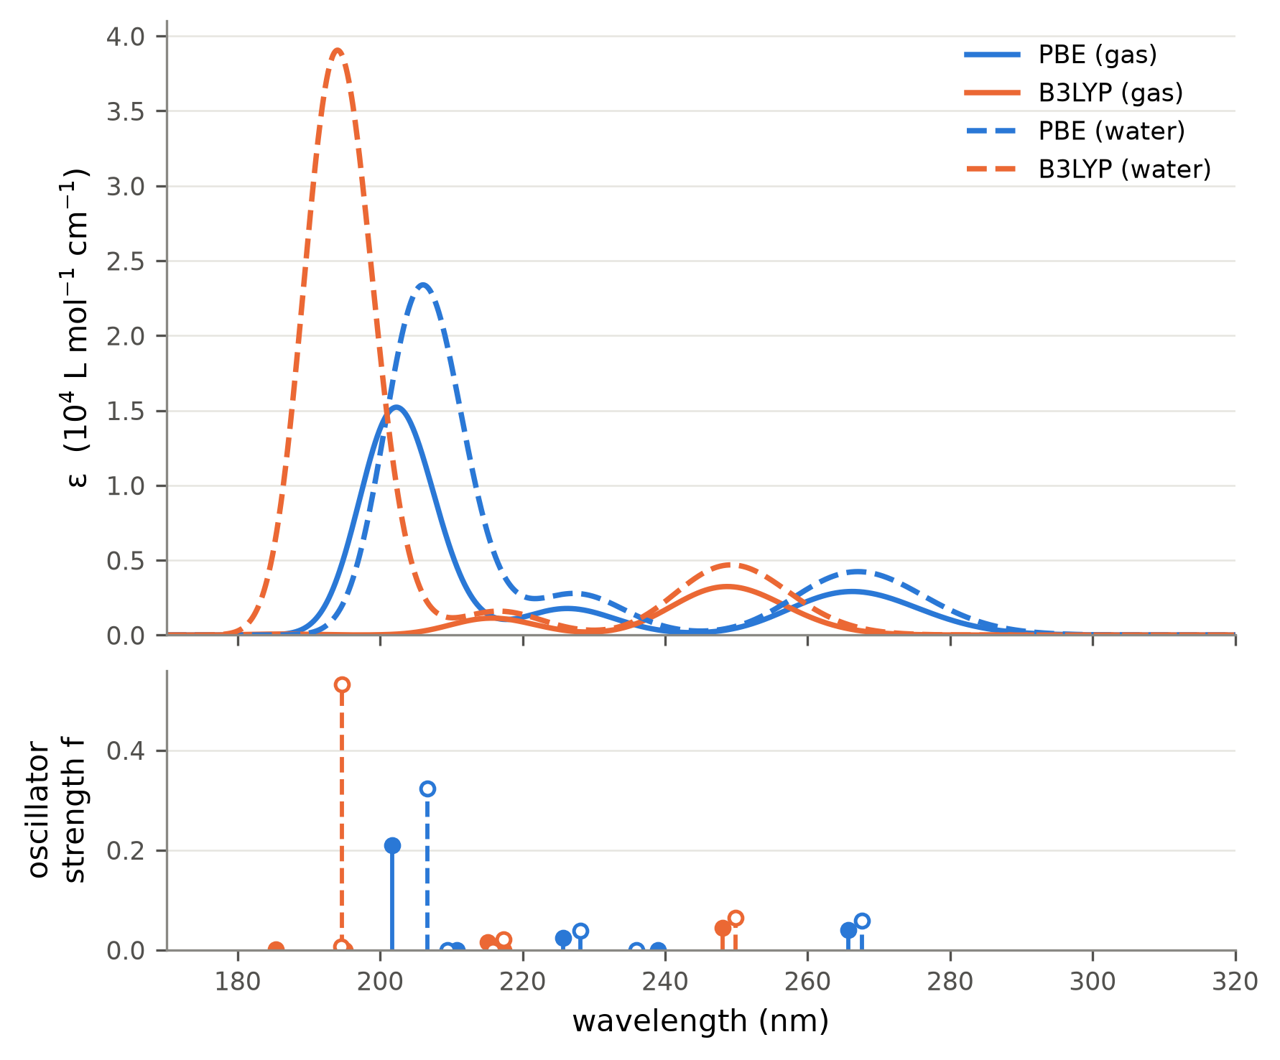
Figure 1. Simulated UV spectra of 2-chlorophenol. Top: each transition broadened by a Gaussian of FWHM 3000 cm⁻¹ (≈0.37 eV) in wavenumber, ε = Σ 2.174×10⁸ f_{i}/FWHM · exp[−2.773 (ν̃ − ν̃_{i})²/FWHM²]. Bottom: oscillator strengths (filled: gas, open: water; gas and water sticks are offset by ±0.6 nm for visibility). Only five states were computed, so the spectra are incomplete below about 200 nm.

Exercise 5 - Magnetic exchange coupling in a Cu(II) dimer from broken-symmetry DFT
The compound is a paddle-wheel dimer with four trifluoroacetate bridges between the two Cu(II) ions (Cu–Cu 2.73 Å) and an alkoxide-type O donor in each axial position; the total charge is −2 as given. Each Cu(II) is d⁹ with S = 1/2. Keywords: ! UKS B3LYP <basis> <auxiliary basis> RIJCOSX TightSCF SlowConv, with %scf BrokenSym 1,1 end and the coordinate line * xyzfile −2 3 (high-spin triplet). ORCA first converges the high-spin state (HS, both spins parallel), then flips the spin on one Cu and converges the broken-symmetry state (BS). The three runs differ only in the relativistic treatment: non-relativistic (def2-SVP, def2/J), DKH (DKH-def2-SVP, SARC/J) and ZORA (ZORA-def2-SVP, SARC/J). The assignment does not specify the non-relativistic level, so B3LYP/def2-SVP was used to keep the functional and basis-set size the same in all three.

Results
Table 1. Total energies of the high-spin and broken-symmetry states, ⟨S²⟩ values and exchange coupling constants J in cm⁻¹. ORCA uses H = −2J S_{A}·S_{B}, so J < 0 means antiferromagnetic coupling. J(1): Ginsberg–Noodleman, J(2): Bencini–Gatteschi, J(3): Yamaguchi, J = (E_{BS} − E_{HS})/(⟨S²⟩_{HS} − ⟨S²⟩_{BS}).
Run | E(HS) / E_{h} | E(BS) / E_{h} | ⟨S²⟩_{HS} | ⟨S²⟩_{BS} | E(HS)−E(BS) / cm⁻¹ | J(1) | J(2) | J(3)
non-relativistic | −6076.975267 | −6076.975094 | 2.0050 | 1.0006 | −38.0 | +38.0 | +19.0 | +37.8
DKH | −6107.249506 | −6107.249605 | 2.0041 | 0.9989 | +21.7 | −21.7 | −10.9 | −21.6
ZORA | −6122.764932 | −6122.765176 | 2.0038 | 0.9976 | +53.5 | −53.5 | −26.8 | −53.2

The broken-symmetry states are the intended ones. The Mulliken spin populations on the two Cu atoms are +0.63 and −0.63 (non-relativistic; +0.72 / −0.72 with ZORA), and ⟨S²⟩_{BS} ≈ 1.0 compared with ⟨S²⟩_{HS} ≈ 2.0, as expected for two localised S = 1/2 centres with opposite spins.

What the table shows
The relativistic treatment lowers the total energy by 30.3 E_{h} (DKH) and 45.8 E_{h} (ZORA). Almost all of this comes from the contraction of the Cu 1s–2p core shells, which is the same in both spin states and cancels in E(HS) − E(BS). The absolute energies of different relativistic Hamiltonians cannot be compared with each other; only energy differences within one Hamiltonian are meaningful.
J comes from a very small energy difference: E(HS) − E(BS) is only 22–54 cm⁻¹, about 244×10⁻⁶ E_{h}, which is 7 orders of magnitude smaller than the total energy and 5 orders smaller than the relativistic energy shift. J(1) and J(3) are nearly equal because ⟨S²⟩_{HS} − ⟨S²⟩_{BS} ≈ 1 here (weak coupling), and J(2) is half of J(1) by definition, so the formula used must always be stated.
With the SVP basis sets, J(3) changes from +37.8 cm⁻¹ (non-relativistic) to −21.6 cm⁻¹ (DKH) and −53.2 cm⁻¹ (ZORA). These changes are negligible compared with the change in total energy, but they are as large as J itself and even change its sign, from weakly ferromagnetic to weakly antiferromagnetic. DKH and ZORA also differ from each other by 32 cm⁻¹. Repeating the three runs with a finer grid (DefGrid3, VeryTightSCF) changed J(3) by less than 0.1 cm⁻¹, so these numbers are not grid noise. To see whether they are converged with respect to the basis set, the calculations were repeated with TZVP basis sets.
Table 2. B3LYP results with SVP-level (def2-SVP, DKH-def2-SVP, ZORA-def2-SVP) and TZVP-level (def2-TZVP, DKH-def2-TZVP, ZORA-def2-TZVP) basis sets, same geometry and BrokenSym setup.
 | E(HS)−E(BS) / cm⁻¹ |  | J(3) / cm⁻¹
Treatment | SVP | TZVP | SVP | TZVP
Non-relativistic | −38.0 | +78.69 | +37.8 | −78.11
DKH | +21.7 | +127.84 | −21.6 | −126.87
ZORA | +53.5 | +127.84 | −53.2 | −126.87

With the larger basis all three calculations give antiferromagnetic coupling, J(3) = −78.1 cm⁻¹ (non-relativistic), −126.87 cm⁻¹ (DKH) and −126.87 cm⁻¹ (ZORA). DKH and ZORA now agree to 0.003 cm⁻¹, and the non-relativistic value is already negative without relativity. The sign change and the DKH/ZORA difference seen with SVP therefore come from the small basis set, not from relativity. With TZVP, scalar relativistic effects shift J by −49 cm⁻¹ and make the antiferromagnetic coupling about 62 % stronger.
For comparison, changing the functional at the non-relativistic SVP level changes J(3) much more: +173 cm⁻¹ with TPSSh (10% exact exchange), +38 cm⁻¹ with B3LYP (20%) and −31 cm⁻¹ with PBE0 (25%).

How important are the relativistic effects on J?
Relativity changes the total energy by tens of hartree, but this is core-electron stabilisation that is the same in the high-spin and broken-symmetry states and cancels in J. The effect that remains on J is about 49 cm⁻¹, or 62 % of |J|. For a 3d metal such as Cu this is small in absolute terms, but it is not negligible because J itself is a small energy. DKH and ZORA give the same J once the basis set is large enough, so the choice between them does not matter here. The table also shows that the SVP basis is too small to resolve the relativistic effect on such a small energy difference, and that the choice of functional affects J more than relativity does.

Exercise 6 - Ab initio and semi-empirical molecular dynamics of a water cluster
Both runs use the ORCA %md module on a cluster cut from an ice crystal, at 400 K with a Nosé–Hoover chain thermostat (time constant 10 fs) and a time step of 0.5 fs, the largest step the manual recommends for systems with hydrogen atoms. The 50 Å sphere was taken as the diameter, so Cell Sphere was set to a radius of 25 Å, centred on the cluster because the input coordinates are not centred on the origin. The sphere is a soft repulsive wall that stops evaporated molecules from flying away. The clusters themselves have radii of only 6.4 Å (a) and 13.7 Å (b), so the wall does not affect the cluster itself and a 50 Å radius would give the same result. Keywords: ! MD PBE def2-SVP def2/J for (a) and ! MD XTB2 for (b).

Setup
Table 1. The two simulations.
 | (a) PBE/def2-SVP | (b) GFN2-xTB
Water molecules | 20 | 128
Atoms | 60 | 384
Steps × 0.5 fs | 200 = 100 fs | 5000 = 2.5 ps
Wall time (1 core) | 4.8 h | 5.6 h
Time per step | 86 s | 4.1 s

Trajectory in Avogadro
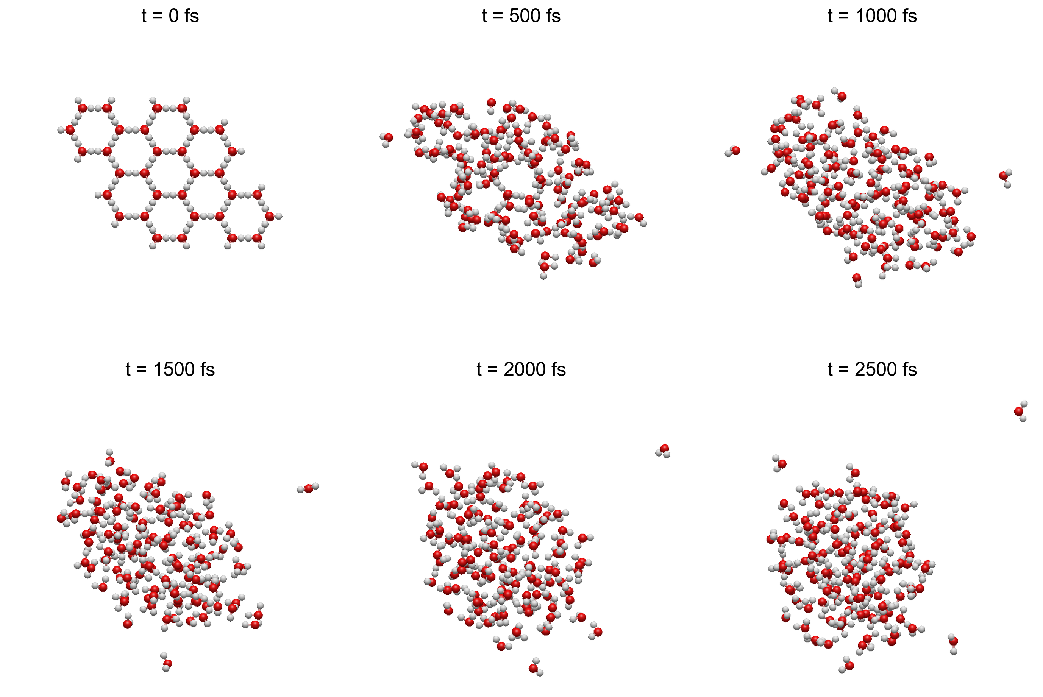
Figure 1. The xTB trajectory (b) opened in Avogadro 2, frames at 500 fs intervals. Red: O, white: H. Because the movie export of Avogadro does not work, the trajectory was displayed frame by frame in Avogadro (every 100th MD step, 51 frames) and the rendered frames were joined into an animated GIF, which is sent with this report as HW2_ZhangXubo_Ex6_water_MD_XTB_Avogadro.gif.

Structures at the beginning and at the end
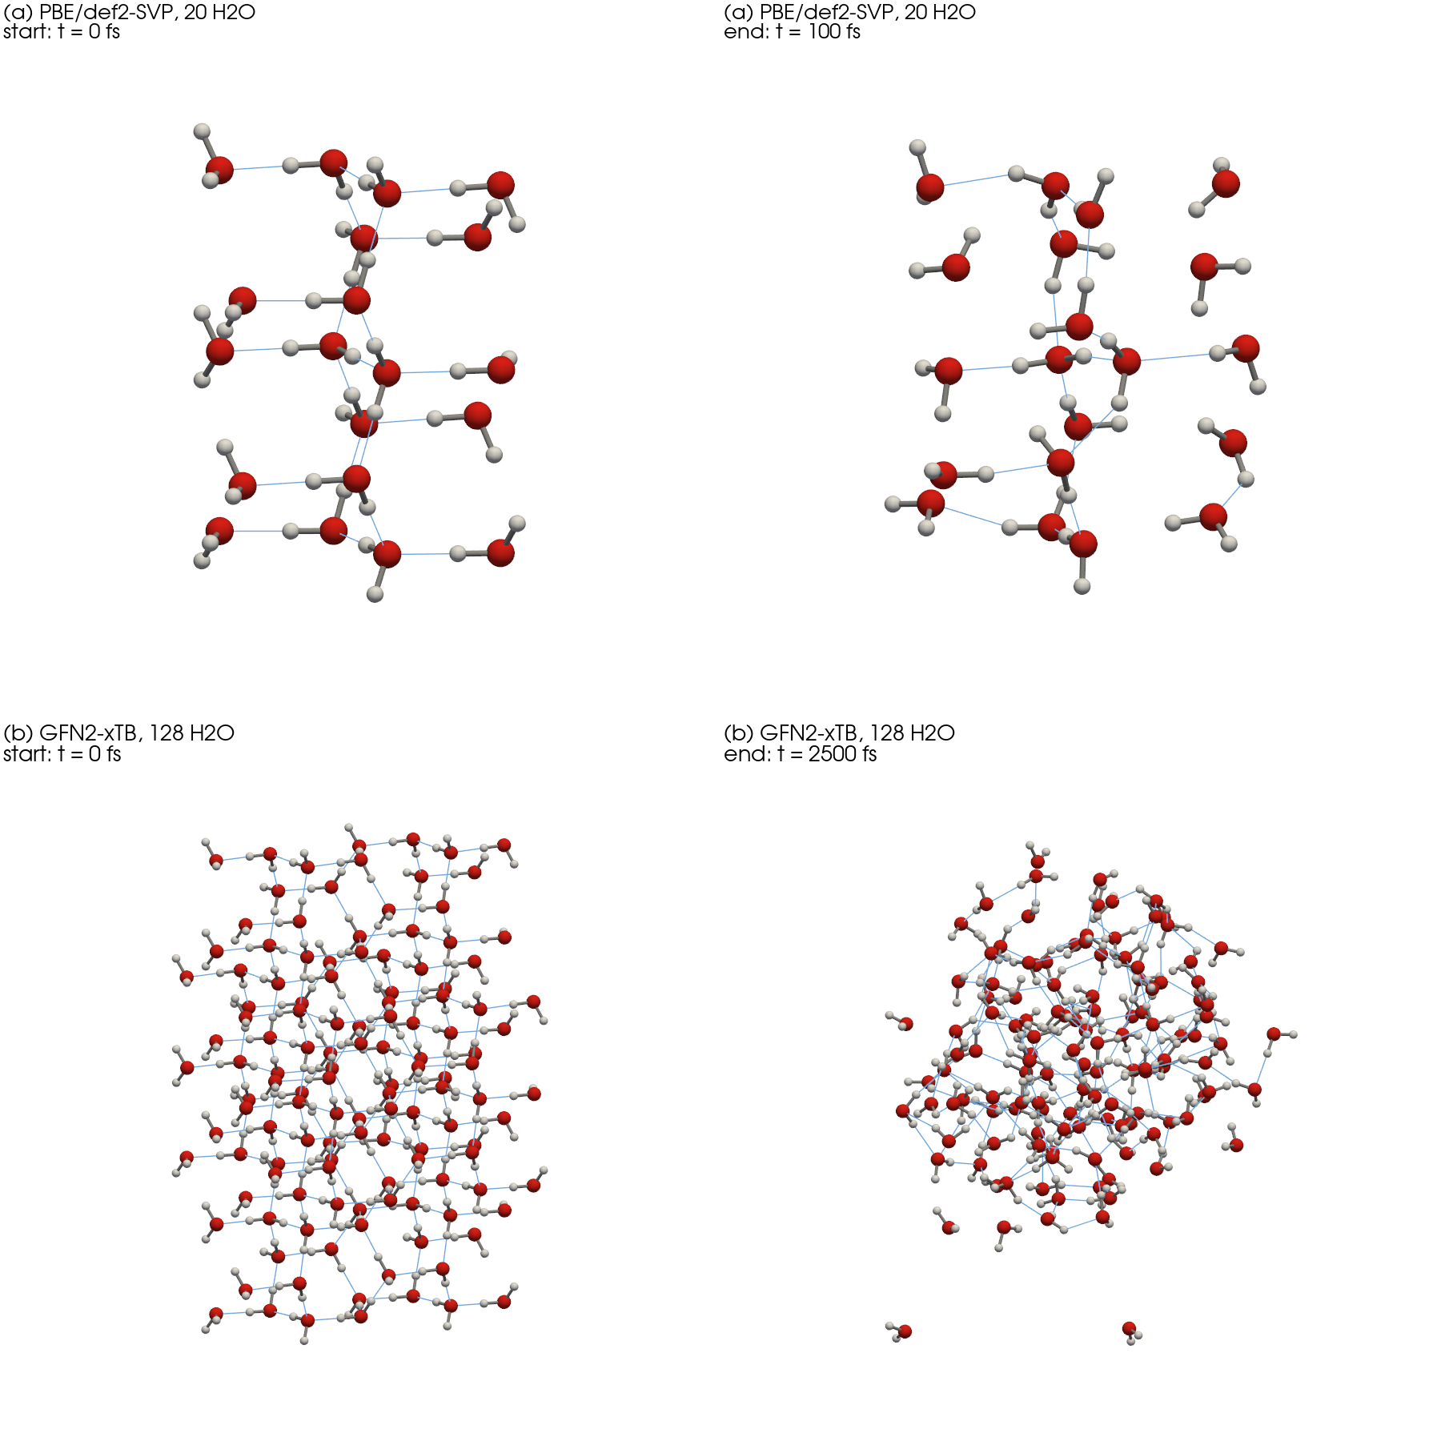
Figure 2. First and last frame of each trajectory. Red: O, white: H, grey sticks: covalent O–H bonds, thin blue lines: hydrogen bonds (H···O < 2.2 Å). Same viewing direction and scale within each row.

Temperature and structure along the trajectories
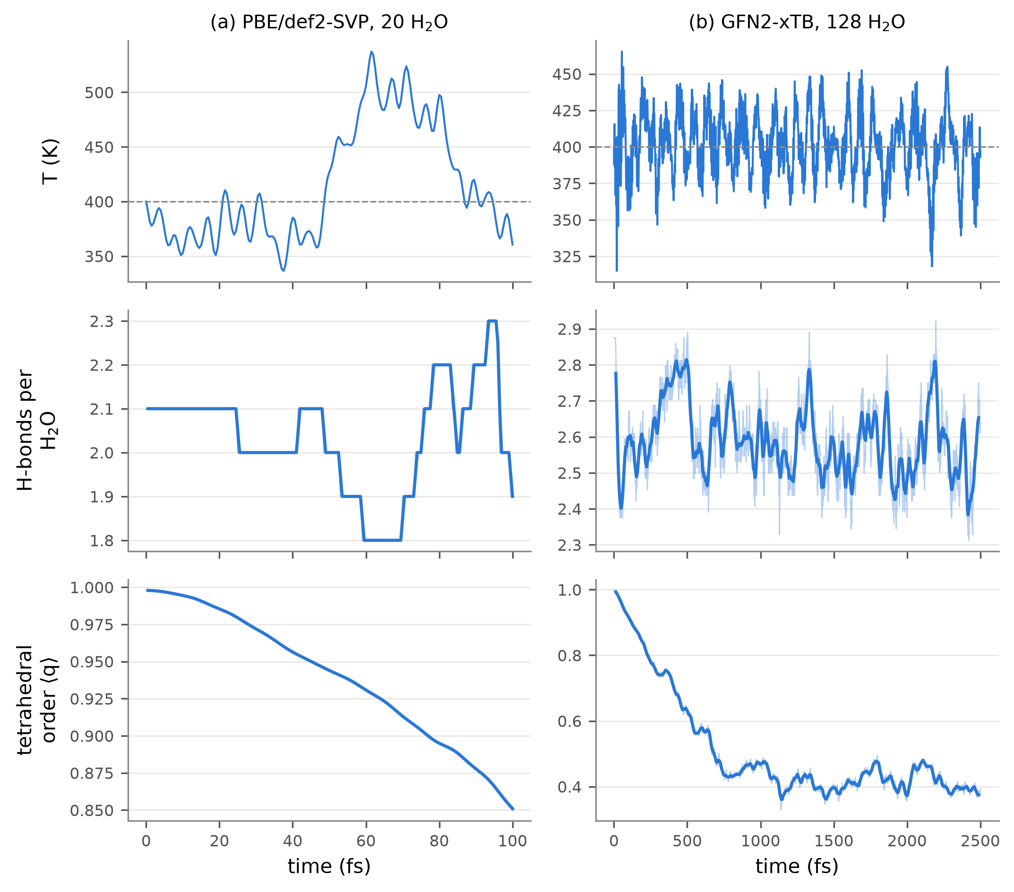
Figure 3. Top: instantaneous temperature (dashed line: the 400 K set point). Middle: hydrogen bonds per water molecule (O···O < 3.5 Å and ∠(H–O···O) < 30°). Bottom: tetrahedral order parameter q averaged over the molecules that start with four neighbours within 3.2 Å (2 of 20 and 48 of 128). Thin lines are per-step values, thick lines a running average.
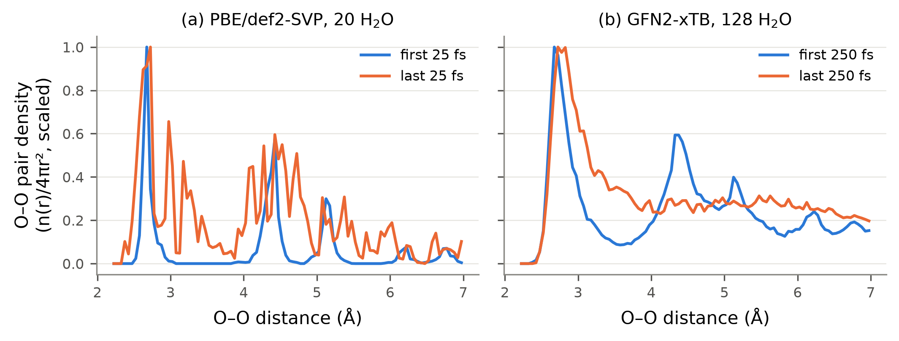
Figure 4. O–O pair distance distribution, n(r)/4πr², at the beginning and at the end of each run, scaled to the same maximum.

What the simulations show
In the xTB run the ice cluster melts, and this shows up in the structure rather than in the temperature. The tetrahedral order of the interior molecules drops from 0.90 to 0.39 within the first ~800 fs and then stays there. In the O–O distribution the second-neighbour peak at 4.4 Å disappears and the minimum at 3.5 Å fills in (Figure 4b). The number of hydrogen bonds hardly changes (2.56 → 2.53 per molecule), so the molecules keep their hydrogen bonds but lose the tetrahedral arrangement and the long-range order of the crystal.
The 100 fs DFT run is too short to see this: q only falls from 0.99 to 0.88 and the pair distribution still has the ice peaks. Hydrogen bonds in water rearrange on a picosecond time scale, so 100 fs only samples vibrations around the starting structure.
In the xTB run some molecules evaporate. The largest O distance from the cluster centre grows from 13.0 Å to 23.6 Å, close to the 25 Å wall, so without the confining sphere these molecules would leave the cluster.
The thermostat keeps the average temperature at the set point: over the second half of the xTB run the mean is 399 K with a standard deviation of 22 K. The 60-atom DFT cluster fluctuates by about ±50 K, because relative temperature fluctuations scale as 1/√N and are large in small systems.

What else can be obtained from the trajectories
Besides the melting, the trajectory and the per-step energies that ORCA writes can be used for:
Structure: radial distribution functions g(r) for O–O, O–H and H–H and the coordination numbers from their integrals, hydrogen-bond distance and angle distributions, and the size and shape of the cluster.
Dynamics: the mean square displacement and the diffusion coefficient, hydrogen-bond lifetimes and reorientation times, and the velocity autocorrelation function, whose Fourier transform gives the vibrational density of states. The dipole autocorrelation function gives the IR spectrum including anharmonic and temperature effects, which a harmonic frequency calculation as in Exercise 1 cannot provide.
Thermodynamics and checks: kinetic and potential energy distributions (the heat capacity follows from their fluctuations), the evaporation rate, and the drift of the conserved energy as a check of the integration, here −3.2 kcal mol⁻¹ over 2.5 ps for xTB and +0.03 kcal mol⁻¹ over 100 fs for DFT.
Snapshots from the trajectory can also serve as starting structures for further calculations, for example spectra of solvated molecules averaged over the sampled configurations.

