CM5235 - Homework ORCA (2026)
Full Name | Zhang Xubo
Student Number | A0359670R
E-mail | zhangxubo@u.nus.edu
Date | 25 September 2026
Signature

Exercise 1 - Study of the ground state of 2-chlorophenol with different computational methods
ORCA 5.0.2, spin-unrestricted Kohn–Sham, def2-TZVP basis; geometry optimisation followed by an analytic frequency calculation: ! UKS <PBE | B3LYP> def2-TZVP def2/J TightSCF TightOpt Opt Freq, with RIJCOSX for B3LYP and CPCM(Water) for the two solvated runs.
In the supplied structure the hydroxyl hydrogen was perpendicular to the ring. It was rotated into the ring plane on the Cl side (cis conformer, intramolecular O–H···Cl contact) before optimisation; all other atoms were left as given. All four optimised structures have 33 real frequencies and no imaginary mode, i.e. they are minima. The other conformer, with the O–H pointing away from Cl, was optimised as a check at the same level (B3LYP/def2-TZVP, gas phase): it is also a minimum but lies 3.3 kcal mol⁻¹ higher in energy (3.0 kcal mol⁻¹ in Gibbs free energy at 298.15 K), which is the intramolecular O–H···Cl interaction. The cis conformer used here is therefore the relevant ground-state structure.

a) Mulliken and Löwdin atomic charges
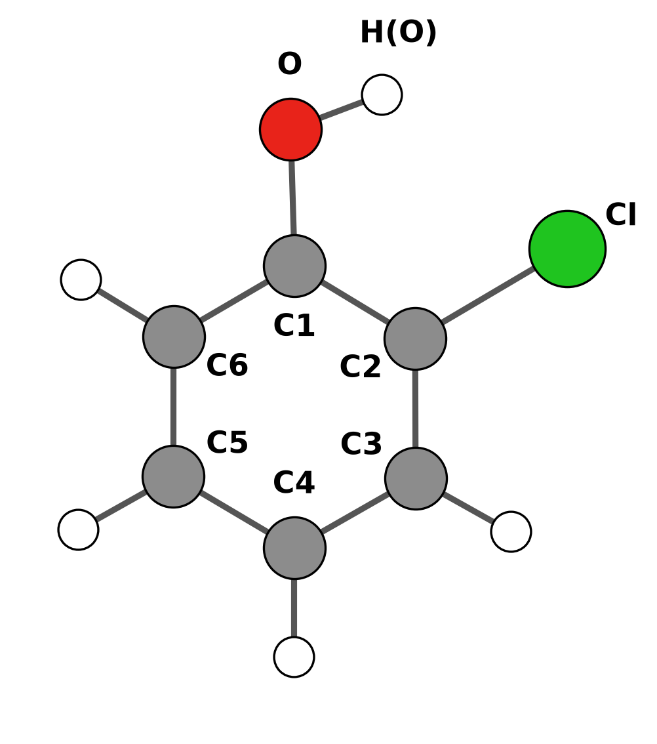
Figure 1. Atom numbering used in Table 1. H(Cn) is the hydrogen bonded to Cn; H(O) is the hydroxyl hydrogen.
Table 1. Atomic charges (e), UKS/def2-TZVP.
 | Mulliken |  |  |  | Löwdin
Atom | PBE gas | B3LYP gas | PBE water | B3LYP water | PBE gas | B3LYP gas | PBE water | B3LYP water
Cl | −0.1320 | −0.1390 | −0.1302 | −0.1399 | +0.3901 | +0.3753 | +0.3877 | +0.3711
O | −0.3215 | −0.3783 | −0.3568 | −0.4165 | +0.1091 | +0.0948 | +0.0963 | +0.0801
C1 | +0.1421 | +0.1795 | +0.1598 | +0.1996 | −0.2951 | −0.2832 | −0.3003 | −0.2879
C2 | +0.1463 | +0.1281 | +0.1257 | +0.1112 | −0.4167 | −0.4058 | −0.4220 | −0.4099
C3 | −0.1728 | −0.1632 | −0.1961 | −0.1845 | −0.1488 | −0.1433 | −0.1512 | −0.1448
C4 | −0.1165 | −0.1230 | −0.1557 | −0.1601 | −0.1545 | −0.1510 | −0.1589 | −0.1541
C5 | −0.0866 | −0.0898 | −0.1254 | −0.1268 | −0.1413 | −0.1351 | −0.1459 | −0.1383
C6 | −0.1931 | −0.1878 | −0.2251 | −0.2186 | −0.1181 | −0.1136 | −0.1258 | −0.1210
H(O) | +0.2975 | +0.3078 | +0.3358 | +0.3452 | +0.1768 | +0.1750 | +0.1919 | +0.1894
H(C3) | +0.1173 | +0.1245 | +0.1495 | +0.1549 | +0.1507 | +0.1478 | +0.1587 | +0.1554
H(C4) | +0.1052 | +0.1110 | +0.1415 | +0.1459 | +0.1467 | +0.1436 | +0.1546 | +0.1513
H(C5) | +0.1051 | +0.1125 | +0.1410 | +0.1471 | +0.1478 | +0.1450 | +0.1558 | +0.1528
H(C6) | +0.1090 | +0.1177 | +0.1359 | +0.1424 | +0.1533 | +0.1506 | +0.1592 | +0.1559

Water increases the charge separation in the hydroxyl group. The Mulliken charge on O goes from −0.322 to −0.357 (PBE) and from −0.378 to −0.417 (B3LYP), and the hydroxyl H goes from +0.297 to +0.336 and from +0.308 to +0.345. B3LYP puts more negative charge on O than PBE. The two partitioning schemes disagree most for the heteroatoms: Löwdin gives Cl a positive charge (+0.37 to +0.39) and O a small positive one, where Mulliken gives negative values. Atomic charges are not observables, and the two schemes divide the overlap density differently, so only the trends within one scheme should be compared.

b) Vibrational frequencies
Table 2. Harmonic vibrational frequencies (cm⁻¹), ORCA mode numbering (modes 0–5 are translations and rotations).
Mode | PBE gas | B3LYP gas | PBE water | B3LYP water
6 | 154.5 | 159.5 | 155.2 | 159.6
7 | 245.2 | 253.0 | 240.3 | 247.7
8 | 255.5 | 264.9 | 255.1 | 264.2
9 | 365.9 | 376.2 | 366.4 | 376.3
10 | 429.6 | 435.1 | 429.2 | 388.8
11 | 475.4 | 454.7 | 439.3 | 453.0
12 | 484.4 | 496.2 | 483.0 | 494.8
13 | 532.9 | 551.9 | 536.3 | 554.9
14 | 546.3 | 565.4 | 545.7 | 564.5
15 | 669.9 | 687.6 | 665.3 | 682.8
16 | 688.5 | 718.0 | 696.7 | 725.9
17 | 727.1 | 760.9 | 728.7 | 761.7
18 | 824.1 | 846.4 | 820.2 | 842.0
19 | 824.4 | 865.9 | 827.6 | 868.4
20 | 887.6 | 939.2 | 904.4 | 954.2
21 | 907.7 | 957.8 | 929.8 | 979.9
22 | 1020.9 | 1047.3 | 1016.0 | 1042.6
23 | 1033.5 | 1064.9 | 1031.1 | 1061.8
24 | 1111.8 | 1142.8 | 1104.3 | 1135.8
25 | 1143.2 | 1181.4 | 1132.2 | 1172.0
26 | 1185.4 | 1214.2 | 1170.2 | 1197.8
27 | 1248.8 | 1278.6 | 1233.4 | 1264.6
28 | 1303.6 | 1325.1 | 1298.1 | 1318.7
29 | 1364.6 | 1372.7 | 1355.7 | 1363.2
30 | 1451.2 | 1495.3 | 1444.5 | 1488.7
31 | 1468.4 | 1514.1 | 1458.4 | 1504.8
32 | 1583.5 | 1625.6 | 1576.7 | 1619.2
33 | 1593.0 | 1634.5 | 1583.2 | 1625.3
34 | 3109.7 | 3175.6 | 3110.2 | 3176.9
35 | 3121.9 | 3188.2 | 3120.0 | 3186.9
36 | 3128.9 | 3195.9 | 3126.4 | 3193.7
37 | 3137.0 | 3203.1 | 3135.5 | 3202.3
38 | 3567.0 | 3721.7 | 3561.5 | 3704.6

B3LYP gives higher frequencies than PBE for nearly every mode (on average by 2.8 % in the gas phase). The largest difference is the O–H stretch (mode 38): 3567 cm⁻¹ with PBE and 3722 cm⁻¹ with B3LYP. Water shifts most modes by only a few cm⁻¹; the O–H stretch is lowered by 6 cm⁻¹ (PBE) and 17 cm⁻¹ (B3LYP).

c)–e) Electric dipole moment, entropy at room temperature and HOMO–LUMO gap
Table 3. Dipole moment, entropy at 298.15 K and frontier orbital energies. S_{el} = 0 (closed-shell singlet); ORCA treats the low-frequency vibrations with Grimme's quasi-RRHO model. HOMO = orbital 32, LUMO = orbital 33 (α and β identical).
Quantity | PBE gas | B3LYP gas | PBE water | B3LYP water
Dipole moment μ (D) | 0.751 | 0.880 | 0.896 | 1.091
S_{vib} (cal mol⁻¹ K⁻¹) | 12.62 | 12.10 | 12.75 | 12.30
S_{rot} (cal mol⁻¹ K⁻¹) | 28.64 | 28.63 | 28.65 | 28.63
S_{trans} (cal mol⁻¹ K⁻¹) | 40.47 | 40.47 | 40.47 | 40.47
S total (cal mol⁻¹ K⁻¹) | 81.73 | 81.19 | 81.86 | 81.40
T·S (kcal mol⁻¹) | 24.37 | 24.21 | 24.41 | 24.27
E_{HOMO} (eV) | −5.676 | −6.449 | −5.666 | −6.429
E_{LUMO} (eV) | −1.490 | −0.690 | −1.463 | −0.647
HOMO–LUMO gap (eV) | 4.186 | 5.759 | 4.204 | 5.782

The dipole moment grows from PBE to B3LYP and from gas to water (0.75 D for PBE in the gas phase, 1.09 D for B3LYP in water): the continuum polarises the molecule. The entropy is almost method-independent (81.2–81.9 cal mol⁻¹ K⁻¹); the translational and rotational parts depend only on mass and geometry, and only the vibrational part changes a little through the low-frequency modes. The HOMO–LUMO gap is 1.6 eV larger with the hybrid functional (5.76 vs 4.19 eV in the gas phase), while water changes it by only 0.02 eV (PBE) and 0.02 eV (B3LYP).

Normal mode 12
“Normal mode number 12” is ambiguous, because the two common numbering schemes differ. ORCA numbers all 3N modes from 0, so modes 0–5 are the translations and rotations and mode 12 is the seventh vibration. Avogadro and Chemcraft list only the 33 real vibrations, starting at 1, so their twelfth entry is ORCA's mode 17. Both are given here.
Table 4. The two modes that “mode 12” can refer to, B3LYP/def2-TZVP gas phase.
 | ORCA mode 12 | ORCA mode 17
Position in the list | 12th of all modes (7th vibration) | 17th of all modes (12th vibration)
Frequency (cm⁻¹) | 496.2 | 760.9
IR intensity (km mol⁻¹) | 11.2 | 69.4
PBE gas / B3LYP gas / PBE water / B3LYP water (cm⁻¹) | 484.4 / 496.2 / 483.0 / 494.8 | 727.1 / 760.9 / 728.7 / 761.7

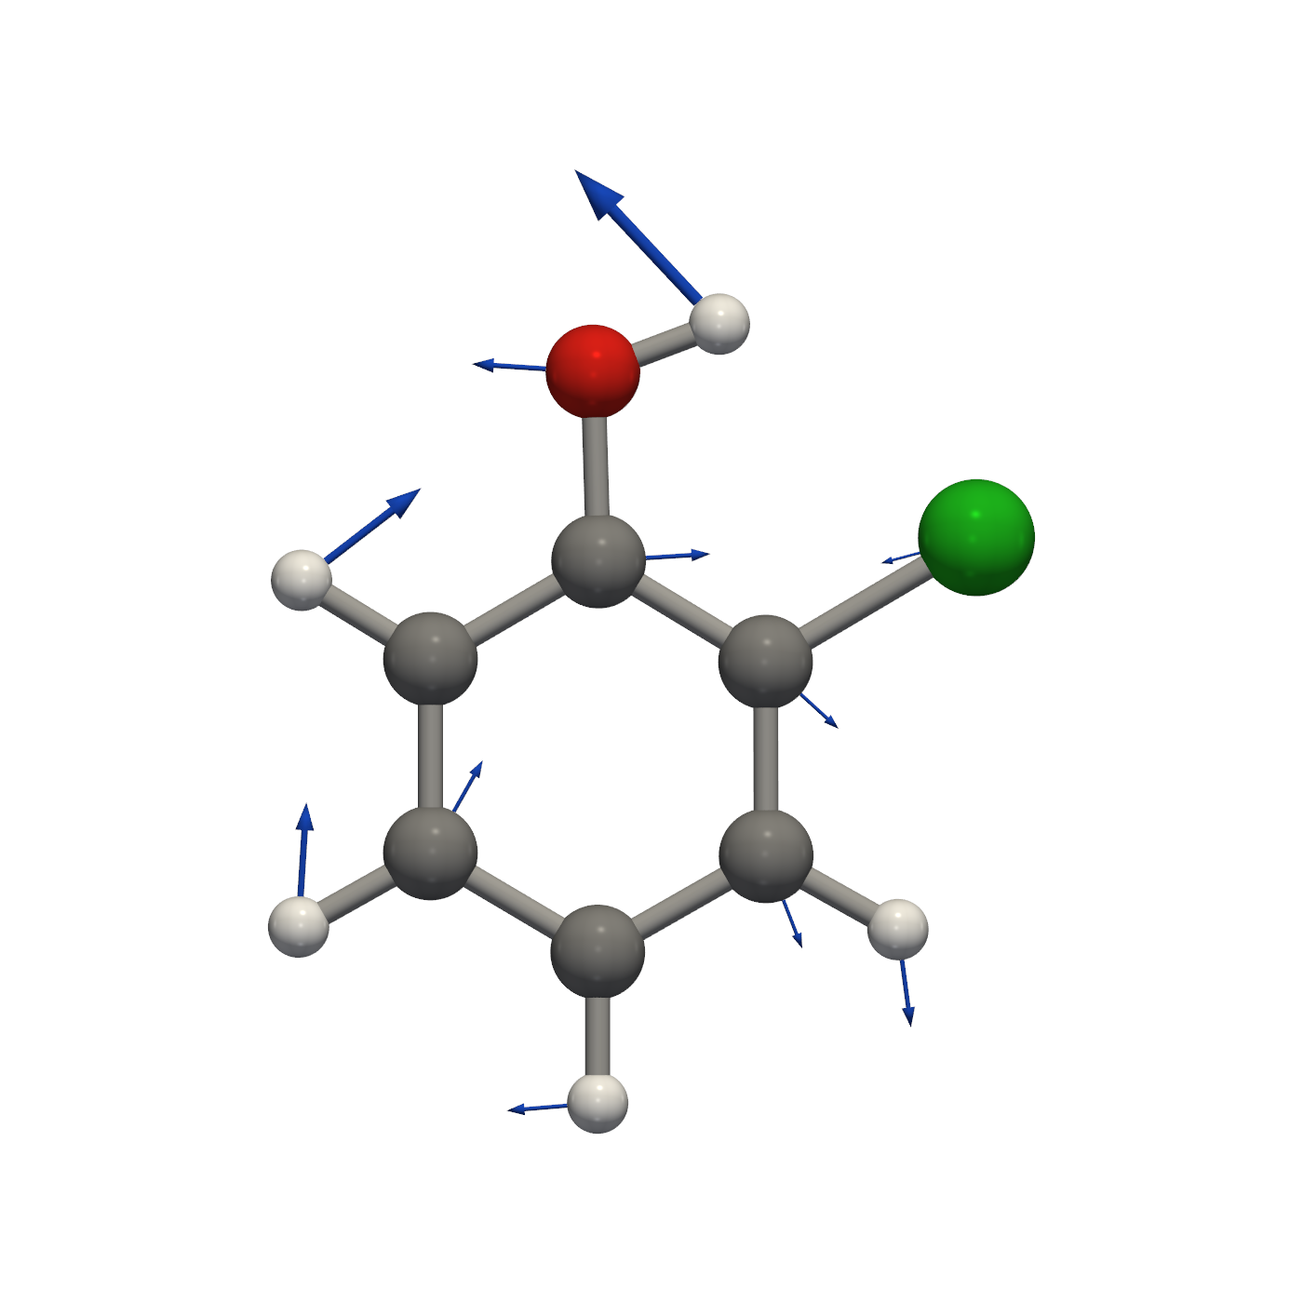
Figure 2. ORCA mode 12 (the 7th vibration), 496.2 cm⁻¹, IR intensity 11.2 km mol⁻¹: in-plane deformation of the ring coupled to C–O–H bending, with the hydroxyl hydrogen moving most. Arrows: atomic displacements. Animation: ex1_mode12_animation_B3LYP_gas.gif.
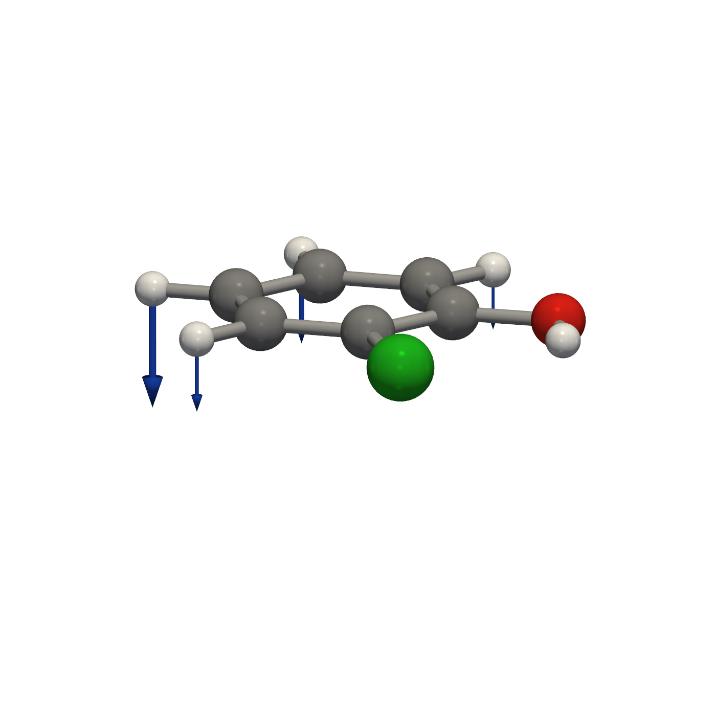
Figure 3. ORCA mode 17, i.e. the 12th vibration as listed by Avogadro, 760.9 cm⁻¹, IR intensity 69.4 km mol⁻¹: out-of-plane bending of the ring C–H bonds. Animation: ex1_mode17_animation_B3LYP_gas.gif.

HOMO and LUMO (B3LYP/def2-TZVP, gas phase)
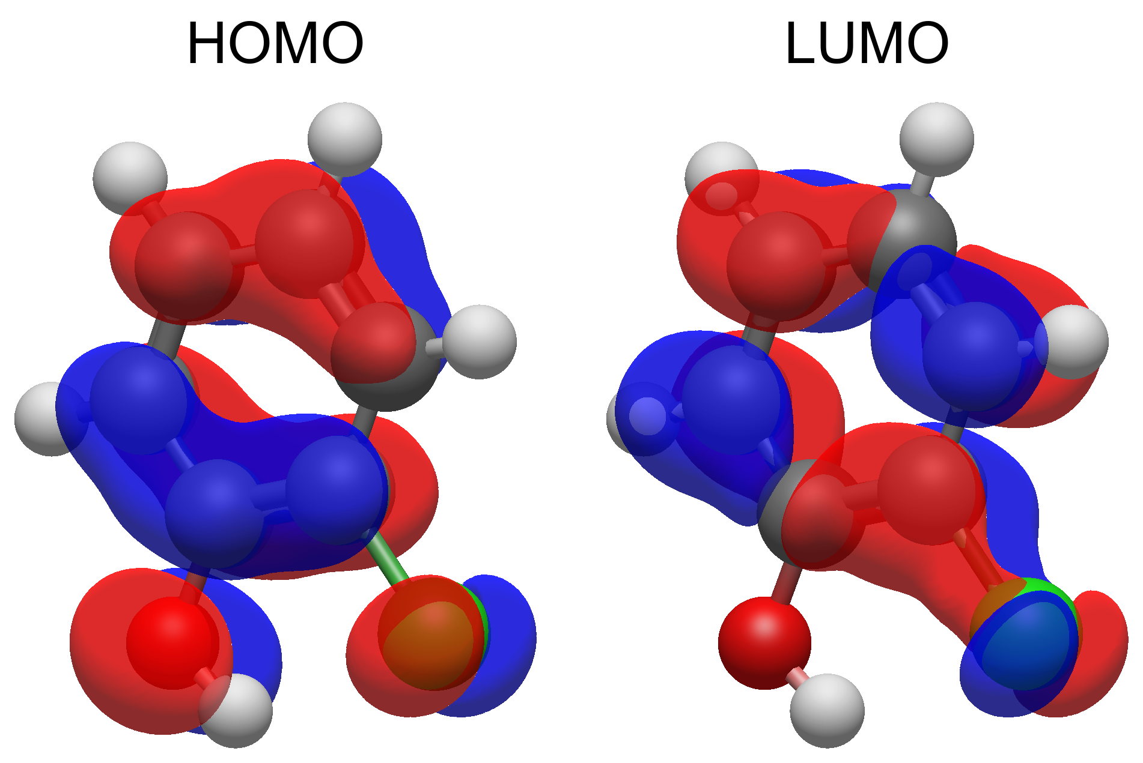
Figure 4. HOMO (orbital 32, −6.45 eV) and LUMO (orbital 33, −0.69 eV), isovalue ±0.02 a.u.; the two colours are the two phases of the orbital. Plotted with Avogadro 2 directly from the ORCA wavefunction (Molden file); Avogadro numbers the same orbitals 33 and 34, because it counts from 1 and ORCA from 0.
Both frontier orbitals are π orbitals. The HOMO is a ring π orbital with one nodal plane across the ring and antibonding contributions from the p lone pairs of O and Cl. The LUMO is a ring π* orbital with a small Cl contribution and almost none on O. The HOMO→LUMO excitation is the main component of the lowest excited state in Exercise 4.

Electron density and electrostatic potential (B3LYP/def2-TZVP, gas phase)
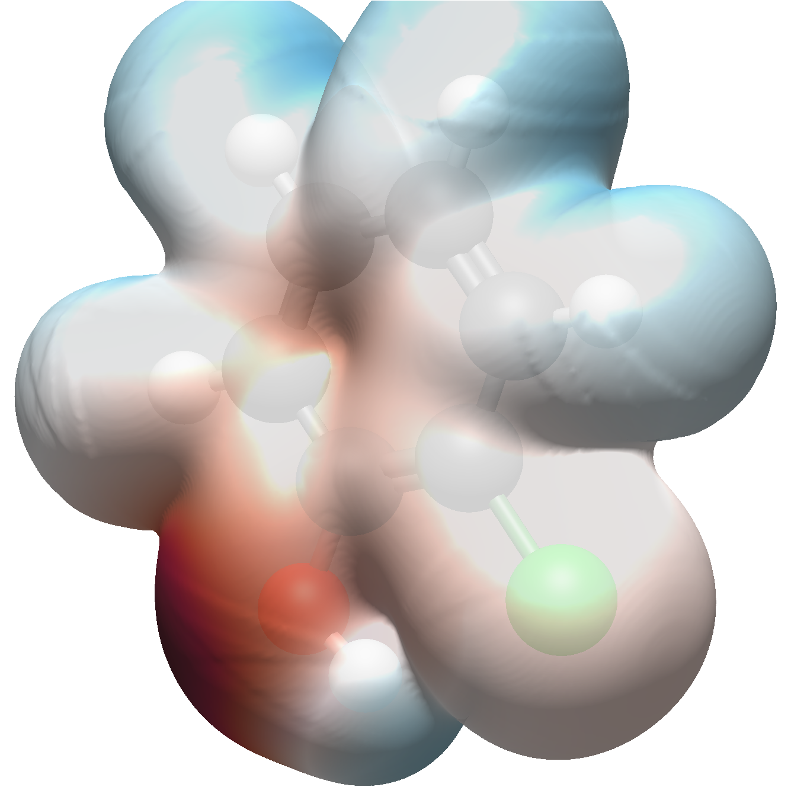
Figure 5. Electron density isosurface (0.001 a.u.) coloured by the electrostatic potential: red = negative, blue = positive. Plotted with Avogadro 2 from the ORCA wavefunction (Molden file). The isosurface itself is the true B3LYP density; the colours are the potential of Avogadro's built-in point-charge model (EEM), which is the only electrostatic potential Avogadro offers.
On the 0.001 a.u. density surface the potential computed from the wavefunction itself (ORCA orca_vpot) ranges from −0.035 to +0.061 a.u. The most negative region is the oxygen lone pair on the side away from Cl, and the π face of the ring is also negative. The most positive region is the hydroxyl hydrogen, which points towards Cl (intramolecular O–H···Cl contact); the ring hydrogens are moderately positive.
Note on the figure: Avogadro places point charges on the nuclei and evaluates their potential on the surface. This reproduces the negative region at oxygen and the positive hydrogens, but it cannot reproduce the negative potential above and below the aromatic ring, because that comes from the π electron distribution and not from any set of atom-centred charges. The numbers quoted above are therefore taken from orca_vpot, which evaluates the potential from the wavefunction.

Exercise 2 - Theoretical question #1: solvent effects

How the solvent was included in Exercise 1
The water calculations of Exercise 1 used the conductor-like polarizable continuum model, CPCM(Water). It is an implicit solvent model: no water molecules are present. The solvent is replaced by a homogeneous, polarizable dielectric with the macroscopic constants of water, ε = 80.4 and refractive index n = 1.33.
Cavity. The molecule sits in a cavity of molecular shape built from overlapping atomic spheres. By default ORCA 5 uses a van der Waals type surface with sphere radii 1.2 times the atomic van der Waals radii (C 1.70, H 1.10, O 1.52, Cl 1.75 Å); for 2-chlorophenol this gives C 2.04, H 1.32, O 1.824 and Cl 2.1 Å. The surface is discretised on Lebedev points (755 points here), and each point carries one surface charge.
Apparent surface charges. The charge distribution of the solute polarises the dielectric, and this polarisation is represented by charges q_{i} on the cavity surface. For a perfect conductor (ε → ∞) the total electrostatic potential on the surface must vanish, V(r_{i}) + Σ_{j} V_{q,j}(r_{i}) = 0, which in matrix form is A q = −V: V_{i} is the potential of the solute (electrons and nuclei) at point i and A is the Coulomb interaction matrix between the surface charges. For a real dielectric the conductor charges are scaled down, A q = −f(ε) V with f(ε) = (ε − 1)/(ε + x). CPCM uses x = 0, so f = 0.9876 for water; x = 0.5 would give the COSMO variant.
Gaussian charges. ORCA 5 smears each surface charge into a spherical Gaussian instead of using a point charge, so that A_{ii} = ζ_{i} (2/π)^{1/2}/F_{i} and A_{ij} = erf(ζ_{ij} r_{ij})/r_{ij}. The switching function F_{i} smoothly removes charges that move inside a neighbouring sphere. With point charges, surface points appear and disappear as the atoms move, and the energy jumps; with Gaussian charges the energy and its derivatives are continuous. This is what makes the analytic gradients and Hessians usable, and both were needed for the Opt and Freq runs in water.
Self-consistent reaction field. The surface charges add a potential V_{solv}(r) = Σ_{i} q_{i}/|r − r_{i}| (with Gaussian smearing) to the one-electron part of the Kohn–Sham operator. The charges depend on the density and the density depends on the charges, so both are updated in every SCF iteration until they are converged together. The SCF minimises the free energy G = ⟨Ψ|Ĥ⁰|Ψ⟩ + ½⟨Ψ|V̂|Ψ⟩; the factor ½ accounts for the work spent polarising the solvent. The orbitals, charges, dipole moment and frequencies of Exercise 1 are therefore those of the polarised, solvated molecule, which is why the dipole moment and the O–H charge separation increase in water.
What the energy contains. The solvent term printed as “CPCM Dielectric” is the electrostatic part of the solvation free energy: −0.00746 Eh (−4.68 kcal mol⁻¹) with PBE and −0.00763 Eh (−4.79 kcal mol⁻¹) with B3LYP at the optimised structures. Plain CPCM in ORCA 5 does not add the non-electrostatic terms (cavity formation, dispersion, repulsion); the output states that the cavity-dispersion term is not included.

Other ways to treat solvent effects in ORCA
CPCM with the COSMO scaling. ! CPCMC(solvent) keeps the same model but uses x = 0.5 in f(ε).
SMD. The Solvation Model based on Density (Marenich, Cramer and Truhlar) uses the CPCM electrostatics with its own intrinsic radii and adds a non-electrostatic cavity–dispersion–solvent-structure (CDS) term, computed from atomic surface tensions and solvent descriptors (refractive index, hydrogen-bond acidity and basicity, surface tension, aromaticity, halogenicity). It is parameterised against experimental solvation free energies and is the usual choice when ΔG_{solv} itself is needed (%cpcm smd true end in ORCA 5, ! SMD(solvent) in ORCA 6).
OpenCOSMO-RS (ORCA 6). Starts from the conductor-screening charges and adds a statistical-thermodynamics treatment of the interacting surface segments. It gives solvation free energies in pure solvents and mixtures and their temperature dependence.
Implicit models for xTB. For semi-empirical GFN-xTB calculations ORCA passes the solvent to the xtb program: ALPB, ddCOSMO or CPCM-X.
Explicit and mixed solvation. Specific solute–solvent interactions, such as a water molecule hydrogen-bonded to the OH group of 2-chlorophenol, are not described by a continuum. They can be added as explicit solvent molecules, either placed by hand or automatically with the ORCA SOLVATOR (ORCA 6), and the solvated cluster can itself be embedded in CPCM (cluster–continuum model). Larger explicit solvent shells can be treated with QM/MM, using the ORCA MM module for the solvent, and molecular dynamics with explicit solvent (as in Exercise 6) samples the solvent configurations.
Excited states. For TD-DFT, CPCM is applied in linear-response form; vertical excitations are normally computed with non-equilibrium solvation, in which only the electronic polarisation of the solvent (ε∞ = n²) follows the fast change of the density.

Exercise 3 - Theoretical question #2: the resolution of the identity (density fitting)

The bottleneck
In HF and DFT the Coulomb and exchange matrices are built from four-centre two-electron integrals,
J_{μν} = Σ_{λσ} P_{λσ} (μν|λσ), K_{μν} = Σ_{λσ} P_{λσ} (μλ|νσ), (μν|λσ) = ∫∫ φ_{μ}(1) φ_{ν}(1) r₁₂⁻¹ φ_{λ}(2) φ_{σ}(2) dr₁ dr₂.
Their number grows as N⁴ with the number of basis functions N. For 2-chlorophenol with def2-TZVP (N = 284, Exercise 1) there are about 8.1 × 10⁸ unique integrals, about 6.5 GB, and they have to be recomputed in every SCF iteration or read back from disk. Correlated methods (MP2, coupled cluster) must in addition transform them to the molecular-orbital basis, which costs N⁵.

The idea
A four-centre integral is the Coulomb interaction between two charge distributions, the orbital products ρ_{μν}(r) = φ_{μ}(r) φ_{ν}(r) and ρ_{λσ}(r). The resolution of the identity (RI), also called density fitting, expands each product in an auxiliary basis of atom-centred functions {χ_{P}}:
ρ_{μν}(r) ≈ Σ_{P} c^{P}_{μν} χ_{P}(r).
The coefficients are chosen to minimise the Coulomb self-energy of the fitting error, which gives c_{μν} = V⁻¹ (P|μν) with the Coulomb metric V_{PQ} = (P|Q). With this choice the error in the energy is only second order in the error of the fitted density. The four-index integral then factorises into three- and two-index pieces:
(μν|λσ) ≈ Σ_{PQ} (μν|P) [V⁻¹]_{PQ} (Q|λσ).
The name comes from this step: it is the same as inserting an approximate identity operator, 1 ≈ Σ_{PQ} |P) [V⁻¹]_{PQ} (Q|, between the two charge distributions. The quality is controlled by the auxiliary basis; ORCA provides fitted sets for each purpose, e.g. def2/J for Coulomb, def2/JK for Coulomb and exchange, def2-TZVP/C for correlation, SARC/J for relativistic basis sets, or AutoAux to generate one automatically.

Where the speed-up comes from
Far fewer integrals. Only three-centre (μν|P) and two-centre (P|Q) integrals are needed, and the auxiliary basis is only 1.5–3 times larger than the orbital basis (def2/J: N_{aux} = 449 for 2-chlorophenol). The count drops from about N⁴/8 = 8.1 × 10⁸ to N²N_{aux}/2 = 1.8 × 10⁷, roughly 45 times fewer, and at about 145 MB they can be kept in memory instead of being recomputed or read from disk.
Coulomb matrix in two cheap steps (RI-J). First the density is fitted, d = V⁻¹ g with g_{Q} = Σ_{λσ} (Q|λσ) P_{λσ}; then J_{μν} = Σ_{P} (μν|P) d_{P}. Both steps cost N²N_{aux} instead of N⁴ and are dense matrix–vector operations that run efficiently on modern processors. For GGA functionals such as PBE, J is the only two-electron term, so RI-J removes the main bottleneck of the whole calculation. The fitting error is small and systematic, so it largely cancels in energy differences.
Exchange (RIJK and RIJCOSX). The exchange matrix couples the indices crosswise and does not factorise as favourably. ORCA either fits it as well (RIJK, with a /JK auxiliary basis) or uses RIJCOSX: RI for J and the chain-of-spheres method for K, in which one electron coordinate is integrated analytically and the other on a numerical grid, K_{μν} ≈ Σ_{g} w_{g} φ_{μ}(r_{g}) Σ_{λσ} A_{νλ}(r_{g}) P_{λσ} φ_{σ}(r_{g}), A_{νλ}(r_{g}) = ∫ φ_{ν}(r) φ_{λ}(r) |r − r_{g}|⁻¹ dr. This scales close to linearly for large molecules. In Exercise 1 the PBE runs used RI-J (def2/J) and the B3LYP runs RIJCOSX (def2/J).
Correlated methods. In RI-MP2 the MO integrals are factorised in the same way, (ia|jb) ≈ Σ_{P} B^{P}_{ia} B^{P}_{jb}, which removes the expensive four-index transformation and gives speed-ups of an order of magnitude or more. The same factorisation is used throughout ORCA's DLPNO methods.

Exercise 4 - Excited states and spectra
TD-DFT for the first five singlet excited states at the four optimised structures of Exercise 1, with the same functional, basis and solvent model as the optimisation: ! RKS <PBE | B3LYP> def2-TZVP def2/J TightSCF (RIJCOSX for B3LYP, CPCM(Water) for the solvated runs) and %tddft NRoots 5 TDA false end, i.e. full linear-response TD-DFT rather than the Tamm–Dancoff approximation. The ground state is closed-shell, so a restricted reference was used; it gives the same ground state as the unrestricted one of Exercise 1 but pure singlet excited states.

Excitation energies of the first five excited states
Table 1. TD-DFT/def2-TZVP singlet excitations: energy E, wavelength λ, oscillator strength f and the orbital transitions with weight ≥ 0.15 (HOMO = orbital 32, LUMO = orbital 33).
Method | State | E (eV) | λ (nm) | f | Main transitions (weight)
PBE (gas) | S₁ | 4.656 | 266.3 | 0.0401 | HOMO→LUMO (0.81), HOMO−1→LUMO+1 (0.18)
 | S₂ | 5.175 | 239.6 | 0.0001 | HOMO→LUMO+2 (0.99)
 | S₃ | 5.478 | 226.3 | 0.0244 | HOMO→LUMO+1 (0.63), HOMO−1→LUMO (0.32)
 | S₄ | 5.865 | 211.4 | 0.0000 | HOMO−1→LUMO+2 (0.98)
 | S₅ | 6.129 | 202.3 | 0.2100 | HOMO−1→LUMO (0.43), HOMO−1→LUMO+1 (0.25)
B3LYP (gas) | S₁ | 4.985 | 248.7 | 0.0447 | HOMO→LUMO (0.79), HOMO−1→LUMO+1 (0.20)
 | S₂ | 5.690 | 217.9 | 0.0002 | HOMO→LUMO+2 (0.97)
 | S₃ | 5.749 | 215.7 | 0.0154 | HOMO→LUMO+1 (0.60), HOMO−1→LUMO (0.38)
 | S₄ | 6.339 | 195.6 | 0.0000 | HOMO−1→LUMO+2 (0.96)
 | S₅ | 6.667 | 186.0 | 0.0009 | HOMO→LUMO+3 (0.98)
PBE (water) | S₁ | 4.643 | 267.0 | 0.0585 | HOMO→LUMO (0.83), HOMO−1→LUMO+1 (0.16)
 | S₂ | 5.267 | 235.4 | 0.0002 | HOMO→LUMO+2 (0.99)
 | S₃ | 5.449 | 227.5 | 0.0377 | HOMO→LUMO+1 (0.64), HOMO−1→LUMO (0.31)
 | S₄ | 5.936 | 208.9 | 0.0000 | HOMO−1→LUMO+2 (0.98)
 | S₅ | 6.018 | 206.0 | 0.3226 | HOMO−1→LUMO (0.54), HOMO→LUMO+1 (0.19)
B3LYP (water) | S₁ | 4.974 | 249.3 | 0.0647 | HOMO→LUMO (0.81), HOMO−1→LUMO+1 (0.18)
 | S₂ | 5.720 | 216.7 | 0.0216 | HOMO→LUMO+1 (0.61), HOMO−1→LUMO (0.37)
 | S₃ | 5.762 | 215.2 | 0.0003 | HOMO→LUMO+2 (0.97)
 | S₄ | 6.390 | 194.0 | 0.5322 | HOMO−1→LUMO (0.58), HOMO→LUMO+1 (0.34)
 | S₅ | 6.395 | 193.9 | 0.0068 | HOMO−1→LUMO+2 (0.95)

Influence of the solvent
Table 2. Excitation energies (eV) in the gas phase and in water, matched by their main transition (the state number is given in brackets, because the order changes), and the solvent shift ΔE = E(water) − E(gas). “–”: not among the first five states.
Main transition | PBE gas | PBE water | ΔE | B3LYP gas | B3LYP water | ΔE
HOMO→LUMO | 4.656 (S₁) | 4.643 (S₁) | −0.013 | 4.985 (S₁) | 4.974 (S₁) | −0.011
HOMO→LUMO+2 | 5.175 (S₂) | 5.267 (S₂) | +0.092 | 5.690 (S₂) | 5.762 (S₃) | +0.072
HOMO→LUMO+1 | 5.478 (S₃) | 5.449 (S₃) | −0.029 | 5.749 (S₃) | 5.720 (S₂) | −0.029
HOMO−1→LUMO+2 | 5.865 (S₄) | 5.936 (S₄) | +0.071 | 6.339 (S₄) | 6.395 (S₅) | +0.056
HOMO−1→LUMO | 6.129 (S₅) | 6.018 (S₅) | −0.111 | – | 6.390 (S₄) | –
HOMO→LUMO+3 | – | – | – | 6.667 (S₅) | – | –

Water changes the excitation energies only slightly: by at most 0.11 eV for the states that appear in both phases. The lowest state, S₁, is the HOMO→LUMO excitation for all four methods and moves by only −0.013 eV with PBE and −0.011 eV with B3LYP (266.3 → 267.0 nm and 248.7 → 249.3 nm). The states dominated by the HOMO→LUMO+1 and HOMO−1→LUMO configurations are lowered by water, whereas the two states that excite into LUMO+2 are raised by 0.06–0.09 eV, so S₂ and S₃ swap order for B3LYP. The effect on the intensities is larger than on the energies: the oscillator strength of S₁ grows from 0.040 to 0.058 (PBE) and from 0.045 to 0.065 (B3LYP). The choice of functional matters much more than the solvent: B3LYP places every state 0.3–0.5 eV above PBE.

UV spectra
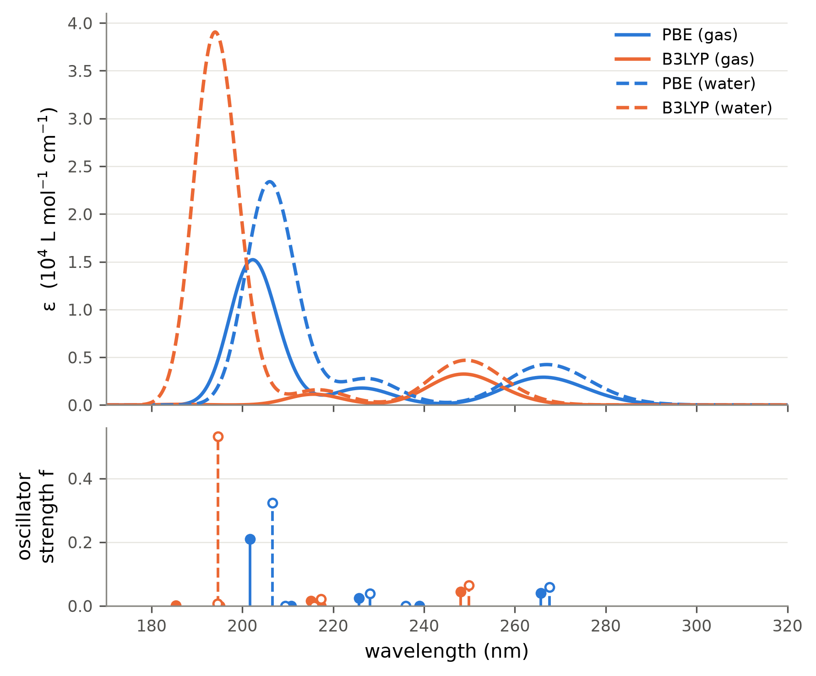
Figure 1. Simulated UV spectra of 2-chlorophenol. Top: each transition broadened by a Gaussian of FWHM 3000 cm⁻¹ (≈0.37 eV) in wavenumber, ε = Σ 2.174×10⁸ f_{i}/FWHM · exp[−2.773 (ν̃ − ν̃_{i})²/FWHM²]. Bottom: oscillator strengths (filled: gas, open: water; gas and water sticks are offset by ±0.6 nm for visibility). Only five states were computed, so the spectra are incomplete below about 200 nm.

Exercise 5 - Magnetic exchange coupling in a Cu(II) dimer from broken-symmetry DFT
The compound is a paddle-wheel dimer: four trifluoroacetate bridges between the two Cu(II) ions (Cu–Cu 2.73 Å) and one alkoxide-type O donor on each axial position; total charge −2 as given. Each Cu(II) is d⁹ with S = 1/2. Keywords: ! UKS B3LYP <basis> <auxiliary basis> RIJCOSX TightSCF SlowConv with %scf BrokenSym 1,1 end and the coordinate line * xyzfile −2 3, i.e. the high-spin multiplicity. ORCA first converges the high-spin state (HS, both spins parallel), then flips the spin on one Cu and converges the broken-symmetry state (BS). The three runs differ only in the relativistic treatment: non-relativistic (def2-SVP, def2/J), DKH (DKH-def2-SVP, SARC/J) and ZORA (ZORA-def2-SVP, SARC/J); the functional and the basis-set size are the same in all three, so the table isolates the relativistic effect. The assignment does not prescribe the non-relativistic level, so B3LYP/def2-SVP was chosen to match the other two.

Results
Table 1. Total energies of the high-spin and broken-symmetry states, their spin expectation values and the exchange coupling constants in cm⁻¹. ORCA uses H = −2J S_{A}·S_{B}, so J < 0 means antiferromagnetic coupling. J(1) is the Ginsberg–Noodleman expression, J(2) the Bencini–Gatteschi one and J(3) the Yamaguchi expression J = (E_{BS} − E_{HS})/(⟨S²⟩_{HS} − ⟨S²⟩_{BS}). The last three rows repeat the calculations with a finer integration grid (DefGrid3) and VeryTightSCF.
Run | E(HS) / E_{h} | E(BS) / E_{h} | ⟨S²⟩_{HS} | ⟨S²⟩_{BS} | E(HS)−E(BS) / cm⁻¹ | J(1) | J(2) | J(3)
non-relativistic | −6076.975267 | −6076.975094 | 2.0050 | 1.0006 | −38.0 | +38.0 | +19.0 | +37.8
DKH | −6107.249506 | −6107.249605 | 2.0041 | 0.9989 | +21.7 | −21.7 | −10.9 | −21.6
ZORA | −6122.764932 | −6122.765176 | 2.0038 | 0.9976 | +53.5 | −53.5 | −26.8 | −53.2
non-relativistic, tight grid | −6076.975278 | −6076.975105 | 2.0050 | 1.0006 | −37.9 | +37.9 | +19.0 | +37.8
DKH, tight grid | −6107.249520 | −6107.249620 | 2.0041 | 0.9989 | +21.9 | −21.9 | −10.9 | −21.8
ZORA, tight grid | −6122.765126 | −6122.765371 | 2.0038 | 0.9976 | +53.7 | −53.7 | −26.9 | −53.4

The broken-symmetry states are the intended ones: the Mulliken spin populations on the two Cu atoms are +0.63 and −0.63 (non-relativistic; +0.72 / −0.72 with ZORA), and ⟨S²⟩_{BS} ≈ 1.0 against ⟨S²⟩_{HS} ≈ 2.0, which is what two localised, antiparallel S = 1/2 centres give.

What the table shows
The relativistic correction to the total energy is enormous, and irrelevant for J. DKH lowers the total energy by 30.3 E_{h} and ZORA by 45.8 E_{h} (6.6 and 10.0 million cm⁻¹). This is almost entirely the contraction and stabilisation of the Cu 1s–2p core shells, which is the same in both spin states and therefore cancels in E(HS) − E(BS). The two relativistic Hamiltonians are also not on the same absolute scale, so only differences within one Hamiltonian are meaningful.
J itself comes from a tiny energy difference. E(HS) − E(BS) is only 22–54 cm⁻¹, i.e. about 244×10⁻⁶ E_{h}: 7 orders of magnitude smaller than the total energy and 5 orders smaller than the relativistic correction.
The three formulas differ by factors, not by physics. J(1) and J(3) agree closely because ⟨S²⟩_{HS} − ⟨S²⟩_{BS} ≈ 1 here, which is the weak-coupling limit that the Yamaguchi expression interpolates to; J(2) is smaller by a factor S_{max}(S_{max}+1)/S_{max}² = 2 by construction. Which one is quoted matters as much as the relativistic treatment, so the convention has to be stated.
Relativistic effects on J with the prescribed SVP basis. J(3) goes from +37.8 cm⁻¹ (non-relativistic) to −21.6 cm⁻¹ (DKH) and −53.2 cm⁻¹ (ZORA). The changes, −59 and −91 cm⁻¹, are tiny compared with the change of the total energy, but as large as J itself, and at this level they even change its sign (weakly ferromagnetic without, weakly antiferromagnetic with relativity). The two relativistic Hamiltonians also disagree with each other by 32 cm⁻¹. Because such small energy differences are easily distorted, the SVP results were checked for numerical and basis-set convergence below.
Numerical check. E(HS) − E(BS) is of the same order as the error of the chain-of-spheres approximation for the exchange integrals, so all three calculations were repeated with a finer integration grid (DefGrid3) and VeryTightSCF (last three rows of Table 1). J(3) changes by only −0.07, −0.13, −0.15 cm⁻¹, less than 0.1 cm⁻¹: the numbers are converged with respect to the numerical integration.

Are the SVP results converged? Basis set and functional
Table 2. Additional B3LYP calculations with the larger TZVP-level basis sets (upper block, compared with the SVP results of Table 1) and non-relativistic SVP calculations with functionals containing 10%, 20% and 25% exact exchange (lower block). Same geometry, charge and BrokenSym setup throughout.
Run | E(HS)−E(BS) / cm⁻¹ | J(3) / cm⁻¹ | Coupling
B3LYP/def2-SVP, non-relativistic | −38.0 | +37.8 | ferromagnetic
B3LYP/DKH-def2-SVP, DKH | +21.7 | −21.6 | antiferromagnetic
B3LYP/ZORA-def2-SVP, ZORA | +53.5 | −53.2 | antiferromagnetic
B3LYP/def2-TZVP, non-rel. | +78.7 | −78.1 | antiferromagnetic
B3LYP/DKH-def2-TZVP, DKH | +127.84 | −126.87 | antiferromagnetic
B3LYP/ZORA-def2-TZVP, ZORA | +127.84 | −126.87 | antiferromagnetic
TPSSh/def2-SVP, non-rel. (10% HF exchange) | −174.9 | +173.4 | ferromagnetic
B3LYP/def2-SVP, non-rel. (20% HF exchange) | −38.0 | +37.8 | ferromagnetic
PBE0/def2-SVP, non-rel. (25% HF exchange) | +30.9 | −30.8 | antiferromagnetic

Basis set: the sign change is an SVP artefact. With TZVP-level basis sets all three calculations give antiferromagnetic coupling: J(3) = −78.1 cm⁻¹ non-relativistic, −126.87 cm⁻¹ with DKH and −126.87 cm⁻¹ with ZORA. DKH and ZORA now agree to 0.003 cm⁻¹ in E(HS) − E(BS) (they differed by 32 cm⁻¹ with SVP), and the non-relativistic value changes sign on its own when the basis is enlarged. The ferromagnetic SVP result and the DKH/ZORA disagreement therefore come from the small SVP basis, not from relativity. With the larger basis the relativistic correction is clean: scalar relativity shifts J by −49 cm⁻¹, i.e. it strengthens the antiferromagnetic coupling by about 62 %.
Functional: the largest uncertainty. With the same SVP basis J(3) is +173 cm⁻¹ for TPSSh (10% exact exchange), +38 cm⁻¹ for B3LYP (20%) and −31 cm⁻¹ for PBE0 (25%), a monotonic trend with the amount of exact exchange spanning 204 cm⁻¹. This is the well-known functional dependence of broken-symmetry DFT and is larger than any of the relativistic shifts.

How important are the relativistic effects on J?
The relativistic Hamiltonian changes the total energy by tens of hartree, but almost all of that is the core-electron stabilisation, which is the same in the high-spin and the broken-symmetry state and cancels in J. What remains for J is a correction of about 49 cm⁻¹ (≈62 % of |J|): for a 3d metal like Cu this is small in absolute terms but not negligible, because the exchange coupling itself is a small energy. DKH and ZORA give the same answer once the basis set is adequate, so for J the choice between the two scalar-relativistic Hamiltonians does not matter. The comparison also shows that such small energy differences need a converged basis set before a relativistic effect can be read from them — the SVP basis prescribed for the exercise is too small for that — and that the exchange-correlation functional, not relativity, is the main source of uncertainty in the computed J.

Exercise 6 - Ab initio and semi-empirical molecular dynamics of a water cluster
Both runs use the ORCA %md module on a cluster cut from an ice crystal, at 400 K with a Nosé–Hoover chain thermostat (time constant 10 fs) and a time step of 0.5 fs, which is the largest step the manual recommends for systems containing hydrogen. The exercise asks for a sphere of size 50 Å; this was read as a diameter, so the ORCA keyword Cell Sphere was given a radius of 25 Å, centred on the cluster (the input files are not centred on the origin). The sphere is a soft repulsive wall that keeps evaporated molecules from flying away; the clusters themselves have radii of only 6.4 Å (a) and 13.7 Å (b), so the wall never acts on the bulk of the cluster, and the results would be the same if the 50 Å were read as a radius. Keywords: ! MD PBE def2-SVP def2/J for (a) and ! MD XTB2 for (b).

Setup and cost
Table 1. The two simulations and what they cost on one core.
 | (a) PBE/def2-SVP | (b) GFN2-xTB
Water molecules | 20 | 128
Atoms | 60 | 384
Steps × 0.5 fs | 200 = 100 fs | 5000 = 2.5 ps
Wall time (1 core) | 4.8 h | 5.6 h
Time per step | 86 s | 4.1 s
Time per step and atom | 1436 ms | 10.6 ms

Structures at the beginning and at the end
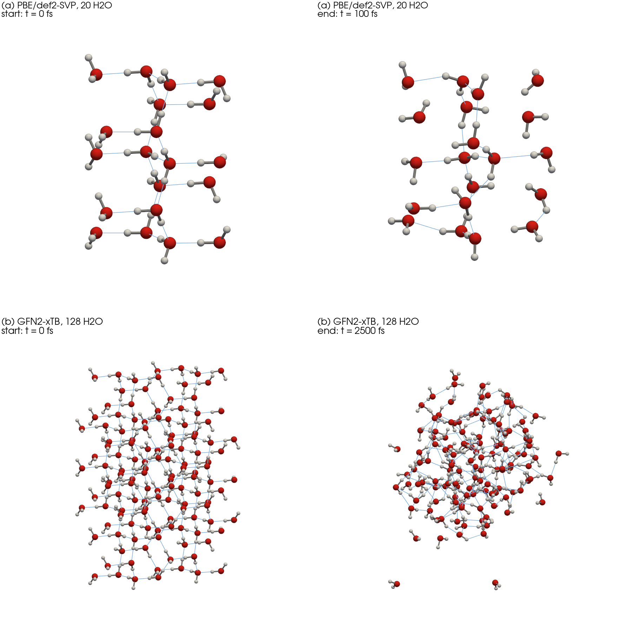
Figure 1. First and last frame of each trajectory. Red: O, white: H, grey sticks: covalent O–H bonds, thin blue lines: hydrogen bonds (H···O < 2.2 Å). Same viewing direction and scale within each row.

Temperature and structure along the trajectories
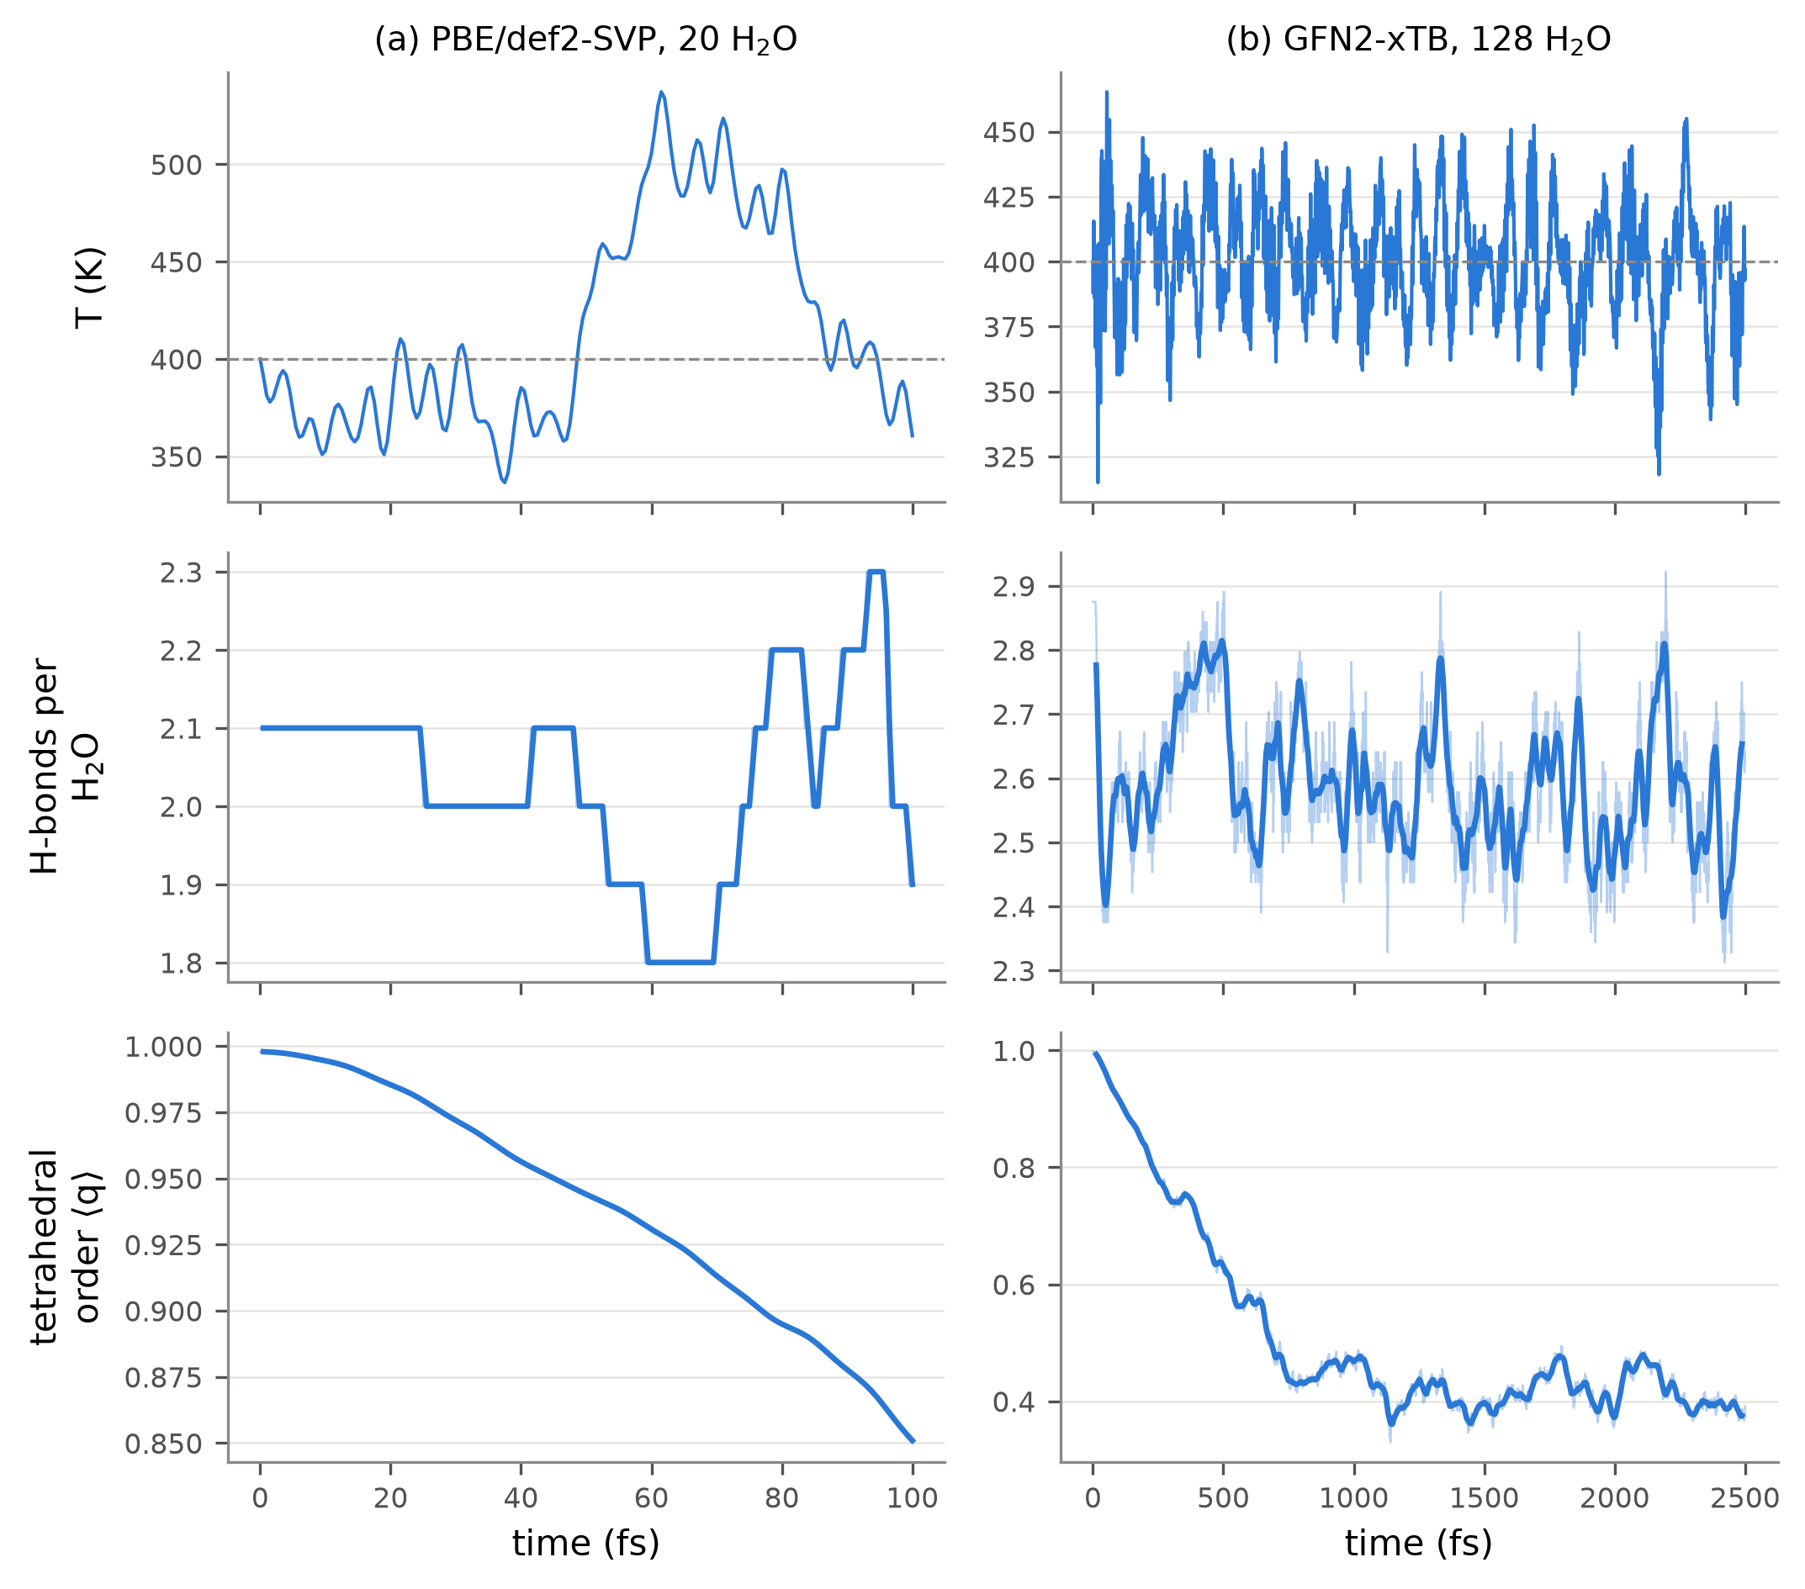
Figure 2. Top: instantaneous temperature (dashed line: the 400 K set point). Middle: hydrogen bonds per water molecule (O···O < 3.5 Å and ∠(H–O···O) < 30°). Bottom: tetrahedral order parameter q averaged over the molecules that start with four neighbours within 3.2 Å (2 of 20 and 48 of 128). Thin lines are per-step values, thick lines a running average.
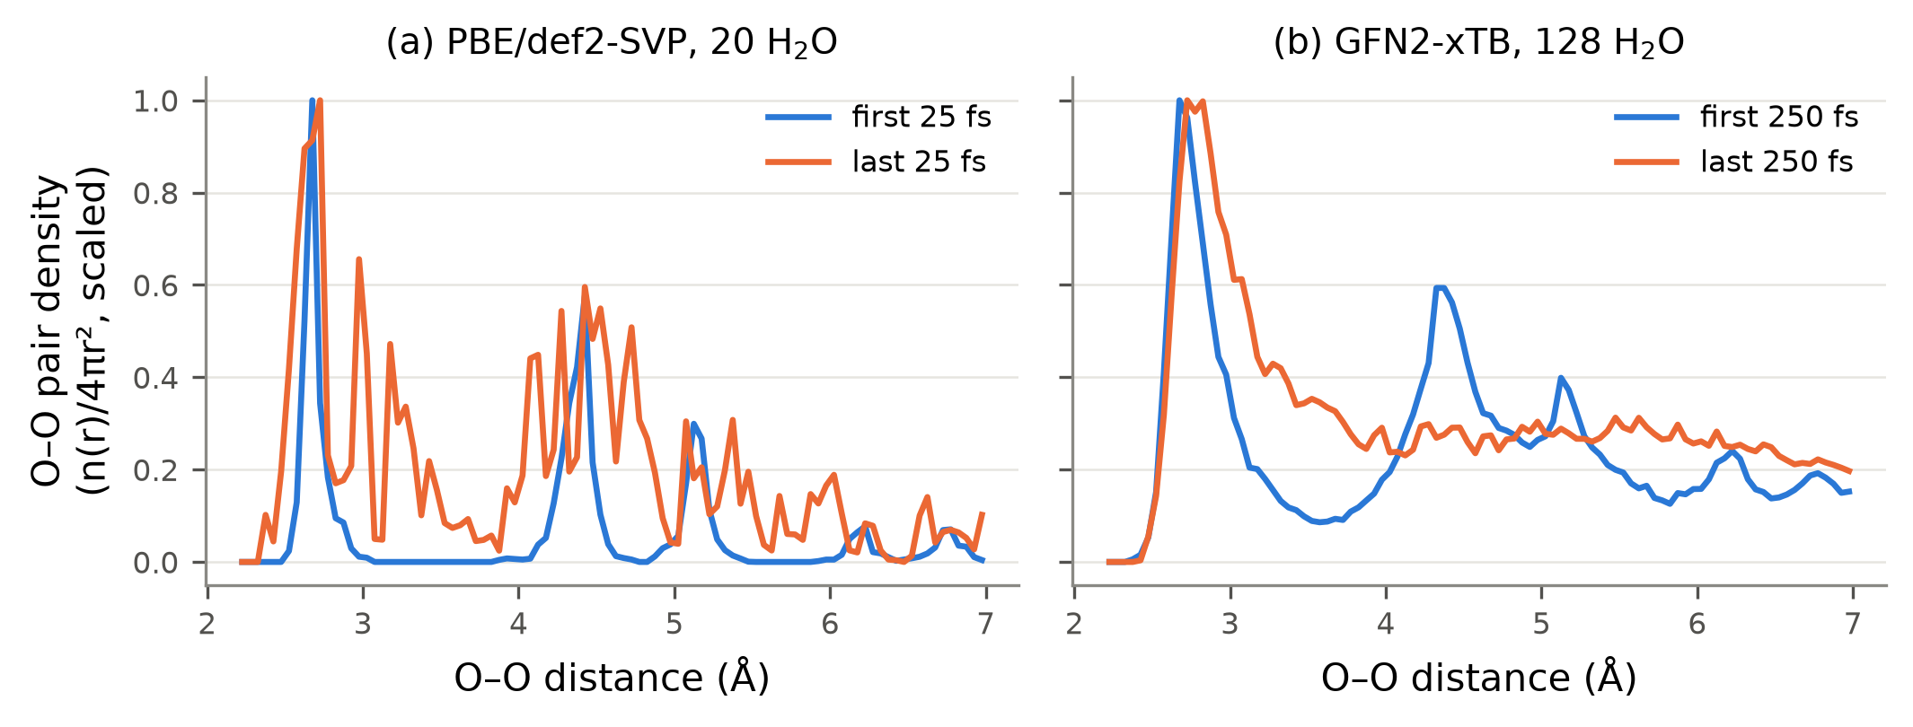
Figure 3. O–O pair distance distribution, n(r)/4πr², at the beginning and at the end of each run, scaled to the same maximum.

What the simulations show
The ice cluster melts, and the melting is visible in the structure, not in the temperature. In the xTB run the tetrahedral order of the interior molecules falls from 0.90 to 0.39 during the first ~800 fs and then stays there; the second-neighbour peak at 4.4 Å in the O–O distribution disappears and the minimum at 3.5 Å fills in (Figure 3b). That is the crystal-to-liquid change the exercise describes: the molecules keep their hydrogen bonds (2.56 → 2.53 per molecule) but lose the tetrahedral arrangement and the long-range order.
100 fs of ab initio MD is not enough to see it. In the DFT run q only falls from 0.99 to 0.88 and the pair distribution still shows the ice peaks. Hydrogen-bond rearrangement in water takes of the order of a picosecond, so a 100 fs trajectory only samples the vibrations around the initial structure.
Molecules evaporate, and the wall is needed. The largest O distance from the centre of the cluster grows from 13.0 Å to 23.6 Å in the xTB run: single molecules leave the hot surface and travel almost to the 25 Å wall. Without the confining sphere they would simply fly away and the cluster would slowly evaporate.
The thermostat works, but small clusters fluctuate strongly. Over the second half of the xTB run the mean temperature is 399 K with a standard deviation of 22 K. In the 60-atom DFT cluster the same thermostat gives swings of ±50 K around the set point, because the temperature of a small system is a strongly fluctuating quantity (the relative fluctuation goes as 1/√N).
Cost decides what is possible. One DFT step costs 86 s for 60 atoms, one xTB step 4.1 s for 384 atoms, i.e. about 136 times more expensive per atom and step. This is why the ab initio run is limited to a small cluster and 100 fs while the semi-empirical run reaches 128 molecules and 2.5 ps in a comparable wall time.

What else can be obtained from the trajectories
The stored trajectory (and the per-step energies in the .csv file that ORCA writes) contains much more than the melting itself:
Structure. Radial distribution functions g(r) for O–O, O–H and H–H and the coordination numbers obtained by integrating them; the distribution of hydrogen-bond distances and angles; the distribution of the tetrahedral order parameter; the size and shape of the cluster.
Dynamics. Mean square displacement and from it the diffusion coefficient; hydrogen-bond lifetimes and reorientation correlation times; velocity autocorrelation, whose Fourier transform gives the vibrational density of states; the dipole autocorrelation function, which gives the infrared spectrum including anharmonic and temperature effects, something a harmonic frequency calculation like Exercise 1 cannot provide.
Thermodynamics and quality control. The distributions of kinetic and potential energy (and from their fluctuations the heat capacity); the evaporation rate; and, as a check on the integration, the drift of the conserved quantity — here −3.2 kcal mol⁻¹ over 2.5 ps for xTB and +0.03 kcal mol⁻¹ over 100 fs for DFT.
Snapshots from the trajectory can also be used as starting structures for other calculations, for example to compute spectra of solvated molecules on configurations sampled by the dynamics.
The animation of the xTB trajectory (every 25th step, 201 frames) is supplied as ex6b_trajectory_animation_XTB.gif.

