Exercise 1 - Study of the ground state of 2-chlorophenol with different computational methods
ORCA 5.0.2, spin-unrestricted Kohn–Sham, def2-TZVP basis; geometry optimisation followed by an analytic frequency calculation: ! UKS <PBE | B3LYP> def2-TZVP def2/J TightSCF TightOpt Opt Freq, with RIJCOSX for B3LYP and CPCM(Water) for the two solvated runs.
In the supplied structure the hydroxyl hydrogen was perpendicular to the ring. Before optimisation it was rotated into the ring plane on the Cl side (cis conformer, intramolecular O–H···Cl contact); all other atoms were left as given. All four optimised structures have 33 real frequencies and no imaginary mode, so they are minima. This conformer was chosen because it is 3.3 kcal mol⁻¹ (3.0 kcal mol⁻¹ in G at 298 K) below the trans conformer, which is also a minimum (B3LYP/def2-TZVP, gas phase).

a) Mulliken and Löwdin atomic charges
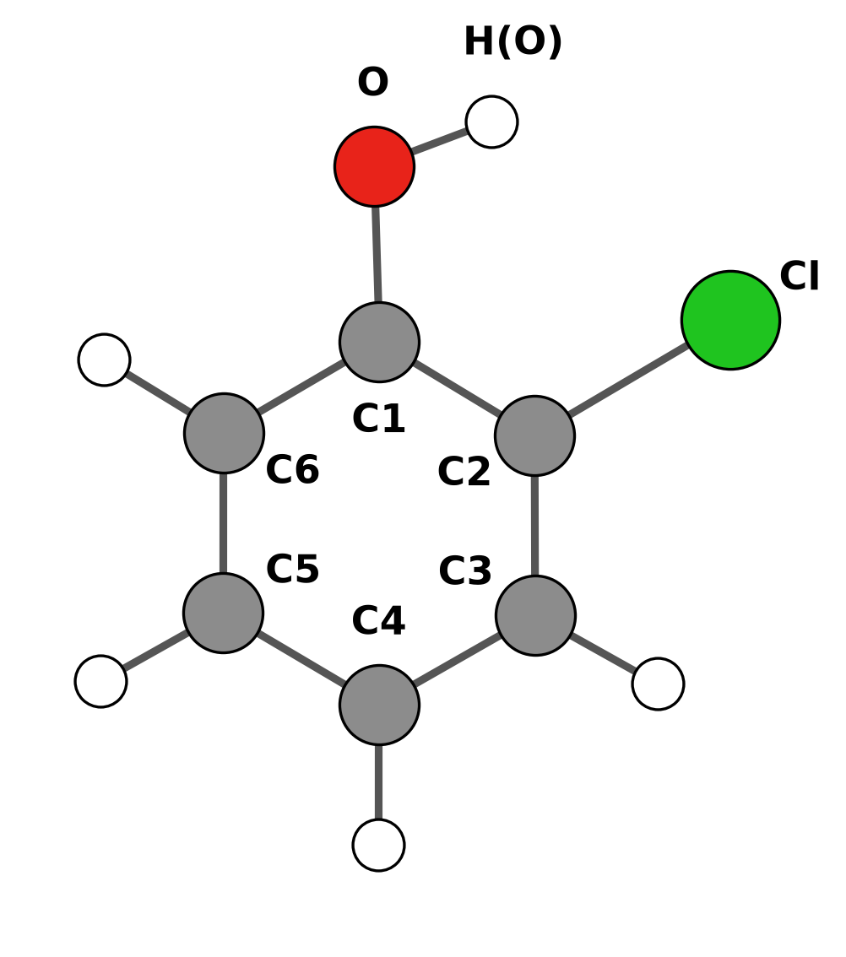
Figure 1. Atom numbering used in Table 1. H(Cn) is the hydrogen bonded to Cn; H(O) is the hydroxyl hydrogen.
Table 1. Atomic charges (e), UKS/def2-TZVP.
 | Mulliken |  |  |  | Löwdin
Atom | PBE gas | B3LYP gas | PBE water | B3LYP water | PBE gas | B3LYP gas | PBE water | B3LYP water
Cl | −0.1320 | −0.1390 | −0.1302 | −0.1399 | +0.3901 | +0.3753 | +0.3877 | +0.3711
O | −0.3215 | −0.3783 | −0.3568 | −0.4165 | +0.1091 | +0.0948 | +0.0963 | +0.0801
C1 | +0.1421 | +0.1795 | +0.1598 | +0.1996 | −0.2951 | −0.2832 | −0.3003 | −0.2879
C2 | +0.1463 | +0.1281 | +0.1257 | +0.1112 | −0.4167 | −0.4058 | −0.4220 | −0.4099
C3 | −0.1728 | −0.1632 | −0.1961 | −0.1845 | −0.1488 | −0.1433 | −0.1512 | −0.1448
C4 | −0.1165 | −0.1230 | −0.1557 | −0.1601 | −0.1545 | −0.1510 | −0.1589 | −0.1541
C5 | −0.0866 | −0.0898 | −0.1254 | −0.1268 | −0.1413 | −0.1351 | −0.1459 | −0.1383
C6 | −0.1931 | −0.1878 | −0.2251 | −0.2186 | −0.1181 | −0.1136 | −0.1258 | −0.1210
H(O) | +0.2975 | +0.3078 | +0.3358 | +0.3452 | +0.1768 | +0.1750 | +0.1919 | +0.1894
H(C3) | +0.1173 | +0.1245 | +0.1495 | +0.1549 | +0.1507 | +0.1478 | +0.1587 | +0.1554
H(C4) | +0.1052 | +0.1110 | +0.1415 | +0.1459 | +0.1467 | +0.1436 | +0.1546 | +0.1513
H(C5) | +0.1051 | +0.1125 | +0.1410 | +0.1471 | +0.1478 | +0.1450 | +0.1558 | +0.1528
H(C6) | +0.1090 | +0.1177 | +0.1359 | +0.1424 | +0.1533 | +0.1506 | +0.1592 | +0.1559

Water increases the charge separation in the hydroxyl group. The Mulliken charge on O goes from −0.322 to −0.357 (PBE) and from −0.378 to −0.417 (B3LYP), and the hydroxyl H goes from +0.297 to +0.336 and from +0.308 to +0.345. B3LYP puts more negative charge on O than PBE. The two partitioning schemes disagree most for the heteroatoms: Löwdin gives Cl a positive charge (+0.37 to +0.39) and O a small positive one, where Mulliken gives negative values. Atomic charges are not observables, and the two schemes divide the overlap density differently, so only the trends within one scheme should be compared.

b) Vibrational frequencies
Table 2. Harmonic vibrational frequencies (cm⁻¹), ORCA mode numbering (modes 0–5 are translations and rotations).
Mode | PBE gas | B3LYP gas | PBE water | B3LYP water
6 | 154.5 | 159.5 | 155.2 | 159.6
7 | 245.2 | 253.0 | 240.3 | 247.7
8 | 255.5 | 264.9 | 255.1 | 264.2
9 | 365.9 | 376.2 | 366.4 | 376.3
10 | 429.6 | 435.1 | 429.2 | 388.8
11 | 475.4 | 454.7 | 439.3 | 453.0
12 | 484.4 | 496.2 | 483.0 | 494.8
13 | 532.9 | 551.9 | 536.3 | 554.9
14 | 546.3 | 565.4 | 545.7 | 564.5
15 | 669.9 | 687.6 | 665.3 | 682.8
16 | 688.5 | 718.0 | 696.7 | 725.9
17 | 727.1 | 760.9 | 728.7 | 761.7
18 | 824.1 | 846.4 | 820.2 | 842.0
19 | 824.4 | 865.9 | 827.6 | 868.4
20 | 887.6 | 939.2 | 904.4 | 954.2
21 | 907.7 | 957.8 | 929.8 | 979.9
22 | 1020.9 | 1047.3 | 1016.0 | 1042.6
23 | 1033.5 | 1064.9 | 1031.1 | 1061.8
24 | 1111.8 | 1142.8 | 1104.3 | 1135.8
25 | 1143.2 | 1181.4 | 1132.2 | 1172.0
26 | 1185.4 | 1214.2 | 1170.2 | 1197.8
27 | 1248.8 | 1278.6 | 1233.4 | 1264.6
28 | 1303.6 | 1325.1 | 1298.1 | 1318.7
29 | 1364.6 | 1372.7 | 1355.7 | 1363.2
30 | 1451.2 | 1495.3 | 1444.5 | 1488.7
31 | 1468.4 | 1514.1 | 1458.4 | 1504.8
32 | 1583.5 | 1625.6 | 1576.7 | 1619.2
33 | 1593.0 | 1634.5 | 1583.2 | 1625.3
34 | 3109.7 | 3175.6 | 3110.2 | 3176.9
35 | 3121.9 | 3188.2 | 3120.0 | 3186.9
36 | 3128.9 | 3195.9 | 3126.4 | 3193.7
37 | 3137.0 | 3203.1 | 3135.5 | 3202.3
38 | 3567.0 | 3721.7 | 3561.5 | 3704.6

B3LYP gives higher frequencies than PBE for nearly every mode (on average by 2.8 % in the gas phase). The largest difference is the O–H stretch (mode 38): 3567 cm⁻¹ with PBE and 3722 cm⁻¹ with B3LYP. Water shifts most modes by only a few cm⁻¹; the O–H stretch is lowered by 6 cm⁻¹ (PBE) and 17 cm⁻¹ (B3LYP).

c)–e) Electric dipole moment, entropy at room temperature and HOMO–LUMO gap
Table 3. Dipole moment, entropy at 298.15 K and frontier orbital energies. S_{el} = 0 (closed-shell singlet); ORCA treats the low-frequency vibrations with Grimme's quasi-RRHO model. HOMO = orbital 32, LUMO = orbital 33 (α and β identical).
Quantity | PBE gas | B3LYP gas | PBE water | B3LYP water
Dipole moment μ (D) | 0.751 | 0.880 | 0.896 | 1.091
S_{vib} (cal mol⁻¹ K⁻¹) | 12.62 | 12.10 | 12.75 | 12.30
S_{rot} (cal mol⁻¹ K⁻¹) | 28.64 | 28.63 | 28.65 | 28.63
S_{trans} (cal mol⁻¹ K⁻¹) | 40.47 | 40.47 | 40.47 | 40.47
S total (cal mol⁻¹ K⁻¹) | 81.73 | 81.19 | 81.86 | 81.40
T·S (kcal mol⁻¹) | 24.37 | 24.21 | 24.41 | 24.27
E_{HOMO} (eV) | −5.676 | −6.449 | −5.666 | −6.429
E_{LUMO} (eV) | −1.490 | −0.690 | −1.463 | −0.647
HOMO–LUMO gap (eV) | 4.186 | 5.759 | 4.204 | 5.782

The dipole moment grows from PBE to B3LYP and from gas to water (0.75 D for PBE in the gas phase, 1.09 D for B3LYP in water): the continuum polarises the molecule. The entropy is almost method-independent (81.2–81.9 cal mol⁻¹ K⁻¹); the translational and rotational parts depend only on mass and geometry, and only the vibrational part changes a little through the low-frequency modes. The HOMO–LUMO gap is 1.6 eV larger with the hybrid functional (5.76 vs 4.19 eV in the gas phase), while water changes it by only 0.02 eV with both functionals.

Normal mode 12
ORCA numbers all 3N modes from 0, so modes 0–5 are translations and rotations and mode 12 is the seventh vibration. Avogadro and Chemcraft list only the 33 vibrations, starting from 1, so their twelfth entry is ORCA mode 17. Since the numbering in the question could mean either, both modes are shown.
Table 4. The two modes that “mode 12” can refer to, B3LYP/def2-TZVP gas phase.
 | ORCA mode 12 | ORCA mode 17
Position in the list | 12th of all modes (7th vibration) | 17th of all modes (12th vibration)
Frequency (cm⁻¹) | 496.2 | 760.9
IR intensity (km mol⁻¹) | 11.2 | 69.4
PBE gas / B3LYP gas / PBE water / B3LYP water (cm⁻¹) | 484.4 / 496.2 / 483.0 / 494.8 | 727.1 / 760.9 / 728.7 / 761.7

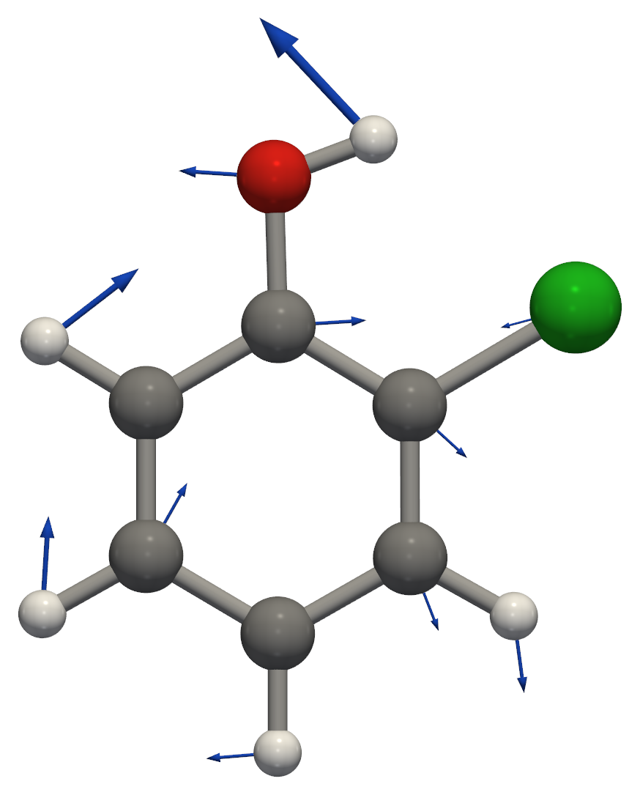
Figure 2a. ORCA mode 12 (7th vibration), 496.2 cm⁻¹, IR intensity 11.2 km mol⁻¹: in-plane ring deformation coupled to C–O–H bending; the hydroxyl H moves most. Arrows show the atomic displacements.
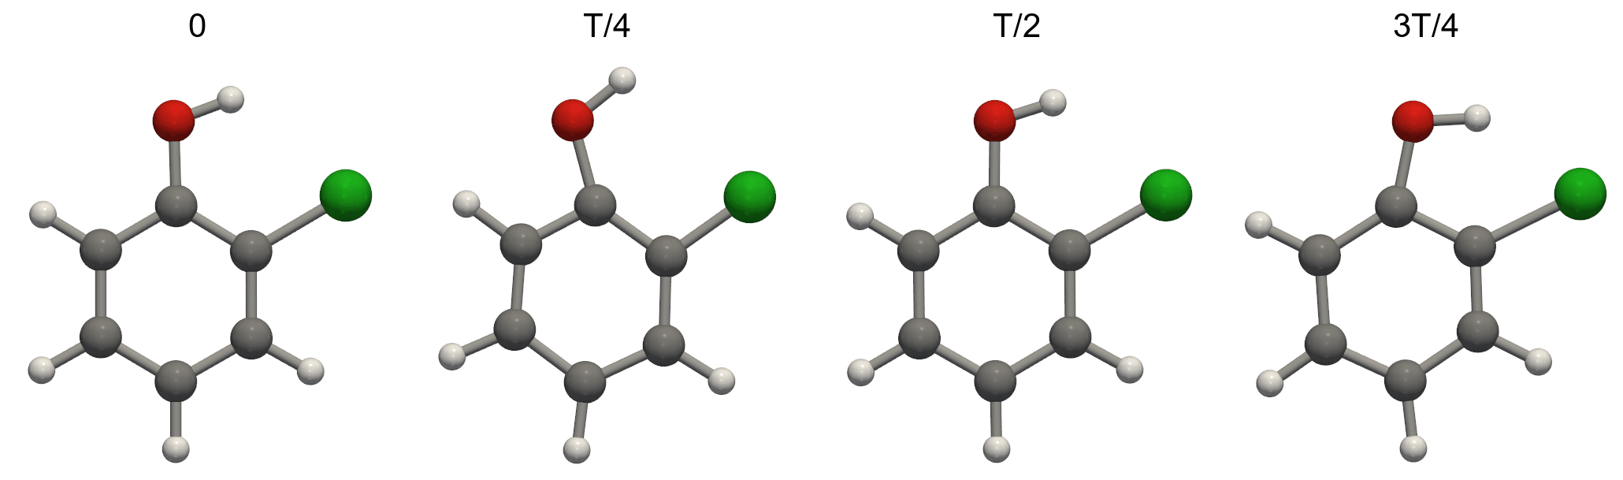
Figure 2b. ORCA mode 12 at four points of one vibrational period T. The animation is sent with this report as HW2_ZhangXubo_Ex1_mode12_ORCA-numbering.gif.
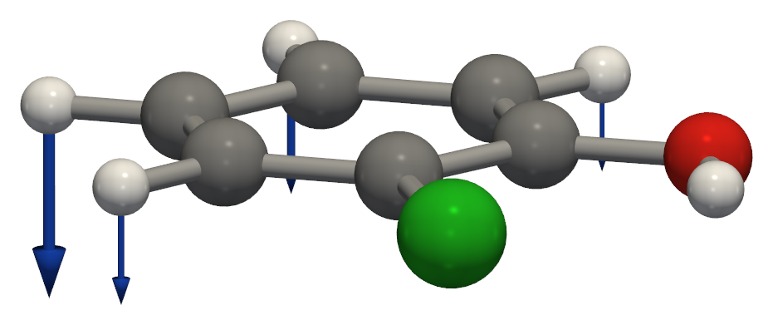
Figure 3. ORCA mode 17 (12th vibration in the Avogadro list), 760.9 cm⁻¹, IR intensity 69.4 km mol⁻¹: out-of-plane bending of the ring C–H bonds. The animation is sent as HW2_ZhangXubo_Ex1_mode12_Avogadro-numbering.gif.
The frames of both modes were generated with orca_pltvib and rendered with Python (PyVista), since the movie export of Avogadro does not work.

HOMO and LUMO (B3LYP/def2-TZVP, gas phase)
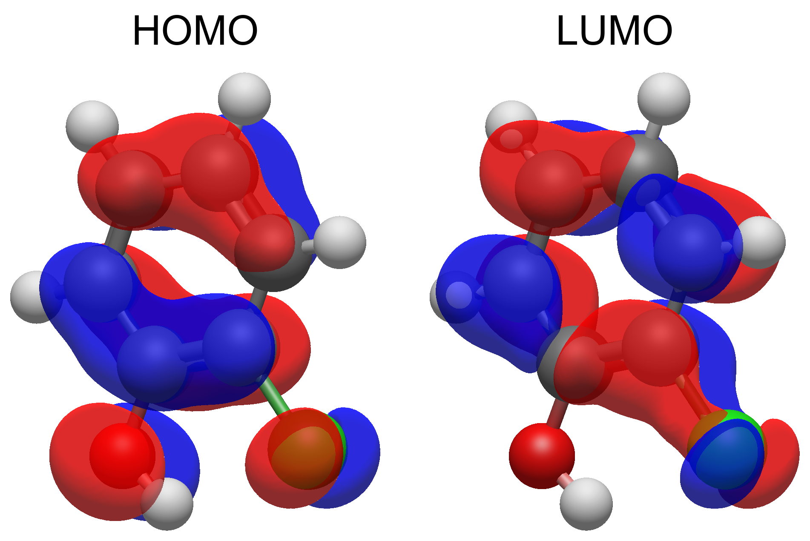
Figure 4. HOMO (orbital 32, −6.45 eV) and LUMO (orbital 33, −0.69 eV), isovalue ±0.02 a.u.; the two colours are the two phases of the orbital. Plotted with Avogadro 2 directly from the ORCA wavefunction (Molden file); Avogadro numbers the same orbitals 33 and 34, because it counts from 1 and ORCA from 0.
Both frontier orbitals are π orbitals. The HOMO is a ring π orbital with one nodal plane across the ring and antibonding contributions from the p lone pairs of O and Cl. The LUMO is a ring π* orbital with a small Cl contribution and almost none on O. The HOMO→LUMO excitation is the main component of the lowest excited state in Exercise 4.

Electron density and electrostatic potential (B3LYP/def2-TZVP, gas phase)
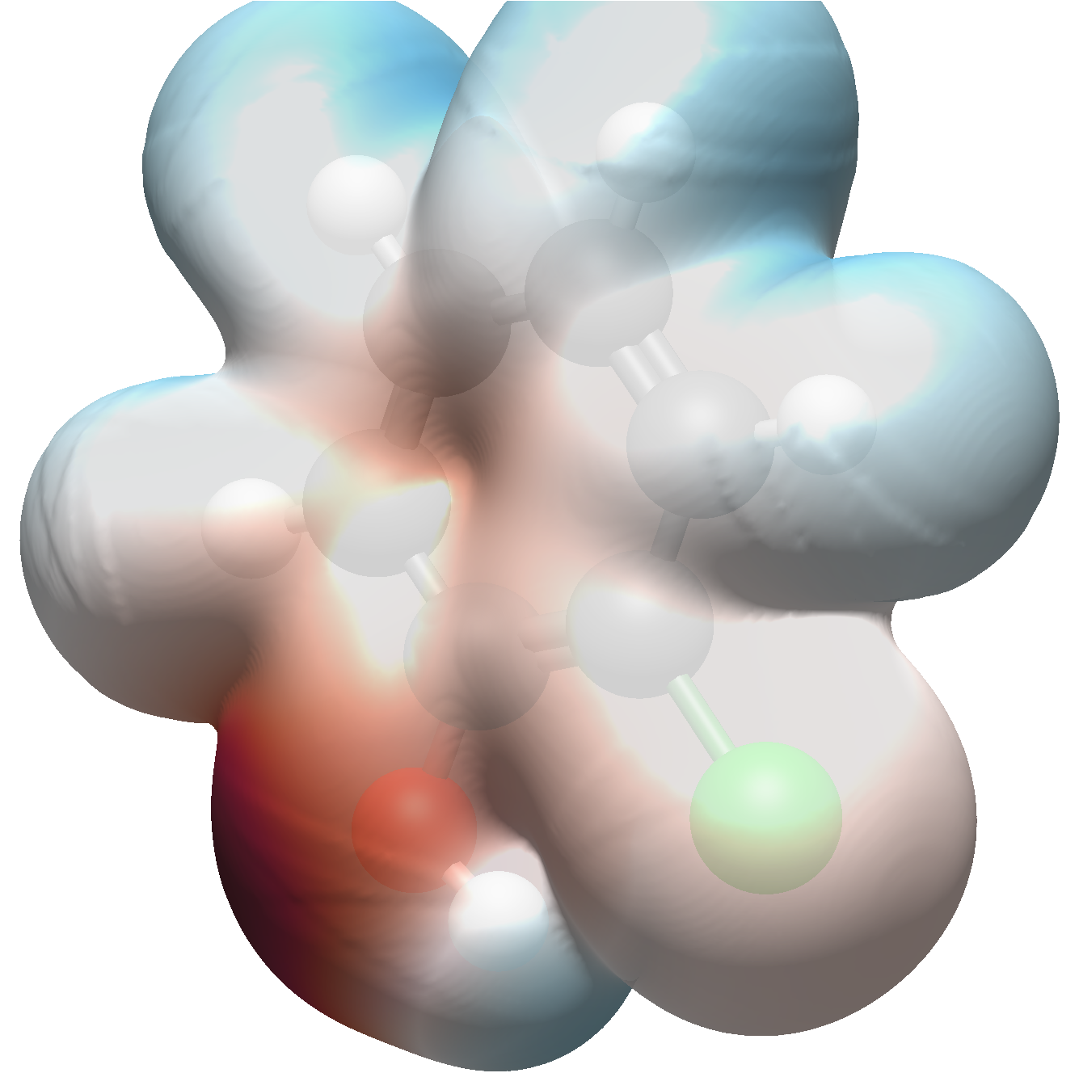
Figure 5. Electron density isosurface (0.001 a.u.) coloured by the electrostatic potential: red = negative, blue = positive. Plotted with Avogadro 2 from the ORCA wavefunction (Molden file). The surface is the B3LYP density; the colours come from Avogadro's point-charge (EEM) potential.
On the 0.001 a.u. density surface the potential calculated from the wavefunction with orca_vpot ranges from −0.035 to +0.061 a.u. The most negative region is the oxygen lone pair on the side away from Cl, and the π face of the ring is also negative. The most positive region is the hydroxyl hydrogen, which points towards Cl (intramolecular O–H···Cl contact); the ring hydrogens are moderately positive. Because Avogadro's colouring uses atom-centred point charges, it misses the negative π region above and below the ring, so the values above are taken from orca_vpot.

