Biopolymers: Structure, Properties and Performance Limits
CM3254 Project Report · [Author 1, Matric No.] · [Author 2, Matric No.] · [Date]
AI Tool Declaration — (final wording to be added on the first page before submission)

1. Introduction and Definition
A biopolymer is a macromolecule synthesised by a living organism: polysaccharides, proteins, nucleic acids, cis-1,4-polyisoprene and lignin together account for most of the organic polymer on Earth [1]. The term is extended here to include polymers made by chemical polymerisation of biomass-derived monomers — principally poly(lactic acid) (PLA) — since their properties are best understood alongside the true biopolymers. Three structural features set these chains apart from synthetic polymers: template-directed biosynthesis fixes chain length and sequence, so proteins and nucleic acids are strictly monodisperse (Đ = 1.00); biological monomer pools are enantiomerically pure, so chains are stereoregular by default; and hydroxyl/amide/carbonyl groups on almost every repeat unit give cohesive energy densities far above the polyolefins'. This report's properties and limitations follow from these three features: high stiffness and crystallinity, but also brittleness, water sensitivity, and decomposition close to or below the melting point (§5.4).

2. Types of Biopolymers
Biopolymers are often classified first by origin — extracted from biomass, synthesised by micro-organisms, or polymerised from bio-based monomers — but origin predicts behaviour poorly: two materials from the same origin can process and degrade completely differently, while two from different origins can behave alike. The repeating linkage along the backbone is the better predictor, since it determines both melting survival and degradation mechanism, so this review is organised by backbone chemistry instead (Table 1, Fig. 1); origin is retained only as a secondary tag on each material, since it still explains why molecular weight and purity vary within a class (§4).
Table 1. Classification of biopolymers by backbone chemistry, the axis this review is organised on; origin (extracted / microbial / bio-monomer) is a secondary property, not the primary split.
Backbone class | Repeating linkage | Representative materials | Characteristic behaviour
Polysaccharide | glycosidic (acetal) | cellulose, starch, chitosan, alginate | dense inter-chain hydrogen bonding; decomposition before melting; enzymatic degradation
Polyester | ester | PHA, PLA | melt-processable but thermally labile; autocatalytic hydrolysis
Protein | amide | silk fibroin, collagen/gelatin | sequence-defined and monodisperse; conformation-controlled properties
Polyphenolic | β-O-4 ether, C–C | lignin | irregular, cross-linked, amorphous; chemically recalcitrant
Polyisoprene | C–C | natural rubber | elastomeric; strain-induced crystallisation

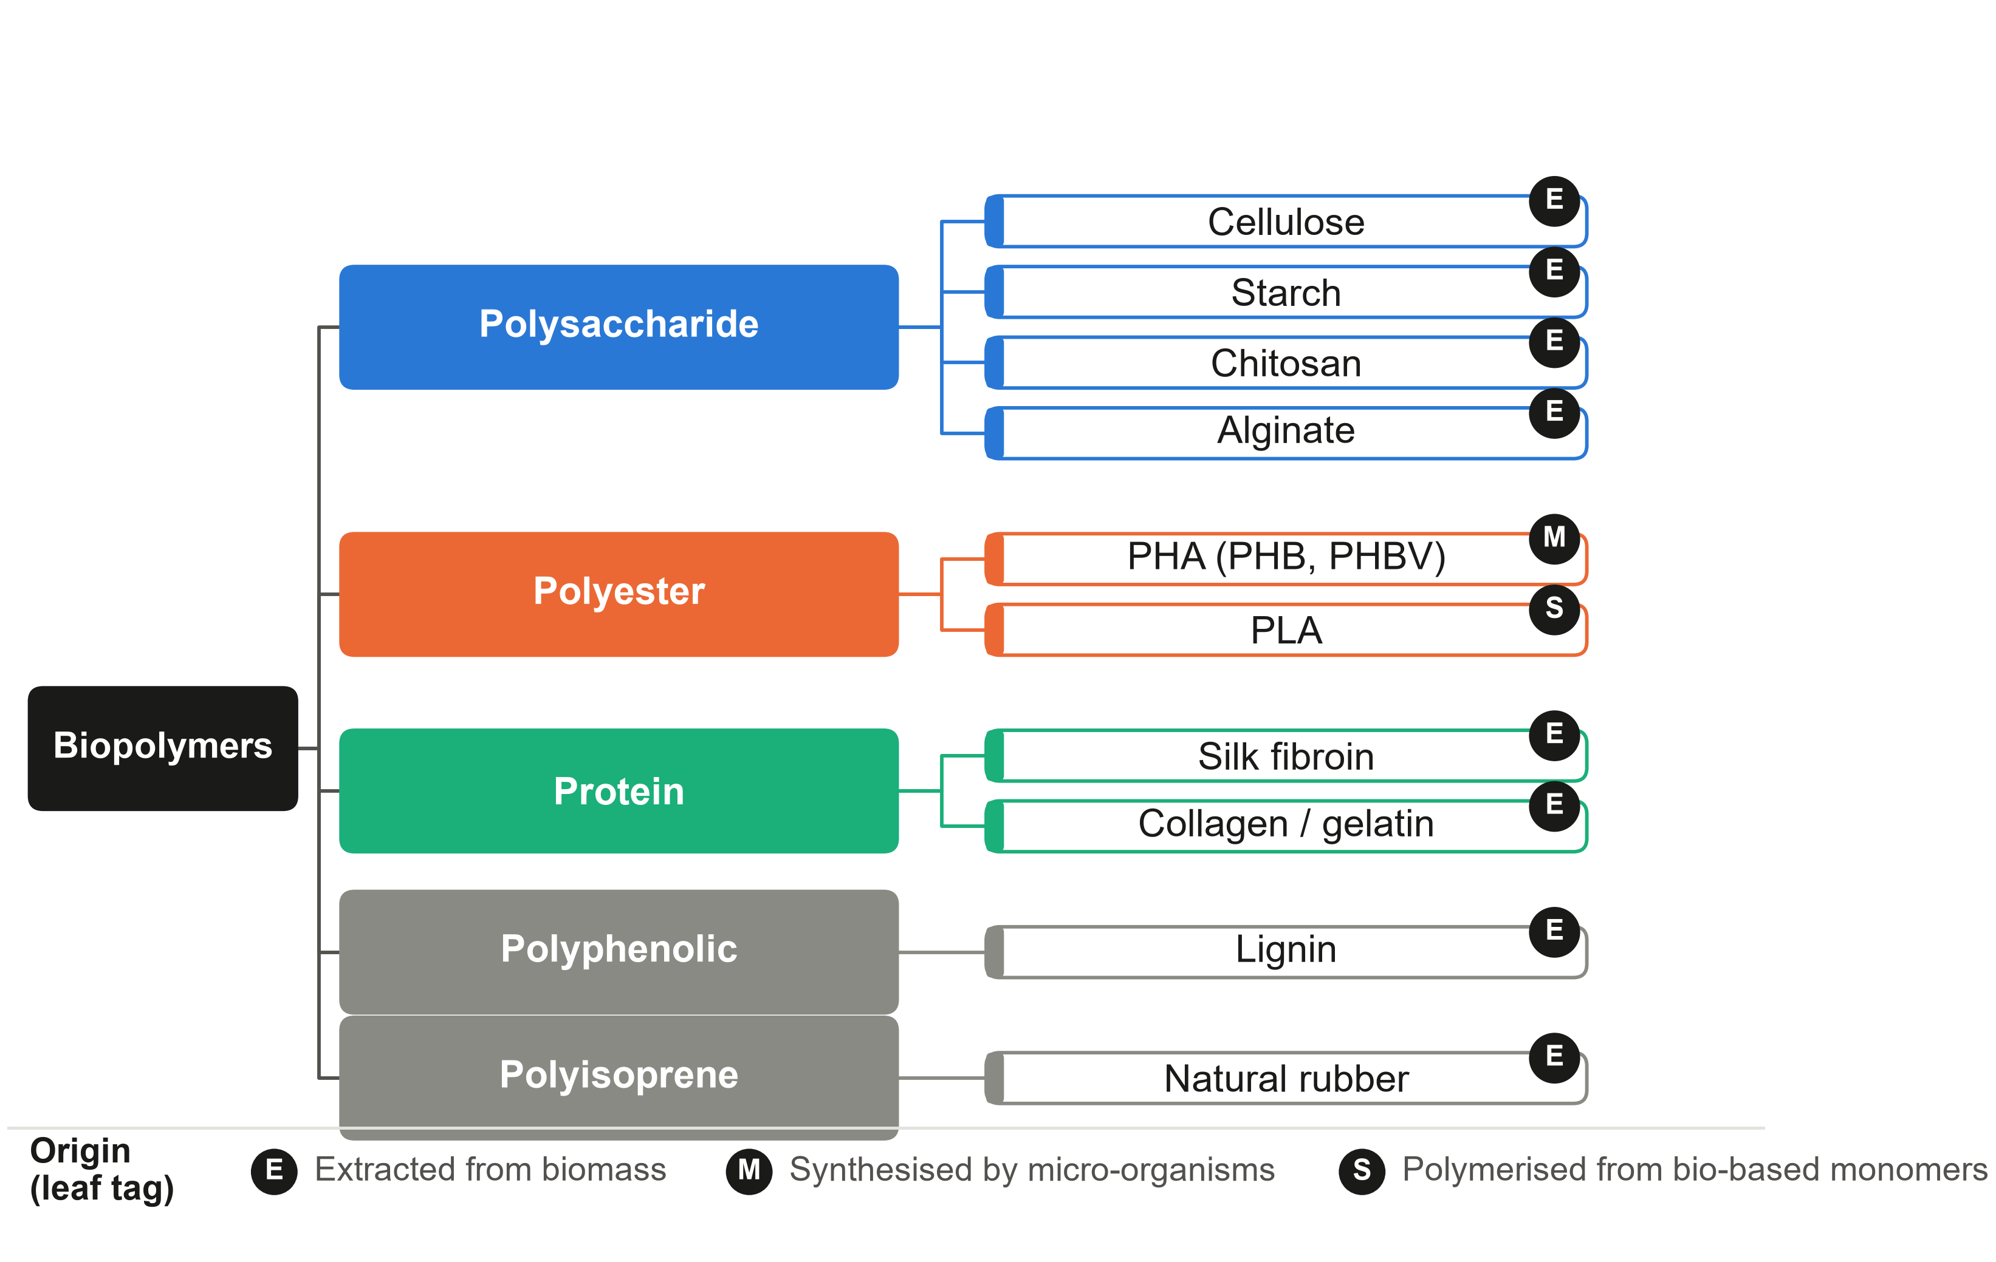
Figure 1. Classification by backbone chemistry (primary branches, coloured, matching Table 1 and Fig. 7), with each material's origin shown as a small E/M/S tag: extracted from biomass, synthesised by micro-organisms, or polymerised from bio-based monomers

3. Structure–Property Relationships of the Major Biopolymer Families
This section examines five biopolymer families along one organising axis: backbone flexibility and the intermolecular forces it permits. Cellulose sits at one extreme — an extended, hydrogen-bonded backbone locked into a crystalline solid that never melts; natural rubber sits at the other — a freely rotating backbone that crystallises only under strain. Between them lie polysaccharides with weaker or ionically tunable interchain forces (starch, chitin/chitosan, alginate), semicrystalline polyesters whose flexibility permits melt processing but only within narrow thermal windows (PHA, PLA), and template-folded proteins whose properties arise from defined secondary/tertiary structure rather than simple chain packing. Lignin — an irregularly cross-linked network with no periodic chain — closes the section as the structural counterpoint to everything else. The claim tested throughout is that backbone chemistry, not biological origin, predicts melting behaviour, hydrolytic/enzymatic susceptibility, and mechanical performance (Table 2). Fig. 7 summarises the force → consequence → limitation causal chain for every family at a glance; the text below adds only mechanism and citations.
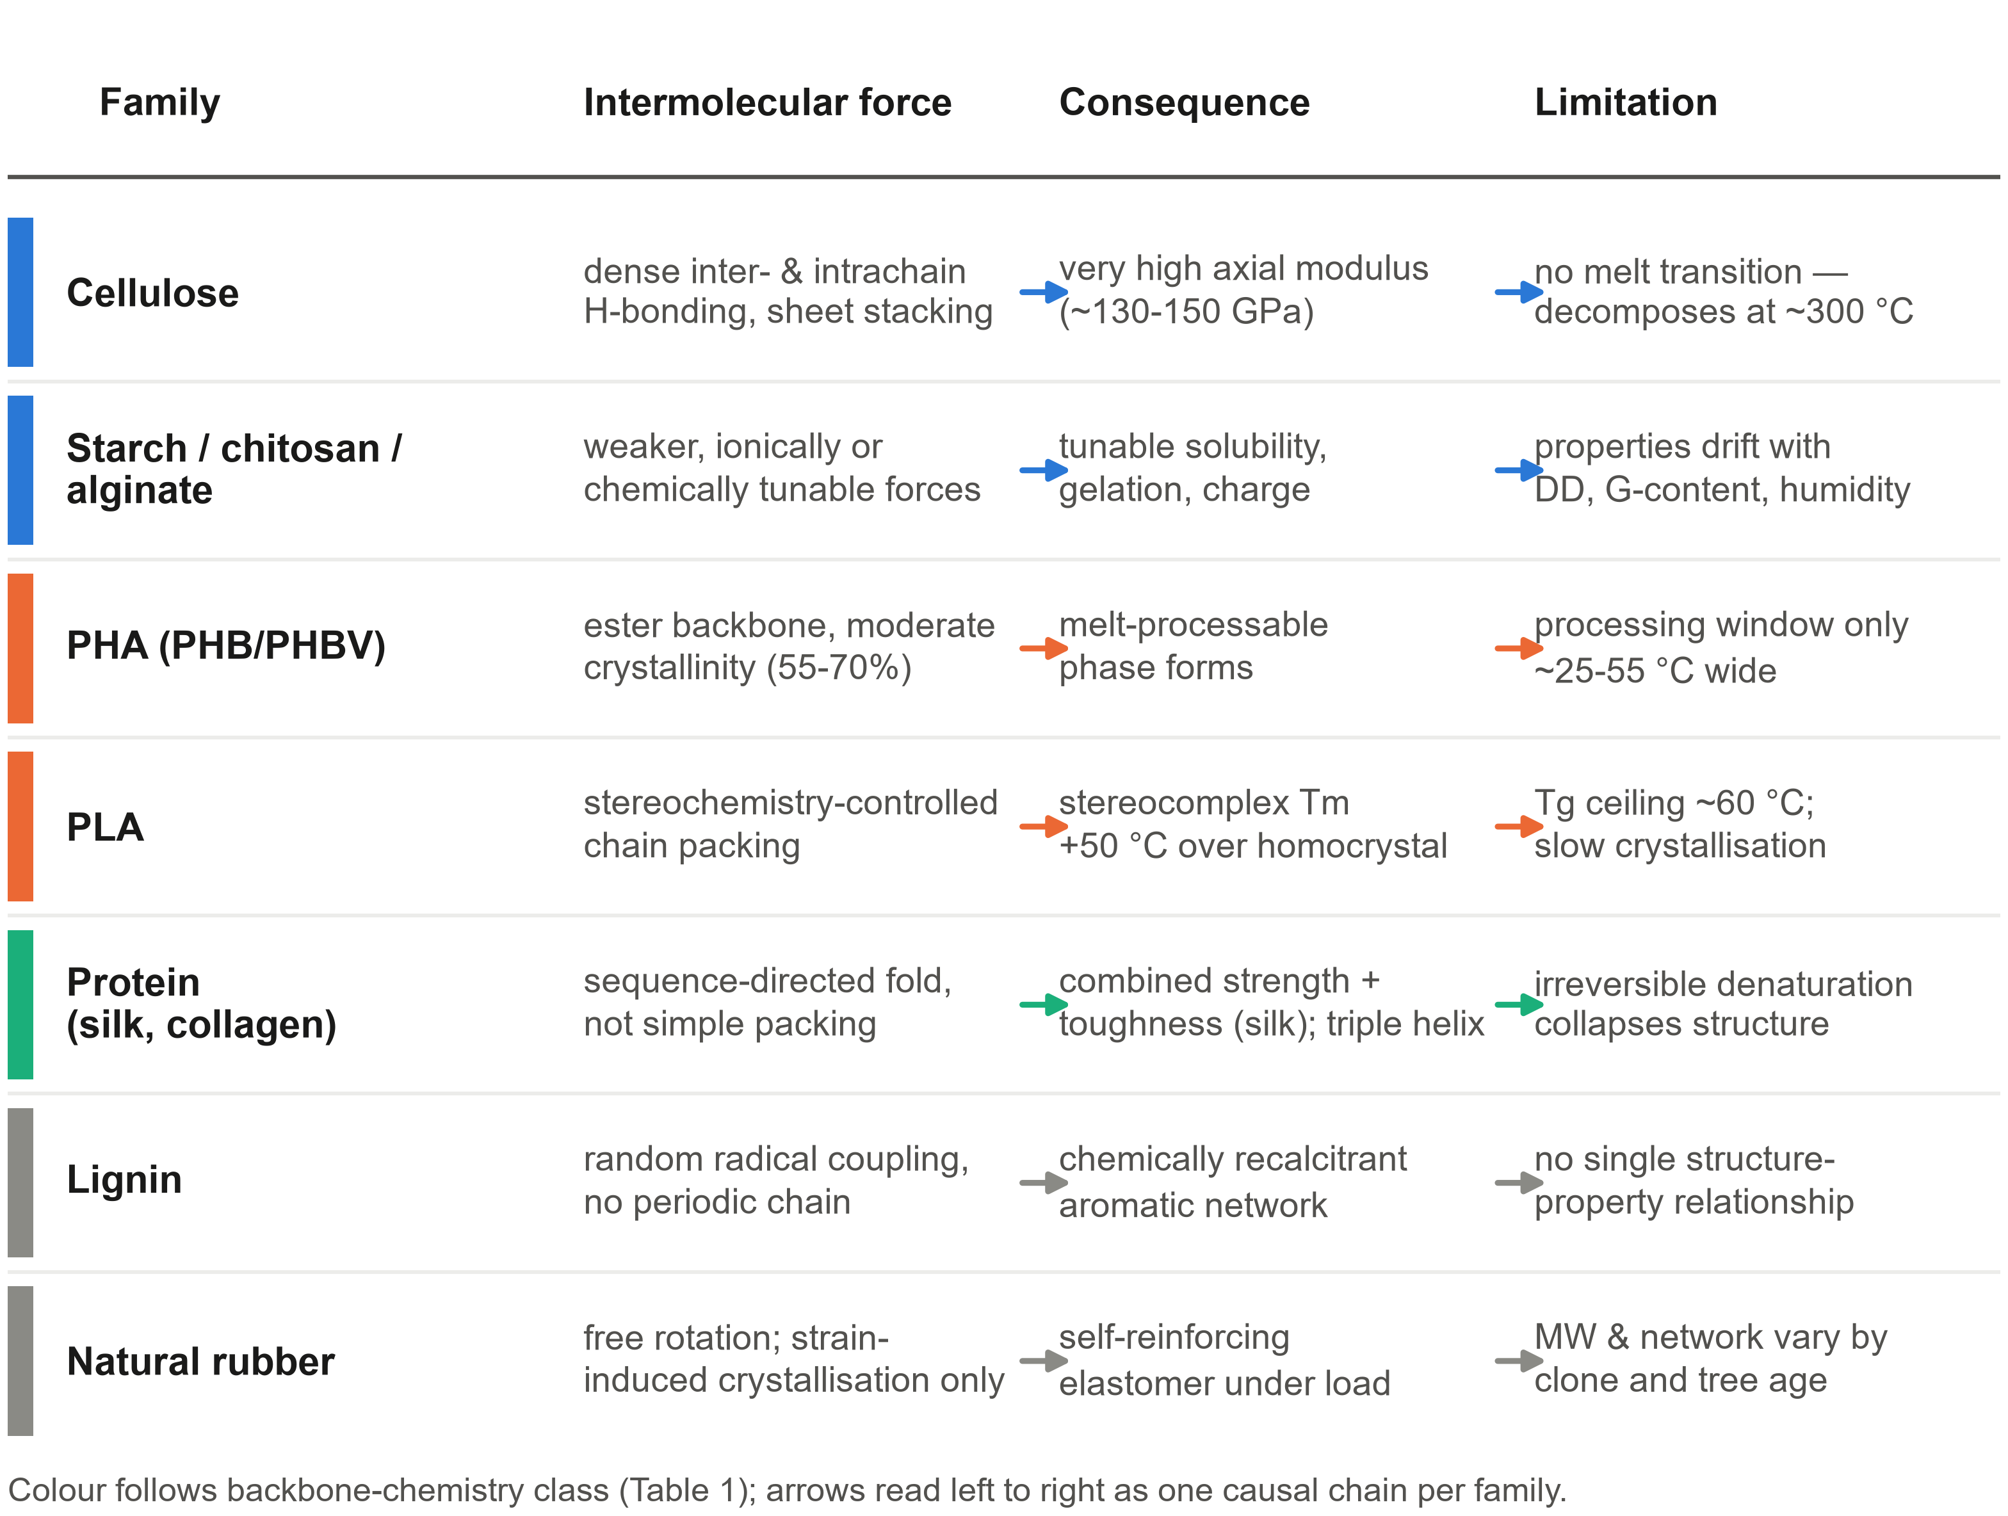
Figure 7. Structure-property causal chain for all seven families: dominant intermolecular force → key consequence → key limitation, colour-coded by backbone class
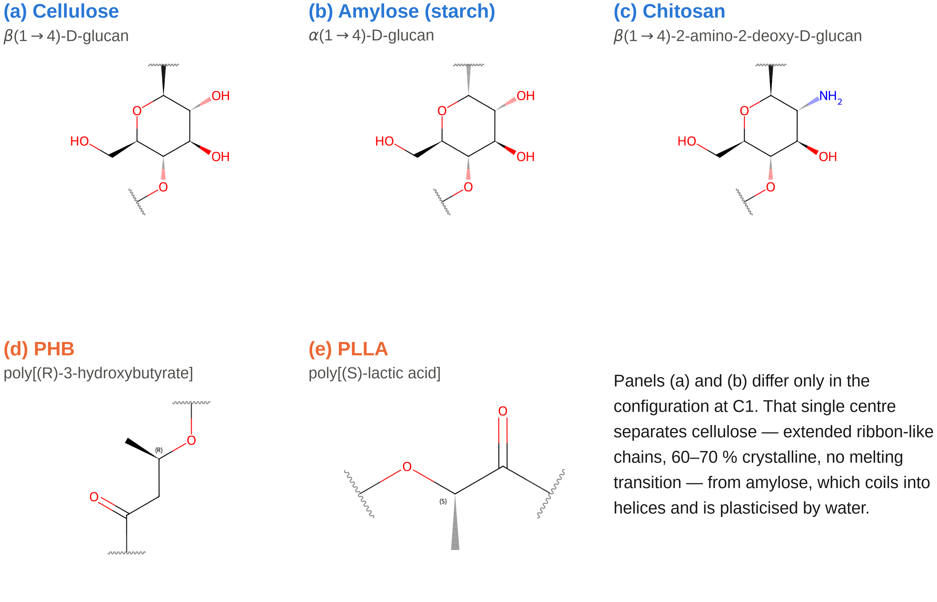
Figure 2. Five representative repeat units (cellulose, amylose, chitosan, PHB, PLLA) drawn from verified SMILES, wedge bonds showing stereochemistry

3.1 Polysaccharides
Polysaccharides span the rigid end of the spectrum. Cellulose — linear β-(1→4)-D-glucopyranose — forms an extended ribbon locked by hydrogen bonding into sheets (Iα, Iβ); processing is restricted to solution routes (NMMO/Lyocell, LiCl/DMAc), and nanocrystals/nanofibrils exploit its crystal modulus as fillers [2].
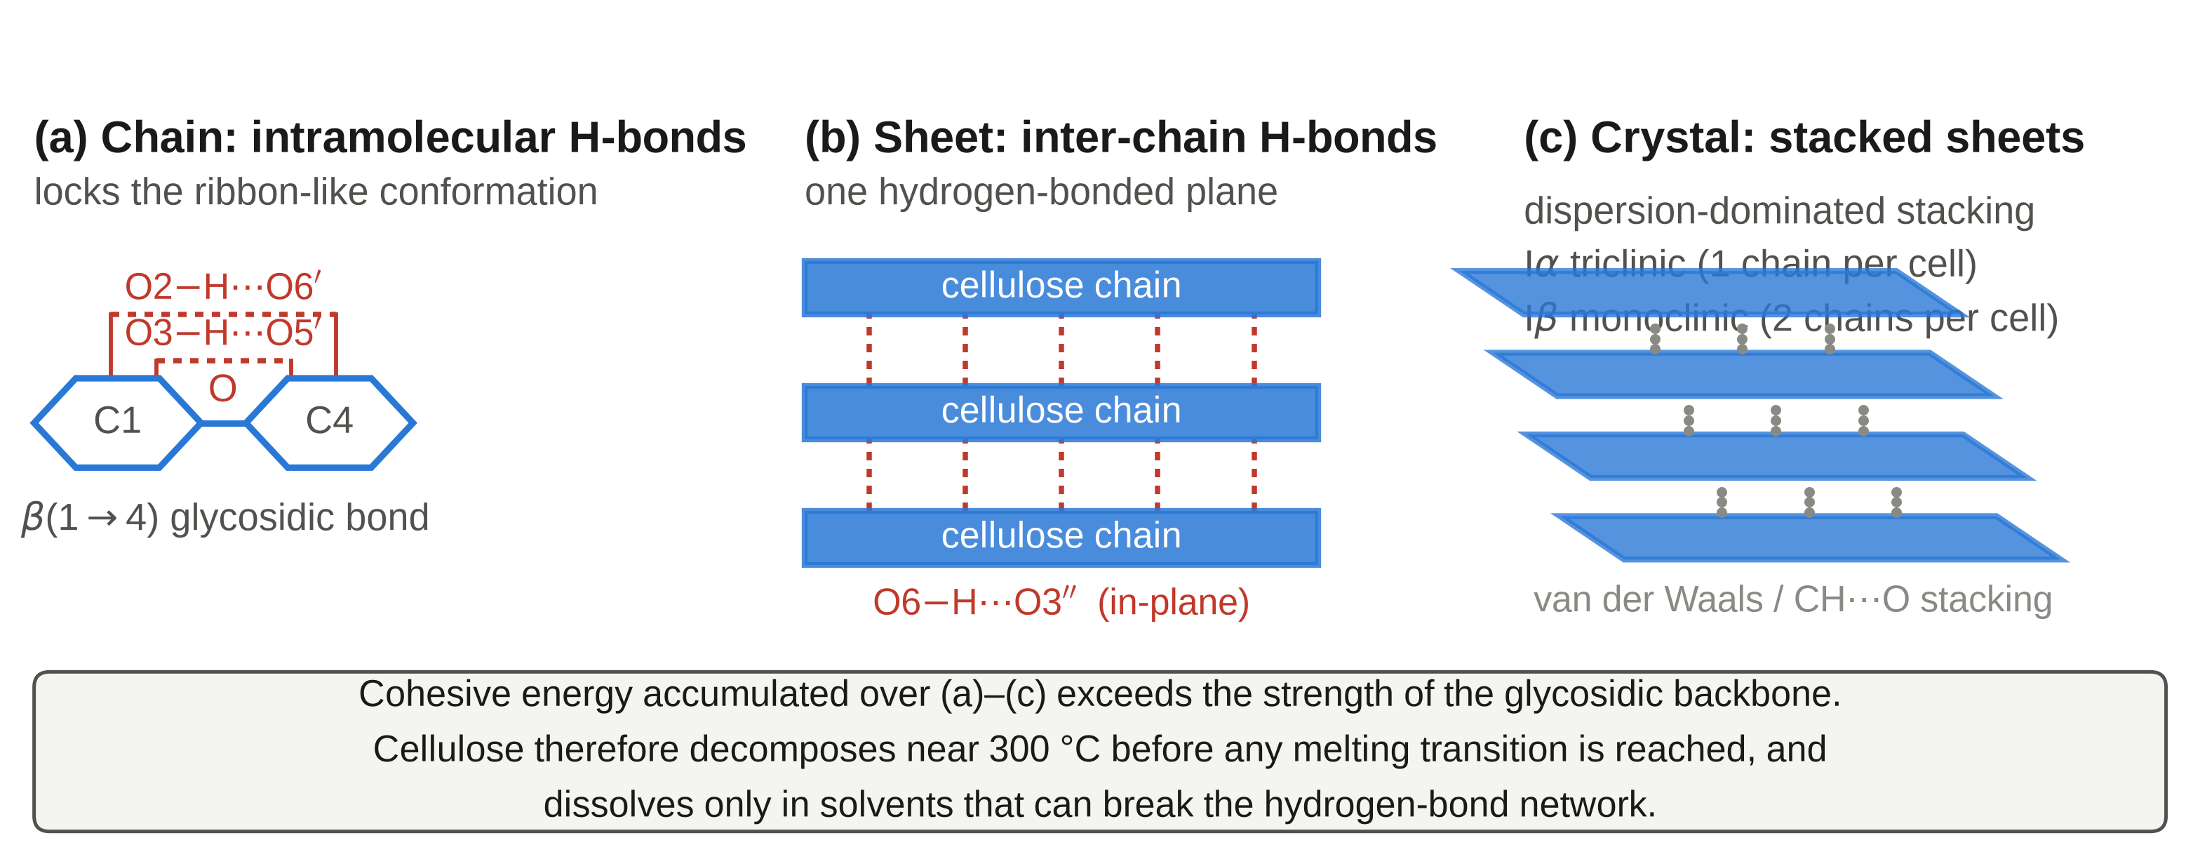
Figure 3. Cellulose's three-tier structure: intrachain H-bond → interchain sheet → interlayer stacking, with a closing line connecting this hierarchy to the 300 °C decomposition-before-melting result
Starch's amylose/amylopectin topology (not chemistry) explains its weaker, humidity-reversible crystallinity (TPS blends with PLA/PBAT). Chitosan's degree of deacetylation (DD) sets solubility and antimicrobial activity, but higher-DD chitosan is typically lower-MW since the same alkaline step that raises DD cleaves the backbone [3]. Alginate gels via Ca²⁺-coordinated "egg-box" GG-blocks [4], G-content setting the stiffness–brittleness trade-off (§8). Others — hyaluronic acid, carrageenan, xanthan, pectin — follow the same linkage-chemistry logic (§8).

3.2 Polyesters: PHA and PLA
PHA (bacterial storage granules; PHB the archetype) is highly crystalline (55–70%) but decomposes via six-membered-ring cis-elimination only tens of degrees above Tm [5] — the narrowest processing window in this report; PHBV/PHBHHx copolymers widen it at the cost of stiffness. PLA: ring-opening polymerisation of lactide (Sn(Oct)₂) reaches useful MW where direct polycondensation cannot; PLLA crystallises slowly, but the PLLA/PDLA stereocomplex co-crystallises with Tm ~50 °C above either homocrystal via tighter enantiomeric packing [6,7]. PBS/PEF follow the same ester logic; PEF is a bio-based PET analogue with superior barrier (§8).

3.3 Protein-based Polymers
Protein properties come from sequence-directed fold, not chain packing. Silk fibroin's β-sheet nanocrystallites (2–4 nm, required for its combined strength and toughness [8]) sit in a compliant amorphous matrix. Collagen's Gly-X-Y triple helix, stabilised by hydroxyproline, denatures irreversibly into gelatin. Zein/casein/soy are film-forming, not structural (§8). Ribosomal synthesis fixes every protein molecule's length and sequence exactly (Đ = 1.0) — unmatched by any non-templated biopolymer (§4).

3.4 Lignin and Other Aromatics
Lignin is cellulose's counterpoint: rigid because regular vs. amorphous because irregular. Radical-coupled monolignols give a randomly cross-linked network (β-O-4 ether ~45–60% of linkages [9]) whose composition varies by species and — for industrial use — extraction method (kraft, organosolv, lignosulfonate), which is why no single "lignin" has one structure–property relationship.

3.5 Natural Rubber
Natural rubber is the flexible extreme and this section's one exception to "crystallinity governs performance": cis-1,4-polyisoprene is amorphous at rest, but strain-induced crystallisation (SIC) self-reinforces the network under load — well documented by X-ray diffraction, largely absent in synthetic cis-polyisoprene [10]. This is not fixed: NR's molecular weight and distribution vary measurably between Hevea clones and with tree age [19], and non-rubber protein/gel content is an active, clone-dependent contributor to network structure — not an incidental impurity [18]. The organising variable here is therefore not "crystallinity" per se but intermolecular architecture under the conditions of use — tested directly against a synthetic analogue in §7.3.
Table 2. Provisional summary of thermal, mechanical and structural properties of the representative biopolymers discussed in §3 (order-of-magnitude ranges, cross-checked against the comparative review of biobased thermoplastics by de Beukelaer et al. [11] and, for PBS specifically, Aliotta et al. [12]; source data in figures/data/*.csv; several individual ref entries still need a material-specific citation before submission — see Fig. 4–5).
Material | Tg/Tm/Td (°C) | Modulus (GPa) | Elongation (%) | Crystallinity / processing
Cellulose | n/o / no melt / ~300 | 10–30 | 8–15 | 60–70%; NMMO/Lyocell, LiCl/DMAc
Starch (TPS) | ~−20 / no melt / ~300 | 0.02–1.0 | 20–100 | semicryst., humidity-dep.; TPS blend
Chitosan | n/o / no melt / ~280 | 1.0–4.0 | 3–30 | low–moderate; dilute-acid solution
Silk fibroin | ~175 / no melt / ~300 | 5–17 | 15–30 | β-sheet nanocrystalline; solution-spun
PHB | 4 / 175 / ~200 | 1.5–4.0 | 2–8 | 55–70%; melt, narrow window
PHBV (20% HV) | 0 / 145 / ~200 | 0.8–2.5 | 5–25 | < PHB; melt, wider window
PLLA | 60 / 175 / ~300 | 2.5–4.0 | 3–10 | slow-crystallising; melt, needs drying
PBS | −32 / 114 / ~350 | 0.3–0.7 | 200–500 | moderate; melt, wide window
Natural rubber | low / SIC only / n/a | 0.001–0.005 | 500–800 | strain-induced [19]; latex coag./vulc.
LDPE (ref.) | −120 / 110 / ~400 | 0.15–0.35 | 200–600 | moderate; melt, very wide window
PET (ref.) | 78 / 255 / ~400 | 2.0–4.0 | 50–300 | moderate; melt, wide window

All values PROVISIONAL — teaching-level ranges used to make Fig. 4/5 and this table internally consistent; must be replaced with cited literature values before submission.
Fig. 11 combines the four property figures scattered across §5.1/5.2/5.4/7.3 into one cross-section overview strip: (a) thermal processing windows (detail in §5.1, Fig. 4), (b) mechanical Ashby map (§5.2, Fig. 5), (c) degradation mechanisms (§5.4, Fig. 6), (d) NR/SBR elasticity scorecard (§7.3, Fig. 8). The full discussion for each panel remains in its own section; this is a navigation aid only.
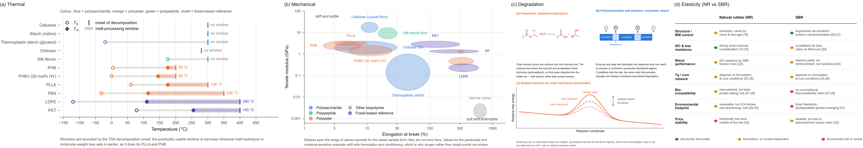
Figure 11. Property overview: (a) thermal windows (b) mechanical Ashby map (c) degradation mechanisms (d) NR/SBR elasticity comparison, four panels stitched horizontally; see the corresponding Fig. 4/5/6/8 sections for detail

4. Molecular Weight and Its Measurement
Molecular weight is reported casually in most surveys — "high molecular weight" — but the distribution, not just the average, is where the biology shows through. Mn, Mw, dispersity Đ = Mw/Mn, and degree of polymerisation (DP) are standard descriptors; Đ matters because it, not Mn alone, determines processing behaviour and the breadth of mechanical property distribution within a batch. Dispersity is a readout of synthesis mechanism, not noise (Fig. 9): template-controlled biosynthesis gives proteins and nucleic acids Đ = 1.0 exactly, while every non-templated route — extraction (cellulose, chitosan, natural rubber) or catalysed polymerisation (PHA, PLA) — broadens the distribution to a degree set by how tightly that route is controlled. Natural rubber is the extreme case: because it is extracted rather than chain-grown, Mw and MWD vary between Hevea clones and with tree age [19] — an agricultural variability with no synthetic-polymer analogue.
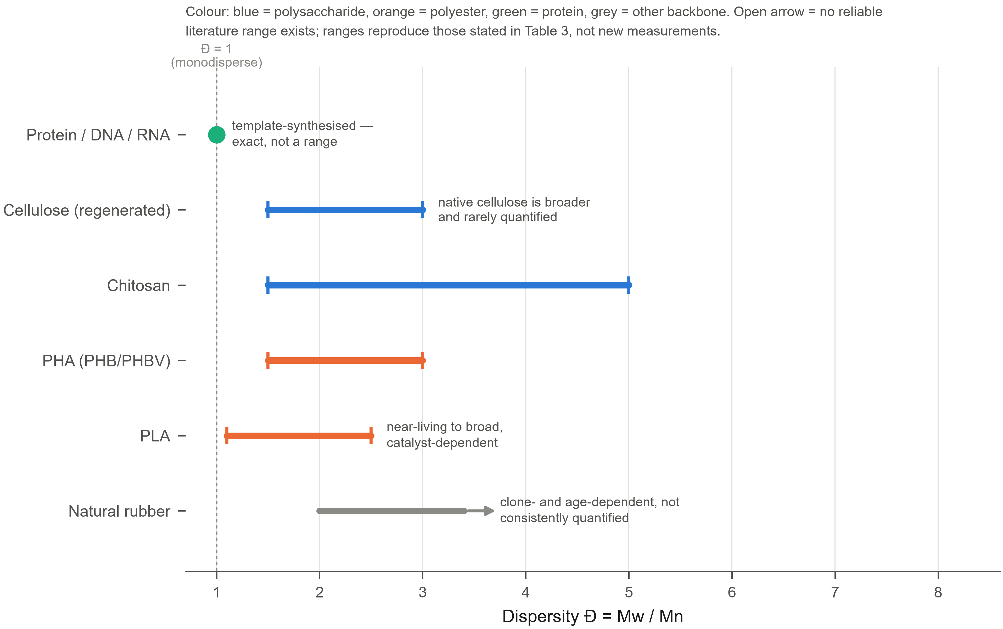
Figure 9. Dispersity Đ across families on a common axis: a point at Đ=1 for templated biosynthesis, ranges for PLA/PHA/chitosan/cellulose, an open-ended arrow for natural rubber's unquantified variability
Why molecular weight controls performance. Mechanical integrity depends on chain entanglement above a characteristic Mc; below it, strength and toughness collapse. Above Mc, tensile strength rises with Mn then saturates (Flory-type, σ ≈ σ∞ − K/Mn), so degradation — first visible as falling MW — can proceed with only modest property loss until crossing back below Mc, where performance collapses abruptly, a failure mode relevant to §7–§8. Measuring biopolymer MW is harder than for synthetic polymers: cellulose dissolves in no standard SEC eluent, requiring derivatisation or specialised solvents that can themselves degrade or aggregate the sample, while aggregation and branching distort SEC calibrated against linear standards. SEC-MALS or Mark–Houwink viscometry are more defensible, but Mark–Houwink parameters are missing for many biopolymer/solvent pairs. The result: reported MW for the same material commonly differs by an order of magnitude across the literature — an artefact of method more than genuine variation, so meaningful comparison requires the method too.
Table 3. Typical number-average molecular weight for representative biopolymers, with the standard method by which each is measured (dispersity Đ is plotted in Fig. 9 instead of repeated here).
Material | Typical Mn | Standard method (key limitation)
Proteins / DNA / RNA | sequence-specific | mass spectrometry (none — templated)
Cellulose (native/Lyocell) | 10⁴–10⁶ g mol⁻¹ | viscometry/SEC-MALS after derivatisation (insoluble in std. eluents)
Chitosan | 10⁴–10⁶ g mol⁻¹ | intrinsic viscosity (DD/MW trade-off, §3.1)
PHA (PHB/PHBV) | 10⁵–10⁶ g mol⁻¹ | GPC/SEC vs polystyrene (calibration mismatch)
PLA | 10⁴–10⁵ g mol⁻¹ | GPC/SEC (moisture-driven hydrolysis in process)
Natural rubber | often >10⁶ g mol⁻¹ | intrinsic viscosity (no synthetic analogue)

Ranges are teaching-level approximations; VERIFY each row against a primary source and replace with cited values before submission.

5. General Property Patterns
Section 3 examined each family in turn; this section turns the same evidence sideways, asking what pattern holds across all of them.

5.1 Thermal Behaviour
A decomposition temperature at or below the melting point is close to the rule here (Fig. 4): the same network that gives stiffness also raises the melting energy toward the bond-breaking energy, crowding the two transitions together — cellulose, chitosan and silk fibroin never melt at all. Among the polyesters this crowding is quantitative: PHB's window spans only ~25 °C, PHBV widens it to ~55 °C, and PLLA's is wider still (§3.2). Fig. 4 plots the TGA onset conservatively — for PLLA and PHB the usable window is narrower still, since melt hydrolysis (§4) begins earlier.
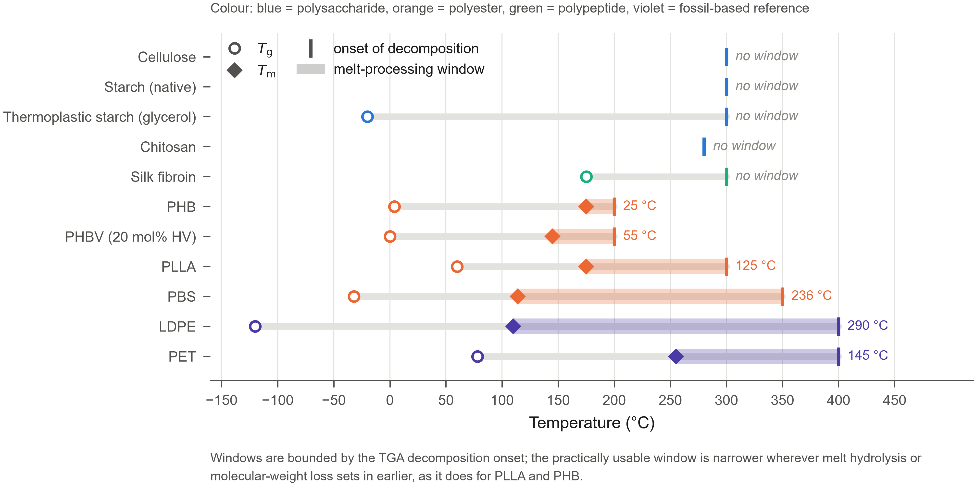
Figure 4. Thermal properties and processing windows: Tg/Tm/Td for each material on a common temperature axis, window width labelled directly

5.2 Mechanical Behaviour
The same logic sets the mechanical envelope (Fig. 5): high crystallinity and dense hydrogen bonding raise modulus but remove the flexible segments that let polyolefins draw before breaking, so biopolymers cluster toward high modulus, low elongation relative to PE/PP/PET. Natural rubber is the exception — no modulus at rest, performance generated on demand by SIC (§3.5, §7.3). Fig. 5's windows are regions, not points: sample form, moisture, crystallinity and thermal history each shift a material's data by an order of magnitude, recurring as "batch variability" in §7.2.
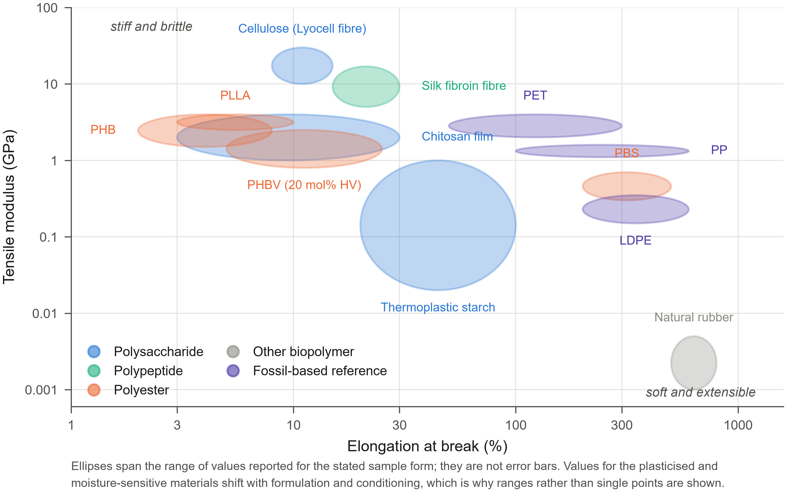
Figure 5. Ashby-style modulus vs. elongation-at-break map, region ellipses in log–log space, PE/PP/PET plotted for reference

5.3 Hydrophilicity and Barrier Properties
The polar groups behind §5.1–5.2's strength have a third consequence: strong hygroscopicity. Absorbed water plasticises the amorphous fraction and swells free volume, so barrier performance falls as humidity rises. ⚙️ Atomistic free-volume/diffusion estimates offer a route to predicting this computationally, ahead of a packaging trial — which is why PLA and starch films must be specified with a storage-humidity condition, not a fixed barrier rating.

5.4 Degradation as a Material Property
Degradation is a rate process governed by structure (Fig. 6). Polyesters degrade by autocatalytic ester hydrolysis (each scission's acid end catalyses further hydrolysis, so interiors degrade faster than surfaces); polysaccharides and proteins instead degrade by enzymatic attack, which can only reach amorphous segments, so rate is set by accessible surface area, not bulk chemistry. Crystallinity therefore recurs as this report's central trade-off — the same feature that sets modulus (§5.2) and blocks water uptake (§5.3) also blocks the attack that would degrade the material. ⚙️ Computed barrier heights for neutral/acid/base-catalysed hydrolysis reproduce the qualitative rate ordering in Fig. 6(c), which is illustrative only.
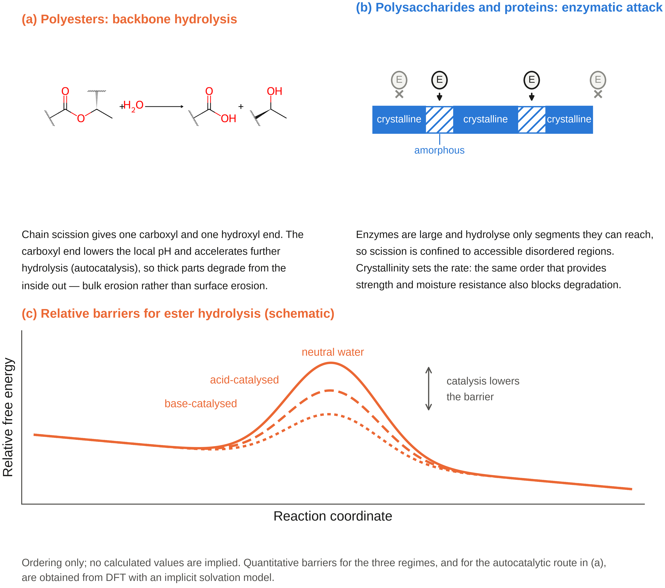
Figure 6. (a) polyester hydrolysis mechanism, autocatalytic bulk erosion; (b) polysaccharide/ protein enzymatic degradation limited to amorphous regions; (c) qualitative energy-barrier ordering for neutral/acid/base-catalysed ester hydrolysis, no values implied

6. Processing
Fig. 10 turns §5.1's windows into a processing decision: whether a stable melt window exists at all sets melt vs. solution processing, and each material's window width then sets how tightly that process must be controlled. The recurring judgement this yields: most reported "performance shortfalls" are processing-window shortfalls, not material-property shortfalls (§5.1–5.2).
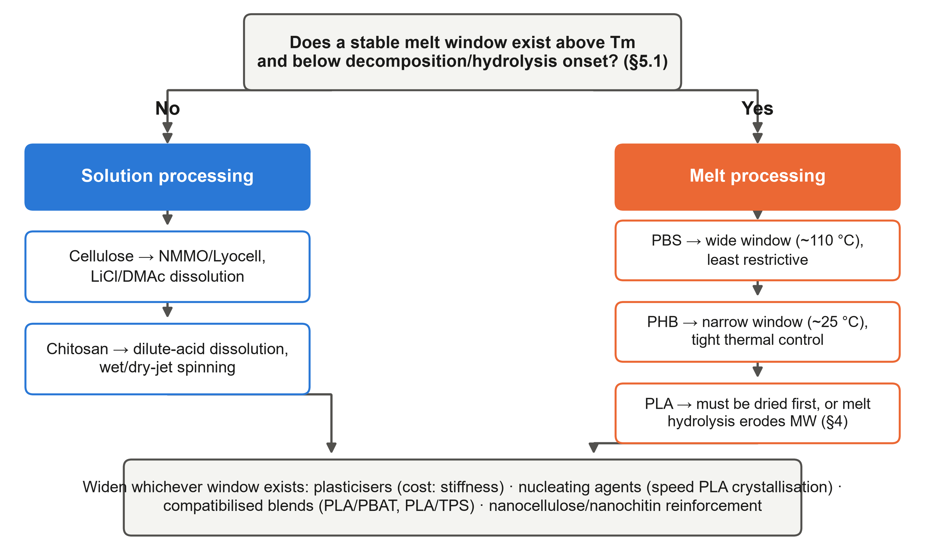
Figure 10. Processing decision flowchart: stable melt window? → melt processing (PBS/PHB/PLA, window width sets control tightness) or solution processing (cellulose/chitosan dissolution routes) → shared countermeasures that widen whichever window exists

7. Advantages and Disadvantages Compared with Synthetic Polymers

7.1 Where Biopolymers Genuinely Win
Four advantages are structural, each tracing back to §3: renewable, non-fossil feedstock — the only one applying uniformly across all families; biodegradability in leakage-prone contexts (mulch film, fishing gear, disposable foodware), where hydrolytic/enzymatic susceptibility becomes desired if the environment matches the material (§5.4); biocompatibility/bioresorbability — PLA/PGA sutures, collagen/alginate hydrogels, chitosan dressings do what commodity synthetics cannot without costly modification, the one space (§8) where biopolymers are the only viable class, though not unconditionally (§7.3); and intrinsic functionality beyond mechanics — chirality (PLA stereocomplexation), pH-responsive charge (chitosan), sequence-encoded bioactivity (silk, collagen), all free from biology.

7.2 Where They Lose — Stated with Numbers, Not Adjectives
(Order-of-magnitude ranges consistent with cited values; each still needs a tighter primary citation before submission.)
- Price. PE/PP ~$1–1.5/kg; PLA several times higher; PHA typically priciest. [cite market report] Not fixed, though — §7.3 shows NR pricing can be more volatile than SBR's for reasons unrelated to polymer chemistry.
- Heat/barrier. PLA's HDT (~55–65 °C) sits well below PP's ~100 °C+ without stereocomplexation (§3.2) [13]; its O₂/CO₂ transmission is comparable to PET's, but water-vapour barrier is worse, and starch films worse again [14] — the correct critique is moisture sensitivity (§5.3), not a blanket oxygen deficit.
- Brittleness/hygroscopicity. PHB's secondary crystallisation and PLA's sub-Tg ageing embrittle over storage; starch drifts with humidity (§3.1, §5.3) and PLA must be dried before melt processing to avoid uncontrolled MW loss (§4).
- Batch variability. Agricultural sourcing (alginate M/G, chitosan DD, starch amylose, NR clone/age [19]) varies in ways petrochemical monomers do not.
- Recycling compatibility. A 2022 study found in-stream PLA at only 0–0.019% of PET recycling streams, with NIR sorting keeping it below the ~1% threshold that measurably affects rPET [15] — a sorting-infrastructure dependency, not an inherent incompatibility.

7.3 Case Study: Natural Rubber vs. a Synthetic Analogue (SBR)
NR and styrene–butadiene rubber (SBR) are compounded, filled and vulcanised the same way and compete directly in the same applications (tyre tread, damping, conveyor belting) — the cleanest same-application comparison here, since differences trace to backbone chemistry, not processing. Fig. 8 scores both across seven dimensions against a literature set compiled for this comparison; citation numbers for every cell are printed on the figure and expand in the References [10,18–32].
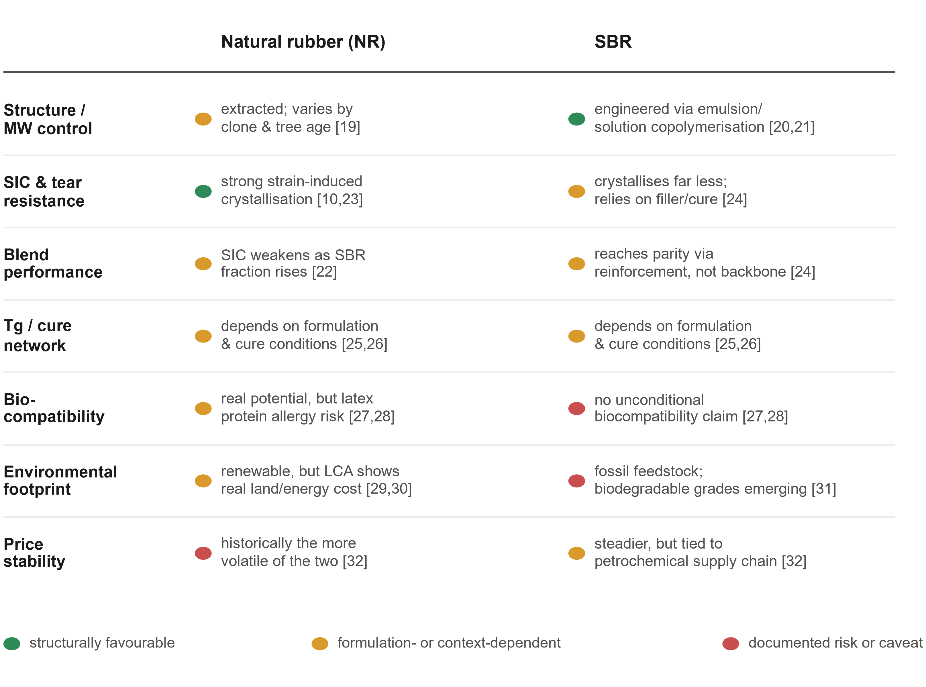
Figure 8. NR vs. SBR scorecard across structure/MW, SIC and tear resistance, blend performance, Tg/cure network, biocompatibility, environmental footprint and price stability; colour marks each cell as structurally favourable, formulation-dependent, or a documented risk
NR is extracted, so its structure and SIC contribution are agricultural variables (clone, tree age); SBR's composition is instead engineered by emulsion/solution copolymerisation in a continuous industrial process [20,21]. Under matched compounding, NR's SIC gives superior tear and crack-growth resistance to start with [10,23], but SBR reaches comparable wear resistance through reinforcement and cure design rather than backbone crystallisation [24] — the clearest single illustration here of backbone chemistry trading off against formulation (§6). The "natural is better" story does not survive contact with the literature, though: NR latex carries a real, SBR-absent allergy risk [27,28], its renewability does not translate into a lower LCA footprint automatically [29,30], and NR pricing has historically been the more volatile of the two for climate/disease reasons unrelated to polymer chemistry [32].

8. Applications
Each application states the property requirement first, then names the material that satisfies it (Table 4). Packaging needs O₂/H₂O barrier, toughness, and heat resistance exceeding PLA's HDT (§7.2); no single biopolymer satisfies all three (§5.3), so packaging is almost always multilayer or blended. Compostable foodware and mulch film are where §7.1's biodegradability, not barrier, drives the design, needing a rate matched to use timescale (§5.4). Biomedical applications need biocompatibility plus a tunable degradation rate (§5.4) — essentially unique here (§7.1, with the NR-latex caveat in §7.3): PGA/PLGA are established suture materials whose main failure mode is local pH drop from hydrolysis products; collagen/alginate/chitosan extend the logic to scaffolds and bioprinting. Textiles/other: Lyocell and PLA fibre exploit cellulose's solution-processed stiffness (§3.1, §6) and PLA's melt-spinnability (§3.2); NR adhesives and PHA/PLA electronics substrates trade predictability for intrinsic adhesion, biodegradability, or biocompatibility.
Table 4. Applications, required property, and material.
Application | Key property required | Representative material(s)
Food packaging | O₂/H₂O barrier + toughness + moderate heat resistance | PLA/PBAT blends; PHA/PLA coatings
Compostable foodware / mulch film | Biodegradability matched to use timescale, not barrier | PLA, starch blends, PBAT/PLA
Sutures / drug release / scaffolds | Biocompatibility + tunable degradation rate | PGA, PLGA, collagen, alginate, chitosan
Textile fibre / electronics substrate | High stiffness/spinnability or film formability | Lyocell, PLA fibre, PHA
Tyre tread / damping / conveyor belting | High tensile/tear strength via SIC, or engineered wear | Natural rubber, NR/SBR blends (§7.3)

9. Current Status, Challenges and Outlook
Global bio-based plastics capacity was ~2.31 million tonnes in 2025 — under 1% of global plastics — projected to double by 2030 [16]. Growth concentrates in bio-based PE/PP (drop-in substitutes, none of this report's structural limitations) and PHA, expanding fastest despite remaining priciest (§7.2) [16]. The bottlenecks are the same three properties organising §5 — processing windows, humidity-dependent performance, batch variability — none solved by scale alone. Two directions look most promising: enzymatic depolymerisation back to monomer (recent hydrolase/oxidase cocktails reached ~60% lactic-acid recovery from post-consumer PLA within 72 hours [17]); and ⚙️ data-driven property prediction (QSPR/ML models) to shorten the trial-and-error cycle of matching backbone chemistry to a processing window.

10. Conclusions
Three judgements follow. First, the performance ceiling here is set by thermal and hygroscopic behaviour (§5.1, §5.3), not mechanical strength (§5.2) — most families meet or exceed synthetic-polymer stiffness and fail instead on processing window and moisture sensitivity. Second, crystallinity governs the entire trade-off (§5.4): the same feature that supplies stiffness, blocks water uptake, and blocks the attack that would degrade the material means raising one predictably lowers the other two — the NR/SBR case study (§7.3) shows the same trade-off through formulation, not backbone chemistry alone. Third, molecular weight data are only comparable alongside their measurement method (§4): the features that make it hard to measure — hydrogen bonding, branching, sequence specificity, agricultural sourcing — are the same features used throughout to explain performance.

References *(32 verified; assignment requires 50–60 — see REFERENCES-TODO below)*
1. Vert, M.; Doi, Y.; Hellwich, K.-H.; Hess, M.; Hodge, P.; Kubisa, P.; Rinaudo, M.; Schué, F. Terminology for biorelated polymers and applications (IUPAC Recommendations 2012). Pure Appl. Chem. 2012, 84, 377–410. DOI: 10.1351/PAC-REC-10-12-04.
2. Rostamabadi, H.; Bist, Y.; Kumar, Y.; Yildirim-Yalcin, M.; Ceyhan, T.; Falsafi, S. R. Cellulose nanofibers, nanocrystals, and bacterial nanocellulose: Fabrication, characterization, and their most recent applications. Future Postharvest Food 2024, 1, 5–33. DOI: 10.1002/fpf2.12001.
3. Hwang, K. T.; Jung, S. T.; Lee, G. D.; Chinnan, M. S.; Park, Y. S.; Park, H. J. Controlling molecular weight and degree of deacetylation of chitosan by response surface methodology. J. Agric. Food Chem. 2002, 50, 1876–1882. DOI: 10.1021/jf011167u.
4. Cao, L.; Lu, W.; Mata, A.; Nishinari, K.; Fang, Y. Egg-box model-based gelation of alginate and pectin: A review. Carbohydr. Polym. 2020, 242, 116389. DOI: 10.1016/j.carbpol.2020.116389.
5. Ariffin, H.; Nishida, H.; Shirai, Y.; Hassan, M. A. Determination of multiple thermal degradation mechanisms of poly(3-hydroxybutyrate). Polym. Degrad. Stab. 2008, 93, 1433–1439. DOI: 10.1016/j.polymdegradstab.2008.05.020.
6. Tsuji, H. Poly(lactide) stereocomplexes: formation, structure, properties, degradation, and applications. Macromol. Biosci. 2005, 5, 569–597. DOI: 10.1002/mabi.200500062.
7. Luo, F.; Fortenberry, A.; Ren, J.; Qiang, Z. Recent progress in enhancing poly(lactic acid) stereocomplex formation for material property improvement. Front. Chem. 2020, 8, 688. DOI: 10.3389/fchem.2020.00688.
8. Keten, S.; Xu, Z.; Ihle, B.; Buehler, M. J. Nanoconfinement controls stiffness, strength and mechanical toughness of β-sheet crystals in silk. Nat. Mater. 2010, 9, 359–367. DOI: 10.1038/nmat2704.
9. Odili, C. C.; Ajibola, A. M.; Sojobi, J. W.; et al. Chemistry of lignin. In Lignin Renewable Materials — Chemistry, Trends, Technology and Application; Ngo, T.-D., Ahvazi, B., Eds.; IntechOpen, 2025. DOI: 10.5772/intechopen.1013010.
10. Huneau, B. Strain-induced crystallization of natural rubber: a review of X-ray diffraction investigations. Rubber Chem. Technol. 2011, 84, 425–452. DOI: 10.5254/1.3601131.
11. de Beukelaer, H.; Hilhorst, M.; Workala, Y.; Maaskant, E.; Post, W. Overview of the mechanical, thermal and barrier properties of biobased and/or biodegradable thermoplastic materials. Polym. Test. 2022, 116, 107803. DOI: 10.1016/j.polymertesting.2022.107803.
12. Aliotta, L.; Seggiani, M.; Lazzeri, A.; Gigante, V.; Cinelli, P. A brief review of poly(butylene succinate) (PBS) and its main copolymers: synthesis, blends, composites, biodegradability, and applications. Polymers 2022, 14, 844. DOI: 10.3390/polym14040844.
13. Zhao, X.; Liu, J.; Li, J.; Liang, X.; Zhou, W.; Peng, S. Strategies and techniques for improving heat resistance and mechanical performances of poly(lactic acid) (PLA) biodegradable materials. Int. J. Biol. Macromol. 2022, 218, 115–134. DOI: 10.1016/j.ijbiomac.2022.07.091.
14. McCurdy, C.; Dixion, D.; Archer, E.; Dooher, T.; Edwards, I. A comparison of the sealing, forming and moisture vapour transmission properties of polylactic acid (PLA), polyethene (PE) and polyethylene terephthalate (PET) coated boards for packaging applications. J. Packag. Technol. Res. 2022, 6, 91–100. DOI: 10.1007/s41783-022-00131-w.
15. Thoden van Velzen, E. U.; Chu, S.; Molenveld, K.; Jašo, V. Effect of poly lactic acid trays on the optical and thermal properties of recycled poly(ethylene terephthalate). Packag. Technol. Sci. 2022, 35, 351–360. DOI: 10.1002/pts.2633.
16. European Bioplastics; nova-Institute. Bioplastics Market Development Update 2025; European Bioplastics e.V.: Berlin, December 2025. Available at: docs.european-bioplastics.org/publications/market_data/2025/EUBP_Market_Data_Report_2025.pdf
17. Salini, A.; Gonnelli, P. M.; Padoan, C.; Helali, Y.; Waeytens, J.; Fusco, S.; Cannella, D. Repurposing commercial hydrolytic and oxidative enzymes toward synergistic PLA depolymerization. ACS Sustain. Chem. Eng. 2025, 13, 20705–20716. DOI: 10.1021/acssuschemeng.5c06901.
18. Huang, S.-Q.; et al. Revealing the structure-property difference of natural rubber prepared by different methods: protein and gel content are key factors. Chin. J. Polym. Sci. 2024, 42, 457–467. DOI: 10.1007/s10118-024-3071-2.
19. Xin, S.; et al. Comparative analysis of latex transcriptomes reveals the potential mechanisms underlying rubber molecular weight variations between Hevea brasiliensis clones RRIM600 and Reyan7-33-97. BMC Plant Biol. 2021, 21, 244. DOI: 10.1186/s12870-021-03022-5.
20. Dhanorkar, R. J.; et al. Synthesis of functionalized styrene butadiene rubber and its applications in S-SBR–silica composites for high-performance tire applications. Ind. Eng. Chem. Res. 2021, 60, 4517–4535. DOI: 10.1021/acs.iecr.0c06155.
21. Zubov, A.; Pokorny, J.; Kosek, J. Styrene–butadiene rubber (SBR) production by emulsion polymerization: dynamic modeling and intensification of the process. Chem. Eng. J. 2012, 207–208, 414–420. DOI: 10.1016/j.cej.2012.06.144.
22. Singer, R.; Ollick, A. M.; Elhadary, M.; El-Sherbiny, I. M.; Gomma, A. Comparative study of natural rubber and styrene-butadiene rubber blends reinforced with different carbon black grades for tire tread production. Sci. Rep. 2026, 16, 24902. DOI: 10.1038/s41598-026-65435-2.
23. Noguchi, F.; et al. Effect of strain-induced crystallization on the tear strength of natural rubber/styrene butadiene rubber blend. Adv. Polym. Technol. 2018, 37, 1850–1858. DOI: 10.1002/adv.21843.
24. Tangudom, P.; Thongsang, S.; Sombatsompop, N. Cure and mechanical properties and abrasive wear behavior of natural rubber, styrene-butadiene rubber and their blends reinforced with silica hybrid fillers. Mater. Des. 2014, 53, 856–864. DOI: 10.1016/j.matdes.2013.07.024.
25. Goyanes, S.; et al. Thermal properties in cured natural rubber/styrene butadiene rubber blends. Eur. Polym. J. 2008, 44, 1525–1534. DOI: 10.1016/j.eurpolymj.2008.02.016.
26. Tang, S.; Li, Z.; Sun, W.; Liu, Y.; Wang, J.; Wang, X.; Lin, J. Natural rubber/styrene–butadiene rubber blend composites potentially applied in damping bearings. Polymers 2024, 16, 1945. DOI: 10.3390/polym16131945.
27. Floriano, J. F.; et al. Biocompatibility studies of natural rubber latex from different tree clones and collection methods. J. Mater. Sci. Mater. Med. 2014, 25, 461–470. DOI: 10.1007/s10856-013-5089-9.
28. Nucera, E.; et al. Latex allergy: current status and future perspectives. J. Asthma Allergy 2020, 13, 385–398. DOI: 10.2147/JAA.S242058.
29. Cucci, G.; Valentini, F.; Dorigato, A. Cradle to gate life cycle assessment of tyre-grade natural rubber produced in Thailand. Sci. Total Environ. 2025, 987, 179653. DOI: 10.1016/j.scitotenv.2025.179653.
30. Dunuwila, P.; et al. Revealing the environmental footprint of crepe rubber production: a life cycle assessment. Sustainability 2025, 17, 1239. DOI: 10.3390/su17031239.
31. Boon, Z. H.; et al. Recent development of biodegradable synthetic rubbers and bio-based rubbers using sustainable materials from biological sources. RSC Adv. 2022, 12, 34028–34052. DOI: 10.1039/D2RA06602E.
32. U.S. Bureau of Labor Statistics. Why the Prices of Natural and Synthetic Rubber Do Not Always Bounce Together; Beyond the Numbers, Vol. 9; U.S. BLS: Washington, DC, 2020. Available at: bls.gov/opub/btn/volume-9/why-the-prices-of-natural-and-synthetic-rubber-do-not-always-bounce-together.htm

