A transportability-aware reliability envelope for project-specific differential-abundance analysis of multi-study rhizosphere 16S rRNA gene sequencing data
Ziwei Tao¹,∗, Jian Xie¹, Fan Yang²
¹ Guangxi University of Science and Technology, Guangxi Colleges and Universities Key Laboratory of Intelligent Computing and Distributed Information Processing, 545006, China
² Zhejiang University of Water Resources and Electric Power, 310018, China
∗ Correspondence: taozw@gxust.edu.cn

Abstract
Publicly available rhizosphere 16S rRNA gene sequencing datasets allow assessment of whether conclusions drawn from microbiome analyses generalize beyond individual studies, but reproducibility across random seeds, accuracy relative to simulator-defined ground truth and transportability to new projects are distinct properties. We integrated data from 45 maize, rice and wheat rhizosphere projects (1,219 samples; 2,025 features) within a unified preprocessing and simulation framework. Differential abundance, core-taxon identification, network inference and sequence classification revealed distinct conditions under which analytical performance deteriorated. Calibration to three disjoint project panels generally met prespecified tolerances for seven or all eight structural summary statistics, yet repeated project-panel prediction passed only 3.87/8 and 3.40/8 checks on average for the two generators. This gap motivated TARE-DA, a transportability-aware reliability envelope that predicts project-specific utility intervals for ALDEx2, ANCOM-BC2, LinDA and MaAsLin2 and assigns one of three evidence labels: ALLOW, CONDITIONAL or DENY. We evaluated 360 method outcomes from 90 project-specific known-effect datasets under ten repeated five-fold project holdouts. Relative to a development-only method-by-scenario prior, TARE-DA reduced utility mean absolute error from 0.0948 to 0.0790 (16.7%), achieved 95.4% conformal interval coverage and reached an AUROC of 0.883 for reliability in the strong-effect stratum. ALLOW precision was 0.983. In a real project-template example, methods produced disjoint candidate sets and TARE withheld approval. A frozen-model test on six previously unseen projects (two per crop, 426 samples and 48 predictions) retained the direction of improvement, with mean absolute error 0.1414 versus 0.1853 and interval coverage 0.854, but all external projects lay outside the 95% development support envelope. TARE-DA therefore improves conditional prediction and supports evidence-based abstention. It does not establish a universal method ranking or unrestricted cross-project generalization.
Keywords: rhizosphere microbiome, 16S rRNA gene sequencing, differential abundance, conformal prediction, transportability, reliability envelope, method benchmarking

Introduction
The growing availability of public rhizosphere 16S rRNA gene sequencing datasets has expanded the scope of microbiome research. Individual reanalyses can now combine hundreds of samples from maize, rice, wheat and other crops. These analyses also bring together studies that differ in amplified regions, sequencing depth, taxonomic reference databases, experimental design and ecological context [1-4]. A taxon consistently detected across studies may reflect a broadly shared biological pattern, methodological procedures common to those studies, or both. Similarly, an association detected in relative-abundance data may arise from a biological response or from the compositional structure of the data. Statistical significance within one project therefore does not, by itself, establish that a treatment-associated difference will generalize to another project, even when the same analytical method is used.
Three claims are often treated as if they were equivalent. The first is reproducibility: a method gives similar answers across seeds, splits or resampling schemes. The second is accuracy: a method recovers a truth defined by a simulation. The third is transportability: a relationship learned from one set of projects remains useful for another set whose composition and design differ. A method can be reproducible but consistently biased, accurate under a simulator but unstable on real panels, or stable across panels while estimating a different target from the one required by the application. Differential-abundance benchmarks have already shown that method rankings depend on datasets, transformations and null models [5-7,17]. Those results do not by themselves specify when a recommendation should be transferred to a new project.
Calibration and transportability are separate statistical problems. A simulator can reproduce aggregate distributions of the observed corpus while still failing to predict a held-out project. Likewise, a prediction model can perform well on random splits of samples while using information from the same projects during training, which is not a test of adaptation to new studies. The distinction is familiar from domain adaptation and covariate-shift theory [22,23], and from external validation in prediction modelling [24]. Microbiome benchmarks have rarely formalized the decision consequence: should a method be recommended for this project, and what performance interval should accompany the recommendation?
Core membership, co-occurrence structure and sequence classification add further estimand differences. Core taxa depend on prevalence, abundance and detection probabilities [15]. Co-occurrence edges are statistical associations rather than demonstrated ecological interactions [12,16]. Taxonomic classifiers depend on reference completeness and the treatment of unseen taxa [3,19]. A multi-domain benchmark can therefore provide useful boundary evidence, but a single leaderboard cannot capture the conditions under which each domain remains reliable.
We addressed this problem in three stages. First, we assembled 45 maize, rice and wheat rhizosphere projects and reprocessed all raw reads through a common pipeline. We calibrated a simulation against eight prespecified structural summaries and evaluated differential abundance, core identification, network inference and sequence classification. Second, we tested whether the calibrated structure transferred to held-out project panels. The failure of that structural exercise showed that calibration and transportability need to be modelled explicitly rather than inferred from one another. Third, we developed the Transportability-Aware Reliability Envelope for differential abundance, TARE-DA. TARE-DA predicts the utility of a method for a target project, produces a conformal interval, estimates the probability that the method meets a prespecified reliability criterion, and returns an explicit recommendation decision. We validated TARE-DA using project-grouped holdouts and then froze the model for a stress test on six external projects with no overlap with the development corpus.
The study asks four questions. Does the development corpus expose method-specific reliability boundaries across analysis domains? Can a project-level reliability envelope improve prediction beyond an unconditional method prior? Does the envelope remain useful when transported to independent projects? Where does the external panel fall outside the measured support of the development model? The answers are reported as separate evidence layers rather than collapsed into a universal ranking.

Results

A harmonized development corpus and an independent stress panel
The development corpus contained 45 projects, with 15 each for maize, rice and wheat, and 1,219 samples (Fig. 1a,b). All projects were reprocessed from public FASTQ reads. After taxon labelling, the common feature space contained 1,580 genus bins, 444 family fallback bins and one unassigned bin. Project sample size ranged from 4 to 35 and had a median of 30. The zero fraction was 91.8%, and only 53 features occurred in at least 50% of samples. Project-level median bacterial depth ranged from 1,863 to 45,530 reads, and modal ASV length ranged from 249 to 482 bp (Table 1).
The frozen simulation reproduced all eight prespecified structural summaries under the primary generator (Fig. 1d). The distances were 0.0077 for prevalence, 0.0080 for rank abundance, 0.0000 for depth, 0.0029 for the within/between-project variance ratio, 0.0021 for Bray-Curtis, 0.0051 for Aitchison distance, 0.0089 for zero fraction and 0.1273 for network topology. These are operational calibration distances, not independent hypothesis tests. Removing the unassigned bin retained all eight tolerances (Supplementary Table S6).
The independent panel was frozen after sequencing and taxonomy quality control and before any external TARE outcome was generated. It contained six projects, two per crop: PRJEB104640 and PRJNA1062967 for maize, PRJDB13616 and PRJNA1044052 for rice, and PRJEB76879 and PRJNA1095845 for wheat. The panel contained 426 samples and had no project accession in common with the development corpus. A processed rice project, PRJDB19884, was excluded before analysis because non-NA genus reads were 24.482%, which belonged to the prespecified 20%-60% review stratum. The six included projects were in the pass stratum and were projected onto the same 2,025-feature vocabulary and 120-feature analysis panel.

Four analysis domains expose non-equivalent reliability boundaries
We used operational definitions throughout. Seed reproducibility meant agreement of a method's result across random seeds while data source, scenario, feature panel and analysis run definitions were held fixed. Accuracy meant recovery of the simulator-defined target, summarized by FDP, power, F1 or false-core rate according to the task. Transportability meant prediction or structural agreement for projects that were not used to fit the model, measured by project-held-out MAE, interval coverage and decision risk. These quantities were kept separate rather than combined into a single leaderboard.
Differential abundance. The strongest sparse-effect scenario contained 20 target features with absolute log2 effects of 1.00. Under the primary generator, ANCOM-BC2 achieved mean FDP 0.008, power 0.878 and F1 0.930. ALDEx2 was conservative, with FDP 0.000, power 0.150 and F1 0.261. LinDA had FDP 0.353, power 0.220 and F1 0.326. MaAsLin2 had FDP 0.048, power 0.275 and F1 0.423 (Fig. 2 and Table 2). Under the correlated-perturbation generator, ANCOM-BC2 again had the highest F1 (0.913), while LinDA retained an elevated FDP (0.257). The LinDA finding was not produced by one seed block: all primary seeds and eight of ten extension seeds exceeded FDP 0.20 in the strong sparse scenario.
The ranking weakened when effects became smaller or denser. ANCOM-BC2 remained the highest-powered method, but its power was only 0.045 and 0.140 in the two smaller sparse settings and 0.136 in the dense setting. The no-effect control produced no discoveries for any method. These results show a boundary for ANCOM-BC2 and a reproducible error-control problem for LinDA, but they do not define whether either method should be recommended for a new project.
The family-only sensitivity changed the method order. With a fixed panel of 120 family fallback features, mean F1 was 0.650 for LinDA, 0.644 for MaAsLin2, 0.543 for ANCOM-BC2 and 0.374 for ALDEx2. Mean FDP remained low for LinDA (0.048) but increased for MaAsLin2 (0.086) and ANCOM-BC2 (0.087). Thus the mixed-level conclusion that ANCOM-BC2 had the highest strong-effect F1 did not survive a change in taxonomic resolution. The defensible conclusion is that DA method rankings are representation-dependent. TARE-DA was not retrained on this family-only benchmark.
Core taxa. The latent core definition required a detection probability of at least 0.90 in at least 80% of projects. Across four non-null scenarios, project-balanced prevalence had the highest mean F1 (0.859), followed by hierarchical occupancy (0.833), pooled prevalence (0.804) and beta-binomial empirical Bayes (0.752) (Fig. 3; Table 2). The advantage of project-balanced prevalence was partly definitional because it mirrors the project-level core target directly.
Depth confounding produced the common failure boundary. Mean F1 fell to 0.497 for project-balanced prevalence, 0.472 for hierarchical occupancy, 0.450 for sample prevalence and 0.423 for beta-binomial empirical Bayes. The decline combined missed core features with false core calls. No method retained the balanced-scenario performance.
Networks. Direct-edge recovery was weak across the synthetic network scenarios. CLR Spearman had the highest mean AUPRC (0.088), followed by CLR Pearson (0.072), graphical lasso (0.069) and the SparCC-like estimator (0.065) (Fig. 4a). True-edge prevalence was only 3.31% in the sparse and project-shift scenarios, giving a random-ranking AUPRC of 0.033. The improvement over random was therefore modest.
Real-panel stability produced a different order. The SparCC-like estimator had the highest cross-panel edge Jaccard (0.188) and hub-degree correlation (0.617), while CLR Spearman had the highest synthetic AUPRC (Fig. 4b). The method that recovered the synthetic direct edges best was not the most stable on real project panels. This is a reliability conflict, not a reason to select the largest number in one column.
Sequence classification. The linear SGD classifier achieved the highest closed-set accuracy (0.915) and macro F1 (0.905) across five split seeds (Fig. 4c). K-mer nearest neighbours and multinomial naive Bayes followed. The small one-dimensional CNN and the from-scratch k-mer Transformer achieved accuracies of 0.090 and 0.075 under a deliberately limited budget of four epochs and approximately twelve optimization steps per split (Fig. 4d). These neural results do not establish that convolutional or Transformer models are generally inferior, and the experiment did not evaluate a pretrained DNA-BERT model. Under unseen-genus shift, multinomial naive Bayes rejected the largest fraction of unknown queries (0.490), whereas the neural models rejected 0.085 and 0.060 at the operating point that retained 95% of known taxa.

A project-level application shows how candidate sets diverge
To connect method reliability to an interpretable project-level workflow, we applied the four DA methods to a simulator-defined strong effect on the observed composition template of PRJNA554261 (Table 7). The project was selected for illustration because it had the largest observed cross-method F1 range among the 45 strong-effect project datasets. No inferential ranking is based on this selection, and the example is not a real treatment-effect validation. ANCOM-BC2 rejected 16 features with F1 0.722 and FDP 0.188. MaAsLin2 rejected three features with F1 0.261 and FDP 0.000. ALDEx2 and LinDA rejected none. No feature was shared by all four methods, and 13 of the 16 ANCOM-BC2 candidates were unique to that method.
TARE-DA gave no ALLOW decision for the ANCOM-BC2 result across the 10 project partitions, despite its comparatively high F1. The lower conformal bound remained low and the reliability probability averaged 0.120. This is a conservative false negative. It illustrates that the decision layer is not optimizing discovery count. For a laboratory, the operational consequence is to avoid treating the 16 candidates as a validated set without a second method, effect-control check or experimental follow-up. Conditional decisions should trigger these checks rather than be interpreted as approval.

Project-panel holdout exposes the gap between calibration and transportability
Three disjoint project panels represented all 45 development projects. Within-panel structural calibration was strong, with 7.33-8.00 of eight summaries passing in each of the six panel-generator combinations after averaging three calibration seeds (Fig. 5a). Ten repeated stratified three-fold partitions then produced 30 held-out panels. Using only training-project information and held-out project count, crop and depth, the template generator passed 3.87/8 summaries on average (SD 1.17; range 2-6) and the correlated-perturbation generator passed 3.40/8 (SD 1.25; range 2-7) (Fig. 5b). The strongest failures involved network topology, zero fraction, prevalence and Aitchison composition. Empirical interval coverage for network centrality was only 0.033, and coverage for network density was 0.167-0.200.
This was a structural transportability result, not a direct estimate of DA accuracy on real held-out projects. It nevertheless established the problem that TARE-DA was designed to solve: if a calibrated simulator cannot be transferred by project metadata alone, a method recommendation should include an empirical performance interval and an explicit permission state.
We then asked whether simulator mismatch and TARE reliability were empirically coupled. For every TARE outer fold, we generated a two-generator structural simulation from the training projects and compared it with the observed nine held-out projects. Across the 50 folds, structural pass count showed weak and non-significant associations with TARE MAE (Spearman rho -0.11 for the template generator and -0.13 for the correlated generator), interval coverage (0.14 and 0.02), interval width (0.05 and -0.05) and false-ALLOW rate (0.11 and -0.09; descriptive p > 0.30). The fold-specific pass counts were concentrated between zero and four checks, so this analysis does not support a claim that structural mismatch predicts TARE calibration. The envelope's validity therefore rests on its own held-out predictions, not on the premise that a structurally calibrated generator guarantees reliable performance prediction.

TARE-DA learns project-specific reliability envelopes
TARE-DA takes a target project's design and observed community structure as input and predicts the utility of a DA method under a specified effect scenario. We generated one null and one strong sparse-effect dataset for each of the 45 projects, producing 90 project-specific datasets. ALDEx2, ANCOM-BC2, LinDA and MaAsLin2 were run on all datasets, producing 360 method outcomes. ALDEx2, ANCOM-BC2 and MaAsLin2 completed all 90 project-level datasets. LinDA completed 86, and its four numerical failures were retained with utility 0 and reliability 0.
The model used 23 features: sample count, depth, ASV length, richness, annotation composition, target-project prevalence, zero fraction, within/between variance ratio, Bray-Curtis, Aitchison and network topology summaries, crop, method and effect severity. A shallow histogram gradient-boosted regression tree predicted utility. Four-fold inner project-group cross-fitting produced conformal residuals, and the 95th percentile radius defined the interval. A separate shallow gradient-boosted classifier estimated the probability that the result met the prespecified reliability criterion. Utility was defined separately by scenario as U = F1 under the strong sparse effect and U = 1 - false-positive rate under the null. It ranged from 0 to 1 and was not a weighted composite of FDP and power. Reliability required FDP <= 0.10 and F1 >= 0.50 for the sparse effect, or false-positive rate <= 0.10 for the null. We therefore report FDP and false-positive rate alongside TARE utility rather than treating utility as a complete error-control criterion.
The model returned ALLOW when the predicted reliability probability was at least 0.80, the lower conformal utility bound was at least 0.50 and the target was inside the development support envelope. It returned DENY when evidence of utility was low while the target remained in support. All remaining in-support cases were CONDITIONAL. Out-of-support targets were reported separately as DEFER_OUT_OF_SUPPORT. In the internal evaluation, all predictions were within the development framework and the reported labels were ALLOW, CONDITIONAL or DENY. DEFER is an applicability label, not evidence that the predicted utility is low.

Internal project holdout supports the reliability envelope
Ten repeated stratified five-fold project holdouts produced 3,600 held-out predictions. TARE-DA reduced utility MAE from 0.0948 under the development-only method-by-scenario prior to 0.0790, a 16.7% reduction (Fig. 6a and Table 3). The improvement occurred in all ten partitions. The 95% conformal interval covered 95.4% of held-out utility values (Fig. 6c). The mean interval width was 0.405 overall and 0.423-0.526 in the strong-effect stratum. This coverage is an empirical marginal result for project-method predictions and is not a guarantee of conditional coverage for every individual project.
The useful gain was concentrated in the strong-effect stratum, where project-specific composition and design mattered most. MAE fell from 0.1640 to 0.1271, a 22.5% reduction. Method-level MAE decreased for every DA method (Fig. 6b): ALDEx2 from 0.1227 to 0.0979, ANCOM-BC2 from 0.1988 to 0.1730, LinDA from 0.1570 to 0.1240 and MaAsLin2 from 0.1776 to 0.1137. Reliability discrimination in this stratum reached AUROC 0.883.
The decision layer was deliberately conservative. Of 3,600 predictions, 1,786 received ALLOW, 30 received CONDITIONAL and 1,784 received DENY. ALLOW precision was 0.983, corresponding to 30 false-ALLOW results and a 1.7% false-ALLOW rate among allowed predictions. In the null scenario, 1,786 of 1,800 results were allowed and 14 were conditional. Under the frozen strong-effect criterion, only 4.4%-6.7% of project-method outcomes were reliable, and TARE-DA issued no ALLOW decisions for that stratum. The result is not a failure to rank risk: strong-effect AUROC remained 0.883. It is a decision rule that requires both a high reliability probability and a lower utility bound. A descriptive threshold grid from probability 0.50-0.90 and lower-bound cutoff 0.20-0.50 changed ALLOW coverage only from 49.2% to 50.1%, with precision 0.981-0.983 and recall of reliable results 0.932-0.947. The frozen rule was therefore not operating on a narrow threshold cliff.

An independent six-project panel tests the frozen model
The serialized TARE-DA model was applied to the six-project external panel without retraining, recalibration or a change in feature definitions (Table 4). The model file retained the same SHA-256 hash before and after external evaluation. We generated 12 project-level known-effect datasets and 48 external project-method outcomes. All 48 method runs completed.
External utility MAE was 0.1414 versus 0.1853 for the development-only prior, a 23.7% reduction (Table 5 and Table 6). Interval coverage was 0.854. Strong-effect reliability AUROC was 0.837. All 24 null results received an ALLOW-core decision and were correct. The utility model denied all 24 strong-effect cases. Twelve of these were actually reliable under the criterion, so the policy avoided false ALLOW decisions at the cost of missed recommendations.
The panel was intentionally treated as a stress test rather than an in-distribution confirmation. All 48 predictions lay beyond the 95th percentile of nearest-neighbour distance to the development feature rows, so the operational applicability output was DEFER_OUT_OF_SUPPORT even though the underlying utility label was usually DENY. Mean support score was 0.062. Four external projects contained 54-177 samples, while the development projects contained 4-35. The model therefore encountered a covariate-shift regime that its development sample did not cover. Covariate-shift theory provides the relevant interpretation: good average prediction does not guarantee valid conditional coverage outside the calibration support [22,23].
The external result supports directional robustness and conservative abstention. It does not support unrestricted transport to arbitrary large rhizosphere projects. A model intended for that regime must either enlarge the development support or define a new target-domain validation before deployment.

What the evidence changes
The benchmark and TARE-DA provide different levels of evidence (Table 8). The multi-domain benchmark shows that method performance is conditional on the estimand and the generator. The project-panel analysis shows that structural calibration does not automatically transfer to unseen projects. TARE-DA shows that a calibrated envelope can improve project-specific prediction and can express uncertainty through a decision boundary. The external panel shows both the value and the limit of a frozen model: predictive direction survived, but distributional support did not.
These results argue against a universal method leaderboard. They support a recommendation protocol in which a method may be used only within a declared evidence envelope and in which abstention is a valid output. For the tested DA methods, the strong-effect results also show why abstention is necessary: the difference between a useful effect-control profile and a conservative but underpowered method is not a single scalar ranking.

Discussion
The central result is a distinction among reliability currencies. A method can be reproducible across seeds yet inaccurate against truth, accurate in a simulator yet unstable on real project panels, and stable across panels yet estimating a different target. The benchmark makes these distinctions observable, and TARE-DA turns them into an actionable prediction for one domain. This framing addresses a limitation of conventional benchmarks: a table of average scores does not tell a user whether a recommendation is supported for a particular study. The PRJNA554261 application makes the consequence concrete. Two methods produced candidate sets, one method produced almost all unique candidates, and the envelope withheld approval despite relatively high target recovery because false-discovery and transport evidence remained weak.
The TARE-DA improvement is modest in absolute terms but is concentrated where it matters. Under the null scenario, the method-by-scenario prior was already nearly exact and TARE-DA did not improve it. Under the heterogeneous strong-effect scenario, the project-specific model reduced MAE by 22.5% and ranked reliable outcomes with an AUROC of 0.883. The conformal interval retained 95.4% coverage in internal holdout, and the decision layer produced high-precision ALLOW recommendations. Reporting only the average across both scenarios would obscure this conditional value.
The external panel changes the interpretation of the contribution. The frozen model reduced external MAE and retained conservative decisions, but every prediction was outside the development support region. We therefore do not describe the external panel as proof of general transportability. It is a prospective stress test that answers a narrower question: does the model fail catastrophically when project size and community structure move outside its training distribution? The answer is no for the measured endpoints, but calibration error increased and recommendation recall was limited. External interval coverage is an empirical result under measured covariate shift and cannot be interpreted as distribution-free conditional coverage under arbitrary shifts. The structural-mismatch analysis also shows why simulator failure should not be used as evidence that the envelope is valid. The two analyses answer different questions.
The study has several limitations. Ground-truth method performance at the project level is defined by the simulation framework rather than established independently in biological experiments. Real studies contain effect structures, host genotype, soil chemistry, spatial gradients and treatments that the prespecified scenarios do not cover. The 45 projects are heterogeneous but not a random sample of global rhizosphere systems. The external panel is project-independent but out of distribution, and its six projects provide limited precision for method-specific AUROC estimates. TARE-DA was not validated across the second generator, so the correlated generator supports the structural and benchmark analyses but not a claim of cross-generator model robustness. The benchmark also used a mutually exclusive genus-primary and family-fallback representation. A family-only strong-effect sensitivity changed the DA method ordering, showing that those rankings are taxonomically conditional. TARE-DA itself was not retrained or revalidated on the family-only panel. The model predicts the performance of four DA methods. Its conceptual structure may be extended to core, network or classification tasks, but those extensions were not trained or validated here. The CNN and Transformer results are limited to a benchmark based on a small reference sequence set and should not be generalized to deep learning in microbiome classification.
TARE-DA is also not a causal model. A high reliability probability means that the method is likely to satisfy a defined utility criterion within the modelled scenarios. It does not mean that the selected taxa are causal, that a co-occurrence edge is ecological, or that a core feature is invariant. The decision output should be accompanied by the effect scenario, target feature panel, sample size and support distance. When support is inadequate, the appropriate action is further local calibration or a new domain-specific study, not an unqualified method recommendation.
The practical recommendation is therefore layered. Use the multi-domain benchmark to identify which method families fail under which data conditions, and repeat the method comparison under the taxonomic resolution that will be used in the target study. Use project-grouped validation to estimate whether a model or simulator transfers beyond the projects used to fit it. Use TARE-DA to obtain a method-specific utility interval and a recommendation state for a new DA study. Treat external-support diagnostics as a release gate rather than a cosmetic warning. This protocol separates evidence generation from evidence transfer and gives reviewers a concrete way to see when a method ranking should not be trusted.

Methods

Development data resource
We assembled 45 public rhizosphere 16S projects from maize, rice and wheat, with 15 projects per crop. Raw reads were obtained from SRA or ENA and screened for file integrity, marker identity, primer carriage, read length and paired-end overlap before denoising. DADA2 was used for filtering, denoising and, where applicable, merging [1]. Taxonomy was assigned with SILVA [3]. ITS, functional-gene, mixed-marker and heavily contaminated projects were excluded. Organelle reads were removed.
Each ASV was assigned to a genus when an eligible genus label was available. Otherwise it was assigned to a family fallback bin if a valid family was available, and reads without a usable genus or family assignment were pooled into one unassigned bin. The hierarchy was mutually exclusive: a read assigned to a genus was not also counted in its parent family bin, and all unresolved reads contributed to one aggregate bin rather than a new biological taxon. The 2,025-feature space was the cross-project union of eligible genus labels, family fallback labels and the unassigned aggregate after common label harmonization, not an intersection restricted to taxa present in all projects. Samples required at least 1,000 bacterial reads for composition-based analyses and simulation-parameter estimation. The complete matrix contained 1,219 samples. In total, 1,192 passed the read threshold.

Simulation and calibration
The simulation framework preserved project membership, sample depth, sample-level zero patterns and composition through an empirical-Bayes project profile and a sample-template multinomial generator. Eight structural summaries were prespecified: prevalence quantiles, log10 rank-abundance quantiles, log-depth quantiles, within/between-project variance ratio, Bray-Curtis distances, Aitchison distances, zero fraction and network topology.
Prevalence, rank abundance, depth, Bray-Curtis and Aitchison distances used the two-sample Kolmogorov-Smirnov statistic. The variance-ratio distance was the absolute relative difference. The zero-fraction distance was the maximum of the absolute scalar difference and the sample-zero-fraction Kolmogorov-Smirnov statistic. Network topology was the maximum of the density and centrality coefficient-of-variation distances. Tolerances were 0.12, 0.12, 0.05, 0.30, 0.10, 0.10, 0.08 and 0.20. They were operational calibration criteria fixed before formal evaluation.

Multi-domain benchmark
Differential abundance used five scenarios: no effect, 20 targets with absolute log2 effects 0.25, 0.50 or 1.00, and 40 dense targets with absolute effect 0.50. The formal strong-effect analysis used generator 1 with seeds 4000-4019 and generator 2 with seeds 7200-7204. ALDEx2, ANCOM-BC2, LinDA and MaAsLin2 were run through a unified R interface [8-11]. The primary multiple-testing threshold was Benjamini-Hochberg q < 0.05 [14]. FDP, power, F1 and direction accuracy were reported per dataset and scenario. TARE-DA was trained and validated only on the primary project-specific generator. Generator 2 was used for benchmark and structural robustness, not as a TARE training source or as a completed TARE cross-generator validation.
Core truth was defined from latent detection probabilities: a feature was core when its detection probability was at least 0.90 in at least 80% of projects. Four methods were compared: pooled prevalence, project-balanced prevalence, beta-binomial empirical Bayes [18] and hierarchical occupancy detection.
Network truth was the non-zero off-diagonal structure of a Gaussian precision matrix. CLR Spearman, CLR Pearson, a SparCC-like proportionality estimator and graphical lasso were compared [12,13]. Cross-panel stability was measured separately on three real 15-project panels using top-decile edge Jaccard and degree-rank Spearman correlation.
The classification benchmark used SILVA r138.2 V4 sequences and 24 eligible genera. Four genera were withheld in each split. Five split seeds were used to compare k-mer nearest neighbours, multinomial naive Bayes, linear SGD, a one-dimensional CNN and a from-scratch k-mer Transformer. The neural models used four epochs and were not extensively tuned. The Transformer was not a pretrained DNA-BERT model.
The taxonomic-resolution sensitivity used the 444 family fallback features. Features were ranked by cross-sample prevalence, mean relative abundance and feature name, and the first 120 were frozen before method outcomes were generated. For each project we generated one strong sparse-effect dataset with 20 family features and balanced conditions. The four DA methods were run with the same project-level fixed-effect interface. This analysis tested the dependence of DA conclusions on the mixed feature hierarchy; TARE-DA was not retrained on the family-only panel.

TARE-DA training corpus
For each development project, we generated a no-effect dataset and a strong sparse-effect dataset on the common 120-feature panel. Conditions were balanced within the project, with at most one sample of imbalance. The strong-effect dataset contained 20 target features with alternating positive and negative log2 effects. Effects were applied by feature multipliers followed by compositional renormalization, and the realized post-renormalization effect was recorded as truth. The requested effect was not treated as truth when the realized effect differed.
We ran ALDEx2, ANCOM-BC2, LinDA and MaAsLin2 in a project-specific fixed-effect condition model. A project random effect is unidentifiable when each dataset contains one project, so these project-level runs did not include a project random term. The main multi-project benchmark, where multiple projects were present, retained the random effect where supported.
For the strong-effect scenario, utility was the F1 score for target recovery. For the null scenario, utility was one minus the false-positive rate. A method result was labelled reliable when FDP <= 0.10 and F1 >= 0.50 under the strong effect, or when false-positive rate <= 0.10 under the null. Failed executions were scored as utility 0 and reliability 0 rather than removed.

TARE-DA model and decision rule
TARE-DA used 23 predictors: sample count, median depth, modal ASV length, median ASV count, unassigned percentage, genus percentage, family percentage, target-project prevalence, zero fraction, within/between variance ratio, median Bray-Curtis, median Aitchison distance, network density, network centrality coefficient of variation, effect severity, crop and method indicators. Continuous variables were standardized using training projects only.
The point model was a histogram gradient-boosted regression tree with squared-error loss, learning rate 0.05, 220 iterations, 12 leaves and at least 12 samples per leaf. The reliability model was a histogram gradient-boosted classifier with 180 iterations, eight leaves and at least 15 samples per leaf. The nonconformity score was the absolute difference between observed and cross-fitted predicted project-method utility. Four-fold inner group cross-fitting assigned all rows from a project to the same inner fold. The conformal radius was the finite-sample empirical residual quantile targeted at approximately 95% marginal coverage [20,21]. The calibration unit was the project-method prediction, not a project-level mean. The interval covers U under the empirical project distribution and is not a per-project conditional coverage guarantee.
The in-support evidence decision used two prespecified outputs: predicted reliability probability and the lower utility bound. ALLOW required probability >= 0.80 and lower bound >= 0.50. DENY required probability < 0.30 or lower bound < 0.20. Other in-support cases were CONDITIONAL, meaning that the result required additional method concordance checks, an explicit effect-control assessment or local sensitivity analysis before biological follow-up. A separate applicability gate compared the target with the development support distance. Targets outside the 95th percentile were labelled DEFER_OUT_OF_SUPPORT regardless of the underlying utility prediction. The evidence thresholds and applicability rule were frozen before external validation. An initial implementation aligned test features with the wrong row subset. After that implementation bug was corrected, the estimator, radius and decision rule were fixed. The reused internal partitions are therefore described as development-stage internal validation rather than an untouched confirmatory test. The external model was applied without retraining.

Internal validation
Ten repeated stratified five-fold partitions were used. All rows from a target project were assigned to one fold. The model, scaler, conformal residuals, regression head and classifier were fitted from scratch within each outer training set. No seed, split or feature from a target project was used. The primary comparator was the mean utility of the same method and scenario estimated from the outer training projects. Reports include MAE, interval coverage, interval width, reliability AUROC, ALLOW precision and false-ALLOW risk. All 3,600 predictions are project-method rows and are not treated as 3,600 independent projects.

Independent external panel
The external panel was selected from a previously locked Route-C cohort of rhizosphere projects. Six projects passed the post-DADA2 taxonomy gate, with two maize, two rice and two wheat projects and 426 samples. The excluded review project had a genus-read rate of 24.482%. Panel inclusion used sequencing and taxonomy quality control only and was frozen before external TARE outcomes were generated.
The frozen 45-project TARE-DA model was loaded from its serialized file without retraining or recalibration. External samples were projected onto the same 2,025-feature vocabulary. We generated one null and one strong sparse-effect dataset per external project, ran the same four DA methods and evaluated the frozen model on 48 project-method outcomes. External AUROC was calculated across project-method outcomes, with each method contributing six projects per scenario. These estimates are descriptive and were not used to rank methods.
Support distance was the nearest Euclidean distance between a scaled external feature vector and a development feature vector. The 95th percentile of within-development nearest-neighbour distances defined the support threshold. An external project was labelled outside support if its distance exceeded this threshold. This diagnostic is a covariate-shift warning, not a formal distribution-free coverage guarantee under arbitrary shift.

Simulator-mismatch linkage
For each of the 50 TARE outer folds, we fitted a nearest-donor structural simulator to the outer training projects only and generated both template and correlated-perturbation predictions for the held-out projects. We recomputed the same eight structural distances and counted the number meeting tolerance. We then merged the fold-level structural pass count with TARE MAE, interval coverage, interval width and false-ALLOW rate. Spearman correlations were descriptive because folds share projects across repeated partitions.

Statistics and reproducibility
Means are reported at the dataset, project, seed or fold level as specified. Confidence intervals for benchmark cells were generated by fixed-seed bootstrap resampling. Repeated project holdouts are correlated because each project can re-enter through different partitions. They were summarized descriptively without treating the 3,600 predictions as independent biological observations. Exact seeds, package versions, command-line entry points and source-data tables are preserved with the analysis package.
All TARE model and output hashes were recorded. The internal TARE run was repeated and all six principal artifacts, including the serialized model, were byte-identical. The external evaluation was repeated and its four output tables were byte-identical. A descriptive grid of probability thresholds 0.50-0.90 and lower-bound thresholds 0.20-0.50 was evaluated to characterize risk-acceptance behavior; it was not used to select or revise the frozen rule.

Data and code availability
Project accessions for the development corpus are listed in the analysis package, and the external panel accession set is listed in Table 4. The analysis package contains preprocessing and benchmark scripts, frozen scenario definitions, seed grids, method-runner code, TARE training and evaluation scripts, figure source data and model hashes. Source and derived files will be deposited at https://github.com/Taozw410/rhizosphere-16s-reliability-boundaries and linked from the final article. Raw FASTQ files and large intermediate files are not redistributed. Public accessions are provided for reconstruction.

Ethics declaration
This study reanalysed publicly available amplicon data. No new human participants, animals or field samples were involved. Institutional ethics approval was not required.

Author contributions
Ziwei Tao: Writing - original draft, formal analysis, software and visualization. Jian Xie: Data curation. Fan Yang: Conceptualization. All authors reviewed and approved the manuscript.

Competing interests
The authors declare no competing interests.

Funding
No specific funding was received for this work.

Use of generative artificial intelligence
Generative AI tools assisted with software development, figure-layout checks and language editing. They were not used as a source of experimental data or as a substitute for the authors' scientific interpretation. The authors reviewed all assisted outputs and take responsibility for the final code, analyses and text.

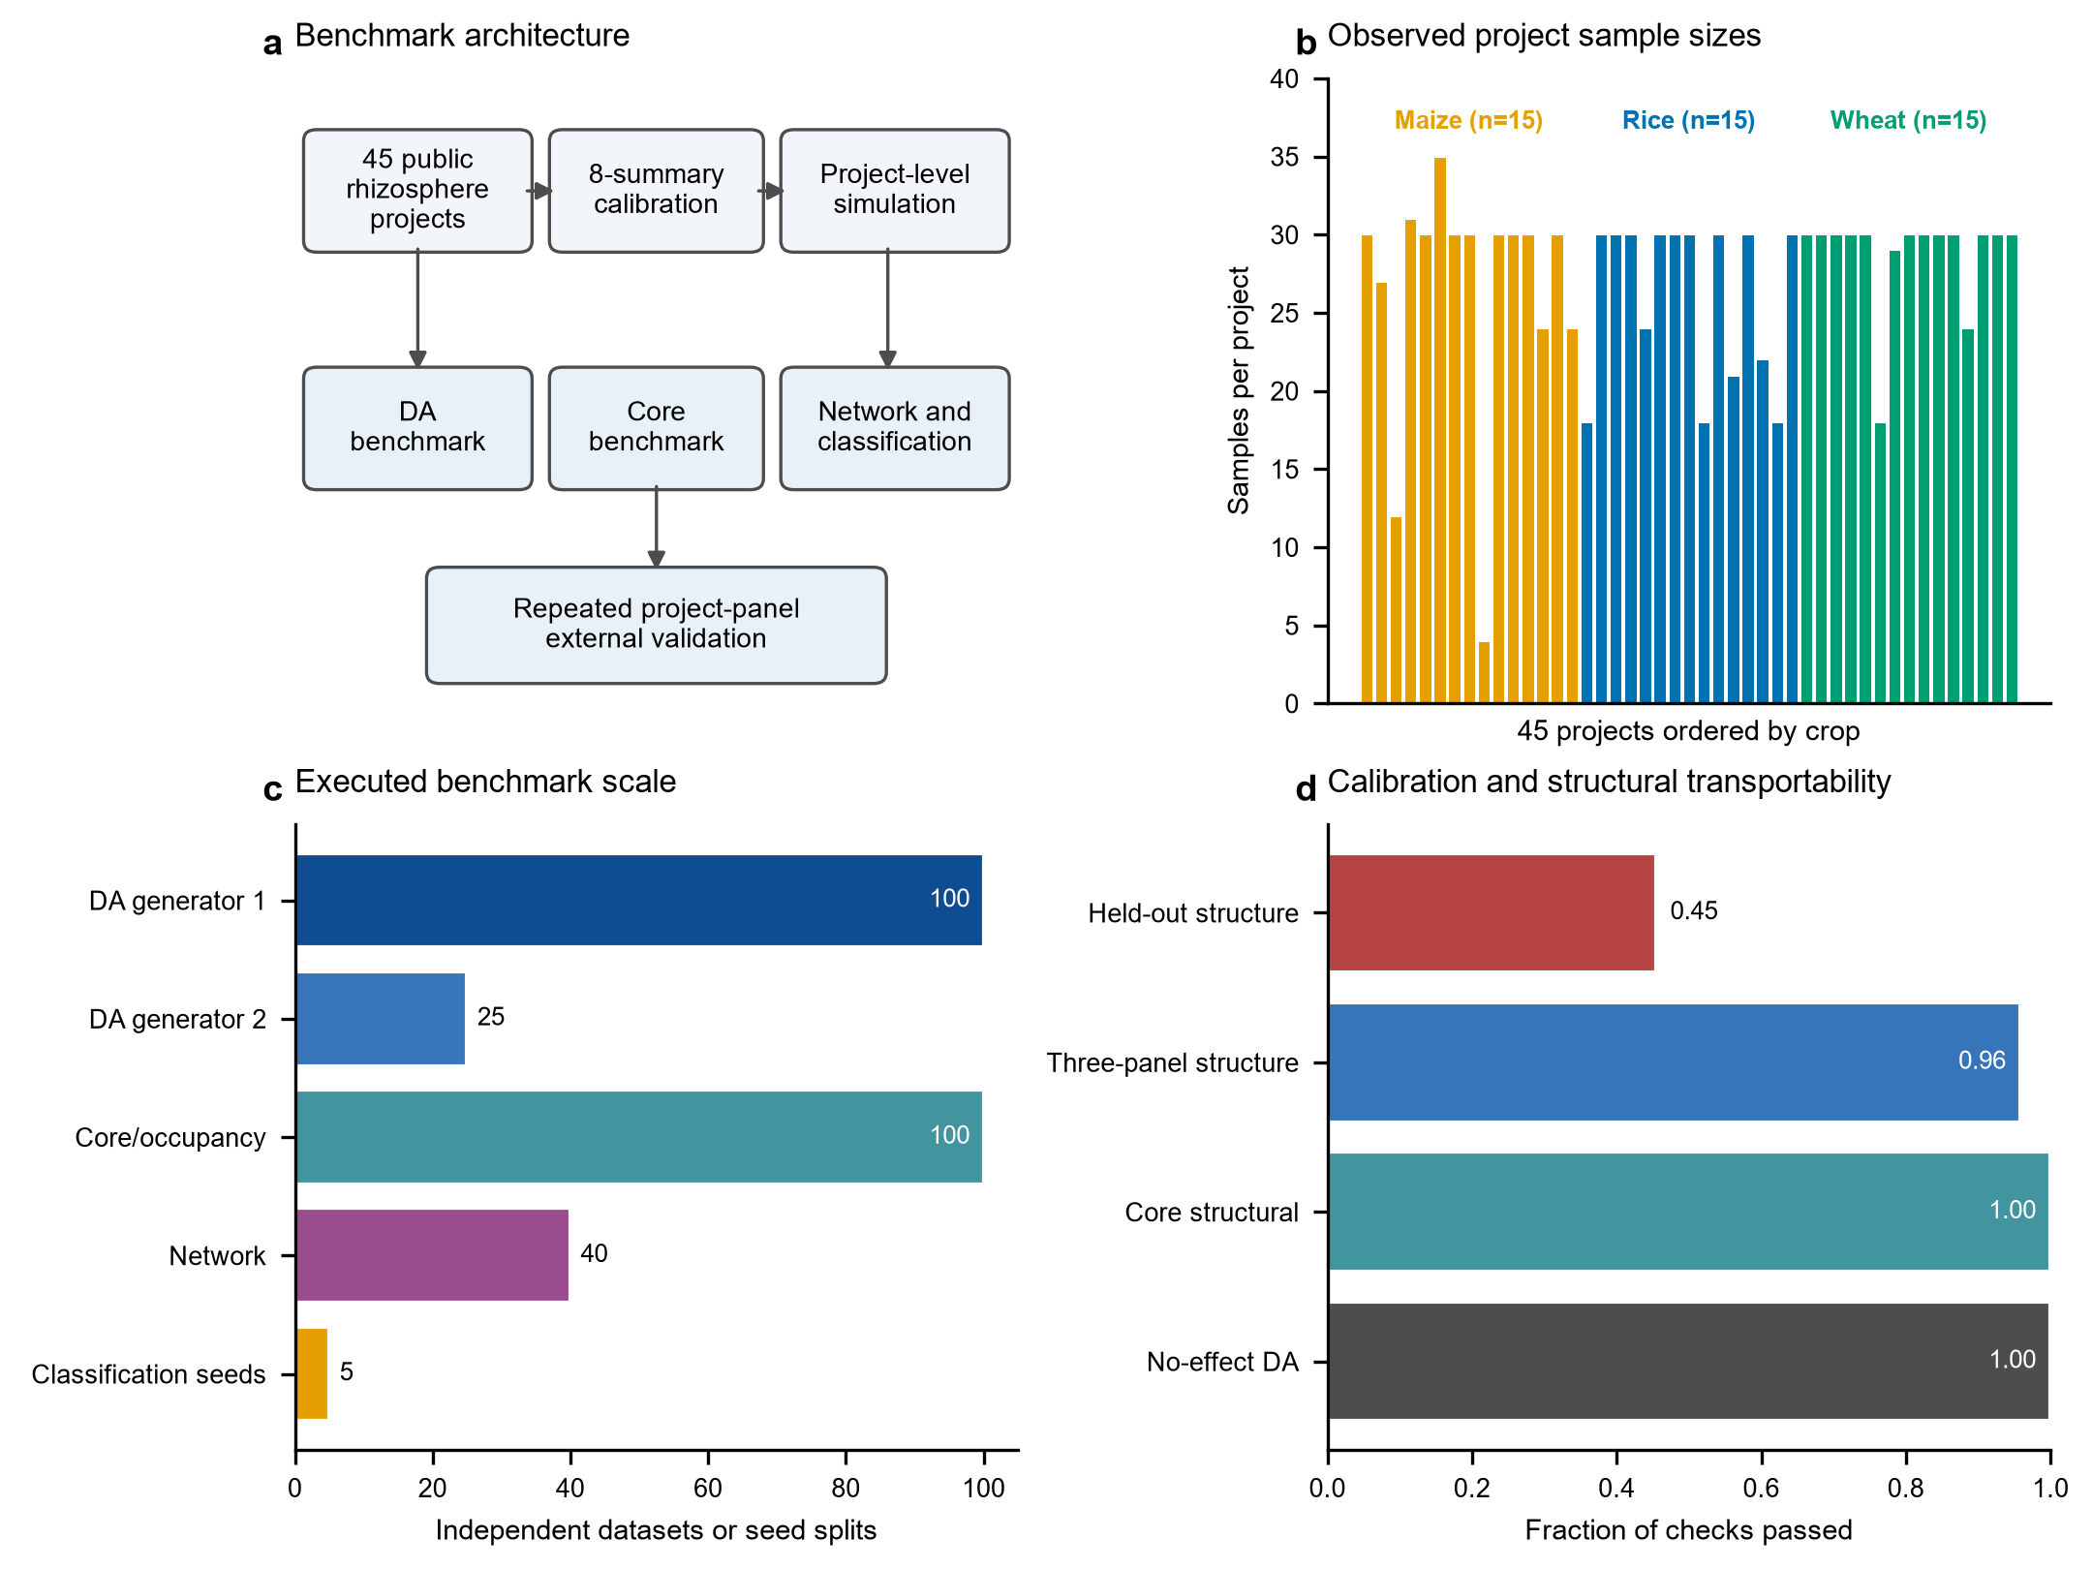
Fig. 1 | A harmonized multi-study resource of rhizosphere 16S rRNA gene sequencing data and its calibration framework.. a Evidence architecture linking public-data harmonization, eight-summary simulation calibration, four analysis domains and project-panel holdout. b Samples per development project (n = 45; 15 maize, 15 rice and 15 wheat projects). c Numbers of generated datasets, random seeds or split units used in each analysis layer. d Fraction of prespecified checks meeting operational tolerances. Denominators are 80 no-effect DA method-dataset checks (four methods × 20 seeds), 10 core stage-scenario calibration cells, 144 three-panel structural checks (three panels × two generators × three seeds × eight summaries) and 480 held-out structural checks (30 panels × two generators × eight summaries). The benchmark supports comparisons within the evaluated scenarios and tasks, not a universal method ranking. Source data are provided in the analysis package.

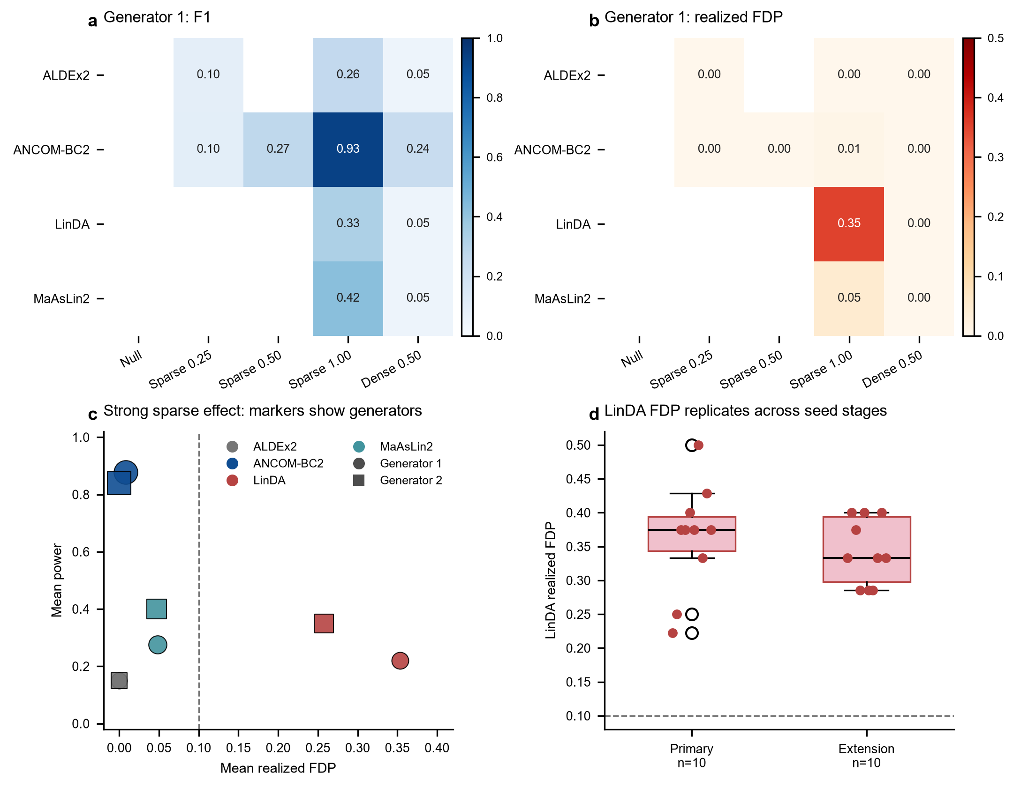
Fig. 2 | Differential-abundance performance depends on scenario and generator.. a Mean F1 for ALDEx2, ANCOM-BC2, LinDA and MaAsLin2 across five frozen scenarios under generator 1. b Mean per-dataset false-discovery proportion (FDP) for the same cells. c Joint FDP-power relationship in the strong sparse-effect scenario, with 20 targets among 120 tested features and absolute log2 effect 1.00. Marker color denotes method, shape denotes generator and area is proportional to F1. d LinDA FDP in primary seeds 4000-4009 and extension seeds 4010-4019. The no-effect control produced no discoveries. FDP is the mean of finite per-dataset values among datasets with at least one discovery; pooled FDP and bootstrap intervals are in the source data. Dashed lines mark FDP = 0.10.

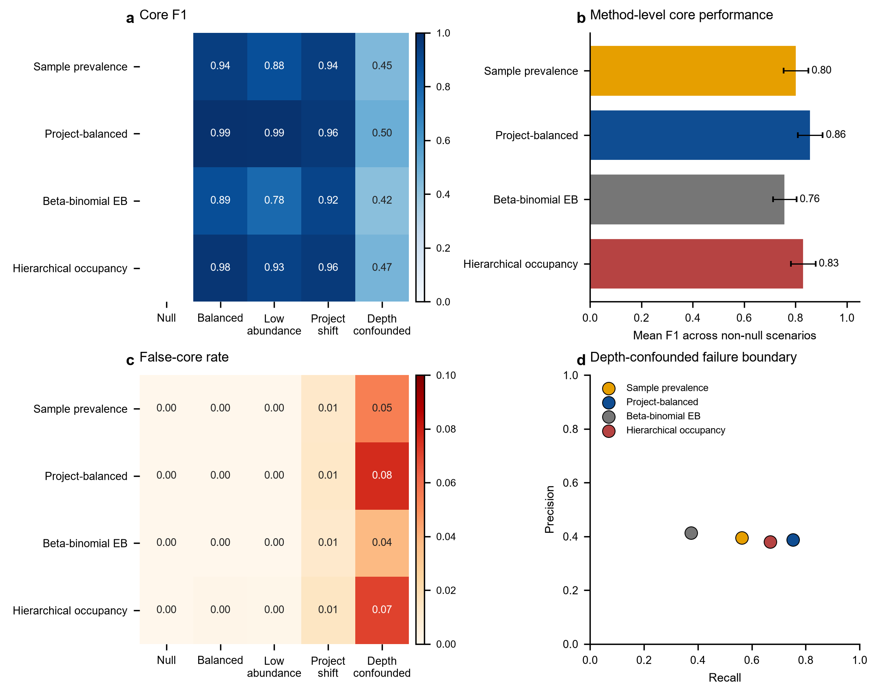
Fig. 3 | Core-feature recovery is strong until sequencing depth is confounded with occupancy.. a Mean core F1 across five core scenarios and 20 datasets per method-scenario cell. b Mean F1 across four non-null scenarios with 95% bootstrap intervals from 5,000 resamples of per-dataset metrics. c Mean false-core rate, with color capped at 0.10. d Recall-precision boundary under depth confounding. The null scenario has no true core features, so the false-core rate is the primary null endpoint. Project-balanced prevalence mirrors the project-level target definition and its advantage is partly definitional.

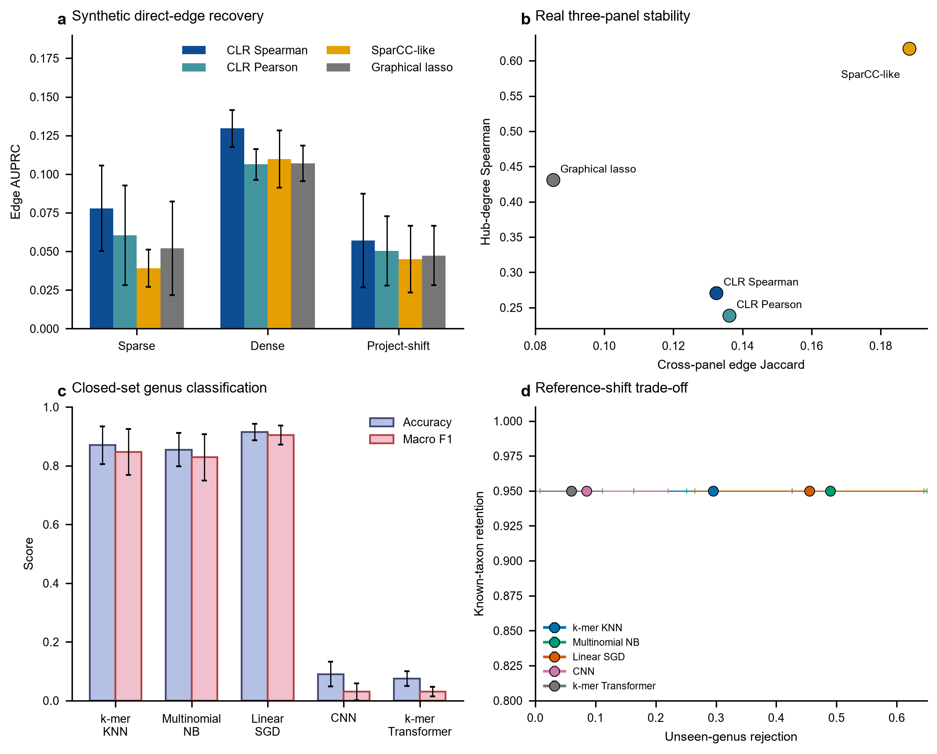
Fig. 4 | Network inference and sequence classification expose different reliability boundaries.. a Mean synthetic direct-edge AUPRC across non-null validation scenarios; error bars show one standard deviation across five validation seeds. b Stability on three disjoint real-data panels, measured by top-decile edge Jaccard and degree-rank Spearman correlation. c Closed-set genus accuracy and macro F1 over five split seeds. d Unseen-genus rejection versus known-taxon retention; the threshold retains 95% of known validation queries. The Transformer was trained from scratch and is not a pretrained DNA-BERT model. Network edges are statistical associations, not ecological interactions.

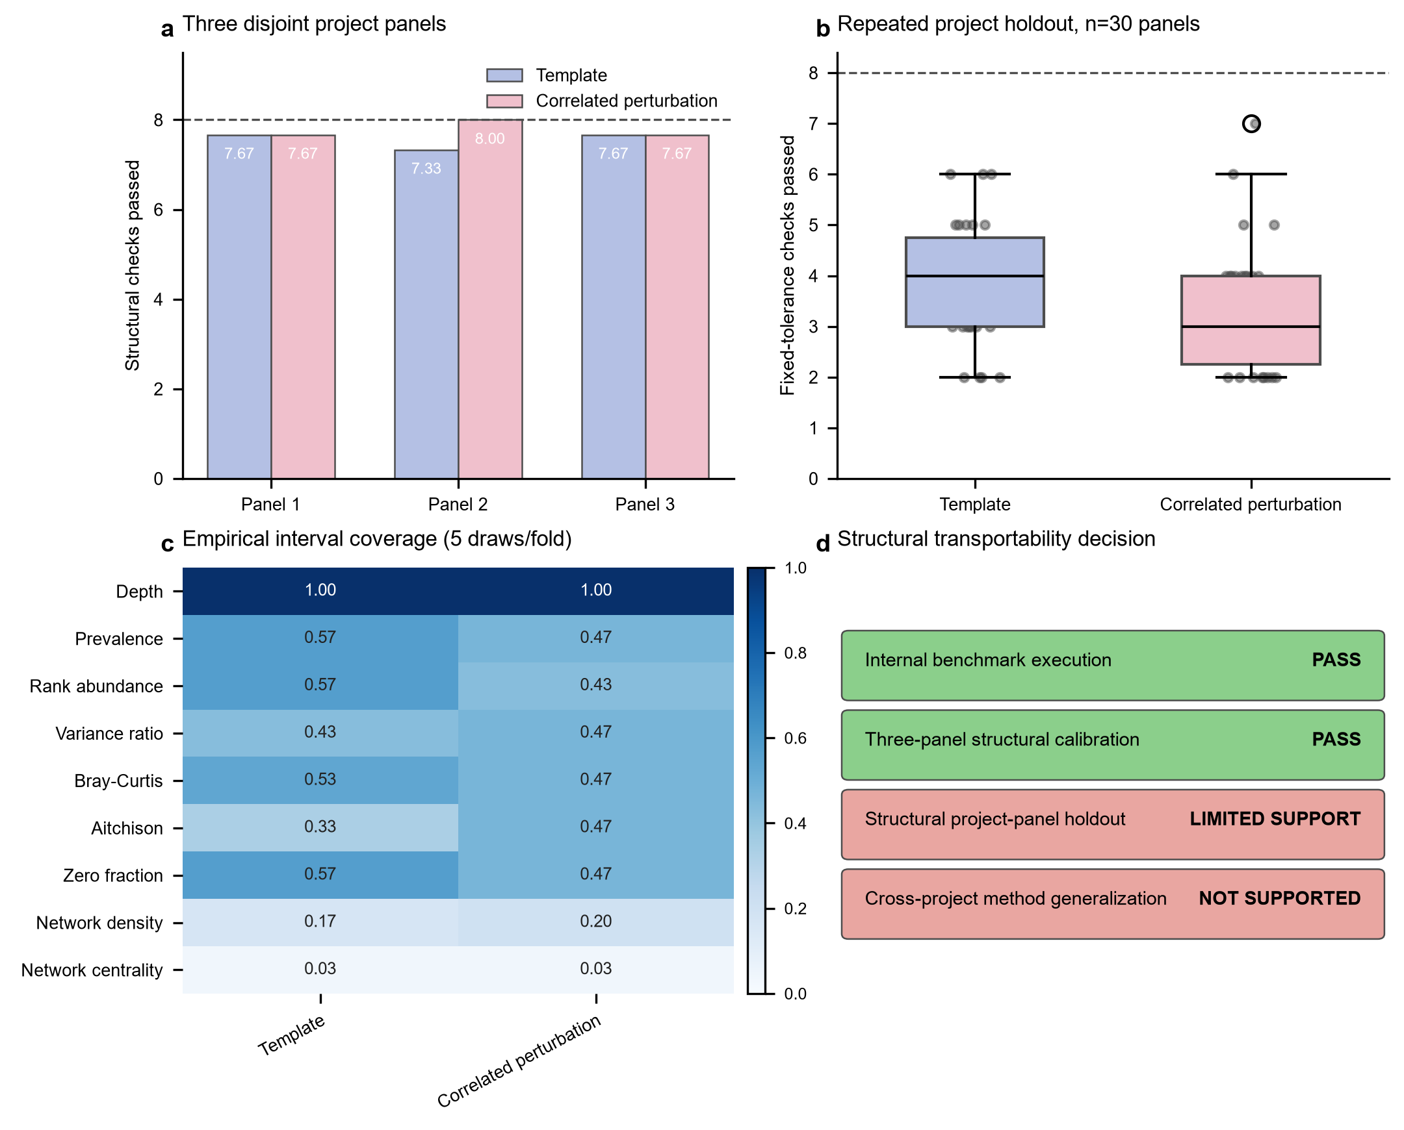
Fig. 5 | Project-panel holdout reveals limited structural transportability.. a Number of eight structural summaries meeting tolerances in three disjoint 15-project panels for the two generators. b Fixed-tolerance checks across 30 held-out panels from 10 repeated stratified three-fold partitions. c Empirical interval coverage for aggregate structural summaries from five predictive draws per fold. d Evidence decision separating within-panel calibration from structural transportability and universal ranking. The 30 panels are correlated because each project is held out once per partition. This analysis evaluates generator structure, not DA accuracy, FDP or ranking on real held-out projects.

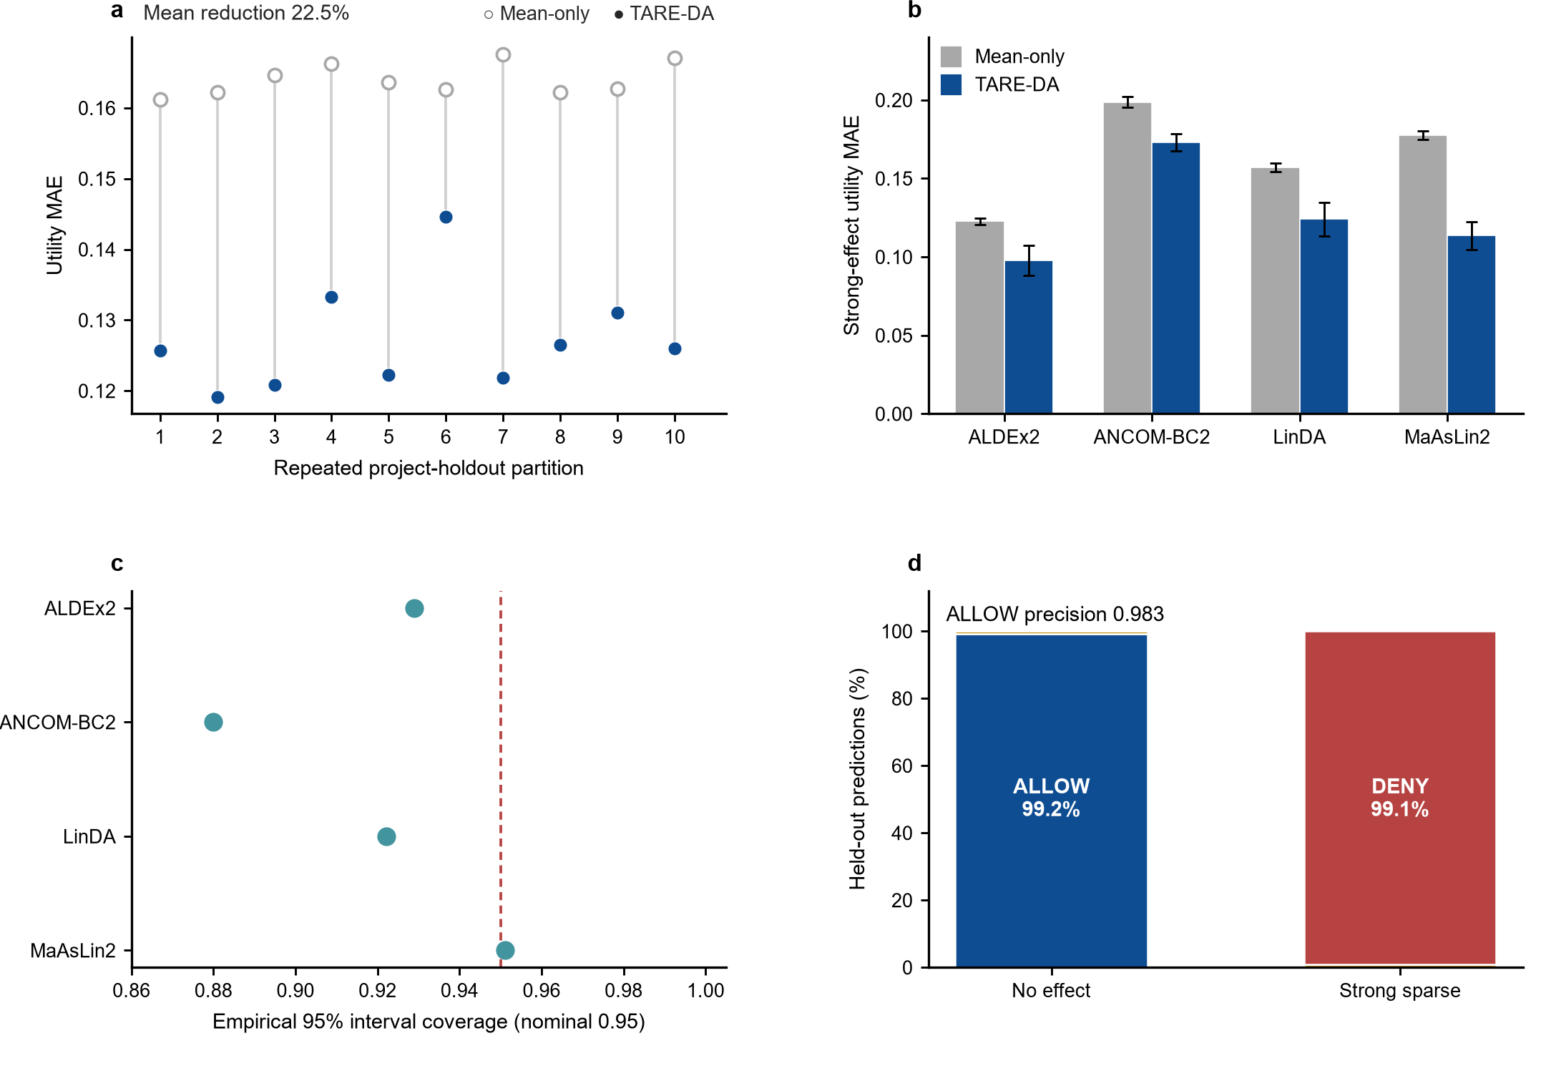
Fig. 6 | Project-held-out TARE-DA improves conditional prediction and supports conservative abstention.. a Utility MAE for TARE-DA and the development-only method-by-scenario prior across 10 repeated project-holdout partitions in the strong-effect scenario. b Method-level strong-effect MAE with one standard deviation across the 10 partitions. c Empirical coverage of the 95% conformal intervals. The dashed line marks nominal coverage 0.95. d ALLOW, CONDITIONAL and DENY decisions across 3,600 internal predictions. Strong-effect results received no ALLOW decisions under the frozen reliability criterion. TARE-DA predicts utility under simulator-defined effects and does not estimate biological truth in unlabelled projects.

Table 1 | Evidence layers and analysis scale
Layer | Projects | Samples | Unit of evaluation | Primary purpose
Development resource | 45 | 1,219 | Project and sample | Build the common feature space and observe multi-project heterogeneity
Structural calibration | 45 | 1,219 | 15-project panel | Assess agreement with eight observed structural summaries
Repeated project holdout | 45 | 1,219 | 30 correlated held-out panels | Test simulator transportability
TARE-DA training | 45 | 1,219 | 90 project-specific known-effect datasets | Train and validate project-level reliability envelopes
TARE-DA internal holdout | 45 | 1,219 | 3,600 project-method predictions | Evaluate interval coverage and recommendation decisions
Family-only sensitivity | 45 | 1,219 | 45 project-level strong-effect datasets | Test dependence on the mixed taxonomic hierarchy
Independent external panel | 6 | 426 | 48 project-method predictions | Stress-test the frozen model with zero project overlap

The 45 development projects comprise 15 maize, 15 rice and 15 wheat studies. The external panel comprises two projects per crop. The external projects are outside the development feature support but independent at the project-accession level.

Table 2 | Differential-abundance and cross-domain reliability boundaries
Domain | Setting | Method | Metric 1 | Metric 2 | Reliability interpretation
Differential abundance | Strong sparse, generator 1 | ANCOM-BC2 | FDP 0.008 | F1 0.930 | Strong recovery but not a universal recommendation
Differential abundance | Strong sparse, generator 1 | ALDEx2 | FDP 0.000 | F1 0.261 | Error control with low power
Differential abundance | Strong sparse, generator 1 | LinDA | FDP 0.353 | F1 0.326 | Reproducible false-discovery boundary
Differential abundance | Strong sparse, generator 1 | MaAsLin2 | FDP 0.048 | F1 0.423 | Intermediate recovery
Differential abundance | Strong sparse, generator 2 | ANCOM-BC2 | FDP 0.000 | F1 0.913 | Main ranking direction reproduced
Differential abundance | Strong sparse, generator 2 | LinDA | FDP 0.257 | F1 0.474 | Elevated FDP persists
Differential abundance | Family-only sensitivity | LinDA | FDP 0.048 | F1 0.650 | Became top-ranked under family features
Differential abundance | Family-only sensitivity | MaAsLin2 | FDP 0.086 | F1 0.644 | Similar recovery with higher FDP
Differential abundance | Family-only sensitivity | ANCOM-BC2 | FDP 0.087 | F1 0.543 | Mixed-level top rank did not persist
Differential abundance | Family-only sensitivity | ALDEx2 | FDP 0.000 | F1 0.374 | Conservative but lower recovery
Core taxa | Four non-null scenarios | Project-balanced prevalence | Mean F1 0.859 | Highest false-core rate 0.076 | Best mean but strong depth sensitivity
Core taxa | Depth-confounded | All methods | F1 0.423-0.497 | - | Common failure boundary
Network | Synthetic non-null | CLR Spearman | AUPRC 0.088 | - | Highest direct-edge recovery
Network | Real panels | SparCC-like | Edge Jaccard 0.188 | Hub rho 0.617 | Highest stability
Classification | Closed set | Linear SGD | Accuracy 0.915 | Macro F1 0.905 | Best limited-budget classifier
Classification | Unseen genus | Multinomial NB | Unknown rejection 0.490 | Known retention 0.950 | Highest unknown rejection

Exact generator-specific confidence intervals and supplemental scenarios are provided in the analysis package. The table is a boundary summary, not a single cross-domain leaderboard.

Table 3 | TARE-DA internal project-held-out validation
Scenario | Method | Predictions | TARE MAE | Development-prior MAE | 95% coverage | Reliability AUROC | ALLOW count
No effect | ALDEx2 | 450 | 0.0103 | 0.0000 | 1.000 | - | 450
No effect | ANCOM-BC2 | 450 | 0.0173 | 0.0132 | 1.000 | 0.153 | 449
No effect | LinDA | 450 | 0.0863 | 0.0869 | 0.953 | 0.226 | 437
No effect | MaAsLin2 | 450 | 0.0094 | 0.0021 | 1.000 | - | 450
Strong sparse | ALDEx2 | 450 | 0.0979 | 0.1227 | 0.929 | 0.868 | 0
Strong sparse | ANCOM-BC2 | 450 | 0.1730 | 0.1988 | 0.880 | 0.900 | 0
Strong sparse | LinDA | 450 | 0.1240 | 0.1570 | 0.922 | 0.853 | 0
Strong sparse | MaAsLin2 | 450 | 0.1137 | 0.1776 | 0.951 | 0.925 | 0
Overall | All methods | 3,600 | 0.0790 | 0.0948 | 0.954 | 0.883 strong effect | 1,786

The analysis uses 10 repeated stratified five-fold project holdouts. The development-prior comparator is the mean utility of the same method and scenario in the outer training projects. ALLOW precision across the full set is 0.983.

Table 4 | Independent external projects
Crop | Project | Platform cluster | Samples | Post-DADA2 QC | Genus reads (%)
Maize | PRJEB104640 | XC_ETH_MAIZE_DROUGHT_2025 | 177 | pass | 81.590
Maize | PRJNA1062967 | XC_GXU_MAIZE_DROUGHT_2024 | 12 | pass | 72.824
Rice | PRJDB13616 | XC_UTOKYO_RICE_2022 | 60 | pass | 89.598
Rice | PRJNA1044052 | XC_CAAS_RICE_2023 | 15 | pass | 86.180
Wheat | PRJEB76879 | XC_UMR5557_WHEAT_2025 | 108 | pass | 81.030
Wheat | PRJNA1095845 | XC_NWAF_WHEAT | 54 | pass | 75.249

The reviewed rice project PRJDB19884 was excluded before external outcome generation because its non-NA genus-read rate was 24.482%, within the prespecified 20%-60% review stratum. No external accession appears in the 45-project development corpus.

Table 5 | TARE-DA external stress test
Scenario | Method | Projects | TARE MAE | Development-prior MAE | Coverage | Reliability AUROC | ALLOW-core
No effect | ALDEx2 | 6 | 0.0060 | 0.0000 | 1.000 | - | 6
No effect | ANCOM-BC2 | 6 | 0.0143 | 0.0098 | 1.000 | - | 6
No effect | LinDA | 6 | 0.0411 | 0.0465 | 1.000 | - | 6
No effect | MaAsLin2 | 6 | 0.0045 | 0.0011 | 1.000 | - | 6
Strong sparse | ALDEx2 | 6 | 0.2190 | 0.3037 | 0.833 | 1.000 | 0
Strong sparse | ANCOM-BC2 | 6 | 0.1970 | 0.2933 | 0.833 | - | 0
Strong sparse | LinDA | 6 | 0.3479 | 0.4315 | 0.500 | 0.875 | 0
Strong sparse | MaAsLin2 | 6 | 0.3016 | 0.3962 | 0.667 | 1.000 | 0
Overall | All methods | 6 | 0.1414 | 0.1853 | 0.854 | 0.837 strong effect | 24

The model was not retrained on external data. ALLOW-core is the underlying utility decision before the applicability gate. All 48 external predictions were outside the 95th percentile of nearest-neighbour distance to the development feature space and therefore received the operational status DEFER_OUT_OF_SUPPORT. The mean support score was 0.062. Method-specific AUROCs are descriptive because each cell contains six projects.

Table 6 | External project-level TARE results
Crop | Project | TARE MAE | Development-prior MAE | Coverage | Reliable methods (of 4) | ALLOW-core | Support
Maize | PRJEB104640 | 0.744 | 0.804 | 0.00 | 3 | 0 | outside q95
Maize | PRJNA1062967 | 0.154 | 0.128 | 1.00 | 0 | 0 | outside q95
Rice | PRJDB13616 | 0.329 | 0.234 | 0.50 | 1 | 0 | outside q95
Rice | PRJNA1044052 | 0.029 | 0.151 | 1.00 | 0 | 0 | outside q95
Wheat | PRJEB76879 | 0.142 | 0.448 | 1.00 | 3 | 0 | outside q95
Wheat | PRJNA1095845 | 0.201 | 0.373 | 0.75 | 2 | 0 | outside q95

Values summarize the four strong-effect method predictions per external project. Every project is outside the development support envelope and therefore receives the operational status DEFER_OUT_OF_SUPPORT. Project-specific method predictions are provided in the source data.

Table 7 | Illustrative project-level differential-abundance application
Method | Rejected features | FDP | F1 | Candidate-set relation | TARE decisions across 10 partitions
ALDEx2 | 0 | 0.000 | 0.000 | No candidates | DENY
ANCOM-BC2 | 16 | 0.188 | 0.722 | 13 candidates unique to this method | DENY
LinDA | 0 | 0.000 | 0.000 | No candidates | CONDITIONAL or DENY
MaAsLin2 | 3 | 0.000 | 0.261 | All 3 shared with ANCOM-BC2 | CONDITIONAL or DENY

The illustration uses the observed composition template of PRJNA554261 with a simulator-defined strong sparse effect. It is not a real treatment-effect validation. No rejected taxon was shared by all four methods. TARE withheld recommendation across partitions even though ANCOM-BC2 recovered most targets, because its FDP was 0.188 and the model's reliability evidence remained low. This example shows how method-dependent candidate lists arise and why TARE is designed to abstain rather than convert one method's output into biological evidence.

Table 8 | Interpretation boundaries
Claim | Supported evidence | Not supported
The domains require different reliability criteria | DA, core, network and classification failure boundaries | A universal cross-domain method ranking
Project-specific prediction adds information | TARE-DA internal and external MAE improvements | Accuracy on unlabelled real-project biological truth
The envelope supports abstention | High ALLOW precision; all strong external utility decisions were DENY | Recovery of every reliable external strong-effect case
Applicability is distinct from utility | All external projects were flagged DEFER_OUT_OF_SUPPORT | Conditional coverage guarantee under arbitrary shift
The external panel is project-independent | Six projects with zero development overlap | In-distribution external generalization
A calibrated simulator can be useful | Eight-summary calibration and scenario comparisons | Reliable structural transfer to arbitrary unseen panels
Network estimates capture association | Reproducible co-occurrence rankings | Ecological interactions or causal roles

References
1. Callahan, B. J., McMurdie, P. J., Rosen, M. J., Han, A. W., Johnson, A. J. A. & Holmes, S. P. DADA2: high-resolution sample inference from Illumina amplicon data. Nature Methods 13, 581-583 (2016). https://doi.org/10.1038/nmeth.3869
2. Bolyen, E. et al. Reproducible, interactive, scalable and extensible microbiome data science using QIIME 2. Nature Biotechnology 37, 852-857 (2019). https://doi.org/10.1038/s41587-019-0209-9
3. Quast, C. et al. The SILVA ribosomal RNA gene database project: improved data processing and web-based tools. Nucleic Acids Research 41, D590-D596 (2013). https://doi.org/10.1093/nar/gks1219
4. Gloor, G. B., Macklaim, J. M., Pawlowsky-Glahn, V. & Egozcue, J. J. Microbiome datasets are compositional: and this is not optional. Frontiers in Microbiology 8, 2224 (2017). https://doi.org/10.3389/fmicb.2017.02224
5. Nearing, J. T. et al. Microbiome differential abundance methods produce different results across 38 datasets. Nature Communications 13, 342 (2022). https://doi.org/10.1038/s41467-022-28034-z
6. Yang, L. & Chen, J. A comprehensive evaluation of microbial differential abundance analysis methods: current status and potential solutions. Microbiome 10, 130 (2022). https://doi.org/10.1186/s40168-022-01320-0
7. Kohnert, E. & Kreutz, C. Benchmarking differential abundance tests for 16S microbiome sequencing data using simulated data based on experimental templates. PLOS One 20, e0321452 (2025). https://doi.org/10.1371/journal.pone.0321452
8. Fernandes, A. D. et al. Unifying the analysis of high-throughput sequencing datasets: characterizing RNA-seq, 16S rRNA gene sequencing and selective growth experiments by compositional data analysis. Microbiome 2, 15 (2014). https://doi.org/10.1186/2049-2618-2-15
9. Lin, H. & Peddada, S. D. Multigroup analysis of compositions of microbiomes with covariate adjustments and repeated measures. Nature Methods 21, 83-91 (2024). https://doi.org/10.1038/s41592-023-02092-7
10. Zhou, H., He, K., Chen, J. & Zhang, X. LinDA: linear models for differential abundance analysis of microbiome compositional data. Genome Biology 23, 95 (2022). https://doi.org/10.1186/s13059-022-02655-5
11. Mallick, H. et al. Multivariable association discovery in population-scale meta-omics studies. PLOS Computational Biology 17, e1009442 (2021). https://doi.org/10.1371/journal.pcbi.1009442
12. Friedman, J. & Alm, E. J. Inferring correlation networks from genomic survey data. PLOS Computational Biology 8, e1002687 (2012). https://doi.org/10.1371/journal.pcbi.1002687
13. Friedman, J., Hastie, T. & Tibshirani, R. Sparse inverse covariance estimation with the graphical lasso. Biostatistics 9, 432-441 (2008). https://doi.org/10.1093/biostatistics/kxm045
14. Benjamini, Y. & Hochberg, Y. Controlling the false discovery rate: a practical and powerful approach to multiple testing. Journal of the Royal Statistical Society: Series B 57, 289-300 (1995). https://doi.org/10.1111/j.2517-6161.1995.tb02031.x
15. Shade, A. & Handelsman, J. Beyond the Venn diagram: the hunt for a core microbiome. Environmental Microbiology 14, 4-12 (2012). https://doi.org/10.1111/j.1462-2920.2011.02680.x
16. McLaren, M. R., Willis, A. D. & Callahan, B. J. Consistent and correctable bias in metagenomic sequencing experiments. eLife 8, e46923 (2019). https://doi.org/10.7554/eLife.46923
17. Pelto, J., Auranen, K., Kujala, J. V. & Lahti, L. Elementary methods provide more replicable results in microbial differential abundance analysis. Briefings in Bioinformatics 26, bbaf130 (2025). https://doi.org/10.1093/bib/bbaf130
18. Martin, B. D., Witten, D. & Willis, A. D. Modeling microbial abundances and dysbiosis with beta-binomial regression. Annals of Applied Statistics 14, 94-115 (2020). https://doi.org/10.1214/19-AOAS1283
19. Ji, Y., Zhou, Z., Liu, H. & Davuluri, R. V. DNABERT: pre-trained bidirectional encoder representations from transformers model for DNA-language in genome. Bioinformatics 37, 2115-2122 (2021). https://doi.org/10.1093/bioinformatics/btab083
20. Lei, J., G'Sell, M., Rinaldo, A., Tibshirani, R. J. & Wasserman, L. Distribution-free predictive inference for regression. Journal of the American Statistical Association 113, 1094-1111 (2018). https://doi.org/10.1080/01621459.2017.1307116
21. Vovk, V., Gammerman, A. & Shafer, G. Algorithmic Learning in a Random World. Springer (2005). https://doi.org/10.1007/b106715
22. Tibshirani, R. J., Barber, R. F., Candes, E. & Ramdas, A. Conformal prediction under covariate shift. Advances in Neural Information Processing Systems 32, 2530-2540 (2019).
23. Ben-David, S., Blitzer, J., Crammer, K., Kulesza, A., Pereira, F. & Vaughan, J. W. A theory of learning from different domains. Machine Learning 79, 151-175 (2010). https://doi.org/10.1007/s10994-009-5152-4
24. Steyerberg, E. W. & Vergouwe, Y. Towards better clinical prediction models: seven steps for development and an ABCD for validation. European Heart Journal 35, 1925-1931 (2014). https://doi.org/10.1093/eurheartj/ehu207

