**MongoDB Set up**

**First set up the MongoDB connection.**

**Here I am using MongoDB Atlas. You can sign up for free tier, it gives you 512MB of storage, that is more than enough for learning purpose.**[Sign Up](https://docs.atlas.mongodb.com/getting-started/) **for MongoDB Atlas and follow the link instructions.**

<https://docs.atlas.mongodb.com/tutorial/create-atlas-account/#register-a-new-service-account>

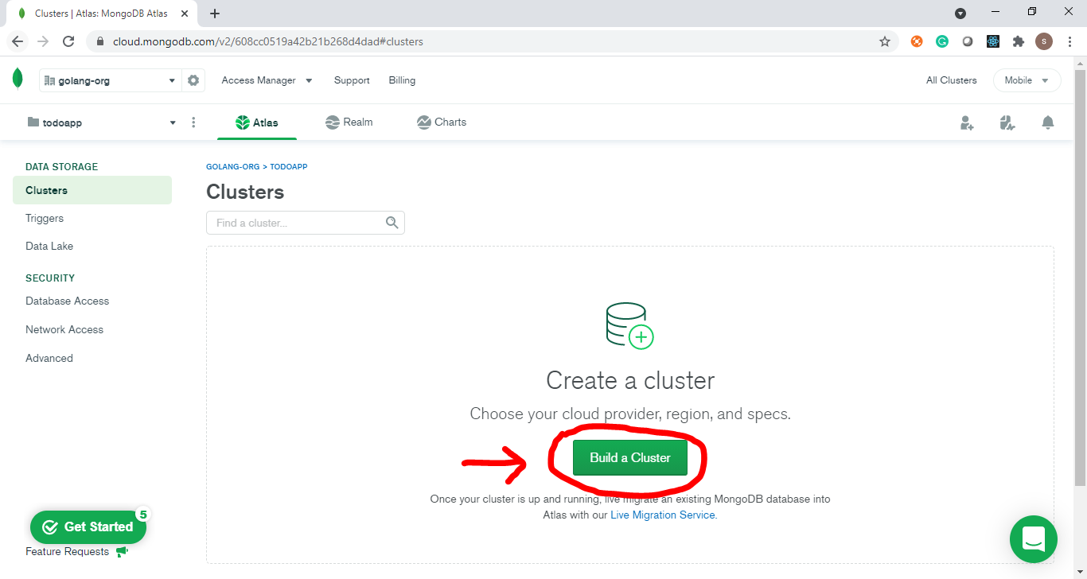

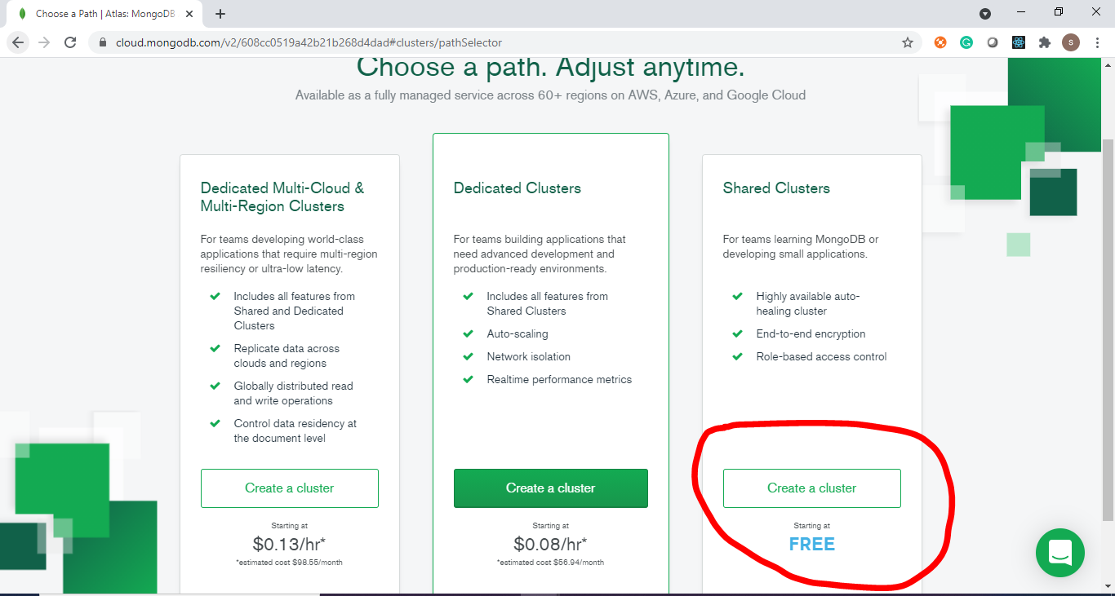

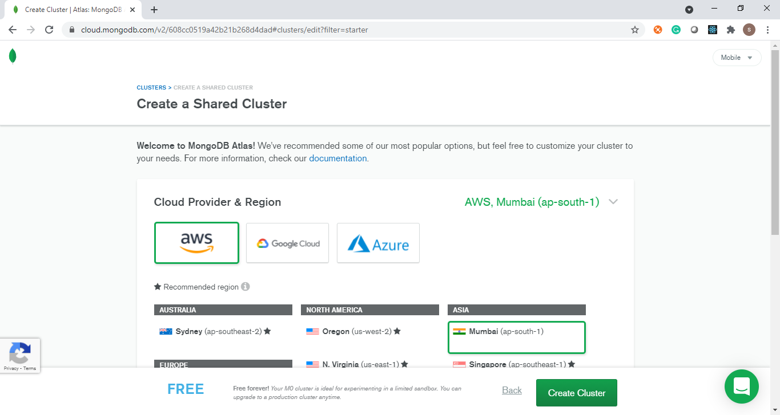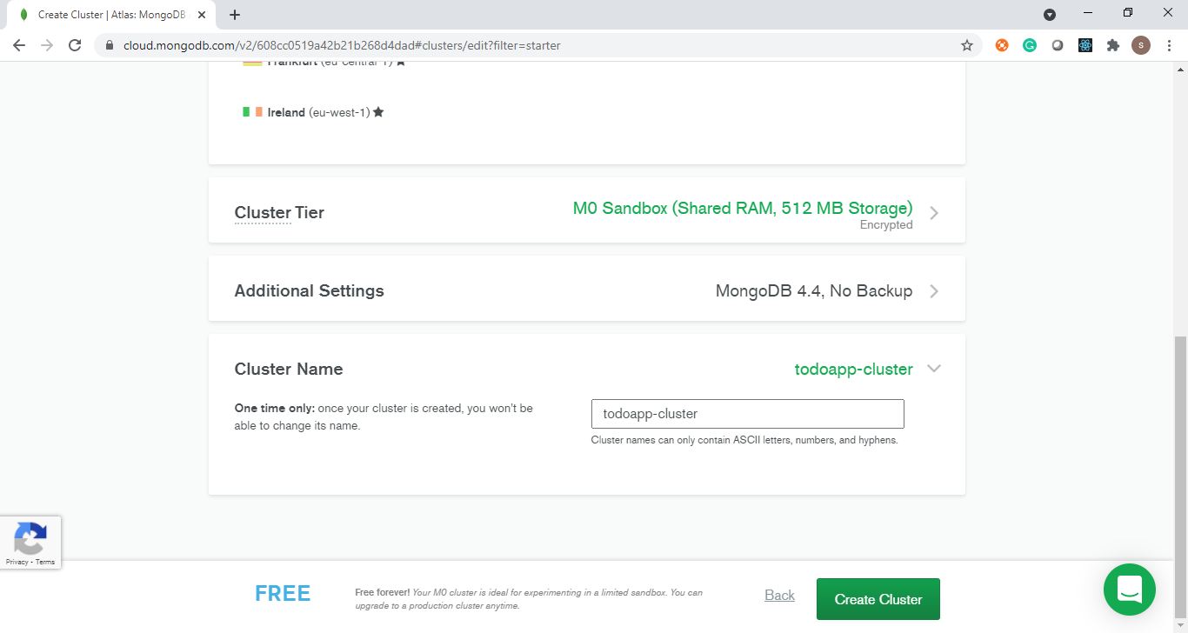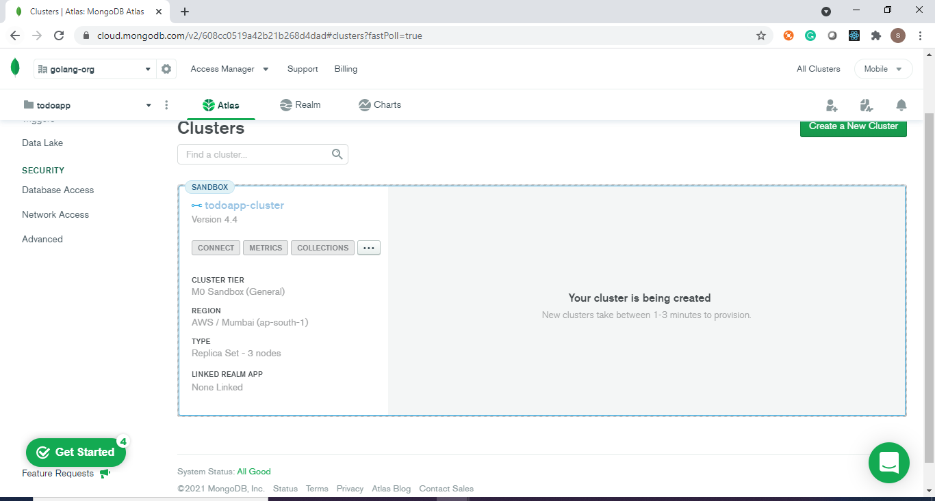

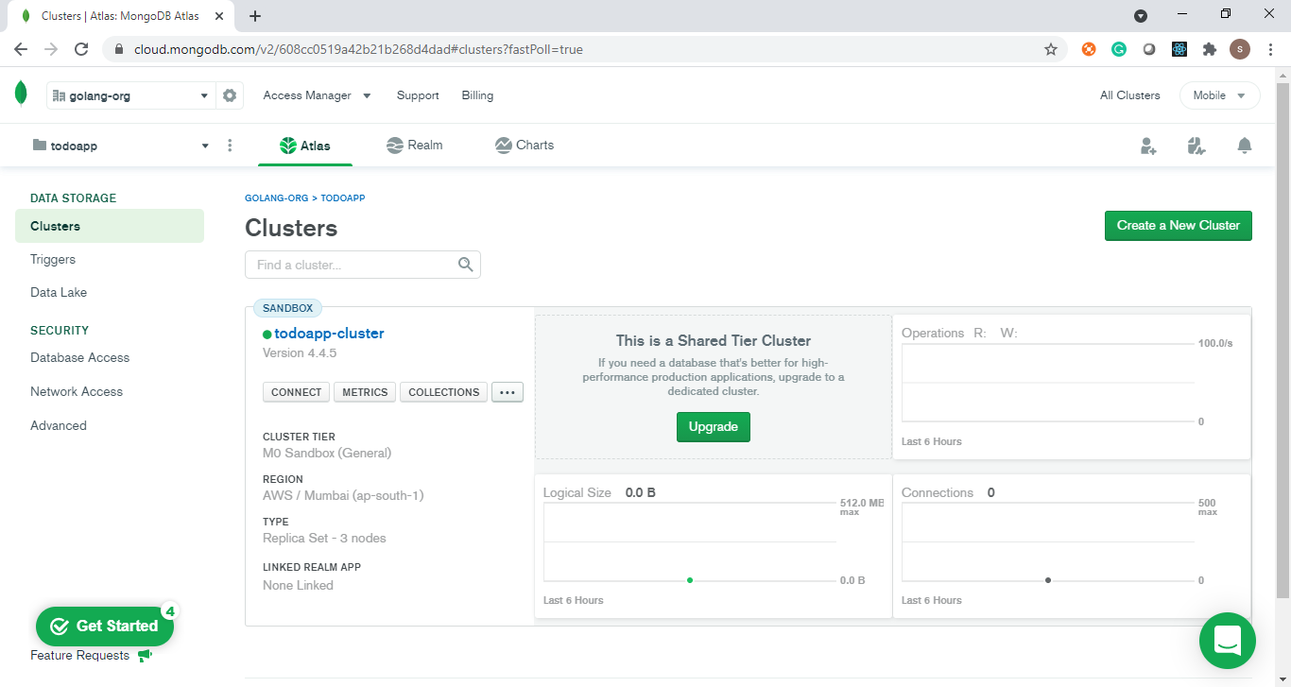

**Once you have your cluster ready, a few things need to be done.**

**First, whitelist your IP address.**

* **Click on “Network Access” under “Security”**
* **Click “ADD IP ADDRESS” and select “ADD CURRENT IP ADDRESS”. This will allow only your computer to interact with it.**

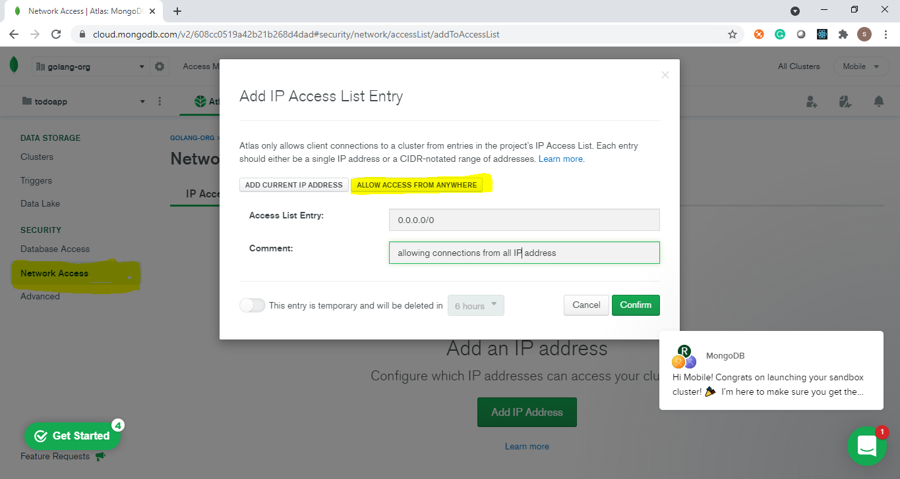

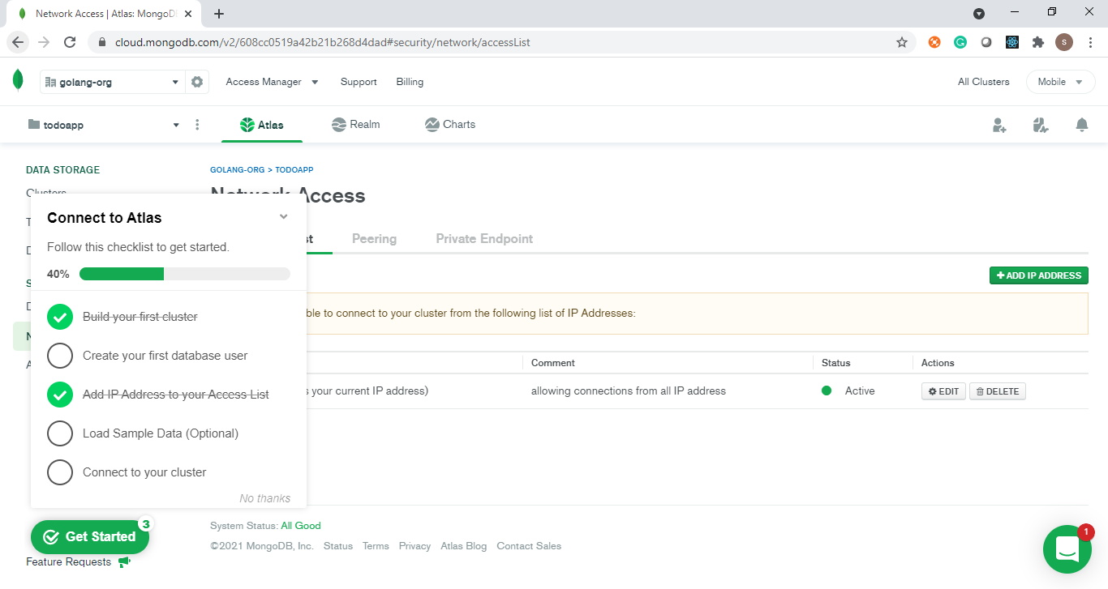

Second, create a user. You can learn more about the user in this [link](https://docs.atlas.mongodb.com/getting-started/#create-a-mongodb-user-for-your-cluster).

* Click “Database Access” under “Security” and create a new user.
* I have admin as a user.

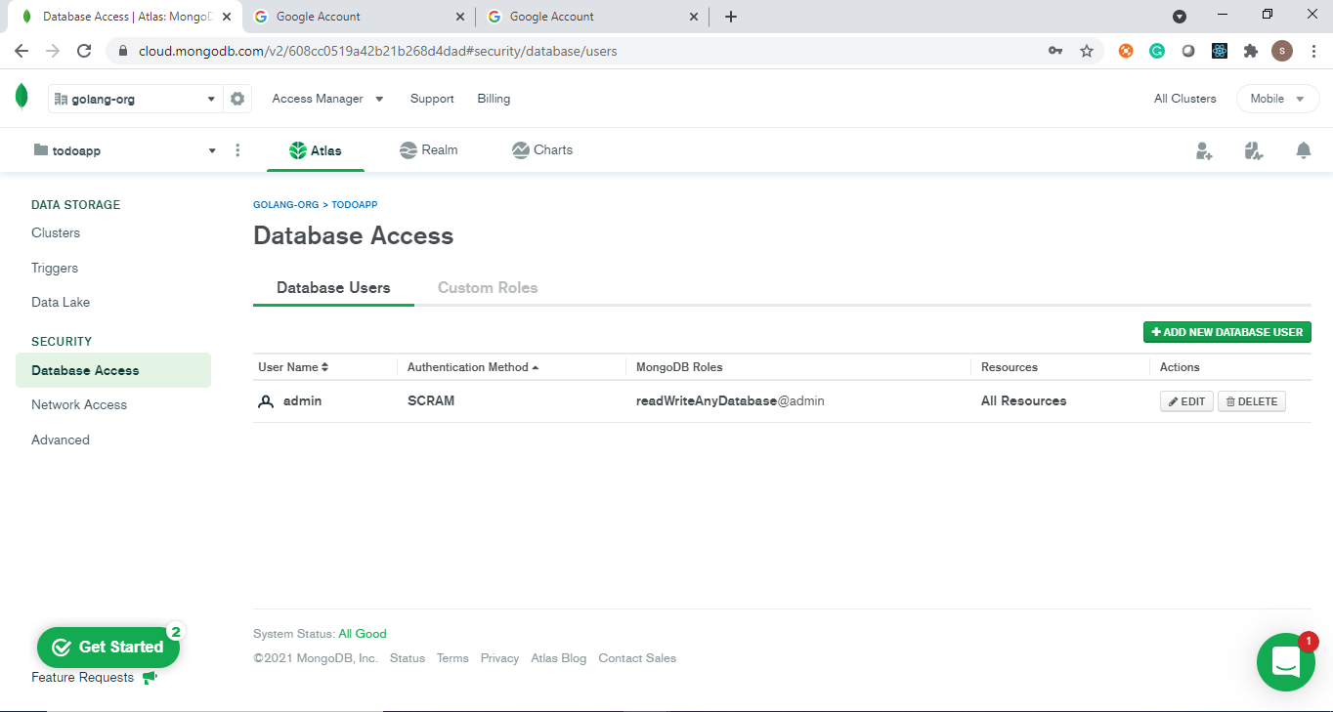

Now, it’s time to get the connection string.

* Go to “Cluster” and click “connect” and then “Connect Your Application”.
* Copy the connection string and paste it in connectionString in middleware.go

