<https://docs.atlas.mongodb.com/getting-started/>

<https://docs.atlas.mongodb.com/tutorial/create-atlas-account/#register-a-new-service-account>

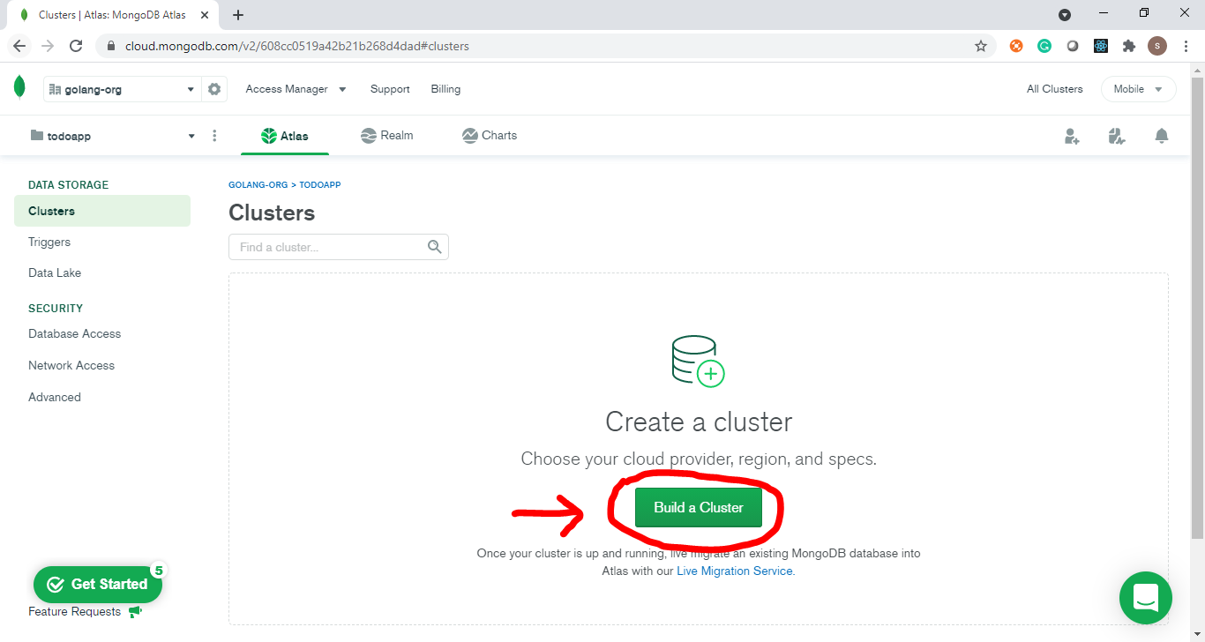

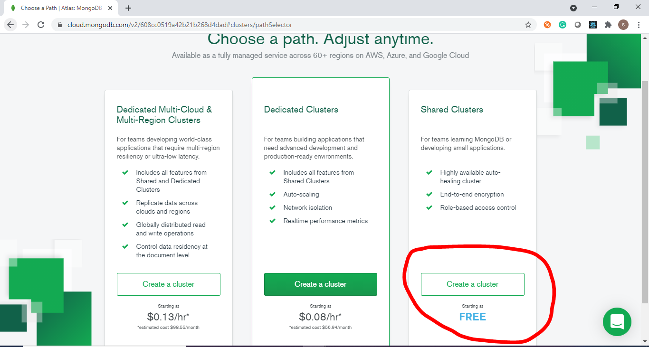

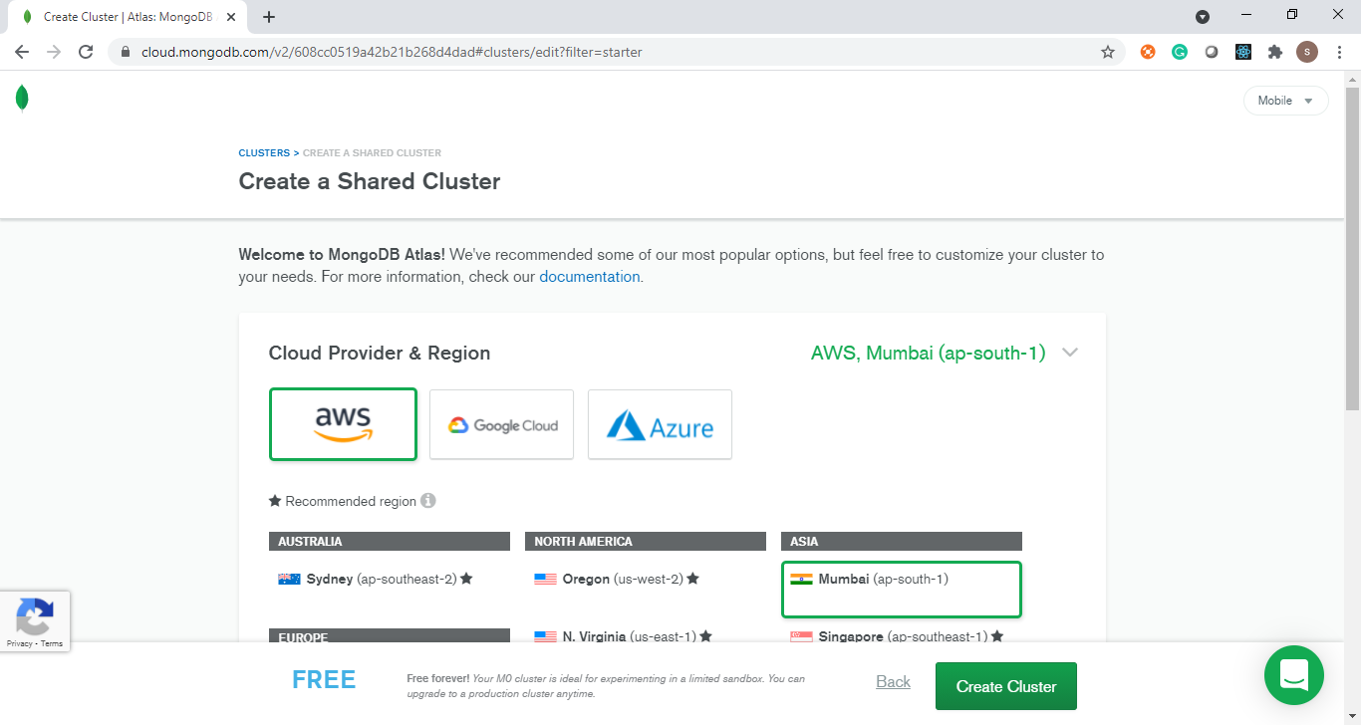

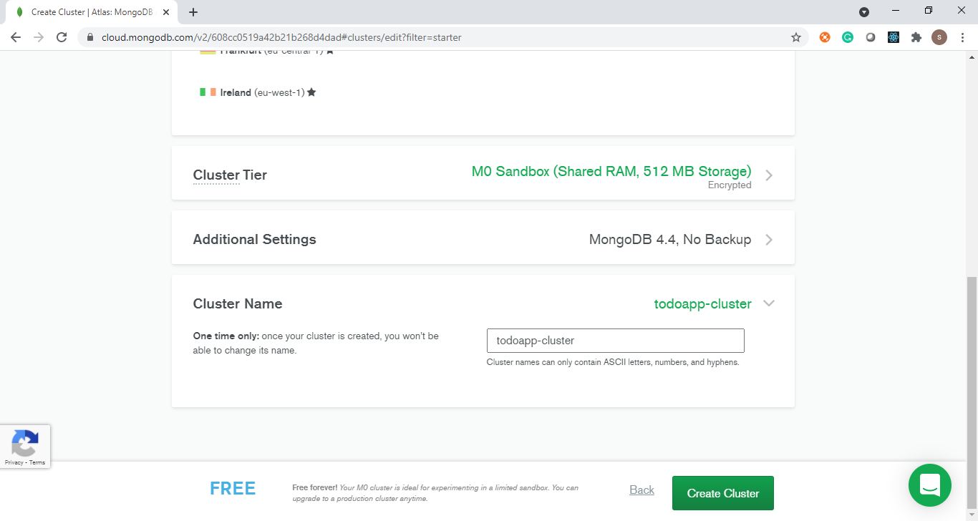

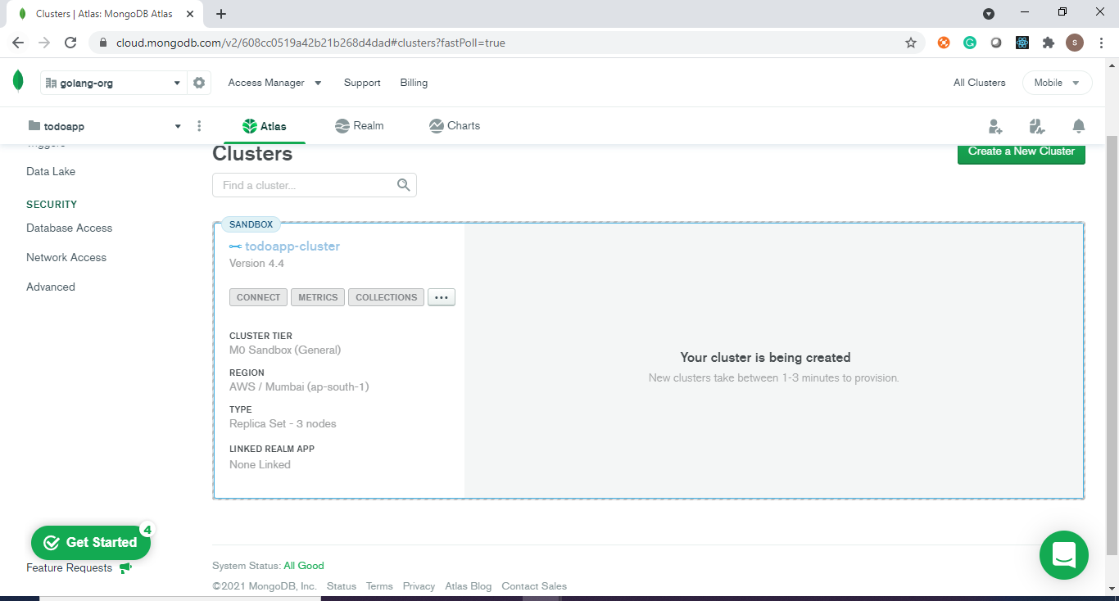

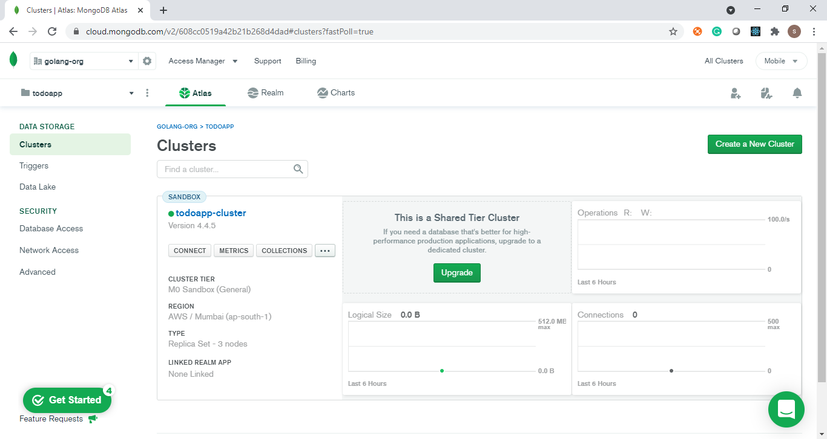

Once you have your cluster ready, a few things need to be done.

First, white list your IP address.

* Click on “Network Access” under “Security”.
* Click “ADD IP ADDRESS” and select “ADD CURRENT IP ADDRESS”. This will allow only your computer to interact with it

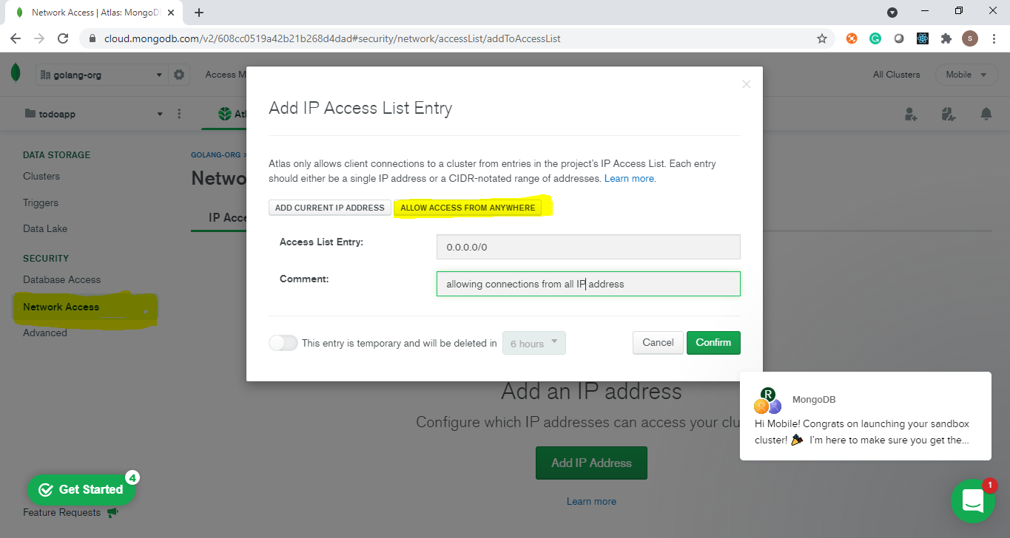

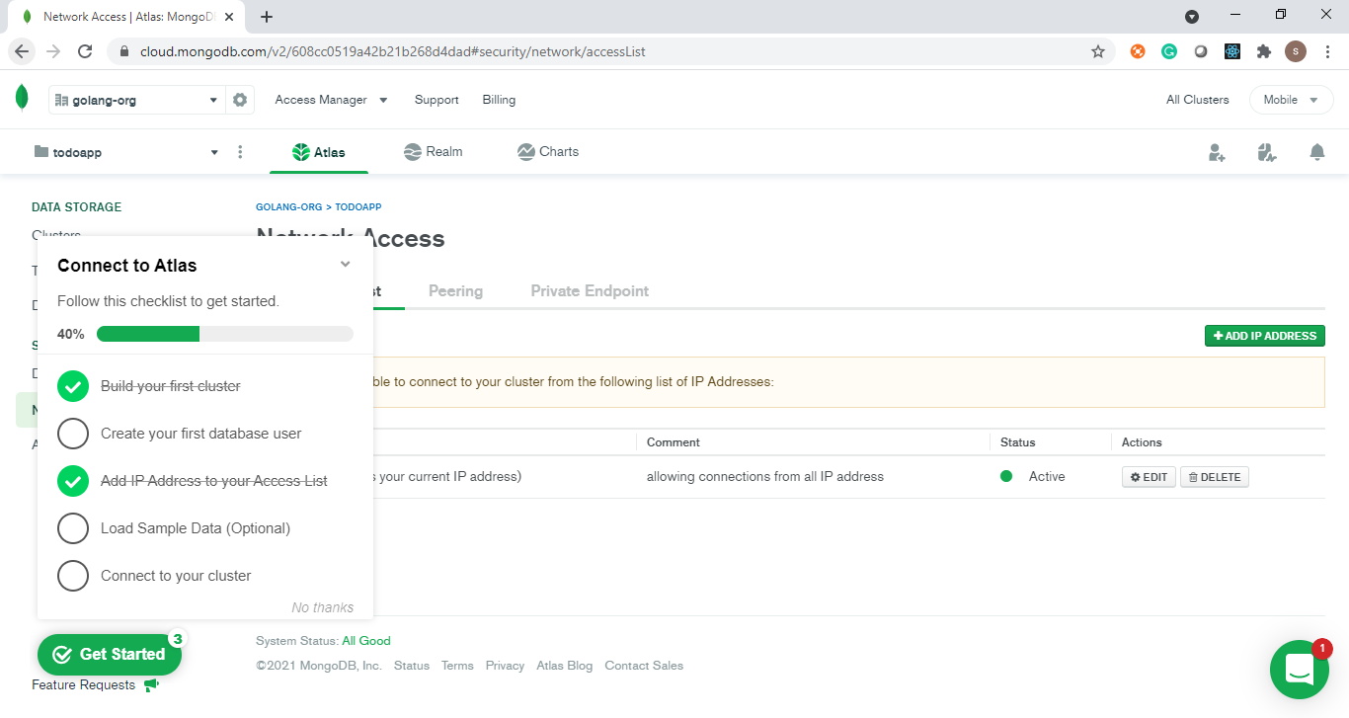

Second, create a user. You can learn more about the user in this [link](https://docs.atlas.mongodb.com/getting-started/#create-a-mongodb-user-for-your-cluster).

* Click “Database Access” under “Security” and create a new user.
* I have admin as a user.

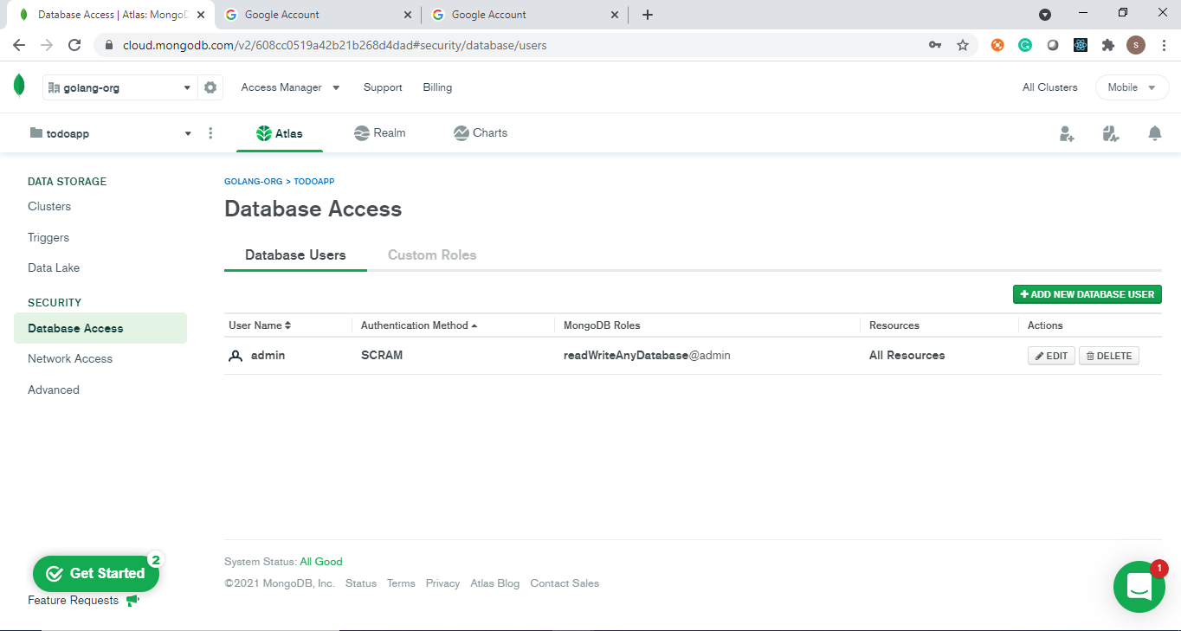

Now, its time to get the connection string.

* Go to “Cluster” and click “connect” and then “Connect Your Application”.
* Copy the connection string and paste it in connectionStringin middleware.go

