<https://www.youtube.com/watch?v=aFvRg1OqJYg&list=PL_RGaFnxSHWr_6xTfF2FrIw-NAOo3iWMy&index=36>

SQL?

1. Structured Query Language
2. SQL doesn't have a loop, Conditional statement, logical operations
3. it can not be used for anything other than data manipulation
4. **DDL** is used to define the data structure it consists of the commands like CREATE, ALTER, DROP,
5. CREATE, ALTER and DELETE database objects such as schema, tables, view, sequence
6. **DML** to manipulate already existing data SELECT, UPDATE, INSERT,DELETE
7. **DCL** is used to control access **GRANT**, **REVOKE**.

KEYS:

1. primary key: **Unique** + **Not null**
2. foreign key: **Maintains referential integrity**
3. unique key: uniquely identifies each record in the database

Normalization

1. **redundancy, inconsistency of the data in the database can be removed.**
2. redundant : Duplicate data: waste of the space in the disk.
3. inconsistency : which will lead to the maintenance problem and effects the ACID

operators available in SQL

1. Arithmetic operators: addition (+), subtraction (-), multiplication (*), division (/)
2. Logical operators: ALL, AND, ANY, ISNULL, EXISTS, **BETWEEN**, IN, LIKE, NOT, OR, UNIQUE
3. Comparison operator: =, !=, <>, <, >, <=, >=, !<, !>
4. Union, Union All, Intersect or Minus
5. **BETWEEN**: The BETWEEN operator is used to display rows based on a range of values
6. **IN** condition operator is used to check for values contained in a specific set of values

view in SQL

1. A view is a virtual table which contains a subset of data within a table
2. A view can have data from one or more tables combined
3. Views are used to apply security mechanism

Index in SQL

1. increase the performance and allow faster retrieval of records from the table.
2. Indexing reduces the number of data pages we need to visit
3. index cannot be duplicated
4. Consider index of book

Which are the different types of indexes in SQL?

1. Unique Index
2. Clustered Index
3. NonClustered Index
4. <https://www.youtube.com/watch?v=aZjYr87r1b8>

difference between NULL value, zero and blank space?

1. NULL value is a value which is 'unavailable, unassigned, unknown
2. zero is a number
3. a blank space is treated as a character.

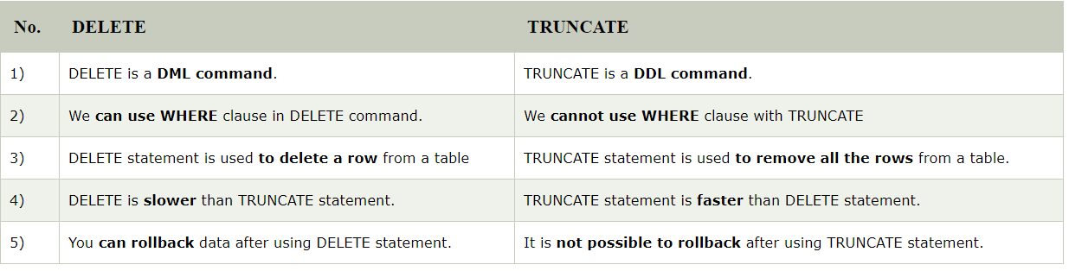

|  |  |
| --- | --- |
|  |  |
|  | DataStructure: Manipulating data in RAM  DBMS: Manipulating data in Disk |
|  |  |
|  |  |
|  |  |
|  |  |

What is ACID property in a database?

ACID is an acronym for Atomicity, Consistency, Isolation, Durability.

**Atomicity**: it requires that each transaction is all or nothing. It means if one part of the transaction fails, the entire transaction fails and the database state is left unchanged.

**Consistency**: the consistency property ensure that the data must meet all validation rules. In simple words you can say that your transaction never leaves your database without completing its state.

**Isolation**: this property ensure that the concurrent property of execution should not be met. The main goal of providing isolation is concurrency control.

**Durability**: durability simply means that once a transaction has been committed, it will remain so, come what may even power loss, crashes or errors.

|  |  |
| --- | --- |
| CREATE Database | **CREATE** DATABASE sample;  **USE** sample;  **DROP** DATABASE sample; |
| Datatypes : | Char()  Varchar(m)  Text : to store text file  Blob (To store images and short video files) |
|  |  |
|  |  |
|  |  |
|  |  |
|  |  |
| Constraints: |  |
| CREATE TABLE |  |
| DESC employee; |  |
| CREATE table from existing table |  |
| It will show all the tables in DB |  |
| To permanently delete a table from DB |  |
|  |  |
| INSERT command |  |
| Inserting Data Into a Table From Another Table |  |
| Operators |  |
| Comparison Operators |  |
| Logical Operators | ALL , AND , BETWEEN , IN ,LIKE, OR, IS NULL |
| LIKE Operator (%, _) |  |
| TOP, LIMIT |  |
| ORDER BY |  |
| GROUP BY |  |
| DISTNCT |  |
| Aliasing Through AS Clause |  |
| JOINS: | JOINS |
| Default join is inner join |  |
| Using GROUP BY Clause with SQL JOINS |  |
| Left Outer JOIN  Retrieve all values from second table including null |  |
| Right Outer JOIN  Retrieve all values from first table including null |  |
|  |  |
|  |  |
| ABS() Function |  |
| ROUND() Function |  |
| CEIL()  FLOOR()  EXP()  LOG(2)  LOG10()  POW(2,7)  GREATEST(5,7,9,19,4,37)  LEAST() |  |
| CONCAT |  |
| UPPER, LOWER |  |
| CREATE VIEW |  |
| ALTER Command |  |
|  |  |
|  |  |
|  |  |
|  |  |
|  |  |
|  |  |
|  |  |
|  |  |
|  |  |
|  |  |
|  |  |