TrafficIQ — Final Project Report
  - Traffic Congestion Prediction System • Complete project submission
CRONUS CONSULTANTS | TrafficIQ | 29 October 2026

Submission information
Item | Details
Project | TrafficIQ — Traffic Congestion Prediction System
Primary city | Kolkata, West Bengal, India
Data sources | TomTom Traffic API and OpenWeather API; no physical sensors
Frontend / backend | Streamlit Community Cloud / FastAPI on Render
ML | Python Random Forest; .py source files
Repository | github.com/Tapas-Halder/traffic-congestion-prediction
Status | Working academic prototype; not production certified

1. Abstract
TrafficIQ forecasts road congestion categories Low, Moderate and Heavy for a 15-minute horizon. The prototype combines real historical traffic observations from TomTom with weather observations from OpenWeather, applies feature engineering and a Random Forest classifier, and presents results through a Streamlit dashboard. A separate CSV workflow accepts coordinates from other cities; those predictions are experimental because the model was trained on Kolkata.

2. Problem statement and objectives
Urban congestion changes with speed, road capacity, weather and time. The objective is to demonstrate an end-to-end reproducible 15-minute congestion prediction workflow using external real-world APIs rather than installed sensors. Objectives include collecting and cleaning data, creating future labels, training a classifier, serving predictions, displaying Kolkata roads/routes/maps, and accepting historical CSV uploads.

3. System architecture
TomTom Traffic API + OpenWeather API
|
Real observation CSV -> cleaning -> future 15-min label pairing
| |
+-----> Random Forest training (.py) -> saved model
|
Public: Streamlit -> Render FastAPI -> live API/model
Local: Streamlit -> CSV inference -> saved model
Worldwide CSV: input coordinates -> predicted checkpoint map
The API collector and FastAPI server handle live requests. The public frontend defaults to Kolkata. The local-only launcher is not an online website feature. External APIs are not called for uploaded CSV predictions.

4. Modules and implementation
Module | Implementation
Data acquisition | backend collector and API service modules
Data preparation | ml/clean_data.py and ml/train_model.py
Model inference | ml/random_forest_model.py and ml/csv_inference.py
API layer | backend/app/main.py and backend/app/routes.py
Public interface | frontend/app.py and frontend/legacy_live_app.py
Local interface | frontend/local_app.py
CSV interface | frontend/csv_app.py

5. Dataset / storage design
The project uses a CSV-based historical dataset, not a relational database. The repository stores data/raw/kolkata_traffic_weather.csv and a cleaned dataset under data/processed/. Core fields include timestamp_utc, location_id, current_speed_kmph, free_flow_speed_kmph, confidence, temperature_c, humidity_pct and rain_1h_mm. Optional latitude, longitude and time_zone support mapped CSV records from worldwide locations. The model artifact is stored locally as a joblib file and must be trusted.

6. Methodology and model
Rows are cleaned and grouped by road identifier. Future targets are paired with the same road about 15 minutes later, allowing a ±5-minute matching tolerance. Features include current speed, free-flow speed, speed ratio, traffic confidence, temperature, humidity, hourly rainfall, local hour and weekday. The classifier is a scikit-learn Random Forest in a preprocessing pipeline. A chronological train/test split avoids random shuffling across time.

7. Relevant source code excerpts
Excerpt A — feature engineering (backend/app/services/features.py):
return {
"current_speed": current,
"free_flow_speed": free,
"speed_ratio": current / free,
"traffic_confidence": confidence,
"temperature": _number(main.get("temp"), "temperature"),
"hour": float(local.hour),
"day_of_week": float(local.weekday()),
}
Excerpt B — FastAPI prediction route (backend/app/main.py):
@app.post("/api/v1/predict")
def prediction(request: PredictionRequest) -> dict:
payload = collect_current_data(request.latitude, request.longitude)
features = build_prediction_features(payload)
result = predict(features)
# The actual route also validates errors and builds the response.
Excerpt C — CSV inference (ml/csv_inference.py):
labels = model.predict(valid[FEATURES])
result["prediction_at_utc"] = (
result["timestamp_utc"] + pd.Timedelta(minutes=15)
)
result["predicted_congestion"] = labels

8. Testing and verification
Check | Evidence / status
CSV validation unit tests | Test cases exist in other-files/tests/test_csv_inference.py; rerun on final commit
Python syntax | Compileall command provided; final run log to attach
API health | Team reported passing online tests; attach timestamped screenshot
Kolkata dashboard / routes | Team reported passing online tests; attach screenshots
Historical offline and CSV | Team reported passing tests; attach actual output captures
Global CSV locations | Code supports coordinates; attach non-Kolkata sample test evidence
Performance / security audit | Not independently verified

9. Measured ML results
The committed evaluation record (documentation/ML_EVALUATION_RESULTS.json) reports 14,652 cleaned rows, 14,566 valid future pairs, 11,638 training rows and 2,916 test rows. Accuracy = 60.22%; macro precision = 54.18%; macro recall = 70.73%; macro F1 = 54.81%; majority-class baseline accuracy = 79.77%. The model does not outperform the baseline in accuracy; no production-grade forecasting claim is justified.
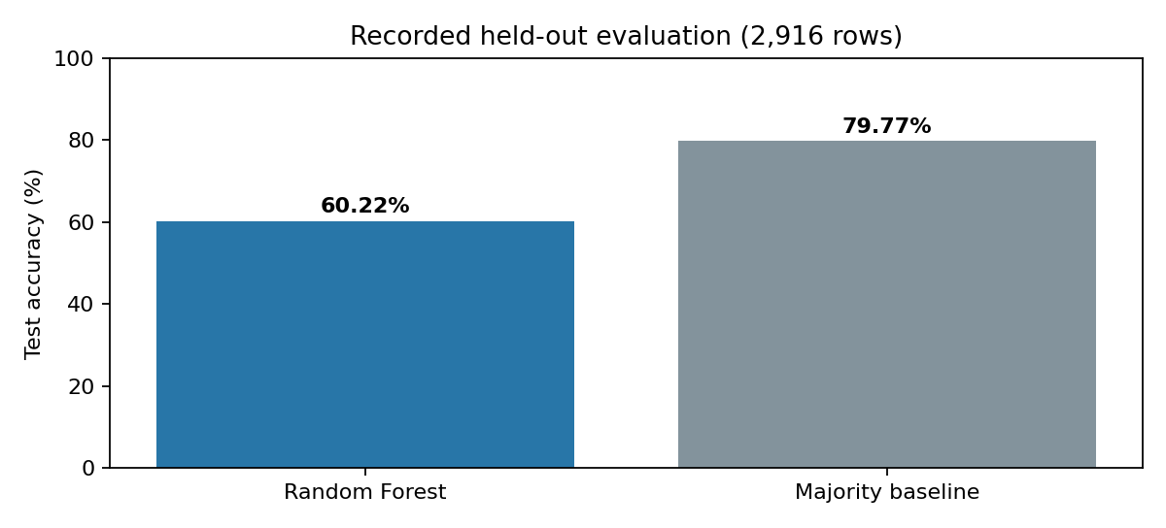

10. User interface and screenshot evidence
Screenshots must be captured from the actual running application. Do not substitute illustrations or generated mockups for test evidence. Capture: (1) public Kolkata dashboard, (2) road status, (3) Kolkata map, (4) route selection, (5) CSV upload and prediction, (6) worldwide CSV map, (7) local offline result, (8) FastAPI /health, (9) GitHub Actions or terminal test output. See documentation/SCREENSHOT_AND_TEST_EVIDENCE_GUIDE.md. These images are not included because no actual app screenshots were supplied.

11. Team responsibilities
Member | Responsibility
Tapas Halder | Team lead, backend, APIs, GitHub, deployment
Soumyadeep Mandal | Frontend and visualizations
Sumit Kumar Mandal | Data preprocessing and features
Subhajit Podder | ML training, evaluation and prediction
Pammi Biswas | Documentation

12. Limitations and future scope
The prototype is Kolkata-trained; results for other cities have not been validated. CSV inference is historical relative to each observation timestamp and does not fetch live APIs. The model underperforms the majority baseline; additional data, calibration, feature selection and temporal validation are needed. The original frontend remains relatively large; modular refactoring, tests, accessibility, monitoring and secret reviews are future work.

13. Conclusion and references
TrafficIQ demonstrates a complete academic software pipeline from external real observations to an interactive prediction interface. The system meets the requested architecture and demonstrates deployment, while the documented limitations prevent overclaiming reliability.
References: GitHub repository; TomTom Traffic API documentation; OpenWeather API documentation; scikit-learn RandomForestClassifier documentation; Streamlit documentation; FastAPI documentation; committed ML evaluation JSON.

