PROJECT AND TEAM INFORMATION

Project Title

EcoTrade: Electronic Barter & Community Donation System

Student / Team Information
Team Name: | tapastomar36
Team member 1 (Team Lead)  First Name-Tapas  Last Name-Tomar  University Roll No-2519549  Student Id-25101281462  Email-tapastomar36@gmail.com | 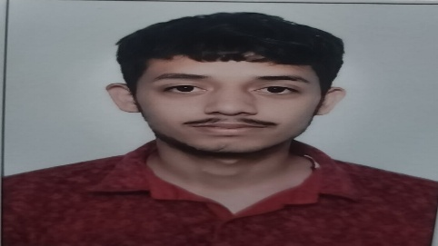
Team member 2  First Name-Tejeswa  University Roll No-2519551  Student Id-2510370401  Email-tejeswa26@gmail.com | 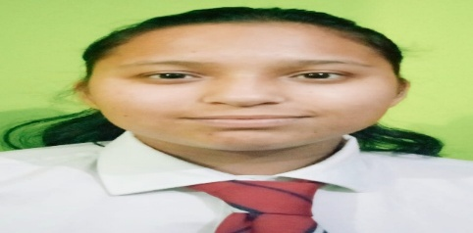
Team member 3  First Name-Muhammad  Last Name-Anas  University Roll No-2519426  Student Id-25101281063  Email-itzmd.anas@gmail.com | 
Team member 4  First Name-Sujal  Last Name-Belwal  University Roll No-2519536  Student Id-25101281063  Email-belwalsujal911@gmail.com | 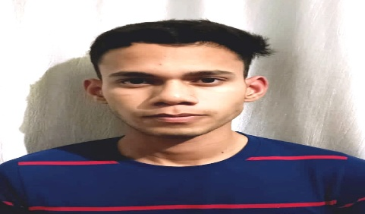

PROPOSAL DESCRIPTION (10 pts)

Motivation (1 pt)
In our college, we noticed two everyday problems where campus resources are either wasted or poorly coordinated.
First, after semesters or project submissions wrap up, a lot of working electronic items—such as Arduino/Raspberry Pi boards, lab sensors, scientific calculators, adapters, and computer peripherals—end up lying idle in hostel cupboards or getting thrown away. Throwing them out directly adds to campus e-waste, while selling them on platforms like OLX comes with price haggling, strangers, and shipping hassles. At the same time, juniors or other students who need these exact components have to purchase them brand new. A cashless, peer-to-peer barter system allows students to trade working gadgets they don't need for devices or components they actually do, keeping electronics in active use and cutting down waste.
Second, when it comes to donations, there is no single campus hub. Our college has its own dedicated blood bank that periodically hosts blood donation drives, but announcements usually get lost in flooded WhatsApp groups, Instagram stories, or paper circulars. Many willing students miss the drives simply because they didn't see the notice in time. Beyond blood drives, students graduating or moving rooms often want to donate textbooks, engineering drafters, lab coats, and other essentials, but have no easy way to connect with peers who could use them.
We wanted to build a unified campus platform using C++ and Object-Oriented Data Structures that solves both issues: promoting sustainability through direct electronic bartering, while providing a clear, structured donation registry for blood drives and general student essentials.

State of the Art / Current solution (1 pt)
Currently, both electronic reuse and campus donations rely on fragmented, informal methods rather than an organized system.
For electronics, students typically post pictures on informal WhatsApp batch groups, batch Discord servers, or commercial classifieds like OLX and Quickr. Commercial platforms are not practical for micro-components or peer-level exchanges because they focus on cash transactions, involve strangers outside campus, and introduce unnecessary commission or logistics friction. On informal chat groups, listings get buried under routine conversations within hours, leading to zero discoverability. Consequently, working electronics often stay forgotten in drawers or end up in campus trash bins.
For donations, our college blood bank and student clubs rely on pinned circulars, physical noticeboard posters, and mass forward chains across social media to announce upcoming blood donation drives or book collection campaigns. These methods are passive and lack structured tracking—there is no automated waitlist, donor eligibility tracking (such as days passed since the last donation), or centralized inventory showing which student essentials (books, lab gear) are currently needed. Because current solutions depend heavily on word-of-mouth, resource distribution remains inefficient across batches.

Project Goals and Milestones (2 pts)
Project Goals:
- Build a fast, modular, console-based desktop application in C++ applying Object-Oriented Programming (OOP) and Data Structures and Algorithms (DSA).
- Create a cashless barter marketplace that allows students to list, browse, and trade working electronics, microcontrollers, and peripherals directly with verified peers.
- Establish a centralized donation tracking system that handles registration for college blood bank donation drives (including donor availability and blood group indexing) as well as peer-to-peer donation of study tools and student essentials.
- Maintain clean terminal-based navigation, persistent file logging, and zero dependencies on heavy external web frameworks for rapid, lightweight execution.
Project Milestones:
- Milestone 1: Planning & Base Architecture (Week 1–2 / Current 20% Evaluation) Define system requirements, design class hierarchies (OOP models for users, electronic items, and donation items), set up authentication logic, and build a working terminal menu with in-memory test data.
- Milestone 2: DSA Implementation & Matching Logic (Week 3–4 / 50% Completion) Integrate hash maps/dictionaries for instant user and inventory lookups, linked lists for traversing barter catalogues, and a priority-based queue system to organize drive registrations and urgent supply requests.
- Milestone 3: Transaction Handling & File Persistence (Week 5–6 / 80% Completion) Implement file-handling (CSV/text file read-write) to save user registries, pending barter requests, and completed donation logs between runs; add input validation to prevent invalid data crashes.
- Milestone 4: Testing, Optimization & Final Polish (Week 7–8 / 100% Completion) Perform edge-case testing, resolve any memory leaks using proper C++ destructor and pointer cleanup, refine terminal UI formatting, and compile the final project report with complexity analysis.

Project Approach (3 pts)
Platform and Environment: The application is designed as a standalone, native desktop console program built using C++ (Standard C++17/C++20). It runs across platforms (Windows/Linux) using standard compilers like GCC/MinGW and Clang, keeping the application lightweight, dependency-free, and resource-efficient.
Object-Oriented Architecture (OOP):
- Encapsulation: Core entities like User, ElectronicItem, and DonationRecord bundle attributes and private access specifiers, exposed only through safe getters, setters, and validation methods.
- Inheritance & Polymorphism: An abstract base class Item defines standard properties (item ID, donor/owner details, timestamp). Derived classes ElectronicItem (adds hardware specs, condition rating, desired barter item) and DonationItem (adds category: blood drive registration vs. physical goods like books/tools) override dynamic display and verification behaviors via virtual functions.
Data Structures & Algorithmic Design (DSA):
- Hash Maps (std::unordered_map): Provides $O\left(1\right)$ average-time indexing for user authentication, student ID lookups, and inventory access by unique IDs.
- Doubly Linked Lists: Used to maintain active barter catalog views, enabling smooth forward and backward pagination through listed electronic gadgets in the terminal.
- Priority Queue (Max-Heap): In the donation module, incoming requests and drive slots are sorted dynamically ($O\left(\log{N}\right)$) by urgency metrics, prioritizing critical blood group requirements and high-demand student supply allocations.
- Vectors / Dynamic Arrays: Used for session-based request buffering and logging past transactions.

System Architecture (High Level Diagram)(2 pts)
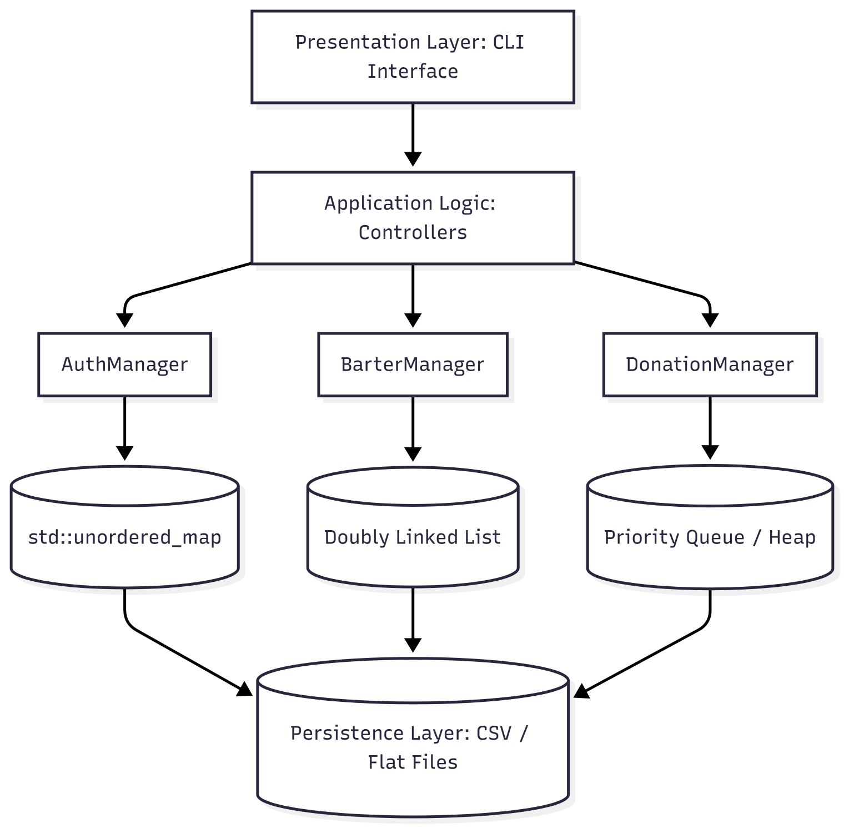

Project Outcome / Deliverables (1 pts)
· Working C++ Console Application: A modular, compiled executable demonstrating core OOP patterns (inheritance, encapsulation, polymorphism) and custom DSA implementations for inventory management and donor registration.
· E-Waste Barter Engine: A fully functional peer-to-peer exchange module where students can create verified listings for idle electronics, browse available hardware, and initiate direct trades without monetary transactions.
· Donation & Drive Registry: A centralized module tracking upcoming campus blood donation camps, donor availability by blood group, and peer-to-peer donations of academic essentials (books, lab equipment).
· Local Persistence Layer: Integrated file-handling mechanisms (.csv / .txt) that persist user records, inventory states, and transaction histories across application sessions.
·Technical Documentation & Source Code: Well-structured source code repository with comprehensive documentation, including UML class diagrams, data structure time/space complexity evaluations, and a user manual for console navigation.

Assumptions
· Campus Exclusivity: All users are registered students or staff members of the institution with valid college roll numbers or IDs.
· Physical Verification & Handover: Electronic item quality, working condition, and final bartering exchanges are verified and handled physically in person by the trading students.
· Medical Compliance: Blood donation criteria, donor health screening, and actual donations follow the established medical safety standards and procedures of the college blood bank.

References
1-cppreference.com: C++ Standard Library & Containers Reference (Vector, Map, Priority Queue, Unordered Map) – https://en.cppreference.com/
2-Central Pollution Control Board (CPCB), Ministry of Environment, Forest & Climate Change (India): E-Waste (Management) Rules and Guidelines – https://eprewaste.cpcb.gov.in/
3-National Blood Transfusion Council (NBTC) & e-RaktKosh Portal: Voluntary Blood Donation Guidelines & Donor Selection Criteria, Ministry of Health and Family Welfare – https://eraktkosh.in/ and https://dghs.mohfw.gov.in/bts.php

