NYC Yellow Taxi Trip Analysis

Data Analysis and Visualization

B. Tech. Semester V

Report Prepared By

Tapasya Patel, Varun Patel


School of Engineering
Institute of Technology
Nirma University
Ahmedabad 382481
Index
Sr. No | Description | Page No.
1 | Introduction | 3
2 | Objective & Dataset Overview | 3
3 | Data Preprocessing | 4
4 | Feature Engineering | 5
5 | Outlier and Correlation Treatment | 8
6 | Spatial Analysis | 9
7. | Clustering Analysis | 9
8. | Regression Modelling | 10
9. | Time Series Analysis | 12
10. | Tableau Dashboards | 13
11. | KNIME Analysis | 15
12. | Power BI Dashboards | 18
13. | Key Performance Indicators (KPIs) | 20
14. | Insights | 21
15. | Future Scopes | 21
16. | References and Links | 21

  - Introduction
The NYC Yellow Taxi dataset is a rich source of information that reflects the transportation dynamics of New York City.
This project analyzes 2015 taxi trip data to uncover insights into trip patterns, fare trends, and operational efficiency using data cleaning, feature engineering, clustering, regression, time series analysis, and visualization techniques.
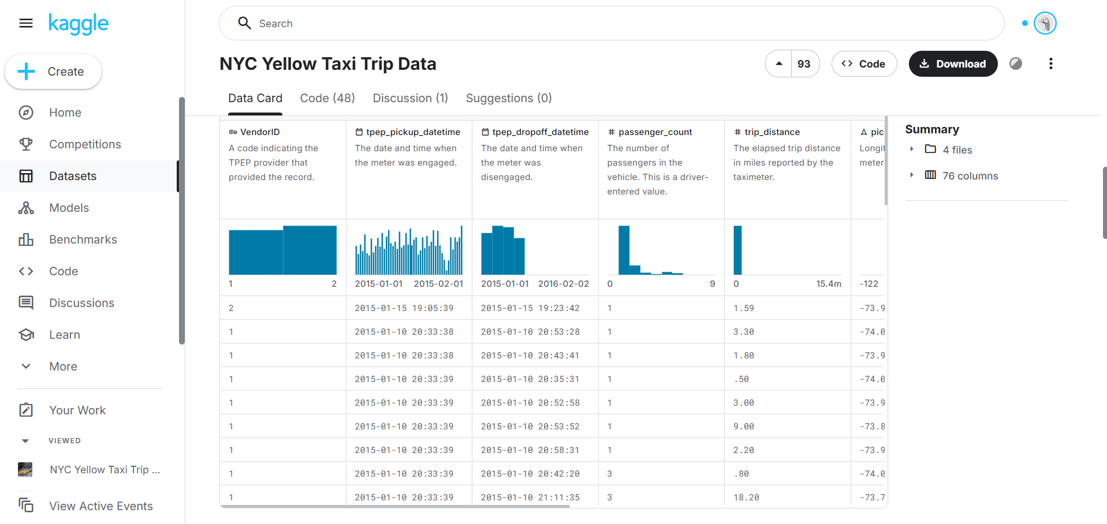

  - Objective & Dataset Overview

- Understand travel demand and fare dynamics
- Identify patterns and anomalies in trips.
- Predict fare amounts using machine learning models.
- Build interactive dashboards for business and driver insights.

Source: NYC Yellow Taxi Trip Data — Kaggle
Period Used: January 2015

Column | Description
pickup_datetime, dropoff_datetime | Trip timestamps
trip_distance | Distance covered (miles)
fare_amount, tip_amount, total_amount | Payment details
pickup_latitude, pickup_longitude | Pickup coordinates
dropoff_latitude, dropoff_longitude | Dropoff coordinates

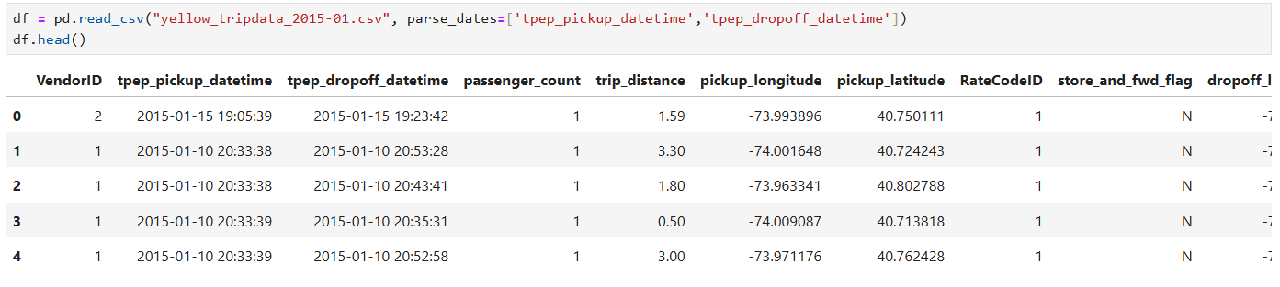

  - Data Preprocessing
- Handling missing and invalid values.
- Fixing geographical bounds (NYC latitude/longitude limits).
- Removing duplicates.
- Outlier removal using quantile-based trimming.
- Dropping irrelevant columns.
- Encoding categorical variables.
- Feature scaling using StandardScaler.
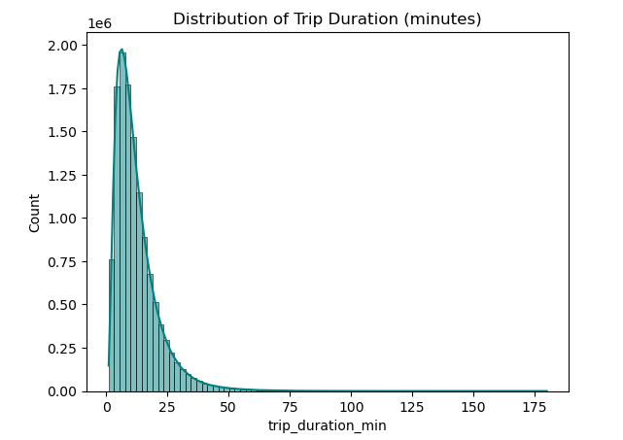

  - Feature Engineering
Feature | Formula / Description
trip_duration_min | Dropoff - Pickup (in minutes)
haversine_km | Great-circle distance between pickup/dropoff
avg_speed_kmph | Distance / Duration
tip_rate | Tip / Fare
fare_per_km | Fare / Distance
fare_per_min | Fare / Duration
hour, day, month, day_of_week, is_weekend | Time-based features

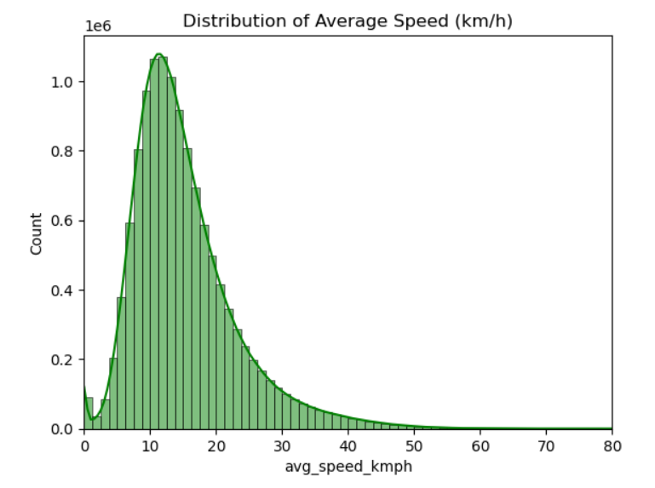
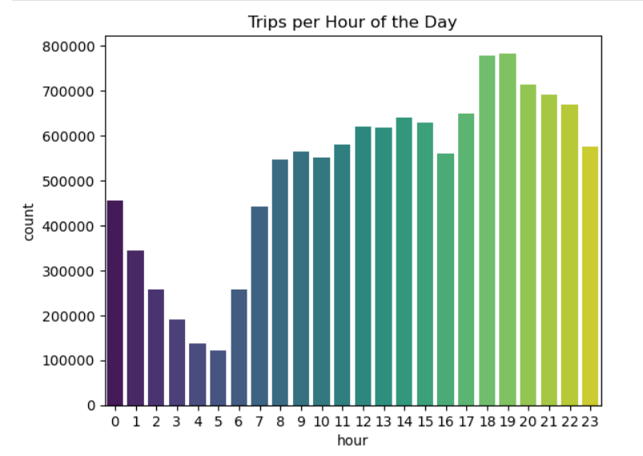

  - Outlier and Correlation
- Outliers detected using boxplots and quantiles.
- Removed extreme points (below 1st or above 99th percentile).
- Highly correlated columns (r > 0.9) were dropped to reduce redundancy.
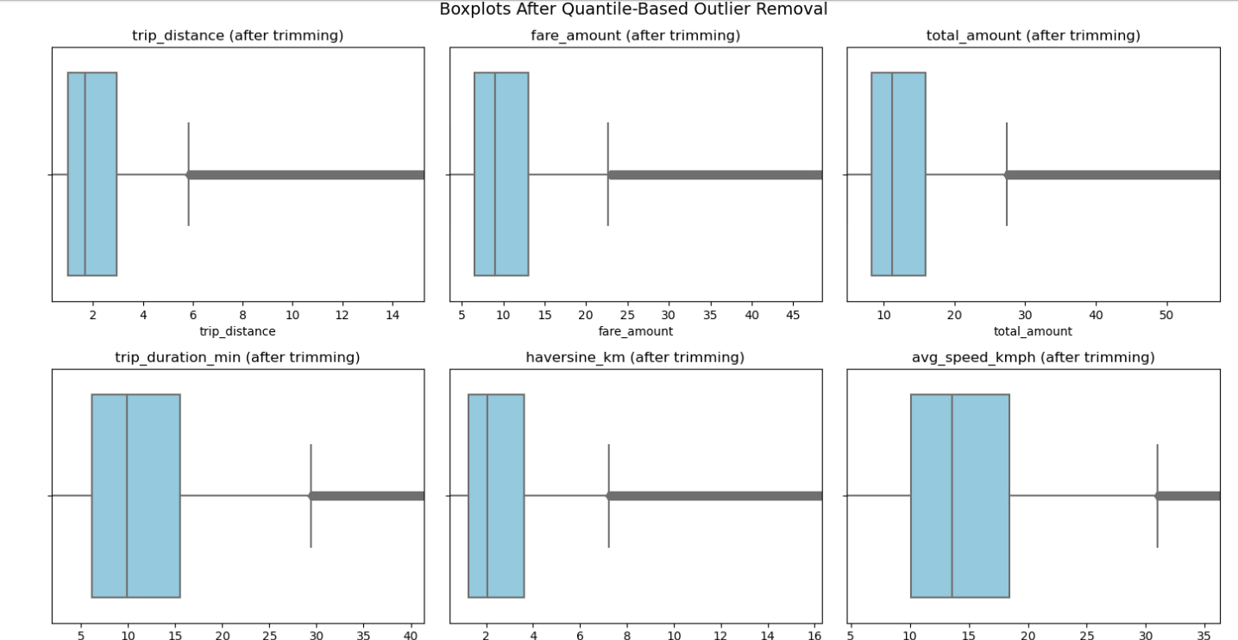
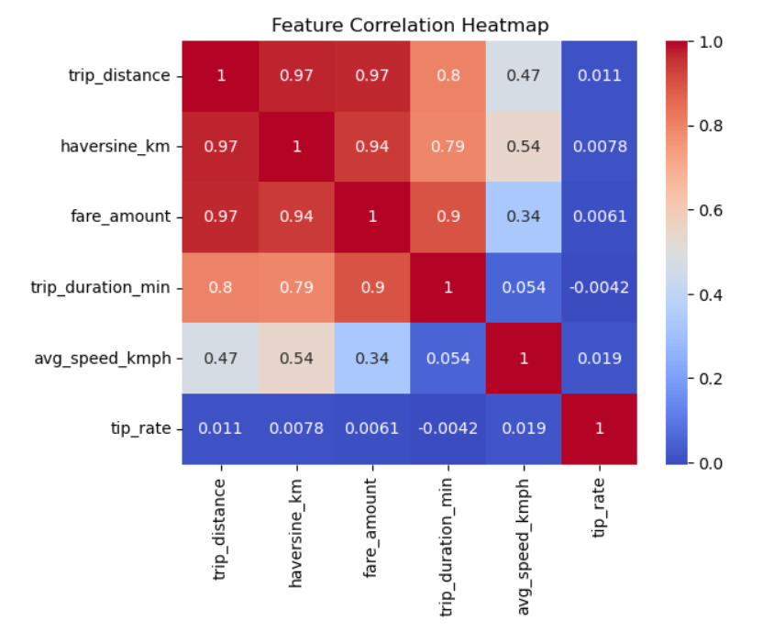

  - Spatial Visualisation
Spatial (map-based) analysis is one of the most powerful aspects of this dataset.
By plotting pickup and dropoff coordinates, we can visualize travel hotspots, demand concentration, and revenue density across New York City.
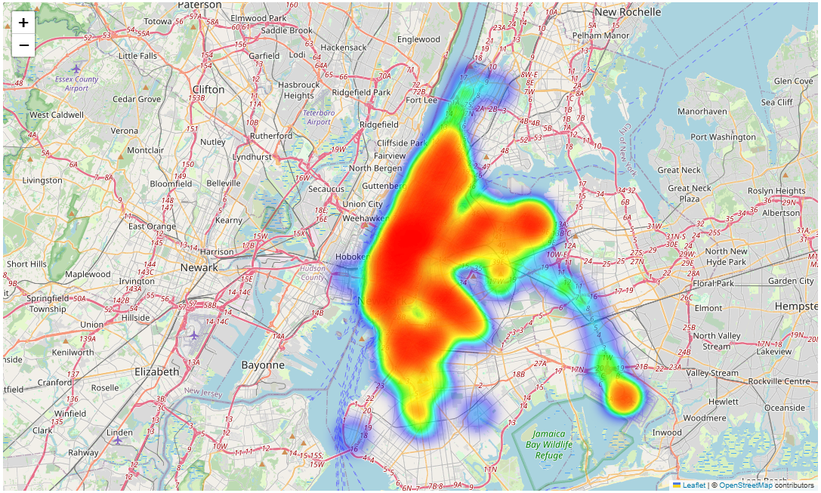

  - Clustering Analysis
Goal: Identify trip behavior clusters (short, medium, long, high fare, etc.)
Features Used:
trip_distance, trip_duration_min, avg_speed_kmph, fare_amount, tip_rate, passenger_count
Algorithm: K-Means
Steps:
- Data normalized (Z-score)
- Optimal k chosen using Elbow and Silhouette methods
- Cluster labels added back to dataset
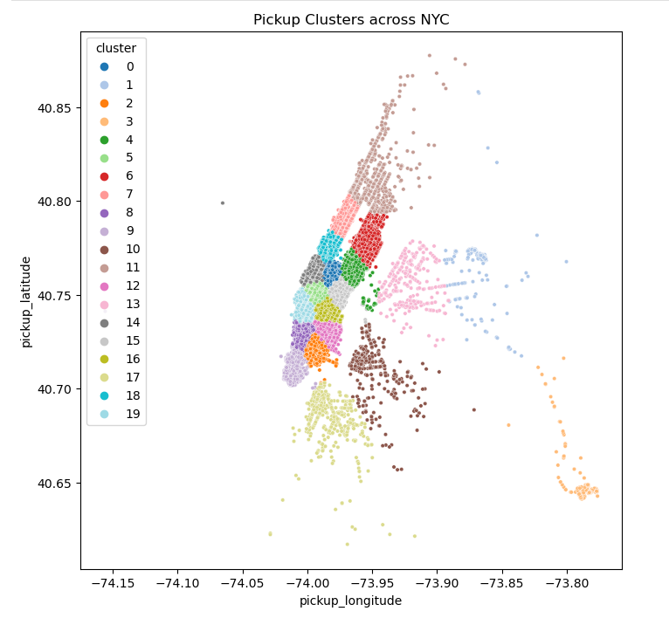
  - Regression Modelling
Objective: Predict total fare amount.
Model Used: Random Forest Regressor
Features:
trip_distance, trip_duration_min, passenger_count, hour, day_of_week

Performance Metrics:
Metric | Value
R² | ~0.89
RMSE | ~3.5
MAE | ~2.7
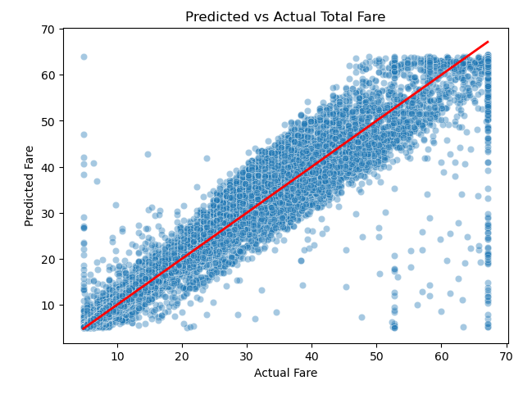
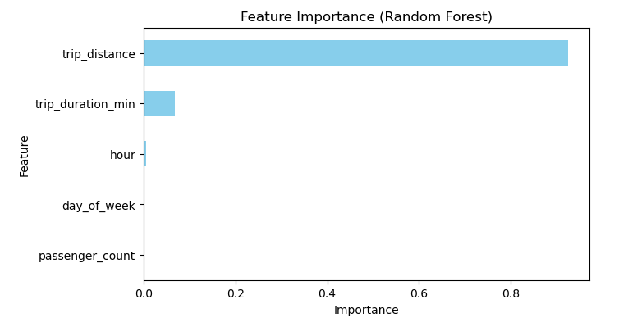
  - Time Series Analysis
Analyzed daily trip counts to detect trend, seasonality, and anomalies.
Used seasonal_decompose() (additive model).
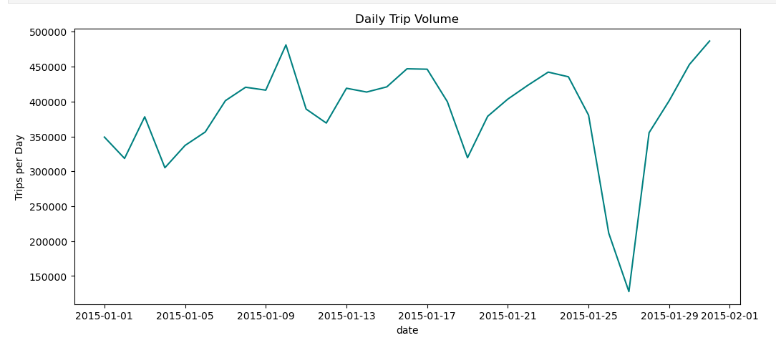

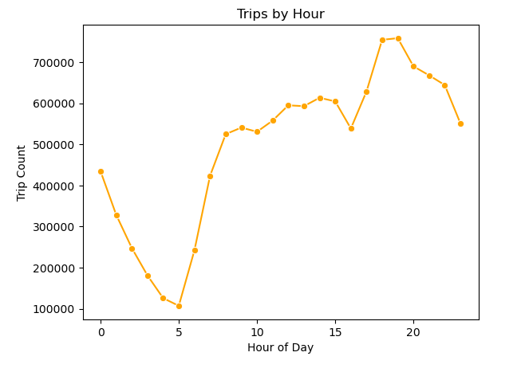
  - Tableau Dashboards
Dashboard 1 – Operations Overview
Objective: Help business stakeholders understand demand and revenue trends.
Visual Components:
- KPIs: Total Duration (sum of all trips), Mean Duration, Average Trip Speed, Average Trip Distance, Mean Fare, Average Tipping Rate, Total Number of Rides
- Trips by Day (Line Chart)
- Trips by Hour (Bar Chart)
- Top Pickup Locations (Map)
- Fare VS Trip (Scatter Plot)
- Average Speed By Hour (Line Chart)
- Quick Filters
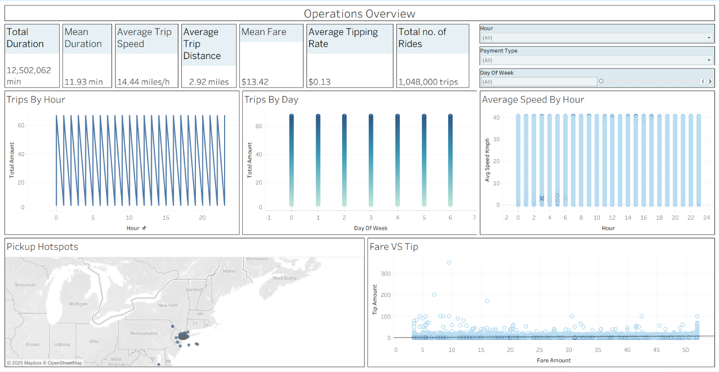

Dashboard 2- Financial Dashboard
Objective: Provide actionable insights to drivers and fleet managers.
Visual Components:
- KPIs: Avg Fare Per Trip, Avg Tip Rate, Total Trips, Total Revenue
- Trip Behvaiour Analysis(Line Chart)
- Revenue Trend Over Time(Line Chart)
- Fare VS Distance(Scatter Plot)
- Revenue By Hour(Line Chart)
- Payment Type (Pie Chart)
- Quick Filters
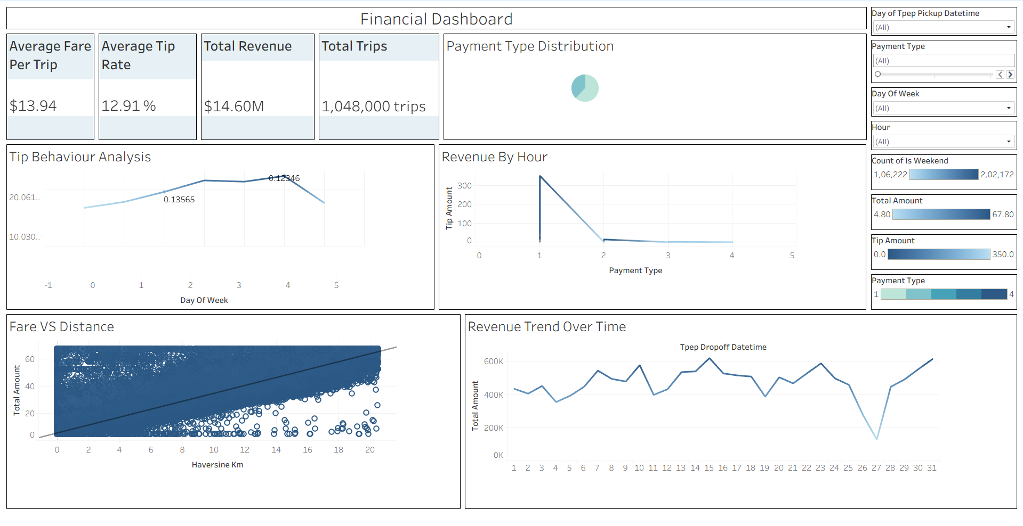

  - KNIME Analysis
The KNIME workflow was developed to perform end-to-end data analysis on the NYC Taxi dataset.
It automates data loading, cleaning, transformation, feature engineering, clustering, model training, and evaluation steps in a modular and visual way.
The goal is to extract actionable insights such as travel patterns, fare behavior, trip duration trends, and customer segments.

- Data Preprocessing and Visualisation:
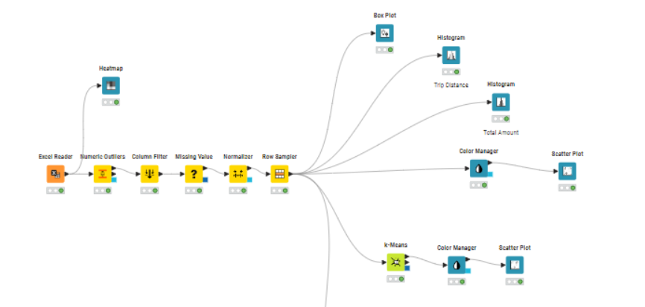

- Clustering
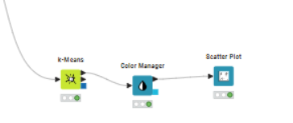

- Regression
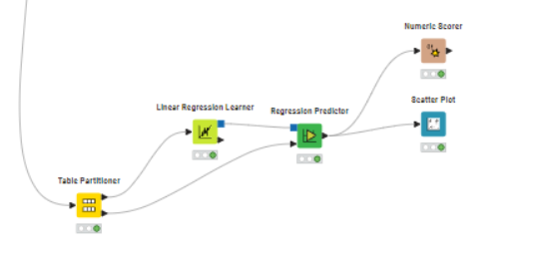
Outputs:
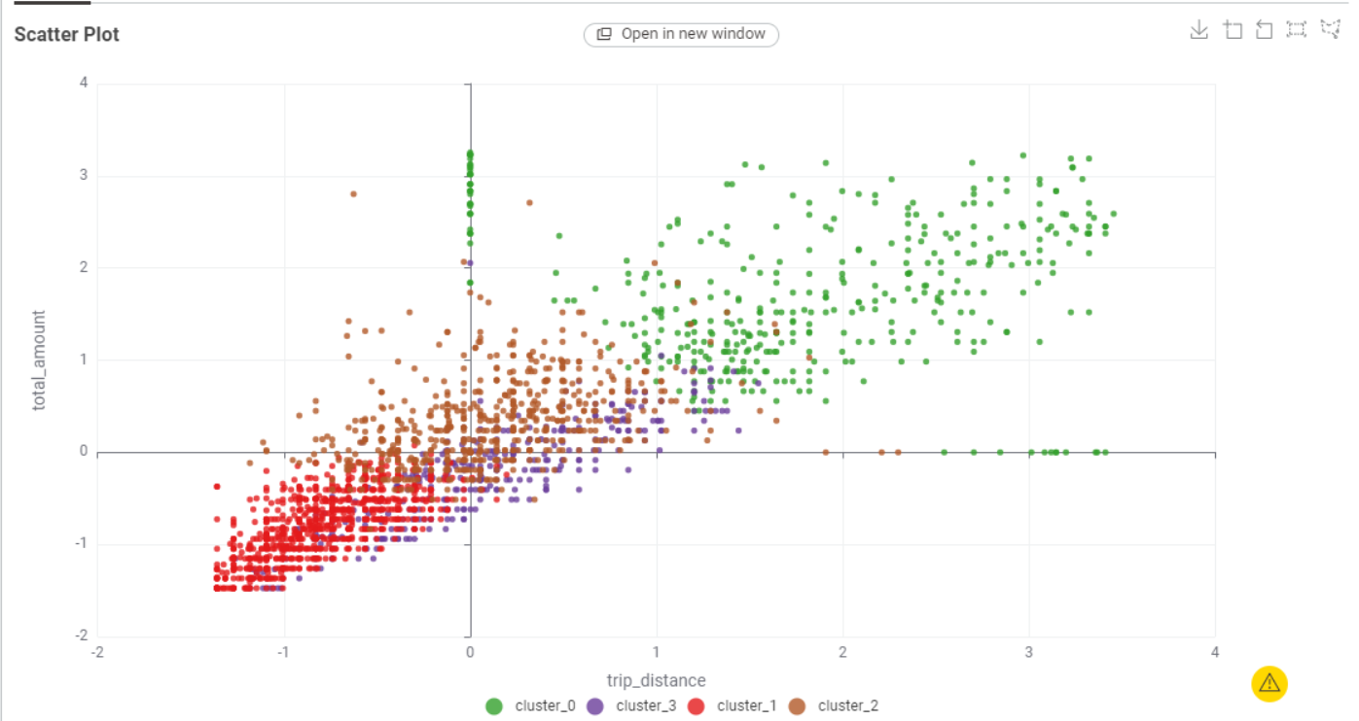
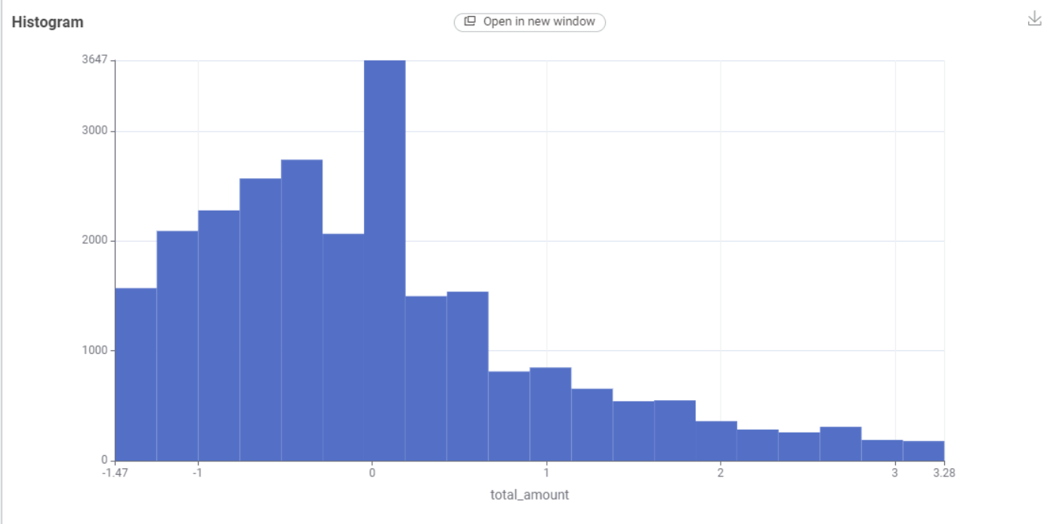

  - Power BI Dashboard
This Power BI project analyzes NYC Yellow Taxi trips using the cleaned dataset cleaned_nyc_taxi.xlsx.
Data was prepared by correcting data types, removing duplicates, and filtering extreme outliers. Key DAX measures such as Total Trips, Total Revenue, Average Fare, Average Distance, Average Speed, Average Trip Duration, and Average Tip Rate were created to drive the dashboards.
Two interactive dashboards were developed:
Dashboard 1 – Operations Overview
Shows trip patterns through:
- Trips by Hour & Day
- Average Speed by Hour
- Pickup Hotspot Map
- Fare vs Tip relationship
Insights: Demand peaks during morning/evening hours, Manhattan and airports are major pickup hotspots.
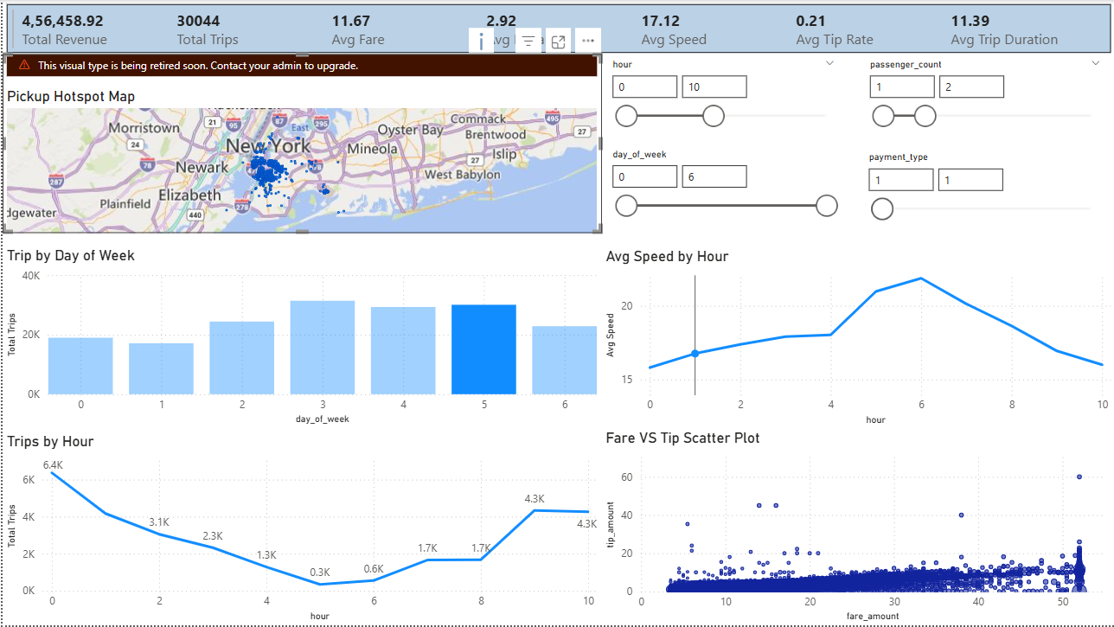

Dashboard 2 – Business & Revenue Insights
Includes:
- Revenue Trend
- Revenue by Passenger Count
- Fare Distribution
- Distance vs Fare
- Payment Type Revenue
Insights: Weekends yield higher revenue, card payments dominate tipping, and fare increases with trip distance.
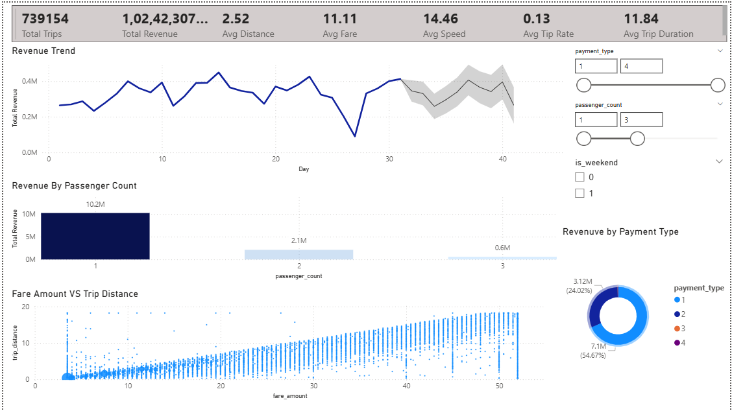

Overall, the dashboards provide clear operational, spatial, and financial insights to support decision-making for taxi services and city transport planning.

  - Key Performance Indicators (KPIs)
KPI | Unit | Description
Total Revenue | USD | Total sum of all trip fares
Average Fare | USD/trip | Mean revenue per trip
Average Speed | km/h | Average travel efficiency
Average Tip Rate | % | Tip proportion of fare
Trip Volume | count | Total completed rides
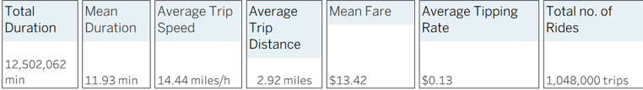
  - Insights and Conclusions
Major Findings:
- Most trips are short (<5 km) within Manhattan.
- Friday evenings and weekends show highest demand and revenue.
- Tip rates are highest for card payments.
- Average fare and distance have a strong positive correlation.
- Model predicts fare amount with ~89% accuracy.

  - Future Scope
- Integrate weather and traffic data for better forecasting.
- Add deep learning (LSTM) for time-series fare prediction.
- Build real-time dashboards using live taxi feeds.

  - References and Links
• NYC Taxi Dataset on Kaggle
• Project Code Repository (GitHub)

