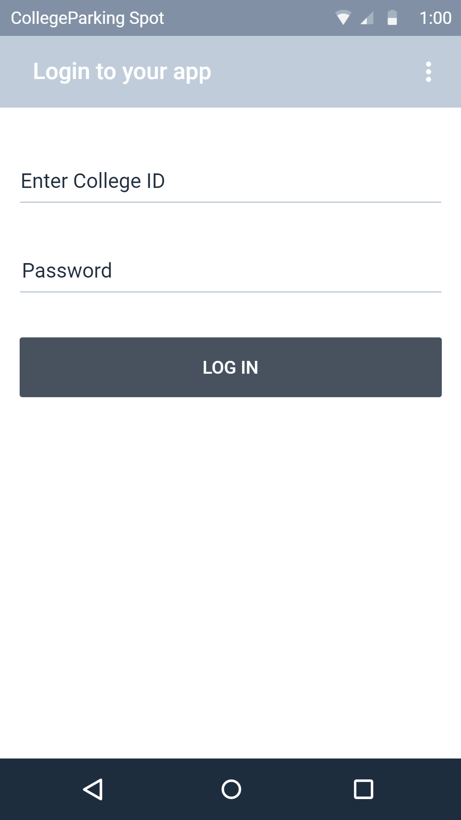

Login: This represents the login phase with college id and password

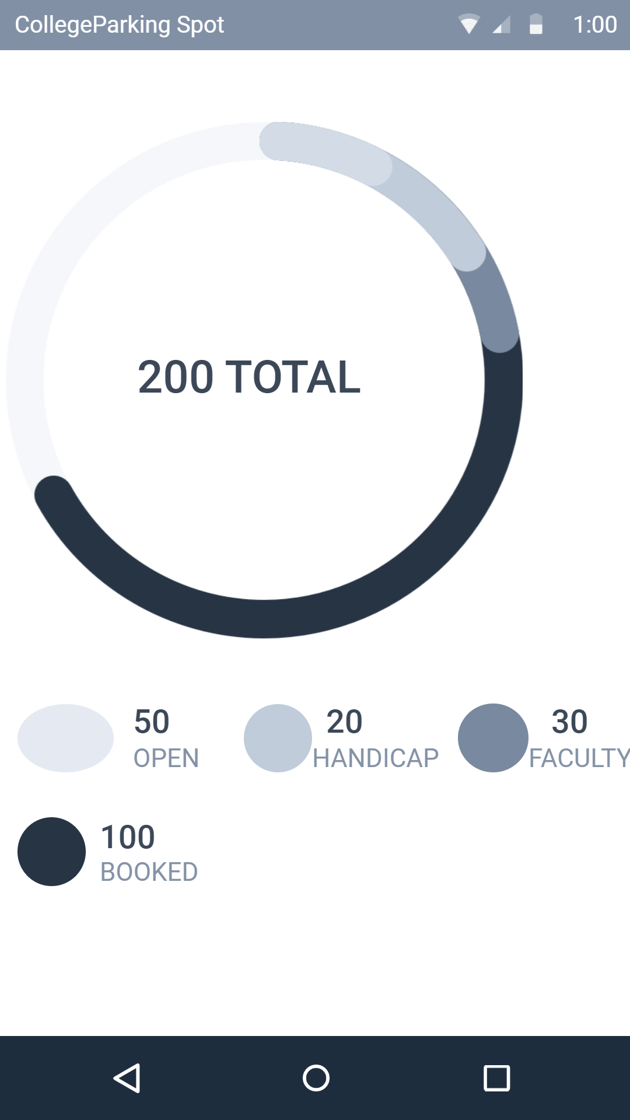

Availability: This represents the availaibility

of space

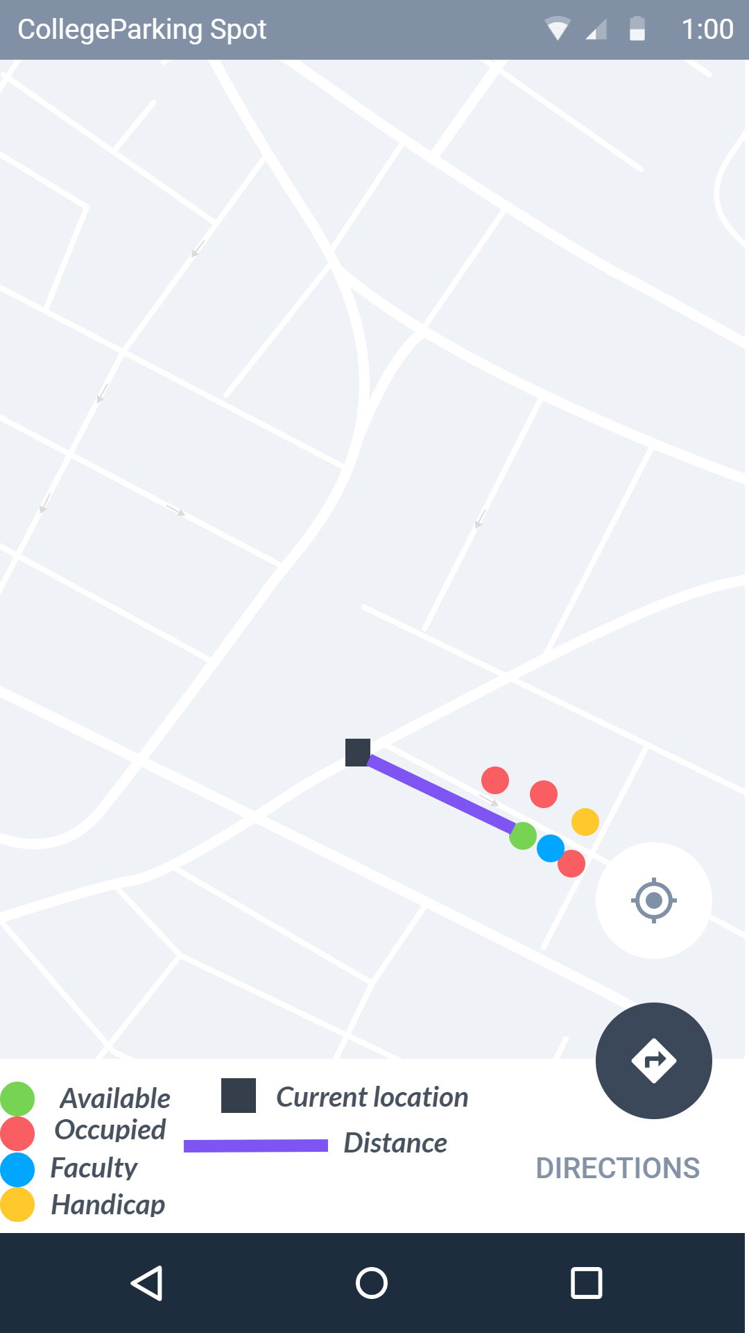

Login: This represents the available parking area along with the nearest spot