TUTORIAL - Creating a PostGIS -database for QGIS PART 1

QuantumGIS is a fully Open Source GIS -software that works with several database management systems. PostgreSQL+PostGIS are also open source and widely used. QGIS is designed to work with PostgreSQL.

You can download and install the PostgreSQL from here: <http://www.postgresql.org/>

You’ll also need the PostGIS since we’re working with spatial data. You can download it from here: <http://postgis.net/> and follow the installation instructions here: <http://postgis.net/install>

QGIS can be downloaded from here: <http://www.qgis.org/en/site/forusers/download.html>

This is for everyone trying to learn about PostgreSQL, PostGIS and QGIS. This tutorial was created with Windows 7, PostgreSQL 9.4, PostGIS 2.1 and QGIS 2.8.2.

Creating the PostGIS-database

After installing the PostGIS + PostgreSQL bundle start the pgAdminIII. I’ve installed a localhost -DB with a username postgres and a password postgres. This is bad practice. In real projects create a more secure username/password combo. I’m using the postgres -username since it’s default and has all the privileges.

More about PostgreSQL users and privileges <http://www.postgresql.org/docs/7.4/static/user-manag.html>

Create a new localhost -connection (or the host where you installed your database)

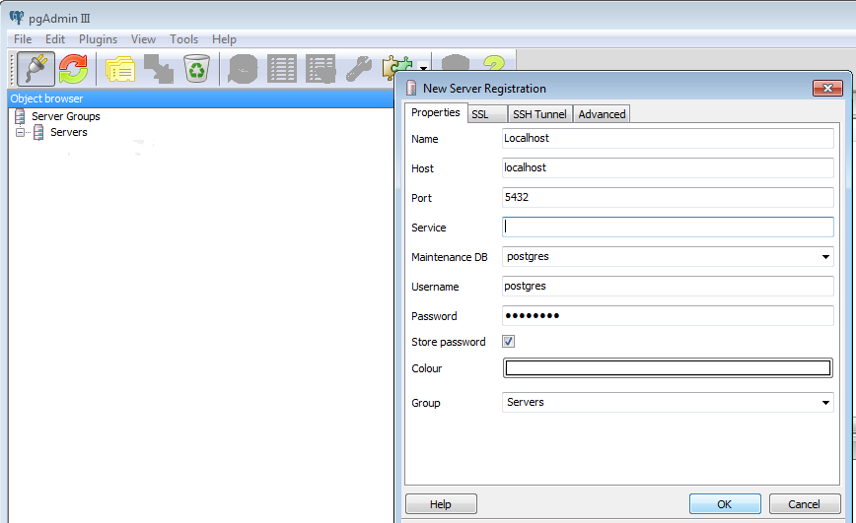

Let’s create a new database called testqgis

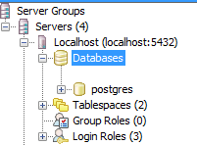

Click the right mouse over Databases

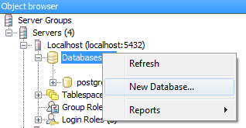

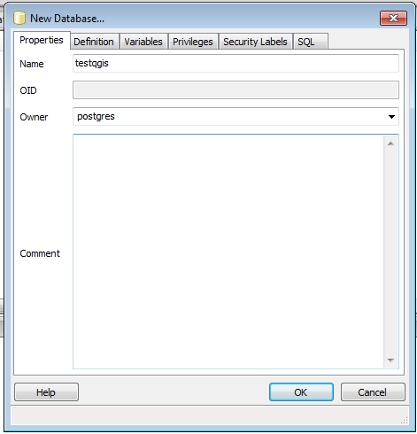

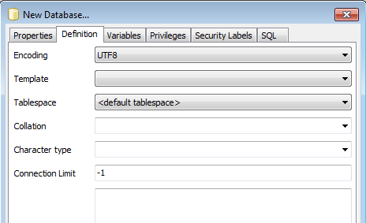

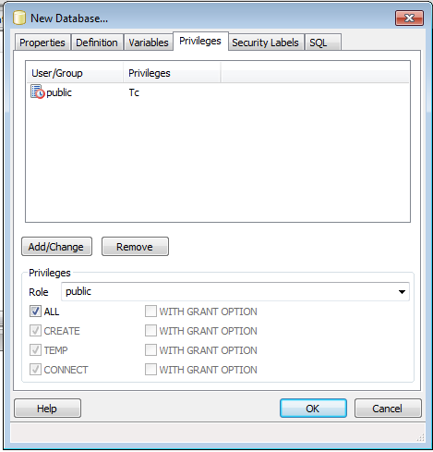

And the new database is created!

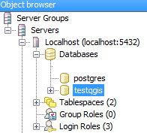

There is one more thing to do. We need to add PostGIS extensions for the database to work properly. Open the SQL editor (Execute arbitrary SQL queries).

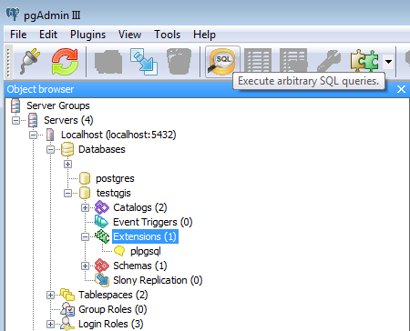

Paste this code to the SQL editor

CREATE EXTENSION postgis

SCHEMA public

VERSION "2.1.7";

CREATE SCHEMA topology

AUTHORIZATION postgres;

CREATE EXTENSION postgis_topology

SCHEMA topology

VERSION "2.1.7"; 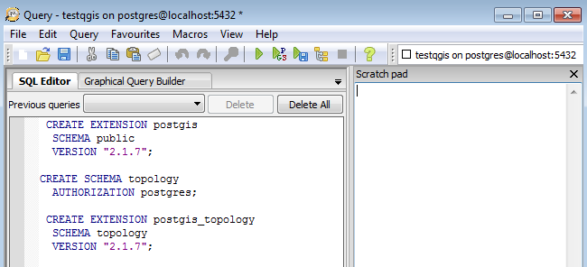

You should see new extensions and a schema appearing under the testqgis database

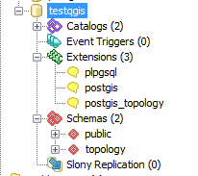

Open the QGIS

Create a new PostGIS -connection to your freshly created PostGIS -database





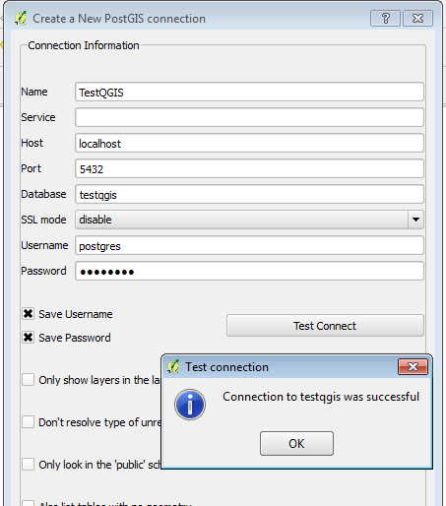

You should see a new connection appearing under the the PostGIS tree root

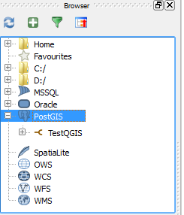

TUTORIAL - Creating a PostGIS -database for QGIS PART 2

**Source code**  
This is for everyone trying to learn about PostgreSQL, PostGIS and QGIS. This tutorial was created with Windows 7, PostgreSQL 9.4, PostGIS 2.1 and QGIS 2.8.2.

You can download all the project files from here (under BuildingsInEspooShp):  
<https://github.com/Tapir79/JDBCTemplateRowMapper>  
Clone (https): <https://github.com/Tapir79/JDBCTemplateRowMapper.git>  
ZIP: <https://github.com/Tapir79/JDBCTemplateRowMapper/archive/master.zip>

Importing the Shape -file to the database

I’m assuming you don’t have any shapefiles to work with. So go ahead and download these test files from my GitHub repository:

. The dataset is the buildings in the city of Espoo. The data is open so it’s free to use for anyone anywhere. They’re 2D -vector shapes since QGIS basic database import tools don’t work with 3D. Go ahead and save them to any local folder on your computer.

The original data is from this website http://www.hri.fi/en/dataset/espoon-rakennukset and I’ve converted to shape -format with FME <https://www.safe.com/fme/> (FME isn’t free but there’s a free trial version).

You’ll find plenty of more open spatial data here: <http://www.hri.fi/en/>

First add the vector layer



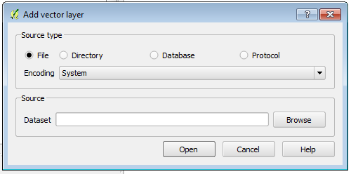

Choose Browse and find the shape-file you downloaded earlier.

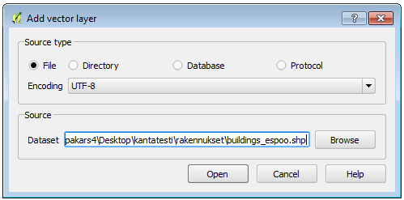

Click Open.

You should see this:

Let’s create a new PostGIS -connection.

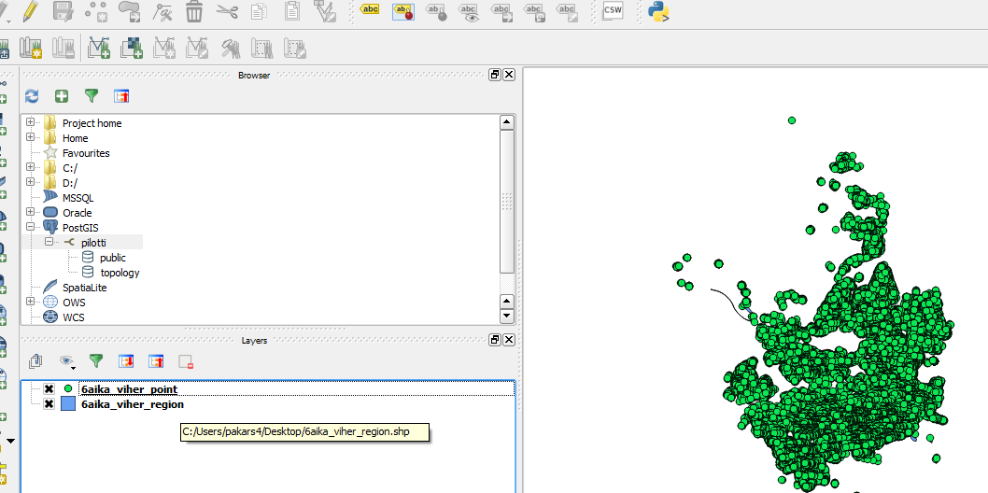

After having a PostGIS -connection choose Spit from Database -menu.

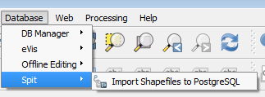

Add the shapefile

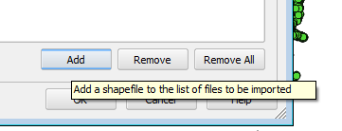

Click OK. The Feature field should not be null. If it is, something’s wrong.

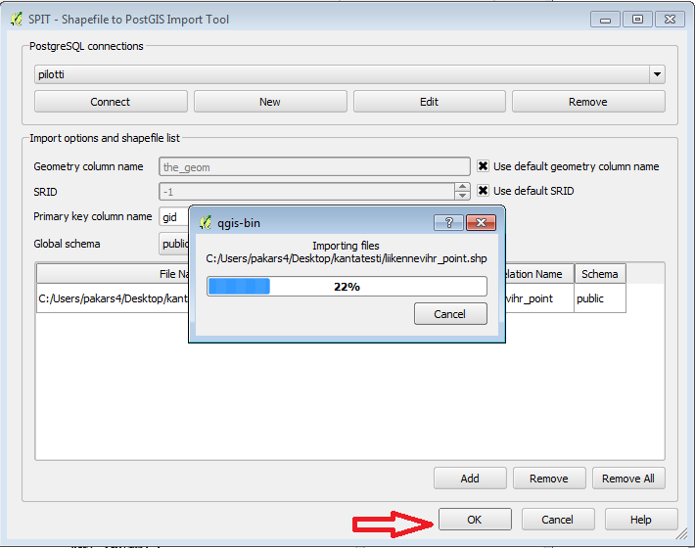

You can view your fresh data with DBManager or choose the data from the QGIS Browser.

Thanks for reading! ☺

SORSAT eka

<ul>

<li><strong>QuantumGIS</strong> is an open source GIS -software that works with several database management systems </li>

<li><strong>PostgreSQL+PostGIS</strong> are also open source and widely used</li>

<li> QGIS is designed to work with PostgreSQL</li>

<li>You can download and install the PostgreSQL from here: http://www.postgresql.org/</li>

<li>You’ll also need the PostGIS since we’re working with spatial data. You can download it from here: http://postgis.net/ and follow the installation instructions here: http://postgis.net/install</li>

<li>QGIS can be downloaded from here: http://www.qgis.org/en/site/forusers/download.html</li>

</ul>

This is for everyone trying to learn about <strong>PostgreSQL, PostGIS and QGIS</strong>. This tutorial was created with Windows 7, PostgreSQL 9.4, PostGIS 2.1 and QGIS 2.8.2.

<–!more–>

<hr />

<strong>Creating the PostGIS-database</strong>

<ol>

<li>After installing the PostGIS + PostgreSQL bundle start the pgAdminIII. I’ve installed a localhost -DB with a username postgres and a password postgres. <em>This is bad practice. In real projects create a more secure username/password combo. I’m using the postgres -username since it’s default and has all the privileges.

More about PostgreSQL users and privileges http://www.postgresql.org/docs/7.4/static/user-manag.html</em></li>

<li>Create a new localhost -connection (or the host where you installed your database)

<img src="">

</li>

<li>Let’s create a new database called testqgis

<img src="">

</li>

<li>Click the right mouse over Databases

<img src="">

<img src="">

<img src="">

<img src="">

</li>

<li>And the new database is created!

<img src="">

</li>

<li>There is one more thing to do. We need to add PostGIS extensions for the database to work properly. Open the SQL editor (<em>Execute arbitrary SQL queries</em>).

</li>

<li>Paste this code to the SQL editor

[sourcecode]

CREATE EXTENSION postgis

SCHEMA public

VERSION "2.1.7";

CREATE SCHEMA topology

AUTHORIZATION postgres;

CREATE EXTENSION postgis_topology

SCHEMA topology

VERSION "2.1.7";

[/sourcecode]

<img src="">

</li>

<li>You should see new extensions and a schema appearing under the testqgis database

<img src="">

</li>

<li>Open the QGIS</li>

<li>Create a new PostGIS -connection to your freshly created PostGIS -database

<img src="">

<img src="">

<img src="">

</li>

<li>

You should see a new connection appearing under the the PostGIS tree root

<img src=""></li>