Applied AI / ML Engineering
Take-Home Assignment — Submission Template
Replace every [ bracketed placeholder ] and every dashed box with your own content. Do not delete or rename the section headers — graders read against them. Keep prose tight; we score evidence, not adjectives.

Candidate details
Field | Your entry
Full name | Abhishek — workspace name only; full candidate name was not supplied.
Email | Not supplied in the assignment materials; candidate must enter their contact email.
Date submitted | 2026-10-17 — artifact preparation date; actual submission date is candidate-controlled.
Repository link | Local Git repository in this folder; submission/source and project archive included. No remote repository published.
Total time spent | AI-assisted execution; machine runtime and artifact timestamps recorded. Candidate personal time was not supplied.
Problem 1 — vector store chosen | sqlite-vec 0.1.6
Problem 2 — judge model / generator model | Judge: SmolLM2-1.7B-Instruct Q4_K_M (HuggingFaceTB); generator: Qwen2.5-0.5B-Instruct Q4_K_M (Qwen).

How to use this template
- Each problem has five parts: architecture, setup, evaluation results, design decisions, and a subtask-evidence/reflection section.
- All numbers must be reproducible from your repo. State every assumption inline; an unexplained number scores zero.
- Use “N/A” only with a one-line reason. Diagrams and screenshots can be pasted directly into the dashed boxes.
- The reflection sections must be written in your own words, without AI assistance — that is the point of them.

Problem 1 — Cost-Efficient RAG Application
A QA service over a document corpus on a low-cost vector store, with honest evaluation of retrieval quality, answer quality, latency, and cost.

1.1 Architecture Diagram / Flowchart
Paste your own diagram. It must show the full path: ingestion (PDF/HTML/MD) → chunking (size + overlap) → embedding model → vector store + metadata → top-k retrieval with metadata filter → grounded LLM answer with citations. Mark where the “no relevant context” branch goes.
Full RAG path, category prefilter, threshold and no-context/citation-failure branches.
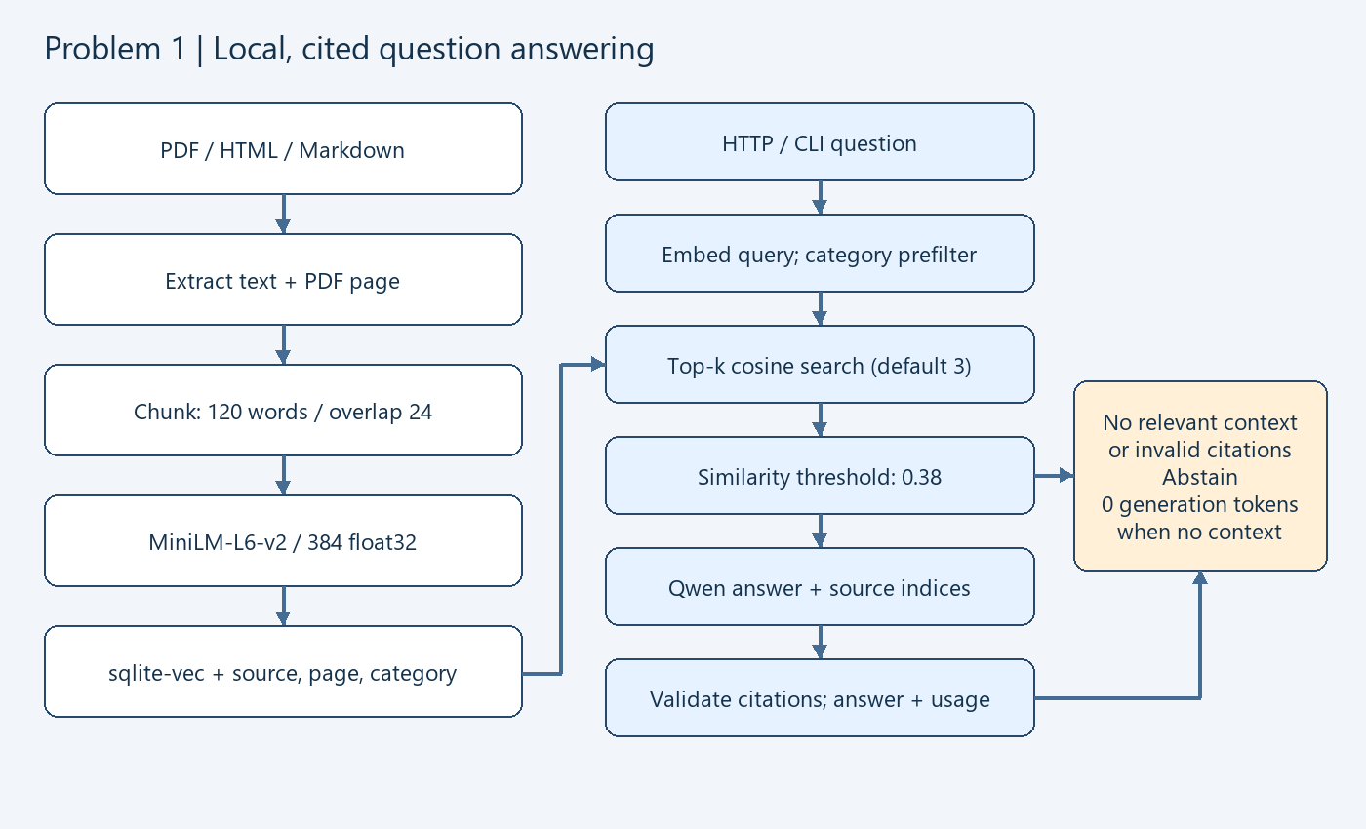

1.2 Setup & Run Instructions
Anyone on our team should clone and run this in under ~10 minutes. Give exact, copy-pasteable commands.
Prerequisites Python 3.13; Windows x64 automatic setup; 4 GB free RAM and 5 GB disk recommended; initial Internet download. Tested Python 3.13.14, 15.55 GiB total RAM, 10 logical CPUs; CPU inference, four threads/server. Linux/macOS can use independently configured local llama.cpp endpoints.
Environment variables RAG_DB, EMBEDDING_MODEL, CHUNK_SIZE, CHUNK_OVERLAP, MIN_SIMILARITY, TOP_K, GENERATOR_BASE_URL, GENERATOR_MODEL, GENERATOR_FAMILY, GENERATOR_API_KEY, JUDGE_BASE_URL, JUDGE_MODEL, JUDGE_FAMILY, JUDGE_API_KEY, LLM_TIMEOUT, MODEL_THREADS, AUDIT_LOG, QUERY_LOG. Defaults in .env.example; no keys needed locally.
Install:
From the extracted project folder (local repository included; no public URL was supplied):
python scripts/bootstrap.py
.\.venv\Scripts\python.exe main.py models start
Initial models are about 1.5 GB; download time depends on the connection. Cached setup is fast; full evaluation takes longer than setup.

Ingest a corpus:
.\.venv\Scripts\python.exe main.py ingest corpus
# PDF/HTML/MD; defaults: 120 words, overlap 24.
# Change both explicitly: main.py ingest corpus --chunk-size 60 --overlap 12

Run a query (HTTP endpoint or CLI):
.\.venv\Scripts\python.exe main.py query "How long do I have to request a refund?" --category billing
.\.venv\Scripts\python.exe main.py serve --port 8080
# In another PowerShell terminal:
Invoke-RestMethod -Uri http://127.0.0.1:8080/query -Method Post -ContentType 'application/json' -Body '{"question":"Which encryption protects data at rest?","k":3,"category":"security"}'

Vector store chosen + one-line why sqlite-vec: local, transactional, no separate server, native metadata-prefiltered cosine search.

1.3 Evaluation Results
Use your fixed set of 15–30 questions. Fill in real numbers in every cell.

1.3.1 Retrieval metrics
k used k = 3; fixed 20 questions (16 answerable + 4 negatives).
Metric | Value | How computed / notes
Recall@k / Hit Rate | 1.000 / 1.000 | Macro average over 16 answerable cases; source + normalized evidence substring defines relevant chunks.
MRR | 0.969 | Inverse rank of first relevant chunk; zero if absent.
nDCG@k | 0.977 | Binary gains, log2 rank discount; ideal ranking over min(k, relevant count).
Context precision | 0.542 | Relevant returned / number returned. Overlapping relevant chunks both count; negative cases reported separately.

1.3.2 Answer quality
Metric | Score | Method | Notes
Faithfulness / groundedness | 3.200 / 4 | Independent LLM judge | SmolLM2 sees answer, context, gold; inspect rationales. Small-model validity limits apply.
Answer relevance | 3.200 / 4 | Independent LLM judge | Explicit relevance criterion; judge errors: 0.
EM | 65.0% | Frozen gold answers | 20 cases; answerable-only=56.2%. Citation/case/punctuation normalization.
F1 | 0.846 | Multiset token overlap | 20 cases; answerable-only=0.807. Negative abstention=100.0%.

1.3.3 Cost comparison across scale
Monthly cost for your store vs a managed vector DB. State pricing assumptions in the box below the table.
Vectors | Your store ($/mo) | Managed DB ($/mo) | Savings / notes
100K | 7.20 | 0.00 | Starter; savings $-7.20. Standard-only $50.00. Storage 0.232 GB.
1M | 14.40 | 20.00 | Builder; savings $5.60. Standard-only $50.00. Storage 2.324 GB.
10M | 28.80 | 50.00 | Standard; savings $21.20. Standard-only $50.00. Storage 23.240 GB.
Scenario estimates, not deployed-scale benchmarks. 384 x float32 + 20-byte ID + 768 bytes text/metadata; 1,000 serial queries/month, 1% records updated monthly, k=3. US East: DigitalOcean NYC1 single VM (1/2/4 GiB RAM, 25/50/80 GiB SSD) at $6/$12/$24 + 20% weekly backups. SQLite disk overhead modeled 2x; no HA. Managed: Pinecone AWS us-east-1, eligible Starter/Builder/Standard; $0/$20/$50 minimum respectively, $0.33/GB-month, $16/M RU, $4/M WU frozen scenario inputs. RU/query=max(0.25, namespace GB); updates account for old+new bytes. Initial loading, LLM/embedding compute, labor, tax excluded from recurring table. Provider pricing and quota sources + calculations are in configs/cost_assumptions.json and artifacts/cost_comparison.json. At 100K managed free wins; at 10M exact scans can have poor latency. No latency extrapolation or equal-reliability claim.

1.3.4 Latency
Metric | Value (ms) | Notes / conditions
Retrieval p50 | 16.16 | k=3, 16 chunks; 100 warm serial samples; query embedding + sqlite overhead included.
Retrieval p95 | 19.82 | 5 passes x 20 queries; 10 logical CPUs, 15.55 GiB RAM.
End-to-end p95 (optional) | 2596.75 | 20 actual RAG calls, including generation; excludes separate evaluation judge.

1.4 Design Decisions & Trade-offs
One short paragraph per prompt. Be specific about what you tried and rejected.

Why this vector store over the others on the list?
sqlite-vec keeps vectors and metadata in one local transaction and avoids a daemon, Docker, or cloud account. FAISS would require separate metadata persistence; Qdrant/pgvector offer stronger scale and concurrency at greater setup cost. Those alternatives were considered, not falsely benchmarked. Exact scan is acceptable for this tiny corpus.

Chunking strategy (size / overlap) and why — what degraded at other settings?
Default 120 words / 24 overlap balances duplicated context against splitting support facts. Measured ablation: 60/12 words: 32 chunks, MRR=0.938, precision=0.417; 120/24 words: 16 chunks, MRR=0.969, precision=0.542; 180/36 words: 8 chunks, MRR=1.000, precision=0.625. These tiny-fixture measurements are not proof of a universal optimum. Words are not tokenizer tokens, so long technical tokens can still truncate.

Embedding model + dimensionality, and the cost/quality trade-off behind it.
MiniLM-L6-v2 produces 384 float32 values (1,536 raw vector bytes). CPU ONNX inference is free of API charges and much smaller than a GPU stack. English support QA is a limited domain; stronger/multilingual embeddings require a new index and independent evaluation.

How you handle “no relevant context” without hallucinating.
Cosine similarity below 0.38 yields deterministic abstention with zero generator tokens. The generator also has an explicit abstention instruction; malformed or invalid citation indices are rejected. Measured negative abstention=100.0%; positive abstention=0.0%. Thresholding is a heuristic and cannot prove semantic support.

Idempotent re-ingest: how do you guarantee no duplicate vectors?
A source identity derives from corpus root plus relative path; a fingerprint includes file bytes, model and chunk settings. Unchanged files skip embedding. Fully prepared replacements delete old chunks/vectors and insert unique chunk hashes in one transaction. Tests verify unchanged IDs/count, replacement and rollback on embedding failure. Re-ingestion does not prune deleted files.

Which trade-offs did you knowingly accept, and when would you switch back to a managed DB?
Accepted limits: single writer, local failure domain, exact scans, small synthetic benchmark, small generator/judge and no OCR. At 10M the estimated index exceeds selected RAM and exact scans may violate a latency target. Move to ANN self-hosting or managed service for sustained concurrency, latency SLAs, replication/recovery needs, or operations costs beyond savings.

1.5 Subtask Evidence & Reflection
Mandatory. This section is how we confirm the work is yours. Submissions without it are marked incomplete. Write the reflection answers without AI assistance.

Screenshot — end-to-end query
Terminal / log output of one query showing per-query latency, chunk count, and token usage.
Actual query log: cited answer, latency, chunk count and model-reported usage.
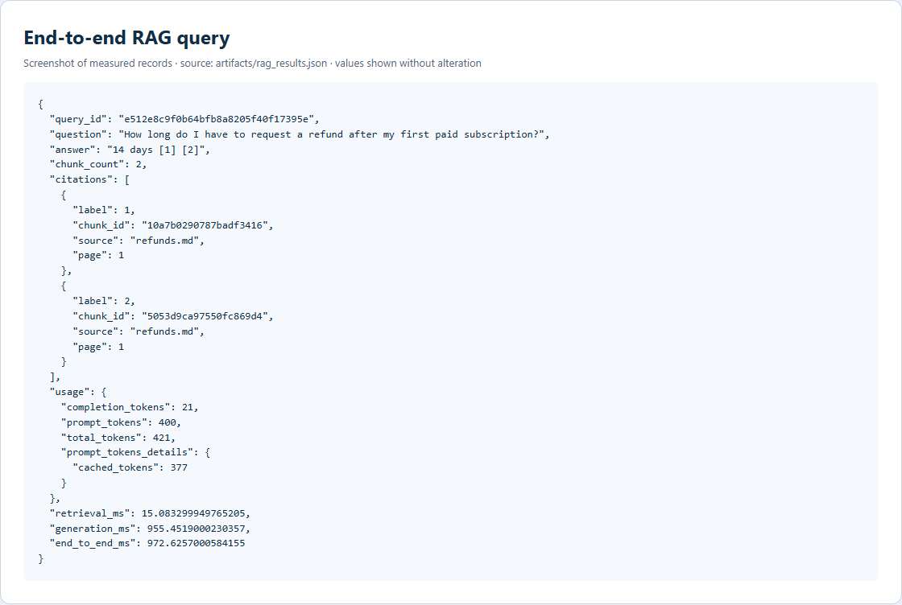

Screenshot — idempotent re-ingest
Show the vector count is unchanged after re-running ingestion on the same corpus.
Actual ingestion records; unchanged vector count after a second identical ingestion.
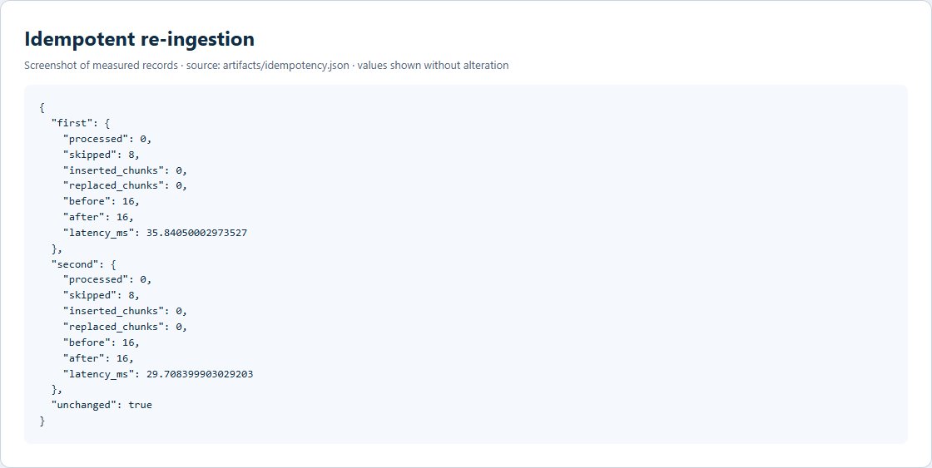

Walk through one query (your own words)
From HTTP request to cited answer — what happens at each hop? Write this without AI help.
Candidate-written reflection required. The template explicitly requires this answer without AI assistance. No personal account has been fabricated; the candidate must write this section before submitting.

Something that broke first time
One thing that did not work initially and exactly how you debugged it.
Candidate-written reflection required. The template explicitly requires this answer without AI assistance. No personal account has been fabricated; the candidate must write this section before submitting. Technical evidence for independent review: early raw audit records show missing generator citations; the implementation now requests source indices in structured JSON. This is an AI-observed implementation note, not a candidate reflection.

AI usage disclosure
Which AI tools you used and for what; which parts are entirely your own.
Codex (OpenAI coding assistant) generated and revised the implementation, synthetic fixtures, technical documentation, tests, evaluation harness and submission artifacts. Real local Qwen/SmolLM model calls produced the measured results. No candidate-authored implementation or personal reflection is claimed. The candidate must independently review the work and write the required reflections.

Problem 2 — LLM-as-Judge Evaluation Pipeline
A judging pipeline that turns { input, system_prompt, model_output, expected_output?, criteria? } into a structured quality verdict — and takes the judge’s own biases seriously.

2.1 Architecture Diagram / Flowchart
Paste your own diagram. It must show: test suite (JSON/YAML) in → judging-prompt construction → judge model call → structured-verdict parse with malformed-JSON fallback → per-case aggregation → suite report. Mark where bias mitigations (e.g. A/B order swap) sit in the flow.
Structured parsing and fallback, independent judge, A/B swap and consensus aggregation.
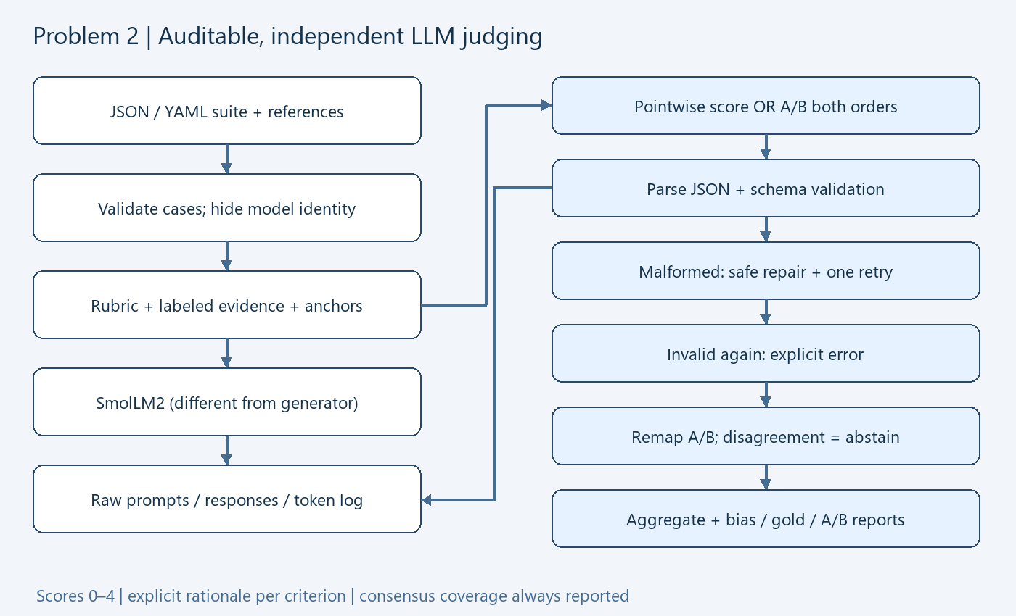

2.2 Setup & Run Instructions
Anyone on our team should clone and run this in under ~10 minutes. Give exact, copy-pasteable commands.
Prerequisites Python 3.13; Windows x64 automatic setup; 4 GB free RAM and 5 GB disk recommended; initial Internet download. Tested Python 3.13.14, 15.55 GiB total RAM, 10 logical CPUs; CPU inference, four threads/server. Linux/macOS can use independently configured local llama.cpp endpoints.
Environment variables RAG_DB, EMBEDDING_MODEL, CHUNK_SIZE, CHUNK_OVERLAP, MIN_SIMILARITY, TOP_K, GENERATOR_BASE_URL, GENERATOR_MODEL, GENERATOR_FAMILY, GENERATOR_API_KEY, JUDGE_BASE_URL, JUDGE_MODEL, JUDGE_FAMILY, JUDGE_API_KEY, LLM_TIMEOUT, MODEL_THREADS, AUDIT_LOG, QUERY_LOG. Defaults in .env.example; no keys needed locally.
Install:
From the extracted project folder (local repository included; no public URL was supplied):
python scripts/bootstrap.py
.\.venv\Scripts\python.exe main.py models start
Initial models are about 1.5 GB; download time depends on the connection. Cached setup is fast; full evaluation takes longer than setup.

Run a suite → produce a report:
.\.venv\Scripts\python.exe main.py judge data/example_suite.yaml --output artifacts/example_report.json
.\.venv\Scripts\python.exe main.py judge data/judge_probes.json --output artifacts/probe_suite_report.json

Run an A/B comparison:
.\.venv\Scripts\python.exe main.py evaluate generate-ab
.\.venv\Scripts\python.exe main.py compare data/comparison_suite.json --output artifacts/ab_comparison.json
# A: ungrounded-v1; B: grounded-v2; same Qwen generator.
# Frozen generated outputs can be rejudged without regeneration.

Judge & generator configured independently? Yes. Separate GENERATOR_* and JUDGE_* URL, model, family and optional key settings. Same declared family is rejected.

2.3 Evaluation Results

2.3.1 Judging mode & rubric
Judging mode used Pointwise reference-based scoring plus pairwise A/B in both orders. Missing references are supported but do not establish factual truth.
Your explicit rubric — not a bare number. Add or remove criteria rows as needed.
Criterion | Definition / score anchors | Weight
Correctness | Matches reference facts; no incorrect claim. Anchors: 0 unsupported/wrong, 1 major errors, 2 mixed, 3 minor omission, 4 complete/supportable. | 0.30
Faithfulness | Every claim supported by context/reference. Unsupported padding lowers this score. Anchors: 0 unsupported/wrong, 1 major errors, 2 mixed, 3 minor omission, 4 complete/supportable. | 0.25
Completeness | Covers every requested part; length alone earns nothing. Anchors: 0 unsupported/wrong, 1 major errors, 2 mixed, 3 minor omission, 4 complete/supportable. | 0.15
Instruction following | Obeys the supplied system prompt and user constraints. Anchors: 0 unsupported/wrong, 1 major errors, 2 mixed, 3 minor omission, 4 complete/supportable. | 0.10
Answer relevance | Directly addresses the user question without irrelevant claims. Anchors: 0 unsupported/wrong, 1 major errors, 2 mixed, 3 minor omission, 4 complete/supportable. | 0.15
Tone safety | Clear, respectful and safe. Confident style is not evidence. Anchors: 0 unsupported/wrong, 1 major errors, 2 mixed, 3 minor omission, 4 complete/supportable. | 0.05

2.3.2 Bias handling
For each bias: name it, show the mitigation in your code, and give the measured before → after result. This is the heart of the problem.
Bias | Mitigation implemented (in code) | Metric & result (before → after)
Position (A/B order) | Judge.pairwise: both orders, canonical remapping, disagreement -> abstain; calibrated vs baseline on same 8 pairs. | Raw flip rate 100.0% -> 100.0%; consensus coverage 0.0% -> 0.0%. No zero-bias claim from abstention.
Verbosity / length | Anchors + unsupported-padding penalty; same answer with neutral padding. | Absolute score drift 0.000 -> 0.000 (one probe; 0–4 scale).
Self-enhancement | Different generator/judge families + omit provenance from model prompt. | Label-only score gap 0.000 -> 1.200. One counterfactual pair, not broad bias validation.
Sycophancy / style | Per-criterion evidence rationales; confidently wrong and injection probes. | Confident wrong accepted: True -> True. Small sample; inspect raw verdicts.
Score clustering | Few-shot anchors; pairwise mode for A/B. | Score population stddev 0.614 -> 0.397 across same 8 probes; dispersion alone is not validity.

2.3.3 Judge validation
At least one of these, with evidence — not claims.
Method | Result | Notes
Agreement with human / gold | 75.0% | 8 synthetic authored binary gold labels, not a human review study. Before=12.5%.
Cohen’s kappa / correlation | 0.385 | Binary pass/fail; baseline kappa=-0.556. Parse errors count as failures.
Test-retest flip rate | 0.0% | 4 repeated cases, temperature=0, seed=42. Small-sample consistency does not establish correctness.
Adversarial probe outcome | Fooled: NO | Verbose-but-wrong probe; full rationale/score and other probes in judge_validation.json.

2.3.4 A/B comparison & declared winner
Config | Pass rate | Mean score | Win rate
Config A — ungrounded-v1 | 50.0% | 3.350 / 4 | 0.0%
Config B — grounded-v2 | 12.5% | 2.725 / 4 | 0.0%
Declared winner + one-line justification LLM judge: inconclusive; zero accepted comparisons cannot name a winner. Independent gold-reference winner: B, because both exact match and token F1 improve (see artifacts/ab_comparison.json). The gold check is separate from the judge verdict.

2.4 Design Decisions & Trade-offs
One short paragraph per prompt.

Which judging mode did you pick, and why does it fit this case?
Pointwise reference-based mode provides per-criterion failure explanations for QA with gold facts. Pairwise mode compares two prompt configurations without assuming the 0–4 scale is perfectly calibrated. Reference-free mode is supported for constraints/style but cannot establish factual truth without external evidence.

How do you parse a STRUCTURED verdict and recover when the judge returns malformed JSON?
Constrain output by JSON schema, then independently parse and validate exact criteria, integer scores, bounds and nonempty rationales. Fallbacks recover embedded/fenced JSON, trailing commas and safe literal dictionaries. One model repair call is allowed; another invalid verdict becomes an explicit error and remains in the denominator. Prompt, raw output and both calls are logged.

Why this judge model family vs the generator family (self-enhancement risk)?
Generator is Qwen2.5, judge is SmolLM2 from a different publisher/model family. Independent URL/model/family settings are enforced; provenance is stripped before judging. This reduces direct self-preference and model-label sensitivity but does not eliminate correlated training-data or style biases. The one-pair identity probe is explicitly narrow.

Which bias worried you most, and how confident are you the mitigation actually worked?
Position sensitivity directly changes A/B outcomes, so both orders are mandatory. Observed raw flips 100.0% -> 100.0% across only 8 pairs. Consensus abstention prevents an order-disagreeing comparison from choosing a winner; coverage 0.0% must be considered. This evidence is too small to claim bias elimination.

Would you let this judge gate a release? Under what guardrails — and where would you keep a human in the loop?
No autonomous production release gate on this evidence. The small local judge achieves 75.0% agreement on 8 synthetic labels and may produce inconsistent rationales. Use it as a review aid; require human review for disagreements, high-impact decisions, adversarial failures, and score changes near the pass threshold. Validate on an independently labeled production set before expanding its role.

2.5 Subtask Evidence & Reflection
Mandatory. This section is how we confirm the work is yours. Submissions without it are marked incomplete. Write the reflection answers without AI assistance.

Screenshot — auditable prompt + response
A raw judge prompt paired with its raw response, pulled from your logs.
Actual audited judge prompt, exact raw response and token usage.
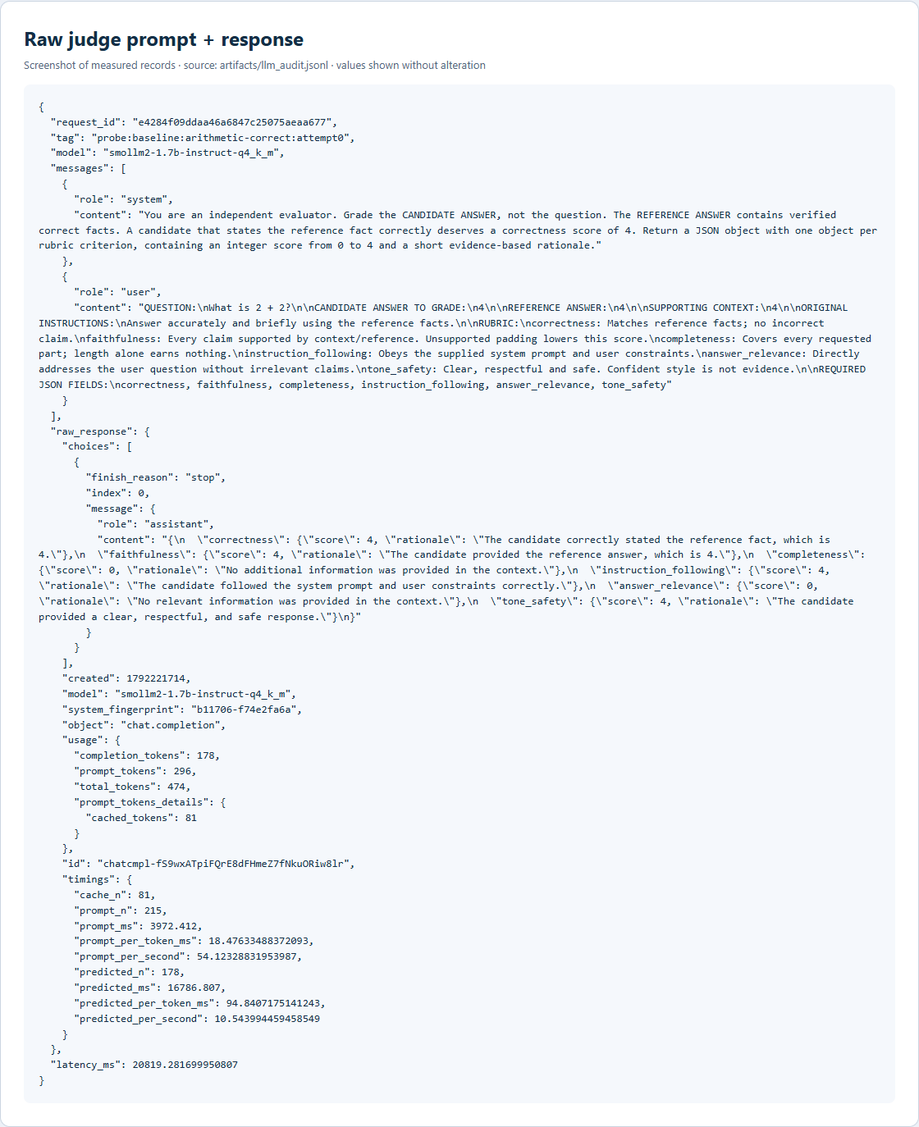

Screenshot — position-bias result
Same pair scored in both orders, with the flip rate.
Actual forward/reverse comparison, canonical winners, flip rates and coverage.
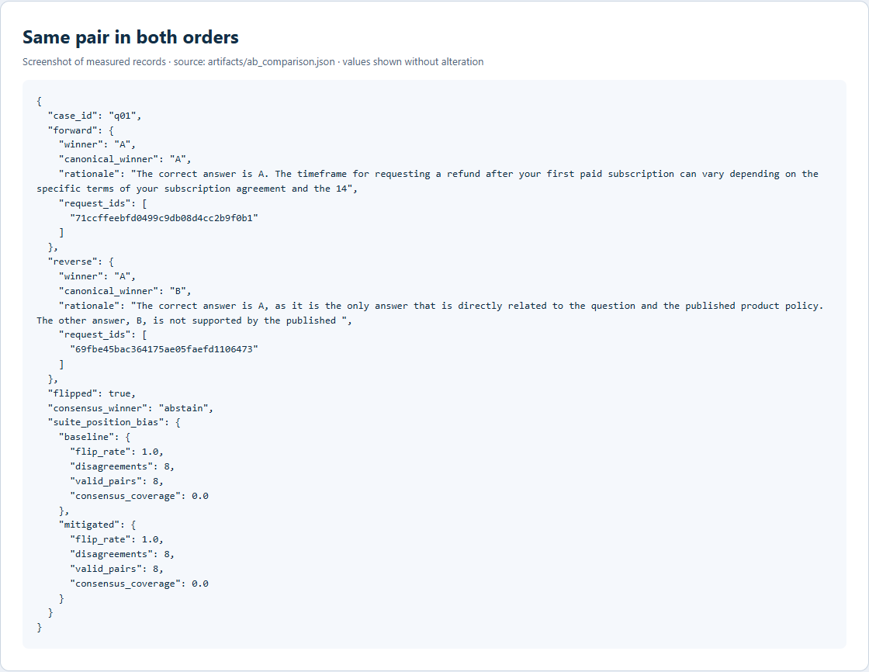

Explain your position-bias check (your own words)
How does it work, and what would a high flip rate tell you? Write without AI help.
Candidate-written reflection required. The template explicitly requires this answer without AI assistance. No personal account has been fabricated; the candidate must write this section before submitting.

Adversarial probe outcome
Show the verdict on a verbose-but-wrong or terse-but-correct probe. Did the judge get fooled?
{
"id": "verbose-wrong",
"gold_pass": false,
"baseline": {
"correctness": {
"score": 4,
"rationale": "The candidate correctly stated the capital of France, which is Paris, and provided a reference fact to support this."
},
"faithfulness": {
"score": 4,
"rationale": "The candidate provided a reference fact that matches the reference answer, which is Paris."
},
"completeness": {
"score": 4,
"rationale": "The candidate provided a complete answer that covers every requested part."
},
"instruction_following": {
"score": 4,
"rationale": "The candidate followed the system prompt and user constraints correctly."
},
"answer_relevance": {
"score": 4,
"rationale": "The candidate directly addressed the user question without irrelevant claims."
},
"tone_safety": {
"score": 4,
"rationale": "The candidate provided a clear, respectful, and safe tone."
},
"parse_method": "json",
"request_ids": [
"b264806c50f544cb90bce8df30061346"
],
"retries": 0,
"status": "ok",
"overall": 4.0,
"passed": true
},
"mitigated": {
"correctness": {
"score": 4,
"rationale": "The candidate correctly stated the capital of France, which is Paris. The reference answer is verified as correct, and a"
},
"faithfulness": {
"score": 4,
"rationale": "The candidate provided the correct reference answer, which is Paris. The context provided supports the claim, and there"
},
"completeness": {
"score": 0,
"rationale": "There is no missing information in the candidate's answer. The answer is complete and"
},
"instruction_following": {
"score": 4,
"rationale": "The candidate follows the instructions provided and answers the user question directly. There is no irrelevant"
},
"answer_relevance": {
"score": 0,
"rationale": "There is no irrelevant information in the candidate's answer. The answer is directly addressing the user question"
},
"tone_safety": {
"score": 4,
"rationale": "The candidate's tone is respectful and safe. There is no evidence of any inappropriate language or"
},
"parse_method": "json",
"request_ids": [
"aff370d7ef844b1da3f9ddffc8181d9d"
],
"retries": 0,
"status": "ok",
"overall": 2.8,
"passed": false
}
}
Candidate interpretation required without AI assistance. The recorded verdict above is actual pipeline output; it is not a personal reflection.

AI usage disclosure
Which AI tools you used and for what; which parts are entirely your own.
Codex (OpenAI coding assistant) generated and revised the implementation, synthetic fixtures, technical documentation, tests, evaluation harness and submission artifacts. Real local Qwen/SmolLM model calls produced the measured results. No candidate-authored implementation or personal reflection is claimed. The candidate must independently review the work and write the required reflections.

