**Name: Tapiwa Motsi**

**Reg number: H200403T**

**Guide on How to run my HIT QUIZ App on your computer**

To be able to use this Quiz l prefer downloading xampp server and host it as local host.

**Files**

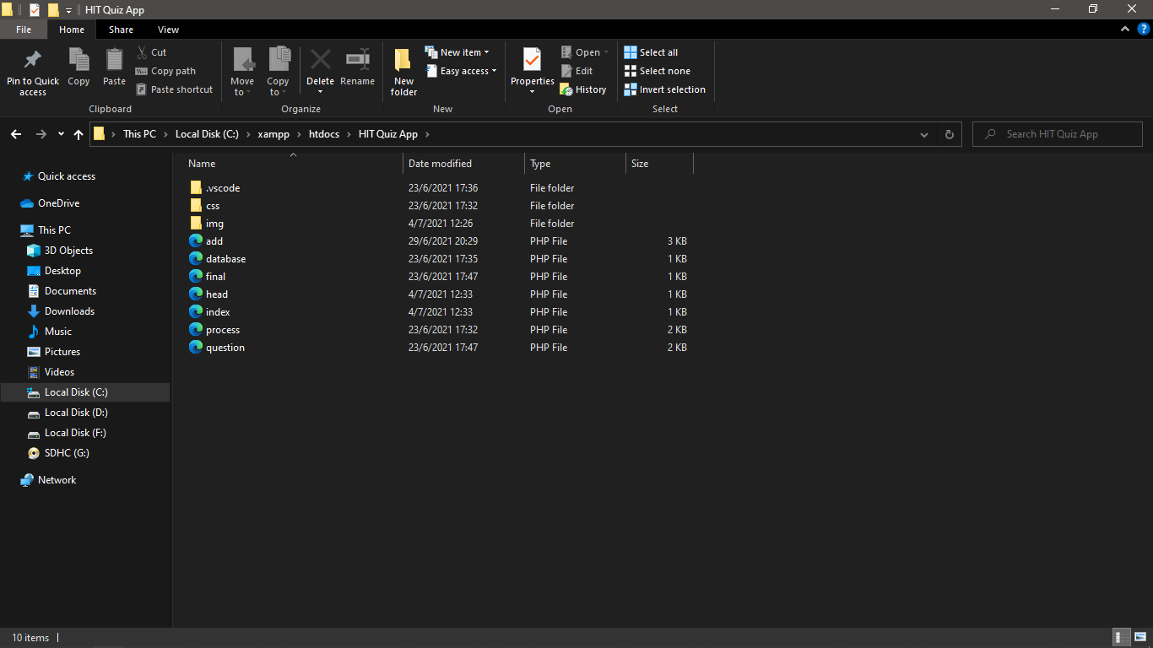

In my HIT Quiz app

1. .vscode – A default document that visual studio creates automatically.
2. Css – contains my css code.
3. Img – it contains all images used for this project including HIT_logo.png
4. Add.php- is used to add questions in the database we are going to create
5. Database.php is used to connect php to the database Error is produced if there is error during the process of connecting.
6. Final.php – is used to provide the results of the quiz
7. Index.php- is the default php that displays.
8. Questions.php- is used to connect php to the database where questions are.

**NB: OPEN DATABASE.php you need to reconfigure the code to make sure it runs**

$db_host = 'localhost';

$db_name = 'quiz';

$db_user = 'root';

$db_pass = '';

In between $db_pass = ‘put your local password here no password leave it’

**Creating Database**

1. Create a schema called `quiz`

Copy and paste into your workbench

CREATE SCHEMA `quiz`

1. Inside quiz scheme we need two tables `questions_tak` and `choices_tak`

Copy and paste the following into your workbench

CREATE TABLE `quiz`.`questions_tak` ( `question_number` INT NOT NULL , `text` TEXT NOT NULL , PRIMARY KEY (`question_number`));

CREATE TABLE `quiz`.`choices_tak` ( `id` INT NOT NULL AUTO_INCREMENT , `question_number` INT NOT NULL , `is_correct` TINYINT NOT NULL DEFAULT '0' , `text` TEXT NOT NULL , PRIMARY KEY (`id`));

**Starting Application**

1. To test whether the database has correctly connected, open index.php

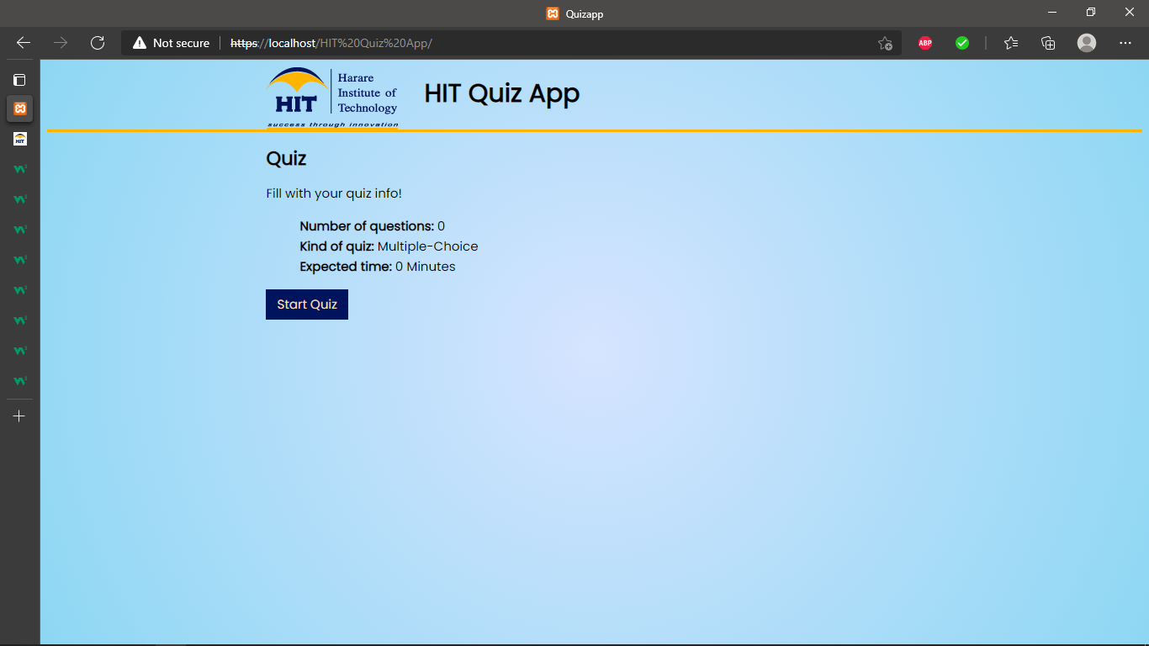

If it takes you to the home page database has correctly connected else an error will show up. Close the page.

1. To add questions in our database you should open add.php

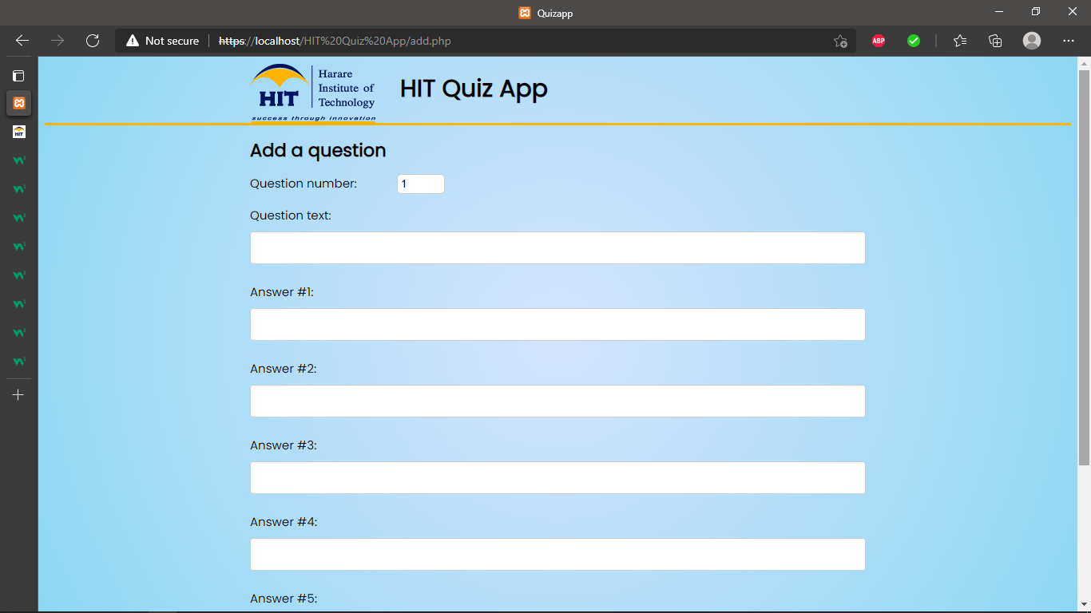

This allow you to add question number , the question , 5 possible answers and the number of correct answers. After you are done you can click submit.

1. After you are done setting up the questions. Return to index.html

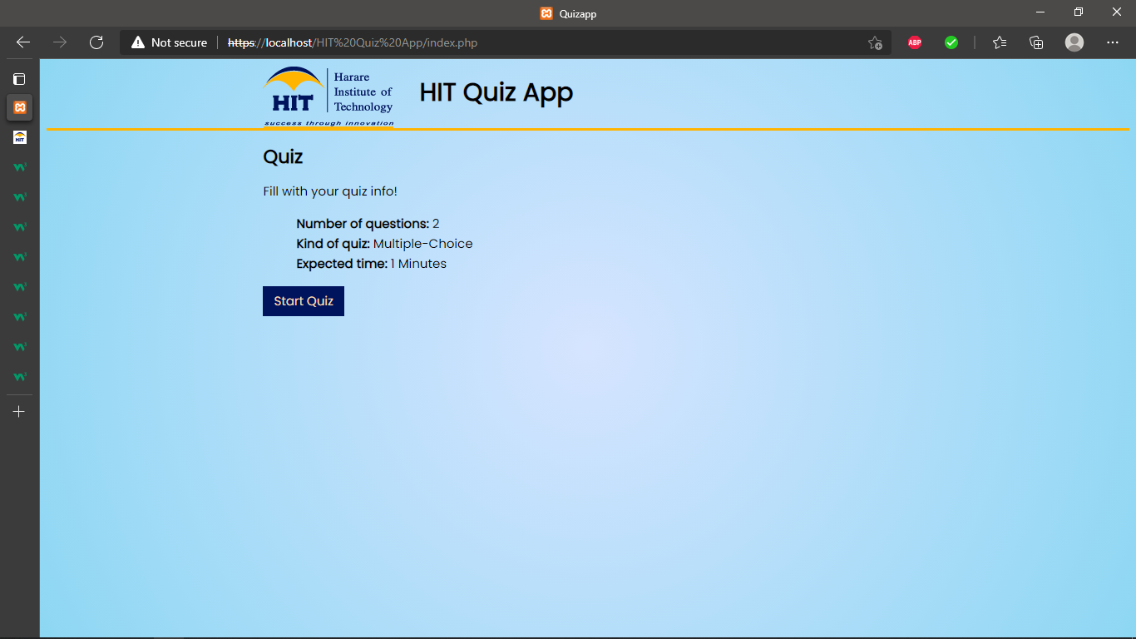

I created two questions

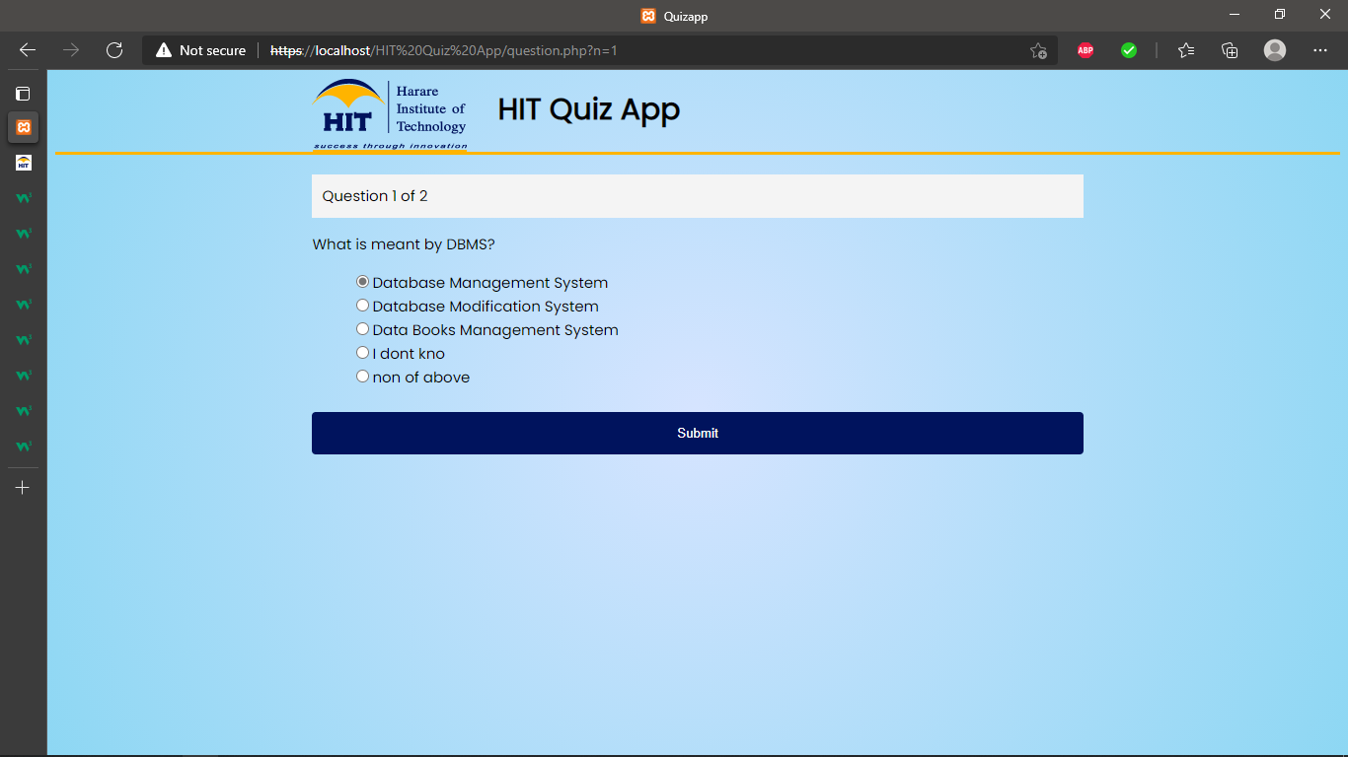 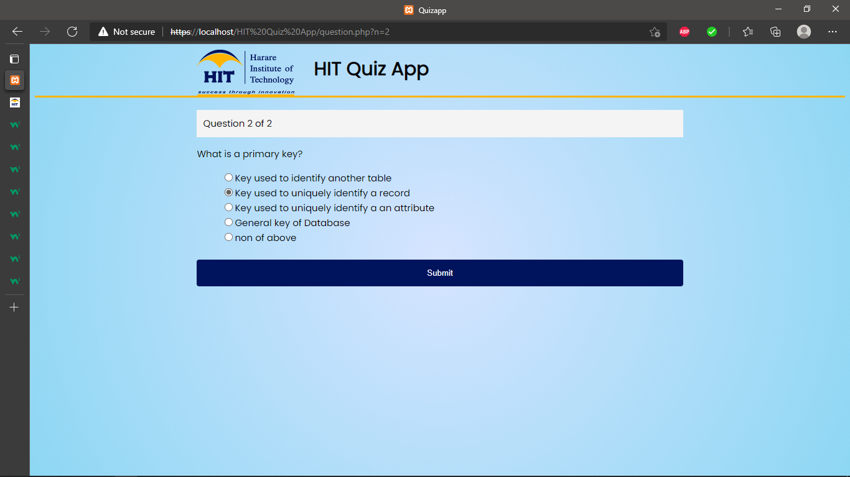

After writing the quiz you will submit

1. After submiting the page you will be taken to final.php where your results will be shown.

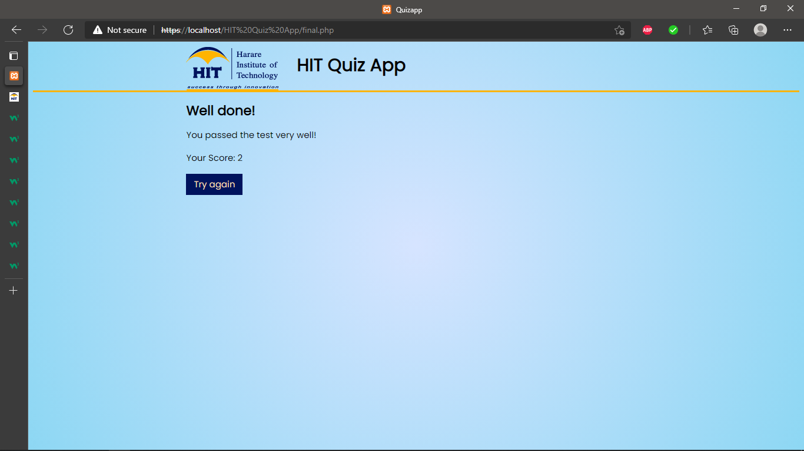

**Databases and EDR Digrams**

