Human Activity Recognition Using Hidden Markov Models
Tapiwanashe Gift Marufu | Machine Learning Techniques II | Formative 2 | 28 October 2026

1 Background and motivation
This project investigates a smartphone-based campus fitness tracker that recognizes standing, walking, jumping and still periods. It could help students understand their movement during exercise while distinguishing a stationary phone from one held by a standing person. Noise and phone handling complicate recognition. I collected accelerometer and gyroscope data, extracted time-domain and frequency-domain features, and implemented a Hidden Markov Model (HMM). Separate recordings assess recognition, while a continuous recording explores predicted changes. The fixed model classified all 28 labelled test windows correctly, but handling produced ambiguity in the continuous recording.

2 Data collection and preprocessing steps
I collected all recordings individually at ALU Soules B Residence, using Sensor Logger version 1.68 on an SM-M346B Android phone. I carried the phone at waist level for standing, walking and jumping, walked on the floor, and placed it on a table for still recordings. Data were recorded on 28 October 2026. The four labels were standing, walking, jumping and still (no movement). Each recording contains acceleration and rotation on the x, y and z axes, epoch timestamps in nanoseconds, and elapsed seconds. Accelerometer.csv excludes gravity; acceleration is in m/s² and rotation in rad/s [1].
Table 1. Cleaned development recordings and separate labelled tests. Lengths and totals refer to development data.
Activity | Files  (train / val) | Length range  (s) | Total  (s) | Test files
Standing | 13 (10 / 3) | 8.38–8.98 | 111.88 | 1
Walking | 13 (10 / 3) | 8.28–9.08 | 111.56 | 1
Still | 12 (10 / 2) | 7.70–8.78 | 101.50 | 1
Jumping | 12 (10 / 2) | 8.30–8.72 | 101.58 | 1
All 50 cleaned development files last 5–10 seconds; each activity exceeds 90 seconds. Four additional test recordings were captured later that day, separately from development recordings, using the same participant and phone. Their cleaned lengths are 8.32–8.58 seconds. A further continuous recording is reserved for qualitative analysis.
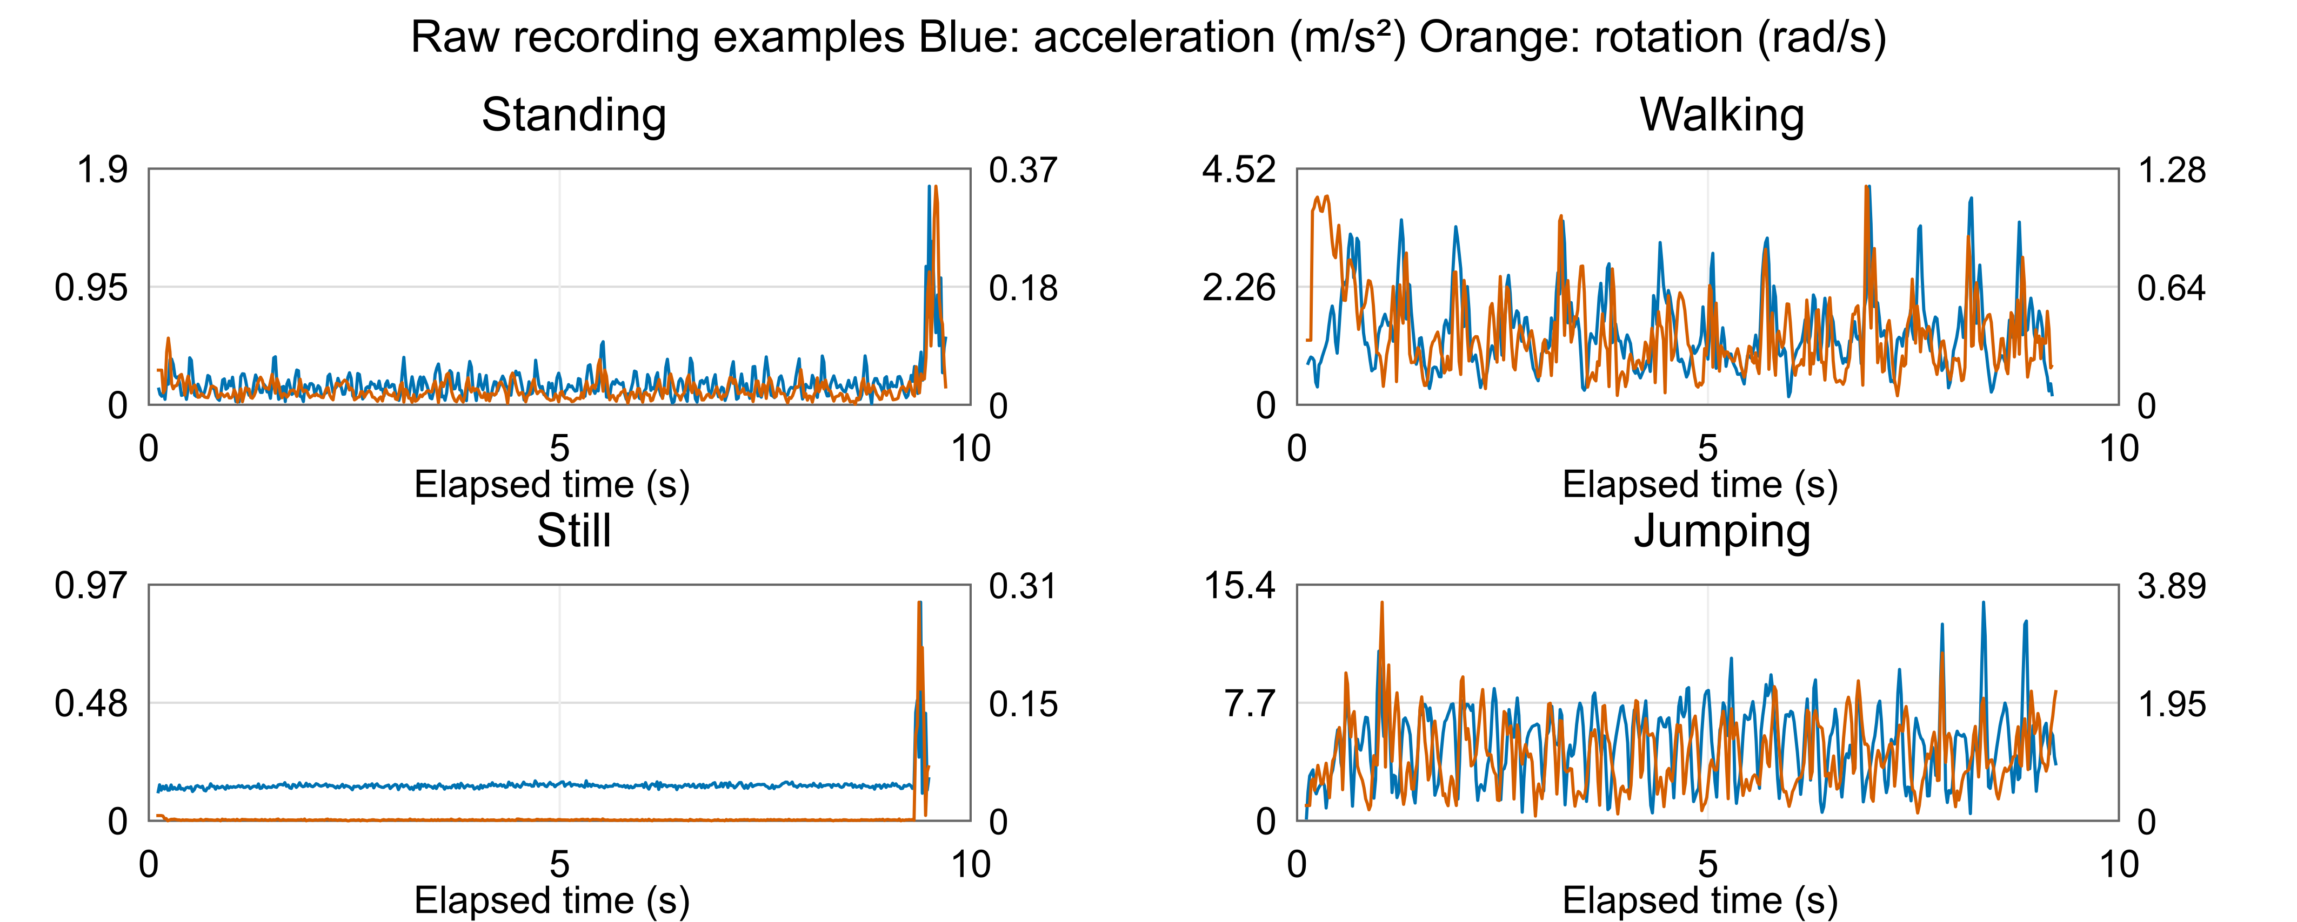
Figure 1. Raw acceleration and rotation magnitudes for recording 1 of each activity. Blue and orange use separate left and right scales; scales differ between panels. End disturbances motivate boundary inspection.
Collection procedure demonstrations: Standing | Walking | Jumping | Still
Project repository: Tapiwanashe6/human-activity-recognition-hmm

2 Data collection and preprocessing steps continued
Quality checks covered 150 sensor files: Accelerometer.csv, TotalAcceleration.csv and Gyroscope.csv in every development recording. All were readable, with no invalid numeric values, duplicate/non-increasing elapsed times, or gaps above 100 ms. Empty annotation and uncalibrated-accelerometer files were ignored. Raw data were preserved. The model uses acceleration without gravity and calibrated gyroscope measurements; total acceleration is retained for reference.
Measured rates were approximately 49.876 Hz, close to the configured 20 ms interval (50 Hz). I restricted recordings to shared sensor coverage and used linear interpolation onto a common 50 Hz grid. Reconstructed epoch timestamps remain separate from elapsed time. All data came from one phone, so cross-device differences were not experimentally tested; alignment provides a common timing basis if additional devices are used.
Boundary inspection supported trimming 0.3 seconds from each end. Still recording 4 contained an earlier disturbance in both sensors, so its final 1.0 second was excluded instead. This was documented rather than deleting the recording. All 50 saved files passed finite-value, uniform-spacing, reconstructed-timestamp and filename/label checks. Test recordings received only the established standard trims and alignment.
Recording-level splitting produced 40 training and 10 validation files (Table 1), before windowing. No recording crosses splits. Each 2-second window contains 100 samples, with a 1-second step and 50% overlap. Two seconds capture repeated movement and give 0.5 Hz FFT-bin spacing. Incomplete trailing windows are excluded. Training produces 280 windows and validation 71, with 6–8 windows per recording. Overlapping windows share information and are not independent trials.
Table 2. Five observation features and their activity-recognition rationale. a is three-axis acceleration and m is its magnitude.
Feature and domain | Calculation | Why included
Acceleration SD  Time | Standard deviation of m | Separates near-stationary still/standing signals from walking and the larger acceleration variations observed in jumping.
Centred SMA  Time | Sum across axes of mean |a − axis mean| | Combines movement across all axes, reducing dependence on one axis; training SMA increased from still through standing and walking to jumping.
Gyroscope RMS  Time | Square root of mean squared rotation magnitude | Distinguishes the table-resting phone from hand wobble during standing and stronger rotation during walking and jumping.
Dominant frequency  FFT | Strongest nonzero bin of centred m | Captures repeated walking/jumping motion. Training means differed, but noise and harmonics make it less reliable for stationary activities.
Band energy  FFT | Sum of normalized one-sided power from 3–10 Hz | Targets faster variations from steps and landings; training energy was highest for jumping and lowest for still. The 3–10 Hz band was not optimized on test data.
For the FFT, I centre m and apply a Hann taper to reduce leakage. One-sided power is normalized by window length and taper energy, with positive-frequency bins doubled except the Nyquist bin. The four magnitude/energy features receive log10(value + 10⁻⁸); dominant frequency is not logged. Logging reduces positive skew; Z-scoring puts different units on comparable scales and makes the variance floor consistent across features. All five features are then Z-scored using training means and population standard deviations only. Validation and test data reuse these parameters. Training means are approximately zero and standard deviations one after scaling; all transformed values are finite.
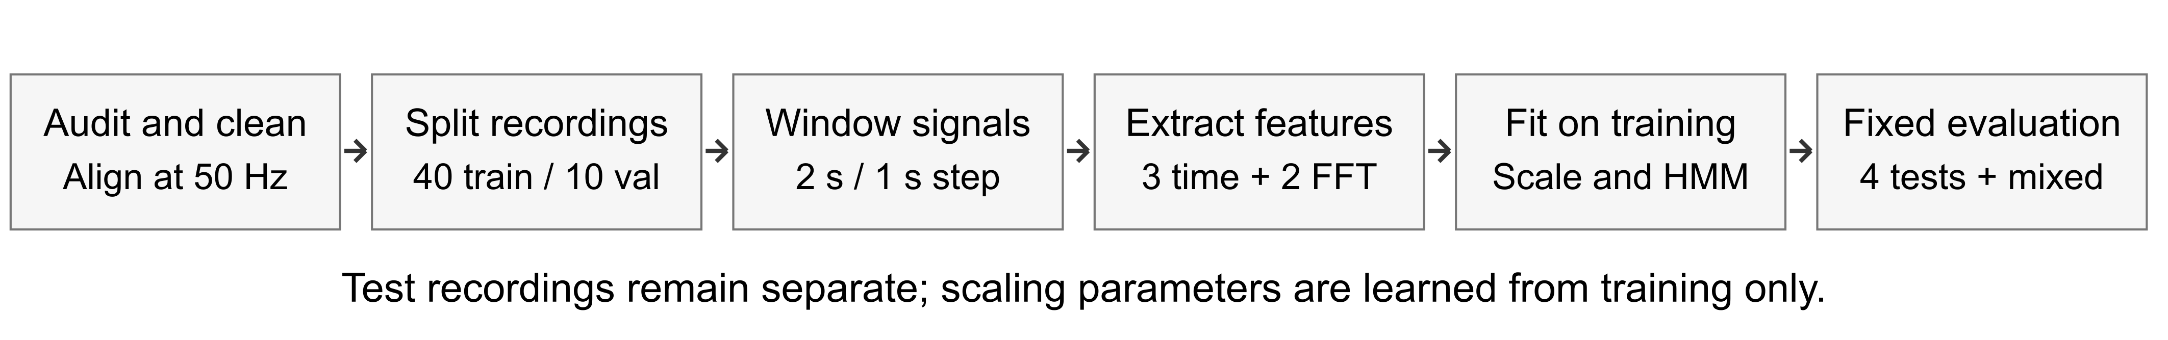
Figure 2. Processing and evaluation workflow. Training-only scaling prevents fitting transformations on validation or test data. Original recordings and the split manifest are retained for reproducibility.

3 HMM setup and implementation details
The four hidden states Z are standing, walking, still and jumping. Each observation X is a five-feature vector, produced once per second. The 4 × 4 matrix A gives next-state probabilities; π gives starting-state probabilities. Emissions B are diagonal Gaussian densities with a mean and variance for each state/feature pair. Conditional feature independence is an approximation: movement-intensity features can be correlated. Figure 3 shows the generative structure [2].
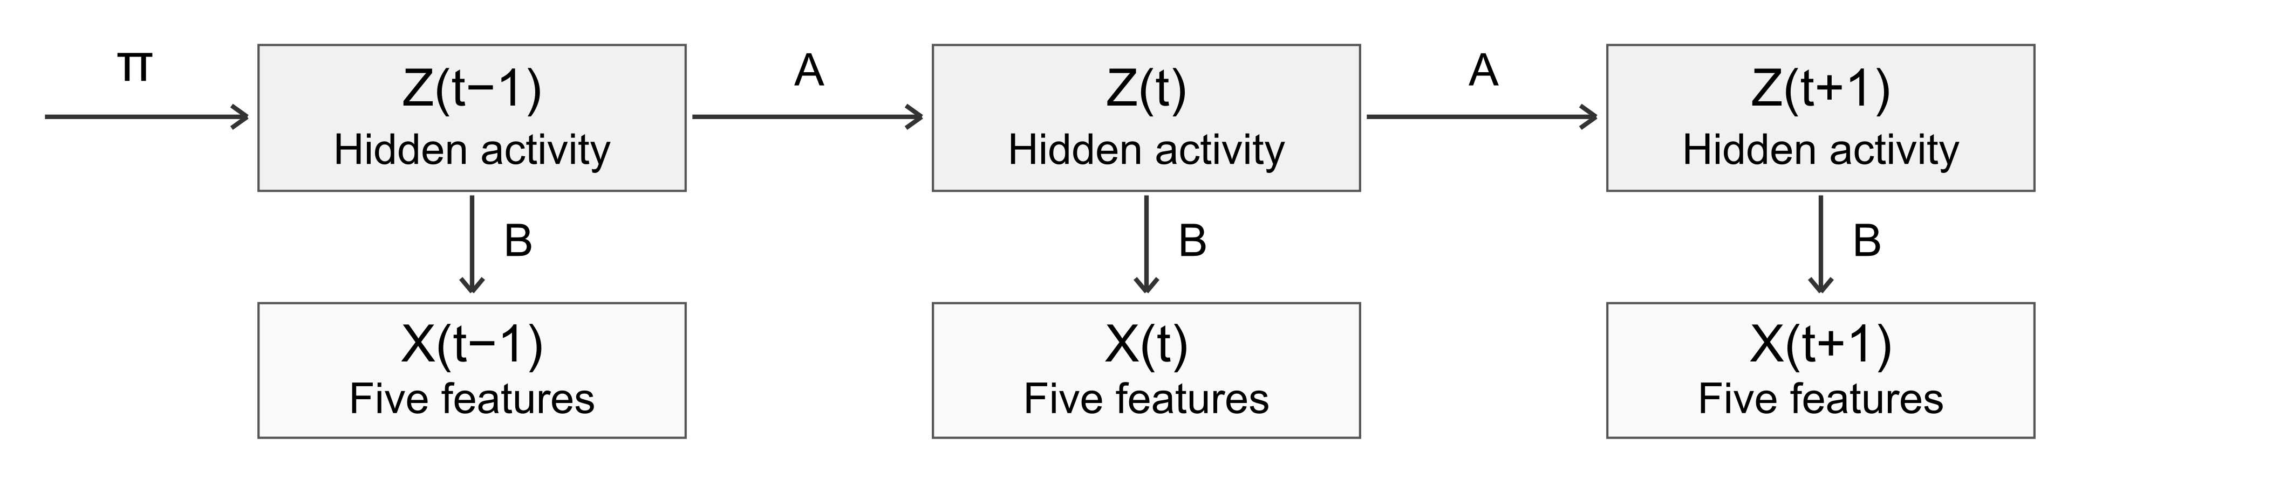
Figure 3. Hidden activities generate observed feature vectors through B; A connects successive states and π describes the start. Gaussian density values are not class probabilities and may exceed one.
Initialization uses labelled training means to anchor state identities, unit variances, uniform π = 0.25, and A with 0.90 self-transition probability and 0.10/3 for each alternative. Baum–Welch then uses soft state membership rather than fixed labels. Independent recordings stay separate: no artificial transitions are counted between shuffled files. A variance floor of 0.001 prevents collapsed densities; transition pseudocounts of 0.1 keep switching paths possible.
Forward–backward computes sequence likelihoods, posterior state weights and expected transitions in log space. Baum–Welch combines these quantities across the 40 training sequences to update π, A, means and variances. Viterbi uses dynamic programming and backtracking to find the most likely complete path. These algorithms model sequential consistency, which could reduce isolated classification errors and improve sensitivity/specificity; this benefit must be checked against an emission-only baseline, not assumed [2].
Because transition pseudocounts are used, training monitors the regularized objective J = sum of sequence log-likelihoods + 0.1 × sum(log Aᵢⱼ). This corresponds to a symmetric Dirichlet prior with parameter 1.1. The stopping rule is an absolute change in J of at most 0.0001; a decrease below −0.000001 raises an error. The limit is 200 updates. A maximum-iteration stop is distinguished from actual convergence.
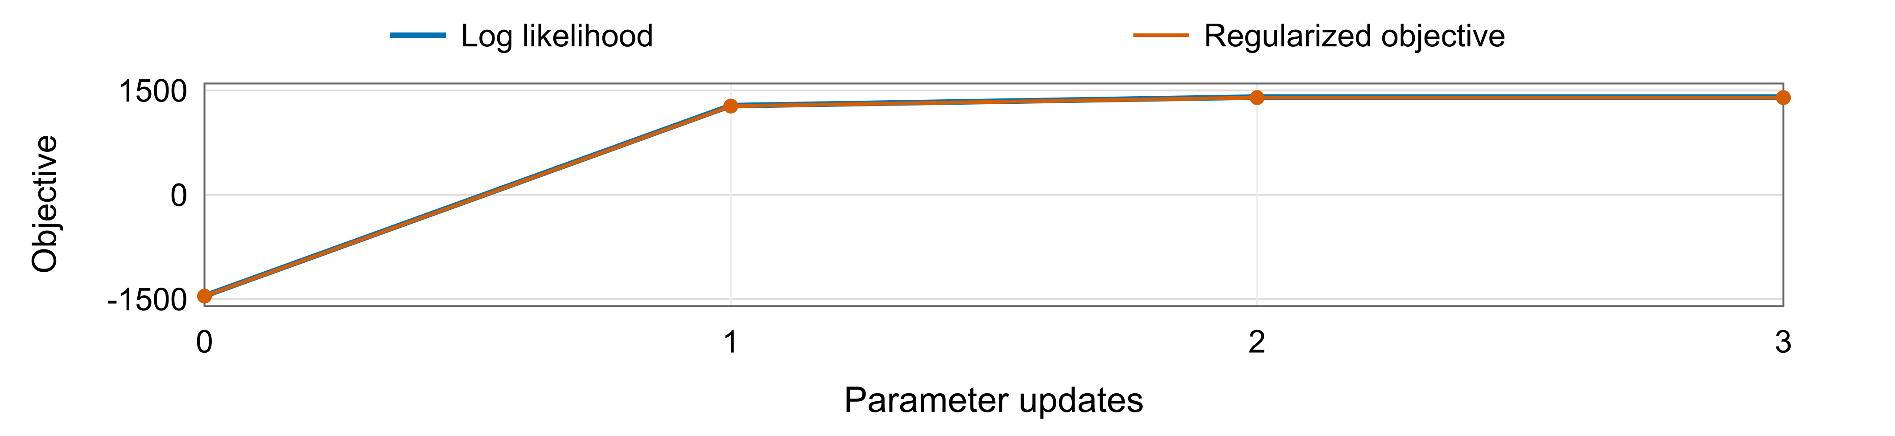
Figure 4. Actual training history. Both curves rise and stabilize; their small separation is the transition log-prior. Baum–Welch converged after three updates.
Log-likelihood rose from −1452.662 to 1404.763; J rose from −1456.785 to 1397.077. Its final change was about −4.55 × 10⁻¹³, within tolerance. Probability rows sum to one and variances respect the floor. Exhaustive enumeration of all eight paths in a two-state, three-window synthetic example independently verified likelihood, posteriors, expected transitions and Viterbi’s best path [0, 1, 1]. All 280 training windows decode correctly; that is a state-mapping sanity check, not independent evaluation.

4 Results and interpretation
Emission-only classification and Viterbi both correctly classified 71/71 validation windows across 10 held-out recordings. I retained the initial feature/window configuration and fixed the model before final testing; no alternative configuration was selected using test results. Four separately recorded labelled tests then contributed seven windows each (28 total). They cover new recordings from the same person and phone, not unseen participants or devices. Reported samples are feature windows rather than raw sensor rows.
Table 3. Final Viterbi results on four labelled unseen recordings. Values are proportions; each activity is evaluated against the other three.
State activity | Number of  samples | Sensitivity | Specificity | Accuracy*
Standing | 7 | 1.000 | 1.000 | 1.000
Walking | 7 | 1.000 | 1.000 | 1.000
Still | 7 | 1.000 | 1.000 | 1.000
Jumping | 7 | 1.000 | 1.000 | 1.000
Sensitivity = TP/(TP+FN); specificity = TN/(TN+FP); *accuracy = (TP+TN)/all windows for each one-versus-rest task. Overall multiclass accuracy is separately 28/28 = 100%. Emission-only classification also scored 28/28; no accuracy advantage from Viterbi was measured. The confusion counts in Figure 5B contain no errors. Overlap means these 28 windows are correlated observations from four files.
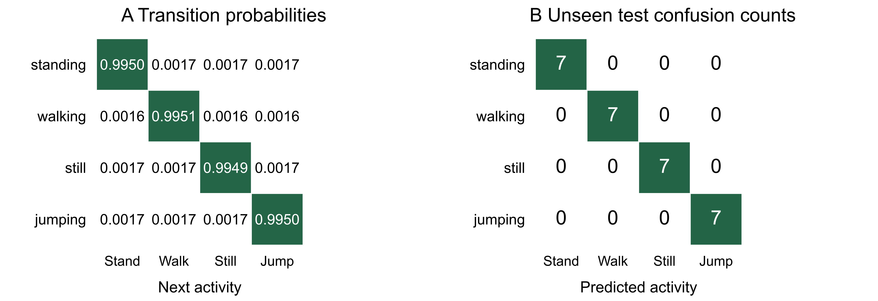
Figure 5. A: learned transitions (rows=current state). B: labelled unseen-test confusion matrix (rows=actual activity). All four activities have seven correct predictions.
Self-transition probabilities range from 0.99495 to 0.99511. Off-diagonal values of about 0.0016–0.0017 are mainly supported by regularization: the training recordings contain no labelled activity switches. These values permit switching but are not measured real-world switching frequencies or typical activity durations.
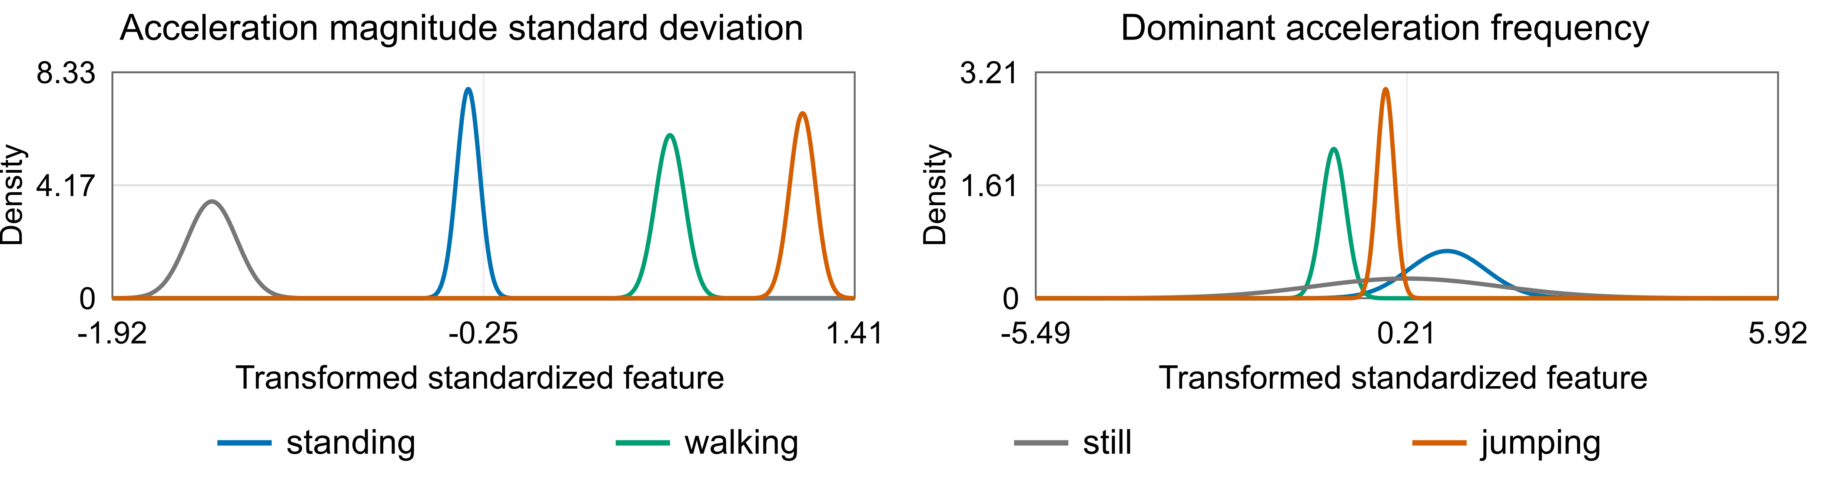
Figure 6. Representative fitted Gaussian emission densities. Acceleration variability separates training activities clearly; dominant frequency overlaps more. All five marginal-density plots and their parameters are available in the notebook. Density heights may exceed one.
Training averages increase from still to jumping for acceleration variability, SMA, rotation RMS and band energy. Dominant frequency is less straightforward: mean values are about 1.60 Hz for walking and 3.89 Hz for jumping, and stationary noise can produce a strongest bin. Therefore, a peak frequency should not automatically be interpreted as step/jump rate. No activity can be ranked hardest by labelled test errors because all four had zero errors.

4 Results and interpretation continued
The additional 43.31-second continuous capture followed the participant-confirmed order still → standing → walking → jumping. Standard preprocessing retained 42.70 seconds and produced 41 windows. Exact activity boundaries were not independently timed, so this capture provides qualitative evidence only and is excluded from accuracy and transition-timing scores.
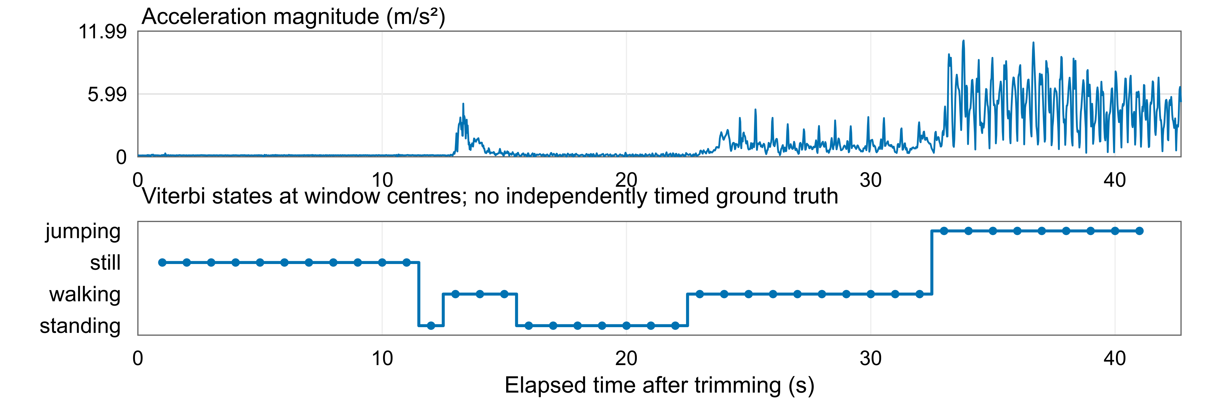
Figure 7. Measured acceleration and fixed-model continuous predictions. Points represent 2-second windows at their centres. Predicted switches are not independently verified transition times; the final incomplete window is excluded.
Predicted runs begin at window starts 0 s (still), 11 s (standing), 12 s (walking), 15 s (standing), 22 s (walking) and 32 s (jumping). The brief early walking run coincides with a motion burst the participant identifies as phone handling. This demonstrates that handling can resemble an activity. I documented the ambiguity without changing the model or assigning retrospective timing labels from its predictions.

5 Discussion and conclusion
The strongest training separation lies in movement intensity; still has minimal rotation, while jumping produces much larger acceleration variations. Standing and still remain a potential challenge when grip, phone position or handling changes. Although all labelled activities scored equally well, the continuous handling episode shows why perfect short-clip accuracy does not establish reliable behavior during real transitions.
Near-uniform sampling and 50 Hz alignment provided consistent windows, while trimming reduced observed boundary disturbances. The study did not experimentally isolate the effect of sampling rate or test different phones. Single-activity training strongly favors persistence, so the learned transition matrix offers limited evidence about realistic human switching patterns. Labelled initial means also mean the method is not entirely unsupervised.
Generalization is limited by one participant/device, few test files, correlated overlapping windows and diagonal Gaussian assumptions. Validation recordings also shared the initial exploratory quality review, so they are a development set rather than a fully blind assessment. Future work should add independently timed continuous training/tests, handling or transition labels, different phone positions, environments and participants, and compare features/window sizes on development data before collecting another untouched test set. Additional sensors could be assessed if they improve a clearly defined failure mode.
The from-scratch HMM converged and recognized all scored windows in the four separate labelled tests. It produced plausible changes in a continuous capture but briefly labelled handling as walking. The work supports feasibility for this limited campus fitness setting; broader robustness, realistic transition learning and precise change detection remain to be established.

References
[1] Sensor Logger. One-Page Unit Reference. Official sensor units
[2] Rabiner, L. R. (1989). A tutorial on hidden Markov models and selected applications in speech recognition. Proceedings of the IEEE, 77(2), 257–286. doi:10.1109/5.18626

