PyCaret is an open-source, low-code machine learning library in Python that simplifies the process of building and deploying machine learning models. It automates many aspects of machine learning workflows, including data preprocessing, model selection, training, hyperparameter tuning, and model evaluation. PyCaret is designed to make it easy for both beginners and experienced data scientists to create machine learning models quickly without needing to write extensive code.
Key features of PyCaret include:
- Low-code: You can perform complex machine learning tasks with just a few lines of code.
- End-to-end workflows: It handles the entire machine learning pipeline, from data preparation to model deployment.
- Multiple model support: It supports classification, regression, clustering, anomaly detection, and natural language processing (NLP) tasks.
- Automatic model comparison: PyCaret compares multiple machine learning models to select the best one based on performance metrics.
- Deployment ready: The library allows for easy deployment of trained models into production using tools like AWS, Google Cloud, and Docker.
Overall, PyCaret is popular among those who want to streamline their machine learning workflow and reduce the time spent coding while still building powerful models.
PyCaret for Citizen Data Scientists
The design and simplicity of PyCaret is inspired by the emerging role of citizen data scientists, a term first used by Gartner. Citizen Data Scientists are ‘power users’ who can perform both simple and moderately sophisticated analytical tasks that would previously have required more expertise. Seasoned data scientists are often difficult to find and expensive to hire but citizen data scientists can be an effective way to mitigate this gap and address data science challenges in the business setting.
PyCaret deployment capabilities
PyCaret is a deployment ready library in Python which means all the steps performed in an ML experiment can be reproduced using a pipeline that is reproducible and guaranteed for production. A pipeline can be saved in a binary file format that is transferable across environments.
PyCaret is seamlessly integrated with BI
PyCaret and its Machine Learning capabilities are seamlessly integrated with environments supporting Python such as Microsoft Power BI, Tableau, Alteryx, and KNIME to name a few. This gives immense power to users of these BI platforms who can now integrate PyCaret into their existing workflows and add a layer of Machine Learning with ease.
PyCaret is ideal for:
- Experienced Data Scientists who want to increase productivity.
- Citizen Data Scientists who prefer a low code machine learning solution.
- Data Science Professionals who want to build rapid prototypes.
- Data Science and Machine Learning students and enthusiasts.
PyCaret at a glance
Classification
Functional API
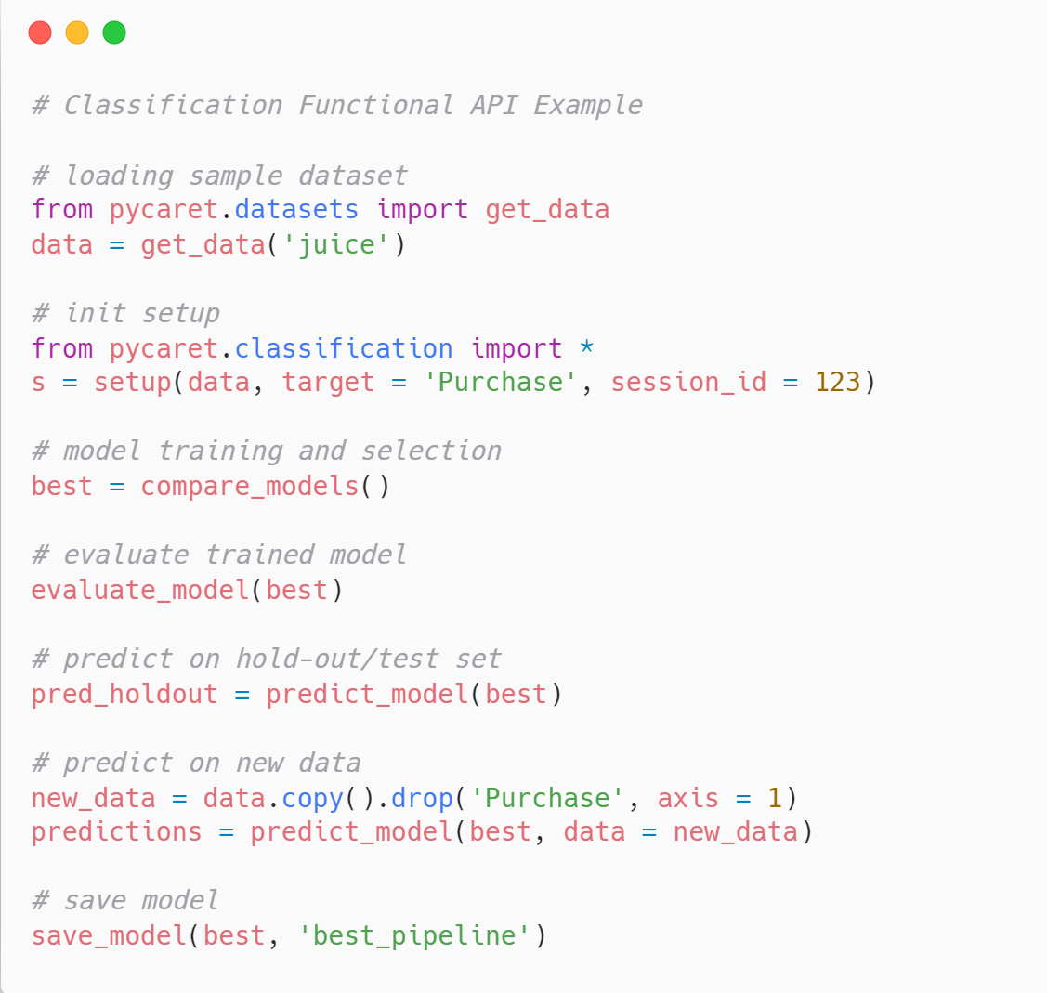
OOP API
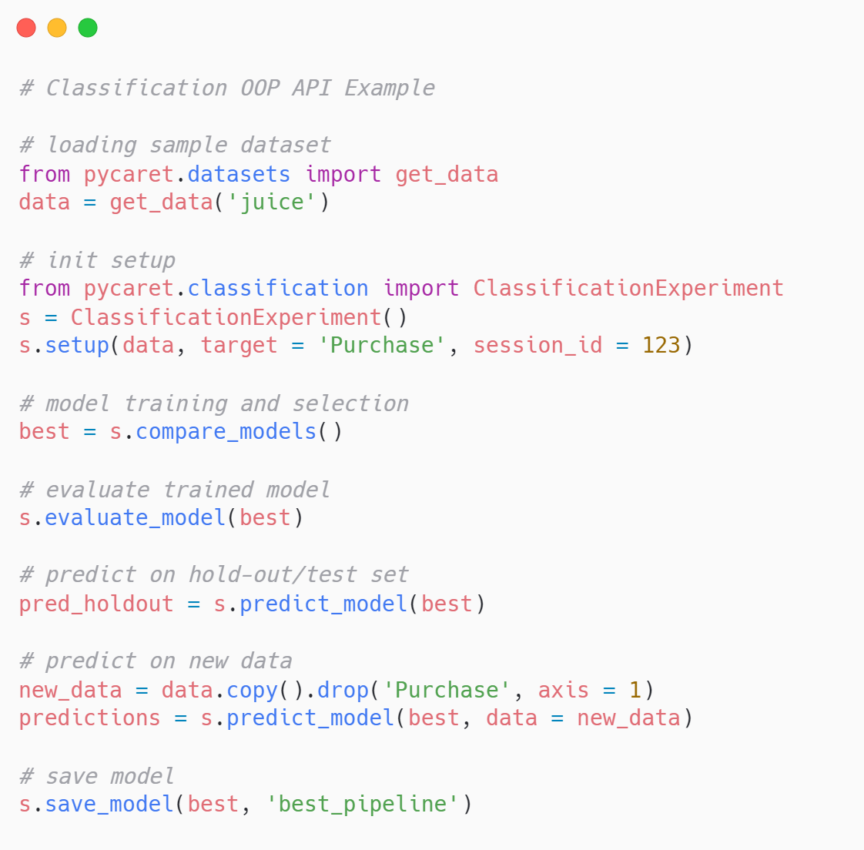
Regression
Functional API
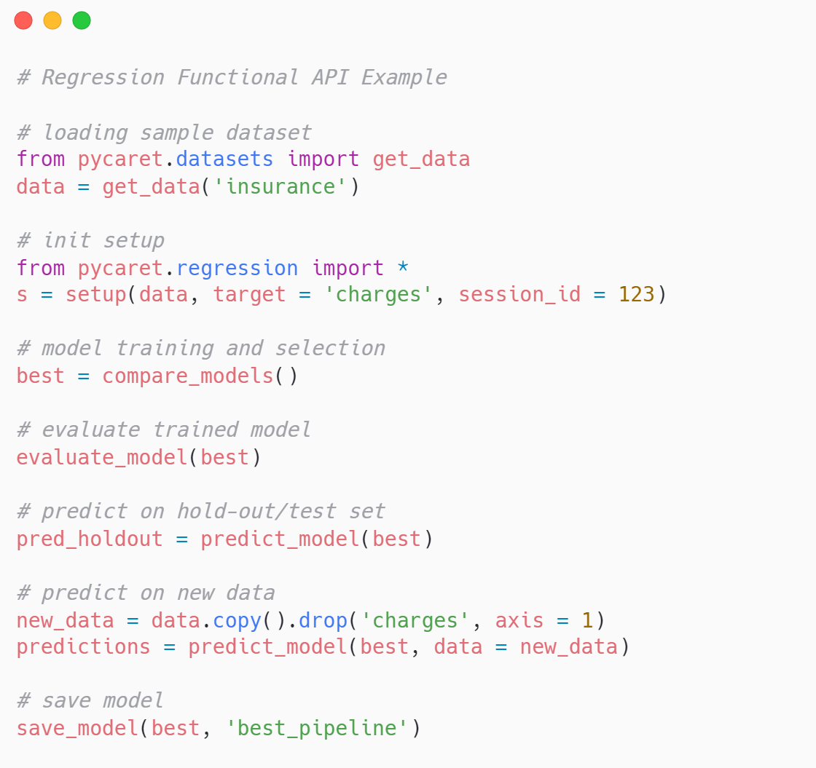
OOP API
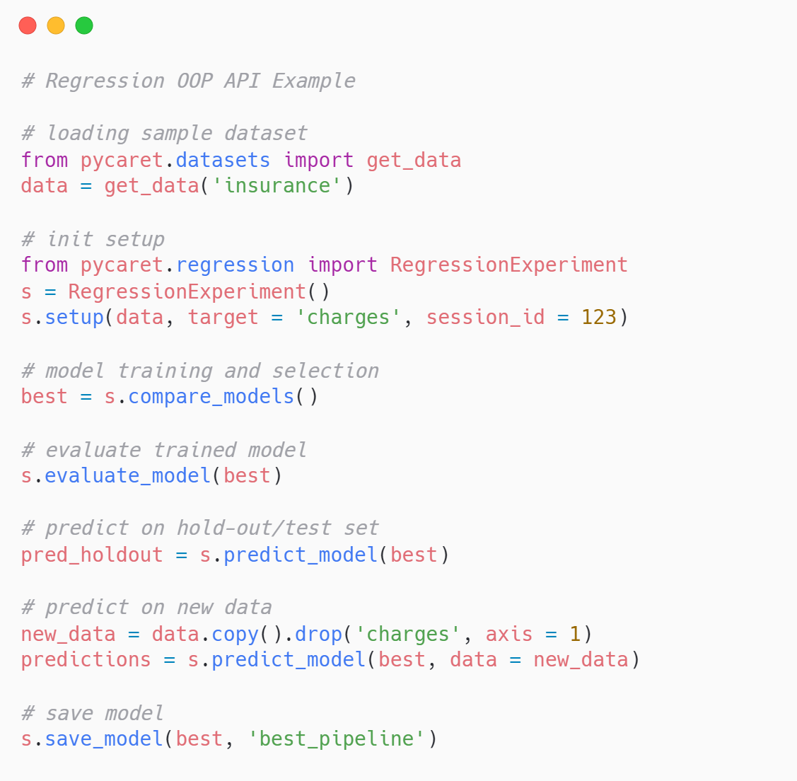
Time Series
Functional API
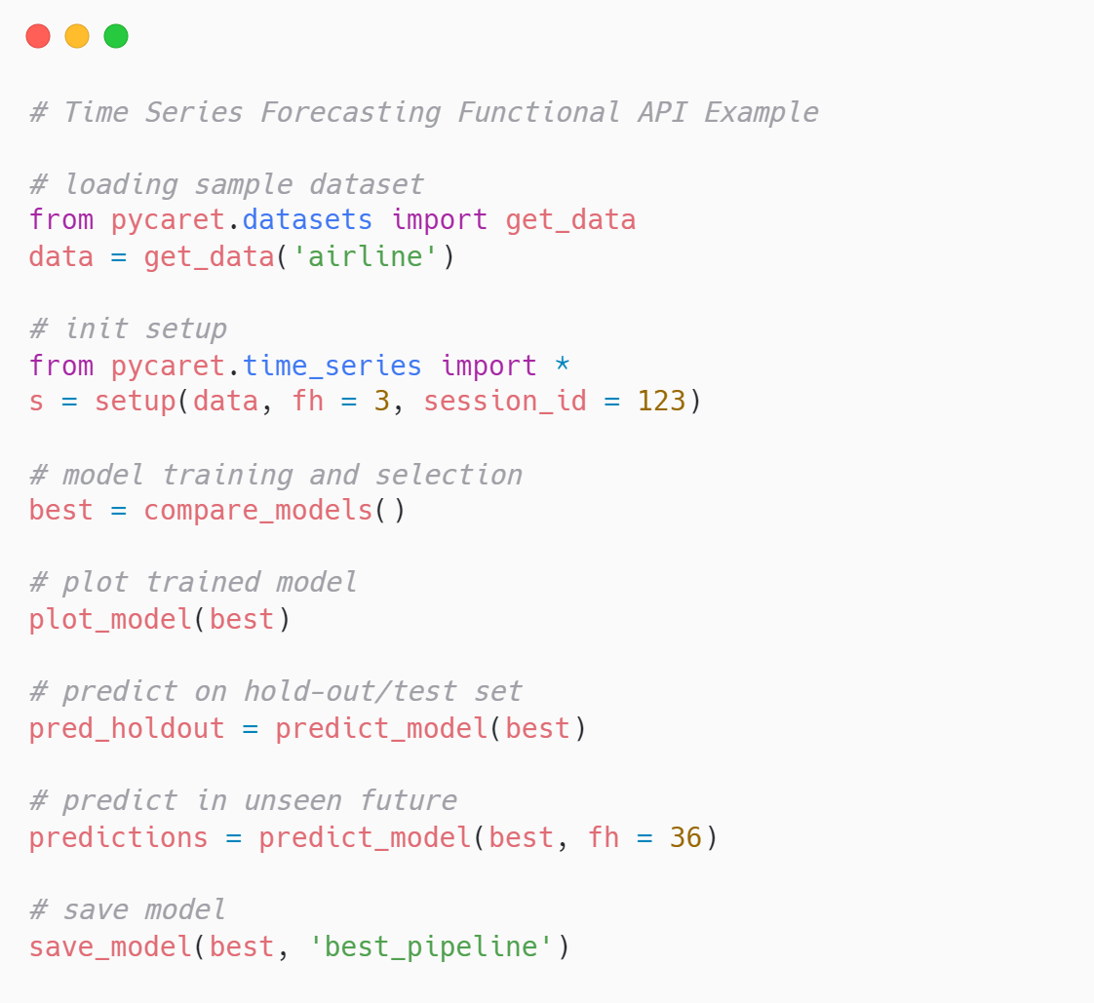
OOP API
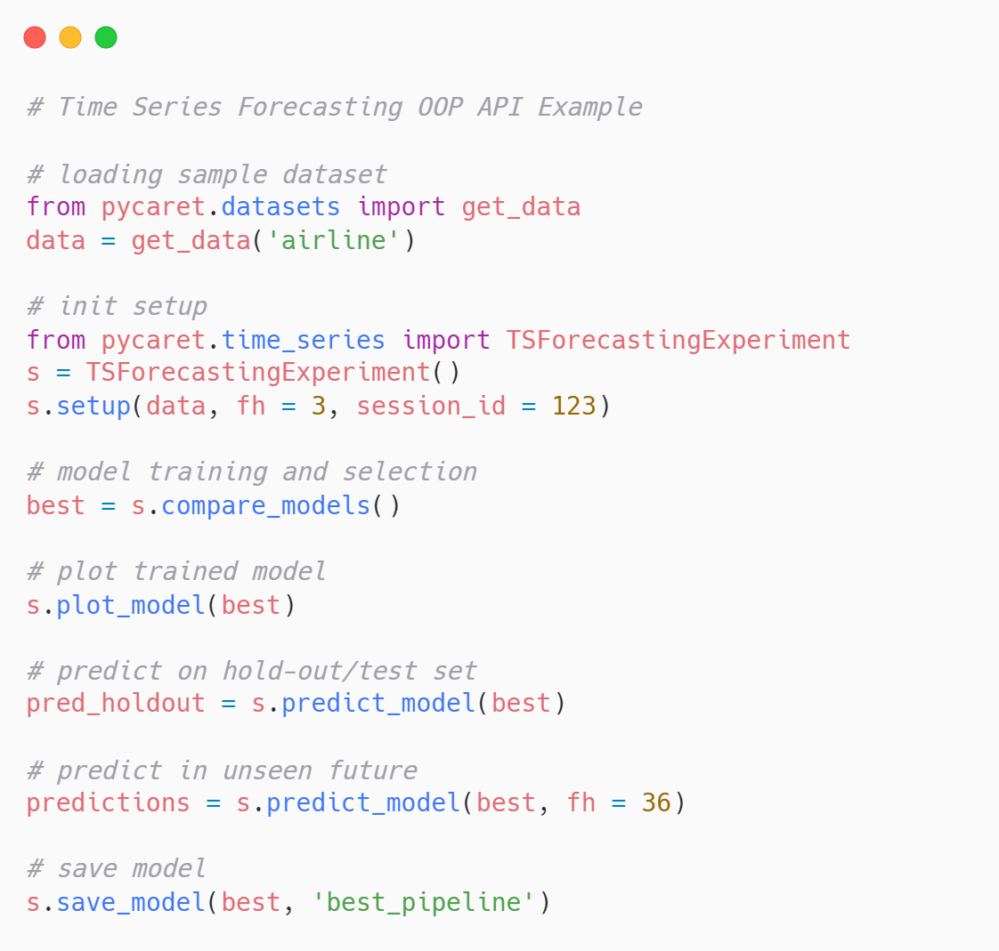
Clustering
Functional API
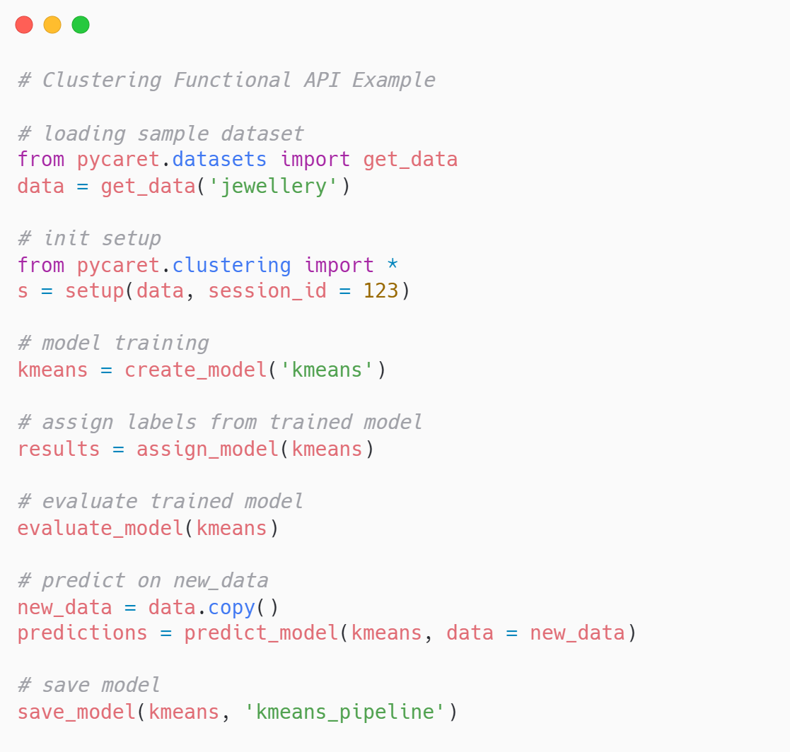
OOP API
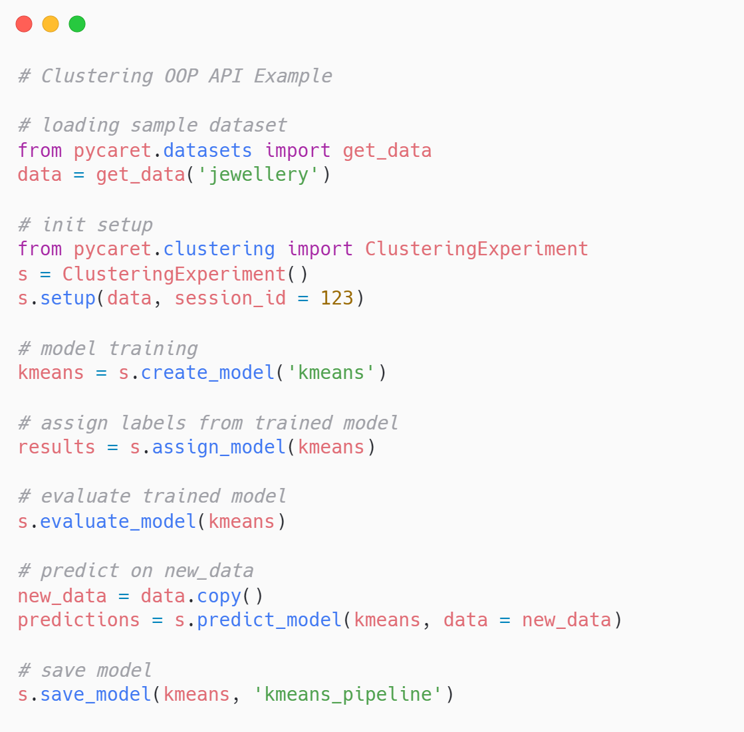
Anomaly Detection
Functional API
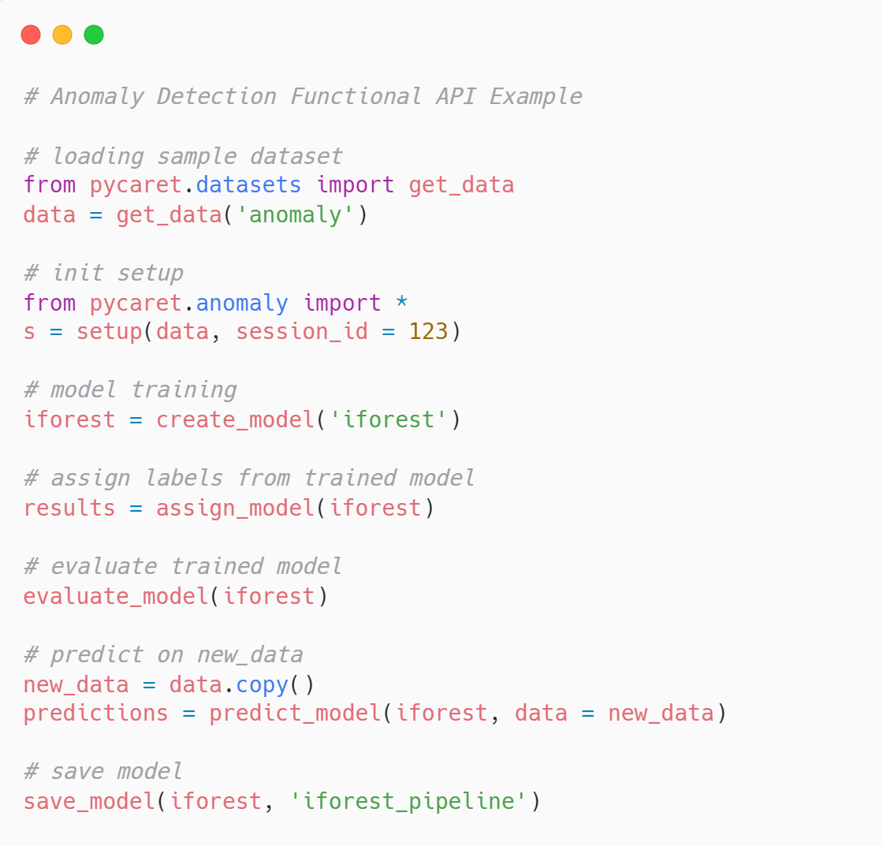
OOP API
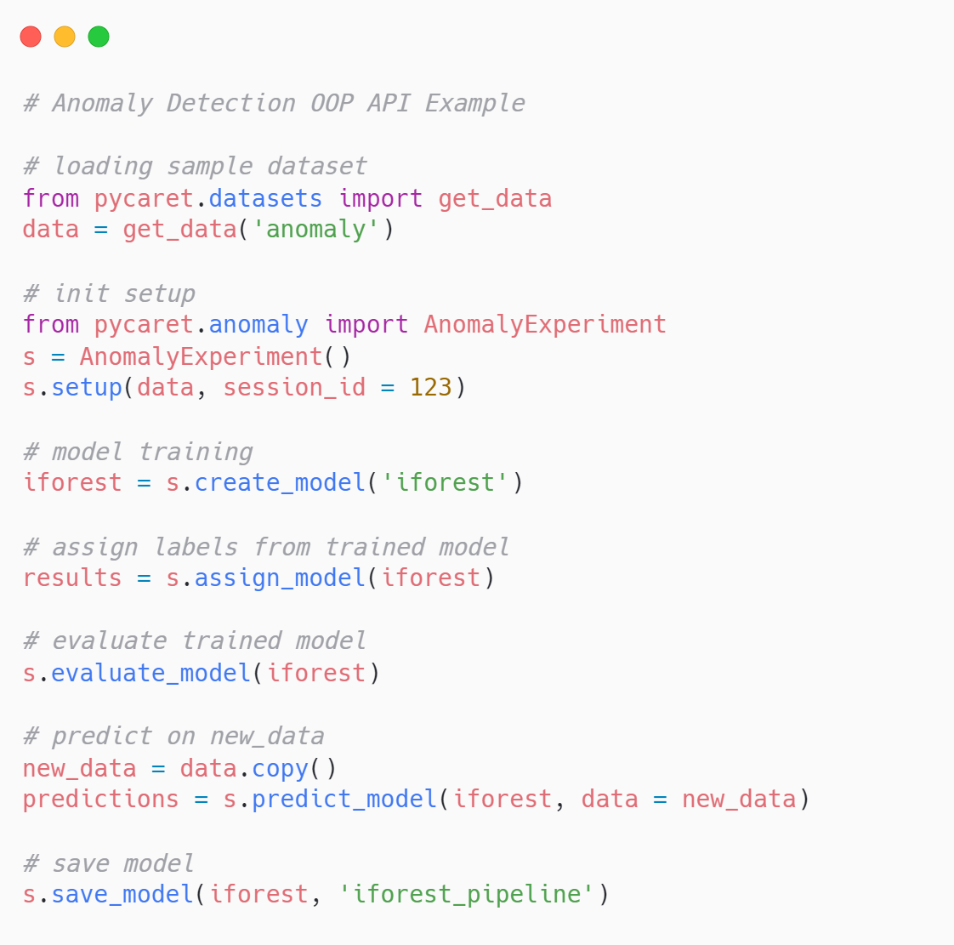
💻Installation
A step-by-step guide to install PyCaret in Python
Option 1: Install via PyPi
PyCaret is tested and supported on 64-bit systems with:
- Python 3.8, 3.9, 3.10, and 3.11
- Ubuntu 16.04 or later
- Windows 7 or later
You can install PyCaret with Python's pip package manager:
pip install pycaret

PyCaret's default installation will not install all the optional dependencies automatically. Depending on the use case, you may be interested in one or more extras:
# install analysis extras
pip install pycaret[analysis]

# models extras
pip install pycaret[models]

# install tuner extras
pip install pycaret[tuner]

# install mlops extras
pip install pycaret[mlops]

# install parallel extras
pip install pycaret[parallel]

# install test extras
pip install pycaret[test]

##

# install multiple extras together
pip install pycaret[analysis,models]

Check out all optional dependencies. If you want to install everything including all the optional dependencies:

# install full version
pip install pycaret[full]

Option 2: Source
Install the development version of the library directly from the source. The API may be unstable. It is not recommended for production use.
pip install git+https://github.com/pycaret/pycaret.git@master –upgrade

Option 3: Docker
Docker creates virtual environments with containers that keep a PyCaret installation separate from the rest of the system. PyCaret docker comes pre-installed with a Jupyter notebook. It can share resources with its host machine (access directories, use the GPU, connect to the Internet, etc.). The PyCaret Docker images are always tested for the latest major releases.
# default version
docker run -p 8888:8888 pycaret/slim

# full version
docker run -p 8888:8888 pycaret/full

To learn more, check out the Docker page for pycaret/slim or pycaret/full.
Environment
In order to avoid potential conflicts with other packages, it is strongly recommended to use a virtual environment, e.g. python3 virtualenv (see python3 virtualenv documentation) or conda environments. Using an isolated environment makes it possible to install a specific version of pycaret and its dependencies independently of any previously installed Python packages.
# create a conda environment
conda create --name yourenvname python=3.8

# activate conda environment
conda activate yourenvname

# install pycaret
pip install pycaret

# create notebook kernel
python -m ipykernel install --user --name yourenvname --display-name "display-name"

Training on GPU
To train models on the GPU, simply pass use_gpu = True in the setup function. There is no change in the use of the API; however, in some cases, additional libraries have to be installed. The following models can be trained on GPUs:
- Extreme Gradient Boosting
- Catboost
- Light Gradient Boosting Machine requires GPU specific installation
- Logistic Regression, Ridge Classifier, Random Forest, K Neighbors Classifier, K Neighbors Regressor, Support Vector Machine, Linear Regression, Ridge Regression, Lasso Regression requires cuML >= 0.15
PyCaret Intel sklearnex support
You can apply Intel optimizations for machine learning algorithms and speed up your workflows. To train models with Intel optimizations use sklearnex engine. There is no change in the use of the API, however, installation of Intel sklearnex is required:
#pip install scikit-learn-intelex

PyCaret is widely used across various industries and applications where machine learning is needed to automate and streamline workflows. Its simplicity and versatility make it suitable for both beginners and experienced professionals. Here are some key use cases and sectors where PyCaret is commonly applied:
1. Banking and Finance
- Credit Risk Scoring: Banks use PyCaret to develop models for predicting customer default risk by analyzing credit history, income, and other factors.
- Fraud Detection: Financial institutions use it to detect fraudulent transactions by building classification models that identify anomalies in transaction patterns.
- Loan Approval: Automating loan approval processes by predicting the likelihood of loan repayment based on customer attributes and credit history.
2. Retail and E-commerce
- Customer Churn Prediction: Retailers use PyCaret to predict customer churn, enabling them to retain customers by identifying those at risk of leaving.
- Product Recommendation Systems: PyCaret is used to build recommendation engines that suggest products based on user behavior, previous purchases, and preferences.
- Demand Forecasting: Retailers use PyCaret to predict future demand for products, helping with inventory planning and supply chain management.
3. Healthcare
- Disease Prediction: Healthcare providers use PyCaret to build predictive models that can detect diseases early based on patient data, lab results, and other clinical indicators.
- Medical Diagnosis: Hospitals and healthcare companies use it for diagnosis automation, predicting the likelihood of diseases based on historical patient data.
- Healthcare Analytics: It helps in understanding patient trends, predicting treatment outcomes, and optimizing resource allocation.
4. Marketing and Customer Analytics
- Customer Segmentation: Marketers use PyCaret to segment customers based on behavior, demographics, or purchasing patterns, enabling personalized marketing campaigns.
- Campaign Effectiveness: Predictive models built with PyCaret help in evaluating the success of marketing campaigns by analyzing customer responses and interactions.
- Customer Lifetime Value Prediction: Businesses use PyCaret to predict the future value of customers, helping prioritize high-value clients and customize their experience.
5. Telecommunications
- Network Optimization: Telecom companies use PyCaret for network optimization by predicting data traffic and network usage patterns.
- Customer Behavior Analysis: PyCaret is used for customer behavior analysis, such as predicting the likelihood of subscription upgrades or downgrades.
- Churn Prediction: Similar to retail, telecom companies use PyCaret to predict customer churn and develop retention strategies.
6. Manufacturing
- Predictive Maintenance: Manufacturers use PyCaret to predict equipment failure by analyzing sensor data, enabling preventive maintenance and reducing downtime.
- Quality Control: PyCaret is used to detect anomalies in production processes and ensure product quality by analyzing data from manufacturing processes.
7. Energy Sector
- Energy Consumption Forecasting: PyCaret is used to predict energy demand, helping utility companies optimize energy production and distribution.
- Renewable Energy Optimization: Predicting solar or wind energy production based on weather conditions using regression models.
- Smart Grids: PyCaret is used in smart grid management for predictive maintenance and optimizing energy distribution.
8. Insurance
- Claim Prediction: Insurance companies use PyCaret to predict the likelihood of a customer filing a claim based on their profile and previous behavior.
- Fraud Detection: Detecting fraudulent insurance claims using anomaly detection techniques and classification models built with PyCaret.
- Underwriting: Automating the underwriting process by predicting customer risk profiles based on historical data and current patterns.
9. Human Resources (HR)
- Employee Attrition Prediction: Companies use PyCaret to predict employee attrition, helping HR departments retain valuable employees by identifying potential flight risks.
- Recruitment Optimization: PyCaret helps in screening candidates and predicting the likelihood of success in a given role based on previous hiring data.
- Performance Prediction: HR analytics teams use PyCaret to predict employee performance and identify high performers for promotions or special projects.
10. Education
- Student Performance Prediction: Educational institutions use PyCaret to predict student outcomes, such as grades and graduation rates, based on factors like attendance, test scores, and demographic data.
- Course Recommendation: Developing recommendation systems for students, helping them select courses that best match their interests and previous academic performance.
- Dropout Prediction: Schools use PyCaret to predict student dropouts by analyzing student behavior, engagement levels, and socio-economic factors.
11. Real Estate
- House Price Prediction: PyCaret is commonly used to predict property prices by analyzing location, property features, and historical price data.
- Rental Yield Prediction: Real estate companies use it to forecast rental yields, helping investors make informed decisions.
- Market Segmentation: Segmenting the real estate market into different tiers based on price, location, and other factors, using clustering techniques.
12. Logistics and Transportation
- Delivery Time Prediction: Logistics companies use PyCaret to predict delivery times based on traffic data, distance, and historical delivery records.
- Route Optimization: Predictive models help optimize delivery routes, reducing costs and improving efficiency.
- Supply Chain Management: Predicting delays in the supply chain, optimizing inventory levels, and minimizing supply disruptions using predictive models.
13. Social Media and Sentiment Analysis
- Sentiment Analysis: PyCaret can be used to classify text data from social media into positive, negative, or neutral sentiment, helping companies monitor brand perception.
- Topic Modeling: Analyzing customer feedback or social media conversations to uncover common topics and trends.
- Engagement Prediction: Predicting how content (such as posts or videos) will perform based on historical engagement data.
14. Natural Language Processing (NLP)
- Text Classification: PyCaret’s NLP module is used for tasks such as spam detection, document classification, and sentiment analysis.
- Named Entity Recognition (NER): Identifying and classifying entities (like names, dates, organizations) in text data.
- Text Summarization: Automating the process of summarizing large text documents.
15. Startups and Small Businesses
- Business Analytics: Startups and small businesses leverage PyCaret for various analytics tasks like predicting sales, customer behavior, and inventory management without needing to invest in large data science teams.
- Prototyping: For rapid prototyping, startups use PyCaret to build machine learning models quickly with minimal code, speeding up product development.
Summary of Benefits in Various Use Cases:
- Ease of Use: PyCaret’s low-code approach makes it accessible to both beginners and professionals, allowing non-data scientists to leverage machine learning.
- Time-Saving: PyCaret reduces the time spent on data preprocessing, model building, and evaluation by automating many tasks.
- Model Transparency: PyCaret provides various tools for interpreting models, making it useful in sectors where model transparency is essential, such as healthcare, finance, and insurance.
- Deployment: The ability to easily deploy models to cloud platforms and integrate with existing business systems makes PyCaret a popular choice in production environments.
Overall, PyCaret is used in diverse fields wherever data-driven decision-making is key, helping companies harness the power of machine learning with minimal coding.
With PyCaret, you can create a wide range of machine learning solutions and models tailored for various tasks. Here’s what you can build with PyCaret:
1. Classification Models
Classification involves predicting discrete labels or categories. PyCaret supports building models for binary and multi-class classification tasks.
- Use Cases:
  - Fraud Detection: Detect fraudulent transactions (e.g., predicting whether a transaction is fraudulent or not).
  - Spam Detection: Classify emails or messages as spam or not spam.
  - Medical Diagnosis: Predict whether a patient has a certain disease based on symptoms and test results.
  - Customer Churn Prediction: Predict whether a customer is likely to churn based on their behavior.
- Algorithms:
  - Logistic Regression
  - Decision Trees
  - Random Forests
  - XGBoost, LightGBM, CatBoost
  - Support Vector Machines (SVM)
  - K-Nearest Neighbors (KNN)
  - Naive Bayes
2. Regression Models
Regression is used to predict continuous values based on input features. PyCaret simplifies building regression models for a wide variety of use cases.
- Use Cases:
  - House Price Prediction: Predict the price of real estate properties based on location, size, and other factors.
  - Sales Forecasting: Estimate future sales based on historical sales data.
  - Demand Forecasting: Predict product demand to optimize inventory levels.
  - Stock Market Prediction: Forecast stock prices or trends.
- Algorithms:
  - Linear Regression
  - Ridge, Lasso, and ElasticNet
  - Decision Trees, Random Forests
  - Gradient Boosting, XGBoost, LightGBM
  - Support Vector Regressor (SVR)
3. Clustering Models
Clustering is an unsupervised learning technique used to group similar data points together. PyCaret makes it easy to create clustering models.
- Use Cases:
  - Customer Segmentation: Segment customers based on purchasing behavior for personalized marketing.
  - Market Segmentation: Group markets into different categories based on similarities in demographics or preferences.
  - Anomaly Detection: Identify unusual patterns or outliers in data (e.g., detecting unusual customer transactions).
- Algorithms:
  - K-Means Clustering
  - Hierarchical Clustering
  - DBSCAN (Density-Based Spatial Clustering)
  - Gaussian Mixture Models (GMM)
4. Anomaly Detection Models
PyCaret supports building models for detecting anomalies or outliers in data, useful for identifying unusual events or patterns.
- Use Cases:
  - Fraud Detection: Detect outliers in transaction data that might indicate fraud.
  - Quality Control: Identify defective products in manufacturing processes based on anomalies in sensor data.
  - Network Security: Detect unusual network traffic patterns that may indicate a security breach.
- Algorithms:
  - Isolation Forest
  - One-Class SVM
  - Local Outlier Factor (LOF)
5. Natural Language Processing (NLP) Models
PyCaret’s NLP module allows users to build models for text data analysis.
- Use Cases:
  - Sentiment Analysis: Classify the sentiment (positive, negative, neutral) of customer reviews or social media posts.
  - Text Classification: Categorize text documents, such as classifying news articles into different topics.
  - Topic Modeling: Automatically discover hidden topics within a collection of text data.
- Techniques:
  - Text Vectorization (TF-IDF, Bag of Words)
  - Topic Modeling (Latent Dirichlet Allocation - LDA)
  - Text Classification (Logistic Regression, Naive Bayes)
6. Time Series Forecasting Models
PyCaret can also be used to build models for time series forecasting, which involves predicting future values based on historical data.
- Use Cases:
  - Sales Forecasting: Predict future sales trends over time.
  - Energy Demand Forecasting: Estimate future energy consumption for better resource planning.
  - Stock Price Prediction: Forecast future stock prices or market trends based on past performance.
- Algorithms:
  - ARIMA (AutoRegressive Integrated Moving Average)
  - Prophet
  - Exponential Smoothing
  - Seasonal Decomposition
7. Recommendation Systems
PyCaret can help build models for recommending items based on user preferences and past behavior.
- Use Cases:
  - Product Recommendations: Suggest products to users on an e-commerce platform based on their browsing and purchasing history.
  - Movie Recommendations: Recommend movies based on users' past ratings or viewing history.
  - Music Recommendations: Suggest songs or playlists based on listening habits.
- Techniques:
  - Collaborative Filtering
  - Content-Based Filtering
  - Hybrid Recommendation Systems
8. Dimensionality Reduction
Dimensionality reduction techniques are used to reduce the number of input features while retaining most of the important information.
- Use Cases:
  - Visualization: Simplify data for visualization in 2D or 3D plots.
  - Feature Selection: Reduce the complexity of models by selecting only the most important features.
  - Compression: Compress data to reduce storage needs without significant loss of information.
- Techniques:
  - Principal Component Analysis (PCA)
  - t-SNE (t-Distributed Stochastic Neighbor Embedding)
  - Feature Importance-Based Reduction
9. Image Classification and Object Detection (via External Libraries)
Although PyCaret doesn't directly handle image data, it can be integrated with other libraries like TensorFlow or PyTorch for image classification tasks.
- Use Cases:
  - Object Detection: Identify objects within an image, such as detecting cars, people, or animals.
  - Image Classification: Classify images into categories (e.g., identifying whether an image contains a cat or a dog).
  - Medical Imaging: Classify medical images (e.g., MRI scans) for detecting diseases.
- Libraries for Integration:
  - TensorFlow
  - PyTorch
  - OpenCV
10. Business Analytics and Decision Support Systems
PyCaret can also be used to develop business analytics models and decision support systems, which help businesses make informed decisions based on predictive analytics.
- Use Cases:
  - Revenue Forecasting: Predict future revenue based on historical trends.
  - Risk Management: Develop models to assess and manage business risks.
  - Customer Lifetime Value (CLV): Predict the lifetime value of a customer for personalized marketing strategies.
Summary of What You Can Create with PyCaret:
- Classification models for tasks like fraud detection, churn prediction, and sentiment analysis.
- Regression models for predicting continuous outcomes like house prices or sales.
- Clustering models for customer segmentation or market segmentation.
- Anomaly detection models for fraud detection and quality control.
- NLP models for text classification, sentiment analysis, and topic modeling.
- Time series forecasting models for predicting future trends in sales, energy demand, and stock prices.
- Recommendation systems for personalized product or content recommendations.
- Dimensionality reduction models for simplifying complex data and improving model performance.
- Image classification and object detection models (via integration with external libraries).
- Business analytics models for forecasting, risk management, and decision support.
These models and systems can be applied across industries such as healthcare, finance, retail, e-commerce, manufacturing, telecommunications, and more.
PyCaret helps users in several key ways, making machine learning more accessible, efficient, and scalable. Here’s how it benefits different stages of machine learning workflows:
1. Streamlines Machine Learning Workflows
- End-to-End Automation: PyCaret automates the entire machine learning workflow, from data preprocessing to model evaluation, saving time and effort. Users don’t need to write complex code for each stage of the pipeline, allowing them to focus on the problem rather than technical details.
- Prebuilt Pipelines: PyCaret constructs pipelines that handle tasks like feature engineering, model training, and prediction generation. These pipelines can be reused for different datasets, streamlining the process.
2. Saves Time with Low-Code Approach
- Minimal Code: PyCaret allows users to build and test machine learning models with just a few lines of code. This drastically reduces the development time, especially when compared to writing detailed scripts from scratch.
- Quick Prototyping: Users can quickly prototype machine learning models for experimentation, compare multiple models in one step, and get results faster. This is especially useful for exploratory data analysis and testing different hypotheses.
3. Makes Machine Learning Accessible to Non-Experts
- Beginner-Friendly: PyCaret’s low-code interface makes it easy for beginners and non-data scientists to get started with machine learning. Its user-friendly API abstracts complex processes, allowing those with limited knowledge of machine learning to build predictive models without extensive expertise.
- Automated Best Model Selection: PyCaret compares multiple models and selects the best-performing one based on the user’s specified evaluation metrics. This helps non-experts choose the right model without needing deep technical knowledge.
4. Improves Productivity for Experienced Data Scientists
- Efficient Experimentation: Experienced data scientists benefit from PyCaret’s automated workflow, which speeds up model comparison, hyperparameter tuning, and cross-validation. This frees up time for more strategic tasks like feature engineering or designing custom models.
- Hyperparameter Tuning: PyCaret automates hyperparameter tuning, a critical step in improving model performance. It helps users optimize their models without manually experimenting with different parameter combinations.
5. Supports Rapid Model Comparison and Evaluation
- Compare Multiple Models Easily: PyCaret’s compare_models function allows users to train and evaluate multiple machine learning models at once, automatically ranking them based on performance metrics. This simplifies model selection and ensures that the best model is chosen efficiently.
- Visualization and Interpretation: PyCaret includes built-in tools for model evaluation, providing visual insights like ROC curves, confusion matrices, feature importance plots, and learning curves. These insights make it easier to interpret how well a model performs and to communicate results to stakeholders.
6. Boosts Collaboration and Reproducibility
- Reusable Pipelines: PyCaret creates complete machine learning pipelines that can be easily shared and reused across teams. This promotes collaboration among data scientists, analysts, and engineers, ensuring that models can be replicated and deployed by different team members.
- Version Control: PyCaret tracks multiple models and experiments, helping teams keep track of different versions and settings used during experimentation.
7. Simplifies Deployment to Production
- Production-Ready Models: PyCaret makes it easy to export trained models and pipelines, which can be deployed directly to production environments. Models can be deployed in cloud platforms like AWS, Google Cloud, or Azure, and also as Docker containers.
- Seamless Integration: Once the model is built and trained, PyCaret allows users to integrate the model with other platforms for generating predictions on new data, making deployment seamless.
8. Increases Accuracy with Hyperparameter Tuning
- Automated Tuning: PyCaret supports automated hyperparameter tuning using techniques like grid search or random search, which improves model performance by optimizing key parameters. This helps users achieve higher accuracy without needing to manually test different configurations.
- Built-in Cross-Validation: PyCaret integrates cross-validation into the workflow, ensuring that the model’s performance is validated on multiple folds of the data. This prevents overfitting and ensures the model generalizes well on unseen data.
9. Supports a Wide Range of Machine Learning Tasks
- Versatility: PyCaret supports various machine learning tasks, including classification, regression, clustering, anomaly detection, natural language processing (NLP), and time series forecasting. This makes it useful for a wide range of use cases across industries such as finance, healthcare, retail, and marketing.
- Business Applications: PyCaret helps build models that solve real-world problems, such as customer churn prediction, fraud detection, sales forecasting, and sentiment analysis. These applications provide businesses with valuable insights for decision-making.
10. Enhances Model Interpretability
- Feature Importance: PyCaret helps users understand which features (input variables) are most important to the model’s predictions, providing insights into what drives the model’s decisions.
- SHAP Plots: PyCaret provides SHAP (Shapley Additive Explanations) plots that explain individual predictions by showing the contribution of each feature to the output, which is important in fields like healthcare and finance where model transparency is critical.
11. Increases Scalability
- Scalable Solutions: PyCaret supports scaling machine learning pipelines to handle large datasets and complex workflows. It can be easily integrated into big data platforms and cloud services, enabling businesses to scale their machine learning efforts.
12. Handles Real-World Data Challenges
- Data Preprocessing: PyCaret automates data preprocessing steps like handling missing values, encoding categorical variables, and scaling numerical data. This ensures that models are built on clean, well-prepared datasets without requiring manual intervention.
- Anomaly Detection: PyCaret’s anomaly detection capabilities help businesses identify irregular patterns in data, such as fraud or faulty behavior in machines, providing actionable insights for preventive actions.
Summary of How PyCaret Helps:
- Speeds up the machine learning process by automating data preparation, model selection, and evaluation.
- Reduces complexity with a low-code interface that makes machine learning accessible to non-experts.
- Enables rapid experimentation with built-in tools for comparing and optimizing models, saving time for both beginners and experienced data scientists.
- Improves model performance through hyperparameter tuning, cross-validation, and automated selection of the best models.
- Simplifies deployment of machine learning models to production environments, making it easy to integrate machine learning into business processes.
- Supports diverse tasks across industries, making it a versatile tool for building predictive models, handling large datasets, and interpreting results.

Case Study: Online Retailing

Objective
To analyze customer behavior in an online retail store by segmenting customers based on their purchasing behavior and predicting future sales. This analysis aims to help the business tailor marketing strategies, optimize inventory, and enhance customer satisfaction.

1. Introduction
In the competitive landscape of online retail, understanding customer behavior is crucial for tailoring marketing strategies, optimizing inventory, and enhancing customer satisfaction. This case study uses a hypothetical dataset of an online retail store to demonstrate how PyCaret can streamline the processes of customer segmentation and sales forecasting.

2. Data Collection

2.1 Dataset Description
For this case study, we will use a public dataset commonly referred to as the Online Retail dataset. It contains transaction records from a UK-based online retailer and includes the following columns:
- InvoiceNo: Unique identifier for each transaction.
- StockCode: Unique identifier for each product.
- Description: Description of the product.
- Quantity: Number of items purchased in each transaction.
- InvoiceDate: Date of the transaction.
- UnitPrice: Price per unit of the product.
- CustomerID: Unique identifier for each customer.
- Country: Country of the customer.

2.2 Data Acquisition
The dataset can be acquired from various platforms, such as Kaggle or UCI Machine Learning Repository.

3. Data Preparation

3.1 Loading the Data
import pandas as pd

# Load the dataset
data = pd.read_excel('Online Retail.xlsx')

# Display the first few rows
print(data.head())

3.2 Data Cleaning
- Remove Duplicates: Ensure there are no duplicate transactions.
# Remove duplicates
data = data.drop_duplicates()
- Handle Missing Values: Identify and handle missing values, especially for crucial columns like CustomerID.
# Check for missing values
print(data.isnull().sum())

# Remove rows with missing CustomerID
data = data[data['CustomerID'].notna()]
- Filter Out Unnecessary Transactions: Remove any records with negative quantities (which may indicate returns) and transactions that don't represent valid purchases.
# Filter out rows with non-positive quantities
data = data[data['Quantity'] > 0]
- Feature Engineering: Create additional features that could be valuable for analysis.
# Create a 'Total' column for the total price of each transaction
data['Total'] = data['Quantity'] * data['UnitPrice']

# Convert InvoiceDate to datetime
data['InvoiceDate'] = pd.to_datetime(data['InvoiceDate'])

3.3 Exploratory Data Analysis (EDA)
Perform some basic EDA to understand the data better.
python
Copy code
import matplotlib.pyplot as plt
import seaborn as sns

# Visualize total sales over time
daily_sales = data.groupby('InvoiceDate').agg({'Total': 'sum'}).reset_index()
plt.figure(figsize=(12, 6))
sns.lineplot(x='InvoiceDate', y='Total', data=daily_sales)
plt.title('Daily Sales Over Time')
plt.xlabel('Date')
plt.ylabel('Total Sales')
plt.xticks(rotation=45)
plt.show()

# Distribution of sales
plt.figure(figsize=(12, 6))
sns.histplot(data['Total'], bins=50, kde=True)
plt.title('Distribution of Transaction Amounts')
plt.xlabel('Transaction Amount')
plt.ylabel('Frequency')
plt.show()

4. Customer Segmentation
Objective: Segment customers based on their purchasing behavior to identify distinct groups (e.g., high-value customers, frequent buyers).

4.1 Creating Customer Features
Create a new DataFrame that aggregates customer behavior metrics.
# Create a new DataFrame with customer features
customer_data = data.groupby('CustomerID').agg({
'InvoiceNo': 'count', # Frequency
'Total': 'sum', # Total spent
'InvoiceDate': 'max' # Last purchase date
}).reset_index()

# Rename columns for clarity
customer_data.columns = ['CustomerID', 'Frequency', 'TotalSpent', 'LastPurchaseDate']

# Calculate Recency in days
customer_data['Recency'] = (data['InvoiceDate'].max() - customer_data['LastPurchaseDate']).dt.days

4.2 Using PyCaret for Clustering
Now, set up the PyCaret environment for clustering.
from pycaret.clustering import *

# Initialize PyCaret
cluster_setup = setup(customer_data, session_id=123, silent=True)

# Compare clustering models
best_model = compare_models()

4.3 Analyzing Clustering Results
After running the clustering models, analyze the results to understand the different customer segments.
# Create a model with the best number of clusters
model = create_model('kmeans', num_clusters=3) # Adjust the number of clusters based on analysis

# Assign cluster labels to customers
customer_data['Cluster'] = predict_model(model)['Cluster']

# Analyze each cluster
cluster_summary = customer_data.groupby('Cluster').mean()
print(cluster_summary)

# Visualize the clusters
plot_model(model)

5. Sales Forecasting
Objective: Predict future sales for better inventory management and marketing strategies.

5.1 Preparing Data for Time Series Forecasting
Aggregate sales data by date for time series analysis.
# Create a daily sales summary
daily_sales = data.groupby('InvoiceDate').agg({'Total': 'sum'}).reset_index()
daily_sales.rename(columns={'Total': 'TotalSales'}, inplace=True)

5.2 Setting Up PyCaret for Time Series Forecasting
from pycaret.time_series import *

# Set up PyCaret for time series forecasting
ts_setup = setup(daily_sales, target='TotalSales', index='InvoiceDate', session_id=123)

# Compare time series forecasting models
best_forecast_model = compare_models()

5.3 Forecasting Future Sales
After training the model, forecast future sales for a specific period.
# Create a final model
final_model = create_model('arima') # Or any other model like 'prophet', 'ets', etc.

# Forecast sales for the next 30 days
future_forecast = predict_model(final_model, fh=30)
print(future_forecast[['ds', 'yhat', 'yhat_lower', 'yhat_upper']])

5.4 Visualizing Forecasts
# Visualize the forecast
plot_model(final_model, plot='forecast', data_kwargs={'fh': 30})

6. Insights and Actionable Strategies
- Customer Segmentation Insights:
  - High-Value Customers: Identify segments with the highest average total spent, allowing for targeted loyalty programs and exclusive offers.
  - Frequent Buyers: Tailor marketing campaigns to reward frequent customers, such as personalized promotions to encourage repeat purchases.
  - At-Risk Customers: Identify customers with high recency scores who have not purchased recently and initiate re-engagement campaigns.
- Sales Forecasting Insights:
  - Inventory Management: Use forecast data to ensure that popular items are adequately stocked ahead of predicted sales spikes, reducing the risk of stockouts.
  - Marketing Strategies: Align marketing campaigns with forecasted sales trends to maximize their impact. For example, run promotions just before peak sales periods to capitalize on high demand.

7. Conclusion
This case study demonstrated how PyCaret can be leveraged for customer segmentation and sales forecasting in an online retailing context. The low-code nature of PyCaret allowed for rapid experimentation and insights, empowering businesses to make data-driven decisions. By implementing customer segmentation strategies and forecasting future sales, online retailers can optimize their operations, enhance customer satisfaction, and ultimately improve their bottom line.

8. Future Work
- A/B Testing: Implement A/B tests to evaluate the effectiveness of marketing strategies based on the identified customer segments.
- Real-Time Analytics: Develop a dashboard for real-time monitoring of sales and customer behavior to facilitate quicker decision-making.
- Integration with Other Systems: Integrate the forecasting model with inventory management systems for automated stock replenishment based on predicted sales.
This detailed case study outlines a comprehensive approach to using PyCaret for online retail analysis, providing insights into customer behavior and enabling informed business decisions.

Case Study: Supply Chain Management

Objective
To enhance supply chain efficiency by accurately forecasting product demand and optimizing inventory levels. This case study will demonstrate how to leverage PyCaret to improve decision-making in supply chain management.

1. Introduction
In the supply chain industry, accurate demand forecasting is crucial for optimizing inventory levels, reducing costs, and improving customer satisfaction. This case study will illustrate how to utilize PyCaret for demand forecasting and inventory optimization in a hypothetical retail supply chain.

2. Data Collection

2.1 Dataset Description
For this case study, we will use a hypothetical dataset containing historical sales data for a retail store. The dataset may include the following columns:
- Date: The date of the sales record.
- ProductID: Unique identifier for each product.
- StoreID: Unique identifier for each store.
- QuantitySold: Number of units sold on that date.
- Price: Selling price of the product.
- Promotion: Indicates whether a promotional event occurred (Yes/No).
- LeadTime: Number of days required to replenish stock.

2.2 Data Acquisition
You can generate synthetic data for this case study or use a public dataset that contains retail sales data. If generating synthetic data, consider using Python's numpy and pandas libraries.

3. Data Preparation

3.1 Generating Sample Data
Let's generate a sample dataset for this case study.
import pandas as pd
import numpy as np

# Set seed for reproducibility
np.random.seed(42)

# Generate date range
date_rng = pd.date_range(start='2020-01-01', end='2021-12-31', freq='D')

# Create sample data
data = pd.DataFrame(date_rng, columns=['Date'])
data['ProductID'] = np.random.choice(['A', 'B', 'C', 'D', 'E'], size=len(data))
data['StoreID'] = np.random.choice(['Store1', 'Store2'], size=len(data))
data['QuantitySold'] = np.random.poisson(lam=20, size=len(data)) # Poisson distribution for sales
data['Price'] = np.random.uniform(10, 100, size=len(data))
data['Promotion'] = np.random.choice(['Yes', 'No'], size=len(data), p=[0.3, 0.7])
data['LeadTime'] = np.random.randint(1, 10, size=len(data))

# Display the first few rows
print(data.head())

3.2 Data Cleaning
Perform necessary data cleaning steps:
# Check for missing values
print(data.isnull().sum())

# Convert Date to datetime format
data['Date'] = pd.to_datetime(data['Date'])

# Display basic statistics
print(data.describe())

3.3 Exploratory Data Analysis (EDA)
Conduct EDA to understand the dataset better.
import matplotlib.pyplot as plt
import seaborn as sns

# Plot total quantity sold over time
total_sales = data.groupby('Date').agg({'QuantitySold': 'sum'}).reset_index()

plt.figure(figsize=(12, 6))
sns.lineplot(x='Date', y='QuantitySold', data=total_sales)
plt.title('Total Quantity Sold Over Time')
plt.xlabel('Date')
plt.ylabel('Quantity Sold')
plt.xticks(rotation=45)
plt.show()

4. Demand Forecasting
Objective: Use historical sales data to forecast future demand for inventory planning.

4.1 Preparing Data for Time Series Forecasting
Aggregate sales data to prepare it for time series analysis.
# Aggregate sales data by month
monthly_sales = data.resample('M', on='Date').agg({'QuantitySold': 'sum'}).reset_index()

# Rename columns
monthly_sales.rename(columns={'QuantitySold': 'TotalSales'}, inplace=True)

# Display the first few rows
print(monthly_sales.head())

4.2 Setting Up PyCaret for Time Series Forecasting
Set up PyCaret to create a forecasting model.
from pycaret.time_series import *

# Initialize the time series setup
ts_setup = setup(monthly_sales, target='TotalSales', index='Date', session_id=123)

# Compare forecasting models
best_forecast_model = compare_models()

4.3 Creating and Evaluating the Forecasting Model
After identifying the best model, create it and evaluate its performance.
# Create the best model
final_model = create_model('prophet') # You can choose 'arima', 'ets', etc. as well

# Evaluate the model
evaluate_model(final_model)

# Forecast future sales for the next 12 months
future_forecast = predict_model(final_model, fh=12)
print(future_forecast[['ds', 'yhat', 'yhat_lower', 'yhat_upper']])

4.4 Visualizing the Forecast
# Plot the forecast
plot_model(final_model, plot='forecast')

5. Inventory Optimization
Objective: Use the demand forecast to optimize inventory levels and reduce costs.

5.1 Establishing Inventory Policies
Using the forecasted demand, determine optimal reorder points and order quantities. This can be done using inventory management models such as Economic Order Quantity (EOQ) and safety stock calculations.
- Economic Order Quantity (EOQ):
EOQ=2DSHEOQ = \sqrt{\frac{2DS}{H}}EOQ=H2DS​​
Where:
  - DDD = Demand (annual)
  - SSS = Cost per order
  - HHH = Holding cost per unit per year
- Safety Stock Calculation:
SafetyStock=Z×σLLSafety Stock = Z \times \sigma_L \sqrt{L}SafetyStock=Z×σL​L​
Where:
  - ZZZ = Z-score (based on service level)
  - σL\sigma_LσL​ = Standard deviation of lead time demand
  - LLL = Lead time (in days)
# Define parameters
D = monthly_sales['TotalSales'].mean() * 12 # Annual demand
S = 50 # Cost per order
H = 10 # Holding cost per unit per year

# Calculate EOQ
EOQ = np.sqrt((2 * D * S) / H)

# Calculate safety stock (assuming lead time demand follows a normal distribution)
lead_time_demand = data.groupby('LeadTime').agg({'QuantitySold': 'sum'}).reset_index()
sigma_L = lead_time_demand['QuantitySold'].std() # Standard deviation of lead time demand
Z = 1.645 # Z-score for 95% service level
L = 5 # Lead time in days

# Calculate safety stock
safety_stock = Z * sigma_L * np.sqrt(L)

# Display results
print(f"EOQ: {EOQ:.2f}")
print(f"Safety Stock: {safety_stock:.2f}")

5.2 Implementing Inventory Management Strategies
Based on the calculated EOQ and safety stock, develop an inventory management strategy.
- Reorder Point (ROP): Calculate when to reorder based on lead time and safety stock.
ROP=d×L+SafetyStockROP = d \times L + Safety StockROP=d×L+SafetyStock
Where:
  - ddd = Average daily demand
  - LLL = Lead time in days
# Calculate average daily demand
average_daily_demand = monthly_sales['TotalSales'].mean() / 30 # Monthly to daily

# Calculate ROP
ROP = (average_daily_demand * L) + safety_stock
print(f"Reorder Point: {ROP:.2f}")

6. Insights and Actionable Strategies
- Demand Forecasting Insights:
  - Accurate demand forecasts enable the business to anticipate changes in customer preferences and adjust inventory levels accordingly.
  - Seasonal trends can be identified, allowing for proactive marketing and inventory strategies during peak periods.
- Inventory Optimization Insights:
  - Implementing EOQ and safety stock calculations can significantly reduce holding costs while ensuring product availability.
  - Establishing clear reorder points helps prevent stockouts, improving customer satisfaction and sales.

7. Conclusion
This case study demonstrated how PyCaret can be leveraged for demand forecasting and inventory optimization in supply chain management. By accurately forecasting demand and implementing effective inventory management strategies, businesses can enhance their operational efficiency, reduce costs, and improve customer satisfaction.

8. Future Work
- Integration with Other Supply Chain Functions: Integrate demand forecasting with procurement and logistics functions to create a holistic supply chain management system.
- Real-Time Analytics: Develop dashboards for real-time monitoring of sales, inventory levels, and demand forecasts to facilitate agile decision-making.
- Advanced Forecasting Techniques: Explore advanced machine learning techniques such as ensemble models, neural networks, and deep learning for improved forecasting accuracy.
This detailed case study outlines a comprehensive approach to using PyCaret for demand forecasting and inventory optimization, providing insights that can help supply chain managers make informed decisions and drive efficiency.

Case Study: Education sector

Objective
To enhance educational outcomes by predicting student performance based on various factors and recommending courses tailored to students' needs and interests. This case study will demonstrate how to leverage PyCaret for data analysis and predictive modeling in the education sector.

1. Introduction
In the education sector, understanding and predicting student performance is crucial for tailoring interventions and improving learning outcomes. Additionally, recommending appropriate courses can help students make informed decisions about their educational paths. This case study illustrates how to utilize PyCaret to analyze student data and develop predictive models.

2. Data Collection

2.1 Dataset Description
For this case study, we will use a hypothetical dataset that simulates student performance and includes the following columns:
- StudentID: Unique identifier for each student.
- Gender: Gender of the student (e.g., Male, Female).
- Age: Age of the student.
- Ethnicity: Ethnic background of the student.
- ParentalLevelOfEducation: Highest level of education attained by the parents.
- Lunch: Type of lunch received (e.g., Standard, Free/Reduced).
- TestPreparationCourse: Whether the student completed a test preparation course (Yes/No).
- MathScore: Score in Mathematics.
- ReadingScore: Score in Reading.
- WritingScore: Score in Writing.
- CourseRecommendation: Recommended course based on performance.

2.2 Data Acquisition
You can generate synthetic data for this case study or use publicly available datasets, such as the Students Performance in Exams dataset from Kaggle.

3. Data Preparation

3.1 Generating Sample Data
Let's generate a synthetic dataset for this case study.
import pandas as pd
import numpy as np

# Set seed for reproducibility
np.random.seed(42)

# Generate sample data
data = pd.DataFrame({
'StudentID': range(1, 201),
'Gender': np.random.choice(['Male', 'Female'], size=200),
'Age': np.random.randint(15, 20, size=200),
'Ethnicity': np.random.choice(['Group A', 'Group B', 'Group C'], size=200),
'ParentalLevelOfEducation': np.random.choice(['High School', 'Associate', 'Bachelor', 'Master'], size=200),
'Lunch': np.random.choice(['Standard', 'Free/Reduced'], size=200),
'TestPreparationCourse': np.random.choice(['Completed', 'None'], size=200),
'MathScore': np.random.randint(0, 101, size=200),
'ReadingScore': np.random.randint(0, 101, size=200),
'WritingScore': np.random.randint(0, 101, size=200)
})

# Display the first few rows
print(data.head())

3.2 Data Cleaning
Perform necessary data cleaning steps:
# Check for missing values
print(data.isnull().sum())

# Display basic statistics
print(data.describe())

3.3 Exploratory Data Analysis (EDA)
Conduct EDA to understand the dataset better.
import matplotlib.pyplot as plt
import seaborn as sns

# Visualize the distribution of scores
plt.figure(figsize=(12, 6))
sns.boxplot(data=data[['MathScore', 'ReadingScore', 'WritingScore']])
plt.title('Distribution of Scores')
plt.ylabel('Score')
plt.show()

# Visualize correlation between scores
plt.figure(figsize=(8, 6))
sns.heatmap(data[['MathScore', 'ReadingScore', 'WritingScore']].corr(), annot=True, cmap='coolwarm')
plt.title('Correlation between Scores')
plt.show()

4. Student Performance Prediction
Objective: Predict student performance based on various features.

4.1 Preparing Data for Modeling
- Feature Engineering: Create a target variable based on scores.
# Create a target variable: Pass or Fail based on average score
data['AverageScore'] = (data['MathScore'] + data['ReadingScore'] + data['WritingScore']) / 3
data['Performance'] = np.where(data['AverageScore'] >= 60, 'Pass', 'Fail')

# Drop unnecessary columns for modeling
model_data = data.drop(columns=['StudentID', 'AverageScore'])
- Encode Categorical Variables: Convert categorical variables to numerical format.
# One-hot encoding of categorical variables
model_data = pd.get_dummies(model_data, drop_first=True)

4.2 Setting Up PyCaret for Classification
Set up PyCaret to create a classification model.
from pycaret.classification import *

# Initialize the setup
clf_setup = setup(model_data, target='Performance', session_id=123, silent=True)

# Compare classification models
best_model = compare_models()

4.3 Creating and Evaluating the Model
After identifying the best model, create it and evaluate its performance.
# Create the best model
final_model = create_model(best_model)

# Evaluate the model
evaluate_model(final_model)

5. Course Recommendation System
Objective: Recommend courses to students based on their performance.

5.1 Defining Recommendation Logic
Based on students' performance scores, define rules for course recommendations.
- High Performers (Score >= 80): Recommend advanced courses.
- Moderate Performers (60 <= Score < 80): Recommend standard courses.
- Low Performers (Score < 60): Recommend remedial or foundational courses.
def recommend_course(row):
if row['AverageScore'] >= 80:
return 'Advanced Course'
elif row['AverageScore'] >= 60:
return 'Standard Course'
else:
return 'Remedial Course'

data['CourseRecommendation'] = data.apply(recommend_course, axis=1)

5.2 Validating Recommendations
Validate the recommendations based on actual scores.
# Check the distribution of course recommendations
recommendation_counts = data['CourseRecommendation'].value_counts()

plt.figure(figsize=(8, 5))
sns.barplot(x=recommendation_counts.index, y=recommendation_counts.values)
plt.title('Course Recommendations Distribution')
plt.ylabel('Number of Students')
plt.xlabel('Recommended Course')
plt.show()

6. Insights and Actionable Strategies
- Predictive Insights:
  - By analyzing the features affecting student performance, educators can tailor interventions for at-risk students, such as additional tutoring or support programs.
  - The predictive model helps in identifying which students are likely to pass or fail, enabling proactive measures to improve outcomes.
- Course Recommendation Insights:
  - Personalized course recommendations can guide students toward suitable academic paths based on their performance, ensuring they receive the necessary support or challenges.
  - Implementing these recommendations can improve student satisfaction and engagement.

7. Conclusion
This case study demonstrated how PyCaret can be utilized in the education sector for student performance prediction and course recommendations. By leveraging predictive analytics, educational institutions can enhance student outcomes and provide tailored learning experiences.

8. Future Work
- Longitudinal Studies: Implement longitudinal analysis to track the effectiveness of recommendations over time and refine them based on evolving student performance data.
- Integration with Learning Management Systems (LMS): Integrate the predictive model and recommendation system with existing LMS platforms for real-time insights and recommendations.
- Advanced Modeling Techniques: Explore advanced machine learning techniques such as ensemble models or neural networks for improved predictive accuracy.
This detailed case study outlines a comprehensive approach to using PyCaret in the education sector, providing valuable insights for educators and administrators to enhance learning experiences and outcomes

Case Study: Manufacturing Sector

Objective
To enhance operational efficiency in a manufacturing plant by implementing predictive maintenance to reduce downtime and improve product quality. This case study will illustrate how to leverage PyCaret for predictive modeling and data analysis in the manufacturing sector.

1. Introduction
In the manufacturing sector, unplanned equipment failures can lead to significant downtime and financial losses. Predictive maintenance helps in forecasting equipment failures before they occur, allowing for timely interventions. Additionally, ensuring product quality is essential for customer satisfaction. This case study demonstrates how to utilize PyCaret for predictive maintenance and quality control.

2. Data Collection

2.1 Dataset Description
For this case study, we will use a hypothetical dataset that simulates manufacturing equipment data and includes the following columns:
- MachineID: Unique identifier for each machine.
- Timestamp: Date and time of the measurement.
- Temperature: Operating temperature of the machine.
- Vibration: Vibration levels of the machine.
- Pressure: Operating pressure of the machine.
- Status: Indicates whether the machine is operational or has failed (Operational/Failed).
- ProductQuality: Quality score of the produced product (0-100).
- MaintenanceNeeded: Indicates whether maintenance is needed (Yes/No).

2.2 Data Acquisition
You can generate synthetic data for this case study or use a public dataset related to manufacturing or equipment maintenance. If generating synthetic data, consider using Python's numpy and pandas libraries.

3. Data Preparation

3.1 Generating Sample Data
Let's generate a synthetic dataset for this case study.
import pandas as pd
import numpy as np

# Set seed for reproducibility
np.random.seed(42)

# Generate sample data
data = pd.DataFrame({
'MachineID': np.random.choice(['Machine1', 'Machine2', 'Machine3', 'Machine4'], size=1000),
'Timestamp': pd.date_range(start='2024-01-01', periods=1000, freq='H'),
'Temperature': np.random.normal(loc=70, scale=10, size=1000), # Normal distribution
'Vibration': np.random.normal(loc=0.5, scale=0.1, size=1000), # Normal distribution
'Pressure': np.random.normal(loc=30, scale=5, size=1000), # Normal distribution
'Status': np.random.choice(['Operational', 'Failed'], size=1000, p=[0.9, 0.1]),
'ProductQuality': np.random.uniform(60, 100, size=1000) # Uniform distribution
})

# Display the first few rows
print(data.head())

3.2 Data Cleaning
Perform necessary data cleaning steps:
# Check for missing values
print(data.isnull().sum())

# Display basic statistics
print(data.describe())

# Check the distribution of Status
print(data['Status'].value_counts())

3.3 Exploratory Data Analysis (EDA)
Conduct EDA to understand the dataset better.
import matplotlib.pyplot as plt
import seaborn as sns

# Visualize the relationship between temperature and machine status
plt.figure(figsize=(12, 6))
sns.boxplot(x='Status', y='Temperature', data=data)
plt.title('Temperature Distribution by Machine Status')
plt.ylabel('Temperature')
plt.show()

# Visualize the distribution of product quality
plt.figure(figsize=(12, 6))
sns.histplot(data['ProductQuality'], bins=30, kde=True)
plt.title('Distribution of Product Quality')
plt.xlabel('Product Quality Score')
plt.ylabel('Frequency')
plt.show()

4. Predictive Maintenance
Objective: Predict equipment failures to schedule timely maintenance and reduce unplanned downtime.

4.1 Preparing Data for Modeling
- Feature Engineering: Convert the status variable to a binary target variable.
# Convert Status to binary
data['Failure'] = np.where(data['Status'] == 'Failed', 1, 0)

# Drop unnecessary columns
model_data = data.drop(columns=['MachineID', 'Timestamp', 'Status', 'ProductQuality'])
- Train-Test Split: Split the data into training and testing sets.
from sklearn.model_selection import train_test_split

X = model_data.drop(columns=['Failure'])
y = model_data['Failure']

X_train, X_test, y_train, y_test = train_test_split(X, y, test_size=0.2, random_state=42)

4.2 Setting Up PyCaret for Classification
Set up PyCaret to create a classification model for predictive maintenance.
from pycaret.classification import *

# Initialize the setup
clf_setup = setup(data=model_data, target='Failure', session_id=123, silent=True)

# Compare classification models
best_model = compare_models()

4.3 Creating and Evaluating the Model
After identifying the best model, create it and evaluate its performance.
python
Copy code
# Create the best model
final_model = create_model(best_model)

# Evaluate the model
evaluate_model(final_model)

# Make predictions on the test set
predictions = predict_model(final_model, data=X_test)
print(predictions[['Temperature', 'Vibration', 'Pressure', 'Failure', 'Label']].head())

5. Quality Control
Objective: Ensure product quality by analyzing factors affecting the quality score.

5.1 Setting Up PyCaret for Regression
- Preparing Data for Quality Control: Drop unnecessary columns and set up the data for regression modeling.
# Prepare data for quality control analysis
quality_data = data[['Temperature', 'Vibration', 'Pressure', 'ProductQuality']]

# Initialize PyCaret for regression
reg_setup = setup(data=quality_data, target='ProductQuality', session_id=123, silent=True)
- Compare Regression Models: Identify the best regression model for predicting product quality.
# Compare regression models
best_quality_model = compare_models()

5.2 Creating and Evaluating the Quality Control Model
Create the best regression model and evaluate its performance.
# Create the best quality model
final_quality_model = create_model(best_quality_model)

# Evaluate the model
evaluate_model(final_quality_model)

# Make predictions on the product quality
quality_predictions = predict_model(final_quality_model)
print(quality_predictions[['Temperature', 'Vibration', 'Pressure', 'ProductQuality', 'Label']].head())

6. Insights and Actionable Strategies
- Predictive Maintenance Insights:
  - By predicting equipment failures, the manufacturing plant can implement preventive maintenance schedules, reducing downtime and maintenance costs.
  - The predictive model can identify critical parameters (like temperature or vibration) that contribute to equipment failure, allowing for targeted monitoring.
- Quality Control Insights:
  - Understanding the factors affecting product quality enables the plant to adjust processes in real-time to maintain high-quality output.
  - The regression model can help identify thresholds for key parameters (like temperature and pressure) that correlate with higher product quality, guiding operational adjustments.

7. Conclusion
This case study demonstrated how PyCaret can be utilized in the manufacturing sector for predictive maintenance and quality control. By leveraging predictive analytics, manufacturers can enhance operational efficiency, reduce costs, and improve product quality.

8. Future Work
- Integration with IoT: Implement real-time monitoring systems using IoT devices to collect data continuously for more accurate predictive maintenance.
- Root Cause Analysis: Conduct root cause analysis on failed machines to enhance the predictive model and improve accuracy.
- Advanced Modeling Techniques: Explore advanced techniques such as ensemble models or neural networks for improved predictive performance.
This detailed case study outlines a comprehensive approach to using PyCaret in the manufacturing sector, providing valuable insights that can help manufacturers optimize their operations and ensure product quality.
For more information visit www.pycaret.org

