Consistent hashing
Consistent hashing is a distributed hashing scheme that aims to minimize the reorganization of data when nodes are added or removed from a hash table. It's particularly useful in distributed systems for load balancing and data distribution across multiple servers.
Key Concepts:
- Hash Ring: Nodes and data are placed on a circular hash space (ring). Each node is assigned a position based on its hash value.
- Data Distribution: Each data item is hashed to determine its position on the ring. The item is stored on the first node found in a clockwise direction.
- Node Addition/Removal:
  - Adding a Node: Only a fraction of data items need to be rehashed and redistributed (those that would now fall before the new node).
  - Removing a Node: Data items previously stored on the removed node are reassigned to the next node on the ring.
Advantages:
- Scalability: It allows for easy addition and removal of nodes with minimal data movement.
- Load Balancing: Helps distribute data evenly across nodes, reducing hotspots.
Applications:
- Distributed caching systems (like Memcached).
- Load balancers in web services.
- Peer-to-peer networks (like BitTorrent).
By reducing the impact of changes in the cluster size, consistent hashing ensures that the system remains efficient and responsive.
Here's a simple implementation of consistent hashing in Java. This code demonstrates a basic consistent hashing algorithm using a hash ring:
import java.util.SortedMap;
import java.util.TreeMap;
public class ConsistentHashing {
private final SortedMap<Integer, String> circle = new TreeMap<>();
private final int numberOfReplicas;
public ConsistentHashing(int numberOfReplicas, String[] nodes) {
this.numberOfReplicas = numberOfReplicas;
for (String node : nodes) {
addNode(node);
}
}
// Hashes a key to an integer
private int hash(String key) {
return key.hashCode() & 0xFFFFFFF; // Use only the lower 28 bits
}
// Adds a node to the hash circle
public void addNode(String node) {
for (int i = 0; i < numberOfReplicas; i++) {
circle.put(hash(node + i), node);
}
}
// Removes a node from the hash circle
public void removeNode(String node) {
for (int i = 0; i < numberOfReplicas; i++) {
circle.remove(hash(node + i));
}
}
// Gets the node for the given key
public String getNode(String key) {
if (circle.isEmpty()) {
return null;
}
int hash = hash(key);
// Get the next highest node
SortedMap<Integer, String> tailMap = circle.tailMap(hash);
Integer nodeHash = tailMap.isEmpty() ? circle.firstKey() : tailMap.firstKey();
return circle.get(nodeHash);
}
public static void main(String[] args) {
String[] nodes = {"Node1", "Node2", "Node3"};
ConsistentHashing consistentHashing = new ConsistentHashing(3, nodes);
// Test getting nodes for various keys
System.out.println("Node for key 'myKey1': " + consistentHashing.getNode("myKey1"));
System.out.println("Node for key 'myKey2': " + consistentHashing.getNode("myKey2"));
System.out.println("Node for key 'myKey3': " + consistentHashing.getNode("myKey3"));
// Add a new node
consistentHashing.addNode("Node4");
System.out.println("After adding Node4:");
System.out.println("Node for key 'myKey1': " + consistentHashing.getNode("myKey1"));
System.out.println("Node for key 'myKey2': " + consistentHashing.getNode("myKey2"));
System.out.println("Node for key 'myKey3': " + consistentHashing.getNode("myKey3"));
// Remove a node
consistentHashing.removeNode("Node2");
System.out.println("After removing Node2:");
System.out.println("Node for key 'myKey1': " + consistentHashing.getNode("myKey1"));
System.out.println("Node for key 'myKey2': " + consistentHashing.getNode("myKey2"));
System.out.println("Node for key 'myKey3': " + consistentHashing.getNode("myKey3"));
}
}
Explanation:
- Hash Function: The hash method generates a hash for a given key, using the hashCode() method.
- Circle Representation: A SortedMap (TreeMap) is used to represent the hash circle. Each node is added multiple times (based on the number of replicas) to improve load balancing.
- Node Management: The addNode and removeNode methods manage nodes in the hash circle.
- Key Lookup: The getNode method finds the appropriate node for a given key by traversing the hash circle.
Usage: You can run the main method to see how keys are mapped to nodes, as well as how adding and removing nodes affects the distribution. Adjust the number of replicas to see how it influences load balancing.
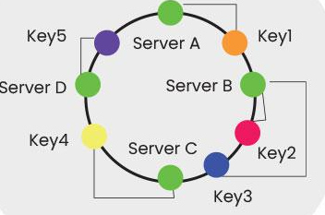
Geohash
Geohashing is a method for encoding latitude and longitude coordinates into a compact string representation. This encoding is useful for spatial indexing and searching, allowing for efficient geographic queries. Here's an overview of how it works and how to use it:
How Geohashing Works:
- Coordinate System: Geohashing uses a geographic coordinate system based on latitude and longitude.
- Grid Division: The Earth is divided into a grid system where each region is represented by a unique code. The grid cells get progressively smaller as the precision of the geohash increases.
- Base32 Encoding: Geohashes are typically represented in a base32 format, using the characters 0123456789bcdefghjkmnpqrstuvwxyz. Each character in the geohash corresponds to a specific geographic region, with longer geohashes providing more precise locations.
Characteristics:
- Precision: The length of the geohash determines the precision of the location; longer hashes correspond to smaller geographic areas.
- Spatial Proximity: Nearby locations produce similar geohashes, which allows for proximity searches.
Example of Usage:
Here's a simple implementation in Java that provides basic functionality for encoding and decoding geohashes:
import java.util.HashMap;
import java.util.Map;
public class Geohash {
private static final String BASE32 = "0123456789bcdefghjkmnpqrstuvwxyz";
private static final Map<Character, Integer> BASE32_MAP = new HashMap<>();
static {
for (int i = 0; i < BASE32.length(); i++) {
BASE32_MAP.put(BASE32.charAt(i), i);
}
}
public static String encode(double latitude, double longitude, int precision) {
StringBuilder geohash = new StringBuilder();
double latMin = -90, latMax = 90;
double lonMin = -180, lonMax = 180;
boolean isEven = true;
for (int i = 0; i < precision * 5; i++) {
if (isEven) {
double lonMid = (lonMin + lonMax) / 2;
if (longitude > lonMid) {
geohash.append('1');
lonMin = lonMid;
} else {
geohash.append('0');
lonMax = lonMid;
}
} else {
double latMid = (latMin + latMax) / 2;
if (latitude > latMid) {
geohash.append('1');
latMin = latMid;
} else {
geohash.append('0');
latMax = latMid;
}
}
isEven = !isEven;
}
// Convert binary string to base32
StringBuilder finalGeohash = new StringBuilder();
for (int i = 0; i < geohash.length(); i += 5) {
String bits = geohash.substring(i, Math.min(i + 5, geohash.length()));
int value = Integer.parseInt(bits, 2);
finalGeohash.append(BASE32.charAt(value));
}
return finalGeohash.toString();
}
public static void main(String[] args) {
double latitude = 37.7749; // Example: San Francisco
double longitude = -122.4194;
int precision = 6; // Adjust precision as needed
String geohash = encode(latitude, longitude, precision);
System.out.println("Geohash for San Francisco: " + geohash);
}
}
Explanation:
Encoding Function: The encode method takes latitude, longitude, and desired precision as inputs. It repeatedly divides the latitude and longitude ranges to find the corresponding binary representation, which is then converted to a base32 geohash.
- Base32 Conversion: The binary string is grouped into segments of 5 bits, which are then converted to base32 characters.
- Main Method: The main method demonstrates how to use the encoding function by geohashing the coordinates for San Francisco.
Applications:
- Location Services: Geohashing is widely used in location-based services, mapping, and geographic information systems (GIS).
- Spatial Queries: It allows for efficient querying of nearby locations, as geohashes of similar length indicate geographic proximity.
Geohashing is a powerful tool for efficiently handling geographic data, enabling fast indexing and searching in spatial databases.
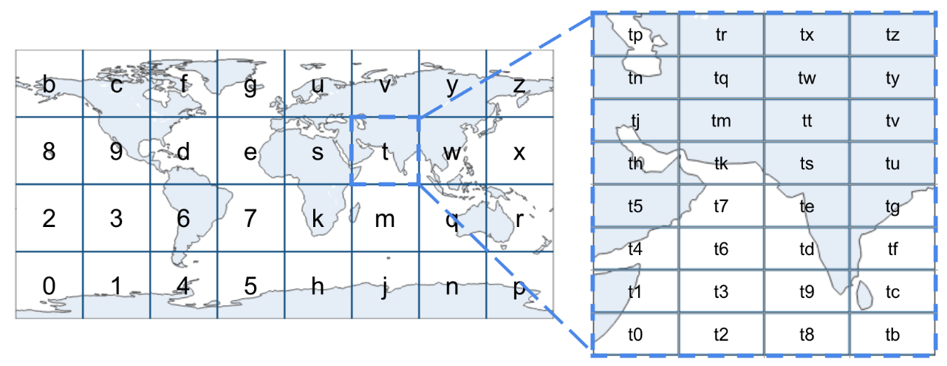
Quadtree
A quadtree is a tree data structure used to partition a two-dimensional space by recursively subdividing it into four quadrants or regions. It is commonly used in computer graphics, spatial indexing, and geographic information systems (GIS) for efficient querying and management of spatial data.
Key Concepts:
- Structure:
- Each node in the quadtree represents a rectangular region of space.
- Each node can have up to four children, corresponding to the four quadrants: northwest (NW), northeast (NE), southwest (SW), and southeast (SE).
- Subdivision:
- A region is subdivided into four equal parts when it exceeds a certain threshold (e.g., when it contains more than a specified number of points or exceeds a certain size).
- This subdivision continues recursively for each quadrant until a stopping condition is met.
- Leaf Nodes:
- Leaf nodes contain data points (e.g., coordinates) or a reference to a larger area if no further subdivision is required.
Advantages:
- Spatial Queries: Quadtrees allow for efficient searching, such as finding points within a specific region or counting points in a bounding box.
- Adaptive Partitioning: The tree can adaptively subdivide regions based on the density of data points, leading to efficient memory usage and performance.
Applications:
- Geographic Information Systems (GIS): For representing spatial data like maps, regions, and layers.
- Image Processing: For representing images as hierarchical structures, allowing for efficient manipulation and compression.
- Collision Detection: In computer graphics and game development, for quickly finding potential collisions among objects.
Example of a Quadtree Implementation in Java:
Here is a basic implementation of a quadtree that can insert points and perform a range search:
import java.awt.Rectangle;
import java.util.ArrayList;
import java.util.List;
class Point {
double x, y;
Point(double x, double y) {
this.x = x;
this.y = y;
}
}
class Quadtree {
private static final int CAPACITY = 4; // Maximum points in a node before subdivision
private Rectangle boundary;
private List<Point> points;
private boolean divided;
private Quadtree northwest;
private Quadtree northeast;
private Quadtree southwest;
private Quadtree southeast;
public Quadtree(Rectangle boundary) {
this.boundary = boundary;
this.points = new ArrayList<>();
this.divided = false;
}
public void insert(Point point) {
if (!boundary.contains(point.x, point.y)) {
return; // Point is out of bounds
}
if (points.size() < CAPACITY) {
points.add(point); // Add point to this node
} else {
if (!divided) {
subdivide(); // Subdivide if capacity is reached
}
northwest.insert(point);
northeast.insert(point);
southwest.insert(point);
southeast.insert(point);
}
}
private void subdivide() {
double x = boundary.getX();
double y = boundary.getY();
double w = boundary.getWidth() / 2;
double h = boundary.getHeight() / 2;
northwest = new Quadtree(new Rectangle((int) x, (int) y, (int) w, (int) h));
northeast = new Quadtree(new Rectangle((int) (x + w), (int) y, (int) w, (int) h));
southwest = new Quadtree(new Rectangle((int) x, (int) (y + h), (int) w, (int) h));
southeast = new Quadtree(new Rectangle((int) (x + w), (int) (y + h), (int) w, (int) h));
divided = true;
}
public List<Point> query(Rectangle range) {
List<Point> found = new ArrayList<>();
if (!boundary.intersects(range)) {
return found; // No intersection
}
for (Point point : points) {
if (range.contains(point.x, point.y)) {
found.add(point); // Point is within range
}
}
if (divided) {
found.addAll(northwest.query(range));
found.addAll(northeast.query(range));
found.addAll(southwest.query(range));
found.addAll(southeast.query(range));
}
return found;
}
public static void main(String[] args) {
Rectangle boundary = new Rectangle(0, 0, 200, 200);
Quadtree quadtree = new Quadtree(boundary);
// Insert some points
quadtree.insert(new Point(25, 25));
quadtree.insert(new Point(50, 50));
quadtree.insert(new Point(75, 75));
quadtree.insert(new Point(100, 100));
quadtree.insert(new Point(150, 150));
// Query for points within a specific range
Rectangle range = new Rectangle(0, 0, 100, 100);
List<Point> foundPoints = quadtree.query(range);
System.out.println("Points found in range: " + foundPoints.size());
}
}
Explanation:
- Point Class: Represents a 2D point with x and y coordinates.
- Quadtree Class:
- Boundary: A Rectangle defines the area covered by the quadtree node.
- Points: A list to store points within the node.
- Subdivision Logic: When the number of points exceeds the defined capacity, the node is subdivided into four quadrants.
- Insert Method: Adds points to the quadtree, subdividing when necessary.
- Query Method: Searches for points within a given rectangular range.
Usage: The main method demonstrates how to create a quadtree, insert points, and perform a query to find points within a specified range.
Quadtrees are effective for managing spatial data, allowing for efficient queries and storage of 2D points, making them a valuable tool in various applications involving geographic data and spatial analysis.
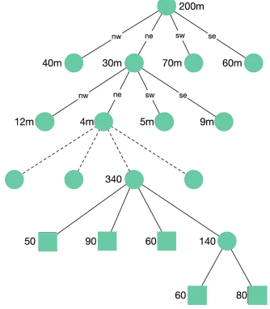
Leaky bucket
The leaky bucket algorithm is a traffic shaping and rate-limiting mechanism used to control data transmission rates in networks. It helps manage the flow of data by ensuring that packets are sent at a constant rate, regardless of the bursty nature of traffic.
Key Concepts:
- Bucket Analogy:
- Imagine a bucket with a hole at the bottom. Water (representing data packets) can flow into the bucket at varying rates, but it leaks out at a steady, defined rate.
- If the bucket fills up, any excess water that cannot flow out is effectively discarded (or delayed), simulating a limit on how much data can be processed at once.
- Parameters:
- Capacity (Bucket Size): The maximum amount of data (or packets) the bucket can hold at any time.
- Leak Rate: The rate at which data is allowed to leave the bucket (e.g., packets per second). This represents the maximum rate of outgoing data transmission.
- Behaviour:
- Normal Operation: When data packets are sent at or below the leak rate, they flow out smoothly.
- Burst Handling: If there is a sudden influx of packets (a burst), they can temporarily fill the bucket. If the bucket overflows, excess packets are discarded or delayed.
- Smoothing Traffic: By controlling the rate of outgoing packets, the leaky bucket algorithm helps to smooth out bursts and ensure a consistent flow.
Applications:
- Network Traffic Control: Used in routers and switches to regulate the flow of packets and prevent congestion.
- API Rate Limiting: Helps manage requests to an API, ensuring that clients do not overwhelm the server with too many requests at once.
- Quality of Service (QoS): Helps enforce bandwidth guarantees in networked applications.
Example of a Simple Leaky Bucket Implementation in Java:
Here's a basic Java implementation of a leaky bucket algorithm:
import java.util.concurrent.TimeUnit;
class LeakyBucket {
private final long capacity; // Maximum capacity of the bucket
private final long leakRate; // Leak rate (tokens per second)
private long water; // Current amount of water in the bucket
private long lastLeakTime; // Last time water was leaked
public LeakyBucket(long capacity, long leakRate) {
this.capacity = capacity;
this.leakRate = leakRate;
this.water = 0;
this.lastLeakTime = System.currentTimeMillis();
}
// Add water to the bucket
public synchronized boolean addWater(long amount) {
leak(); // Ensure to leak before adding
if (water + amount <= capacity) {
water += amount; // Fill the bucket
return true; // Successful addition
}
return false; // Bucket overflows
}
// Leak water from the bucket based on the elapsed time
private void leak() {
long now = System.currentTimeMillis();
long elapsed = now - lastLeakTime;
if (elapsed > 0) {
long leakedWater = (elapsed * leakRate) / 1000; // Calculate how much has leaked
if (leakedWater > 0) {
water = Math.max(0, water - leakedWater); // Decrease the water level
lastLeakTime = now; // Update last leak time
}
}
}
public static void main(String[] args) throws InterruptedException {
LeakyBucket bucket = new LeakyBucket(10, 2); // Capacity of 10, leak rate of 2 per second
// Simulating adding water
for (int i = 0; i < 15; i++) {
boolean added = bucket.addWater(1); // Trying to add 1 unit of water
if (added) {
System.out.println("Added water: " + (i + 1));
} else {
System.out.println("Bucket overflowed at attempt: " + (i + 1));
}
TimeUnit.MILLISECONDS.sleep(300); // Wait for 300ms between attempts
}
}
}
Explanation:
- LeakyBucket Class:
- Attributes:
- capacity: Maximum size of the bucket.
- leakRate: The rate at which the bucket leaks (units per second).
- water: Current amount of water in the bucket.
- lastLeakTime: Timestamp of the last leak.
- addWater Method: Before adding water, it calls leak() to adjust the current water level based on the elapsed time. If adding the new amount does not exceed the bucket's capacity, it updates the water level.
- leak Method: Calculates how much water has leaked since the last leak based on the elapsed time and updates the water level accordingly.
- Main Method: Simulates adding water (data packets) to the bucket, demonstrating how the bucket handles overflow.
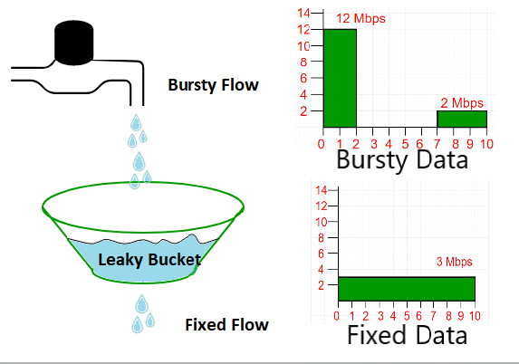
Token Bucket
The token bucket algorithm is a traffic shaping and rate-limiting mechanism used to control the amount of data that can be transmitted over a network. It allows for bursts of data while enforcing an average transmission rate over time, making it suitable for various applications in networking and APIs.
Key Concepts:
- Bucket Analogy:
- Imagine a bucket that can hold a certain number of tokens. Each token represents a unit of data (e.g., a packet or byte) that can be sent.
- Tokens are added to the bucket at a constant rate. If the bucket fills up (i.e., reaches its capacity), additional tokens are discarded.
- Parameters:
- Bucket Capacity: The maximum number of tokens the bucket can hold.
- Token Generation Rate: The rate at which tokens are added to the bucket (e.g., tokens per second).
- Data Transmission: Each time data is sent, a corresponding number of tokens must be removed from the bucket.
- Behaviour:
- If there are enough tokens in the bucket, the data can be sent immediately.
- If there are not enough tokens, the data must wait until more tokens are available, which helps to smooth out bursts of traffic.
Advantages:
- Burst Handling: The token bucket allows for short bursts of traffic, accommodating spikes in demand while enforcing an overall average rate.
- Flexible Rate Limiting: It can adapt to changing traffic patterns and is often used in real-time applications.
Applications:
- Network Traffic Control: Used in routers and switches to manage outgoing traffic and prevent network congestion.
- API Rate Limiting: Controls the number of requests a user can make to an API within a specified time frame.
- Quality of Service (QoS): Ensures bandwidth allocation for various applications based on their needs.
Example of a Simple Token Bucket Implementation in Java:
Here's a basic implementation of a token bucket algorithm in Java:
import java.util.concurrent.TimeUnit;
class TokenBucket {
private final long capacity; // Maximum number of tokens in the bucket
private final long tokenRate; // Token generation rate (tokens per second)
private long tokens; // Current number of tokens in the bucket
private long lastRefillTime; // Last time tokens were refilled
public TokenBucket(long capacity, long tokenRate) {
this.capacity = capacity;
this.tokenRate = tokenRate;
this.tokens = capacity; // Start with a full bucket
this.lastRefillTime = System.currentTimeMillis();
}
// Attempt to consume tokens from the bucket
public synchronized boolean consume(long tokensToConsume) {
refill(); // Refill the bucket before consuming
if (tokens >= tokensToConsume) {
tokens -= tokensToConsume; // Consume tokens
return true; // Successful consumption
}
return false; // Not enough tokens
}
// Refill the bucket based on the elapsed time
private void refill() {
long now = System.currentTimeMillis();
long elapsed = now - lastRefillTime;
if (elapsed > 0) {
long newTokens = (elapsed * tokenRate) / 1000; // Calculate how many new tokens to add
tokens = Math.min(capacity, tokens + newTokens); // Add tokens without exceeding capacity
lastRefillTime = now; // Update last refill time
}
}
public static void main(String[] args) throws InterruptedException {
TokenBucket bucket = new TokenBucket(10, 5); // Capacity of 10 tokens, 5 tokens per second
// Simulating token consumption
for (int i = 0; i < 15; i++) {
boolean consumed = bucket.consume(1); // Trying to consume 1 token
if (consumed) {
System.out.println("Consumed 1 token at attempt: " + (i + 1));
} else {
System.out.println("Not enough tokens at attempt: " + (i + 1));
}
TimeUnit.MILLISECONDS.sleep(400); // Wait for 400ms between attempts
}
}
}
Explanation:
- TokenBucket Class:
- Attributes:
  - capacity: Maximum number of tokens the bucket can hold.
  - tokenRate: Rate at which tokens are generated (tokens per second).
  - tokens: Current number of tokens in the bucket.
  - lastRefillTime: Timestamp of the last time the bucket was refilled.
- consume Method: Before consuming tokens, it calls the refill() method to add tokens based on the elapsed time. If there are enough tokens, it decreases the token count and allows the operation to proceed.
- refill Method: Calculates how many new tokens should be added based on the elapsed time since the last refill, ensuring it does not exceed the bucket's capacity.
- Main Method: Simulates attempts to consume tokens, demonstrating how the bucket behaves when tokens are available and when they are not.
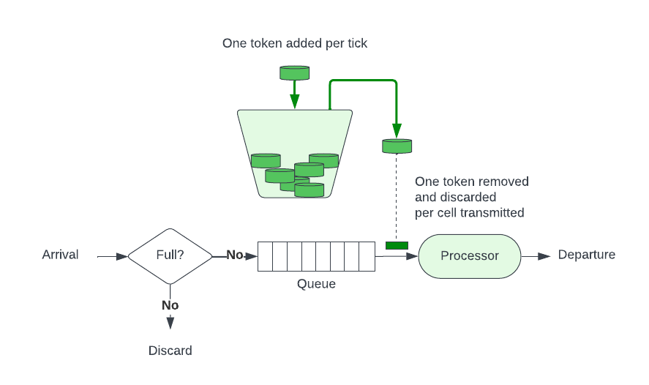
Trie
A trie (pronounced as "try") is a tree-like data structure used primarily for storing strings, enabling efficient retrieval of keys in a dataset. It is particularly useful for scenarios involving prefix searches, autocomplete features, and spell checking.
Key Concepts:
- Structure:
- Each node in a trie represents a single character of a string.
- The path from the root to a node corresponds to a prefix of one or more strings stored in the trie.
- Each node can have multiple children, each representing the next possible character in the string.
- Insertion:
- To insert a string into a trie, you start at the root and add nodes for each character in the string. If a character already exists in the trie, you simply move to that child node.
- Searching:
- To search for a string, traverse the trie following the path dictated by the characters in the string. If you reach the end of the string and have traversed valid nodes, the string exists in the trie.
- Prefix Search:
- Tries can be used to efficiently search for all strings with a given prefix, as all strings that share the same prefix will share a common path in the trie.
Advantages:
- Fast Lookups: Searching for a string or prefix is efficient, typically O(m), where m is the length of the string.
- Prefix Queries: Easy to implement prefix-based queries, making tries suitable for autocomplete features.
Disadvantages:
- Space Consumption: Tries can consume more memory compared to other data structures like hash tables, especially for sparse datasets.
Applications:
- Autocomplete Systems: Suggesting possible completions for partially typed words.
- Spell Checkers: Checking the correctness of words and suggesting corrections.
- IP Routing: Storing routing prefixes in networking applications.
Example of a Simple Trie Implementation in Java:
Here's a basic implementation of a trie that supports insertion and searching of strings:
import java.util.HashMap;
import java.util.Map;
class TrieNode {
Map<Character, TrieNode> children; // Child nodes
boolean isEndOfWord; // Indicates if the node marks the end of a word
public TrieNode() {
children = new HashMap<>();
isEndOfWord = false;
}
}
class Trie {
private final TrieNode root;
public Trie() {
root = new TrieNode(); // Initialize the root node
}
// Insert a word into the trie
public void insert(String word) {
TrieNode current = root;
for (char c : word.toCharArray()) {
current = current.children.computeIfAbsent(c, k -> new TrieNode());
}
current.isEndOfWord = true; // Mark the end of the word
}
// Search for a word in the trie
public boolean search(String word) {
TrieNode current = root;
for (char c : word.toCharArray()) {
current = current.children.get(c);
if (current == null) {
return false; // Character path not found
}
}
return current.isEndOfWord; // Return true if it's the end of a word
}
// Search for a prefix in the trie
public boolean startsWith(String prefix) {
TrieNode current = root;
for (char c : prefix.toCharArray()) {
current = current.children.get(c);
if (current == null) {
return false; // Prefix path not found
}
}
return true; // Prefix found
}
public static void main(String[] args) {
Trie trie = new Trie();
// Insert words into the trie
trie.insert("hello");
trie.insert("helium");
trie.insert("helicopter");
// Search for words
System.out.println(trie.search("hello")); // Output: true
System.out.println(trie.search("helium")); // Output: true
System.out.println(trie.search("helicopter")); // Output: true
System.out.println(trie.search("helic")); // Output: false
System.out.println(trie.startsWith("hel")); // Output: true
System.out.println(trie.startsWith("xyz")); // Output: false
}
}
Explanation:
- TrieNode Class: Each TrieNode contains a map of its children and a boolean to indicate if it marks the end of a word.
- Trie Class: The Trie class manages the root node and provides methods for inserting words and searching for both words and prefixes.
- insert Method: Adds a word to the trie by traversing or creating nodes for each character.
- search Method: Checks if a complete word exists in the trie by traversing the nodes corresponding to the characters in the word.
- startsWith Method: Checks if any words in the trie start with a given prefix by traversing the nodes corresponding to the prefix characters.
- Main Method: Demonstrates inserting words into the trie and searching for them, showing both successful and unsuccessful search results.
Bloom Filter
A Bloom filter is a space-efficient probabilistic data structure used to test whether an element is a member of a set. It is particularly useful in scenarios where space is at a premium and the cost of false positives can be tolerated, but false negatives are not acceptable.
Key Concepts:
- Structure:
- A Bloom filter consists of a bit array of fixed size and a number of hash functions.
- When adding an element, multiple hash functions generate indices in the bit array, and the corresponding bits are set to 1.
- To check for membership, the same hash functions are used to generate indices. If all bits at those indices are set to 1, the element is considered to be in the set (though it might be a false positive).
- False Positives:
- Bloom filters can return false positives (indicating an element is in the set when it is not), but they never return false negatives (indicating an element is not in the set when it actually is).
- The probability of false positives increases with the number of elements added to the filter and the size of the bit array.
- No Deletion:
- Traditional Bloom filters do not support deletion of elements since this could lead to incorrect results (a false negative).
Parameters:
- Size of the Bit Array: A larger bit array reduces the probability of false positives.
- Number of Hash Functions: Using more hash functions increases the chance of collisions but reduces the number of false positives.
Applications:
- Web Caching: Checking if a page is in the cache without needing to search the entire cache.
- Database Query Optimization: Quickly checking if a key is likely present in a database.
- Network Routing: Used in network protocols for efficient membership checking.
Example of a Simple Bloom Filter Implementation in Java:
Here’s a basic implementation of a Bloom filter in Java:
import java.util.BitSet;
import java.util.Random;
class BloomFilter {
private final BitSet bitSet; // Bit array
private final int size; // Size of the bit array
private final int numHashFunctions; // Number of hash functions
public BloomFilter(int size, int numHashFunctions) {
this.size = size;
this.numHashFunctions = numHashFunctions;
this.bitSet = new BitSet(size);
}
// Hash function to create multiple hash values for a given string
private int[] hash(String value) {
int[] hashes = new int[numHashFunctions];
Random random = new Random(value.hashCode());
for (int i = 0; i < numHashFunctions; i++) {
hashes[i] = Math.abs(random.nextInt()) % size;
}
return hashes;
}
// Add a value to the Bloom filter
public void add(String value) {
int[] hashes = hash(value);
for (int hash : hashes) {
bitSet.set(hash); // Set the corresponding bits
}
}
// Check if a value is possibly in the Bloom filter
public boolean contains(String value) {
int[] hashes = hash(value);
for (int hash : hashes) {
if (!bitSet.get(hash)) {
return false; // If any bit is 0, definitely not in the set
}
}
return true; // All bits are 1, so it might be in the set
}
public static void main(String[] args) {
BloomFilter bloomFilter = new BloomFilter(100, 5); // 100 bits, 5 hash functions
// Adding elements
bloomFilter.add("apple");
bloomFilter.add("banana");
bloomFilter.add("orange");
// Checking for elements
System.out.println(bloomFilter.contains("apple")); // Output: true
System.out.println(bloomFilter.contains("banana")); // Output: true
System.out.println(bloomFilter.contains("grape")); // Output: false (may be true due to false positive)
}
}
Explanation:
- BloomFilter Class: Contains a BitSet to represent the bit array and parameters for its size and the number of hash functions.
- hash Method: Generates hash values for a given string using a random number generator seeded with the string's hash code.
- add Method: Computes hash values for the input string and sets the corresponding bits in the BitSet.
- contains Method: Checks if an element is possibly in the set by verifying if all the bits at the computed hash indices are set.
- Main Method: Demonstrates adding elements to the Bloom filter and checking for their presence.
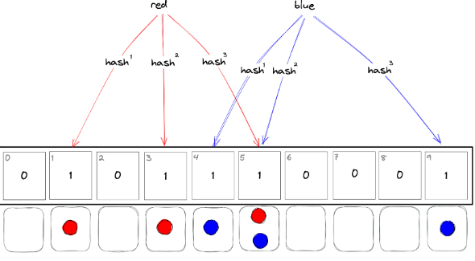
Raft/Paxos
Raft and Paxos are two consensus algorithms designed to achieve agreement among distributed systems. They are essential for maintaining consistency in environments where network partitions and node failures can occur.
Paxos
- Overview:
- Paxos is a protocol for achieving consensus in a network of unreliable nodes.
- It was introduced by Leslie Lamport in the late 1970s and is well-suited for environments where nodes may fail or messages may be lost.
- Key Concepts:
- Proposers: Nodes that propose values for consensus.
- Acceptors: Nodes that receive proposals and decide whether to accept them.
- Learners: Nodes that learn the chosen value once consensus is reached.
- Phases:
- Prepare Phase: A proposer selects a proposal number and sends a "prepare" request to a majority of acceptors.
- Promise Phase: If an acceptor receives a prepare request with a proposal number greater than any it has seen, it responds with a promise not to accept lower-numbered proposals and may return the highest-numbered proposal it has accepted (if any).
- Accept Phase: The proposer can send an "accept" request to the acceptors with the chosen value, and if a majority accepts, consensus is achieved.
- Challenges:
- Paxos can be difficult to understand and implement correctly.
- It requires a majority of acceptors to reach consensus, which can limit availability in certain failure scenarios.
Raft
- Overview:
- Raft is a more understandable alternative to Paxos that was developed to provide a practical consensus algorithm that is easier to implement.
- Introduced by Diego Ongaro and John Ousterhout in 2014, Raft aims to explain the consensus process in a more intuitive way.
- Key Concepts:
- Leader: One node is elected as the leader, which manages the log and handles client requests.
- Followers: Nodes that replicate the leader's log entries.
- Candidates: Nodes that can become leaders if they believe the leader has failed.
- Phases:
- Leader Election: Nodes start as followers. If a follower doesn’t hear from the leader in a given time, it becomes a candidate and requests votes from other nodes to become a leader.
- Log Replication: The leader accepts client requests and appends the corresponding entries to its log. It then replicates these log entries to the followers.
- Commitment: Once a log entry is replicated to a majority of nodes, it is considered committed, and the leader notifies the followers.
- Challenges:
- Although Raft is easier to implement than Paxos, it still has complexities related to maintaining consistency, especially during network partitions.
Comparison
- Complexity: Raft is generally considered easier to understand and implement compared to Paxos due to its more structured approach.
- Leader Election: Raft has a single leader, which simplifies log management and client interactions. In contrast, Paxos allows multiple proposers, which can complicate the process.
- Performance: Both algorithms can perform similarly in terms of throughput, but Raft’s approach to log replication may yield better performance in certain conditions.
Use Cases
- Paxos: Used in systems requiring high availability and consistency, such as distributed databases (e.g., Google's Chubby lock service).
- Raft: Commonly used in modern distributed systems for state machines and key-value stores (e.g., HashiCorp's Consul, etcd).
Implementing full consensus algorithms like Paxos and Raft in Java requires significant code due to their complexity.
Paxos Example in Java
Here’s a simplified implementation of the Paxos consensus algorithm:
import java.util.HashMap;
import java.util.Map;
import java.util.Set;
import java.util.concurrent.ConcurrentHashMap;
class PaxosNode {
private final int id;
private int currentProposalNumber;
private int acceptedProposalNumber = -1;
private int acceptedValue = -1;
private static final Map<Integer, PaxosNode> nodes = new ConcurrentHashMap<>();
public PaxosNode(int id) {
this.id = id;
nodes.put(id, this);
}
public void propose(int proposalNumber, int value) {
// Prepare Phase
boolean promiseReceived = prepare(proposalNumber);
if (promiseReceived) {
// Accept Phase
accept(proposalNumber, value);
}
}
private boolean prepare(int proposalNumber) {
if (proposalNumber > currentProposalNumber) {
currentProposalNumber = proposalNumber;
// Simulate sending prepare request to a majority and receiving promises
return sendPrepareToMajority(proposalNumber);
}
return false;
}
private boolean sendPrepareToMajority(int proposalNumber) {
int promises = 0;
for (PaxosNode node : nodes.values()) {
if (node.id != id && node.promise(proposalNumber)) {
promises++;
}
}
return promises > nodes.size() / 2; // Check for majority
}
public boolean promise(int proposalNumber) {
if (proposalNumber >= currentProposalNumber) {
currentProposalNumber = proposalNumber;
return true; // Respond with a promise
}
return false;
}
private void accept(int proposalNumber, int value) {
acceptedProposalNumber = proposalNumber;
acceptedValue = value;
// Simulate sending accept to majority
sendAcceptToMajority(proposalNumber, value);
}
private void sendAcceptToMajority(int proposalNumber, int value) {
int accepted = 0;
for (PaxosNode node : nodes.values()) {
if (node.id != id && node.accept(proposalNumber, value)) {
accepted++;
}
}
if (accepted > nodes.size() / 2) {
System.out.println("Consensus reached with value: " + value);
}
}
public boolean accept(int proposalNumber, int value) {
if (proposalNumber >= acceptedProposalNumber) {
acceptedProposalNumber = proposalNumber;
acceptedValue = value;
return true; // Accept the proposal
}
return false;
}
public static void main(String[] args) {
PaxosNode node1 = new PaxosNode(1);
PaxosNode node2 = new PaxosNode(2);
PaxosNode node3 = new PaxosNode(3);
node1.propose(1, 42); // Node 1 proposes a value
}
}
Raft Example in Java
Here’s a simplified implementation of the Raft consensus algorithm:
import java.util.HashMap;
import java.util.Map;
import java.util.Random;
class RaftNode {
private final int id;
private State state;
private int term;
private int votedFor = -1;
private static final Map<Integer, RaftNode> nodes = new HashMap<>();
private static final Random random = new Random();
private enum State { FOLLOWER, CANDIDATE, LEADER }
public RaftNode(int id) {
this.id = id;
this.state = State.FOLLOWER;
nodes.put(id, this);
}
public void startElection() {
state = State.CANDIDATE;
term++;
votedFor = id;
int votes = 1; // Vote for self
// Simulate requesting votes from other nodes
for (RaftNode node : nodes.values()) {
if (node.id != id && node.requestVote(term, id)) {
votes++;
}
}
if (votes > nodes.size() / 2) {
state = State.LEADER;
System.out.println("Node " + id + " became the leader for term " + term);
}
}
public boolean requestVote(int candidateTerm, int candidateId) {
if (candidateTerm > term) {
term = candidateTerm;
votedFor = candidateId;
state = State.FOLLOWER; // Become a follower
return true;
}
return false; // Vote denied
}
public void appendEntries() {
if (state == State.LEADER) {
// Simulate log replication to followers
for (RaftNode node : nodes.values()) {
if (node.id != id) {
// Replicate log entries to followers
System.out.println("Node " + id + " replicates log to Node " + node.id);
}
}
}
}
public static void main(String[] args) {
RaftNode node1 = new RaftNode(1);
RaftNode node2 = new RaftNode(2);
RaftNode node3 = new RaftNode(3);
// Simulating election
node1.startElection();
node2.startElection();
node3.startElection();
// Leader replicates logs
for (RaftNode node : nodes.values()) {
if (node.state == State.LEADER) {
node.appendEntries();
}
}
}
}
Explanation:
- Paxos Example:
- Node Structure: Each PaxosNode represents a node in the Paxos algorithm, with methods for proposing values, preparing proposals, and accepting values.
- Propose Method: Starts the process of proposing a value.
- Prepare and Accept Phases: Handle the phases of the Paxos protocol, simulating sending requests to other nodes.
- Main Method: Creates three nodes and simulates a proposal.
- Raft Example:
- Node Structure: Each RaftNode represents a node in the Raft algorithm, with states (follower, candidate, leader), term management, and vote requests.
- Start Election: Initiates the leader election process.
- Append Entries: Allows the leader to replicate log entries to followers.
- Main Method: Creates three nodes, simulates elections, and shows log replication.

