Here’s a step-by-step guide on how to manage development using Git, starting with creating a local repository, working with branches, and pushing changes to a remote repository like GitHub:

**Step 1: Set up a Local Repository**

1. **Clone a Remote Repository (if one exists): 2**

bash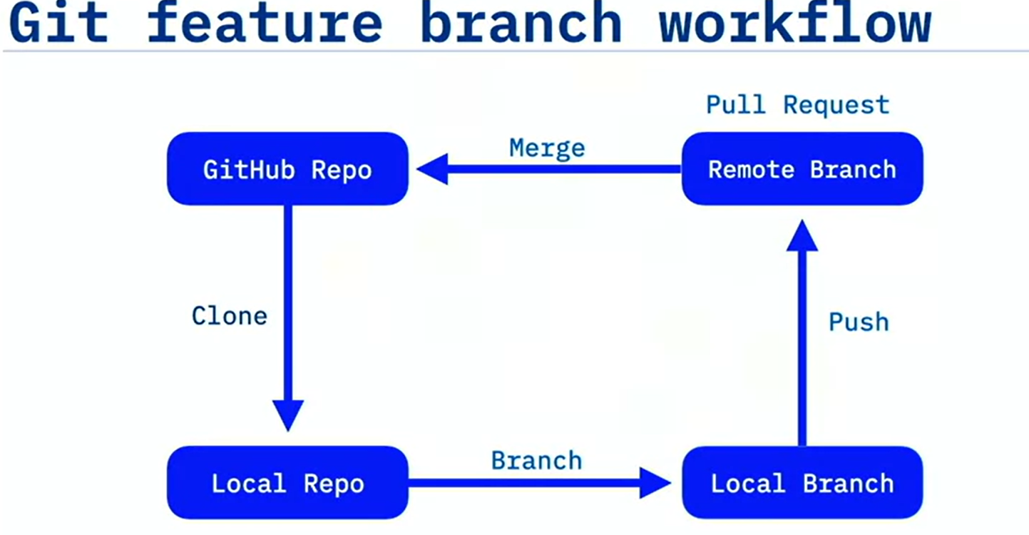

Copy code

git clone https://github.com/username/repository.git

This command copies the remote repository from GitHub to your local machine.

1. **Initialize a Local Repository (if starting from scratch):**

bash

Copy code

git init

This initializes a new Git repository in your local folder.

**Step 2: Create and Work on a Local Branch**

1. **Create a New Local Branch:**

bash

Copy code

git checkout -b your-branch-name

This creates and switches to a new branch, where you can work on your development tasks.

1. **Check the Current Branch:**

bash

Copy code

git branch

This shows all local branches and highlights the active branch.

**Step 3: Make Changes and Commit Them**

1. **Stage the Files:**

bash

Copy code

git add <file-name>

Or stage all changes:

bash

Copy code

git add .

1. **Commit the Changes:**

bash

Copy code

git commit -m "Your commit message"

This saves your staged changes in your local repository.

**Step 4: Push Changes to the Remote Repository**

1. **Push Your Local Branch to the Remote Repository:**

bash

Copy code

git push origin your-branch-name

This uploads the local branch to the remote repository on GitHub.

**Step 5: Create a Pull Request (PR) on GitHub**

1. After pushing the branch, go to GitHub, navigate to the repository, and you should see an option to create a pull request from your branch.
2. **Create the Pull Request** to merge your branch into the main branch or another target branch.

**Step 6: Merge the Pull Request**

1. Once the pull request has been reviewed and approved, you can merge it via the GitHub interface.

**Step 7: Update Local Repository and Branches**

1. **Switch Back to the Main Branch:**

bash

Copy code

git checkout main

1. **Pull the Latest Changes to Ensure Your Local Main is Up-to-Date:**

bash

Copy code

git pull origin main

1. **Delete Local Branch (optional, after merging):**

bash

Copy code

git branch -d your-branch-name

**Step 8: Delete Remote Branch (optional)**

bash

Copy code

git push origin --delete your-branch-name

This workflow helps in developing features, fixing bugs, or implementing tasks in an organized way using Git and GitHub for version control and collaboration.