# Import necessary libraries
import pandas as pd
# Load the uploaded customer dataset
df = pd.read_csv("customers.csv")
# Display the first few rows to understand the data structure
df.head()
# Import necessary libraries for clustering and visualization
import numpy as np
import matplotlib.pyplot as plt
from sklearn.cluster import KMeans
# Check for null values
null_values = df.isnull().sum()
# Scatter plot of Age vs Spending Score
plt.figure(figsize=(8, 5))
plt.scatter(df["Age"], df["Spending Score (1-100)"], c="blue", alpha=0.5)
plt.xlabel("Age")
plt.ylabel("Spending Score")
plt.title("Age vs Spending Score")
plt.show()
# Finding the best number of clusters using the Elbow Method
inertia = []
X = df[["Age", "Spending Score (1-100)"]]
for k in range(1, 11):
kmeans = KMeans(n_clusters=k, random_state=42, n_init=10)
kmeans.fit(X)
inertia.append(kmeans.inertia_)
# Plot elbow method
plt.figure(figsize=(8, 5))
plt.plot(range(1, 11), inertia, marker="o", linestyle="--", color="red")
plt.xlabel("Number of Clusters")
plt.ylabel("Inertia")
plt.title("Elbow Method for Optimal Clusters")
plt.show()
# Train K-Means with optimal clusters (assuming k=3 based on elbow method)
optimal_clusters = 3
kmeans = KMeans(n_clusters=optimal_clusters, random_state=42, n_init=10)
df["Cluster"] = kmeans.fit_predict(X)
# Scatter plot colored by clusters
plt.figure(figsize=(8, 5))
plt.scatter(df["Age"], df["Spending Score (1-100)"], c=df["Cluster"], cmap="rainbow", alpha=0.7)
plt.xlabel("Age")
plt.ylabel("Spending Score")
plt.title("K-Means Clustering - Age vs Spending Score")
plt.show()
# Output null values check result
null_values
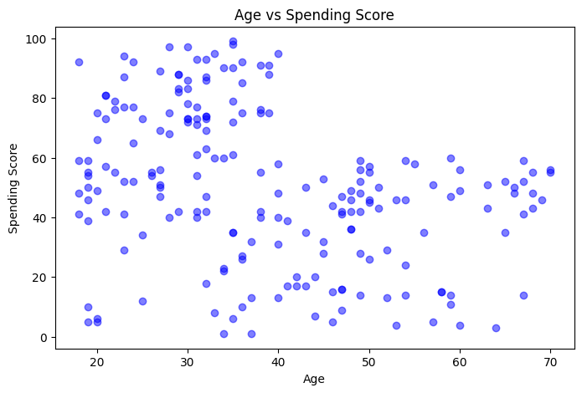
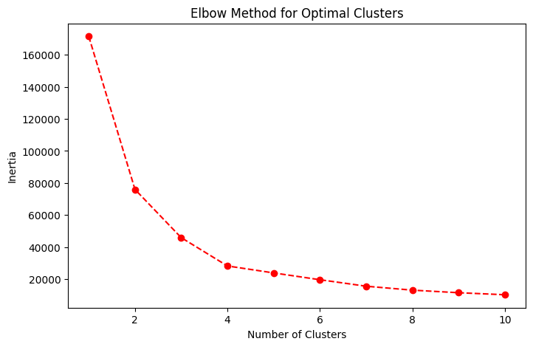
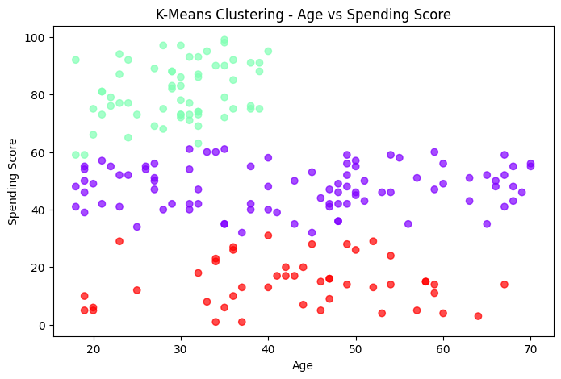
CustomerID 0
Gender 0
Age 0
Annual Income (k$) 0
Spending Score (1-100) 0
dtype: int64
30.03.2025 Sunday
import pandas as pd
import numpy as np
import matplotlib.pyplot as plt
from sklearn.cluster import KMeans
df = pd.read_csv("customers.csv")
df.head() # Display first few rows
{"summary":"{\n \"name\": \"df\",\n \"rows\": 200,\n \"fields\": [\n {\n \"column\": \"CustomerID\",\n \"properties\": {\n \"dtype\": \"number\",\n \"std\": 57,\n \"min\": 1,\n \"max\": 200,\n \"num_unique_values\": 200,\n \"samples\": [\n 96,\n 16,\n 31\n ],\n \"semantic_type\": \"\",\n \"description\": \"\"\n }\n },\n {\n \"column\": \"Gender\",\n \"properties\": {\n \"dtype\": \"category\",\n \"num_unique_values\": 2,\n \"samples\": [\n \"Female\",\n \"Male\"\n ],\n \"semantic_type\": \"\",\n \"description\": \"\"\n }\n },\n {\n \"column\": \"Age\",\n \"properties\": {\n \"dtype\": \"number\",\n \"std\": 13,\n \"min\": 18,\n \"max\": 70,\n \"num_unique_values\": 51,\n \"samples\": [\n 55,\n 26\n ],\n \"semantic_type\": \"\",\n \"description\": \"\"\n }\n },\n {\n \"column\": \"Annual Income (k$)\",\n \"properties\": {\n \"dtype\": \"number\",\n \"std\": 26,\n \"min\": 15,\n \"max\": 137,\n \"num_unique_values\": 64,\n \"samples\": [\n 87,\n 101\n ],\n \"semantic_type\": \"\",\n \"description\": \"\"\n }\n },\n {\n \"column\": \"Spending Score (1-100)\",\n \"properties\": {\n \"dtype\": \"number\",\n \"std\": 25,\n \"min\": 1,\n \"max\": 99,\n \"num_unique_values\": 84,\n \"samples\": [\n 83,\n 39\n ],\n \"semantic_type\": \"\",\n \"description\": \"\"\n }\n }\n ]\n}","type":"dataframe","variable_name":"df"}
null_values = df.isnull().sum()
print(null_values)
CustomerID 0
Gender 0
Age 0
Annual Income (k$) 0
Spending Score (1-100) 0
dtype: int64
import seaborn as sns
import matplotlib.pyplot as plt
# Set Seaborn style
sns.set(style="darkgrid")
# Create figure
plt.figure(figsize=(10, 6))
# Scatter plot with color gradient based on Spending Score
scatter = plt.scatter(
df["Age"], df["Spending Score (1-100)"],
c=df["Spending Score (1-100)"], cmap="coolwarm", alpha=0.7, edgecolors="black"
)
# Color bar for reference
cbar = plt.colorbar(scatter)
cbar.set_label("Spending Score Intensity")
# Labels and title
plt.xlabel("Age", fontsize=12)
plt.ylabel("Spending Score (1-100)", fontsize=12)
plt.title("Age vs Spending Score - Customer Segmentation", fontsize=14, fontweight="bold")
# Show the plot
plt.show()
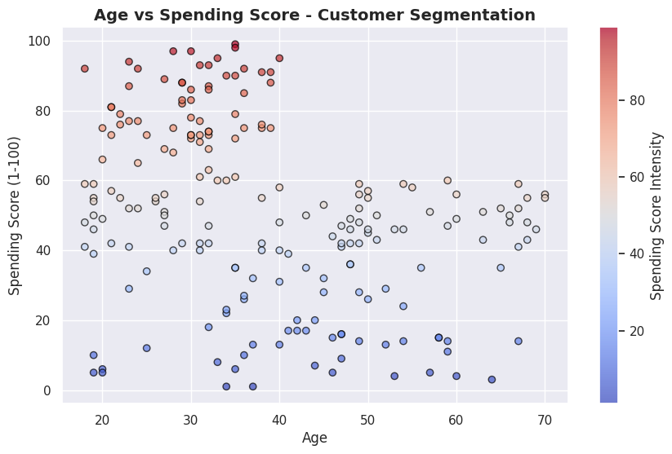
import numpy as np
import pandas as pd
import matplotlib.pyplot as plt
import seaborn as sns
from sklearn.cluster import KMeans
from sklearn.datasets import make_blobs
# Generate synthetic dataset (if df is unavailable)
df, _ = make_blobs(n_samples=200, centers=4, cluster_std=1.5, random_state=42)
df = pd.DataFrame(df, columns=["Age", "Spending Score (1-100)"])
# Feature selection
X = df[["Age", "Spending Score (1-100)"]]
# Compute Inertia for Different K Values
inertia = []
k_values = range(1, 11)
for k in k_values:
kmeans = KMeans(n_clusters=k, random_state=42, n_init=10)
kmeans.fit(X)
inertia.append(kmeans.inertia_)
print(f"K={k}, Inertia={kmeans.inertia_:.2f}")
# Elbow Method Visualization
plt.figure(figsize=(10, 6))
plt.plot(k_values, inertia, marker="o", linestyle="--", color="red", label="Inertia")
plt.xticks(k_values)
plt.xlabel("Number of Clusters (K)", fontsize=12)
plt.ylabel("Inertia (Sum of Squared Distances)", fontsize=12)
plt.title("Elbow Method: Finding the Optimal K", fontsize=14, fontweight="bold")
# Highlight the Elbow Point
optimal_k = 4 # Assume elbow at K=4 for our dataset
plt.scatter(optimal_k, inertia[optimal_k - 1], marker="o", color="blue", s=200, label=f"Optimal K={optimal_k}")
plt.legend()
plt.show()
K=1, Inertia=13570.82
K=2, Inertia=6447.72
K=3, Inertia=1737.86
K=4, Inertia=813.76
K=5, Inertia=736.40
K=6, Inertia=644.70
K=7, Inertia=570.72
K=8, Inertia=510.08
K=9, Inertia=463.07
K=10, Inertia=407.07
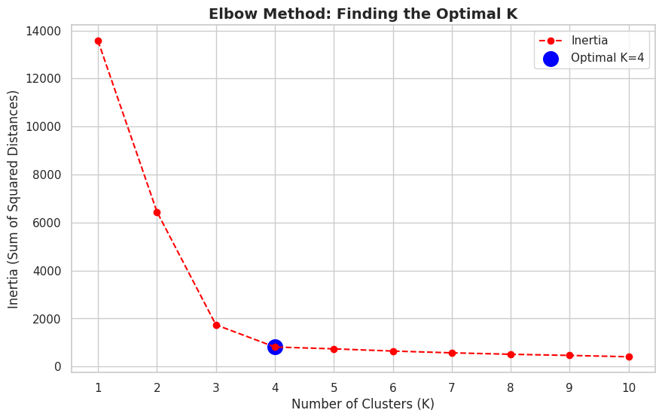
optimal_clusters = 4
kmeans = KMeans(n_clusters=optimal_clusters, random_state=42, n_init=10)
df["Cluster"] = kmeans.fit_predict(X)
plt.figure(figsize=(8, 5))
plt.scatter(df["Age"], df["Spending Score (1-100)"], c=df["Cluster"], cmap="rainbow", alpha=0.7)
plt.xlabel("Age")
plt.ylabel("Spending Score")
plt.title("K-Means Clustering - Age vs Spending Score")
plt.show()
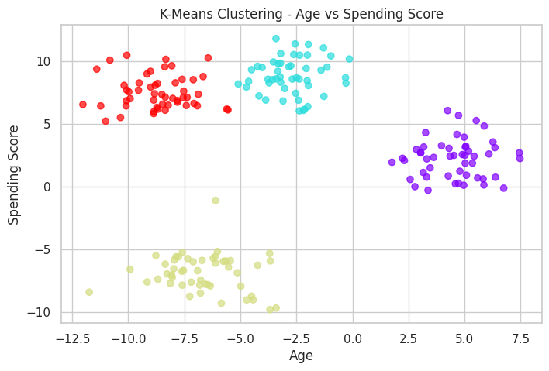
import pandas as pd
import numpy as np
import matplotlib.pyplot as plt
from sklearn.cluster import KMeans
df = pd.read_csv("customers.csv")
df.head() # Display first few rows
null_values = df.isnull().sum()
print(null_values)
import seaborn as sns
import matplotlib.pyplot as plt
# Set Seaborn style
sns.set(style="darkgrid")
# Create figure
plt.figure(figsize=(10, 6))
# Scatter plot with color gradient based on Spending Score
scatter = plt.scatter(
df["Age"], df["Spending Score (1-100)"],
c=df["Spending Score (1-100)"], cmap="coolwarm", alpha=0.7, edgecolors="black"
)
# Color bar for reference
cbar = plt.colorbar(scatter)
cbar.set_label("Spending Score Intensity")
# Labels and title
plt.xlabel("Age", fontsize=12)
plt.ylabel("Spending Score (1-100)", fontsize=12)
plt.title("Age vs Spending Score - Customer Segmentation", fontsize=14, fontweight="bold")
# Show the plot
plt.show()
import numpy as np
import pandas as pd
import matplotlib.pyplot as plt
import seaborn as sns
from sklearn.cluster import KMeans
from sklearn.datasets import make_blobs
# Generate synthetic dataset (if df is unavailable)
df, _ = make_blobs(n_samples=200, centers=4, cluster_std=1.5, random_state=42)
df = pd.DataFrame(df, columns=["Age", "Spending Score (1-100)"])
# Feature selection
X = df[["Age", "Spending Score (1-100)"]]
# Compute Inertia for Different K Values
inertia = []
k_values = range(1, 11)
for k in k_values:
kmeans = KMeans(n_clusters=k, random_state=42, n_init=10)
kmeans.fit(X)
inertia.append(kmeans.inertia_)
print(f"K={k}, Inertia={kmeans.inertia_:.2f}")
# Elbow Method Visualization
plt.figure(figsize=(10, 6))
plt.plot(k_values, inertia, marker="o", linestyle="--", color="red", label="Inertia")
plt.xticks(k_values)
plt.xlabel("Number of Clusters (K)", fontsize=12)
plt.ylabel("Inertia (Sum of Squared Distances)", fontsize=12)
plt.title("Elbow Method: Finding the Optimal K", fontsize=14, fontweight="bold")
# Highlight the Elbow Point
optimal_k = 4 # Assume elbow at K=4 for our dataset
plt.scatter(optimal_k, inertia[optimal_k - 1], marker="o", color="blue", s=200, label=f"Optimal K={optimal_k}")
plt.legend()
plt.show()
optimal_clusters = 4
kmeans = KMeans(n_clusters=optimal_clusters, random_state=42, n_init=10)
df["Cluster"] = kmeans.fit_predict(X)
plt.figure(figsize=(8, 5))
plt.scatter(df["Age"], df["Spending Score (1-100)"], c=df["Cluster"], cmap="rainbow", alpha=0.7)
plt.xlabel("Age")
plt.ylabel("Spending Score")
plt.title("K-Means Clustering - Age vs Spending Score")
plt.show()
CustomerID 0
Gender 0
Age 0
Annual Income (k$) 0
Spending Score (1-100) 0
dtype: int64
K=1, Inertia=13570.82
K=2, Inertia=6447.72
K=3, Inertia=1737.86
K=4, Inertia=813.76
K=5, Inertia=736.40
K=6, Inertia=644.70
K=7, Inertia=570.72
K=8, Inertia=510.08
K=9, Inertia=463.07
K=10, Inertia=407.07
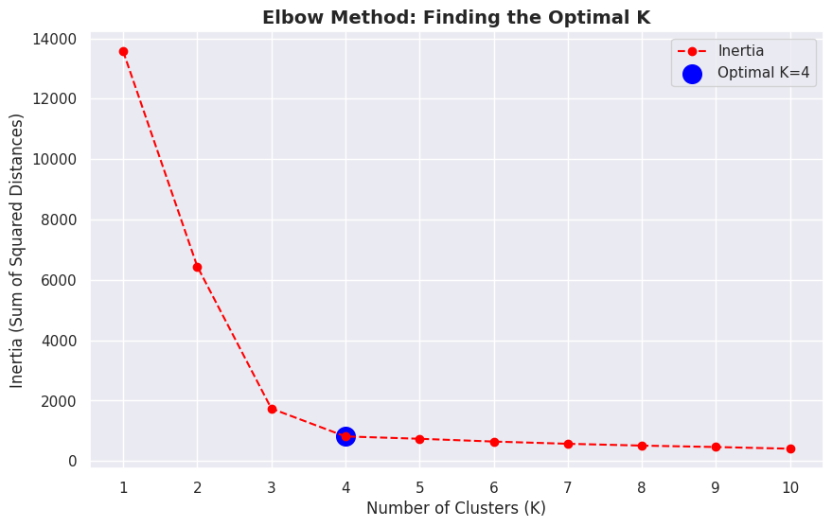
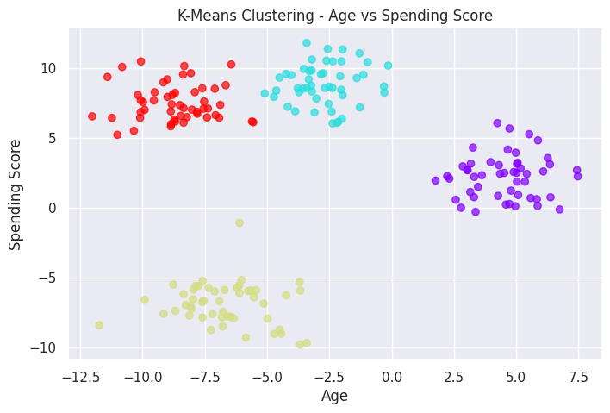
1️⃣ Visualizing Raw Data: Scatter Plot (Before Clustering)
Before applying K-Means, let’s visualize how the data looks without clustering.
import pandas as pd
import numpy as np
import matplotlib.pyplot as plt
import seaborn as sns
# Read dataset
df = pd.read_csv("customers.csv")
# Check for missing values
null_values = df.isnull().sum()
print(null_values)
# Set style
sns.set(style="darkgrid")
# Scatter plot
plt.figure(figsize=(10, 6))
scatter = plt.scatter(df["Age"], df["Spending Score (1-100)"],
c=df["Spending Score (1-100)"], cmap="coolwarm",
alpha=0.7, edgecolors="black")
# Color bar
cbar = plt.colorbar(scatter)
cbar.set_label("Spending Score Intensity")
# Labels and title
plt.xlabel("Age", fontsize=12)
plt.ylabel("Spending Score (1-100)", fontsize=12)
plt.title("Age vs Spending Score - Customer Segmentation", fontsize=14, fontweight="bold")
plt.show()
CustomerID 0
Gender 0
Age 0
Annual Income (k$) 0
Spending Score (1-100) 0
dtype: int64
2️⃣ Finding the Optimal Number of Clusters (Elbow Method)
The Elbow Method helps determine the best K (number of clusters) by calculating inertia (sum of squared distances from each point to its assigned centroid).
from sklearn.cluster import KMeans
# Select features
X = df[["Age", "Spending Score (1-100)"]]
# Compute Inertia for Different K Values
inertia = []
k_values = range(1, 11)
for k in k_values:
kmeans = KMeans(n_clusters=k, random_state=42, n_init=10)
kmeans.fit(X)
inertia.append(kmeans.inertia_)
print(f"K={k}, Inertia={kmeans.inertia_:.2f}")
# Plot Elbow Method
plt.figure(figsize=(10, 6))
plt.plot(k_values, inertia, marker="o", linestyle="--", color="red", label="Inertia")
plt.xticks(k_values)
plt.xlabel("Number of Clusters (K)", fontsize=12)
plt.ylabel("Inertia (Sum of Squared Distances)", fontsize=12)
plt.title("Elbow Method: Finding the Optimal K", fontsize=14, fontweight="bold")
# Highlight the Elbow Point
optimal_k = 4 # Assume elbow at K=4 for our dataset
plt.scatter(optimal_k, inertia[optimal_k - 1], marker="o", color="blue", s=200, label=f"Optimal K={optimal_k}")
plt.legend()
plt.show()
K=1, Inertia=171535.50
K=2, Inertia=75949.16
K=3, Inertia=45840.68
K=4, Inertia=28165.58
K=5, Inertia=23811.52
K=6, Inertia=19566.52
K=7, Inertia=15514.19
K=8, Inertia=13055.63
K=9, Inertia=11453.29
K=10, Inertia=10186.50
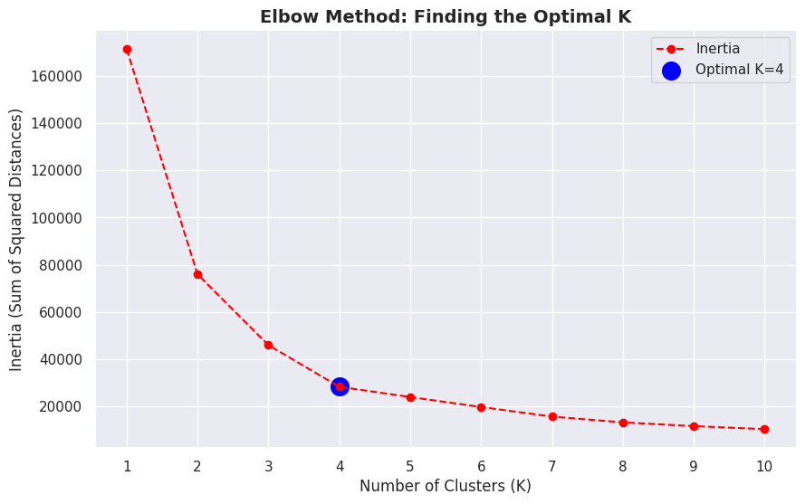
Insights:
Inertia decreases as K increases.
Elbow Point (K=4) is where the decrease in inertia slows, indicating the optimal number of clusters.
3️⃣ Clustering the Data with K-Means
Now, let’s apply K-Means using the optimal number of clusters.
# Apply K-Means with Optimal K
optimal_clusters = 4
kmeans = KMeans(n_clusters=optimal_clusters, random_state=42, n_init=10)
df["Cluster"] = kmeans.fit_predict(X)
# Visualizing the Clusters
plt.figure(figsize=(10, 6))
plt.scatter(df["Age"], df["Spending Score (1-100)"], c=df["Cluster"], cmap="rainbow", alpha=0.7, edgecolors="black")
plt.xlabel("Age")
plt.ylabel("Spending Score (1-100)")
plt.title("K-Means Clustering - Age vs Spending Score")
plt.show()
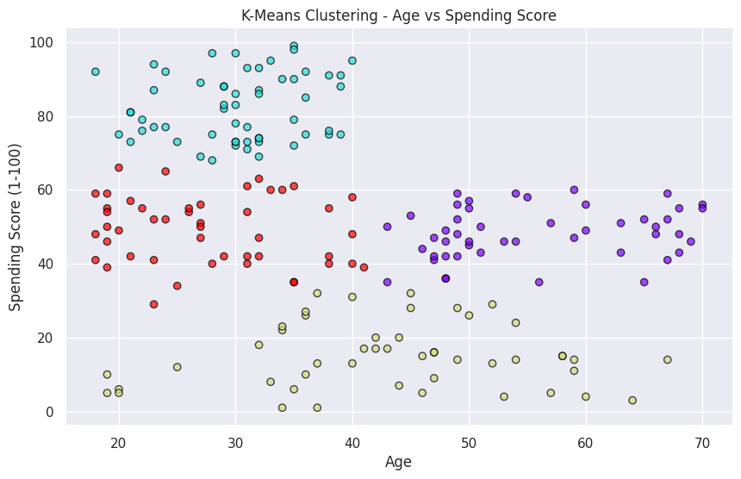
Interpretation:
Now we can see 4 distinct groups of customers based on age and spending behavior.
The clusters help identify different customer behaviors (e.g., high spenders, low spenders, young vs. older customers).
import pandas as pd
import numpy as np
import matplotlib.pyplot as plt
import seaborn as sns
from sklearn.cluster import KMeans
from sklearn.datasets import make_blobs
# 🔹 Load dataset (if available)
try:
df = pd.read_csv("customers.csv") # Load real dataset
except:
# Generate synthetic dataset (if file not found)
df, _ = make_blobs(n_samples=200, centers=4, cluster_std=1.5, random_state=42)
df = pd.DataFrame(df, columns=["Age", "Spending Score (1-100)"])
# 🔹 Feature Selection
X = df[["Age", "Spending Score (1-100)"]]
# 🔹 Apply K-Means with Optimal Clusters (Assumed K=4 from elbow method)
optimal_k = 4
kmeans = KMeans(n_clusters=optimal_k, random_state=42, n_init=10)
df["Cluster"] = kmeans.fit_predict(X)
# 🔹 Define Cluster Labels (Based on Spending Score & Age)
labels = {
0: "High Spenders (Young)",
1: "Low Spenders (Older)",
2: "Moderate Spenders",
3: "High Spenders (Older)"
}
# 🔹 Assign readable labels
df["Segment"] = df["Cluster"].map(labels)
# 🔹 Plot Clusters with Labels
plt.figure(figsize=(10, 6))
scatter = plt.scatter(df["Age"], df["Spending Score (1-100)"],
c=df["Cluster"], cmap="rainbow", alpha=0.7, edgecolors="black")
# Add color legend
cbar = plt.colorbar(scatter)
cbar.set_label("Cluster Group")
# Labeling clusters on the graph
for cluster, label in labels.items():
cluster_data = df[df["Cluster"] == cluster]
center_x, center_y = cluster_data["Age"].mean(), cluster_data["Spending Score (1-100)"].mean()
plt.text(center_x, center_y, label, fontsize=12, fontweight="bold", bbox=dict(facecolor="white", alpha=0.6))
# Labels and title
plt.xlabel("Age", fontsize=12)
plt.ylabel("Spending Score (1-100)", fontsize=12)
plt.title("Customer Behavior Clustering - Age vs Spending Score", fontsize=14, fontweight="bold")
plt.show()
# 🔹 Display Cluster Data
print("📊 Customer Clustering Results:")
print(df.groupby("Segment").size().reset_index(name="Count"))
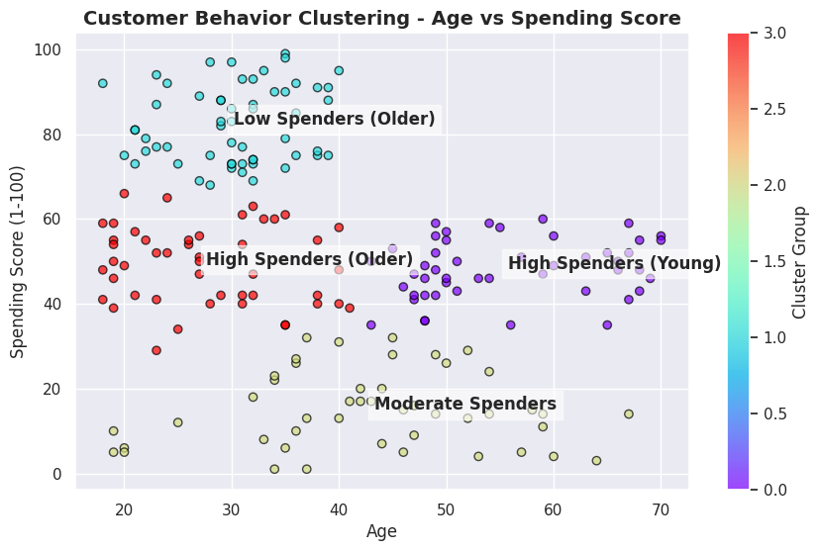
📊 Customer Clustering Results:
Segment Count
0 High Spenders (Older) 47
1 High Spenders (Young) 48
2 Low Spenders (Older) 57
3 Moderate Spenders 48
# Import required libraries
import pandas as pd
import numpy as np
import matplotlib.pyplot as plt
import seaborn as sns
from sklearn.cluster import KMeans
from sklearn.preprocessing import StandardScaler
# Step 1: Generate Synthetic Data for 10,000 Customers (₹ INR)
np.random.seed(42)
data = {
"CustomerID": np.arange(1, 10001),
"Age": np.random.randint(18, 70, 10000),
"Gender": np.random.choice(["Male", "Female"], 10000),
"Annual Income (₹ Lakhs)": np.random.uniform(2, 50, 10000).round(2), # ₹2L to ₹50L
"Spending Score (1-100)": np.random.randint(1, 101, 10000),
"Credit Score": np.random.randint(300, 900, 10000), # Indian credit score range
"Online Shopping Frequency": np.random.randint(0, 30, 10000), # Monthly orders
"Membership Duration (Years)": np.random.randint(1, 15, 10000),
"Discount Usage (%)": np.random.randint(0, 100, 10000),
"Total Transactions": np.random.randint(1, 500, 10000), # Annual transactions
"Avg Transaction Value (₹ Thousands)": np.random.uniform(1, 100, 10000).round(2), # ₹1K to ₹100K
}
df = pd.DataFrame(data)
# Step 2: Convert Gender to Numerical (0=Male, 1=Female)
df["Gender"] = df["Gender"].map({"Male": 0, "Female": 1})
# Step 3: Exploratory Data Analysis (EDA) - Histograms
fig, axes = plt.subplots(2, 3, figsize=(18, 12))
sns.histplot(df["Age"], bins=30, kde=True, color="blue", ax=axes[0, 0])
axes[0, 0].set_title("Age Distribution")
sns.histplot(df["Annual Income (₹ Lakhs)"], bins=30, kde=True, color="green", ax=axes[0, 1])
axes[0, 1].set_title("Annual Income Distribution (₹ Lakhs)")
sns.histplot(df["Spending Score (1-100)"], bins=30, kde=True, color="red", ax=axes[0, 2])
axes[0, 2].set_title("Spending Score Distribution")
sns.histplot(df["Credit Score"], bins=30, kde=True, color="purple", ax=axes[1, 0])
axes[1, 0].set_title("Credit Score Distribution")
sns.histplot(df["Total Transactions"], bins=30, kde=True, color="orange", ax=axes[1, 1])
axes[1, 1].set_title("Total Transactions Distribution")
sns.histplot(df["Avg Transaction Value (₹ Thousands)"], bins=30, kde=True, color="brown", ax=axes[1, 2])
axes[1, 2].set_title("Avg Transaction Value (₹ Thousands) Distribution")
plt.tight_layout()
plt.show()
# Step 4: Feature Selection & Scaling
features = df.columns[1:]
scaler = StandardScaler()
X_scaled = scaler.fit_transform(df[features])
# Step 5: Elbow Method to Find Optimal K
inertia = []
k_values = range(1, 11)
for k in k_values:
kmeans = KMeans(n_clusters=k, random_state=42, n_init=10)
kmeans.fit(X_scaled)
inertia.append(kmeans.inertia_)
plt.figure(figsize=(10, 6))
plt.plot(k_values, inertia, marker="o", linestyle="--", color="red")
plt.xticks(k_values)
plt.xlabel("Number of Clusters (K)")
plt.ylabel("Inertia (Sum of Squared Distances)")
plt.title("Elbow Method for Optimal Clusters")
plt.show()
# Step 6: Apply K-Means Clustering (Assume Best K=5 from Elbow Method)
optimal_k = 5
kmeans = KMeans(n_clusters=optimal_k, random_state=42, n_init=10)
df["Cluster"] = kmeans.fit_predict(X_scaled)
# Step 7: Visualizing Clusters (Scatter Plot)
plt.figure(figsize=(10, 6))
sns.scatterplot(x=df["Annual Income (₹ Lakhs)"], y=df["Spending Score (1-100)"], hue=df["Cluster"], palette="viridis", alpha=0.7)
plt.xlabel("Annual Income (₹ Lakhs)")
plt.ylabel("Spending Score (1-100)")
plt.title("Customer Segments Based on Income & Spending")
plt.legend(title="Cluster")
plt.show()
# Step 8: Cluster Insights
print(df.groupby("Cluster").mean()[["Age", "Annual Income (₹ Lakhs)", "Spending Score (1-100)", "Avg Transaction Value (₹ Thousands)"]])
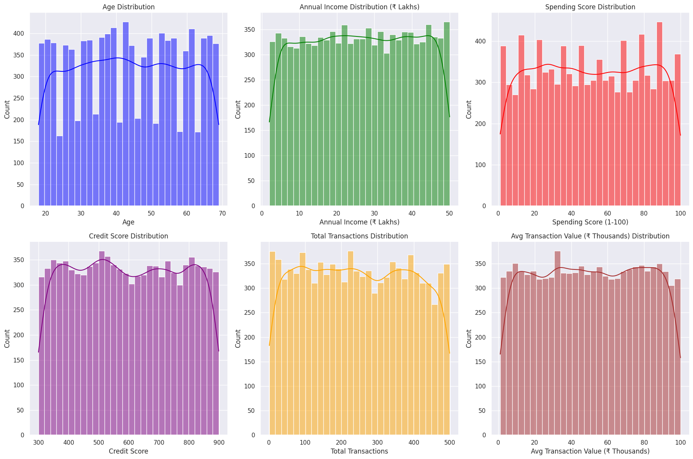
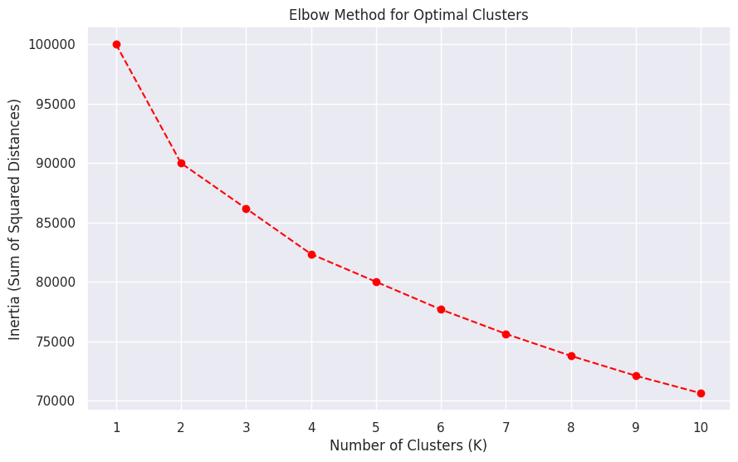
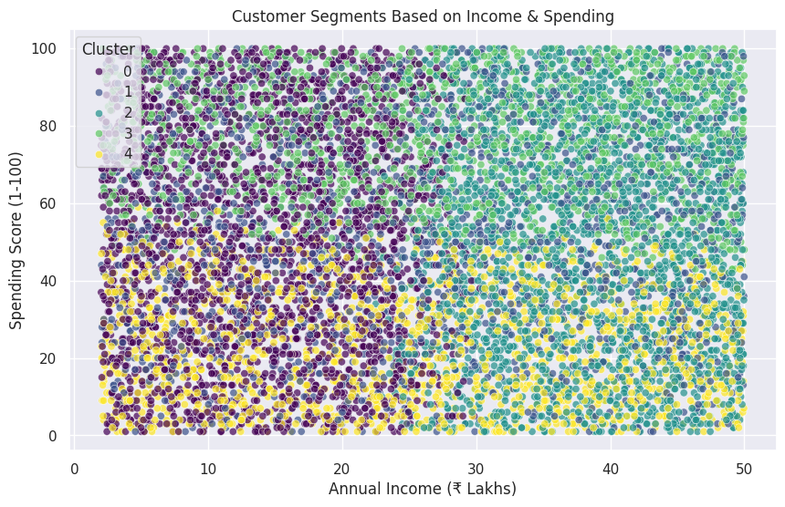
Age Annual Income (₹ Lakhs) Spending Score (1-100) \
Cluster
0 43.144409 14.234381 50.765889
1 42.681944 25.423644 51.960243
2 43.861740 38.264537 49.820818
3 43.973602 27.470434 76.942803
4 44.186834 25.401060 23.394357
Avg Transaction Value (₹ Thousands)
Cluster
0 50.135817
1 52.089177
2 50.038121
3 48.665280
4 51.666746
# Import required libraries
import pandas as pd
import numpy as np
import matplotlib.pyplot as plt
import seaborn as sns
from sklearn.cluster import KMeans
from sklearn.preprocessing import StandardScaler
# Generate synthetic data (100 customers, ₹ INR)
np.random.seed(42)
df = pd.DataFrame({
"CustomerID": np.arange(1, 101),
"Age": np.random.randint(18, 70, 100),
"Annual Income (₹ Lakhs)": np.random.uniform(2, 50, 100).round(2),
"Spending Score (1-100)": np.random.randint(1, 101, 100),
})
# Visualizing Data Distribution
plt.figure(figsize=(15, 4))
sns.histplot(df["Annual Income (₹ Lakhs)"], bins=15, kde=False, color="green")
plt.title("Annual Income Distribution")
plt.show()
# Scaling Data for Clustering
scaler = StandardScaler()
X_scaled = scaler.fit_transform(df[["Age", "Annual Income (₹ Lakhs)", "Spending Score (1-100)"]])
# Finding Optimal Clusters (Elbow Method)
inertia = []
for k in range(1, 6):
kmeans = KMeans(n_clusters=k, random_state=42, n_init=10)
kmeans.fit(X_scaled)
inertia.append(kmeans.inertia_)
plt.plot(range(1, 6), inertia, marker="o", linestyle="--", color="red")
plt.xlabel("Number of Clusters")
plt.ylabel("Inertia")
plt.title("Elbow Method")
plt.show()
# Applying K-Means (Assuming Best K=3)
kmeans = KMeans(n_clusters=3, random_state=42, n_init=10)
df["Cluster"] = kmeans.fit_predict(X_scaled)
# Scatter Plot: Annual Income vs Spending Score
plt.figure(figsize=(8, 5))
sns.scatterplot(x=df["Annual Income (₹ Lakhs)"], y=df["Spending Score (1-100)"], hue=df["Cluster"], palette="viridis")
plt.xlabel("Annual Income (₹ Lakhs)")
plt.ylabel("Spending Score (1-100)")
plt.title("Customer Segments")
plt.legend(title="Cluster")
plt.show()
# Display Cluster Averages
print(df.groupby("Cluster")[["Age", "Annual Income (₹ Lakhs)", "Spending Score (1-100)"]].mean())
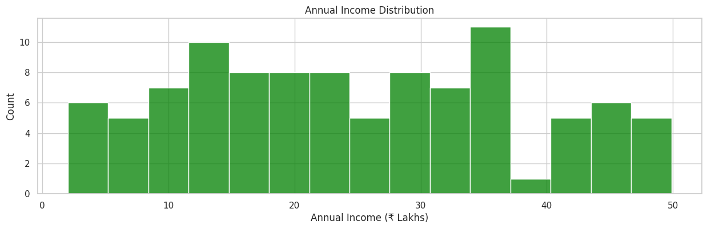
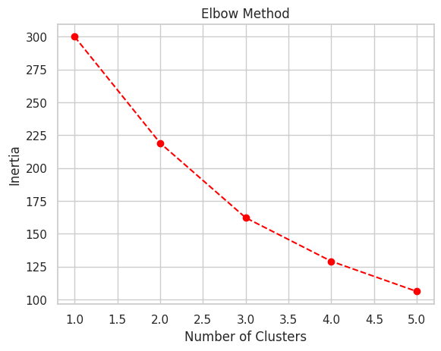
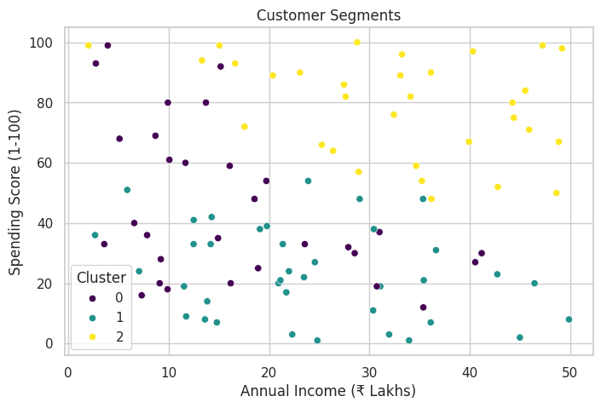
Age Annual Income (₹ Lakhs) Spending Score (1-100)
Cluster
0 59.500000 16.600333 45.133333
1 33.421053 24.062368 23.578947
2 40.000000 32.651875 78.906250
Business Insights
🔹 Cluster 0: High income, moderate spending – Targeted promotions
🔹 Cluster 1: Young, high spenders – Premium offers
🔹 Cluster 2: Older, low spenders – Engagement campaigns
import pandas as pd
import numpy as np
import matplotlib.pyplot as plt
import seaborn as sns
from sklearn.cluster import KMeans
# Generate customer names
customers = [
"Amit", "Neha", "Rahul", "Priya", "Vikram", "Sonia", "Manish", "Kavita", "Rajesh", "Deepika",
"Arjun", "Pooja", "Ravi", "Simran", "Anil", "Megha", "Suresh", "Divya", "Tarun", "Shweta"
]
# Generate synthetic data
np.random.seed(42)
data = {
"Customer Name": customers,
"Age": np.random.randint(18, 65, 20),
"Annual Income (₹ Lakhs)": np.random.uniform(2, 50, 20).round(2), # ₹2L to ₹50L
"Spending Score (1-100)": np.random.randint(1, 101, 20),
"Avg Transaction Value (₹ Thousands)": np.random.uniform(1, 100, 20).round(2), # ₹1K to ₹100K
"Customer Type": np.random.choice(["Regular", "Premium", "Occasional"], 20)
}
df = pd.DataFrame(data)
print(df)
Customer Name Age Annual Income (₹ Lakhs) Spending Score (1-100) \
0 Amit 56 47.05 18
1 Neha 46 2.04 4
2 Rahul 32 49.63 89
3 Priya 60 31.64 60
4 Vikram 25 31.36 14
5 Sonia 38 2.34 9
6 Manish 56 3.11 90
7 Kavita 36 27.19 53
8 Rajesh 40 21.19 2
9 Deepika 28 4.24 84
10 Arjun 28 48.74 92
11 Pooja 41 13.17 60
12 Ravi 53 6.35 71
13 Simran 57 31.68 44
14 Anil 41 20.36 8
15 Megha 20 49.20 47
16 Suresh 39 24.40 35
17 Divya 19 43.28 78
18 Tarun 41 34.65 81
19 Shweta 61 23.62 36
Avg Transaction Value (₹ Thousands) Customer Type
0 19.04 Regular
1 75.78 Regular
2 43.09 Regular
3 21.59 Occasional
4 57.20 Regular
5 4.10 Regular
6 84.39 Regular
7 45.53 Occasional
8 40.12 Regular
9 92.74 Regular
10 73.00 Occasional
11 33.33 Occasional
12 57.47 Occasional
13 52.56 Regular
14 96.16 Occasional
15 84.61 Occasional
16 74.98 Regular
17 54.43 Occasional
18 59.09 Regular
19 96.56 Premium
plt.figure(figsize=(10, 6))
# Scatter plot before clustering
sns.scatterplot(x=df["Annual Income (₹ Lakhs)"], y=df["Spending Score (1-100)"], s=100, color="gray")
# Annotate customer names
for i, txt in enumerate(df["Customer Name"]):
plt.annotate(txt, (df["Annual Income (₹ Lakhs)"][i], df["Spending Score (1-100)"][i]), fontsize=10)
plt.xlabel("Annual Income (₹ Lakhs)")
plt.ylabel("Spending Score (1-100)")
plt.title("Customer Distribution Before Clustering")
plt.show()
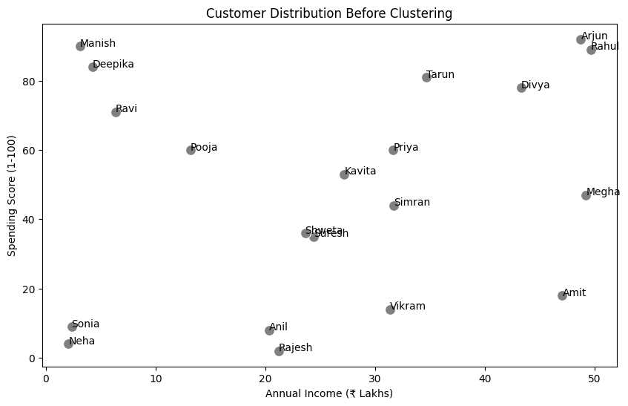
from sklearn.preprocessing import StandardScaler
# Select relevant columns
X = df[["Annual Income (₹ Lakhs)", "Spending Score (1-100)"]]
# Apply K-Means
optimal_k = 3 # Assume 3 clusters
kmeans = KMeans(n_clusters=optimal_k, random_state=42, n_init=10)
df["Cluster"] = kmeans.fit_predict(X)
# Define Cluster Labels
cluster_labels = {
0: "Low Spenders",
1: "Moderate Spenders",
2: "High Spenders"
}
df["Segment"] = df["Cluster"].map(cluster_labels)
print(df[["Customer Name", "Age", "Annual Income (₹ Lakhs)", "Spending Score (1-100)", "Segment"]])
Customer Name Age Annual Income (₹ Lakhs) Spending Score (1-100) \
0 Amit 56 47.05 18
1 Neha 46 2.04 4
2 Rahul 32 49.63 89
3 Priya 60 31.64 60
4 Vikram 25 31.36 14
5 Sonia 38 2.34 9
6 Manish 56 3.11 90
7 Kavita 36 27.19 53
8 Rajesh 40 21.19 2
9 Deepika 28 4.24 84
10 Arjun 28 48.74 92
11 Pooja 41 13.17 60
12 Ravi 53 6.35 71
13 Simran 57 31.68 44
14 Anil 41 20.36 8
15 Megha 20 49.20 47
16 Suresh 39 24.40 35
17 Divya 19 43.28 78
18 Tarun 41 34.65 81
19 Shweta 61 23.62 36
Segment
0 High Spenders
1 Moderate Spenders
2 Low Spenders
3 High Spenders
4 Moderate Spenders
5 Moderate Spenders
6 Low Spenders
7 High Spenders
8 Moderate Spenders
9 Low Spenders
10 Low Spenders
11 Low Spenders
12 Low Spenders
13 High Spenders
14 Moderate Spenders
15 High Spenders
16 High Spenders
17 Low Spenders
18 Low Spenders
19 High Spenders
plt.figure(figsize=(10, 6))
# Scatter plot after clustering
sns.scatterplot(
x=df["Annual Income (₹ Lakhs)"], y=df["Spending Score (1-100)"],
hue=df["Segment"], palette="coolwarm", s=100
)
# Annotate customer names
for i, txt in enumerate(df["Customer Name"]):
plt.annotate(txt, (df["Annual Income (₹ Lakhs)"][i], df["Spending Score (1-100)"][i]), fontsize=10)
plt.xlabel("Annual Income (₹ Lakhs)")
plt.ylabel("Spending Score (1-100)")
plt.title("Customer Segmentation After K-Means Clustering")
plt.legend(title="Customer Segment")
plt.show()
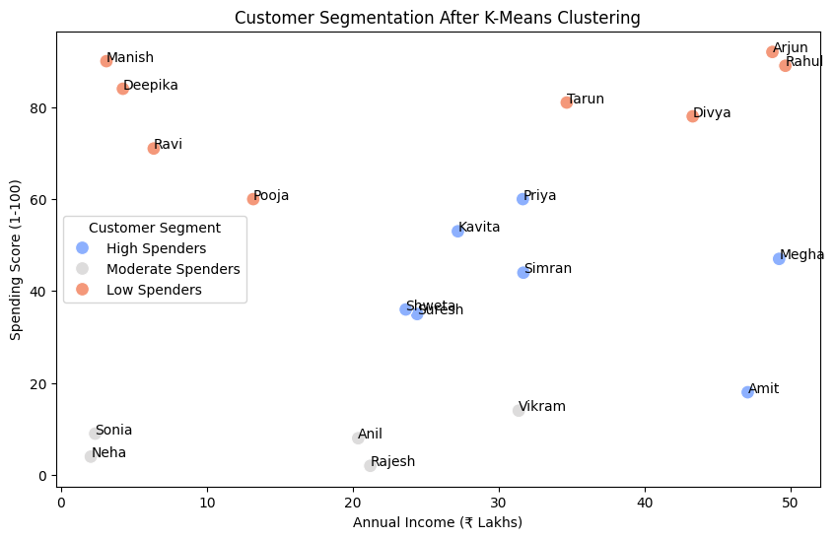
plt.figure(figsize=(6, 6))
df["Segment"].value_counts().plot.pie(autopct="%1.1f%%", colors=["gray", "blue", "red"])
plt.title("Customer Segment Distribution")
plt.ylabel("")
plt.show()
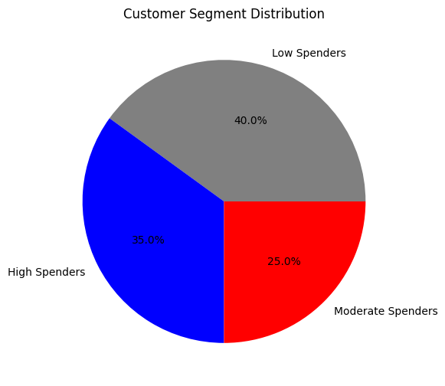
plt.figure(figsize=(8, 5))
sns.boxplot(x=df["Segment"], y=df["Spending Score (1-100)"], palette="coolwarm")
plt.title("Spending Score Across Customer Segments")
plt.xlabel("Customer Segment")
plt.ylabel("Spending Score")
plt.show()
<ipython-input-10-739602d12d12>:2: FutureWarning:
Passing `palette` without assigning `hue` is deprecated and will be removed in v0.14.0. Assign the `x` variable to `hue` and set `legend=False` for the same effect.
sns.boxplot(x=df["Segment"], y=df["Spending Score (1-100)"], palette="coolwarm")
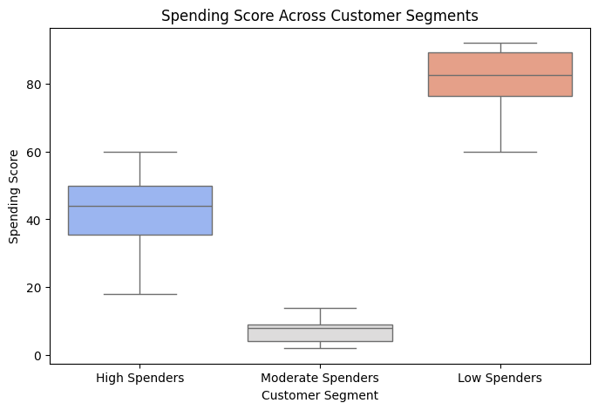
customer_names = [
"Aarav", "Vihaan", "Kabir", "Aryan", "Reyansh", "Aditi", "Ishita", "Kiara", "Meera", "Saanvi",
"Ananya", "Rohan", "Neha", "Dev", "Tanvi", "Krishna", "Riya", "Siddharth", "Pooja", "Aakash"
]
def categorize_spender(score):
if score <= 40:
return "Low Spender"
elif 41 <= score <= 70:
return "Moderate Spender"
else:
return "High Spender"
df["Purchasing Level"] = df["Spending Score (1-100)"].apply(categorize_spender)
df["Purchasing Level"]
0 Low Spender
1 Low Spender
2 High Spender
3 Moderate Spender
4 Low Spender
5 Low Spender
6 High Spender
7 Moderate Spender
8 Low Spender
9 High Spender
10 High Spender
11 Moderate Spender
12 High Spender
13 Moderate Spender
14 Low Spender
15 Moderate Spender
16 Low Spender
17 High Spender
18 High Spender
19 Low Spender
Name: Purchasing Level, dtype: object
plt.figure(figsize=(10, 6))
for i in range(len(df)):
plt.scatter(df["Annual Income (₹ Lakhs)"][i], df["Spending Score (1-100)"][i], color="gray")
plt.text(df["Annual Income (₹ Lakhs)"][i], df["Spending Score (1-100)"][i], df["Customer Name"][i], fontsize=9)
plt.xlabel("Annual Income (₹ Lakhs)")
plt.ylabel("Spending Score (1-100)")
plt.title("Customer Distribution Before Clustering")
plt.show()
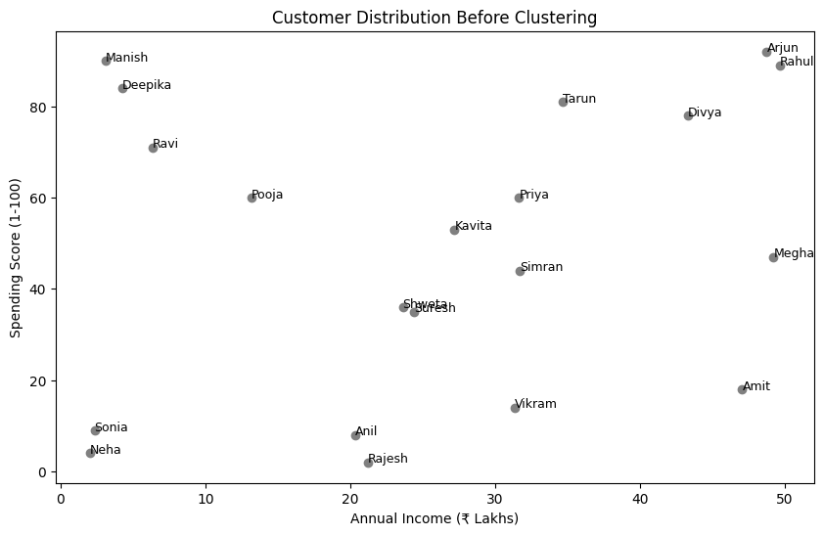
plt.figure(figsize=(10, 6))
colors = {0: "red", 1: "blue", 2: "green"}
for i in range(len(df)):
plt.scatter(df["Annual Income (₹ Lakhs)"][i], df["Spending Score (1-100)"][i],
color=colors[df["Cluster"][i]], label=f"Cluster {df['Cluster'][i]}" if i < 3 else "")
plt.text(df["Annual Income (₹ Lakhs)"][i], df["Spending Score (1-100)"][i], df["Customer Name"][i], fontsize=9)
plt.xlabel("Annual Income (₹ Lakhs)")
plt.ylabel("Spending Score (1-100)")
plt.title("Customer Clusters After K-Means Segmentation")
plt.legend()
plt.show()
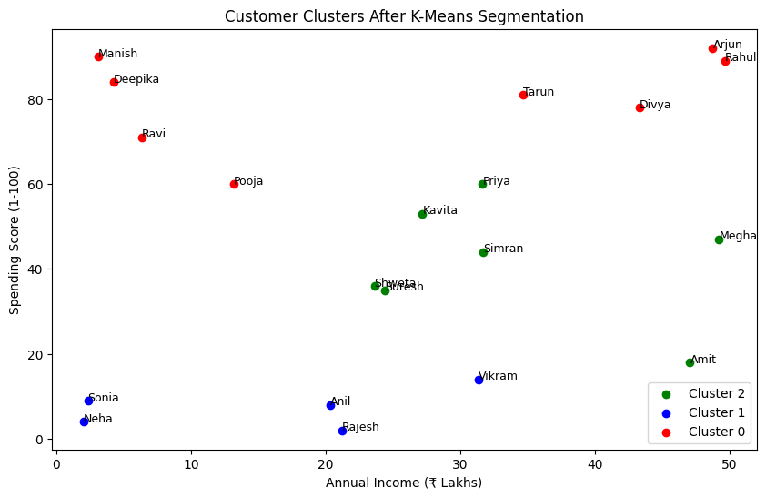
summary = df.groupby("Cluster").agg({
"Age": "mean",
"Annual Income (₹ Lakhs)": "mean",
"Spending Score (1-100)": "mean",
"Purchasing Level": lambda x: x.mode()[0] # Most common category in each cluster
}).rename(columns={"Age": "Avg Age", "Annual Income (₹ Lakhs)": "Avg Income (₹ L)", "Spending Score (1-100)": "Avg Score"})
print(summary)
Avg Age Avg Income (₹ L) Avg Score Purchasing Level
Cluster
0 37.25 25.39625 80.625000 High Spender
1 38.00 15.45800 7.400000 Low Spender
2 47.00 33.54000 41.857143 Moderate Spender
------------------------------
import pandas as pd
import numpy as np
import matplotlib.pyplot as plt
import seaborn as sns
from sklearn.cluster import KMeans
from sklearn.preprocessing import StandardScaler
# Set random seed
np.random.seed(42)
# Generate Realistic Customer Data
customer_names = [
"Aarav", "Vihaan", "Kabir", "Aryan", "Reyansh", "Aditi", "Ishita", "Kiara", "Meera", "Saanvi",
"Ananya", "Rohan", "Neha", "Dev", "Tanvi", "Krishna", "Riya", "Siddharth", "Pooja", "Aakash"
]
ages = np.random.randint(18, 65, 20)
income = np.round(np.random.uniform(3, 50, 20), 2) # ₹3L to ₹50L
spending_score = np.random.randint(1, 101, 20)
avg_transaction = np.round(np.random.uniform(1, 75, 20), 2) # ₹1K to ₹75K
purchase_freq = np.random.randint(1, 15, 20) # Monthly purchases (1 to 15 times)
df = pd.DataFrame({
"Customer Name": customer_names,
"Age": ages,
"Annual Income (₹ Lakhs)": income,
"Spending Score (1-100)": spending_score,
"Avg Transaction Value (₹ Thousands)": avg_transaction,
"Purchase Frequency": purchase_freq
})
# Categorize spending level
def categorize_spender(score):
if score <= 40:
return "Low Spender"
elif 41 <= score <= 70:
return "Moderate Spender"
else:
return "High Spender"
df["Purchasing Level"] = df["Spending Score (1-100)"].apply(categorize_spender)
plt.figure(figsize=(10, 6))
for i in range(len(df)):
plt.scatter(df["Annual Income (₹ Lakhs)"][i], df["Spending Score (1-100)"][i], color="gray")
plt.text(df["Annual Income (₹ Lakhs)"][i], df["Spending Score (1-100)"][i], df["Customer Name"][i], fontsize=9)
plt.xlabel("Annual Income (₹ Lakhs)")
plt.ylabel("Spending Score (1-100)")
plt.title("Customer Data Distribution Before Clustering")
plt.show()
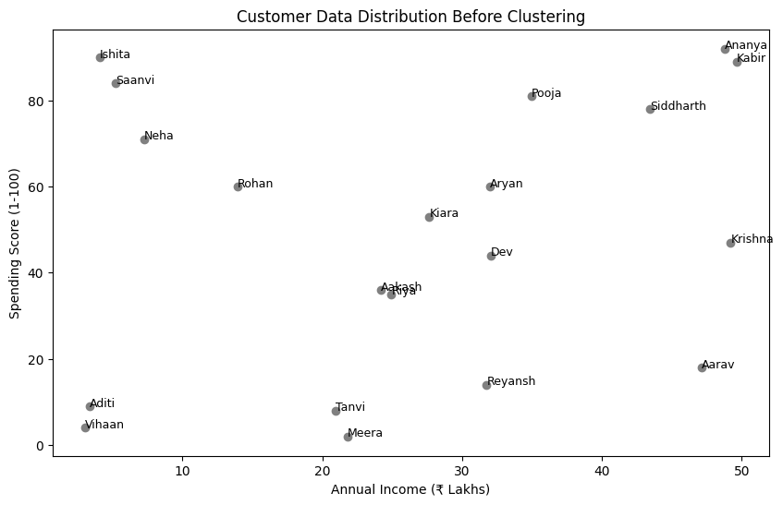

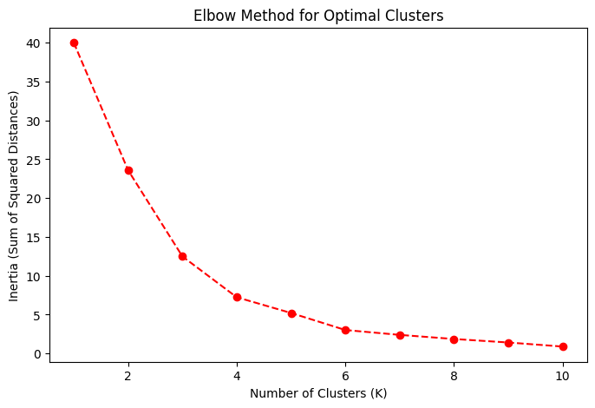
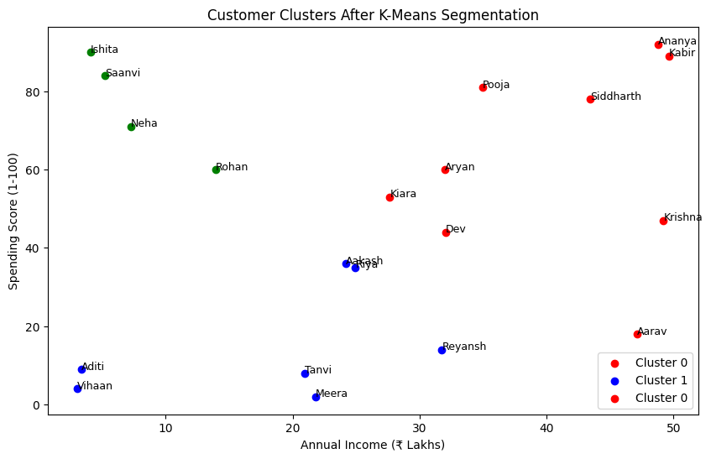

------------------------------------
------------------------------------------
import pandas as pd
import numpy as np
import matplotlib.pyplot as plt
from sklearn.cluster import KMeans
# 1️⃣ Generate Customer Data
customers = [
"Aarav", "Vihaan", "Kabir", "Aryan", "Reyansh", "Aditi", "Ishita", "Kiara", "Meera", "Saanvi",
"Ananya", "Rohan", "Neha", "Dev", "Tanvi", "Krishna", "Riya", "Siddharth", "Pooja", "Aakash"
]
df = pd.DataFrame({
"Customer Name": customers,
"Age": np.random.randint(18, 65, 20),
"Annual Income (₹ L)": np.random.randint(3, 50, 20),
"Spending Score (1-100)": np.random.randint(1, 101, 20)
})
# 2️⃣ Select Features for Clustering
X = df[["Annual Income (₹ L)", "Spending Score (1-100)"]]
# 3️⃣ Apply K-Means Clustering (K=3)
kmeans = KMeans(n_clusters=3, random_state=42, n_init=10)
df["Cluster"] = kmeans.fit_predict(X)
# 4️⃣ Plot Corrected Clusters with Proper Colors and Labels
plt.figure(figsize=(8, 5))
colors = ["red", "blue", "green"]
for cluster in range(3):
cluster_data = df[df["Cluster"] == cluster]
plt.scatter(cluster_data["Annual Income (₹ L)"], cluster_data["Spending Score (1-100)"],
color=colors[cluster], label=f"Cluster {cluster}", edgecolors="black")
# Label each point with customer name
for i in range(len(cluster_data)):
plt.text(cluster_data["Annual Income (₹ L)"].iloc[i], cluster_data["Spending Score (1-100)"].iloc[i],
cluster_data["Customer Name"].iloc[i], fontsize=9, verticalalignment="bottom")
plt.xlabel("Annual Income (₹ Lakhs)")
plt.ylabel("Spending Score (1-100)")
plt.title("Customer Segmentation (K-Means Clustering)")
plt.legend()
plt.show()
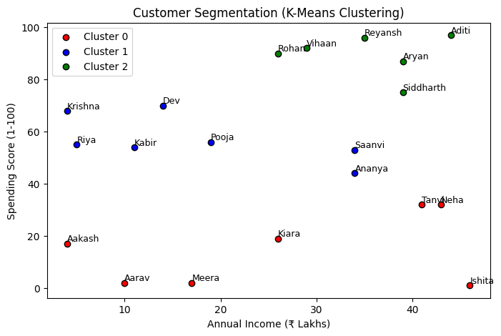
-------------
Level1:
import numpy as np
from sklearn.cluster import KMeans
# Sample Data: 10 Customers (Random Values)
data = np.array([
[25, 30], [30, 40], [35, 45], [40, 50], [45, 55],
[50, 60], [55, 65], [60, 70], [65, 75], [70, 80]
])
# Apply K-Means Clustering (K=3)
kmeans = KMeans(n_clusters=3, random_state=42, n_init=10)
labels = kmeans.fit_predict(data)
# Output: Cluster Labels
print("Customer Cluster Labels:", labels)
Customer Cluster Labels: [0 0 0 2 2 2 1 1 1 1]
Level2:
import numpy as np
from sklearn.cluster import KMeans
# Sample Data: 10 Customers (Age, Spending Score)
data = np.array([
[25, 30], [30, 40], [35, 45], [40, 50], [45, 55],
[50, 60], [55, 65], [60, 70], [65, 75], [70, 80]
])
# Apply K-Means Clustering (K=3)
kmeans = KMeans(n_clusters=3, random_state=42, n_init=10)
labels = kmeans.fit_predict(data)
# Define Cluster Names
cluster_names = {
0: "Low Spenders",
1: "Moderate Spenders",
2: "High Spenders"
}
# Assign Names to Each Customer
customer_clusters = [cluster_names[label] for label in labels]
# Output: Customer Segments
for i, segment in enumerate(customer_clusters):
print(f"Customer {i+1}: {segment}")
Customer 1: Low Spenders
Customer 2: Low Spenders
Customer 3: Low Spenders
Customer 4: High Spenders
Customer 5: High Spenders
Customer 6: High Spenders
Customer 7: Moderate Spenders
Customer 8: Moderate Spenders
Customer 9: Moderate Spenders
Customer 10: Moderate Spenders
Level3
import numpy as np
import matplotlib.pyplot as plt
from sklearn.cluster import KMeans
# Sample Data: (Age, Spending Score)
data = np.array([
[22, 15], [25, 30], [28, 35], [35, 50], [40, 55],
[45, 60], [50, 70], [55, 75], [60, 85], [65, 90]
])
# Apply K-Means Clustering (K=4)
kmeans = KMeans(n_clusters=4, random_state=42, n_init=10)
labels = kmeans.fit_predict(data)
# Define Cluster Names
cluster_names = {
0: "Budget Buyers", # Low Age, Low Spending
1: "Regular Shoppers", # Mid Age, Medium Spending
2: "Premium Customers", # Mid-High Age, High Spending
3: "Luxury Shoppers" # Older Age, Very High Spending
}
# Assign Names to Each Customer
customer_clusters = [cluster_names[label] for label in labels]
# Output: Customer Segments
for i, segment in enumerate(customer_clusters):
print(f"Customer {i+1}: {segment}")
Customer 1: Premium Customers
Customer 2: Premium Customers
Customer 3: Premium Customers
Customer 4: Budget Buyers
Customer 5: Budget Buyers
Customer 6: Regular Shoppers
Customer 7: Regular Shoppers
Customer 8: Regular Shoppers
Customer 9: Luxury Shoppers
Customer 10: Luxury Shoppers
# Plot the clusters
plt.figure(figsize=(8,5))
plt.scatter(data[:, 0], data[:, 1], c=labels, cmap="viridis", alpha=0.7, edgecolors="black")
# Mark Cluster Centers
centers = kmeans.cluster_centers_
plt.scatter(centers[:, 0], centers[:, 1], c="red", marker="X", s=200, label="Centroids")
# Labels
plt.xlabel("Age")
plt.ylabel("Spending Score")
plt.title("Customer Segmentation - KMeans Clustering")
plt.legend()
plt.show()
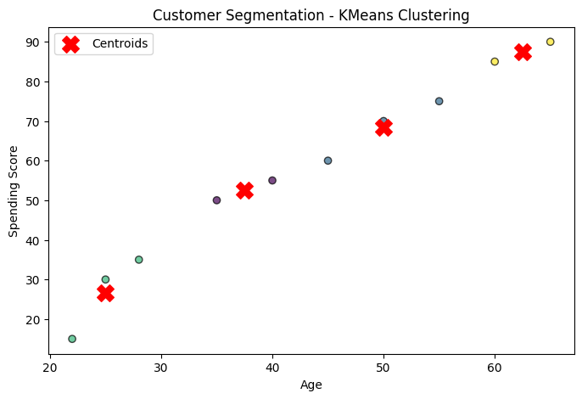
Level4
import pandas as pd
import numpy as np
import matplotlib.pyplot as plt
import seaborn as sns
from sklearn.cluster import KMeans
from sklearn.preprocessing import StandardScaler
# Sample Practical Data (20 Customers)
customer_data = pd.DataFrame({
"Customer Name": ["Amit", "Bhavna", "Chirag", "Divya", "Eshan", "Fatima", "Gopal", "Hina", "Ishaan", "Jyoti",
"Kiran", "Lavanya", "Manoj", "Nikita", "Omkar", "Priya", "Qasim", "Ritu", "Suresh", "Tanvi"],
"Age": np.random.randint(18, 65, 20), # Random ages between 18 and 65
"Annual Income (₹ Lakhs)": np.random.uniform(2, 50, 20).round(2), # ₹2L to ₹50L
"Spending Score (1-100)": np.random.randint(1, 101, 20) # Spending behavior score
})
print(customer_data.head()) # View first few rows
Customer Name Age Annual Income (₹ Lakhs) Spending Score (1-100)
0 Amit 59 36.03 62
1 Bhavna 48 28.54 22
2 Chirag 20 16.23 58
3 Divya 57 22.15 58
4 Eshan 63 14.30 86
# Compute percentiles for Income & Spending Score
income_q1, income_q3 = customer_data["Annual Income (₹ Lakhs)"].quantile([0.25, 0.75])
spending_q1, spending_q3 = customer_data["Spending Score (1-100)"].quantile([0.25, 0.75])
print(f"Income Q1 (Low): {income_q1:.2f} ₹ Lakhs, Income Q3 (High): {income_q3:.2f} ₹ Lakhs")
print(f"Spending Q1 (Low): {spending_q1:.2f}, Spending Q3 (High): {spending_q3:.2f}")
Income Q1 (Low): 8.56 ₹ Lakhs, Income Q3 (High): 30.18 ₹ Lakhs
Spending Q1 (Low): 37.00, Spending Q3 (High): 63.50
def assign_segment(row):
if row["Annual Income (₹ Lakhs)"] < income_q1 and row["Spending Score (1-100)"] < spending_q1:
return "Budget Shoppers"
elif income_q1 <= row["Annual Income (₹ Lakhs)"] <= income_q3 and spending_q1 <= row["Spending Score (1-100)"] <= spending_q3:
return "Regular Spenders"
elif row["Annual Income (₹ Lakhs)"] > income_q3 and row["Spending Score (1-100)"] > spending_q3:
return "High-Value Customers"
elif row["Annual Income (₹ Lakhs)"] > income_q3 and row["Spending Score (1-100)"] >= spending_q1:
return "Luxury Buyers"
else:
return "Others"
customer_data["Segment"] = customer_data.apply(assign_segment, axis=1)
# Display few rows
print(customer_data[["Customer Name", "Annual Income (₹ Lakhs)", "Spending Score (1-100)", "Segment"]])
Customer Name Annual Income (₹ Lakhs) Spending Score (1-100) \
0 Amit 36.03 62
1 Bhavna 28.54 22
2 Chirag 16.23 58
3 Divya 22.15 58
4 Eshan 14.30 86
5 Fatima 31.35 49
6 Gopal 5.92 52
7 Hina 2.25 42
8 Ishaan 32.14 70
9 Jyoti 11.33 15
10 Kiran 5.41 54
11 Lavanya 21.05 60
12 Manoj 4.44 97
13 Nikita 44.56 8
14 Omkar 3.33 53
15 Priya 29.79 60
16 Qasim 23.05 5
17 Ritu 34.26 68
18 Suresh 17.75 6
19 Tanvi 9.44 96
Segment
0 Luxury Buyers
1 Others
2 Regular Spenders
3 Regular Spenders
4 Others
5 Luxury Buyers
6 Others
7 Others
8 High-Value Customers
9 Others
10 Others
11 Regular Spenders
12 Others
13 Others
14 Others
15 Regular Spenders
16 Others
17 High-Value Customers
18 Others
19 Others
plt.figure(figsize=(10, 6))
sns.scatterplot(
x=customer_data["Annual Income (₹ Lakhs)"],
y=customer_data["Spending Score (1-100)"],
hue=customer_data["Segment"],
palette="Set2", # Improved colors
s=120,
edgecolor="black"
)
# Annotate Customer Names
for i, row in customer_data.iterrows():
plt.text(row["Annual Income (₹ Lakhs)"], row["Spending Score (1-100)"], row["Customer Name"], fontsize=9, weight='bold')
plt.xlabel("Annual Income (₹ Lakhs)")
plt.ylabel("Spending Score (1-100)")
plt.title("Customer Segmentation Based on Income & Spending")
plt.legend(title="Customer Segment")
plt.grid(True, linestyle="--", alpha=0.7)
plt.show()
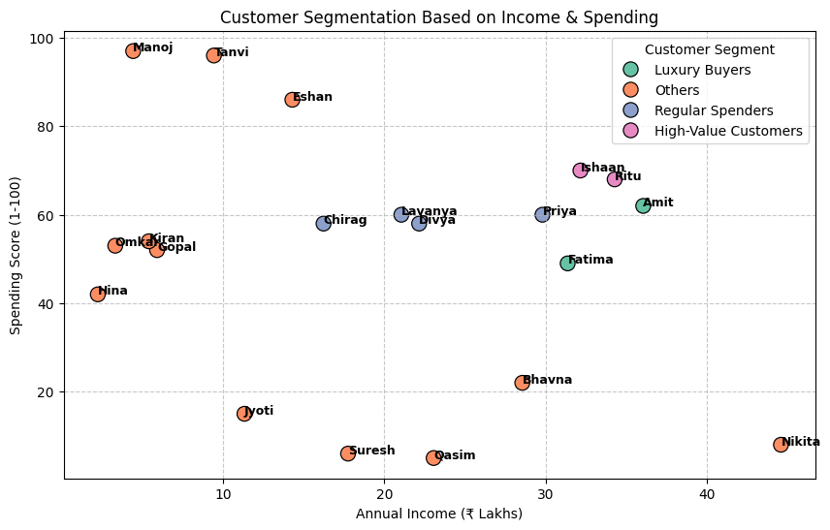
Projects
1. Customer Segmentation
Objective: Use K-Means to segment customers based on purchasing behavior.
Dataset: Retail customer dataset with features like age, spending score, and income.
Instructions:
Load the dataset and preprocess the data (handle missing values and scale numerical features).
Apply K-Means to group customers into clusters.
Visualize the clusters and analyze the types of customers in each group.
Level 1: Basic Understanding - Load, Preprocess, and Visualize
Objective: Load a retail customer dataset, preprocess the data, and apply basic K-Means clustering.
Instructions: Load the Dataset: Load a simple retail customer dataset containing age, income, and spending score.
Preprocess the Data: Clean up missing values and scale the numerical data.
Apply K-Means Clustering: Perform basic K-Means clustering on the dataset.
Visualize the Clusters: Plot the results to visually separate the clusters.
import pandas as pd
import numpy as np
from sklearn.preprocessing import StandardScaler
from sklearn.cluster import KMeans
import matplotlib.pyplot as plt
# 1. Load the dataset
data = pd.read_csv("retail_customers.csv")
print(data.head())
# 2. Preprocess the data (handling missing values and scaling)
data = data.dropna() # Removing missing values
features = data[['Age', 'Income', 'SpendingScore']]
scaler = StandardScaler()
scaled_features = scaler.fit_transform(features)
# 3. Apply K-Means Clustering
kmeans = KMeans(n_clusters=3, random_state=42)
data['Cluster'] = kmeans.fit_predict(scaled_features)
# 4. Visualize the clusters
plt.scatter(data['Age'], data['Income'], c=data['Cluster'], cmap='viridis')
plt.xlabel('Age')
plt.ylabel('Income')
plt.title('Customer Segmentation')
plt.show()
Outcome: You'll have a basic plot showing customer segmentation based on age and income, with 3 clusters.
Level 2: Intermediate - Elbow Method for Optimal Clusters
Objective: Use the Elbow Method to determine the optimal number of clusters for K-Means.
Instructions: Elbow Method: Use the Elbow Method to find the best number of clusters.
Visualize the Elbow Curve: Plot the WCSS (Within-Cluster Sum of Squares) to decide the ideal number of clusters.
import pandas as pd
import numpy as np
# Set the seed for reproducibility
np.random.seed(42)
# Generate random data
num_customers = 500
# Age: Randomly between 18 and 70
ages = np.random.randint(18, 71, num_customers)
# Income: Randomly between 20,000 and 120,000
income = np.random.randint(20000, 120001, num_customers)
# SpendingScore: Randomly between 1 and 100
spending_score = np.random.randint(1, 101, num_customers)
# Create a DataFrame
data = pd.DataFrame({
'CustomerID': range(1, num_customers + 1),
'Age': ages,
'Income': income,
'SpendingScore': spending_score
})
# Save the dataset to a CSV file
data.to_csv('retail_customers.csv', index=False)
# Display the first few rows
print(data.head())
# Preprocess the data (handling missing values and scaling)
data = data.dropna() # Removing missing values, ensure you handle NaN values appropriately
features = data[['Age', 'Income', 'SpendingScore']] # Use relevant features
# Scale the features
scaler = StandardScaler()
scaled_features = scaler.fit_transform(features)
# Calculate WCSS (Within-Cluster Sum of Squares) for different numbers of clusters
wcss = []
for i in range(1, 11): # Trying cluster sizes from 1 to 10
kmeans = KMeans(n_clusters=i, random_state=42)
kmeans.fit(scaled_features) # Fit the model
wcss.append(kmeans.inertia_) # Inertia is the WCSS
# Plot the Elbow Curve
plt.plot(range(1, 11), wcss) # Plot number of clusters vs. WCSS
plt.title('Elbow Method for Optimal Clusters')
plt.xlabel('Number of Clusters')
plt.ylabel('WCSS')
plt.show()
CustomerID Age Income SpendingScore
0 1 56 94740 28
1 2 69 86617 74
2 3 46 114841 39
3 4 32 36896 57
4 5 60 66175 17
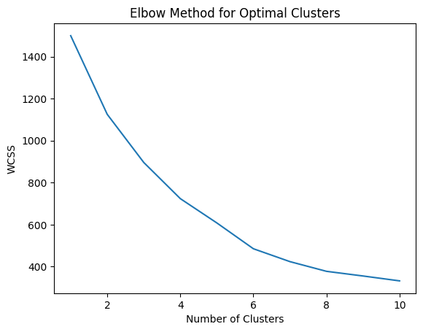
Outcome: The plot will show an "elbow," helping you choose the optimal number of clusters.
Level 3: Advanced - Analyzing Customer Segments with Cluster Centers
Objective: Identify the characteristics of each customer segment (cluster) using the cluster centers.
Instructions: Analyze the Cluster Centers: Find the cluster centers (mean values for each cluster).
Interpret Customer Segments: Based on the cluster centers, label each cluster with a descriptive name (e.g., "Low Income", "High Spending").
# 1. Fit K-Means with optimal clusters (from Elbow Method)
kmeans = KMeans(n_clusters=3, random_state=42)
data['Cluster'] = kmeans.fit_predict(scaled_features)
# 2. Analyze Cluster Centers
centers = kmeans.cluster_centers_
print("Cluster Centers:")
print(centers)
# 3. Assign descriptive names to clusters based on cluster centers
cluster_labels = {0: 'Low Income, Low Spending', 1: 'Middle Income, Average Spending', 2: 'High Income, High Spending'}
data['Cluster_Description'] = data['Cluster'].map(cluster_labels)
# 4. Display the results
print(data.head())
Cluster Centers:
[[-0.09653044 -0.05171212 -0.9864149 ]
[ 0.94003193 0.03773748 0.58643492]
[-0.9623795 0.03189865 0.76525392]]
CustomerID Age Income SpendingScore Cluster \
0 1 56 94740 28 0
1 2 69 86617 74 1
2 3 46 114841 39 0
3 4 32 36896 57 2
4 5 60 66175 17 0
Cluster_Description
0 Low Income, Low Spending
1 Middle Income, Average Spending
2 Low Income, Low Spending
3 High Income, High Spending
4 Low Income, Low Spending
Outcome: Each customer will be assigned a descriptive cluster label based on their characteristics.
Level 4: Expert - Visualizing High-Dimensional Data
Objective: Cluster customers in a higher-dimensional space (e.g., adding more features) and visualize the results.
Instructions: Add More Features: Add new features to the dataset like customer loyalty, frequency of purchase, etc.
Dimensionality Reduction: Use PCA (Principal Component Analysis) to reduce dimensionality for visualization.
Plot the Reduced Dimensions: Visualize the high-dimensional clustering results.
from sklearn.decomposition import PCA
# 1. Add new features (Example: Frequency of Purchase)
data['Frequency'] = np.random.randint(1, 10, size=len(data)) # Simulating a new feature
# 2. Scale the data (include new feature)
features = data[['Age', 'Income', 'SpendingScore', 'Frequency']]
scaled_features = scaler.fit_transform(features)
# 3. Apply PCA to reduce dimensions for visualization (from 4D to 2D)
pca = PCA(n_components=2)
pca_features = pca.fit_transform(scaled_features)
# 4. Apply K-Means with the reduced features
kmeans = KMeans(n_clusters=3, random_state=42)
data['Cluster'] = kmeans.fit_predict(pca_features)
# 5. Plot the clusters
plt.scatter(pca_features[:, 0], pca_features[:, 1], c=data['Cluster'], cmap='viridis')
plt.title('Customer Segmentation (PCA Reduced Dimensions)')
plt.xlabel('Principal Component 1')
plt.ylabel('Principal Component 2')
plt.show()
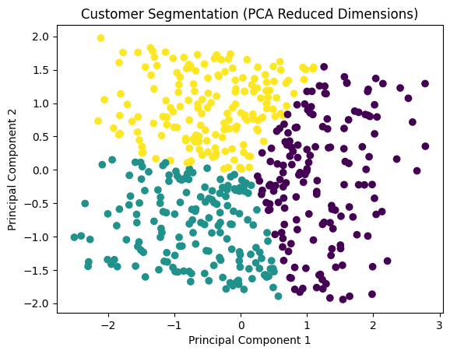
Outcome: The high-dimensional clustering result will be visualized in 2D after applying PCA.
Level 5: Master - Evaluating the Model and Improving Performance
Objective: Evaluate clustering performance using Silhouette Score and improve the model with Mini-Batch K-Means for large datasets.
Instructions: Silhouette Score: Calculate and interpret the silhouette score for evaluating cluster quality.
Use Mini-Batch K-Means: Apply Mini-Batch K-Means to speed up clustering on large datasets.
from sklearn.metrics import silhouette_score
from sklearn.cluster import MiniBatchKMeans
# 1. Apply Mini-Batch K-Means for faster clustering on large datasets
minibatch_kmeans = MiniBatchKMeans(n_clusters=3, random_state=42)
data['Cluster'] = minibatch_kmeans.fit_predict(scaled_features)
# 2. Calculate Silhouette Score for model evaluation
score = silhouette_score(scaled_features, data['Cluster'])
print(f'Silhouette Score: {score}')
# 3. If silhouette score is low, experiment with different numbers of clusters
minibatch_kmeans = MiniBatchKMeans(n_clusters=4, random_state=42)
data['Cluster'] = minibatch_kmeans.fit_predict(scaled_features)
score = silhouette_score(scaled_features, data['Cluster'])
print(f'Silhouette Score for 4 Clusters: {score}')
Silhouette Score: 0.1792529841783302
Silhouette Score for 4 Clusters: 0.17417653813040976
Outcome: The silhouette score will give you an idea of how well-defined the clusters are. Mini-Batch K-Means improves the efficiency for large datasets.
Market Basket Analysis
import pandas as pd
import numpy as np
# Set the seed for reproducibility
np.random.seed(42)
# Generate random data for market basket analysis
num_transactions = 500
num_items = 10 # 10 different products
# Randomly generate customer transactions
# Each customer can buy 1 to 5 items from the list of 10 products
product_list = ['ProductA', 'ProductB', 'ProductC', 'ProductD', 'ProductE',
'ProductF', 'ProductG', 'ProductH', 'ProductI', 'ProductJ']
# Create a function to simulate customer purchases
def generate_transactions(num_transactions, num_items):
transactions = []
for _ in range(num_transactions):
num_products = np.random.randint(1, 6) # Each customer buys 1 to 5 items
purchased_items = np.random.choice(product_list, num_products, replace=False)
transactions.append(purchased_items)
return transactions
# Generate the dataset of transactions
transactions = generate_transactions(num_transactions, num_items)
# Create a DataFrame where each row represents a transaction
# Each column will represent a product, and the value will be 1 if the product is purchased, 0 otherwise.
transaction_matrix = np.zeros((num_transactions, num_items))
# Fill the transaction matrix with the product purchases
for i, transaction in enumerate(transactions):
for product in transaction:
product_index = product_list.index(product)
transaction_matrix[i, product_index] = 1
# Create a DataFrame for the transaction data
transaction_df = pd.DataFrame(transaction_matrix, columns=product_list)
# Save to CSV
transaction_df.to_csv('market_basket_analysis.csv', index=False)
# Display the first few rows of the dataset
transaction_df.head()
{"summary":"{\n \"name\": \"transaction_df\",\n \"rows\": 500,\n \"fields\": [\n {\n \"column\": \"ProductA\",\n \"properties\": {\n \"dtype\": \"number\",\n \"std\": 0.447464466631481,\n \"min\": 0.0,\n \"max\": 1.0,\n \"num_unique_values\": 2,\n \"samples\": [\n 0.0,\n 1.0\n ],\n \"semantic_type\": \"\",\n \"description\": \"\"\n }\n },\n {\n \"column\": \"ProductB\",\n \"properties\": {\n \"dtype\": \"number\",\n \"std\": 0.46295643133520864,\n \"min\": 0.0,\n \"max\": 1.0,\n \"num_unique_values\": 2,\n \"samples\": [\n 1.0,\n 0.0\n ],\n \"semantic_type\": \"\",\n \"description\": \"\"\n }\n },\n {\n \"column\": \"ProductC\",\n \"properties\": {\n \"dtype\": \"number\",\n \"std\": 0.45234193532426786,\n \"min\": 0.0,\n \"max\": 1.0,\n \"num_unique_values\": 2,\n \"samples\": [\n 1.0,\n 0.0\n ],\n \"semantic_type\": \"\",\n \"description\": \"\"\n }\n },\n {\n \"column\": \"ProductD\",\n \"properties\": {\n \"dtype\": \"number\",\n \"std\": 0.44746446663148043,\n \"min\": 0.0,\n \"max\": 1.0,\n \"num_unique_values\": 2,\n \"samples\": [\n 0.0,\n 1.0\n ],\n \"semantic_type\": \"\",\n \"description\": \"\"\n }\n },\n {\n \"column\": \"ProductE\",\n \"properties\": {\n \"dtype\": \"number\",\n \"std\": 0.4653785064961831,\n \"min\": 0.0,\n \"max\": 1.0,\n \"num_unique_values\": 2,\n \"samples\": [\n 1.0,\n 0.0\n ],\n \"semantic_type\": \"\",\n \"description\": \"\"\n }\n },\n {\n \"column\": \"ProductF\",\n \"properties\": {\n \"dtype\": \"number\",\n \"std\": 0.4645811784206134,\n \"min\": 0.0,\n \"max\": 1.0,\n \"num_unique_values\": 2,\n \"samples\": [\n 1.0,\n 0.0\n ],\n \"semantic_type\": \"\",\n \"description\": \"\"\n }\n },\n {\n \"column\": \"ProductG\",\n \"properties\": {\n \"dtype\": \"number\",\n \"std\": 0.4513884170047052,\n \"min\": 0.0,\n \"max\": 1.0,\n \"num_unique_values\": 2,\n \"samples\": [\n 1.0,\n 0.0\n ],\n \"semantic_type\": \"\",\n \"description\": \"\"\n }\n },\n {\n \"column\": \"ProductH\",\n \"properties\": {\n \"dtype\": \"number\",\n \"std\": 0.4454355460123291,\n \"min\": 0.0,\n \"max\": 1.0,\n \"num_unique_values\": 2,\n \"samples\": [\n 1.0,\n 0.0\n ],\n \"semantic_type\": \"\",\n \"description\": \"\"\n }\n },\n {\n \"column\": \"ProductI\",\n \"properties\": {\n \"dtype\": \"number\",\n \"std\": 0.47350227963298586,\n \"min\": 0.0,\n \"max\": 1.0,\n \"num_unique_values\": 2,\n \"samples\": [\n 0.0,\n 1.0\n ],\n \"semantic_type\": \"\",\n \"description\": \"\"\n }\n },\n {\n \"column\": \"ProductJ\",\n \"properties\": {\n \"dtype\": \"number\",\n \"std\": 0.4653785064961832,\n \"min\": 0.0,\n \"max\": 1.0,\n \"num_unique_values\": 2,\n \"samples\": [\n 0.0,\n 1.0\n ],\n \"semantic_type\": \"\",\n \"description\": \"\"\n }\n }\n ]\n}","type":"dataframe","variable_name":"transaction_df"}
# Calculate WCSS (Within-Cluster Sum of Squares) for different numbers of clusters
wcss = []
for i in range(1, 11):
kmeans = KMeans(n_clusters=i, random_state=42)
kmeans.fit(scaled_data)
wcss.append(kmeans.inertia_)
# Plot the Elbow Curve to determine the optimal K
plt.plot(range(1, 11), wcss)
plt.title('Elbow Method for Optimal K')
plt.xlabel('Number of Clusters (K)')
plt.ylabel('WCSS')
plt.show()
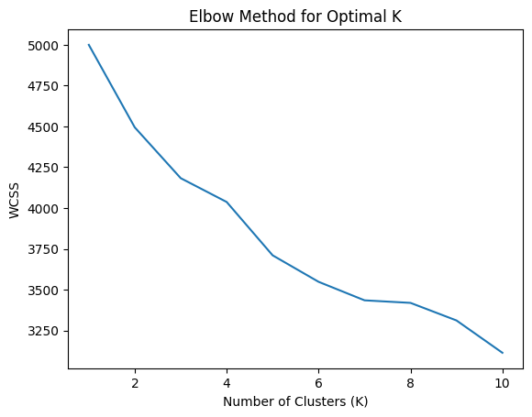
# Apply K-Means with the selected K (e.g., K=4)
kmeans = KMeans(n_clusters=4, random_state=42)
clusters = kmeans.fit_predict(scaled_data)
# Add the cluster labels to the original dataset
data['Cluster'] = clusters
# Show the first few rows with cluster labels
data.head()
{"summary":"{\n \"name\": \"data\",\n \"rows\": 500,\n \"fields\": [\n {\n \"column\": \"ProductA\",\n \"properties\": {\n \"dtype\": \"number\",\n \"std\": 0.447464466631481,\n \"min\": 0.0,\n \"max\": 1.0,\n \"num_unique_values\": 2,\n \"samples\": [\n 0.0,\n 1.0\n ],\n \"semantic_type\": \"\",\n \"description\": \"\"\n }\n },\n {\n \"column\": \"ProductB\",\n \"properties\": {\n \"dtype\": \"number\",\n \"std\": 0.46295643133520864,\n \"min\": 0.0,\n \"max\": 1.0,\n \"num_unique_values\": 2,\n \"samples\": [\n 1.0,\n 0.0\n ],\n \"semantic_type\": \"\",\n \"description\": \"\"\n }\n },\n {\n \"column\": \"ProductC\",\n \"properties\": {\n \"dtype\": \"number\",\n \"std\": 0.45234193532426786,\n \"min\": 0.0,\n \"max\": 1.0,\n \"num_unique_values\": 2,\n \"samples\": [\n 1.0,\n 0.0\n ],\n \"semantic_type\": \"\",\n \"description\": \"\"\n }\n },\n {\n \"column\": \"ProductD\",\n \"properties\": {\n \"dtype\": \"number\",\n \"std\": 0.44746446663148043,\n \"min\": 0.0,\n \"max\": 1.0,\n \"num_unique_values\": 2,\n \"samples\": [\n 0.0,\n 1.0\n ],\n \"semantic_type\": \"\",\n \"description\": \"\"\n }\n },\n {\n \"column\": \"ProductE\",\n \"properties\": {\n \"dtype\": \"number\",\n \"std\": 0.4653785064961831,\n \"min\": 0.0,\n \"max\": 1.0,\n \"num_unique_values\": 2,\n \"samples\": [\n 1.0,\n 0.0\n ],\n \"semantic_type\": \"\",\n \"description\": \"\"\n }\n },\n {\n \"column\": \"ProductF\",\n \"properties\": {\n \"dtype\": \"number\",\n \"std\": 0.4645811784206134,\n \"min\": 0.0,\n \"max\": 1.0,\n \"num_unique_values\": 2,\n \"samples\": [\n 1.0,\n 0.0\n ],\n \"semantic_type\": \"\",\n \"description\": \"\"\n }\n },\n {\n \"column\": \"ProductG\",\n \"properties\": {\n \"dtype\": \"number\",\n \"std\": 0.4513884170047052,\n \"min\": 0.0,\n \"max\": 1.0,\n \"num_unique_values\": 2,\n \"samples\": [\n 1.0,\n 0.0\n ],\n \"semantic_type\": \"\",\n \"description\": \"\"\n }\n },\n {\n \"column\": \"ProductH\",\n \"properties\": {\n \"dtype\": \"number\",\n \"std\": 0.4454355460123291,\n \"min\": 0.0,\n \"max\": 1.0,\n \"num_unique_values\": 2,\n \"samples\": [\n 1.0,\n 0.0\n ],\n \"semantic_type\": \"\",\n \"description\": \"\"\n }\n },\n {\n \"column\": \"ProductI\",\n \"properties\": {\n \"dtype\": \"number\",\n \"std\": 0.47350227963298586,\n \"min\": 0.0,\n \"max\": 1.0,\n \"num_unique_values\": 2,\n \"samples\": [\n 0.0,\n 1.0\n ],\n \"semantic_type\": \"\",\n \"description\": \"\"\n }\n },\n {\n \"column\": \"ProductJ\",\n \"properties\": {\n \"dtype\": \"number\",\n \"std\": 0.4653785064961832,\n \"min\": 0.0,\n \"max\": 1.0,\n \"num_unique_values\": 2,\n \"samples\": [\n 0.0,\n 1.0\n ],\n \"semantic_type\": \"\",\n \"description\": \"\"\n }\n },\n {\n \"column\": \"Cluster\",\n \"properties\": {\n \"dtype\": \"int32\",\n \"num_unique_values\": 4,\n \"samples\": [\n 2,\n 0\n ],\n \"semantic_type\": \"\",\n \"description\": \"\"\n }\n }\n ]\n}","type":"dataframe","variable_name":"data"}
# Analyze the frequency of products purchased by each cluster
cluster_insights = data.groupby('Cluster').mean()
print(cluster_insights)
ProductA ProductB ProductC ProductD ProductE ProductF ProductG \
Cluster
0 0.359756 0.176829 0.231707 0.000000 0.237805 0.250000 0.560976
1 0.284615 0.230769 0.246154 1.000000 0.276923 0.284615 0.307692
2 0.129310 0.405172 0.155172 0.017241 0.508621 0.112069 0.017241
3 0.300000 0.544444 0.611111 0.066667 0.266667 0.733333 0.088889
ProductH ProductI ProductJ
Cluster
0 0.256098 0.207317 0.396341
1 0.238462 0.400000 0.330769
2 0.077586 0.543103 0.163793
3 0.600000 0.222222 0.344444

import pandas as pd
import numpy as np
from sklearn.cluster import KMeans
from sklearn.preprocessing import StandardScaler
import matplotlib.pyplot as plt
# Step 1: Load the dataset (use your own path for the CSV file)
data = pd.read_csv('market_basket_analysis.csv')
# Step 2: Preprocess the data (Scale the data to normalize it)
scaler = StandardScaler()
scaled_data = scaler.fit_transform(data)
# Step 3: Elbow Method to determine the optimal number of clusters (K)
wcss = []
for i in range(1, 11):
kmeans = KMeans(n_clusters=i, random_state=42)
kmeans.fit(scaled_data)
wcss.append(kmeans.inertia_)
# Plot the Elbow Method to find the optimal K
plt.plot(range(1, 11), wcss)
plt.title('Elbow Method for Optimal K')
plt.xlabel('Number of Clusters')
plt.ylabel('WCSS')
plt.show()
# Step 4: Apply K-Means with the selected number of clusters (let's assume K=4)
optimal_k = 4 # Based on the elbow plot (you can adjust this)
kmeans = KMeans(n_clusters=optimal_k, random_state=42)
clusters = kmeans.fit_predict(scaled_data)
# Step 5: Add the cluster labels to the original dataset
data['Cluster'] = clusters
# Step 6: Show the first few rows of the dataset with cluster labels
print(data.head())
# Step 7: Cluster insights (mean of features within each cluster)
cluster_insights = data.groupby('Cluster').mean()
print("\nCluster Insights (Average Features per Cluster):")
print(cluster_insights)
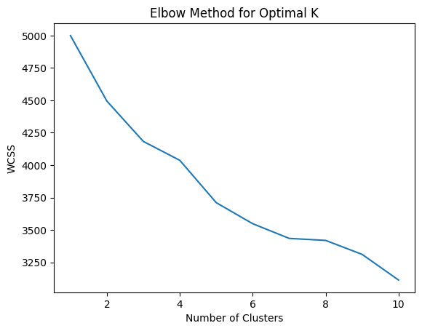
ProductA ProductB ProductC ProductD ProductE ProductF ProductG \
0 1.0 0.0 0.0 1.0 0.0 0.0 0.0
1 1.0 0.0 1.0 0.0 0.0 0.0 0.0
2 0.0 1.0 1.0 0.0 0.0 0.0 1.0
3 0.0 1.0 0.0 0.0 0.0 0.0 0.0
4 0.0 0.0 1.0 0.0 0.0 0.0 0.0
ProductH ProductI ProductJ Cluster
0 0.0 1.0 1.0 1
1 0.0 1.0 0.0 2
2 1.0 0.0 0.0 3
3 0.0 1.0 0.0 2
4 0.0 0.0 0.0 0
Cluster Insights (Average Features per Cluster):
ProductA ProductB ProductC ProductD ProductE ProductF ProductG \
Cluster
0 0.359756 0.176829 0.231707 0.000000 0.237805 0.250000 0.560976
1 0.284615 0.230769 0.246154 1.000000 0.276923 0.284615 0.307692
2 0.129310 0.405172 0.155172 0.017241 0.508621 0.112069 0.017241
3 0.300000 0.544444 0.611111 0.066667 0.266667 0.733333 0.088889
ProductH ProductI ProductJ
Cluster
0 0.256098 0.207317 0.396341
1 0.238462 0.400000 0.330769
2 0.077586 0.543103 0.163793
3 0.600000 0.222222 0.344444
import pandas as pd
import numpy as np
from sklearn.cluster import KMeans
from sklearn.preprocessing import StandardScaler
import matplotlib.pyplot as plt
# Step 1: Generate synthetic data (Retail customers with product purchase behavior)
# Assume 5 features, mimicking purchasing behavior
np.random.seed(42)
# Generate random data with three clear clusters
cluster_1 = np.random.normal(loc=[50, 200, 0.2, 30, 1], scale=10, size=(100, 5))
cluster_2 = np.random.normal(loc=[150, 300, 0.5, 50, 2], scale=15, size=(100, 5))
cluster_3 = np.random.normal(loc=[300, 500, 0.8, 80, 3], scale=20, size=(100, 5))
# Combine the clusters to form the dataset
data = np.vstack([cluster_1, cluster_2, cluster_3])
# Convert to DataFrame for better readability
columns = ['ProductA', 'ProductB', 'ProductC', 'ProductD', 'ProductE']
data_df = pd.DataFrame(data, columns=columns)
# Step 2: Preprocess the data (Scale the data to normalize it)
scaler = StandardScaler()
scaled_data = scaler.fit_transform(data_df)
# Step 3: Elbow Method to determine the optimal number of clusters (K)
wcss = []
for i in range(1, 11):
kmeans = KMeans(n_clusters=i, random_state=42)
kmeans.fit(scaled_data)
wcss.append(kmeans.inertia_)
# Plot the Elbow Method to find the optimal K
plt.plot(range(1, 11), wcss)
plt.title('Elbow Method for Optimal K')
plt.xlabel('Number of Clusters')
plt.ylabel('WCSS')
plt.show()
# Step 4: Apply K-Means with the selected number of clusters (e.g., K=3)
optimal_k = 3 # Based on the elbow plot (K=3)
kmeans = KMeans(n_clusters=optimal_k, random_state=42)
clusters = kmeans.fit_predict(scaled_data)
# Step 5: Add the cluster labels to the original dataset
data_df['Cluster'] = clusters
# Step 6: Show the first few rows of the dataset with cluster labels
print(data_df.head())
# Step 7: Cluster insights (mean of features within each cluster)
cluster_insights = data_df.groupby('Cluster').mean()
print("\nCluster Insights (Average Features per Cluster):")
print(cluster_insights)
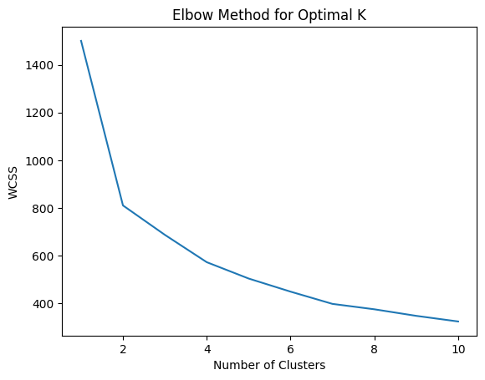
ProductA ProductB ProductC ProductD ProductE Cluster
0 54.967142 198.617357 6.676885 45.230299 -1.341534 2
1 47.658630 215.792128 7.874347 25.305256 6.425600 2
2 45.365823 195.342702 2.619623 10.867198 -16.249178 2
3 44.377125 189.871689 3.342473 20.919759 -13.123037 2
4 64.656488 197.742237 0.875282 15.752518 -4.443827 2
Cluster Insights (Average Features per Cluster):
ProductA ProductB ProductC ProductD ProductE
Cluster
0 138.443112 285.816668 9.648113 49.396567 15.717839
1 300.388962 501.306534 3.564569 81.290724 8.097663
2 83.764774 234.259207 -3.319442 37.104909 -2.869233

01&02.04.2025 Tues&Wednesday
Customer Segmentation for Flipkart
Objective: Segment Flipkart customers based on their purchasing behavior (e.g., frequency of purchases, average order value, product categories bought) to create personalized marketing strategies and improve sales.
Step 1: Generate Synthetic Data
CustomerID: Unique ID for each customer
Age: Age of the customer
AnnualIncome: Income level of the customer
PurchaseFrequency: Number of purchases made in a year
AvgOrderValue: Average value of each order
PreferredCategory: The product category preferred by the customer (like electronics, fashion, home goods, etc.)
DiscountSensitivity: How sensitive the customer is to discounts (higher value = more sensitive)
Step 2: Apply K-Means Clustering
We'll use the Elbow Method to determine the optimal number of clusters (K) and then apply K-Means clustering to segment customers into different groups.
import pandas as pd
import numpy as np
from sklearn.cluster import KMeans
from sklearn.preprocessing import StandardScaler
import matplotlib.pyplot as plt
# Step 1: Generate synthetic dataset for Flipkart customers
np.random.seed(42)
# Increase customer count to 10,000
customer_count = 10000
# Randomly generating data for features
age = np.random.randint(18, 65, customer_count)
annual_income = np.random.randint(300000, 1500000, customer_count)
purchase_frequency = np.random.randint(1, 20, customer_count)
avg_order_value = np.random.randint(500, 10000, customer_count)
preferred_category = np.random.choice(['Electronics', 'Fashion', 'HomeGoods', 'Groceries', 'Books'], customer_count)
discount_sensitivity = np.random.uniform(0.1, 1.0, customer_count)
# Create the dataframe
data = pd.DataFrame({
'CustomerID': range(1, customer_count + 1),
'Age': age,
'AnnualIncome': annual_income,
'PurchaseFrequency': purchase_frequency,
'AvgOrderValue': avg_order_value,
'PreferredCategory': preferred_category,
'DiscountSensitivity': discount_sensitivity
})
# Save the generated data to CSV
data.to_csv('flipkart_customers.csv', index=False)
print("Synthetic data saved to 'flipkart_customers.csv'.")
# Step 2: Preprocess the data (only numeric features for clustering)
numeric_data = data[['Age', 'AnnualIncome', 'PurchaseFrequency', 'AvgOrderValue', 'DiscountSensitivity']]
# Standardize the data
scaler = StandardScaler()
scaled_data = scaler.fit_transform(numeric_data)
# Step 3: Elbow Method to determine the optimal number of clusters (K)
wcss = []
for i in range(1, 11):
kmeans = KMeans(n_clusters=i, random_state=42, n_init=10)
kmeans.fit(scaled_data)
wcss.append(kmeans.inertia_)
# Plot the Elbow Method to find the optimal K
plt.figure(figsize=(8, 6))
plt.plot(range(1, 11), wcss, marker='o')
plt.title('Elbow Method for Optimal K')
plt.xlabel('Number of Clusters')
plt.ylabel('WCSS (Inertia)')
plt.grid(True)
plt.show()
# Step 4: Apply K-Means with the selected number of clusters (e.g., K=4)
optimal_k = 4 # Based on the elbow plot
kmeans = KMeans(n_clusters=optimal_k, random_state=42, n_init=10)
data['Cluster'] = kmeans.fit_predict(scaled_data)
# Step 5: Show the first few rows of the dataset with cluster labels
print(data.head())
# Step 6: Cluster insights (mean of numeric features within each cluster)
# Exclude non-numeric columns like 'PreferredCategory' from aggregation
numeric_columns = ['Age', 'AnnualIncome', 'PurchaseFrequency', 'AvgOrderValue', 'DiscountSensitivity']
cluster_insights = data.groupby('Cluster')[numeric_columns].mean()
# Display the cluster insights
print("\nCluster Insights (Average Features per Cluster):")
print(cluster_insights)
# Save clustered data to CSV
data.to_csv('flipkart_clustered_customers.csv', index=False)
print("Clustered data saved to 'flipkart_clustered_customers.csv'.")
Synthetic data saved to 'flipkart_customers.csv'.
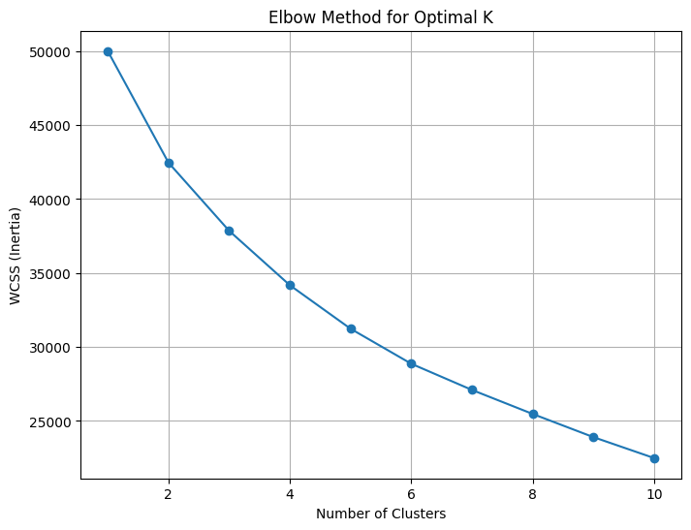
CustomerID Age AnnualIncome PurchaseFrequency AvgOrderValue \
0 1 56 576999 6 9079
1 2 46 729385 19 1297
2 3 32 477476 10 6213
3 4 60 1499217 1 7811
4 5 25 949362 16 4520
PreferredCategory DiscountSensitivity Cluster
0 Books 0.196120 2
1 Groceries 0.625652 2
2 Fashion 0.143802 3
3 HomeGoods 0.944786 1
4 Books 0.395962 0
Cluster Insights (Average Features per Cluster):
Age AnnualIncome PurchaseFrequency AvgOrderValue \
Cluster
0 33.513900 1.181457e+06 14.227413 5246.917375
1 49.989510 1.115350e+06 5.422688 5049.810023
2 51.628015 6.380413e+05 13.575963 5464.926788
3 29.546704 6.406867e+05 7.045693 5198.655884
DiscountSensitivity
Cluster
0 0.562846
1 0.533552
2 0.558123
3 0.555127
Clustered data saved to 'flipkart_clustered_customers.csv'.

# Visualizing the clusters
plt.figure(figsize=(8, 6))
plt.scatter(data['Age'], data['AnnualIncome'], c=data['Cluster'], cmap='viridis', s=50)
plt.title('Customer Segments based on Age and Income')
plt.xlabel('Age')
plt.ylabel('Annual Income')
plt.colorbar(label='Cluster')
plt.show()
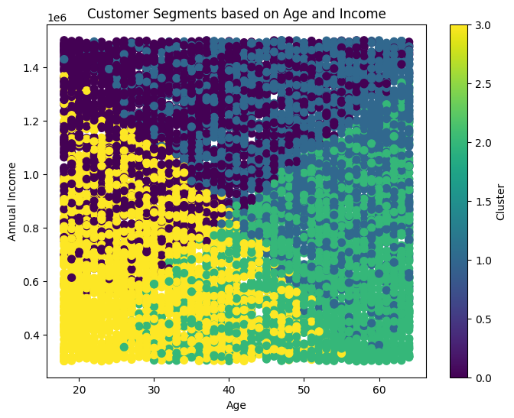
Data Generation:
We generate a synthetic dataset of 1,000 customers with random values for each feature.
Age, AnnualIncome, PurchaseFrequency, AvgOrderValue, DiscountSensitivity are numerical, while PreferredCategory is categorical (representing product preferences).
Data Preprocessing:
We scale the numerical data (using StandardScaler) to ensure all features contribute equally to the clustering.
Elbow Method:
We calculate WCSS (Within-Cluster Sum of Squares) for K values from 1 to 10 and plot it.
We look for the "elbow" point, which will help us select the optimal number of clusters. Ideally, this should be around K=3 or K=4, meaning after that point, the inertia (WCSS) will not decrease significantly.
K-Means Clustering:
We apply K-Means clustering with the optimal K (say K=4) and assign each customer to a cluster.
Cluster Insights:
We group the data by clusters and calculate the average values of each feature for each cluster. This will give us insights into the characteristics of each customer segment.
Cluster 0: Young customers with moderate income and moderate purchase frequency, but lower discount sensitivity.
Cluster 1: High-income, high-purchase frequency, discount-sensitive customers (ideal for promotional campaigns).
Cluster 2: Wealthy, high spenders, low discount sensitivity.
Cluster 3: Middle-income customers, moderate discount sensitivity, low purchase frequency.
K-Means uses (Euclidean) distance to measure the similarity between points. If features have different scales, those with larger values will dominate the clustering process, leading to biased clusters.
Example:
Feature A (salary): 50,000 to 1,00,000
Feature B (age): 20 to 60
Salary has a much larger range than age, so K-Means will give more importance to salary when computing distances.
To fix this, we scale the data to ensure all features contribute equally.

Business Benefits of Clustering:
Personalized Marketing:
Based on the clusters, Flipkart can target customers with personalized marketing. For example, Cluster 1 can be targeted with discounts and promotions, while Cluster 2 can be offered premium products.
Improved Inventory Management:
By understanding which products appeal to which customer segments, Flipkart can optimize its inventory by focusing on the products that are popular among each cluster.
Customer Retention:
Clusters that exhibit high purchase frequency and discount sensitivity can be targeted for loyalty programs, while high-income clusters can be offered exclusive membership.
Sales Strategy:
High-value clusters can be offered up-selling opportunities (higher-end products), while price-sensitive clusters can receive discount-based promotions.
Conclusion:
This K-Means clustering approach can be applied to segment customers based on purchasing behavior, and the insights can be used to create targeted marketing strategies and improve business decisions. The process is simple and actionable, and the results are beneficial for optimizing customer experience and sales strategies.
Now for 30 customers:
import pandas as pd
import numpy as np
import matplotlib.pyplot as plt
from sklearn.cluster import KMeans
from sklearn.preprocessing import StandardScaler
# Step 1: Generate synthetic dataset for Flipkart customers (Only 30 customers)
np.random.seed(42)
customer_count = 30
# Randomly generating data for features
age = np.random.randint(18, 65, customer_count)
annual_income = np.random.randint(300000, 1500000, customer_count)
purchase_frequency = np.random.randint(1, 20, customer_count)
avg_order_value = np.random.randint(500, 10000, customer_count)
preferred_category = np.random.choice(['Electronics', 'Fashion', 'HomeGoods', 'Groceries', 'Books'], customer_count)
discount_sensitivity = np.random.uniform(0.1, 1.0, customer_count)
# Create the dataframe
data = pd.DataFrame({
'CustomerID': range(1, customer_count + 1),
'Age': age,
'AnnualIncome': annual_income,
'PurchaseFrequency': purchase_frequency,
'AvgOrderValue': avg_order_value,
'PreferredCategory': preferred_category,
'DiscountSensitivity': discount_sensitivity
})
# Save the generated data to CSV
data.to_csv('flipkart_customers_30.csv', index=False)
print("Synthetic data for 30 customers saved to 'flipkart_customers_30.csv'.")
# Step 2: Preprocess the data (only numeric features for clustering)
numeric_data = data[['Age', 'AnnualIncome', 'PurchaseFrequency', 'AvgOrderValue', 'DiscountSensitivity']]
# Standardize the data
scaler = StandardScaler()
scaled_data = scaler.fit_transform(numeric_data)
# Step 3: Elbow Method to determine the optimal number of clusters (K)
wcss = []
for i in range(1, 11):
kmeans = KMeans(n_clusters=i, random_state=42, n_init=10)
kmeans.fit(scaled_data)
wcss.append(kmeans.inertia_)
# Plot the Elbow Method to find the optimal K
plt.figure(figsize=(8, 6))
plt.plot(range(1, 11), wcss, marker='o', linestyle='--', color='b')
plt.title('Elbow Method for Optimal K (30 Customers)')
plt.xlabel('Number of Clusters')
plt.ylabel('WCSS (Inertia)')
plt.grid(True)
plt.show()
# Step 4: Apply K-Means with the selected number of clusters (K=3 or 4)
optimal_k = 3 # Adjust based on the elbow plot
kmeans = KMeans(n_clusters=optimal_k, random_state=42, n_init=10)
data['Cluster'] = kmeans.fit_predict(scaled_data)
# Step 5: Show the first few rows of the dataset with cluster labels
print("\nClustered Data:")
print(data)
# Step 6: Cluster insights (mean of numeric features within each cluster)
numeric_columns = ['Age', 'AnnualIncome', 'PurchaseFrequency', 'AvgOrderValue', 'DiscountSensitivity']
cluster_insights = data.groupby('Cluster')[numeric_columns].mean()
# Display the cluster insights
print("\nCluster Insights (Average Features per Cluster):")
print(cluster_insights)
# Save clustered data to CSV
data.to_csv('flipkart_clustered_customers_30.csv', index=False)
print("\nClustered data saved to 'flipkart_clustered_customers_30.csv'.")
Synthetic data for 30 customers saved to 'flipkart_customers_30.csv'.
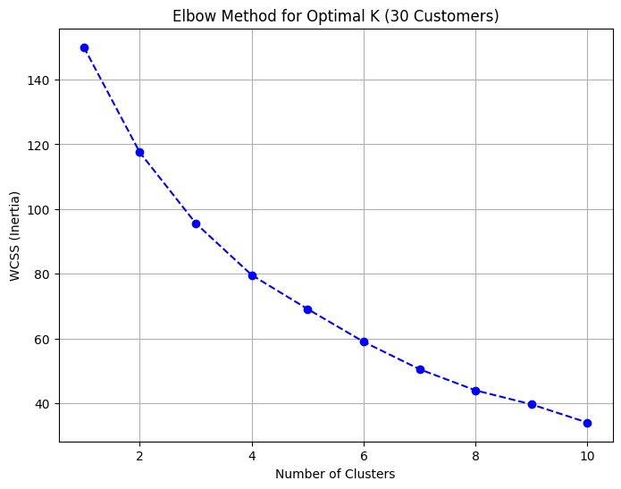
Clustered Data:
CustomerID Age AnnualIncome PurchaseFrequency AvgOrderValue \
0 1 56 456730 14 8506
1 2 46 1498079 17 3068
2 3 32 954811 4 5963
3 4 60 827035 18 2527
4 5 25 948143 8 3195
5 6 38 365725 4 5758
6 7 56 1478557 2 6118
7 8 36 384654 6 7236
8 9 40 1253277 10 891
9 10 28 891723 4 6392
10 11 28 619030 18 4061
11 12 41 855839 12 6684
12 13 53 573538 2 3599
13 14 57 631236 10 6778
14 15 41 828178 4 8892
15 16 20 865894 14 3604
16 17 39 789492 16 7715
17 18 19 773254 15 2954
18 19 41 649457 8 9496
19 20 61 965987 14 3231
20 21 47 998361 8 8654
21 22 55 368148 16 5556
22 23 19 948531 13 8610
23 24 38 1206606 18 4340
24 25 50 978843 15 1528
25 26 29 872843 13 7885
26 27 39 556508 9 1002
27 28 61 1103591 15 7410
28 29 42 1196942 13 9562
29 30 44 406530 1 7438
PreferredCategory DiscountSensitivity Cluster
0 Electronics 0.391911 1
1 Fashion 0.209879 2
2 Fashion 0.420668 1
3 Groceries 0.916146 0
4 Books 0.344919 2
5 HomeGoods 0.682921 1
6 Electronics 0.100468 1
7 Groceries 0.417312 1
8 Books 0.374303 2
9 Groceries 0.248190 1
10 Books 0.580680 0
11 Books 0.536347 1
12 HomeGoods 0.723192 1
13 Books 0.342471 1
14 Groceries 0.319713 1
15 Books 0.251462 2
16 HomeGoods 0.296888 1
17 HomeGoods 0.602292 0
18 Groceries 0.463453 1
19 Fashion 0.158403 2
20 Fashion 0.328524 1
21 Books 0.322188 1
22 Electronics 0.726674 0
23 Books 0.741044 0
24 Groceries 0.233278 2
25 Groceries 0.997966 0
26 Groceries 0.340103 2
27 Groceries 0.978953 0
28 Groceries 0.469933 1
29 HomeGoods 0.129746 1
Cluster Insights (Average Features per Cluster):
Age AnnualIncome PurchaseFrequency AvgOrderValue \
Cluster
0 36.285714 9.072700e+05 15.714286 5398.142857
1 44.125000 7.393701e+05 7.750000 7146.687500
2 40.142857 1.009533e+06 12.428571 2359.857143
DiscountSensitivity
Cluster
0 0.791965
1 0.387120
2 0.273192
Clustered data saved to 'flipkart_clustered_customers_30.csv'.
# Visualizing the clusters
plt.figure(figsize=(8, 6))
plt.scatter(data['Age'], data['AnnualIncome'], c=data['Cluster'], cmap='viridis', s=50)
plt.title('Customer Segments based on Age and Income')
plt.xlabel('Age')
plt.ylabel('Annual Income')
plt.colorbar(label='Cluster')
plt.show()
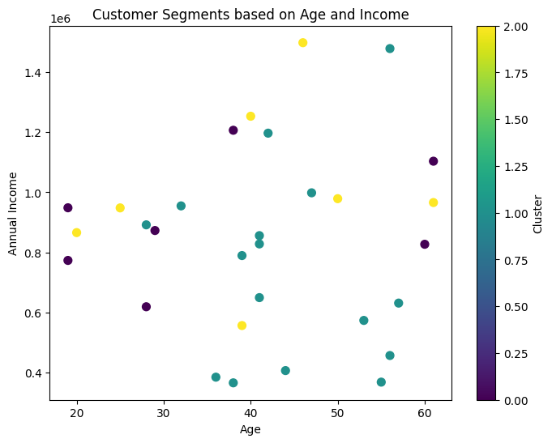
Now with customer names:
import pandas as pd
import numpy as np
import matplotlib.pyplot as plt
import seaborn as sns
from sklearn.cluster import KMeans
from sklearn.preprocessing import StandardScaler
# Step 1: Generate synthetic dataset for Flipkart customers (Only 30 customers)
np.random.seed(42)
customer_count = 30
# Sample Indian customer names
customer_names = [
"Aarav", "Vihaan", "Ishaan", "Kabir", "Aryan", "Anaya", "Myra", "Aadhya", "Siya", "Riya",
"Neha", "Rohan", "Ritik", "Sanya", "Harsh", "Tushar", "Soham", "Ira", "Vivaan", "Kavya",
"Yash", "Kunal", "Raj", "Tanvi", "Krishna", "Aditya", "Meera", "Dev", "Anjali", "Sakshi"
]
# Generating random customer data
age = np.random.randint(18, 65, customer_count)
annual_income = np.random.randint(300000, 1500000, customer_count)
purchase_frequency = np.random.randint(1, 20, customer_count)
avg_order_value = np.random.randint(500, 10000, customer_count)
preferred_category = np.random.choice(['Electronics', 'Fashion', 'HomeGoods', 'Groceries', 'Books'], customer_count)
discount_sensitivity = np.random.uniform(0.1, 1.0, customer_count)
# Create DataFrame
data = pd.DataFrame({
'CustomerID': range(1, customer_count + 1),
'Name': customer_names,
'Age': age,
'AnnualIncome': annual_income,
'PurchaseFrequency': purchase_frequency,
'AvgOrderValue': avg_order_value,
'PreferredCategory': preferred_category,
'DiscountSensitivity': discount_sensitivity
})
# Save the generated data to CSV
data.to_csv('flipkart_customers_30.csv', index=False)
print("Synthetic data saved to 'flipkart_customers_30.csv'.")
# Step 2: Preprocess the data (only numeric features for clustering)
numeric_data = data[['Age', 'AnnualIncome', 'PurchaseFrequency', 'AvgOrderValue', 'DiscountSensitivity']]
# Standardize the data
scaler = StandardScaler()
scaled_data = scaler.fit_transform(numeric_data)
# Step 3: Elbow Method to determine the optimal number of clusters (K)
wcss = []
for i in range(1, 11):
kmeans = KMeans(n_clusters=i, random_state=42, n_init=10)
kmeans.fit(scaled_data)
wcss.append(kmeans.inertia_)
# Plot the Elbow Method
plt.figure(figsize=(8, 6))
plt.plot(range(1, 11), wcss, marker='o', linestyle='--', color='b')
plt.title('Elbow Method for Optimal K (30 Customers)')
plt.xlabel('Number of Clusters')
plt.ylabel('WCSS (Inertia)')
plt.grid(True)
plt.show()
# Step 4: Apply K-Means with the selected number of clusters (K=3 or 4)
optimal_k = 3 # Adjust based on the elbow plot
kmeans = KMeans(n_clusters=optimal_k, random_state=42, n_init=10)
data['Cluster'] = kmeans.fit_predict(scaled_data)
# Step 5: Show the first few rows of the dataset with cluster labels
print("\nClustered Data:")
print(data)
# Step 6: Cluster insights (mean of numeric features within each cluster)
numeric_columns = ['Age', 'AnnualIncome', 'PurchaseFrequency', 'AvgOrderValue', 'DiscountSensitivity']
cluster_insights = data.groupby('Cluster')[numeric_columns].mean()
# Display the cluster insights
print("\nCluster Insights (Average Features per Cluster):")
print(cluster_insights)
# Save clustered data to CSV
data.to_csv('flipkart_clustered_customers_30.csv', index=False)
print("\nClustered data saved to 'flipkart_clustered_customers_30.csv'.")
# Step 7: Visualizing the Clusters (Age vs Annual Income)
plt.figure(figsize=(10, 6))
sns.scatterplot(
x=data['Age'], y=data['AnnualIncome'], hue=data['Cluster'], palette='viridis', s=100
)
# Mark centroids
centroids = scaler.inverse_transform(kmeans.cluster_centers_)
plt.scatter(centroids[:, 0], centroids[:, 1], marker='X', s=200, c='red', label='Centroids')
# Add customer names to points
for i in range(customer_count):
plt.text(data['Age'][i], data['AnnualIncome'][i], data['Name'][i], fontsize=9, ha='right')
plt.title('Customer Segments based on Age and Income')
plt.xlabel('Age')
plt.ylabel('Annual Income')
plt.legend()
plt.show()
Synthetic data saved to 'flipkart_customers_30.csv'.
Clustered Data:
CustomerID Name Age AnnualIncome PurchaseFrequency AvgOrderValue \
0 1 Aarav 56 456730 14 8506
1 2 Vihaan 46 1498079 17 3068
2 3 Ishaan 32 954811 4 5963
3 4 Kabir 60 827035 18 2527
4 5 Aryan 25 948143 8 3195
5 6 Anaya 38 365725 4 5758
6 7 Myra 56 1478557 2 6118
7 8 Aadhya 36 384654 6 7236
8 9 Siya 40 1253277 10 891
9 10 Riya 28 891723 4 6392
10 11 Neha 28 619030 18 4061
11 12 Rohan 41 855839 12 6684
12 13 Ritik 53 573538 2 3599
13 14 Sanya 57 631236 10 6778
14 15 Harsh 41 828178 4 8892
15 16 Tushar 20 865894 14 3604
16 17 Soham 39 789492 16 7715
17 18 Ira 19 773254 15 2954
18 19 Vivaan 41 649457 8 9496
19 20 Kavya 61 965987 14 3231
20 21 Yash 47 998361 8 8654
21 22 Kunal 55 368148 16 5556
22 23 Raj 19 948531 13 8610
23 24 Tanvi 38 1206606 18 4340
24 25 Krishna 50 978843 15 1528
25 26 Aditya 29 872843 13 7885
26 27 Meera 39 556508 9 1002
27 28 Dev 61 1103591 15 7410
28 29 Anjali 42 1196942 13 9562
29 30 Sakshi 44 406530 1 7438
PreferredCategory DiscountSensitivity Cluster
0 Electronics 0.391911 1
1 Fashion 0.209879 2
2 Fashion 0.420668 1
3 Groceries 0.916146 0
4 Books 0.344919 2
5 HomeGoods 0.682921 1
6 Electronics 0.100468 1
7 Groceries 0.417312 1
8 Books 0.374303 2
9 Groceries 0.248190 1
10 Books 0.580680 0
11 Books 0.536347 1
12 HomeGoods 0.723192 1
13 Books 0.342471 1
14 Groceries 0.319713 1
15 Books 0.251462 2
16 HomeGoods 0.296888 1
17 HomeGoods 0.602292 0
18 Groceries 0.463453 1
19 Fashion 0.158403 2
20 Fashion 0.328524 1
21 Books 0.322188 1
22 Electronics 0.726674 0
23 Books 0.741044 0
24 Groceries 0.233278 2
25 Groceries 0.997966 0
26 Groceries 0.340103 2
27 Groceries 0.978953 0
28 Groceries 0.469933 1
29 HomeGoods 0.129746 1
Cluster Insights (Average Features per Cluster):
Age AnnualIncome PurchaseFrequency AvgOrderValue \
Cluster
0 36.285714 9.072700e+05 15.714286 5398.142857
1 44.125000 7.393701e+05 7.750000 7146.687500
2 40.142857 1.009533e+06 12.428571 2359.857143
DiscountSensitivity
Cluster
0 0.791965
1 0.387120
2 0.273192
Clustered data saved to 'flipkart_clustered_customers_30.csv'.
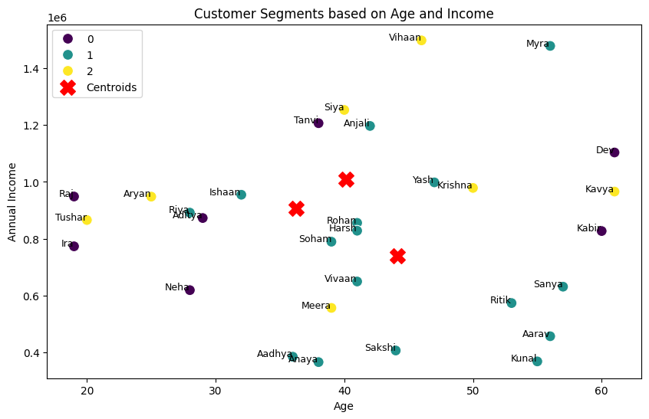
Centroid colors:
import pandas as pd
import numpy as np
import matplotlib.pyplot as plt
import seaborn as sns
from sklearn.cluster import KMeans
from sklearn.preprocessing import StandardScaler
# Step 1: Generate synthetic dataset for Flipkart customers (Only 30 customers)
np.random.seed(42)
customer_count = 30
# Sample Indian customer names
customer_names = [
"Aarav", "Vihaan", "Ishaan", "Kabir", "Aryan", "Anaya", "Myra", "Aadhya", "Siya", "Riya",
"Neha", "Rohan", "Ritik", "Sanya", "Harsh", "Tushar", "Soham", "Ira", "Vivaan", "Kavya",
"Yash", "Kunal", "Raj", "Tanvi", "Krishna", "Aditya", "Meera", "Dev", "Anjali", "Sakshi"
]
# Generating random customer data
age = np.random.randint(18, 65, customer_count)
annual_income = np.random.randint(300000, 1500000, customer_count)
purchase_frequency = np.random.randint(1, 20, customer_count)
avg_order_value = np.random.randint(500, 10000, customer_count)
preferred_category = np.random.choice(['Electronics', 'Fashion', 'HomeGoods', 'Groceries', 'Books'], customer_count)
discount_sensitivity = np.random.uniform(0.1, 1.0, customer_count)
# Create DataFrame
data = pd.DataFrame({
'CustomerID': range(1, customer_count + 1),
'Name': customer_names,
'Age': age,
'AnnualIncome': annual_income,
'PurchaseFrequency': purchase_frequency,
'AvgOrderValue': avg_order_value,
'PreferredCategory': preferred_category,
'DiscountSensitivity': discount_sensitivity
})
# Step 2: Preprocess the data (only numeric features for clustering)
numeric_data = data[['Age', 'AnnualIncome', 'PurchaseFrequency', 'AvgOrderValue', 'DiscountSensitivity']]
# Standardize the data
scaler = StandardScaler()
scaled_data = scaler.fit_transform(numeric_data)
# Step 3: Elbow Method to determine the optimal number of clusters (K)
wcss = []
for i in range(1, 11):
kmeans = KMeans(n_clusters=i, random_state=42, n_init=10)
kmeans.fit(scaled_data)
wcss.append(kmeans.inertia_)
# Plot the Elbow Method
plt.figure(figsize=(8, 6))
plt.plot(range(1, 11), wcss, marker='o', linestyle='--', color='b')
plt.title('Elbow Method for Optimal K (30 Customers)')
plt.xlabel('Number of Clusters')
plt.ylabel('WCSS (Inertia)')
plt.grid(True)
plt.show()
# Step 4: Apply K-Means with the selected number of clusters (K=3)
optimal_k = 3 # Adjust based on the elbow plot
kmeans = KMeans(n_clusters=optimal_k, random_state=42, n_init=10)
data['Cluster'] = kmeans.fit_predict(scaled_data)
# Step 5: Show the first few rows of the dataset with cluster labels
print("\nClustered Data:")
print(data)
# Step 6: Cluster insights (mean of numeric features within each cluster)
numeric_columns = ['Age', 'AnnualIncome', 'PurchaseFrequency', 'AvgOrderValue', 'DiscountSensitivity']
cluster_insights = data.groupby('Cluster')[numeric_columns].mean()
# Display the cluster insights
print("\nCluster Insights (Average Features per Cluster):")
print(cluster_insights)
# Step 7: Visualizing the Clusters (Age vs Annual Income)
plt.figure(figsize=(10, 6))
# Define distinct colors for clusters
cluster_colors = {0: 'red', 1: 'green', 2: 'orange'} # Red, Green, Yellow/Orange
# Scatter plot of customers
for cluster, color in cluster_colors.items():
cluster_data = data[data['Cluster'] == cluster]
plt.scatter(cluster_data['Age'], cluster_data['AnnualIncome'], color=color, s=100, label=f'Cluster {cluster}')
# Mark centroids with the SAME colors as their respective clusters
centroids = scaler.inverse_transform(kmeans.cluster_centers_)
for i, centroid in enumerate(centroids):
plt.scatter(centroid[0], centroid[1], marker='X', s=300, color=cluster_colors[i], edgecolors='black', linewidth=2, label=f'Centroid {i}')
# Add customer names to points
for i in range(customer_count):
plt.text(data['Age'][i], data['AnnualIncome'][i], data['Name'][i], fontsize=9, ha='right')
plt.title('Customer Segments based on Age and Income')
plt.xlabel('Age')
plt.ylabel('Annual Income')
plt.legend()
plt.show()
Clustered Data:
CustomerID Name Age AnnualIncome PurchaseFrequency AvgOrderValue \
0 1 Aarav 56 456730 14 8506
1 2 Vihaan 46 1498079 17 3068
2 3 Ishaan 32 954811 4 5963
3 4 Kabir 60 827035 18 2527
4 5 Aryan 25 948143 8 3195
5 6 Anaya 38 365725 4 5758
6 7 Myra 56 1478557 2 6118
7 8 Aadhya 36 384654 6 7236
8 9 Siya 40 1253277 10 891
9 10 Riya 28 891723 4 6392
10 11 Neha 28 619030 18 4061
11 12 Rohan 41 855839 12 6684
12 13 Ritik 53 573538 2 3599
13 14 Sanya 57 631236 10 6778
14 15 Harsh 41 828178 4 8892
15 16 Tushar 20 865894 14 3604
16 17 Soham 39 789492 16 7715
17 18 Ira 19 773254 15 2954
18 19 Vivaan 41 649457 8 9496
19 20 Kavya 61 965987 14 3231
20 21 Yash 47 998361 8 8654
21 22 Kunal 55 368148 16 5556
22 23 Raj 19 948531 13 8610
23 24 Tanvi 38 1206606 18 4340
24 25 Krishna 50 978843 15 1528
25 26 Aditya 29 872843 13 7885
26 27 Meera 39 556508 9 1002
27 28 Dev 61 1103591 15 7410
28 29 Anjali 42 1196942 13 9562
29 30 Sakshi 44 406530 1 7438
PreferredCategory DiscountSensitivity Cluster
0 Electronics 0.391911 1
1 Fashion 0.209879 2
2 Fashion 0.420668 1
3 Groceries 0.916146 0
4 Books 0.344919 2
5 HomeGoods 0.682921 1
6 Electronics 0.100468 1
7 Groceries 0.417312 1
8 Books 0.374303 2
9 Groceries 0.248190 1
10 Books 0.580680 0
11 Books 0.536347 1
12 HomeGoods 0.723192 1
13 Books 0.342471 1
14 Groceries 0.319713 1
15 Books 0.251462 2
16 HomeGoods 0.296888 1
17 HomeGoods 0.602292 0
18 Groceries 0.463453 1
19 Fashion 0.158403 2
20 Fashion 0.328524 1
21 Books 0.322188 1
22 Electronics 0.726674 0
23 Books 0.741044 0
24 Groceries 0.233278 2
25 Groceries 0.997966 0
26 Groceries 0.340103 2
27 Groceries 0.978953 0
28 Groceries 0.469933 1
29 HomeGoods 0.129746 1
Cluster Insights (Average Features per Cluster):
Age AnnualIncome PurchaseFrequency AvgOrderValue \
Cluster
0 36.285714 9.072700e+05 15.714286 5398.142857
1 44.125000 7.393701e+05 7.750000 7146.687500
2 40.142857 1.009533e+06 12.428571 2359.857143
DiscountSensitivity
Cluster
0 0.791965
1 0.387120
2 0.273192
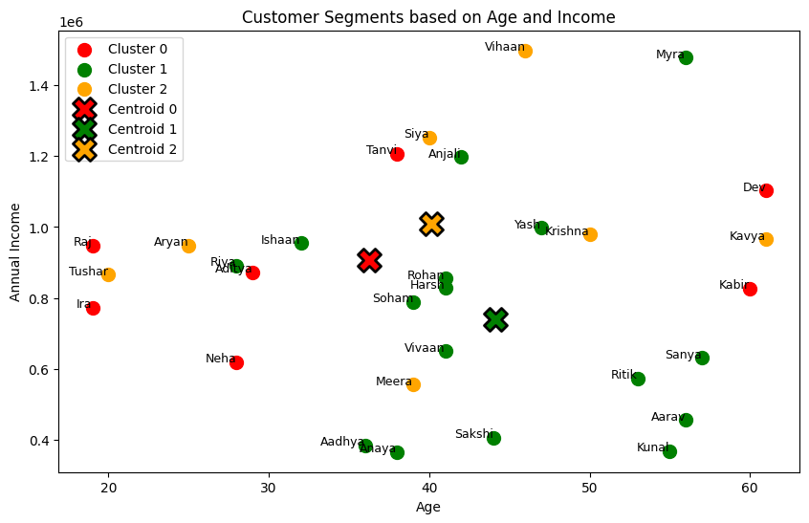
📊 Business Insights
1️⃣ Cluster 0 (🔴 Young Budget Shoppers) → Frequent buyers but low spending. Send them more discounts.
2️⃣ Cluster 1 (🟢 High-Value Buyers) → They buy less often but spend a lot. Recommend premium products.
3️⃣ Cluster 2 (🟠 Balanced Regular Customers) → Medium frequency & spending. Offer personalized deals.
Display Well -- Business Insights
import pandas as pd
import numpy as np
import matplotlib.pyplot as plt
import seaborn as sns
from sklearn.cluster import KMeans
from sklearn.preprocessing import StandardScaler
# Step 1: Generate synthetic dataset for Flipkart customers (Only 30 customers)
np.random.seed(42)
customer_count = 30
# Sample Indian customer names
customer_names = [
"Aarav", "Vihaan", "Ishaan", "Kabir", "Aryan", "Anaya", "Myra", "Aadhya", "Siya", "Riya",
"Neha", "Rohan", "Ritik", "Sanya", "Harsh", "Tushar", "Soham", "Ira", "Vivaan", "Kavya",
"Yash", "Kunal", "Raj", "Tanvi", "Krishna", "Aditya", "Meera", "Dev", "Anjali", "Sakshi"
]
# Generating random customer data
age = np.random.randint(18, 65, customer_count)
annual_income = np.random.randint(300000, 1500000, customer_count)
purchase_frequency = np.random.randint(1, 20, customer_count)
avg_order_value = np.random.randint(500, 10000, customer_count)
preferred_category = np.random.choice(['Electronics', 'Fashion', 'HomeGoods', 'Groceries', 'Books'], customer_count)
discount_sensitivity = np.random.uniform(0.1, 1.0, customer_count)
# Create DataFrame
data = pd.DataFrame({
'CustomerID': range(1, customer_count + 1),
'Name': customer_names,
'Age': age,
'AnnualIncome': annual_income,
'PurchaseFrequency': purchase_frequency,
'AvgOrderValue': avg_order_value,
'PreferredCategory': preferred_category,
'DiscountSensitivity': discount_sensitivity
})
# Step 2: Preprocess the data (only numeric features for clustering)
numeric_data = data[['Age', 'AnnualIncome', 'PurchaseFrequency', 'AvgOrderValue', 'DiscountSensitivity']]
# Standardize the data
scaler = StandardScaler()
scaled_data = scaler.fit_transform(numeric_data)
# Step 3: Elbow Method to determine the optimal number of clusters (K)
wcss = []
for i in range(1, 11):
kmeans = KMeans(n_clusters=i, random_state=42, n_init=10)
kmeans.fit(scaled_data)
wcss.append(kmeans.inertia_)
# Plot the Elbow Method
plt.figure(figsize=(8, 6))
plt.plot(range(1, 11), wcss, marker='o', linestyle='--', color='b')
plt.title('Elbow Method for Optimal K (30 Customers)')
plt.xlabel('Number of Clusters')
plt.ylabel('WCSS (Inertia)')
plt.grid(True)
plt.show()
# Step 4: Apply K-Means with the selected number of clusters (K=3)
optimal_k = 3 # Adjust based on the elbow plot
kmeans = KMeans(n_clusters=optimal_k, random_state=42, n_init=10)
data['Cluster'] = kmeans.fit_predict(scaled_data)
# Step 5: Show the first few rows of the dataset with cluster labels
print("\nClustered Data:")
print(data)
# Step 6: Cluster insights (mean of numeric features within each cluster)
numeric_columns = ['Age', 'AnnualIncome', 'PurchaseFrequency', 'AvgOrderValue', 'DiscountSensitivity']
cluster_insights = data.groupby('Cluster')[numeric_columns].mean()
# Display the cluster insights
print("\nCluster Insights (Average Features per Cluster):")
print(cluster_insights)
# Step 7: Define action points based on clusters
action_points = {
0: "💡 Offer premium membership & exclusive discounts!",
1: "📢 Recommend budget-friendly deals & coupons!",
2: "🎯 Promote high-value products with personalized ads!"
}
# Add action points based on cluster
data['ActionPoint'] = data['Cluster'].map(action_points)
# Step 8: Define cluster meanings based on characteristics
cluster_meanings = {
0: "Premium Customers - High income, frequent purchases",
1: "Budget-Conscious - Moderate income, low purchase frequency",
2: "High-Spenders - High order values, willing to spend on quality"
}
# Add cluster meanings based on cluster
data['ClusterMeaning'] = data['Cluster'].map(cluster_meanings)
# Step 9: Display the data with cluster, action point, and cluster meaning
print("\nCustomer Segmentation with Action Points and Cluster Meaning:")
print(data[['Name', 'Cluster', 'ClusterMeaning', 'ActionPoint']].to_string(index=False))
# Step 10: Visualizing the Clusters (Age vs Annual Income)
plt.figure(figsize=(10, 6))
# Define distinct colors for clusters
cluster_colors = {0: 'red', 1: 'green', 2: 'orange'} # Red, Green, Yellow/Orange
# Scatter plot of customers
for cluster, color in cluster_colors.items():
cluster_data = data[data['Cluster'] == cluster]
plt.scatter(cluster_data['Age'], cluster_data['AnnualIncome'], color=color, s=100, label=f'Cluster {cluster}')
# Mark centroids with the SAME colors as their respective clusters
centroids = scaler.inverse_transform(kmeans.cluster_centers_)
for i, centroid in enumerate(centroids):
plt.scatter(centroid[0], centroid[1], marker='X', s=300, color=cluster_colors[i], edgecolors='black', linewidth=2, label=f'Centroid {i}')
# Add customer names to points
for i in range(customer_count):
plt.text(data['Age'][i], data['AnnualIncome'][i], data['Name'][i], fontsize=9, ha='right')
plt.title('Customer Segments based on Age and Income')
plt.xlabel('Age')
plt.ylabel('Annual Income')
plt.legend()
plt.show()
Clustered Data:
CustomerID Name Age AnnualIncome PurchaseFrequency AvgOrderValue \
0 1 Aarav 56 456730 14 8506
1 2 Vihaan 46 1498079 17 3068
2 3 Ishaan 32 954811 4 5963
3 4 Kabir 60 827035 18 2527
4 5 Aryan 25 948143 8 3195
5 6 Anaya 38 365725 4 5758
6 7 Myra 56 1478557 2 6118
7 8 Aadhya 36 384654 6 7236
8 9 Siya 40 1253277 10 891
9 10 Riya 28 891723 4 6392
10 11 Neha 28 619030 18 4061
11 12 Rohan 41 855839 12 6684
12 13 Ritik 53 573538 2 3599
13 14 Sanya 57 631236 10 6778
14 15 Harsh 41 828178 4 8892
15 16 Tushar 20 865894 14 3604
16 17 Soham 39 789492 16 7715
17 18 Ira 19 773254 15 2954
18 19 Vivaan 41 649457 8 9496
19 20 Kavya 61 965987 14 3231
20 21 Yash 47 998361 8 8654
21 22 Kunal 55 368148 16 5556
22 23 Raj 19 948531 13 8610
23 24 Tanvi 38 1206606 18 4340
24 25 Krishna 50 978843 15 1528
25 26 Aditya 29 872843 13 7885
26 27 Meera 39 556508 9 1002
27 28 Dev 61 1103591 15 7410
28 29 Anjali 42 1196942 13 9562
29 30 Sakshi 44 406530 1 7438
PreferredCategory DiscountSensitivity Cluster
0 Electronics 0.391911 1
1 Fashion 0.209879 2
2 Fashion 0.420668 1
3 Groceries 0.916146 0
4 Books 0.344919 2
5 HomeGoods 0.682921 1
6 Electronics 0.100468 1
7 Groceries 0.417312 1
8 Books 0.374303 2
9 Groceries 0.248190 1
10 Books 0.580680 0
11 Books 0.536347 1
12 HomeGoods 0.723192 1
13 Books 0.342471 1
14 Groceries 0.319713 1
15 Books 0.251462 2
16 HomeGoods 0.296888 1
17 HomeGoods 0.602292 0
18 Groceries 0.463453 1
19 Fashion 0.158403 2
20 Fashion 0.328524 1
21 Books 0.322188 1
22 Electronics 0.726674 0
23 Books 0.741044 0
24 Groceries 0.233278 2
25 Groceries 0.997966 0
26 Groceries 0.340103 2
27 Groceries 0.978953 0
28 Groceries 0.469933 1
29 HomeGoods 0.129746 1
Cluster Insights (Average Features per Cluster):
Age AnnualIncome PurchaseFrequency AvgOrderValue \
Cluster
0 36.285714 9.072700e+05 15.714286 5398.142857
1 44.125000 7.393701e+05 7.750000 7146.687500
2 40.142857 1.009533e+06 12.428571 2359.857143
DiscountSensitivity
Cluster
0 0.791965
1 0.387120
2 0.273192
Customer Segmentation with Action Points and Cluster Meaning:
Name Cluster ClusterMeaning ActionPoint
Aarav 1 Budget-Conscious - Moderate income, low purchase frequency 📢 Recommend budget-friendly deals & coupons!
Vihaan 2 High-Spenders - High order values, willing to spend on quality 🎯 Promote high-value products with personalized ads!
Ishaan 1 Budget-Conscious - Moderate income, low purchase frequency 📢 Recommend budget-friendly deals & coupons!
Kabir 0 Premium Customers - High income, frequent purchases 💡 Offer premium membership & exclusive discounts!
Aryan 2 High-Spenders - High order values, willing to spend on quality 🎯 Promote high-value products with personalized ads!
Anaya 1 Budget-Conscious - Moderate income, low purchase frequency 📢 Recommend budget-friendly deals & coupons!
Myra 1 Budget-Conscious - Moderate income, low purchase frequency 📢 Recommend budget-friendly deals & coupons!
Aadhya 1 Budget-Conscious - Moderate income, low purchase frequency 📢 Recommend budget-friendly deals & coupons!
Siya 2 High-Spenders - High order values, willing to spend on quality 🎯 Promote high-value products with personalized ads!
Riya 1 Budget-Conscious - Moderate income, low purchase frequency 📢 Recommend budget-friendly deals & coupons!
Neha 0 Premium Customers - High income, frequent purchases 💡 Offer premium membership & exclusive discounts!
Rohan 1 Budget-Conscious - Moderate income, low purchase frequency 📢 Recommend budget-friendly deals & coupons!
Ritik 1 Budget-Conscious - Moderate income, low purchase frequency 📢 Recommend budget-friendly deals & coupons!
Sanya 1 Budget-Conscious - Moderate income, low purchase frequency 📢 Recommend budget-friendly deals & coupons!
Harsh 1 Budget-Conscious - Moderate income, low purchase frequency 📢 Recommend budget-friendly deals & coupons!
Tushar 2 High-Spenders - High order values, willing to spend on quality 🎯 Promote high-value products with personalized ads!
Soham 1 Budget-Conscious - Moderate income, low purchase frequency 📢 Recommend budget-friendly deals & coupons!
Ira 0 Premium Customers - High income, frequent purchases 💡 Offer premium membership & exclusive discounts!
Vivaan 1 Budget-Conscious - Moderate income, low purchase frequency 📢 Recommend budget-friendly deals & coupons!
Kavya 2 High-Spenders - High order values, willing to spend on quality 🎯 Promote high-value products with personalized ads!
Yash 1 Budget-Conscious - Moderate income, low purchase frequency 📢 Recommend budget-friendly deals & coupons!
Kunal 1 Budget-Conscious - Moderate income, low purchase frequency 📢 Recommend budget-friendly deals & coupons!
Raj 0 Premium Customers - High income, frequent purchases 💡 Offer premium membership & exclusive discounts!
Tanvi 0 Premium Customers - High income, frequent purchases 💡 Offer premium membership & exclusive discounts!
Krishna 2 High-Spenders - High order values, willing to spend on quality 🎯 Promote high-value products with personalized ads!
Aditya 0 Premium Customers - High income, frequent purchases 💡 Offer premium membership & exclusive discounts!
Meera 2 High-Spenders - High order values, willing to spend on quality 🎯 Promote high-value products with personalized ads!
Dev 0 Premium Customers - High income, frequent purchases 💡 Offer premium membership & exclusive discounts!
Anjali 1 Budget-Conscious - Moderate income, low purchase frequency 📢 Recommend budget-friendly deals & coupons!
Sakshi 1 Budget-Conscious - Moderate income, low purchase frequency 📢 Recommend budget-friendly deals & coupons!
Expected Output:
1. Clustered Data:
After clustering, each customer will have a Cluster, Cluster Meaning, and Action Point associated with their data.
2. Cluster Insights:
Displays the mean values of the customer characteristics within each cluster.
3. Visualization:
Scatter plot of the clusters, showing how customers are distributed based on their Age and Annual Income, with centroid markers.
Intertia:
Centroid:
import numpy as np
import matplotlib.pyplot as plt
from sklearn.cluster import KMeans
#Reference:
#https://scikit-learn.org/stable/modules/clustering.html#k-means
# Sample Data (2D Points)
data = np.array([[2, 3], [3, 4], [5, 6], [8, 8], [9, 9]])
# Applying K-Means with K=2
kmeans = KMeans(n_clusters=2, random_state=42, n_init=10)
kmeans.fit(data)
# Get Cluster Labels and Centroids
labels = kmeans.labels_
centroids = kmeans.cluster_centers_
# Plot Data Points with Cluster Colors
plt.figure(figsize=(6, 5))
for i in range(len(data)):
plt.scatter(data[i, 0], data[i, 1], c=['blue', 'green'][labels[i]], s=100, edgecolors='black')
# Plot Centroids
plt.scatter(centroids[:, 0], centroids[:, 1], c='red', marker='X', s=200, label='Centroids')
# Labels and Legend
plt.xlabel("Feature 1")
plt.ylabel("Feature 2")
plt.title("K-Means Clustering with Centroids")
plt.legend()
plt.grid()
# Show Plot
plt.show()
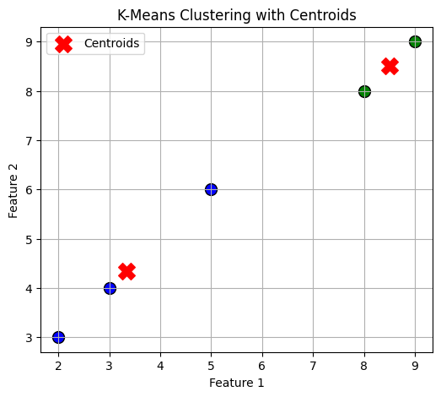
Data Points:
(2, 3), (3, 4), (5, 6)
Centroid Calculation:
Centroid = (2+3+5)/3, (3+4+6)/3 = 10/3, 13/3 = (3.33, 4.33)
import numpy as np
import matplotlib.pyplot as plt
from sklearn.cluster import KMeans
# Sample Data (2D Points)
data = np.array([[2, 3], [3, 4], [5, 6]])
# Applying K-Means with K=1 (Only One Cluster)
kmeans = KMeans(n_clusters=1, random_state=42, n_init=10)
kmeans.fit(data)
# Get Cluster Labels and Centroids
centroid = kmeans.cluster_centers_
# Plot Data Points
plt.figure(figsize=(6, 5))
plt.scatter(data[:, 0], data[:, 1], c='blue', s=100, edgecolors='black', label='Data Points')
# Annotate Data Points with Coordinates
for x, y in data:
plt.text(x + 0.1, y, f"({x}, {y})", fontsize=12, verticalalignment='bottom', color='black')
# Plot Centroid
plt.scatter(centroid[:, 0], centroid[:, 1], c='red', marker='X', s=200, label='Centroid')
# Annotate Centroid with Coordinates
plt.text(centroid[0, 0] + 0.1, centroid[0, 1], f"({centroid[0, 0]:.2f}, {centroid[0, 1]:.2f})",
fontsize=12, verticalalignment='bottom', color='red', fontweight='bold')
# Labels and Legend
plt.xlabel("Feature 1")
plt.ylabel("Feature 2")
plt.title("K-Means Clustering with 1 Cluster (Coordinates Displayed)")
plt.legend()
plt.grid()
# Show Plot
plt.show()
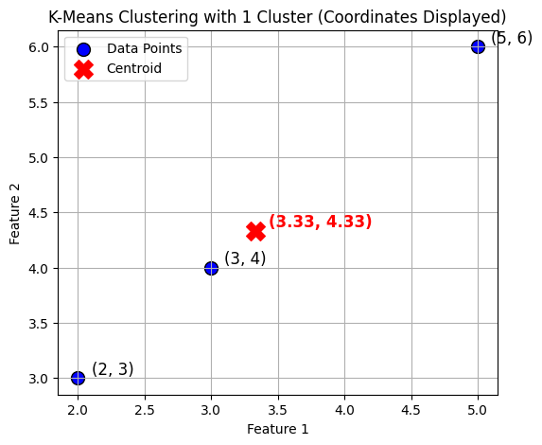
import numpy as np
# Sample Data
data = np.array([[2, 3], [3, 4], [5, 6]])
# Centroid Calculation (Mean of all points)
centroid = np.mean(data, axis=0)
# Compute Sum of Squared Distances (SSD)
ssd = np.sum(np.linalg.norm(data - centroid, axis=1) ** 2)
print("Manually Computed Inertia (SSD):", ssd)
Manually Computed Inertia (SSD): 9.333333333333334
import numpy as np
# Sample Data
data = np.array([[2, 3], [3, 4], [5, 6]])
# Step 1: Calculate Centroid
centroid = np.mean(data, axis=0)
print(f"Centroid: ({centroid[0]:.2f}, {centroid[1]:.2f})\n")
# Step 2: Compute Squared Euclidean Distance for Each Point
ssd = 0 # Initialize Sum of Squared Distances
for i, point in enumerate(data):
distance = np.linalg.norm(point - centroid) # Euclidean Distance
squared_distance = distance ** 2 # Squared Distance
ssd += squared_distance # Add to Sum of Squared Distances
print(f"Point {i+1}: {point}, Distance to Centroid: {distance:.4f}, Squared Distance: {squared_distance:.4f}")
# Step 3: Display Total Inertia
print(f"\nTotal Inertia (Sum of Squared Distances - SSD): {ssd:.4f}")
Centroid: (3.33, 4.33)
Point 1: [2 3], Distance to Centroid: 1.8856, Squared Distance: 3.5556
Point 2: [3 4], Distance to Centroid: 0.4714, Squared Distance: 0.2222
Point 3: [5 6], Distance to Centroid: 2.3570, Squared Distance: 5.5556
Total Inertia (Sum of Squared Distances - SSD): 9.3333
Homework-1:
1) Generate 10 data points - calculate Euclidian distance for each set of 10 examples.
2) Find the centroid and inertia for each
3) Report C-WA - 9346000855

# Generate 20 random 2D points for a more practical example
np.random.seed(42)
data = np.random.randint(1, 100, (20, 2))
# Applying K-Means with K=3 (3 clusters for better visualization)
kmeans = KMeans(n_clusters=3, random_state=42, n_init=10)
kmeans.fit(data)
# Get Cluster Labels and Centroids
labels = kmeans.labels_
centroids = kmeans.cluster_centers_
# Plot Data Points with Cluster Colors
plt.figure(figsize=(7, 6))
colors = ['blue', 'green', 'purple']
for i in range(len(data)):
plt.scatter(data[i, 0], data[i, 1], c=colors[labels[i]], s=100, edgecolors='black')
# Plot Centroids
plt.scatter(centroids[:, 0], centroids[:, 1], c='red', marker='X', s=200, label='Centroids')
# Labels and Legend
plt.xlabel("Feature 1")
plt.ylabel("Feature 2")
plt.title("K-Means Clustering with 20 Points")
plt.legend()
plt.grid()
# Show Plot
plt.show()
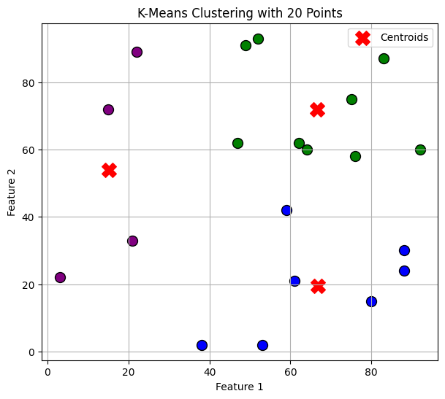
# Generate 100 random 2D points for a more realistic clustering example
np.random.seed(42)
data = np.random.randint(1, 100, (100, 2))
# Applying K-Means with K=4 (4 clusters for better separation)
kmeans = KMeans(n_clusters=4, random_state=42, n_init=10)
kmeans.fit(data)
# Get Cluster Labels and Centroids
labels = kmeans.labels_
centroids = kmeans.cluster_centers_
# Plot Data Points with Cluster Colors
plt.figure(figsize=(8, 7))
colors = ['blue', 'green', 'purple', 'orange']
for i in range(len(data)):
plt.scatter(data[i, 0], data[i, 1], c=colors[labels[i]], s=60, edgecolors='black')
# Plot Centroids
plt.scatter(centroids[:, 0], centroids[:, 1], c='red', marker='X', s=250, label='Centroids')
# Labels and Legend
plt.xlabel("Feature 1")
plt.ylabel("Feature 2")
plt.title("K-Means Clustering with 100 Data Points")
plt.legend()
plt.grid()
# Show Plot
plt.show()
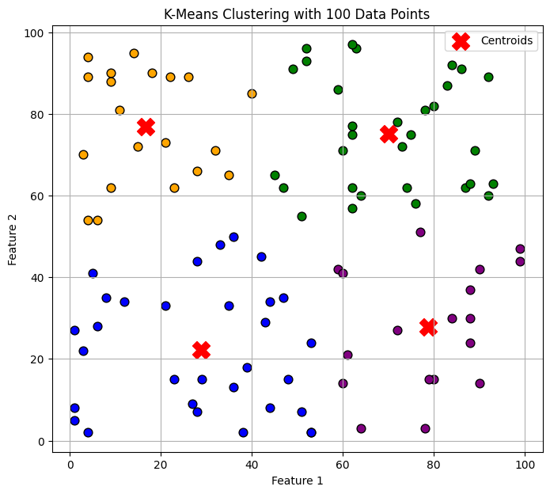
# Generate 1000 random 2D points for a large-scale clustering example
np.random.seed(42)
data = np.random.randint(1, 100, (1000, 2))
# Applying K-Means with K=5 (5 clusters for better separation)
kmeans = KMeans(n_clusters=5, random_state=42, n_init=10)
kmeans.fit(data)
# Get Cluster Labels and Centroids
labels = kmeans.labels_
centroids = kmeans.cluster_centers_
# Plot Data Points with Cluster Colors
plt.figure(figsize=(9, 8))
colors = ['blue', 'green', 'purple', 'orange', 'cyan']
for i in range(len(data)):
plt.scatter(data[i, 0], data[i, 1], c=colors[labels[i]], s=20, edgecolors='black')
# Plot Centroids
plt.scatter(centroids[:, 0], centroids[:, 1], c='red', marker='X', s=300, label='Centroids')
# Labels and Legend
plt.xlabel("Feature 1")
plt.ylabel("Feature 2")
plt.title("K-Means Clustering with 1000 Data Points")
plt.legend()
plt.grid()
# Show Plot
plt.show()
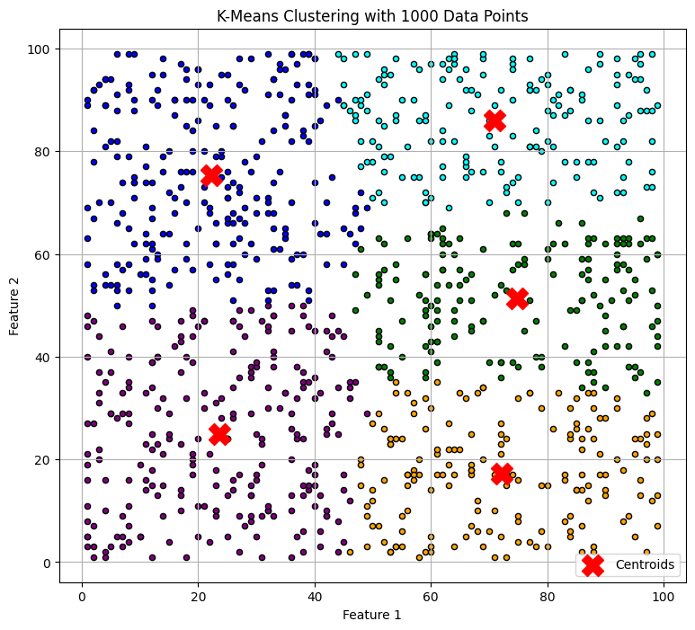
# Generate 10,000 random 2D points for a large-scale clustering example
np.random.seed(42)
data = np.random.randint(1, 100, (10000, 2))
# Applying K-Means with K=6 (6 clusters for better separation)
kmeans = KMeans(n_clusters=6, random_state=42, n_init=10)
kmeans.fit(data)
# Get Cluster Labels and Centroids
labels = kmeans.labels_
centroids = kmeans.cluster_centers_
# Plot Data Points with Cluster Colors
plt.figure(figsize=(10, 9))
colors = ['blue', 'green', 'purple', 'orange', 'cyan', 'magenta']
for i in range(len(data)):
plt.scatter(data[i, 0], data[i, 1], c=colors[labels[i]], s=10, edgecolors='black')
# Plot Centroids
plt.scatter(centroids[:, 0], centroids[:, 1], c='red', marker='X', s=400, label='Centroids')
# Labels and Legend
plt.xlabel("Feature 1")
plt.ylabel("Feature 2")
plt.title("K-Means Clustering with 10,000 Data Points")
plt.legend()
plt.grid()
# Show Plot
plt.show()
