Intertia:
Centroid:
import numpy as np
import matplotlib.pyplot as plt
from sklearn.cluster import KMeans
#Reference:
#https://scikit-learn.org/stable/modules/clustering.html#k-means
# Sample Data (2D Points)
data = np.array([[2, 3], [3, 4], [5, 6], [8, 8], [9, 9]])
# Applying K-Means with K=2
kmeans = KMeans(n_clusters=2, random_state=42, n_init=10)
kmeans.fit(data)
# Get Cluster Labels and Centroids
labels = kmeans.labels_
centroids = kmeans.cluster_centers_
# Plot Data Points with Cluster Colors
plt.figure(figsize=(6, 5))
for i in range(len(data)):
plt.scatter(data[i, 0], data[i, 1], c=['blue', 'green'][labels[i]], s=100, edgecolors='black')
# Plot Centroids
plt.scatter(centroids[:, 0], centroids[:, 1], c='red', marker='X', s=200, label='Centroids')
# Labels and Legend
plt.xlabel("Feature 1")
plt.ylabel("Feature 2")
plt.title("K-Means Clustering with Centroids")
plt.legend()
plt.grid()
# Show Plot
plt.show()
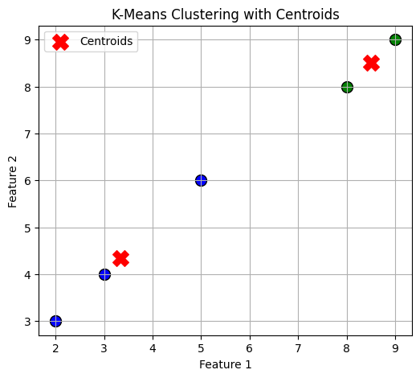
Data Points:
(2, 3), (3, 4), (5, 6)
Centroid Calculation:
Centroid = (2+3+5)/3, (3+4+6)/3 = 10/3, 13/3 = (3.33, 4.33)
import numpy as np
import matplotlib.pyplot as plt
from sklearn.cluster import KMeans
# Sample Data (2D Points)
data = np.array([[2, 3], [3, 4], [5, 6]])
# Applying K-Means with K=1 (Only One Cluster)
kmeans = KMeans(n_clusters=1, random_state=42, n_init=10)
kmeans.fit(data)
# Get Cluster Labels and Centroids
centroid = kmeans.cluster_centers_
# Plot Data Points
plt.figure(figsize=(6, 5))
plt.scatter(data[:, 0], data[:, 1], c='blue', s=100, edgecolors='black', label='Data Points')
# Annotate Data Points with Coordinates
for x, y in data:
plt.text(x + 0.1, y, f"({x}, {y})", fontsize=12, verticalalignment='bottom', color='black')
# Plot Centroid
plt.scatter(centroid[:, 0], centroid[:, 1], c='red', marker='X', s=200, label='Centroid')
# Annotate Centroid with Coordinates
plt.text(centroid[0, 0] + 0.1, centroid[0, 1], f"({centroid[0, 0]:.2f}, {centroid[0, 1]:.2f})",
fontsize=12, verticalalignment='bottom', color='red', fontweight='bold')
# Labels and Legend
plt.xlabel("Feature 1")
plt.ylabel("Feature 2")
plt.title("K-Means Clustering with 1 Cluster (Coordinates Displayed)")
plt.legend()
plt.grid()
# Show Plot
plt.show()
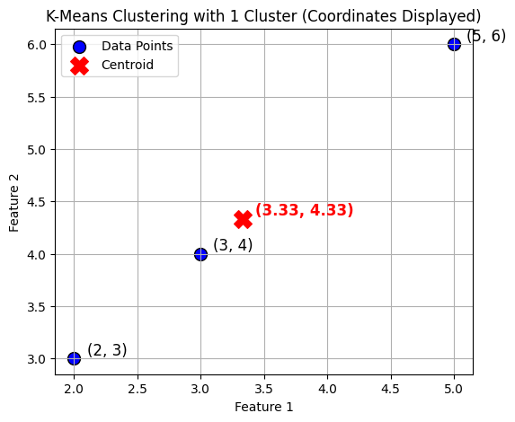
import numpy as np
# Sample Data
data = np.array([[2, 3], [3, 4], [5, 6]])
# Centroid Calculation (Mean of all points)
centroid = np.mean(data, axis=0)
# Compute Sum of Squared Distances (SSD)
ssd = np.sum(np.linalg.norm(data - centroid, axis=1) ** 2)
print("Manually Computed Inertia (SSD):", ssd)
Manually Computed Inertia (SSD): 9.333333333333334
import numpy as np
# Sample Data
data = np.array([[2, 3], [3, 4], [5, 6]])
# Step 1: Calculate Centroid
centroid = np.mean(data, axis=0)
print(f"Centroid: ({centroid[0]:.2f}, {centroid[1]:.2f})\n")
# Step 2: Compute Squared Euclidean Distance for Each Point
ssd = 0 # Initialize Sum of Squared Distances
for i, point in enumerate(data):
distance = np.linalg.norm(point - centroid) # Euclidean Distance
squared_distance = distance ** 2 # Squared Distance
ssd += squared_distance # Add to Sum of Squared Distances
print(f"Point {i+1}: {point}, Distance to Centroid: {distance:.4f}, Squared Distance: {squared_distance:.4f}")
# Step 3: Display Total Inertia
print(f"\nTotal Inertia (Sum of Squared Distances - SSD): {ssd:.4f}")
Centroid: (3.33, 4.33)
Point 1: [2 3], Distance to Centroid: 1.8856, Squared Distance: 3.5556
Point 2: [3 4], Distance to Centroid: 0.4714, Squared Distance: 0.2222
Point 3: [5 6], Distance to Centroid: 2.3570, Squared Distance: 5.5556
Total Inertia (Sum of Squared Distances - SSD): 9.3333
02.04.2025 Wednesday - Homework-1:
1) Generate 10 data points - calculate Euclidian distance for each set of 10 examples.
2) Find the centroid and inertia for each
3) Report C-WA - 9346000855

# Generate 20 random 2D points for a more practical example
np.random.seed(42)
data = np.random.randint(1, 100, (20, 2))
# Applying K-Means with K=3 (3 clusters for better visualization)
kmeans = KMeans(n_clusters=3, random_state=42, n_init=10)
kmeans.fit(data)
# Get Cluster Labels and Centroids
labels = kmeans.labels_
centroids = kmeans.cluster_centers_
# Plot Data Points with Cluster Colors
plt.figure(figsize=(7, 6))
colors = ['blue', 'green', 'purple']
for i in range(len(data)):
plt.scatter(data[i, 0], data[i, 1], c=colors[labels[i]], s=100, edgecolors='black')
# Plot Centroids
plt.scatter(centroids[:, 0], centroids[:, 1], c='red', marker='X', s=200, label='Centroids')
# Labels and Legend
plt.xlabel("Feature 1")
plt.ylabel("Feature 2")
plt.title("K-Means Clustering with 20 Points")
plt.legend()
plt.grid()
# Show Plot
plt.show()
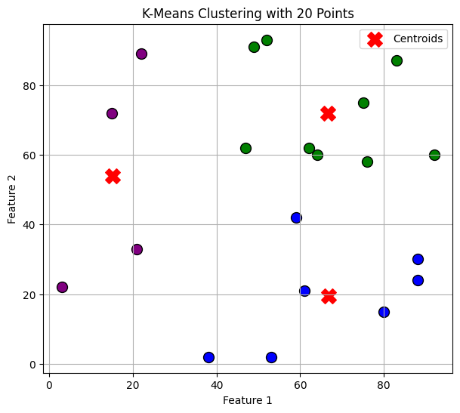
# Generate 100 random 2D points for a more realistic clustering example
np.random.seed(42)
data = np.random.randint(1, 100, (100, 2))
# Applying K-Means with K=4 (4 clusters for better separation)
kmeans = KMeans(n_clusters=4, random_state=42, n_init=10)
kmeans.fit(data)
# Get Cluster Labels and Centroids
labels = kmeans.labels_
centroids = kmeans.cluster_centers_
# Plot Data Points with Cluster Colors
plt.figure(figsize=(8, 7))
colors = ['blue', 'green', 'purple', 'orange']
for i in range(len(data)):
plt.scatter(data[i, 0], data[i, 1], c=colors[labels[i]], s=60, edgecolors='black')
# Plot Centroids
plt.scatter(centroids[:, 0], centroids[:, 1], c='red', marker='X', s=250, label='Centroids')
# Labels and Legend
plt.xlabel("Feature 1")
plt.ylabel("Feature 2")
plt.title("K-Means Clustering with 100 Data Points")
plt.legend()
plt.grid()
# Show Plot
plt.show()
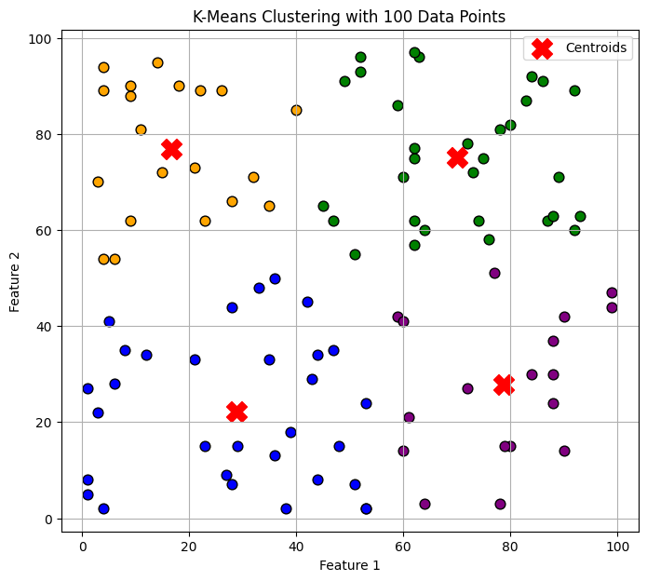
# Generate 1000 random 2D points for a large-scale clustering example
np.random.seed(42)
data = np.random.randint(1, 100, (1000, 2))
# Applying K-Means with K=5 (5 clusters for better separation)
kmeans = KMeans(n_clusters=5, random_state=42, n_init=10)
kmeans.fit(data)
# Get Cluster Labels and Centroids
labels = kmeans.labels_
centroids = kmeans.cluster_centers_
# Plot Data Points with Cluster Colors
plt.figure(figsize=(9, 8))
colors = ['blue', 'green', 'purple', 'orange', 'cyan']
for i in range(len(data)):
plt.scatter(data[i, 0], data[i, 1], c=colors[labels[i]], s=20, edgecolors='black')
# Plot Centroids
plt.scatter(centroids[:, 0], centroids[:, 1], c='red', marker='X', s=300, label='Centroids')
# Labels and Legend
plt.xlabel("Feature 1")
plt.ylabel("Feature 2")
plt.title("K-Means Clustering with 1000 Data Points")
plt.legend()
plt.grid()
# Show Plot
plt.show()
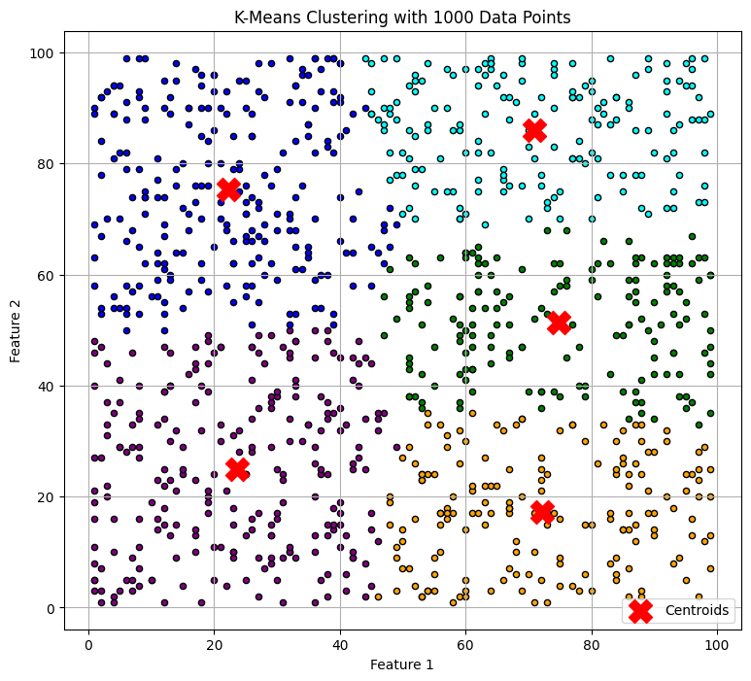
# Generate 10,000 random 2D points for a large-scale clustering example
np.random.seed(42)
data = np.random.randint(1, 100, (10000, 2))
# Applying K-Means with K=6 (6 clusters for better separation)
kmeans = KMeans(n_clusters=6, random_state=42, n_init=10)
kmeans.fit(data)
# Get Cluster Labels and Centroids
labels = kmeans.labels_
centroids = kmeans.cluster_centers_
# Plot Data Points with Cluster Colors
plt.figure(figsize=(10, 9))
colors = ['blue', 'green', 'purple', 'orange', 'cyan', 'magenta']
for i in range(len(data)):
plt.scatter(data[i, 0], data[i, 1], c=colors[labels[i]], s=10, edgecolors='black')
# Plot Centroids
plt.scatter(centroids[:, 0], centroids[:, 1], c='red', marker='X', s=400, label='Centroids')
# Labels and Legend
plt.xlabel("Feature 1")
plt.ylabel("Feature 2")
plt.title("K-Means Clustering with 10,000 Data Points")
plt.legend()
plt.grid()
# Show Plot
plt.show()
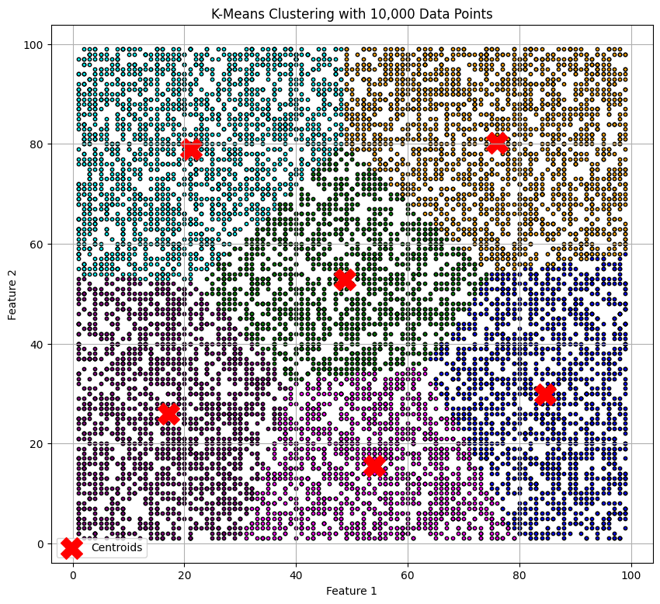
03.04.2025 Thursday
Flipkart Customers - Segmentation
Method: Clustering - K Means
1. Importing Libraries
import numpy as np
import pandas as pd
import matplotlib.pyplot as plt
from sklearn.cluster import KMeans
2. Generate Customer Data
customers = [ "Aarav", "Vihaan", "Kabir", "Aryan", "Reyansh", "Aditi", "Ishita", "Kiara", "Meera", "Saanvi",
"Ananya", "Rohan", "Neha", "Dev", "Tanvi", "Krishna", "Riya", "Siddharth", "Pooja", "Aakash"]
df = pd.DataFrame(
{
"Customer Name": customers,
"Age": np.random.randint(18, 65, 20),
"Annual Income (₹ L)": np.random.randint(3, 50, 20),
"Spending Score (1-100)": np.random.randint(1, 101, 20)
}
)
df
{"summary":"{\n \"name\": \"df\",\n \"rows\": 20,\n \"fields\": [\n {\n \"column\": \"Customer Name\",\n \"properties\": {\n \"dtype\": \"string\",\n \"num_unique_values\": 20,\n \"samples\": [\n \"Aarav\",\n \"Siddharth\",\n \"Krishna\"\n ],\n \"semantic_type\": \"\",\n \"description\": \"\"\n }\n },\n {\n \"column\": \"Age\",\n \"properties\": {\n \"dtype\": \"number\",\n \"std\": 12,\n \"min\": 19,\n \"max\": 62,\n \"num_unique_values\": 19,\n \"samples\": [\n 39,\n 49,\n 33\n ],\n \"semantic_type\": \"\",\n \"description\": \"\"\n }\n },\n {\n \"column\": \"Annual Income (\\u20b9 L)\",\n \"properties\": {\n \"dtype\": \"number\",\n \"std\": 12,\n \"min\": 3,\n \"max\": 49,\n \"num_unique_values\": 19,\n \"samples\": [\n 43,\n 8,\n 20\n ],\n \"semantic_type\": \"\",\n \"description\": \"\"\n }\n },\n {\n \"column\": \"Spending Score (1-100)\",\n \"properties\": {\n \"dtype\": \"number\",\n \"std\": 30,\n \"min\": 2,\n \"max\": 96,\n \"num_unique_values\": 17,\n \"samples\": [\n 8,\n 42,\n 22\n ],\n \"semantic_type\": \"\",\n \"description\": \"\"\n }\n }\n ]\n}","type":"dataframe","variable_name":"df"}
3. Select Features for Clustering
X = df[["Annual Income (₹ L)", "Spending Score (1-100)"]]
X
4. Plot - Elbow Method
WCSS (Intertia) vs K (1 to 10)
#Compute WCSS (Within-Cluster Sum of Squares) for k=1 to k=10
wcss = []
for k in range(1, 11): #1, 2, 3, ....10
kmeans = KMeans(n_clusters = k, random_state = 42)
kmeans.fit(X)
wcss.append(kmeans.inertia_)
print("For", k, ":", wcss)
For 1 : [21121.75]
For 2 : [21121.75, 6395.07142857143]
For 3 : [21121.75, 6395.07142857143, 4203.055555555555]
For 4 : [21121.75, 6395.07142857143, 4203.055555555555, 2607.5]
For 5 : [21121.75, 6395.07142857143, 4203.055555555555, 2607.5, 1567.0]
For 6 : [21121.75, 6395.07142857143, 4203.055555555555, 2607.5, 1567.0, 1185.75]
For 7 : [21121.75, 6395.07142857143, 4203.055555555555, 2607.5, 1567.0, 1185.75, 754.8000000000001]
Purpose: wcss (Within-Cluster Sum of Squares) will store the sum of squared distances from each point to the centroid of its assigned cluster.
Why?: This helps us determine the optimal number of clusters (k) using the Elbow Method.

Purpose: Loop through k values from 1 to 10.
Why?: We test different cluster sizes to see how WCSS changes.

n_clusters=k → Specifies the number of clusters.
random_state=42 → Ensures reproducibility (same results every time).
n_init=10 → Runs K-Means 10 times with different centroid seeds and picks the best solution (default behavior in older versions of Scikit-learn).

Plot WCSS vs K
plt.figure(figsize=(8, 5))
plt.plot(range(1, 11), wcss, marker = 'o', linestyle = '--', color = 'b')
plt.xlabel('Number of Clusters (k)')
plt.ylabel('WCSS (Inertia)')
plt.title('Elbow Method for Optimal K')
plt.grid(True)
plt.show()
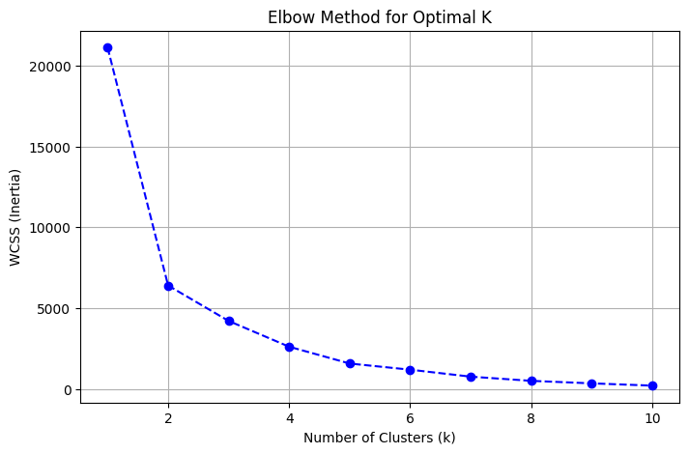
04.04.2025 Friday
- Short session - 11 am or so 1 hr...
- To be covered: After dividing cluster --- identify customers to cluster1.
- Q&A: WCSS and cluster
- Session - Objective:
Ploting X & Y for 10000 data points (customers 1, 2, 3, ........... --- belong to some features for each):
import numpy as np
import pandas as pd
import matplotlib.pyplot as plt
# Step 1: Generate random data (10,000 points)
np.random.seed(42) # for reproducibility
x = np.random.randn(10000) # normally distributed X values
y = np.random.randn(10000) # normally distributed Y values
# Step 2: Create a DataFrame
df = pd.DataFrame({'X': x, 'Y': y})
# Step 3: Plot the data
plt.figure(figsize=(10, 6))
plt.scatter(df['X'], df['Y'], alpha=0.5, s=10, color='blue')
plt.title('Scatter Plot of 10,000 Random Points')
plt.xlabel('X-axis')
plt.ylabel('Y-axis')
plt.grid(True)
plt.show()
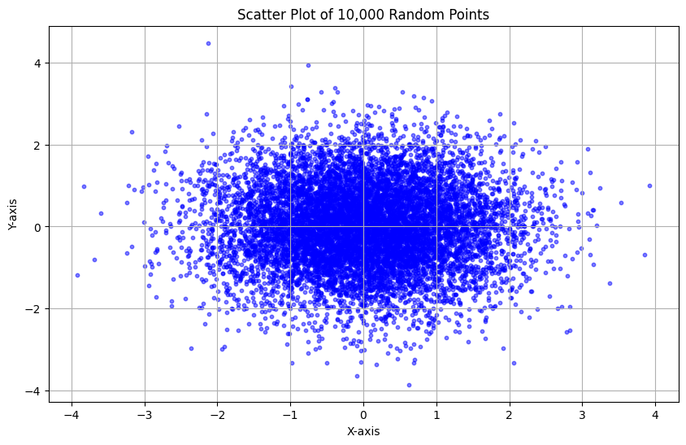
import numpy as np
import pandas as pd
import matplotlib.pyplot as plt
# Step 1: Generate more dispersed random data (10,000 points)
np.random.seed(42) # for reproducibility
x = np.random.randn(10000) * 50 # scaled X values
y = np.random.randn(10000) * 50 # scaled Y values
# Step 2: Create a DataFrame
df = pd.DataFrame({'X': x, 'Y': y})
# Step 3: Plot the data
plt.figure(figsize=(10, 6))
plt.scatter(df['X'], df['Y'], alpha=0.5, s=10, color='green')
plt.title('Scatter Plot of 10,000 Randomly Dispersed Points')
plt.xlabel('X-axis')
plt.ylabel('Y-axis')
plt.grid(True)
plt.show()
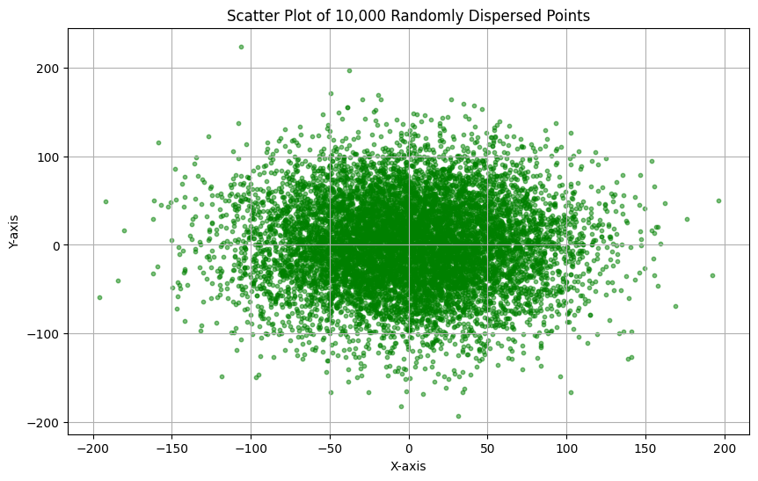
import numpy as np
import pandas as pd
import matplotlib.pyplot as plt
# Step 1: Generate highly dispersed data
np.random.seed(42)
x = np.random.randn(10000) * 200 # much wider X range
y = np.random.randn(10000) * 200 # much wider Y range
# Step 2: Create DataFrame
df = pd.DataFrame({'X': x, 'Y': y})
# Step 3: Plot
plt.figure(figsize=(12, 8))
plt.scatter(df['X'], df['Y'], alpha=0.4, s=8, color='purple')
plt.title('Highly Dispersed Scatter Plot of 10,000 Points')
plt.xlabel('X-axis')
plt.ylabel('Y-axis')
plt.grid(True)
plt.show()
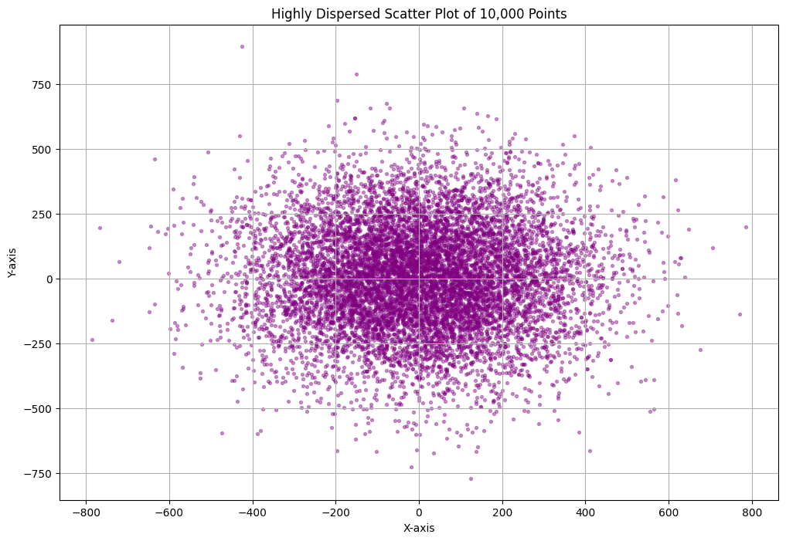
import numpy as np
import pandas as pd
import matplotlib.pyplot as plt
# Step 1: Generate ultra-dispersed data
np.random.seed(42)
x = np.random.randn(10000) * 1000 # super wide X
y = np.random.randn(10000) * 1000 # super wide Y
# Step 2: DataFrame
df = pd.DataFrame({'X': x, 'Y': y})
# Step 3: Plot
plt.figure(figsize=(12, 8))
plt.scatter(df['X'], df['Y'], alpha=0.3, s=6, color='crimson')
plt.title('Ultra Dispersed Scatter Plot of 10,000 Points')
plt.xlabel('X-axis')
plt.ylabel('Y-axis')
plt.grid(True)
plt.show()
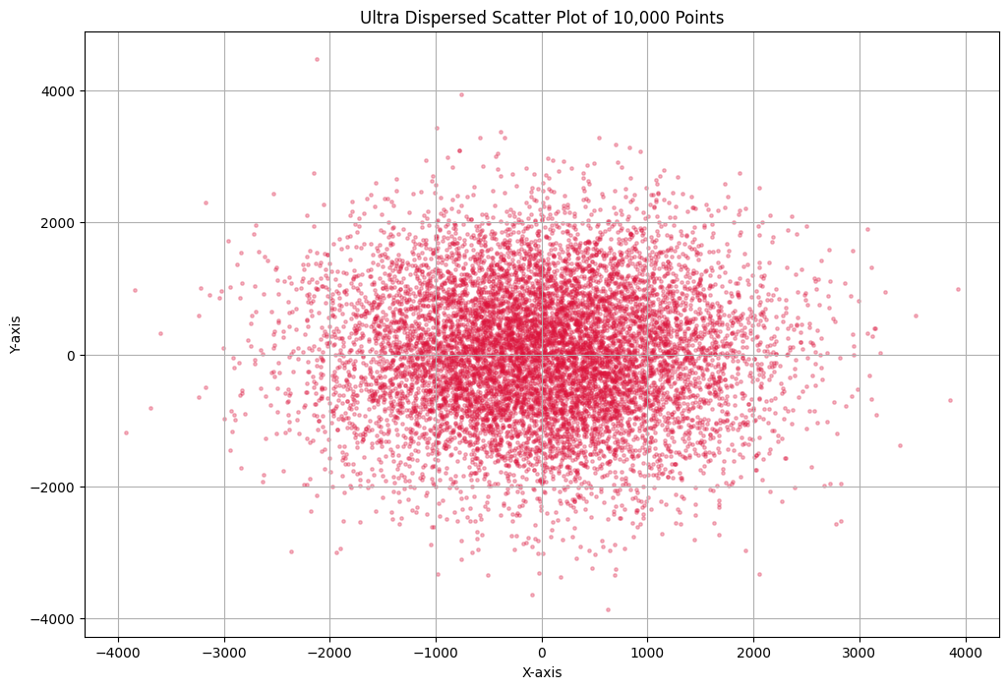
import numpy as np
import pandas as pd
import matplotlib.pyplot as plt
# Generate uniformly spread data between -5000 to +5000
np.random.seed(42)
x = np.random.uniform(-5000, 5000, 10000)
y = np.random.uniform(-5000, 5000, 10000)
# Create DataFrame
df = pd.DataFrame({'X': x, 'Y': y})
# Plot the data
plt.figure(figsize=(8, 6))
plt.scatter(df['X'], df['Y'], alpha=0.5, s=6, color='teal')
plt.title('Uniformly Wide Spread Scatter Plot of 10,000 Points')
plt.xlabel('X-axis')
plt.ylabel('Y-axis')
plt.grid(True)
plt.show()
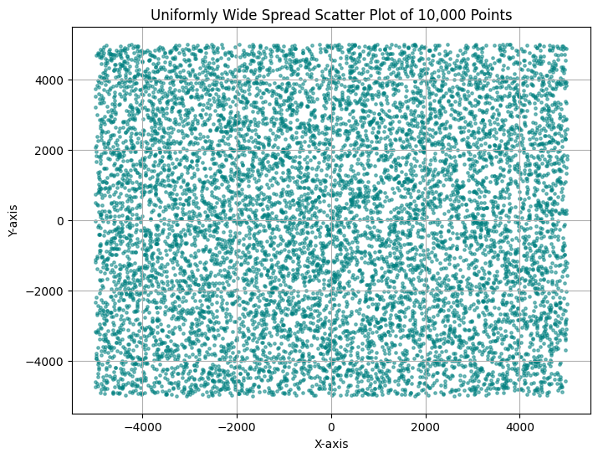
5. Plot the data of flipkart customers
# Simple Scatter Plot
plt.figure(figsize = (10, 6))
plt.scatter(df["Annual Income (₹ L)"], df["Spending Score (1-100)"], color='blue', alpha=0.7)
plt.title("Income vs Spending Score")
plt.xlabel("Annual Income (₹ L)")
plt.ylabel("Spending Score (1-100)")
plt.grid(True)
plt.show()
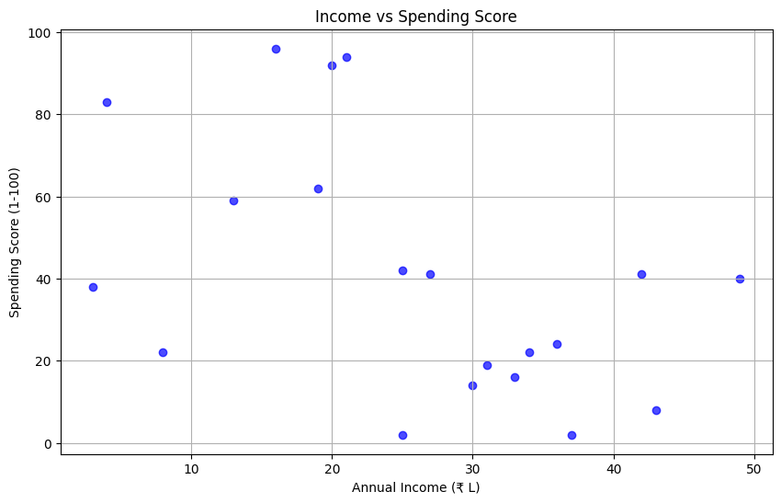
6) Apply K-Means Clustering (K=3)
kmeans = KMeans(n_clusters = 3)
df['Cluster'] = kmeans.fit_predict(X)
df
#help(kmeans.fit_predict)
7) Plot Clusters with Proper Colors and Labels
df.head()
plt.figure(figsize=(8, 5))
colors = ["red", "blue", "green"]
for cluster in range(3): #cluster 0, 1, 2
clustered_data = df[df['Cluster'] == cluster]
plt.scatter(
clustered_data["Annual Income (₹ L)"], clustered_data["Spending Score (1-100)"],
color = colors[cluster], label = f"Cluster {cluster}", edgecolors = "black"
)
plt.xlabel("Annual Income (₹ Lakhs)")
plt.ylabel("Spending Score (1-100)")
plt.title("Customer Segmentation (K-Means Clustering)")
plt.legend()
plt.show()
---------------------------------------------------------------------------
NameError Traceback (most recent call last)
<ipython-input-1-d627c4ff7955> in <cell line: 0>()
----> 1 plt.figure(figsize=(8, 5))
2
3 colors = ["red", "blue", "green"]
4
5 for cluster in range(3): #cluster 0, 1, 2
NameError: name 'plt' is not defined
Home Work:
- Write the names of customers on the customer data points above.
- Increase the customers - 100 to 1000 to 10000
- Follow pdf document for home work mini projects

