# Import necessary libraries for clustering and visualization
import numpy as np
import pandas as pd
import matplotlib.pyplot as plt
from sklearn.cluster import Kmeans

# df = pd.read_csv(‘customers.csv’) # upload from files or datasets
df.head() # Display the first few rows to understand the data structure
# Check for null values
null_values = df.isnull().sum()
# Scatter plot of Age vs Spending Score
plt.figure(figsize=(8, 5))
plt.scatter(df["Age"], df["Spending Score (1-100)"], c="blue", alpha=0.5)
plt.xlabel("Age")
plt.ylabel("Spending Score")
plt.title("Age vs Spending Score")
plt.show()
# Finding the best number of clusters using the Elbow Method
inertia = []
X = df[["Age", "Spending Score (1-100)"]]
for k in range(1, 11):
kmeans = KMeans(n_clusters=k, random_state=42, n_init=10)
kmeans.fit(X)
inertia.append(kmeans.inertia_)
# Plot elbow method
plt.figure(figsize=(8, 5))
plt.plot(range(1, 11), inertia, marker="o", linestyle="--", color="red")
plt.xlabel("Number of Clusters")
plt.ylabel("Inertia")
plt.title("Elbow Method for Optimal Clusters")
plt.show()
# Train K-Means with optimal clusters (assuming k=3 based on elbow method)
optimal_clusters = 3
kmeans = KMeans(n_clusters=optimal_clusters, random_state=42, n_init=10)
df["Cluster"] = kmeans.fit_predict(X)
# Scatter plot colored by clusters
plt.figure(figsize=(8, 5))
plt.scatter(df["Age"], df["Spending Score (1-100)"], c=df["Cluster"], cmap="rainbow", alpha=0.7)
plt.xlabel("Age")
plt.ylabel("Spending Score")
plt.title("K-Means Clustering - Age vs Spending Score")
plt.show()
# Output null values check result
null_values
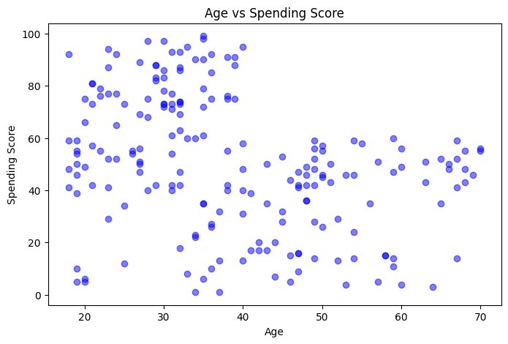
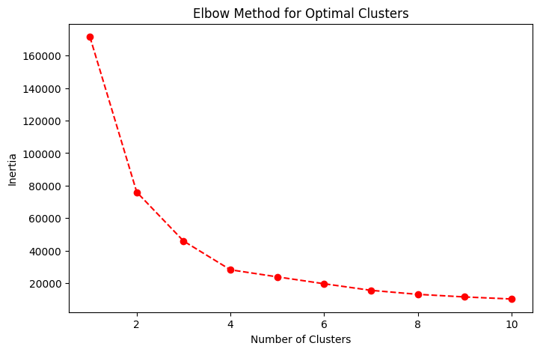
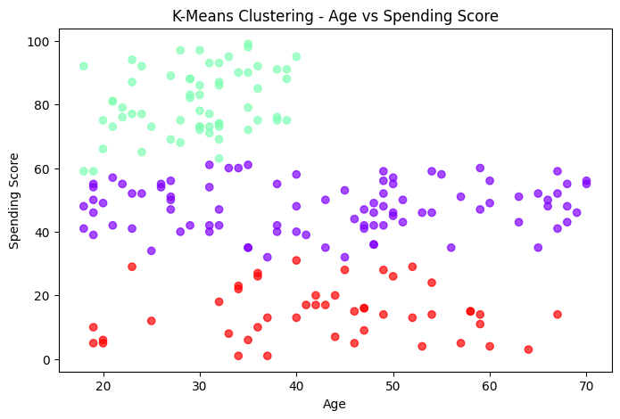
# Set Seaborn style
sns.set(style="darkgrid")
# Create figure
plt.figure(figsize=(10, 6))
# Scatter plot with color gradient based on Spending Score
scatter = plt.scatter(
df["Age"], df["Spending Score (1-100)"],
c=df["Spending Score (1-100)"], cmap="coolwarm", alpha=0.7, edgecolors="black"
)
# Color bar for reference
cbar = plt.colorbar(scatter)
cbar.set_label("Spending Score Intensity")
# Labels and title
plt.xlabel("Age", fontsize=12)
plt.ylabel("Spending Score (1-100)", fontsize=12)
plt.title("Age vs Spending Score - Customer Segmentation", fontsize=14, fontweight="bold")
# Show the plot
plt.show()

# THE END

