Visualizing Raw Data: Scatter Plot (Before Clustering)
Before applying K-Means, let’s visualize how the data looks without clustering.
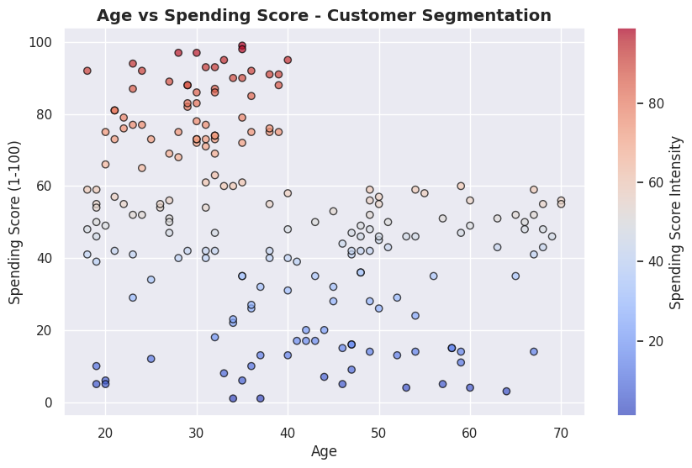
2️⃣ Finding the Optimal Number of Clusters (Elbow Method)
The Elbow Method helps determine the best K (number of clusters) by calculating inertia (sum of squared distances from each point to its assigned centroid).
import pandas as pd
import numpy as np
from sklearn.datasets import make_blobs
from sklearn.cluster import KMeans
import seaborn as sns

# Generate sythetic dataset(if df is unavailable)
df,_ = make_blobs(n_samples=500,centers=4,cluster_std=1.5,random_state=42)
df = pd.DataFrame(df,columns=['Age','Spending Score(1-100)'])

# Feature selection or # Select features
X = df[['Age','Spending Score(1-100)']]
# Compute Inertia for Different K Values
inertia = []
k_values = range(1, 11)
for k in k_values:
kmeans = KMeans(n_clusters=k, random_state=42, n_init=10)
kmeans.fit(X)
inertia.append(kmeans.inertia_)
print(f"K={k}, Inertia={kmeans.inertia_:.2f}")
# Plot Elbow Method
plt.figure(figsize=(10, 6))
plt.plot(k_values, inertia, marker="o", linestyle="--", color="red", label="Inertia")
plt.xticks(k_values)
plt.xlabel("Number of Clusters (K)", fontsize=12)
plt.ylabel("Inertia (Sum of Squared Distances)", fontsize=12)
plt.title("Elbow Method: Finding the Optimal K", fontsize=14, fontweight="bold")
# Highlight the Elbow Point
optimal_k = 4 # Assume elbow at K=4 for our dataset
plt.scatter(optimal_k, inertia[optimal_k - 1], marker="o", color="blue", s=200, label=f"Optimal K={optimal_k}")
plt.legend()
plt.show()
K=1, Inertia=171535.50
K=2, Inertia=75949.16
K=3, Inertia=45840.68
K=4, Inertia=28165.58
K=5, Inertia=23811.52
K=6, Inertia=19566.52
K=7, Inertia=15514.19
K=8, Inertia=13055.63
K=9, Inertia=11453.29
K=10, Inertia=10186.50
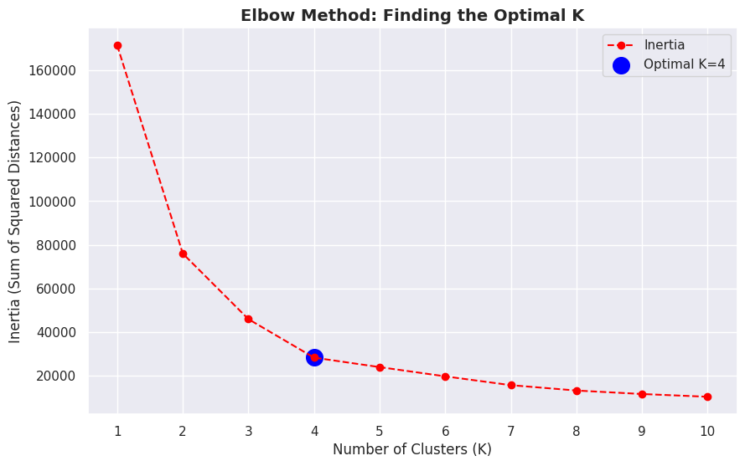
Insights:
Inertia decreases as K increases.
Elbow Point (K=4) is where the decrease in inertia slows, indicating the optimal number of clusters.
3️⃣ Clustering the Data with K-Means
Now, let’s apply K-Means using the optimal number of clusters.
# Apply K-Means with Optimal K
optimal_clusters = 4
kmeans = KMeans(n_clusters=optimal_clusters, random_state=42, n_init=10)
df["Cluster"] = kmeans.fit_predict(X)
# Visualizing the Clusters
plt.figure(figsize=(10, 6))
plt.scatter(df["Age"], df["Spending Score (1-100)"], c=df["Cluster"], cmap="rainbow", alpha=0.7, edgecolors="black")
plt.xlabel("Age")
plt.ylabel("Spending Score (1-100)")
plt.title("K-Means Clustering - Age vs Spending Score")
plt.show()
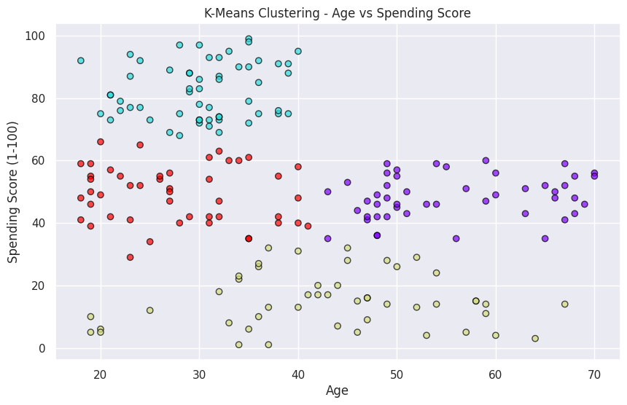
Interpretation:
Now we can see 4 distinct groups of customers based on age and spending behavior.
The clusters help identify different customer behaviors (e.g., high spenders, low spenders, young vs. older customers).
import pandas as pd
import numpy as np
import matplotlib.pyplot as plt
import seaborn as sns
from sklearn.cluster import KMeans
from sklearn.datasets import make_blobs
# 🔹 Load dataset (if available)
try:
df = pd.read_csv("customers.csv") # Load real dataset
except:
# Generate synthetic dataset (if file not found)
df, _ = make_blobs(n_samples=200, centers=4, cluster_std=1.5, random_state=42)
df = pd.DataFrame(df, columns=["Age", "Spending Score (1-100)"])
# 🔹 Feature Selection
X = df[["Age", "Spending Score (1-100)"]]
# 🔹 Apply K-Means with Optimal Clusters (Assumed K=4 from elbow method)
optimal_k = 4
kmeans = KMeans(n_clusters=optimal_k, random_state=42, n_init=10)
df["Cluster"] = kmeans.fit_predict(X)
# 🔹 Define Cluster Labels (Based on Spending Score & Age)
labels = {
0: "High Spenders (Young)",
1: "Low Spenders (Older)",
2: "Moderate Spenders",
3: "High Spenders (Older)"
}
# 🔹 Assign readable labels
df["Segment"] = df["Cluster"].map(labels)
# 🔹 Plot Clusters with Labels
plt.figure(figsize=(10, 6))
scatter = plt.scatter(df["Age"], df["Spending Score (1-100)"], c=df["Cluster"], cmap="rainbow", alpha=0.7, edgecolors="black")
# Add color legend
cbar = plt.colorbar(scatter)
cbar.set_label("Cluster Group")
# Labeling clusters on the graph
for cluster, label in labels.items():
cluster_data = df[df["Cluster"] == cluster]
center_x, center_y = cluster_data["Age"].mean(), cluster_data["Spending Score (1-100)"].mean()
plt.text(center_x, center_y, label, fontsize=12, fontweight="bold", bbox=dict(facecolor="white", alpha=0.6))
# Labels and title
plt.xlabel("Age", fontsize=12)
plt.ylabel("Spending Score (1-100)", fontsize=12)
plt.title("Customer Behavior Clustering - Age vs Spending Score", fontsize=14, fontweight="bold")
plt.show()
# 🔹 Display Cluster Data
print("📊 Customer Clustering Results:")
print(df.groupby("Segment").size().reset_index(name="Count"))
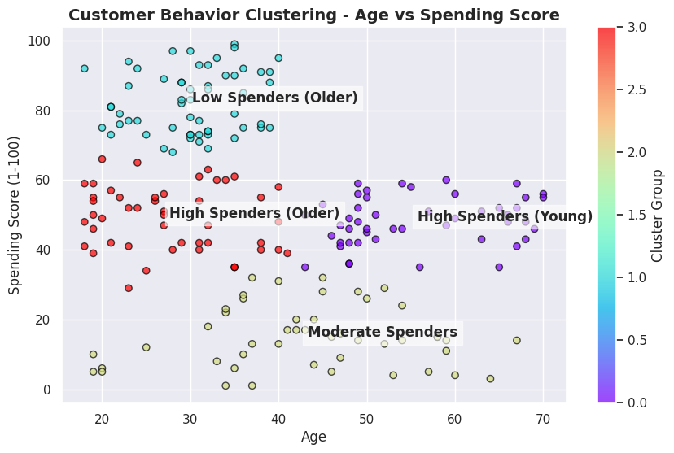
📊 Customer Clustering Results:
Segment Count
0 High Spenders (Older) 47
1 High Spenders (Young) 48
2 Low Spenders (Older) 57
3 Moderate Spenders 48

