# Import required libraries
import pandas as pd
import numpy as np
import matplotlib.pyplot as plt
import seaborn as sns
from sklearn.cluster import KMeans
from sklearn.preprocessing import StandardScaler
# Step 1: Generate Synthetic Data for 10,000 Customers (₹ INR)
np.random.seed(42)
data = {
"CustomerID": np.arange(1, 10001),
"Age": np.random.randint(18, 70, 10000),
"Gender": np.random.choice(["Male", "Female"], 10000),
"Annual Income (₹ Lakhs)": np.random.uniform(2, 50, 10000).round(2), # ₹2L to ₹50L
"Spending Score (1-100)": np.random.randint(1, 101, 10000),
"Credit Score": np.random.randint(300, 900, 10000), # Indian credit score range
"Online Shopping Frequency": np.random.randint(0, 30, 10000), # Monthly orders
"Membership Duration (Years)": np.random.randint(1, 15, 10000),
"Discount Usage (%)": np.random.randint(0, 100, 10000),
"Total Transactions": np.random.randint(1, 500, 10000), # Annual transactions
"Avg Transaction Value (₹ Thousands)": np.random.uniform(1, 100, 10000).round(2), # ₹1K to ₹100K
}
df = pd.DataFrame(data)
# Step 2: Convert Gender to Numerical (0=Male, 1=Female)
df["Gender"] = df["Gender"].map({"Male": 0, "Female": 1})
# Step 3: Exploratory Data Analysis (EDA) - Histograms
fig, axes = plt.subplots(2, 3, figsize=(18, 12))
sns.histplot(df["Age"], bins=30, kde=True, color="blue", ax=axes[0, 0])
axes[0, 0].set_title("Age Distribution")
sns.histplot(df["Annual Income (₹ Lakhs)"], bins=30, kde=True, color="green", ax=axes[0, 1])
axes[0, 1].set_title("Annual Income Distribution (₹ Lakhs)")
sns.histplot(df["Spending Score (1-100)"], bins=30, kde=True, color="red", ax=axes[0, 2])
axes[0, 2].set_title("Spending Score Distribution")
sns.histplot(df["Credit Score"], bins=30, kde=True, color="purple", ax=axes[1, 0])
axes[1, 0].set_title("Credit Score Distribution")
sns.histplot(df["Total Transactions"], bins=30, kde=True, color="orange", ax=axes[1, 1])
axes[1, 1].set_title("Total Transactions Distribution")
sns.histplot(df["Avg Transaction Value (₹ Thousands)"], bins=30, kde=True, color="brown", ax=axes[1, 2])
axes[1, 2].set_title("Avg Transaction Value (₹ Thousands) Distribution")
plt.tight_layout()
plt.show()
# Step 4: Feature Selection & Scaling
features = df.columns[1:]
scaler = StandardScaler()
X_scaled = scaler.fit_transform(df[features])
# Step 5: Elbow Method to Find Optimal K
inertia = []
k_values = range(1, 11)
for k in k_values:
kmeans = KMeans(n_clusters=k, random_state=42, n_init=10)
kmeans.fit(X_scaled)
inertia.append(kmeans.inertia_)
plt.figure(figsize=(10, 6))
plt.plot(k_values, inertia, marker="o", linestyle="--", color="red")
plt.xticks(k_values)
plt.xlabel("Number of Clusters (K)")
plt.ylabel("Inertia (Sum of Squared Distances)")
plt.title("Elbow Method for Optimal Clusters")
plt.show()
# Step 6: Apply K-Means Clustering (Assume Best K=5 from Elbow Method)
optimal_k = 5
kmeans = KMeans(n_clusters=optimal_k, random_state=42, n_init=10)
df["Cluster"] = kmeans.fit_predict(X_scaled)
# Step 7: Visualizing Clusters (Scatter Plot)
plt.figure(figsize=(10, 6))
sns.scatterplot(x=df["Annual Income (₹ Lakhs)"], y=df["Spending Score (1-100)"], hue=df["Cluster"], palette="viridis", alpha=0.7)
plt.xlabel("Annual Income (₹ Lakhs)")
plt.ylabel("Spending Score (1-100)")
plt.title("Customer Segments Based on Income & Spending")
plt.legend(title="Cluster")
plt.show()
# Step 8: Cluster Insights
print(df.groupby("Cluster").mean()[["Age", "Annual Income (₹ Lakhs)", "Spending Score (1-100)", "Avg Transaction Value (₹ Thousands)"]])
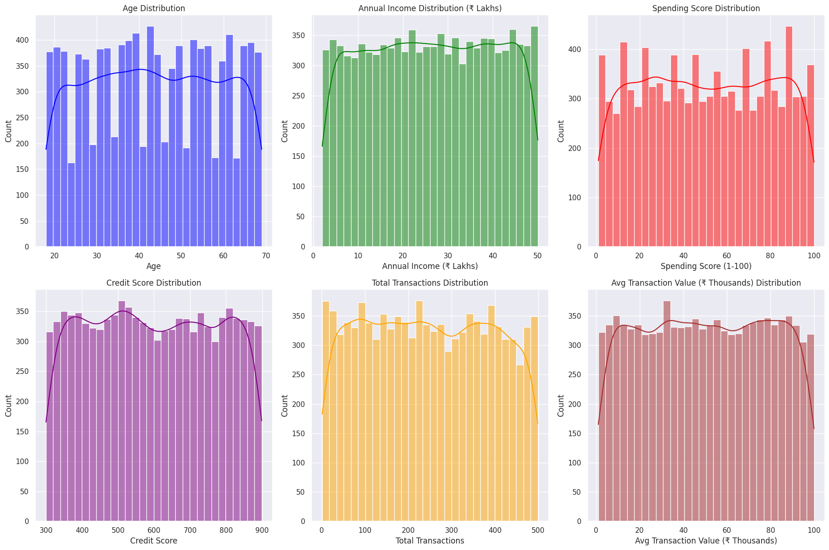
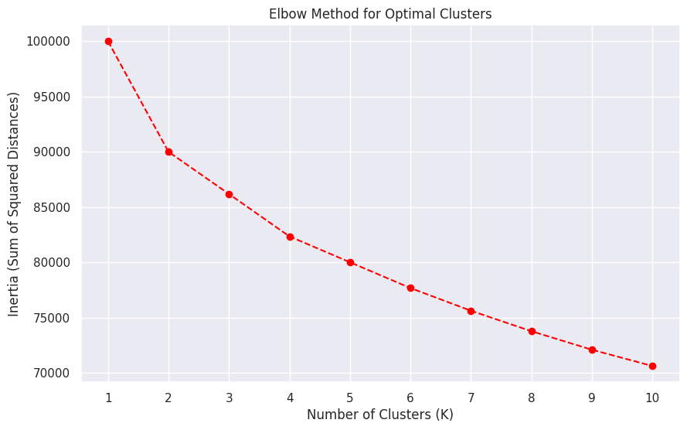
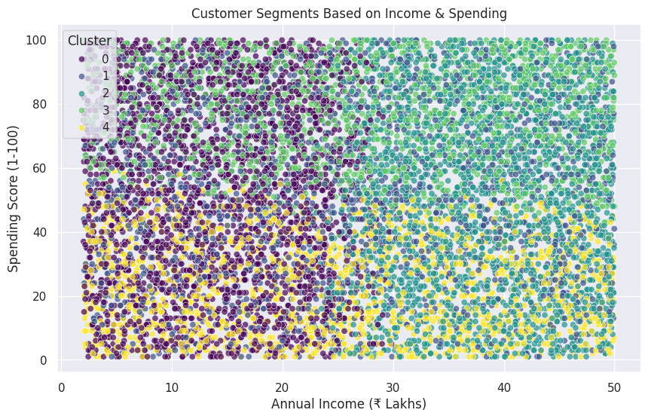
Age Annual Income (₹ Lakhs) Spending Score (1-100) \
Cluster
0 43.144409 14.234381 50.765889
1 42.681944 25.423644 51.960243
2 43.861740 38.264537 49.820818
3 43.973602 27.470434 76.942803
4 44.186834 25.401060 23.394357
Avg Transaction Value (₹ Thousands)
Cluster
0 50.135817
1 52.089177
2 50.038121
3 48.665280
4 51.666746
# the END

