# Import required libraries
import pandas as pd
import numpy as np
import matplotlib.pyplot as plt
import seaborn as sns
from sklearn.cluster import KMeans
from sklearn.preprocessing import StandardScaler
# Generate synthetic data (100 customers, ₹ INR)
np.random.seed(42)
df = pd.DataFrame({
"CustomerID": np.arange(1, 101),
"Age": np.random.randint(18, 70, 100),
"Annual Income (₹ Lakhs)": np.random.uniform(2, 50, 100).round(2),
"Spending Score (1-100)": np.random.randint(1, 101, 100),
})
# Visualizing Data Distribution
plt.figure(figsize=(15, 4))
sns.histplot(df["Annual Income (₹ Lakhs)"], bins=15, kde=False, color="green")
plt.title("Annual Income Distribution")
plt.show()
# Scaling Data for Clustering
scaler = StandardScaler()
X_scaled = scaler.fit_transform(df[["Age", "Annual Income (₹ Lakhs)", "Spending Score (1-100)"]])
# Finding Optimal Clusters (Elbow Method)
inertia = []
for k in range(1, 6):
kmeans = KMeans(n_clusters=k, random_state=42, n_init=10)
kmeans.fit(X_scaled)
inertia.append(kmeans.inertia_)
plt.plot(range(1, 6), inertia, marker="o", linestyle="--", color="red")
plt.xlabel("Number of Clusters")
plt.ylabel("Inertia")
plt.title("Elbow Method")
plt.show()
# Applying K-Means (Assuming Best K=3)
kmeans = KMeans(n_clusters=3, random_state=42, n_init=10)
df["Cluster"] = kmeans.fit_predict(X_scaled)
# Scatter Plot: Annual Income vs Spending Score
plt.figure(figsize=(8, 5))
sns.scatterplot(x=df["Annual Income (₹ Lakhs)"], y=df["Spending Score (1-100)"], hue=df["Cluster"], palette="viridis")
plt.xlabel("Annual Income (₹ Lakhs)")
plt.ylabel("Spending Score (1-100)")
plt.title("Customer Segments")
plt.legend(title="Cluster")
plt.show()
# Display Cluster Averages
print(df.groupby("Cluster")[["Age", "Annual Income (₹ Lakhs)", "Spending Score (1-100)"]].mean())
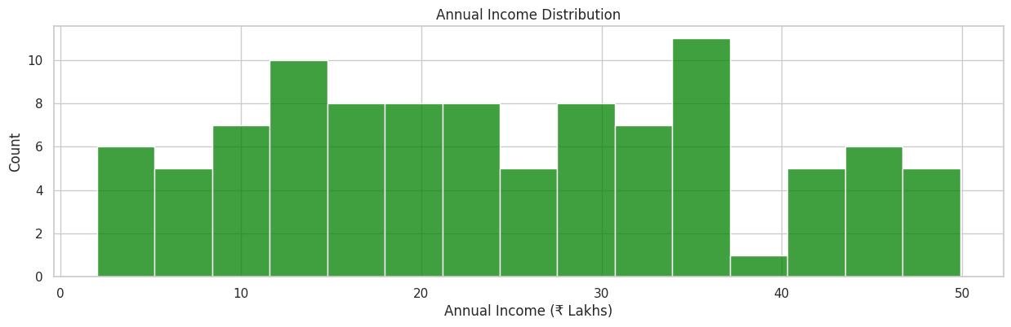
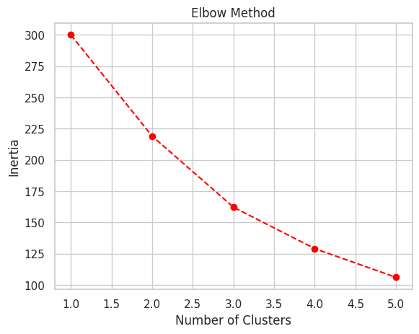
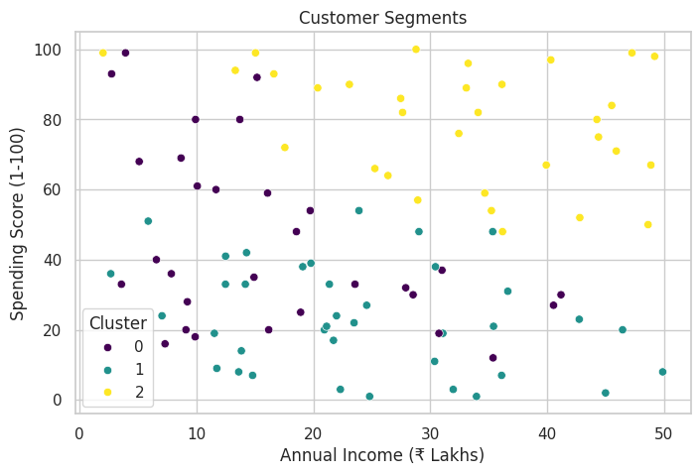
Age Annual Income (₹ Lakhs) Spending Score (1-100)
Cluster
0 59.500000 16.600333 45.133333
1 33.421053 24.062368 23.578947
2 40.000000 32.651875 78.906250
Business Insights
🔹 Cluster 0: High income, moderate spending – Targeted promotions
🔹 Cluster 1: Young, high spenders – Premium offers
🔹 Cluster 2: Older, low spenders – Engagement campaigns
import pandas as pd
import numpy as np
import matplotlib.pyplot as plt
import seaborn as sns
from sklearn.cluster import KMeans
# Generate customer names
customers = [
"Amit", "Neha", "Rahul", "Priya", "Vikram", "Sonia", "Manish", "Kavita", "Rajesh", "Deepika",
"Arjun", "Pooja", "Ravi", "Simran", "Anil", "Megha", "Suresh", "Divya", "Tarun", "Shweta"
]
# Generate synthetic data
np.random.seed(42)
data = {
"Customer Name": customers,
"Age": np.random.randint(18, 65, 20),
"Annual Income (₹ Lakhs)": np.random.uniform(2, 50, 20).round(2), # ₹2L to ₹50L
"Spending Score (1-100)": np.random.randint(1, 101, 20),
"Avg Transaction Value (₹ Thousands)": np.random.uniform(1, 100, 20).round(2), # ₹1K to ₹100K
"Customer Type": np.random.choice(["Regular", "Premium", "Occasional"], 20)
}
df = pd.DataFrame(data)
print(df)
Customer Name Age Annual Income (₹ Lakhs) Spending Score (1-100) \
0 Amit 56 47.05 18
1 Neha 46 2.04 4
2 Rahul 32 49.63 89
3 Priya 60 31.64 60
4 Vikram 25 31.36 14
5 Sonia 38 2.34 9
6 Manish 56 3.11 90
Avg Transaction Value (₹ Thousands) Customer Type
0 19.04 Regular
1 75.78 Regular
2 43.09 Regular
3 21.59 Occasional
4 57.20 Regular
plt.figure(figsize=(10, 6))
# Scatter plot before clustering
sns.scatterplot(x=df["Annual Income (₹ Lakhs)"], y=df["Spending Score (1-100)"], s=100, color="gray")
# Annotate customer names
for i, txt in enumerate(df["Customer Name"]):
plt.annotate(txt, (df["Annual Income (₹ Lakhs)"][i], df["Spending Score (1-100)"][i]), fontsize=10)
plt.xlabel("Annual Income (₹ Lakhs)")
plt.ylabel("Spending Score (1-100)")
plt.title("Customer Distribution Before Clustering")
plt.show()
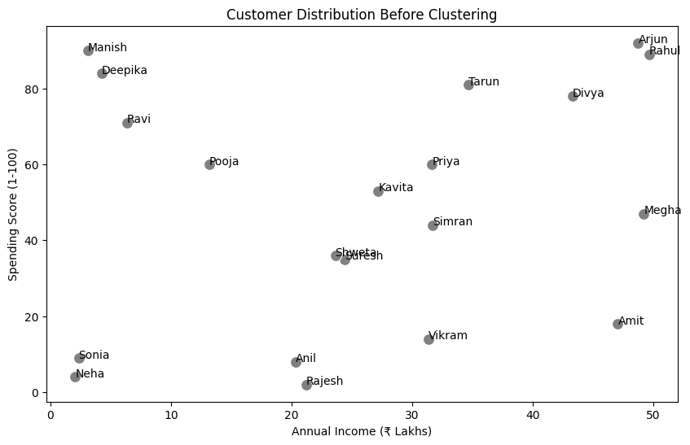
from sklearn.preprocessing import StandardScaler
# Select relevant columns
X = df[["Annual Income (₹ Lakhs)", "Spending Score (1-100)"]]
# Apply K-Means
optimal_k = 3 # Assume 3 clusters
kmeans = KMeans(n_clusters=optimal_k, random_state=42, n_init=10)
df["Cluster"] = kmeans.fit_predict(X)
# Define Cluster Labels
cluster_labels = {
0: "Low Spenders",
1: "Moderate Spenders",
2: "High Spenders"
}
df["Segment"] = df["Cluster"].map(cluster_labels)
print(df[["Customer Name", "Age", "Annual Income (₹ Lakhs)", "Spending Score (1-100)", "Segment"]])
Customer Name Age Annual Income (₹ Lakhs) Spending Score (1-100) \
0 Amit 56 47.05 18
1 Neha 46 2.04 4
2 Rahul 32 49.63 89
3 Priya 60 31.64 60
4 Vikram 25 31.36 14
5 Sonia 38 2.34 9
Segment
0 High Spenders
1 Moderate Spenders
2 Low Spenders
3 High Spenders
4 Moderate Spenders
plt.figure(figsize=(10, 6))
# Scatter plot after clustering
sns.scatterplot(
x=df["Annual Income (₹ Lakhs)"], y=df["Spending Score (1-100)"],
hue=df["Segment"], palette="coolwarm", s=100
)
# Annotate customer names
for i, txt in enumerate(df["Customer Name"]):
plt.annotate(txt, (df["Annual Income (₹ Lakhs)"][i], df["Spending Score (1-100)"][i]), fontsize=10)
plt.xlabel("Annual Income (₹ Lakhs)")
plt.ylabel("Spending Score (1-100)")
plt.title("Customer Segmentation After K-Means Clustering")
plt.legend(title="Customer Segment")
plt.show()
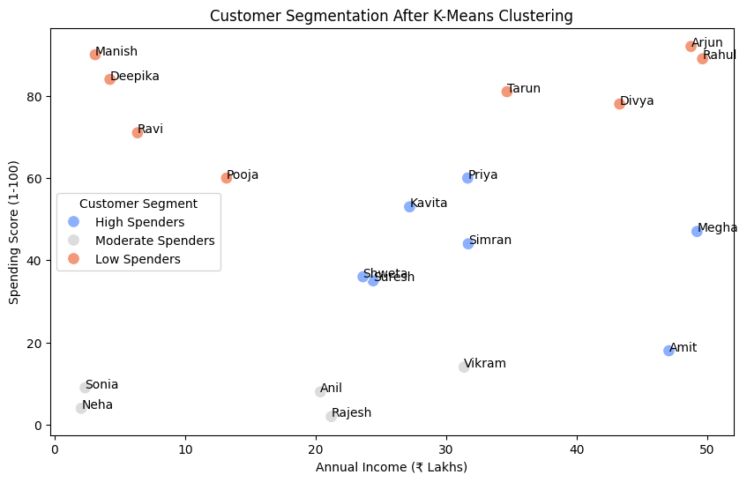
plt.figure(figsize=(6, 6))
df["Segment"].value_counts().plot.pie(autopct="%1.1f%%", colors=["gray", "blue", "red"])
plt.title("Customer Segment Distribution")
plt.ylabel("")
plt.show()
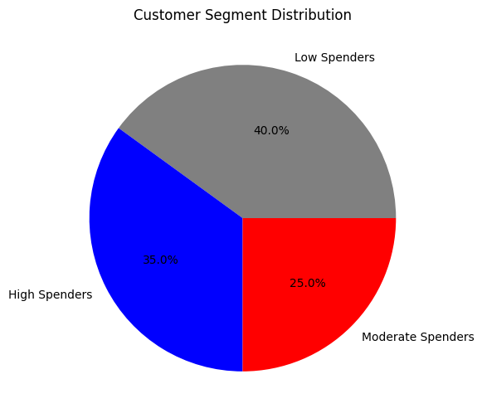
plt.figure(figsize=(8, 5))
sns.boxplot(x=df["Segment"], y=df["Spending Score (1-100)"], palette="coolwarm")
plt.title("Spending Score Across Customer Segments")
plt.xlabel("Customer Segment")
plt.ylabel("Spending Score")
plt.show()
<ipython-input-10-739602d12d12>:2: FutureWarning:
Passing `palette` without assigning `hue` is deprecated and will be removed in v0.14.0. Assign the `x` variable to `hue` and set `legend=False` for the same effect.
sns.boxplot(x=df["Segment"], y=df["Spending Score (1-100)"], palette="coolwarm")
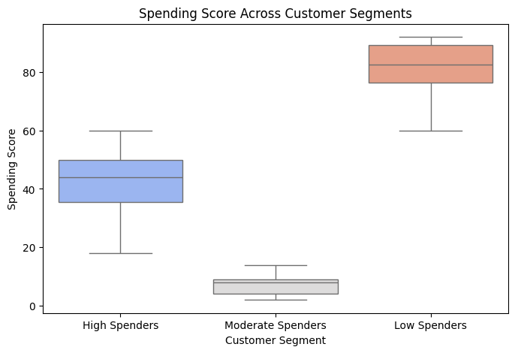
customer_names = [
"Aarav", "Vihaan", "Kabir", "Aryan", "Reyansh", "Aditi", "Ishita", "Kiara", "Meera", "Saanvi",
"Ananya", "Rohan", "Neha", "Dev", "Tanvi", "Krishna", "Riya", "Siddharth", "Pooja", "Aakash"
]
def categorize_spender(score):
if score <= 40:
return "Low Spender"
elif 41 <= score <= 70:
return "Moderate Spender"
else:
return "High Spender"
df["Purchasing Level"] = df["Spending Score (1-100)"].apply(categorize_spender)
df["Purchasing Level"]
0 Low Spender
1 Low Spender
2 High Spender
3 Moderate Spender
4 Low Spender
5 Low Spender
6 High Spender
Name: Purchasing Level, dtype: object
plt.figure(figsize=(10, 6))
for i in range(len(df)):
plt.scatter(df["Annual Income (₹ Lakhs)"][i], df["Spending Score (1-100)"][i], color="gray")
plt.text(df["Annual Income (₹ Lakhs)"][i], df["Spending Score (1-100)"][i], df["Customer Name"][i], fontsize=9)
plt.xlabel("Annual Income (₹ Lakhs)")
plt.ylabel("Spending Score (1-100)")
plt.title("Customer Distribution Before Clustering")
plt.show()
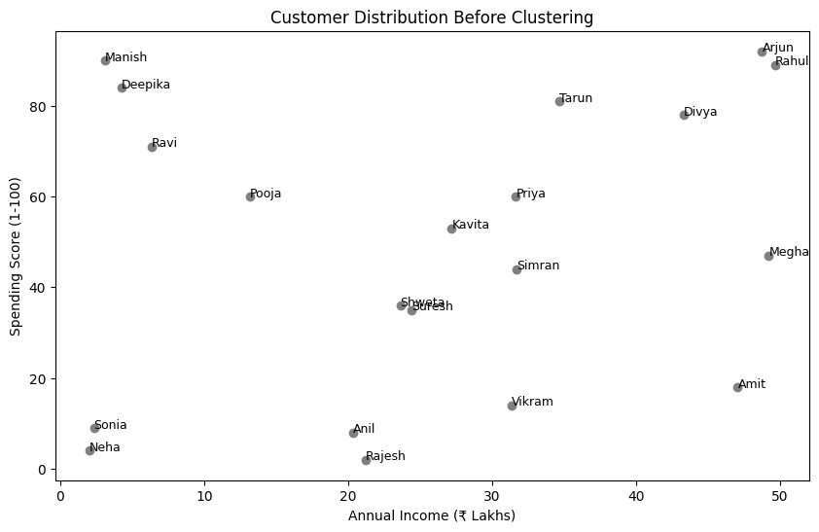
plt.figure(figsize=(10, 6))
colors = {0: "red", 1: "blue", 2: "green"}
for i in range(len(df)):
plt.scatter(df["Annual Income (₹ Lakhs)"][i], df["Spending Score (1-100)"][i],
color=colors[df["Cluster"][i]], label=f"Cluster {df['Cluster'][i]}" if i < 3 else "")
plt.text(df["Annual Income (₹ Lakhs)"][i], df["Spending Score (1-100)"][i], df["Customer Name"][i], fontsize=9)
plt.xlabel("Annual Income (₹ Lakhs)")
plt.ylabel("Spending Score (1-100)")
plt.title("Customer Clusters After K-Means Segmentation")
plt.legend()
plt.show()
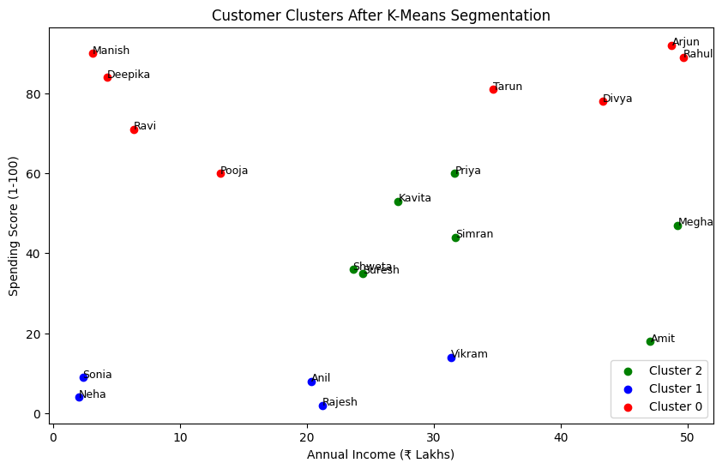
summary = df.groupby("Cluster").agg({
"Age": "mean",
"Annual Income (₹ Lakhs)": "mean",
"Spending Score (1-100)": "mean",
"Purchasing Level": lambda x: x.mode()[0] # Most common category in each cluster
}).rename(columns={"Age": "Avg Age", "Annual Income (₹ Lakhs)": "Avg Income (₹ L)", "Spending Score (1-100)": "Avg Score"})
print(summary)
Avg Age Avg Income (₹ L) Avg Score Purchasing Level
Cluster
0 37.25 25.39625 80.625000 High Spender
1 38.00 15.45800 7.400000 Low Spender
2 47.00 33.54000 41.857143 Moderate Spender

# THE END

