‘import pandas as pd
import numpy as np
import matplotlib.pyplot as plt
import seaborn as sns
from sklearn.cluster import KMeans
from sklearn.preprocessing import StandardScaler
# Set random seed
np.random.seed(42)
# Generate Realistic Customer Data
customer_names = [
"Aarav", "Vihaan", "Kabir", "Aryan", "Reyansh", "Aditi", "Ishita", "Kiara", "Meera", "Saanvi",
"Ananya", "Rohan", "Neha", "Dev", "Tanvi", "Krishna", "Riya", "Siddharth", "Pooja", "Aakash"
]
ages = np.random.randint(18, 65, 20)
income = np.round(np.random.uniform(3, 50, 20), 2) # ₹3L to ₹50L
spending_score = np.random.randint(1, 101, 20)
avg_transaction = np.round(np.random.uniform(1, 75, 20), 2) # ₹1K to ₹75K
purchase_freq = np.random.randint(1, 15, 20) # Monthly purchases (1 to 15 times)
df = pd.DataFrame({
"Customer Name": customer_names,
"Age": ages,
"Annual Income (₹ Lakhs)": income,
"Spending Score (1-100)": spending_score,
"Avg Transaction Value (₹ Thousands)": avg_transaction,
"Purchase Frequency": purchase_freq
})
# Categorize spending level
def categorize_spender(score):
if score <= 40:
return "Low Spender"
elif 41 <= score <= 70:
return "Moderate Spender"
else:
return "High Spender"
df["Purchasing Level"] = df["Spending Score (1-100)"].apply(categorize_spender)
plt.figure(figsize=(10, 6))
for i in range(len(df)):
plt.scatter(df["Annual Income (₹ Lakhs)"][i], df["Spending Score (1-100)"][i], color="gray")
plt.text(df["Annual Income (₹ Lakhs)"][i], df["Spending Score (1-100)"][i], df["Customer Name"][i], fontsize=9)
plt.xlabel("Annual Income (₹ Lakhs)")
plt.ylabel("Spending Score (1-100)")
plt.title("Customer Data Distribution Before Clustering")
plt.show()
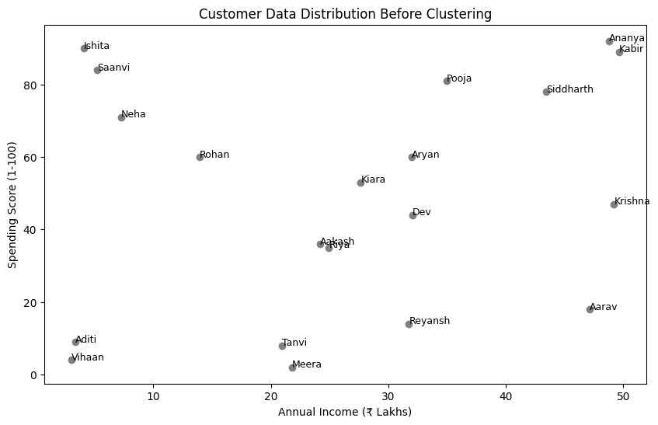

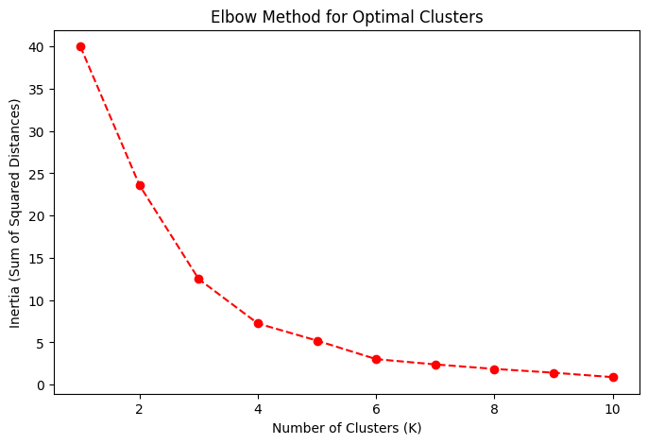
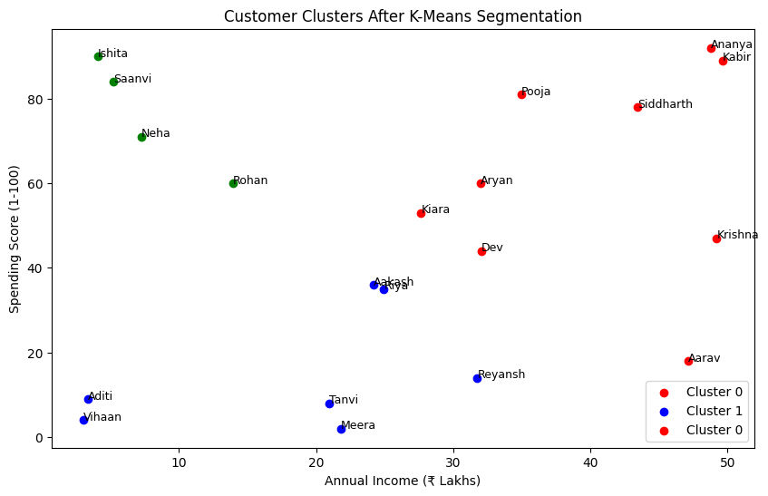

-------------------THE END-----------------
import pandas as pd
import numpy as np
import matplotlib.pyplot as plt
from sklearn.cluster import KMeans
# 1️⃣ Generate Customer Data
customers = [
"Aarav", "Vihaan", "Kabir", "Aryan", "Reyansh", "Aditi", "Ishita", "Kiara", "Meera", "Saanvi",
"Ananya", "Rohan", "Neha", "Dev", "Tanvi", "Krishna", "Riya", "Siddharth", "Pooja", "Aakash"
]
df = pd.DataFrame({
"Customer Name": customers,
"Age": np.random.randint(18, 65, 20),
"Annual Income (₹ L)": np.random.randint(3, 50, 20),
"Spending Score (1-100)": np.random.randint(1, 101, 20)
})
# 2️⃣ Select Features for Clustering
X = df[["Annual Income (₹ L)", "Spending Score (1-100)"]]
# 3️⃣ Apply K-Means Clustering (K=3)
kmeans = KMeans(n_clusters=3, random_state=42, n_init=10)
df["Cluster"] = kmeans.fit_predict(X)
# 4️⃣ Plot Corrected Clusters with Proper Colors and Labels
plt.figure(figsize=(8, 5))
colors = ["red", "blue", "green"]
for cluster in range(3):
cluster_data = df[df["Cluster"] == cluster]
plt.scatter(cluster_data["Annual Income (₹ L)"], cluster_data["Spending Score (1-100)"],
color=colors[cluster], label=f"Cluster {cluster}", edgecolors="black")
# Label each point with customer name
for i in range(len(cluster_data)):
plt.text(cluster_data["Annual Income (₹ L)"].iloc[i], cluster_data["Spending Score (1-100)"].iloc[i],
cluster_data["Customer Name"].iloc[i], fontsize=9, verticalalignment="bottom")
plt.xlabel("Annual Income (₹ Lakhs)")
plt.ylabel("Spending Score (1-100)")
plt.title("Customer Segmentation (K-Means Clustering)")
plt.legend()
plt.show()
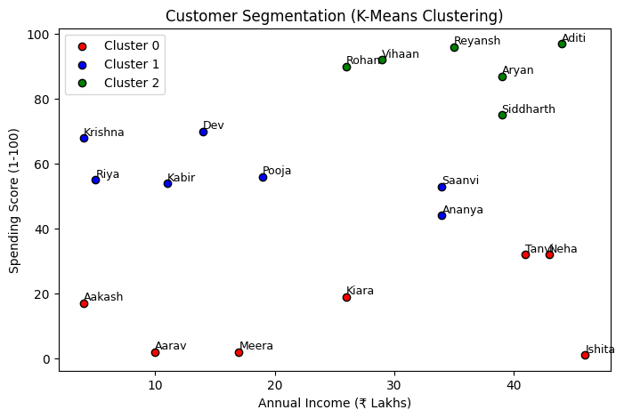
Level1:
import numpy as np
from sklearn.cluster import KMeans
# Sample Data: 10 Customers (Random Values)
data = np.array([
[25, 30], [30, 40], [35, 45], [40, 50], [45, 55],
[50, 60], [55, 65], [60, 70], [65, 75], [70, 80]
])
# Apply K-Means Clustering (K=3)
kmeans = KMeans(n_clusters=3, random_state=42, n_init=10)
labels = kmeans.fit_predict(data)
# Output: Cluster Labels
print("Customer Cluster Labels:", labels)
Customer Cluster Labels: [0 0 0 2 2 2 1 1 1 1]
Level2:
import numpy as np
from sklearn.cluster import KMeans
# Sample Data: 10 Customers (Age, Spending Score)
data = np.array([
[25, 30], [30, 40], [35, 45], [40, 50], [45, 55],
[50, 60], [55, 65], [60, 70], [65, 75], [70, 80]
])
# Apply K-Means Clustering (K=3)
kmeans = KMeans(n_clusters=3, random_state=42, n_init=10)
labels = kmeans.fit_predict(data)
# Define Cluster Names
cluster_names = {
0: "Low Spenders",
1: "Moderate Spenders",
2: "High Spenders"
}
# Assign Names to Each Customer
customer_clusters = [cluster_names[label] for label in labels]
# Output: Customer Segments
for i, segment in enumerate(customer_clusters):
print(f"Customer {i+1}: {segment}")
Customer 1: Low Spenders
Customer 2: Low Spenders
Customer 3: Low Spenders
Customer 4: High Spenders
Level3
import numpy as np
import matplotlib.pyplot as plt
from sklearn.cluster import KMeans
# Sample Data: (Age, Spending Score)
data = np.array([
[22, 15], [25, 30], [28, 35], [35, 50], [40, 55],
[45, 60], [50, 70], [55, 75], [60, 85], [65, 90]
])
# Apply K-Means Clustering (K=4)
kmeans = KMeans(n_clusters=4, random_state=42, n_init=10)
labels = kmeans.fit_predict(data)
# Define Cluster Names
cluster_names = {
0: "Budget Buyers", # Low Age, Low Spending
1: "Regular Shoppers", # Mid Age, Medium Spending
2: "Premium Customers", # Mid-High Age, High Spending
3: "Luxury Shoppers" # Older Age, Very High Spending
}
# Assign Names to Each Customer
customer_clusters = [cluster_names[label] for label in labels]
# Output: Customer Segments
for i, segment in enumerate(customer_clusters):
print(f"Customer {i+1}: {segment}")
Customer 1: Premium Customers
Customer 2: Premium Customers
Customer 3: Premium Customers
Customer 4: Budget Buyers
Customer 5: Budget Buyers
# Plot the clusters
plt.figure(figsize=(8,5))
plt.scatter(data[:, 0], data[:, 1], c=labels, cmap="viridis", alpha=0.7, edgecolors="black")
# Mark Cluster Centers
centers = kmeans.cluster_centers_
plt.scatter(centers[:, 0], centers[:, 1], c="red", marker="X", s=200, label="Centroids")
# Labels
plt.xlabel("Age")
plt.ylabel("Spending Score")
plt.title("Customer Segmentation - KMeans Clustering")
plt.legend()
plt.show()
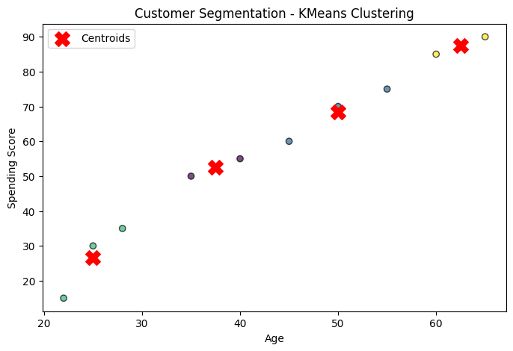
Level4
import pandas as pd
import numpy as np
import matplotlib.pyplot as plt
import seaborn as sns
from sklearn.cluster import KMeans
from sklearn.preprocessing import StandardScaler
# Sample Practical Data (20 Customers)
customer_data = pd.DataFrame({
"Customer Name": ["Amit", "Bhavna", "Chirag", "Divya", "Eshan", "Fatima", "Gopal", "Hina", "Ishaan", "Jyoti","Kiran", "Lavanya", "Manoj", "Nikita", "Omkar", "Priya", "Qasim", "Ritu", "Suresh", "Tanvi"],
"Age": np.random.randint(18, 65, 20), # Random ages between 18 and 65
"Annual Income (₹ Lakhs)": np.random.uniform(2, 50, 20).round(2), # ₹2L to ₹50L
"Spending Score (1-100)": np.random.randint(1, 101, 20) # Spending behavior score
})
print(customer_data.head()) # View first few rows
Customer Name Age Annual Income (₹ Lakhs) Spending Score (1-100)
0 Amit 59 36.03 62
1 Bhavna 48 28.54 22
2 Chirag 20 16.23 58
3 Divya 57 22.15 58
4 Eshan 63 14.30 86
# Compute percentiles for Income & Spending Score
income_q1, income_q3 = customer_data["Annual Income (₹ Lakhs)"].quantile([0.25, 0.75])
spending_q1, spending_q3 = customer_data["Spending Score (1-100)"].quantile([0.25, 0.75])
print(f"Income Q1 (Low): {income_q1:.2f} ₹ Lakhs, Income Q3 (High): {income_q3:.2f} ₹ Lakhs")
print(f"Spending Q1 (Low): {spending_q1:.2f}, Spending Q3 (High): {spending_q3:.2f}")
Income Q1 (Low): 8.56 ₹ Lakhs, Income Q3 (High): 30.18 ₹ Lakhs
Spending Q1 (Low): 37.00, Spending Q3 (High): 63.50
def assign_segment(row):
if row["Annual Income (₹ Lakhs)"] < income_q1 and row["Spending Score (1-100)"] < spending_q1:
return "Budget Shoppers"
elif income_q1 <= row["Annual Income (₹ Lakhs)"] <= income_q3 and spending_q1 <= row["Spending Score (1-100)"] <= spending_q3:
return "Regular Spenders"
elif row["Annual Income (₹ Lakhs)"] > income_q3 and row["Spending Score (1-100)"] > spending_q3:
return "High-Value Customers"
elif row["Annual Income (₹ Lakhs)"] > income_q3 and row["Spending Score (1-100)"] >= spending_q1:
return "Luxury Buyers"
else:
return "Others"
customer_data["Segment"] = customer_data.apply(assign_segment, axis=1)
# Display few rows
print(customer_data[["Customer Name", "Annual Income (₹ Lakhs)", "Spending Score (1-100)", "Segment"]])
Customer Name Annual Income (₹ Lakhs) Spending Score (1-100) \
0 Amit 36.03 62
1 Bhavna 28.54 22
2 Chirag 16.23 58
3 Divya 22.15 58
4 Eshan 14.30 86
Segment
0 Luxury Buyers
1 Others
2 Regular Spenders
3 Regular Spenders
4 Others
5 Luxury Buyers
plt.figure(figsize=(10, 6))
sns.scatterplot(
x=customer_data["Annual Income (₹ Lakhs)"],
y=customer_data["Spending Score (1-100)"],
hue=customer_data["Segment"],
palette="Set2", # Improved colors
s=120,
edgecolor="black"
)
# Annotate Customer Names
for i, row in customer_data.iterrows():
plt.text(row["Annual Income (₹ Lakhs)"], row["Spending Score (1-100)"], row["Customer Name"], fontsize=9, weight='bold')
plt.xlabel("Annual Income (₹ Lakhs)")
plt.ylabel("Spending Score (1-100)")
plt.title("Customer Segmentation Based on Income & Spending")
plt.legend(title="Customer Segment")
plt.grid(True, linestyle="--", alpha=0.7)
plt.show()
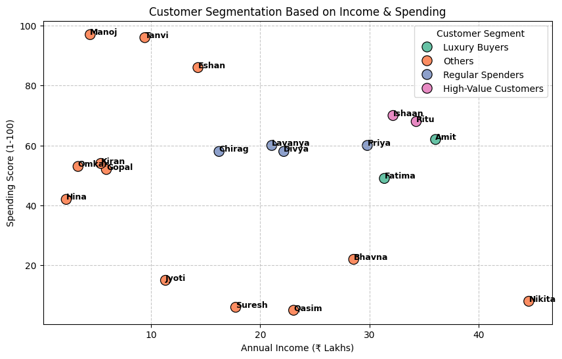

# THE END

