PROJECT REPORT

Library Management System

Submitted by

NAME :TAQIUDDIN

REG NO : 25BAI10349
COURSE:PROGRAMMING IN JAVA
COURSE CODE : CSE2006
SESSION:FALL SEMESTER 2026-27
FACULTY: DR. P MUTHUSUNDARI

1. Title
Library Management System — a command-line application for managing a library's book catalog and borrowing records.

2. Problem Statement
Small libraries and reading rooms often track their book inventory and lending activity manually or in disorganized spreadsheets, making it hard to know at a glance which books are available, which are checked out, and to whom. This project implements a lightweight, dependency-free command-line system that lets a librarian manage the catalog and issue/return workflow from a terminal, with all data safely persisted to disk between sessions.

3. Objectives
- Allow adding and removing books from a catalog, each with a title, author, ISBN, and number of copies.
- Allow searching the catalog by title, author, or ISBN.
- Allow issuing a book to a borrower, automatically tracking how many copies remain available.
- Allow returning a previously issued book using its issue record ID.
- Provide visibility into outstanding (unreturned) issues and full issue history.
- Persist all data locally so it is not lost when the program exits.
- Be fully runnable from the command line with no GUI, database server, or external service dependency.

CSV file storage was chosen over a database engine to keep the project fully self-contained: it needs no server, no credentials, and no network access, so it can be cloned and run immediately on any machine with a JDK installed.
.

4. How to Run
Full setup instructions are provided in README.md. In short:
mvn clean package
java -jar target/library-management-system.jar

5. Possible Future Enhancements
- Add due dates and overdue-fine calculation.
- Add multiple borrower fields (e.g., member ID, contact info) and a dedicated Borrower entity.
- Replace CSV storage with an embedded database (e.g., SQLite) for larger catalogs.
- Add unit tests (JUnit) for the Library service layer.
- Add role-based access (librarian vs. student) and a fine-payment ledger.

6. INPUT/OUTPUT

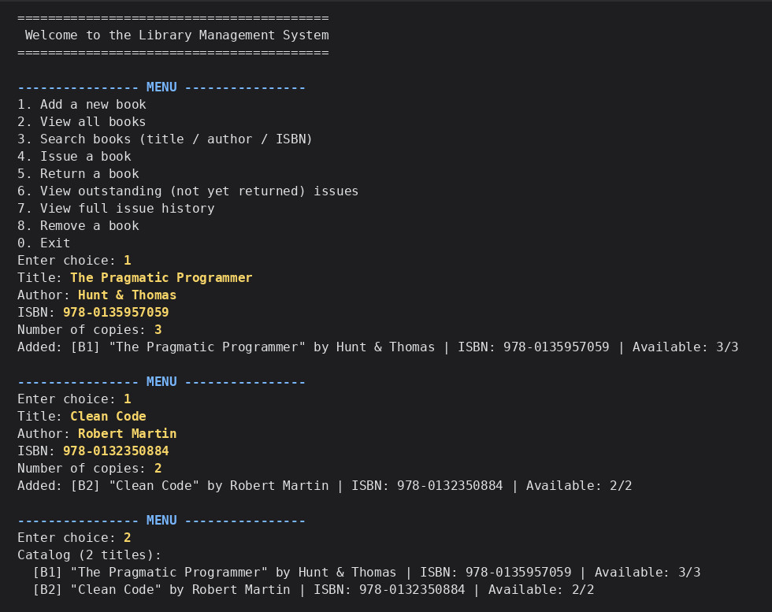

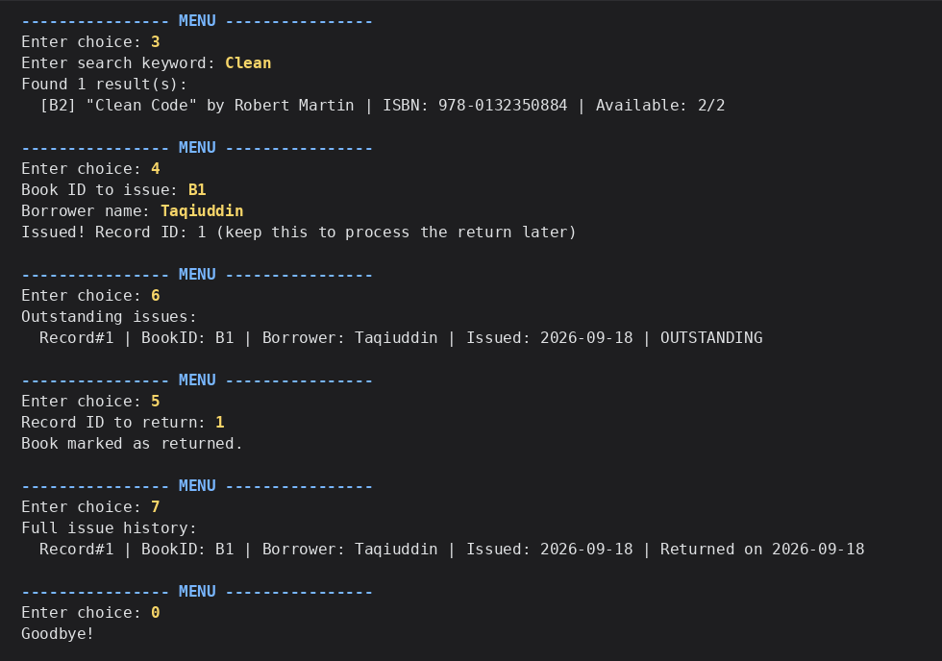

7.Conclusion
The Library Management System meets all stated objectives: it provides a complete, dependency-free, terminal-based workflow for managing a book catalog and its lending activity, with durable local persistence and a menu-driven interface that requires no prior setup beyond a JDK and Maven. The modular, layered design keeps persistence, business logic, and presentation cleanly separated, making the codebase easy to extend with the enhancements outlined above.

