**Securing CI process**

**Task**

It is necessary to implement signature verification for commits in Gitlab-ce, as well as to stop the execution of the pipeline on the gitlab-runner side in case the signature does not match.

**Part 1**

    1. Install Ubuntu 22.04  and allocate 4 GB of RAM to it. To install GitLab-ce, follow a tutorial or video guide

    2. To install GitLab-ce, follow a tutorial or video guide

* Need to install curl - sudo apt install curl
* Don't forget to edit /etc/hosts

    3. Create a gpg key pair

* Help- https://docs.gitlab.com/ee/user/project/repository/signed_commits/gpg.html
* Specify email  admin@example.com

4. Copy the public part of the key to User Settings>GPG Keys.

    5. Clone the previously created project.

    6. Create any file/script and commit the changes, not forgetting to sign it

The result should be this(You will see green Verified picture in the Project>code>commits field):

https://lh7-us.googleusercontent.com/Xv-yi08XuzQmz26BEriuY1SC_A-3QXJchv6DcrFLOUpgL19ND6YX8QOEbGqvNiP97bG-sUVUF5CLxFltrAxOaEmlZG5wBH9GtRwRZLA0zyPx_Ti9AvXx9MOs9bDmy0JRzZyrofGlVoRvzrm8USNbSU0

**Part 2**

    1.Install gitlab-runner tutorial (Needed for executing pipelines after pushing commits).

    2. Register the runner, whereby the executor is specified as shell (Register token you can find in Project>Settings>CI/CD>Runners).

    3. In the runner settings, you need to select this option

https://lh7-us.googleusercontent.com/44j9f-KZte68yStsoVPX7L7JxsCzaw6cymglYwityKvJUSuQDsYkm-tKvMbDL2r4NOjqqlSiI93dclj81-Hw6xAEbvT_lUx4sOa835Tme9iIrc2AkSgqoRpommvB-qLETlgFgFGzvRKV6aPTZL8Y3e4

    4. Create the Pipeline. (You need to create a file in the project - .gitlab-ci.yml)

    5. The contents of this file can be (export will show all the env variables. Hint  - this may help you to realize checking the commit sign)

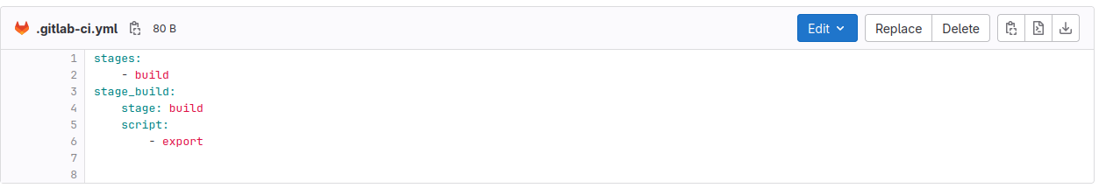

    6. Implement signature verification on the runner side, via config file /etc/gitlab-runner/config.toml

    7. To make everything work, you need to import the public key of the user who signs on behalf of the  gitlab-runner user

  8. The result should be this(with signature):



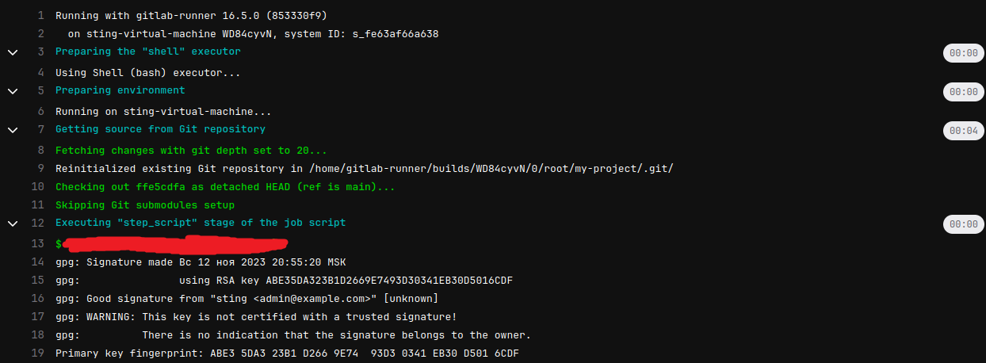

    Without signature:

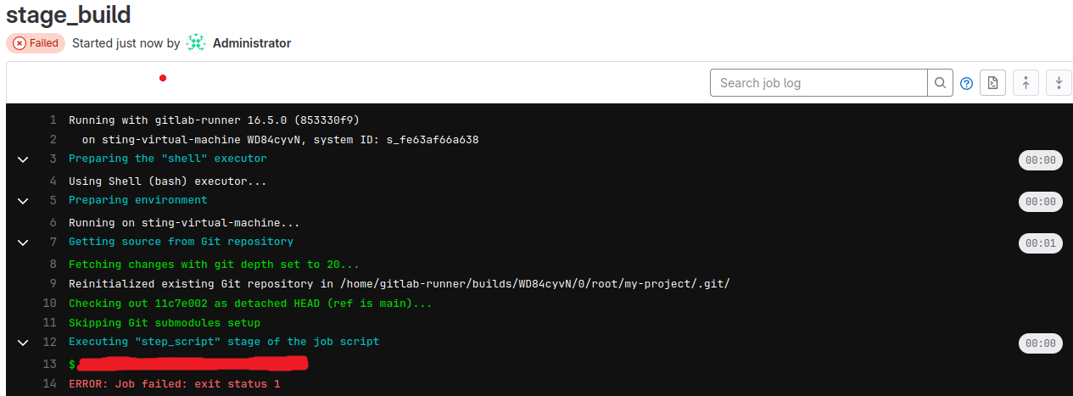

**Answer**

    Send screenshots and descriptions confirming completion of the task. (The job/stage name should be labeled with your name)