Assignment: 3

Course: BMI 506

Date: March 30, 2015

Project Title: Patients Like Mine

Team Members: Matt Halbert (591), Eric Holden (506), Tara Salehpour (506,591), Michelle Winerep (591)

Contributions:
Both, Eric and Tara contributed equally.

Objective
The goal of this project is to implement a tool within the framework of the PLM system that allows a domain expert to author a template for use in the generation of a database query. The templates are composed of an input template, which defines the variables, their ranges, and their relative timeframes in order to determine which patients are considered similar to the patient of interest, and an output template, which defines the variables and their relative timeframe to be extracted from the cohort of similar patients. The authoring tool will allow the domain expert to select the variables to be included in both the input and output templates from an internal knowledge base. The template will then be used in conjunction with a patient of interest's information in order to generate a database query which will then be run on the past patients database(s) to extract information from patients that are determined to be suitably similar.

Our team has decided to use the Fast Healthcare Interoperability Resources (FHIR) Clinical Information Model. The data has already been structured in FHIR, so we feel it is logical to continue to use this model. According to our stakeholder and domain expert, Dr. Peter Li, the values and types in FHIR work well with the data we will be using. According to the FHIR documentation¹, FHIR can satisfy the needs covered by all of the previous primary HL7 standards (V2, V3 and CDA). In many cases, it also provides additional benefits in terms of ease of interoperability. FHIR has a superior ability to interact with EMRs, which is a feature that we will very likely be implementing In order to query and retrieve patient data. The appendix includes the JavaScript Object Notation (JSON) data schema files that will be utilized to build this model.

Deliverables
Since we are unable to produce a working version of the proposed program at this time, we have instead created a mock-up of what this program might look like in practice. Of course, as a mock-up, the features presented may be altered due to feasibility or time constraints that are not clear at this time. As stated in our project description, our goal is to create a tool that tackles both the template creation and query generation aspects of PLM. Since both of these different aspects of PLM will be initiated by different people (a domain expert in the case of template creation, and a clinician in the case of query generation), the final program must accommodate this by offering two different perspectives. The first perspective (Figure 1 below) refers to the template creation aspect of PLM. There are three main windows that will be used. The first window on the left will contain a categorical listing of all the variables that can be included in the input and output templates populated from the internal knowledge base. Parent categories will have + and – buttons beside them to show or hide the children variables or categories. The purpose of this is to allow the user to quickly and easily navigate to a variable of interest. In addition, there will be a search function to navigate directly to a known variable. Ideally, this search functionality will support both plain text look-up and look-up by codes such as LOINC. Once a variable has been navigated to either by hierarchical or direct search, it can be selected. Once selected, the user can press either the “Add to Input” or “Add to Output” buttons to add that variable to the input template or output template respectively. Adding a variable to a template will append that variable to the end of the current list of variables in that template. The modification options available for the variable will depend on both the type of variable (defined within the knowledge base) and the type of template it is added to. For the input template, there are three main types of variables: numeric variables, demographic variables, and categorical variables. Numeric variables will have a range of similarity defined by percentages. These percentages can be asymmetric (+20% through -10%) or denote an exact value (0% through 0%). The numeric variable will also have a relative timeframe drop-down menu which will contain a number of potential values before and after various clinical events. Demographic variables are variables such as gender and race which do not have an easily defined range of similarity. In general, including these variables in the input template means the user is trying to make an exact match, so no similarity range will be defined. Since these values are inherent to the patient and do not change over time, no relative timeframe will be defined either. Categorical variables are variables that have no clearly defined range of similarity (e.g. boolean variables), but whose values do change over time, allowing for a timeframe to be defined. Any variable that is included in the output template will not have a defined range of similarity, since the value will be extracted as-is from the cohort of similar patients. Both the input and output template will allow the user to select a variable by clicking on it. Once selected, the variable can be removed by pressing the appropriate button. Finally, pressing the “Save Template” button will allow the user to name and save the template for later use within PLM. Since the template will only be used within the PLM system, it need not conform to standard file formats.
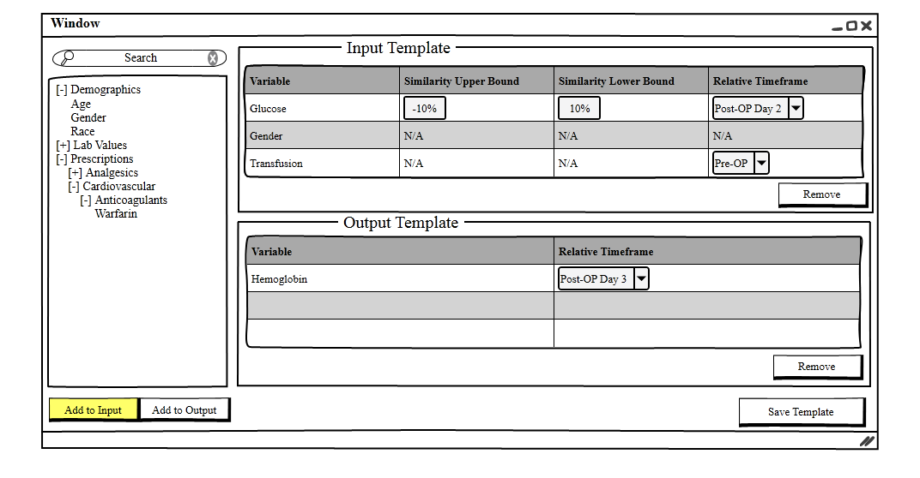
Figure 1: Template Creation (Domain Expert Perspective)

The next perspective (Figure 2 below) refers to the query generation aspects of PLM. This aspect is relatively simple compared to the template creation discussed above. The clinician can select a patient to search on by pressing the appropriate button, which will bring up a listing of the available patients. Once selected, the tool will display the patient's name and ID for verification. The user can then select the appropriate pre-made search template from the drop-down menu. Depending on how many templates are made, this drop-down menu might need to be modified such that the user can select a broad search template category first (e.g. “Colorectal Surgery”) before selecting the specific template of interest. Once a patient and template are selected, the user can click the “Initiate Search” button to generate the query.
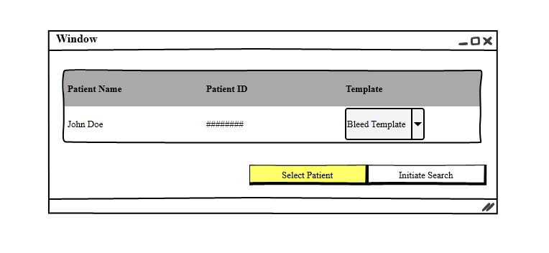
Figure 2: Query Generation (Clinician Perspective)

To illustrate how this system might work in practice, we have created an example template for Post-OP day 2 of colorectal surgery to detect bleeds. The sample input and output templates can be found in Figure 3 below. Note that since this is an example, the variables and similarity ranges included may be very different in actual practice.
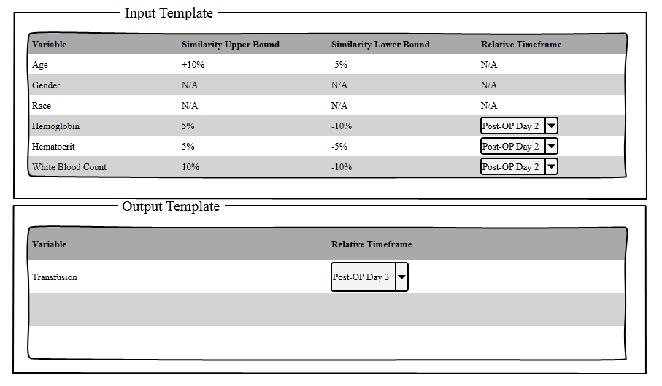
Figure 3: Bleed Template Example

If this template were applied to a Caucasian male of age 30 with a hemoglobin measurement of 16 gm/dL, a hematocrit of 50%, and a white blood count of 6000 c/mcL in relation to a surgery performed on 01/01/15, then the query below (Figure 4) would be generated. The query ranges are generated by multiplying the patient of interest's values by the percentages defined in the template if applicable. For example, a range of +-10% would multiply the original value by 1.1 and .9 respectively. The result of that multiplication is then rounded to the nearest valid value for that variable. In the example below, all values were rounded to integers. Again, it should be noted that this query is merely an example using SQL. The form of the query may need to be altered to conform to the file system in use as well as the structure of the data within it.

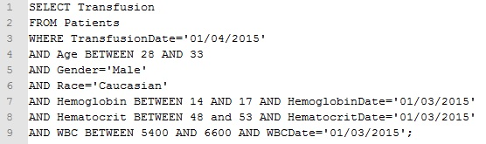
Figure 4: Query Example
References
- Hl7.org [Internet]. The relationship between FHIR and other HL7 standards; 2015 [cited 24 March 2015]; Available from: http://www.hl7.org/implement/standards/fhir/comparison.html

Appendix
JSON Data Schema

Encounter
{
"identifier" : [
{
"use" : "official",
"value" : "123_1234567_12345678901234567890"
}
],
"extension" : [
{
"valueDate" : "2000-01-01T01:01:01.0000000",
"url" : "http://mayo.edu/#OREntry"
},
{
"valueDate" : "2000-01-01T01:01:01.0000000",
"url" : "http://mayo.edu/#AnesthesiaStarted"
},
{
"valueDate" : "2000-01-01T02:02:02.0000000",
"url" : "http://mayo.edu/#SurgeryStarted"
},
{
"valueDate" : "2000-01-01T03:03:03.0000000",
"url" : "http://mayo.edu/#SurgeryEnd"
},
{
"valueDate" : "2000-01-01T04:04:04.0000000",
"url" : "http://mayo.edu/#AnesthesiaEnd"
},
{
"url" : "http://mayo.edu/#ORExit"
},
{
"url" : "http://mayo.edu/#PACUStart"
},
{
"url" : "http://mayo.edu/#PACUEnd"
},
{
"url" : "http://mayo.edu/#PACUDischarge"
}
],
"resourceType" : "Encounter",
"subject" : {
"reference" : "Patient/1234567"
}
}

Flowsheet1
{
"extension" : [
{
"valueDate" : "2000-01-01T:01:01.100000",
"url" : "http://ease.mayo.edu/#LastUpdateDtTm"
},
{
"valueCodeableConcept" : {
"text" : "FlowSheet",
"coding" : [
{
"display" : "FlowSheet",
"code" : 1001
}
]
},
"url" : "http://ease.mayo.edu/#Source"
}
],
"resourceType" : "Observation",
"subject" : {
"reference" : "Patient/1234567"
},
"status" : "final",
"name" : {
"text" : "POSITION/CUFF",
"coding" : [
{
"display" : "Position/Cuff-ILW-XCNCPT",
"code" : "POSITION/CUFF"
}
]
},
"valueString" : "Lt Arm Sit",
"identifier" : {
"use" : "official",
"value" : "123_1234567_123456789_VITAL SIGNS._10"
},
"appliesDate" : "2000-01-01T01:01:01.0000000",
"issued" : "2000-01-01T01:01:01-01:00"
}

Flowsheet2
{
"extension" : [
{
"valueDate" : "2000-01-01T01:01:01.1000000",
"url" : "http://ease.mayo.edu/#LastUpdateDtTm"
},
{
"valueCodeableConcept" : {
"text" : "FlowSheet",
"coding" : [
{
"display" : "FlowSheet",
"code" : 1001
}
]
},
"url" : "http://ease.mayo.edu/#Source"
}
],
"resourceType" : "Observation",
"subject" : {
"reference" : "Patient/1234567"
},
"status" : "final",
"name" : {
"text" : "SYSTOLIC BP (MMHG)",
"coding" : [
{
"display" : "Systolic BP (mmHg)-ILW-XCNCPT",
"code" : "SYSTOLIC BP (MMHG)"
}
]
},
"valueQuantity" : {
"value" : 120,
"units" : "MMHG"
},
"identifier" : {
"use" : "official",
"value" : "123_1234567_123456789_VITAL SIGNS._8"
},
"appliesDate" : "2000-01-01T01:01:01.0000000",
"issued" : "2000-01-01T01:01:01-01:01"
}

Flowsheet3
{
"extension" : [
{
"valueDate" : "2000-01-01T01:01:01.1000000",
"url" : "http://ease.mayo.edu/#LastUpdateDtTm"
},
{
"valueCodeableConcept" : {
"text" : "FlowSheet",
"coding" : [
{
"display" : "FlowSheet",
"code" : 1001
}
]
},
"url" : "http://ease.mayo.edu/#Source"
}
],
"resourceType" : "Observation",
"subject" : {
"reference" : "Patient/1234567"
},
"status" : "final",
"name" : {
"text" : "PULSE RATE/MIN",
"coding" : [
{
"display" : "Pulse Rate/min-ILW-XCNCPT",
"code" : "PULSE RATE/MIN"
}
]
},
"valueQuantity" : {
"value" : 80,
"units" : "/MIN"
},
"identifier" : {
"use" : "official",
"value" : "123_1234567_123456789_VITAL SIGNS._6"
},
"appliesDate" : "2000-01-01T01:01:01.0000000",
"issued" : "2000-01-01T01:01:01-01:00"
}

MedAdmin1
{
"dosage" : [
{
"site" : {
"text" : "E012345H"
},
"quantity" : {
"value" : 0,
"code" : 2.000,
"units" : "GM"
},
"timingPeriod" : {
"end" : "1/1/2000 1:01:00 PM",
"start" : "1/1/2000 1:01:00 PM"
},
"route" : {
"text" : "IV"
}
}
],
"resourceType" : "MedicationAdministration",
"whenGiven" : {
"end" : "1/1/2000 1:01:00 PM",
"start" : "1/1/2000 1:01:00 PM"
},
"status" : "completed",
"prescription" : {
"reference" : "http://mayo/ease/componentid/12345678",
"display" : "CEFAZOLIN 2 GM/10 ML SYRINGE"
},
"identifier" : [
{
"use" : "official",
"value" : "123_1234567_1234_1234_1_1"
}
],
"patient" : {
"reference" : "Patient/1234567"
},
"medication" : {
"display" : "CEFAZOLIN 2 GM/10 ML SYRINGE"
},
"practitioner" : {
"reference" : "/",
"display" : "doctor, doctor d"
}
}

MedAdmin2
{
"dosage" : [
{
"site" : {
"text" : "E012345H"
},
"quantity" : {
"value" : 0,
"code" : "NewBag/Sy$",
"units" : "ML"
},
"timingPeriod" : {
"end" : "1/1/2000 1:01:00 PM",
"start" : "1/1/2000 1:01:00 PM"
},
"route" : {
"text" : "IV"
}
}
],
"resourceType" : "MedicationAdministration",
"whenGiven" : {
"end" : "1/1/2000 1:01:00 PM",
"start" : "1/1/2000 1:01:00 PM"
},
"status" : "completed",
"prescription" : {
"reference" : "http://mayo/ease/componentid/12345678",
"display" : "SODIUM BICARBONATE 50 MEQ VIAL"
},
"identifier" : [
{
"use" : "official",
"value" : "123_1234567_1234_1234_1_1"
}
],
"patient" : {
"reference" : "Patient/1234567"
},
"medication" : {
"display" : "SODIUM BICARBONATE 50 MEQ VIAL"
},
"practitioner" : {
"reference" : "/",
"display" : "nurse, nurse n"
}
}

Order
{
"when" : {
"schedule" : {
"event" : [
{
"start" : "2005-01-01T01:01:01.0000000"
}
]
}
},
"source" : {
"reference" : "/",
"display" : "patient, patient p"
},
"identifier" : [
{
"use" : "official",
"value" : "123_1234567_123456789^ICC-EO_123456789^ICC-EO"
}
],
"extension" : [
{
"url" : "http://ease.mayo.edu/#orderGroup",
"valueString" : "MED"
},
{
"url" : "http://ease.mayo.edu/#orderType",
"valueString" : "RX"
},
{
"url" : "http://ease.mayo.edu/#orderSubType",
"valueString" : "RX"
},
{
"url" : "http://ease.mayo.edu/#orderStatus"
}
],
"resourceType" : "Order",
"subject" : {
"reference" : "Patient/1234567"
},
"date" : "2000-01-01T01:01:01.0000000"
}

Patient
{
"extension" : [
{
"valueCodeableConcept" : {
"coding" : [
{
"system" : "http://mayoweb.mayo.edu/dms-it/reference/data_standards/reg-ctable-race.html#curr_race",
"code" : "O"
}
]
},
"url" : "http://mayoweb.mayo.edu/dms-it/reference/data_standards/reg-ctable-race.html#curr_race"
},
{
"valueCodeableConcept" : {
"coding" : [
{
"system" : "http://mayoweb.mayo.edu/dms-it/reference/data_standards/reg-ctable-race.html#curr_ethn",
"code" : "N"
}
]
},
"url" : "http://mayoweb.mayo.edu/dms-it/reference/data_standards/reg-ctable-race.html#curr_ethn"
},
{
"valueCodeableConcept" : {
"coding" : [
{
"system" : "http://mayo.edu/#Religion"
}
]
},
"url" : "http://mayo.edu/#Religion"
}
],
"language" : "EN",
"resourceType" : "Patient",
"name" : [
{
"given" : [
"first"
],
"use" : "usual",
"suffix" : [
"Mr."
],
"text" : "last, first",
"family" : [
"last"
]
}
],
"birthDate" : "2000-01-01T00:00:00.0000000",
"identifier" : [
{
"use" : "official",
"value" : 1234567
},
{
"use" : "usual",
"value" : 01234567
}
],
"address" : [
{
"country" : "USA",
"zip" : "12345-6789",
"city" : "anycity",
"extension" : [
{
"valueCodeableConcept" : {
"coding" : [
{
"system" : "http://mayo.edu/#County",
"code" : "anycounty"
}
]
},
"url" : "http://mayo.edu/#County"
}
],
"use" : "home",
"state" : "ZZ",
"line" : [
"123 Main Street"
]
}
],
"communication" : [
{
"coding" : [
{
"code" : "EN"
}
]
}
],
"telecom" : [
{
"use" : "home",
"system" : "phone",
"value" : "(123)123-1234"
},
{
"use" : "work",
"system" : "phone"
}
],
"gender" : {
"coding" : [
{
"system" : "v3/AdministrativeGender",
"code" : "M"
}
]
},
"maritalStatus" : {
"coding" : [
{
"system" : "v3/MaritalStatus",
"code" : "M"
}
]
}
}

Procedure
{
"performer" : [
{
"person" : {
"reference" : "Practitioner/12345678",
"display" : "surgeon, surgeon surgeon"
}
}
],
"resourceType" : "Procedure",
"date" : {
"end" : "2000-01-01T01:01:01.0000000",
"start" : "2000-01-01T02:02:02.0000000"
},
"subject" : {
"reference" : "Patient/1234567"
},
"report" : [
{
"display" : "XX"
}
],
"outcome" : "Z",
"identifier" : [
{
"use" : "official",
"value" : "123_1234567_12345678-1"
}
],
"bodySite" : [
{
"coding" : [
{
"display" : "Chest-- 2 Views",
"code" : 01234
}
]
}
],
"indication" : [
{
"coding" : [
{
"display" : "cough, SOB"
}
]
}
],
"type" : {
"coding" : [
{
"display" : "RADIOLOGY",
"code" : 1234
}
]
}
}

