**Netra Video Analytics Tool – Functional and UI Specs**

Incorporating video analytics into the current Netra dashboard.

**1. Uploading Images and Videos**

In the upper right hand corner of the dashboard window, where the user’s email is, is a drop-down menu. This will now include “Upload videos” and “Upload images” options. Each of these menu selections will launch a window where users can select which files to upload.



Note: behind the scenes the uploaded files will need to be tagged for access, so that only the users who upload the image/video files can search on and find those files.

**2. Searching**

The Search button is now a drop-down button with two options - “Search Images” and “Search Videos”. By default the button is set to “Search Images”:



When the user click-holds the button they see an option to choose “Search Videos”:



When “Search Images” is selected the “Search on/social media icons” are displayed, but when “Search Videos” is selected, the social media icons disappear:



*Open question: will video analytics users need the ability to search on context/humans and time window as well?*

**2a. Searching through Videos**

Action: Users type a brand into the Search bar and click the “Search Videos” button.

Result: Thumbnails of the matching videos are shown in the main window:

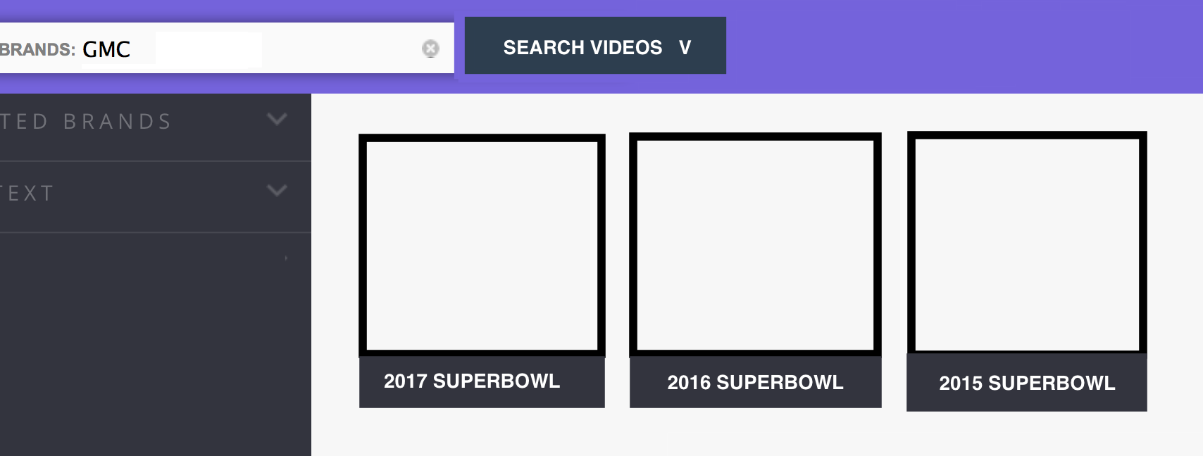

We can sort the videos in various ways – date, logo prominence, etc. We could also allow users to hover over any thumbnail to view video-level analytics.

*Open question: will video analytics users need the left hand pane that shows related brands and context?*

Action: Users double-click on any video thumbnail

Result: A detailed view of the video is displayed:

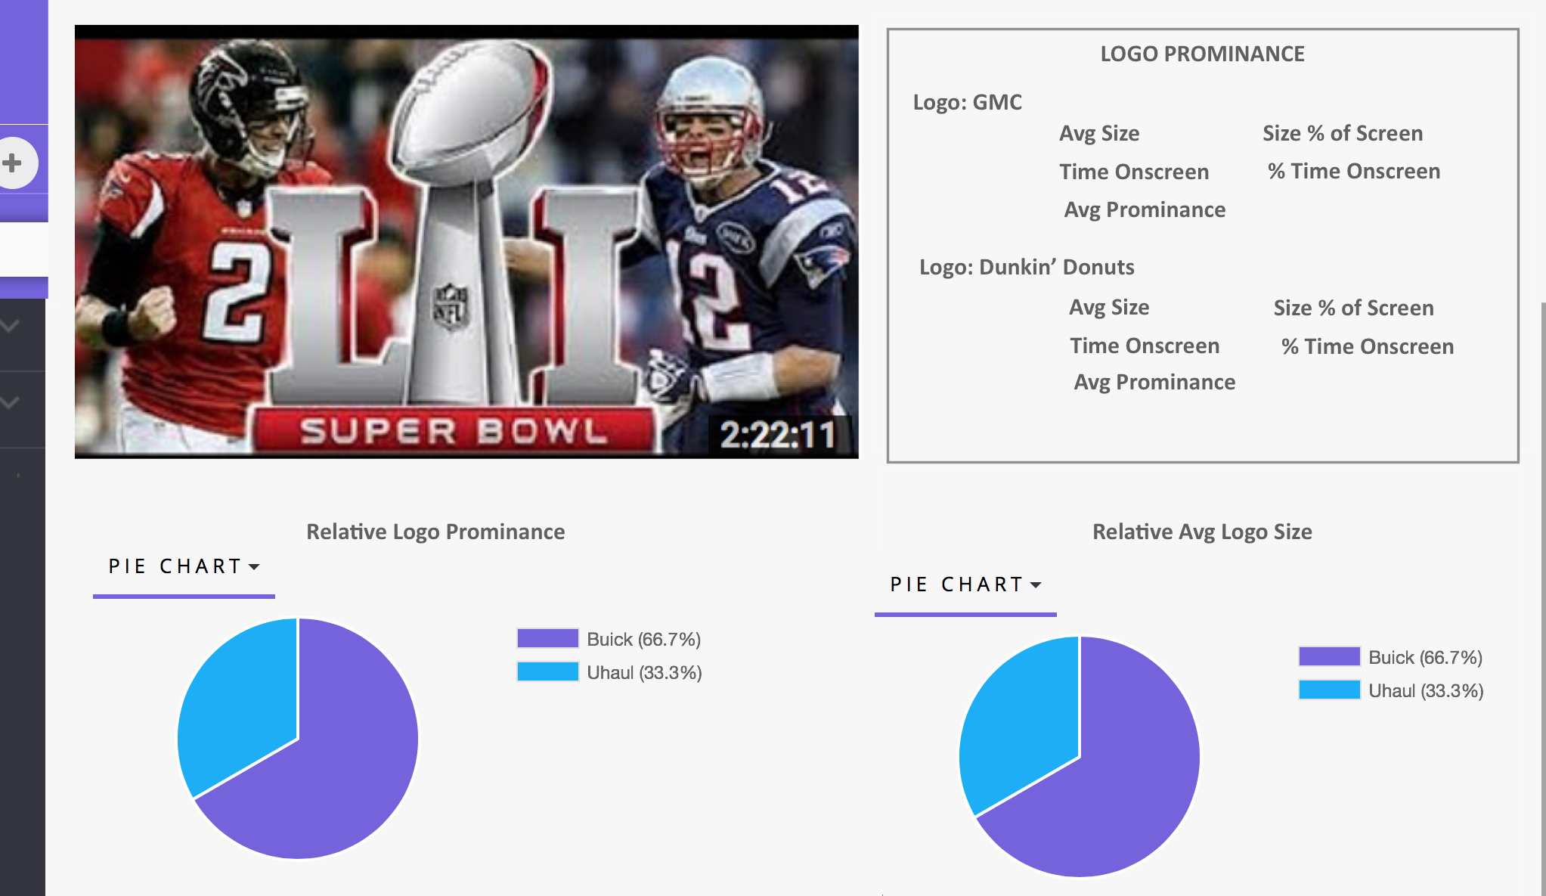

**3. Detailed Video Stats View**

This view contains a few frames:

1. The video
2. Video-level Stats. The Video Stats frame displays, for each logo seen in the video:
   * The logo
   * The average logo size
   * % of time that the logo was visible onscreen
   * The average logo prominence – calculated based on a formula using the logo size, the quadrant the logo is shown in, and the length of time the logo was visible in the video
3. Below the Video Stats frame are a couple of other frames containing pie charts showing each logo’s relative duration and relative prominence.
4. Nice-to-have/Phase 2 ideas:
   1. Show frame-specific analytics. Allow users to stop at any point in the video and see analytics for that frame: logos present, logo size, prominence rating, etc.
   2. Put a horizontal pane below the video which shows the logo prominence/size as it changes throughout the duration of the video.

*Open question: will video analytics users need the left hand pane that shows related brands and context?*