Tara Sadowski

02/24/21

IT FDN 130 A Wi 21: Foundations Of Databases & SQL Programming

Assignment 06

Views, Functions, and Stored Procedures

## Introduction

Views, along with Functions and Stored Procedures, are stored queries and subroutines. They can be used to create relational tables and preform transactions without directly affecting the data stored in the database.

## When Views are Used

Views are useful for a variety of actions. They allow complex select commands to be reduced to a single line command, saving time and allowing access to less technically proficient users. Views also allow grouping and perform aggregations on the data to be stored separately. Views can also be used add a layer of security, as they create table views that are built out of the stored data, but do not actively allow such data to be altered (in most cases, there are exceptions).

## Differences Between Views, Functions, and Stored Procedures

Views are queries of relational tables (figure 1). While a View can include tables where the presented data is created through aggregations and functions, the view does not perform the actions.

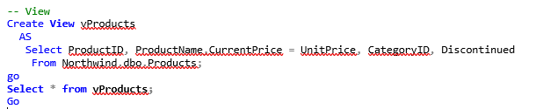

Figure – View (same returned information as other figures)

Functions, similar to views, can return a table. Unlike views, it can use parameters that the user can include to define what data the table returns (figure 2). Scaler functions can also return single values.

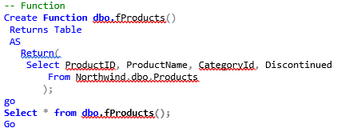

Figure - Function (same returned information as other figures)

Stored Procedures (Figure 3) are similar to Functions except they allow for more flexibility than functions and can return multiple results.

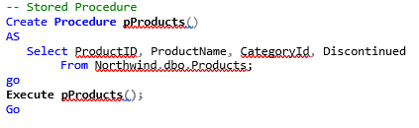

Figure - Stored Procedure (same returned information as other figures)

## Conclusion

Views, Functions, and Stored Procedures are all similar in that they allow for greater ease in entering common and complex statements and procedures and add in levels of security to the underlying database from unintended or unwanted manipulation. The three do differ on the levels of complexity allowed and how much user can influence the results.