Future Improvements to ProduceRetailDB
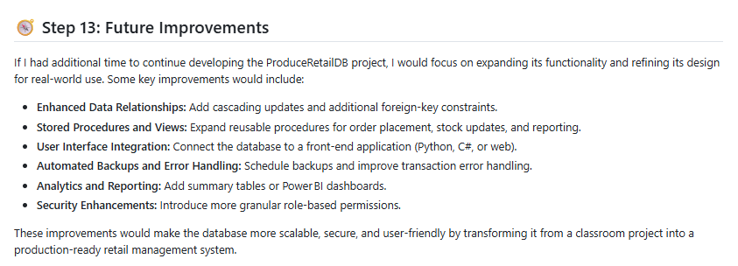

- Enhanced Data Relationships: Introduce foreign‑key constraints and cascading updates to strengthen referential integrity between tables such as `Orders`, `OrderItems`, and `Inventory`.
(I purposely only included essential constraints as this is an introductory project but given more time, I think I would have wanted to strengthen referential integrity as best practice.)
- Stored Procedures and Views: Replace repetitive queries with stored procedures for common operations (e.g., placing an order, updating stock) and create views for simplified reporting.
(I created several stored procedures for common retail metrics, but they mostly focus on displaying sales data. If I continued the project, I’d want to build procedures that automate everyday tasks, things like placing an order or updating stock. I also think adding more views would make reporting easier and more user-friendly.)
- User Interface Integration: Connect the database to a front‑end application using Python or C# to allow staff to manage customers and inventory through a graphical interface.
(Realistically, not everyone using a system like this would be comfortable writing SQL queries. If I had more time, I’d create a small API or a basic front-end. Even a simple interface would make the database much easier for people of varying technical ability.)
- Automated Backups and Error Handling: Schedule regular backups and add error‑handling logic to transactions to improve reliability.
(I think a lot in terms of QA, so I’d like to add more detailed error-handling logic to transactions and set up automated backups. These are small things, but they would make a big difference in reliability.)
- Analytics and Reporting: Implement summary tables or Power BI dashboards to visualize sales trends and inventory levels.
(Because I’ve worked with Power BI, I can’t help but think how much more meaningful the sales metrics would be if they were visualized in a dashboard. Turning my common retail procedures into charts and reports would make the data much easier to understand.)
- Security Enhancements: Add role‑based permissions beyond `db_owner` and `db_datareader`, such as a `db_datawriter` role for staff who need limited update access.
(I think security should be at the forefront of everything we do. I only created basic admin and staff logins, but in a real system I’d want more detailed role-based permissions. Adding custom roles for different staff responsibilities would make the system safer and more realistic.)

