“Infinite Ride -Vehicle Rental Service System”


BY
Name: TARA PAUDEL
TU Registration Number: 7-2-1133-29-2021
College Roll No: 08
Chitwan College of Technology
Department of Information Management
Bharatpur-12, Chitwan

A Project Report Submitted to
Faculty of Management, Tribhuvan University
in partial fulfillment of the requirements for the degree of
Bachelor of Information Management(BIM)

Bharatpur
2025

STUDENT DECLARATION

This is to certify that I have completed the Project entitled "Vehicle Rental System" under the guidance of "Pravesh Koirala" in partial fulfillment of the requirements for the degree of Bachelor of Information Management at Faculty of Management, Tribhuvan University. This is my original work, and I have not submitted it elsewhere earlier.

Date: ..……..…….
Tara Paudel

CERTIFICATE FROM THE SUPERVISOR

This is to certify that the project entitled “Vehicle Rental System” is an academic work done by “Tara Paudel” submitted in partial fulfillment of the requirement for the degree of Bachelor of Information Management at Faculty of Management, Tribhuvan University under my guidance and supervision. To the nest of my knowledge, the information presented by her in the project report has not been submitted earlier.

………………………
Pravesh Koirala
Date:

APPROVAL SHEET

This is to certify the project entitled “Vehicle Rental System” submitted by “Tara Paudel” has been examined and approved. In our opinion, it meets the required scope and quality standards for a project submitted in partial fulfillment of the requirement for the degree of Bachelors of Information Management.
Approval Panel:
S. No. | Name | Designation | Signature
1 | Pravesh Koirala | Project Supervisor
2 | Nirjan Ghimire | Program Coordinator
3 |  | Internal Examiner
4 |  | External Examiner

Date of Defense: …………….
Department: Information Management
Faculty: Faculty of Management

ACKNOWLEDGEMENT

I extend my heartfelt gratitude to all those who have been instrumental in the completion of the Vehicle Rental System. Firstly, I would like to express my sincere appreciation to my supervisor for their invaluable guidance, encouragement, and expertise throughout this project. Their insights and support played a crucial role in shaping the system’s development and success. I am also deeply thankful to the faculty members at the Department of Computer Application for equipping me with the necessary knowledge and resources to undertake this project. Their teachings and mentorship have been invaluable in my journey.
Furthermore, I would like to extend my gratitude to the vehicle rental company for their cooperation and assistance in providing the necessary data and requirements, which helped in designing a system that meets real-world needs. My deepest appreciation goes to my family and friends for their unwavering support, motivation, and understanding throughout this endeavor. Their encouragement has been a constant source of inspiration.
Lastly, I am grateful to all the users who participated in testing and provided valuable feedback. Your suggestions and inputs have been instrumental in refining and improving the system, ensuring a seamless and efficient experience.

Tara Paudel

ABSTRACT

This project presents the design and development of a vehicle rental system that provides a user-friendly and efficient platform for customers to rent vehicles online. The system allows users to browse available vehicles, request a driver if needed, and complete rental bookings seamlessly. Key functionalities include vehicle categorization, user management, rental order processing, and booking confirmation.
The primary objective of this project is to implement core concepts of database management, web development in the context of vehicle rentals. Built using Django for the backend (Django Software Foundation, 2024), HTML, CSS, Tailwind, JavaScript for the frontend, and SQLite as the database, the system ensures smooth functionality tailored for a single-company rental service.
Additionally, this project focuses on providing a responsive, and structured platform while enhancing our technical expertise through real-world application. The system serves as a foundation for further enhancements, such as integrating multiple branches, refining the admin panel, and improving the user experience.

TABLE OF CONTENTS

STUDENT DECLARATION ii
CERTIFICATE FROM THE SUPERVISOR iii
APPROVAL SHEET iv
ACKNOWLEDGEMENT v
ABSTRACT vi
LIST OF FIGURES ix
LIST OF ABBREVIATIONS x
Chapter 1: INTRODUCTION 1
1.1 Introduction 1
1.2 About Organization 1
1.3 Problem Statement 2
1.4 Objectives 2
1.5 Scope 3
1.6 Project Features 3
1.7 Limitations 4
1.8 Development Methodology 5
1.9 Report Organization 6
Chapter 2: BACKGROUND STUDY AND LITERATURE REVIEW 7
2.1 Background Study 7
2.2 Literature Review 7
Chapter 3: SYSTEM ANALYSIS AND DESIGN 9
3.1 System Analysis 9
3.1.1 Required Analysis 9
3.1.2 Feasibility Study 10
3.1.3 Analysis 11
• Sequence Diagram 11
CHAPTER 4: SYSTEM DESIGN 15
4.1 System Design Concepts 16
4.1.1 Component Diagram 16
4.1.2 Deployment Diagram 17
CHAPTER 5: IMPLEMENTATION AND TESTING 18
5.1 Implementation 18
5.1.1CASE Tools 18
5.1.2 Tool Used 18
5.2 Testing 19
5.2.1 Test Case for Unit Testing 19
5.2.2 Test Case for System Testing 21
5.3 Result Analysis 21
5.4 Risks 23
CHAPTER 6: CONCLUSION AND FUTURE RECOMMENDATIONS 24
6.1 Conclusion 24
6.2 Future Works 24
REFERENCES 25
Appendices 26

LIST OF FIGURES
Figure 1.1: Agile Method 5
Figure 3.1: Use Case Diagram 9
Figure 3.2:Gantt Chart 11
Figure 3.3:Sequence Diagram 11
Figure 3.4: User Activity Diagram 12
Figure 3.5: Admin Activity Diagram 13
Figure 3.6: ER-Diagram 14
Figure 3.7: Schema Diagram 15
Figure 4.1: Component Diagram 16
Figure 4.2:Deployment Diagram 17

LIST OF ABBREVIATIONS

CSS Cascading Style Sheets
GPS Global Positioning System
HTML Hypertext Markup Language
HTTPS Hypertext Transfer Protocol Secure
OTP One-Time Password
SDLC Software Development Life Cycle
UI User Interface
UML Unified Modeling Language

CHAPTER 1: INTRODUCTION

1.1 Introduction
This report documents the development of the Vehicle Rental Service System, a web-based application created as part of the Bachelor's in Information Management program. The system aims to provide a seamless, real-time platform for users to rent vehicles, manage reservations, and track vehicle availability. It allows administrators to efficiently manage the fleet, customer details, and rental transactions, ensuring an organized and streamlined process for vehicle rental.
By offering an intuitive interface, the system empowers users to make informed decisions on vehicle rentals based on availability, price, and location. Admins have the ability to manage vehicle listings, monitor bookings, and update rental terms, ensuring smooth operations. While the website does not facilitate direct payments, it serves as a reliable platform for vehicle rentals, offering users an overview of options available.
The Vehicle Rental Service System addresses a growing need for efficient vehicle rental management and streamlined user experience. This project contributes to improving customer satisfaction, operational efficiency, and overall transparency within the vehicle rental industry.

1.2 About Organization
Infinite Ride is a trusted and customer-centric vehicle rental service dedicated to providing reliable and affordable transportation solutions. Established in [2025], Infinite Ride has grown into a reputable name in the industry, known for its commitment to quality service, well-maintained vehicles, and customer satisfaction.
Infinite Ride offers a diverse fleet of vehicles, including cars, SUVs, jeeps, buses, and bikes to a wide range of customer needs from individual travelers to group tours. Customers can choose between self-drive options for cars or company provide driver for added convenience on selected vehicles.
At Infinite Ride, we prioritize safety, convenience, and affordability, ensuring that every rental experience is smooth and hassle-free. Our company continuously adapts to customer preferences and industry trends modern fleet management practices to enhance service quality , with a vision to be a leader in the vehicle rental sector, Infinite Ride is committed to providing top-notch services, expanding its offerings, and embracing sustainable business practices, taking cues from services like Getaround (Getaround, 2011). Whether for personal trips, business travel, or group excursions, Infinite Ride remains a trusted choice for reliable transportation.

1.3 Problem Statement
In Nepal, vehicle rental services are an essential part of the transportation industry, providing flexible travel options for individuals and businesses. However, many existing vehicle rental systems face significant challenges related to usability, efficiency, security, and service reliability. Traditional rental processes often involve manual booking, unclear pricing structures, and lack of real-time availability, leading to customer dissatisfaction and operational inefficiencies.
Customers frequently encounter issues such as complicated booking procedures, limited vehicle availability updates, lack of transparency in pricing, and the absence of a streamlined driver request feature. Additionally, rental businesses struggle with vehicle management, tracking reservations, and ensuring smooth communication between customers and service providers.
This project aims to develop a modern, user-friendly, and secure vehicle rental system that enhances the rental experience for both customers and the company. The system will offer an intuitive online booking process, real-time vehicle availability updates, secure customer authentication, and an efficient reservation management system. Customers will be able to select vehicles based on their needs, request drivers where applicable, and receive clear pricing details, ensuring a seamless and transparent rental process.
By implementing a digital vehicle rental platform, this project seeks to address key challenges such as booking inefficiencies, lack of automation, security risks, and operational difficulties, ultimately improving customer satisfaction and optimizing business operations.
1.4 Objectives
This project aims to develop a modern, efficient, and user-friendly vehicle rental system that enhances the rental experience for both customers and administrators. By providing real-time vehicle availability, transparent pricing, and a seamless booking process, the system will streamline operations and improve overall customer satisfaction. Additionally, it will empower administrators with essential tools for managing fleet operations, reservations, and rental policies, ensuring a smooth and well-organized service.
The primary objectives of this project are:
- To provide real-time vehicle availability and pricing information, allowing users to make informed booking decisions.
- To enable customers to book vehicles, view rental details, and manage their booking history, ensuring a seamless experience.
- To equip administrators with advanced tools for fleet management, customer reservations, and rental policies.
- To enhance transparency and efficiency by reducing manual processes and improving communication between users and service providers.

1.5 Scope
The Vehicle Rental System is designed to cater to a single vehicle rental company, with the possibility of future expansion to multiple branches. The system will include the following features:
- User Registration and login Authentication.
- Vehicle listing with detailed information and availability status.
- Booking and Reservation Management.
- Rental history tracking and report generation.
- Admin Dashboard for Fleet and Booking Management.

1.6 Project Features
The vehicle rental system will include multiple user-friendly features to enhance convenience, security, and operational efficiency. The system will provide an intuitive experience for customers looking to rent a vehicle while equipping administrators with robust tools for managing bookings and the fleet.
User Feature:
- User Registration and Login: Secure authentication for customers to manage bookings.
- Vehicle Browsing: Users can view available vehicles and check details.
- Booking System: A seamless booking process allowing customers to reserve vehicles easily.
- Rental History & Management: Users can view past bookings, upcoming reservations, and manage cancellations.

Admin Features:
- Admin Dashboard: A centralized interface to monitor bookings, vehicle status, and customer interactions.
- Vehicle Management: Admins can add, update, or remove vehicle listings with details such as pricing, availability, and rental policies.
- Booking & Customer Management: Admins can oversee reservations, customer profiles.
- Reporting & Analytics: Data-driven insights on business performance, customer trends, and vehicle usage.

1.7 Limitations
- Requires stable internet connectivity for real-time data updates.
- Non-Transactional Features (does not support online payments).
- Potential security risks in managing customer and vehicle data.
- Compatibility across devices may vary.
- Initial focus is limited to a specific region or city for fleet management
1.8 Development Methodology
The Software Development Life Cycle (SDLC) is a structured process that guides the development, maintenance, and enhancement of software.
For this project, we are using the Agile methodology, which focuses on iterative development and continuous feedback. Agile allows for breaking down the development into smaller cycles, enabling flexibility and responsiveness to changing requirements. Each iteration is adjusted based on feedback from users and stakeholders, ensuring that the system evolves to meet their needs. This approach is ideal for small-scale projects like the vehicle rental system, allowing for frequent updates and improvements.

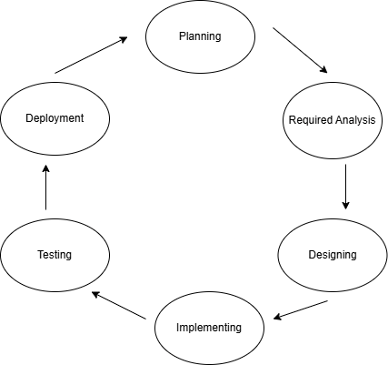
Figure 1.1: Agile Method

1.9 Report Organization
This study has been organized into the following six chapters:
Chapter 1: Outlines the problem definition, project goals, features, scope, and limitations for the Infinite Ride project.
Chapter 2: We examine related research, including assessments of publications, journals, and past theses on vehicle rental platforms and transportation systems. This chapter also discusses the history and advancements in vehicle rental solutions.
Chapter 3: For the Infinite Ride the analysis includes requirements gathering, system architecture, and feasibility studies.
Chapter 4: The system design, covering the overall system architecture, workflow, and visual representations through class, object, activity, and other relevant diagrams for the vehicle rental platform.
Chapter 5: This chapter explores the implementation and testing processes. It also includes the tools and technologies used to create and implement the vehicle rental system.
Chapter 6: We conclude with the project’s completion and discuss potential future enhancements for the Infinite Ride.

CHAPTER 2: BACKGROUND STUDY AND LITERATURE REVIEW
2.1 Background Study
The vehicle rental industry in Nepal has been evolving steadily in recent years, driven by the growing demand for transportation solutions in both urban and rural areas. With the rise in tourism, business activities, and the need for private transportation, vehicle rental services have become an integral part of the travel and transportation sectors. The industry, however, faces challenges such as a lack of standardized services, limited digital platforms for booking, and insufficient online payment systems.
The growth of vehicle rental services in Nepal was initially slow due to limited internet access, low awareness of online services, and the absence of digital payment infrastructure. Over time, however, the introduction of smartphones, mobile internet, and digital wallets like e Sewa and Khalti has significantly improved the ease of access to such services. Furthermore, the increased adoption of social media and online platforms has opened new opportunities for businesses to reach potential customers.
The vehicle rental market has also seen positive growth due to the rise in domestic tourism and increased demand for rentals by both individuals and businesses. Traditional rental services, primarily based in Kathmandu and other major cities, often faced inefficiencies, including manual booking systems, lack of transparency, and limited payment options. However, recent advancements in mobile technology and e-commerce have spurred the emergence of digital platforms offering vehicle rental services with more user-friendly features and improved service delivery.
Our vehicle rental platform, Infinite Ride, aims to address these challenges by offering a digital solution that allows customers to easily book vehicles online, view real-time availability. By focusing on customer experience and convenience, Infinite Ride aims to transform the vehicle rental service landscape in Nepal and provide a reliable, easy-to-use platform for customers.

2.2 Literature Review
Vehicle Rental Platforms in Nepal:
- Sasto Rental: Sasto Rental is one of the notable platforms in Nepal, offering a wide range of vehicles (Sasto Rental, 2024), including cars, SUVs, and motorcycles. It allows customers to book vehicles online through its website and mobile app. The platform's user interface is straightforward, catering to both experienced and new users. It offers features like vehicle availability tracking, customer reviews, and transparent pricing. However, Sasto Rental’s platform has been critiqued for its limited payment options and slow customer support during high-demand periods. It mostly serves customers in urban areas and faces challenges in reaching remote regions.
- Nepal Vehicle Rental: Nepal Vehicle Rental is another established player in the Nepalese vehicle rental industry. The platform offers a variety of vehicles for rent and caters to both tourists and locals. It has an easy-to-navigate website, with a focus on quality and convenience. While the platform is competitive, it lacks some of the more advanced features found in newer platforms, such as real-time vehicle availability and user-friendly booking interfaces. It also primarily operates in Kathmandu and surrounding areas, which limits its market reach.

- Easy Rent Nepal: Easy Rent Nepal is a customer-friendly platform providing a range of well-maintained rental vehicles (Easy Vehicle Rental, 2024), including sedans, SUVs, and 4WDs. It primarily caters to business travelers and families looking for a comfortable rental experience. The platform offers both chauffeur-driven and self-drive options, with flexible rental durations. However, its pricing is on the higher side compared to budget-focused rental services, and its operations are mostly limited to major cities. Additional charges may apply for long-distance travel.

CHAPTER 3: SYSTEM ANALYSIS AND DESIGN

3.1 System Analysis
System analysis is the process of evaluating the vehicle rental platform's requirements, design, and feasibility. It involves breaking down the system into its core components to understand their interaction and ensure the platform meets the project's goals.

3.1.1 Required Analysis
Requirement analysis is a critical first step in the development process, forming the foundation for the success of the Infinite Ride vehicle rental platform. This phase involves gathering and defining both functional and non-functional requirements to ensure the system addresses business needs and provides value to users.
- Functional Requirements:
A specification that outlines the activities, behaviors, or functions that a system,
product, or application must have been known as a functional requirement. The
Functional Requirements of Infinite Ride can be demonstrated using Use Case diagram as:

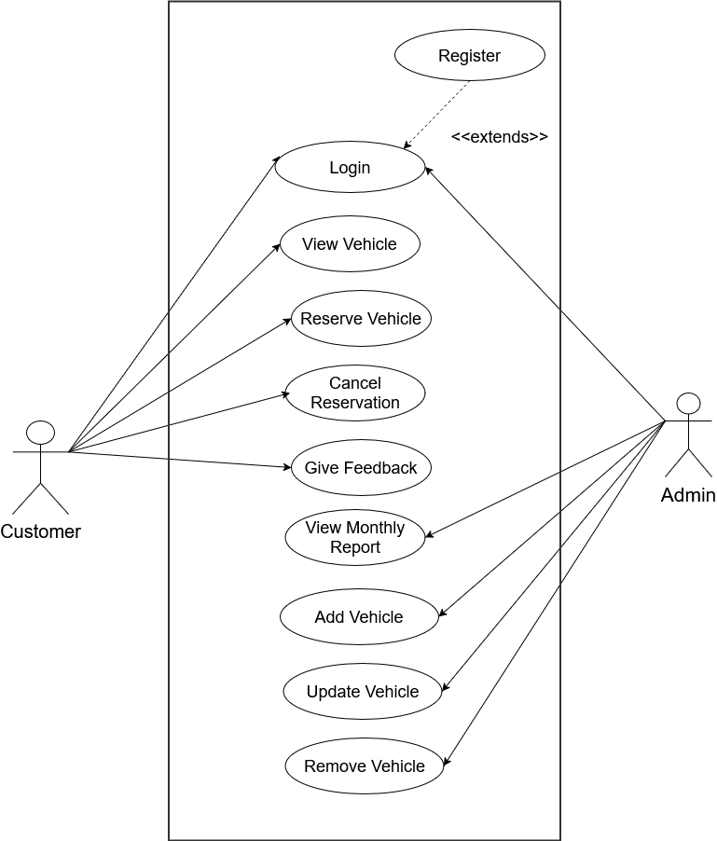
Figure 3.1: Use Case Diagram

- Non-Functional Requirements
- Page Load Time: The system should ensure that the average page load time does not exceed 5 seconds for an optimal user experience.
- Scalability: The system should be scalable both horizontally and vertically, allowing it to handle increased traffic as the user base grows.
- Availability: The platform must maintain a high availability rate, targeting 99.9% uptime to ensure ensuring that customers can access the system for vehicle bookings at any time.
- Security: User passwords must be securely hashed and salted using Django’s built-in authentication system, which follows industry-standard cryptographic algorithms (PBKDF2, Argon2, or bcrypt).
- User Interface: The platform should have a clean, intuitive, and user-friendly interface, making it easy for customers to browse available vehicles, book rentals, and manage their reservations effortlessly.
- Cross-Browser Compatibility: The system must function seamlessly across all major web browsers (e.g., Chrome, Firefox, Safari, Edge), ensuring accessibility to a wide range of users.
3.1.2 Feasibility Study
- Technical Feasibility:
The website leverages compatible technologies for front-end (e.g., HTML, CSS, Bootstrap) and back-end (Python Django). Integration with databases and APIs ensures technical reliability.
- Operational Feasibility:
The system meets the operational needs of vehicle rental services by providing features like real-time vehicle reservation management.
- Economic Feasibility:
The project is cost-effective, requiring minimal investments in hardware and software, with long-term benefits in market transparency and user satisfaction.
- Schedule Feasibility:
The project follows a clear development timeline, ensuring timely delivery of features like user registration, search functionalities, and booking management.

Weeks  Activities | 1st  week | 2nd  week | 3rd  week | 4th  week | 5th  week | 6th  week | 7th  week | 8th  week | 9th  week | 10th  week
Software Analysis
Documentation
System Design
Coding
Testing
Gantt Chart
Figure 3.2:Gantt Chart

3.1.3 Analysis
Sequence Diagram
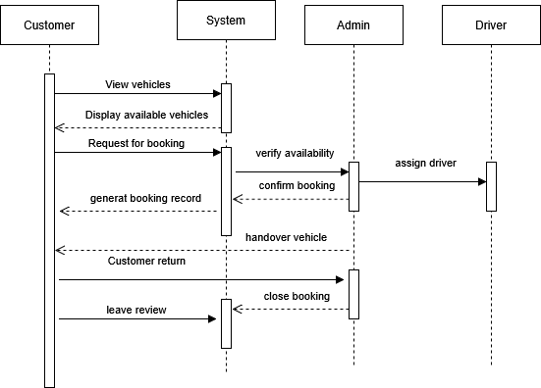
Figure 3.3:Sequence Diagram

- Activity Diagram
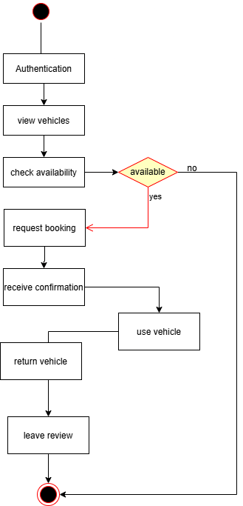
Figure 3.4: User Activity Diagram
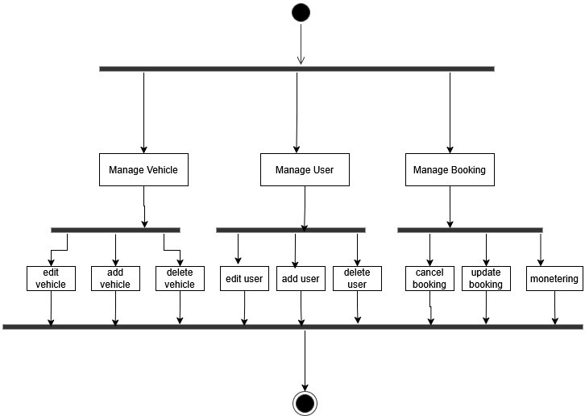
Figure 3.5: Admin Activity Diagram

ER Diagram
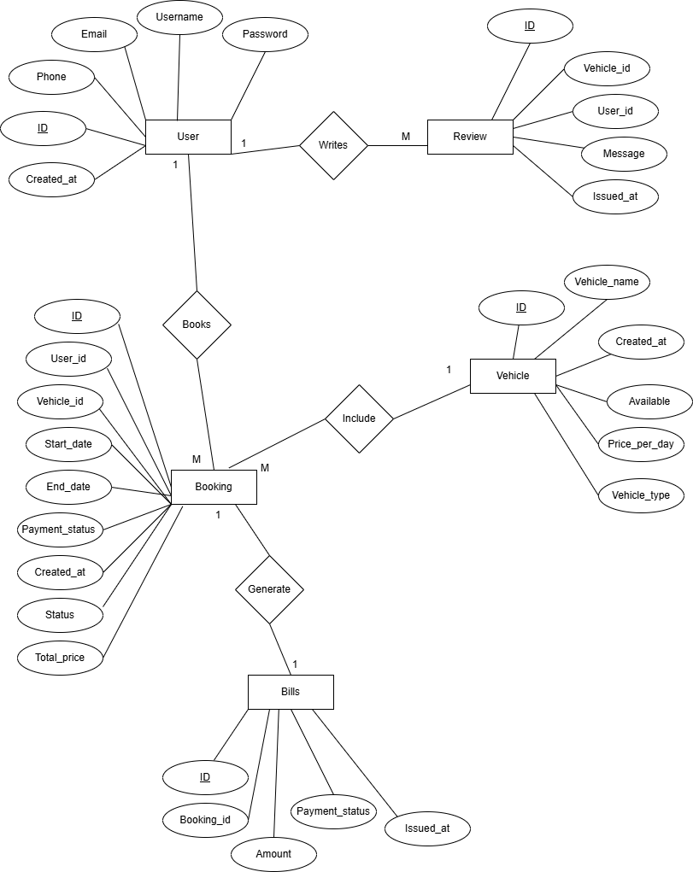

Figure 3.6: ER-Diagram
Schema Diagram
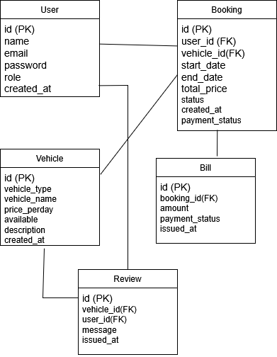

Figure 3.7: Schema Diagram

CHAPTER 4: SYSTEM DESIGN

4.1 System Design Concepts
The Infinite Ride vehicle rental system involves various components that store and manage detailed information about vehicles, bookings, users and fleet management. Below are the core concepts for the system

4.1.1 Component Diagram
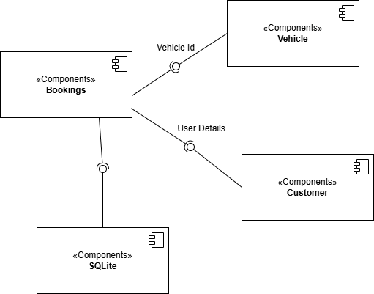
Figure 4.1: Component Diagram
Above figure depicts the relationships and dependencies between various system components in the vehicle rental application. The components in the diagram include Booking, Vehicle, Customer, Account, and SQLite Database. Each component is represented as a rectangular box labeled with the stereotype «component», followed by its name. Arrows and lines between the components indicate the communication or dependency relationships. For example, the Booking component interacts with the Vehicle, Customer, and SQLite Database components, suggesting that it manages the booking process, involving customer details, vehicle selection, and booking storage. Similarly, the Account component handles user authentication and account-related information, storing customer details, login credentials, and booking history. The SQLite Database component acts as the central storage for booking, vehicle, and customer data, supporting the interaction between all other components. This diagram serves as a high-level representation of the software architecture, focusing on the interaction and data flow between the key modules of the system.

4.1.2 Deployment Diagram
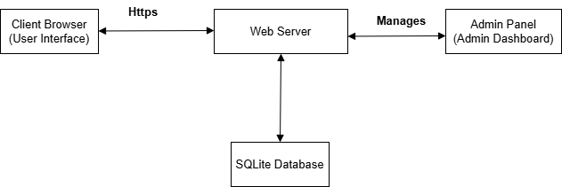
Figure 4.2:Deployment Diagram
Above figure is a UML deployment diagram representing the physical architecture of the Vehicle Rental System and the interactions between its components. It illustrates four key devices:
- Database Server: it responsible for storing and managing system data, including customer information, vehicle availability, and booking details.
- Web Server: The web server processes incoming requests, handles application logic, and serves content to the client. It also interacts with the SQLite Database to fetch and store data related to bookings, vehicles, and customers.
- Client Device: This represents the end-user’s system where customers can interact with the application through the browser to make bookings, view vehicles, and check booking history.
- Admin Panel: It provides an interface for administrators to manage vehicle availability, view and modify bookings, and manage customer accounts. The Admin Panel interacts with the web server to process admin-level requests.
The diagram indicates that the Client Device communicates with the Web Server using HTTPS protocols, typically on port 8000. The Web Server in turn interacts with the Database Server to retrieve or store data from the SQLite Database. Both the Admin Panel and the Customer Interface rely on the web server for data handling and content delivery.

CHAPTER 5: IMPLEMENTATION AND TESTING

5.1 Implementation
To ensure effective project management, planning, development, and deployment, a range of tools and technologies were used during the implementation of the vehicle rental system. Utilizing CASE tools for planning and design, along with programming tools for development, the process was structured around well-defined workflows. This approach ensured the system was delivered with optimal performance, usability, and functionality.

5.1.1CASE Tools
During the development of the vehicle rental system, various CASE tools were used to assist with project management, design, and documentation. The following tools were utilized:
- Draw.io: Wireframes, system architecture diagrams, and user flow charts were created using Draw.io. This tool provided a visual representation of the UI/UX design and helped in understanding the interaction between different system components.
- Microsoft Word: Microsoft Word was used for documenting the development process, code explanations, and project requirements. It played a crucial role in maintaining structured documentation throughout the project.
- Microsoft PowerPoint: Presentations outlining the system’s design, features, and progress were created using Microsoft PowerPoint. These presentations were essential for showcasing the project to stakeholders and team members.

5.1.2 Tool Used
- HTML & CSS: HTML was used for structuring the content on the website
The project design was also informed by online Django tutorials (TechVidvan, 2024)., while CSS was used for styling and layout design.
- Bootstrap: Bootstrap was utilized for responsive design and pre-built UI components, ensuring a consistent and mobile-friendly user interface.
- JavaScript: JavaScript was used to add interactivity and dynamic elements to enhance user engagement.
- Tailwind CSS: Tailwind CSS was employed for styling the admin dashboard, offering a utility-first approach for rapid design adjustments.
- Django: Django served as the back-end framework, providing a secure and efficient environment for handling authentication, routing, and database management.
- SQLite: SQLite was used as the database management system to store and manage user accounts, vehicle and bookings.

5.2 Testing
To guarantee functionality, security, and performance, testing is an essential step in the vehicle rental system development process. Several techniques were used during the testing process to find defects, confirm code behavior, and ensure the platform functions as intended. The two main forms of testing conducted were:

5.2.1 Test Case for Unit Testing
The goal of unit testing is to confirm that each system component such as functions, methods, or classes works. Before incorporating them into the broader system, it ensures that every component of the program functions properly when used separately.
- For User Registration
Table 1: Test Case for User Registration
Test case ID | Test Scenario | Test Steps | Input Test Data | Expected Results | Actual Results | Pass/Fail
TC-1 | Check  Signup  activity  with  valid  data | - Open  the site  and go  to sign  up.  - Fill  Up the  form  and  click  register. | -Name: Tara  -Email: tara1@gmail.com  -phone:9876543210  -password: password123 | User should  get  “Account  Successfully  Created”  message  and  redirected to  login page | As  expected, | Pass
TC-2 | Check  Signup  activity  with  invalid  data | - Open  the site  and go  to sign  up.  - Fill  Up the  form  and  click  register. | -Name: Tara  -Email: tara1@gmail.com  -phone:9876543  -password: pass | User should  Get  “phone number should be 10 digits”,  “Password  should be 8  character  long”  message | As expected, | Pass

- For User Log In
Table 2:Test Case for User Login
Test Case Id | Test Scenario | Test  Steps | Input Test Data | Expected  Results | Actual  Results | Pass/  Fail
TC-3 | Check Sign In activity with valid data | - Open  the site  and go to login  page.  - Enter  email  and  password  and click  login. | -Email: tara1@gmail.com  -Password: password123 | User  should be  logged in  and gets redirected  to home  page. | As  Expected, | Pass
TC-4 | Check Sign In activity with invalid data | - Open  the site  and go to login  page.  - Enter  email  and  password  and click  login. | -Email: tara1@gmail.com  -Password: password | User  should get  “Invalid  password”  error  message. | As  Expected, | Pass

- For Vehicle Booking
Table 3:Test Case for Vehicle Booking
Test  case ID | Test  Scenario | Test Steps | Expected  Results | Actual  Results | Pass/  Fail
TC-6 | Verify vehicle booking process | - Open the site  - Browse available vehicles  - Click "View Details"  - Click "Book Now"  - Fill in the booking form  - Submit the form  -Confirm booking | confirmation message should be displayed saying "Booked" | As expected, | Pass

5.2.2 Test Case for System Testing
System testing is a comprehensive stage where the entire application is examined to ensure that all components function as expected. It involves testing every aspect of the vehicle rental system, including interactions between the front-end and back-end.
- Test for User Registration and Login Flow: We tested whether new users could register and log in using their email and password. The system successfully authenticated registered users and redirected them to the home page. Invalid credentials resulted in an error message.
- Test for Vehicle Booking Process:
We verified that:
- The "Book Now" button was disabled when a vehicle was unavailable.
- When a vehicle was available, clicking "Book Now" opened a form.
- Users could enter start date, end date, and other required details.
- The system accurately calculated and displayed the total rental amount.
- Clicking the "Confirm Booking" button successfully booked the vehicle.
- A "Booked" confirmation message was displayed.
- Test for Booking History and Status Updates: Users could view their booking history, which listed all previous and ongoing bookings. Each booking displayed its status (e.g., Pending, Active, Completed).
- Test for Review Submission After Booking Completion: After a booking was marked "Completed", users could access the review section. Submitted reviews were successfully stored and displayed.
- Test for Bill Generation and Payment Status: After confirming a booking, users could view their bill, which displayed. Once the user paid the amount, the payment status changed to "Paid" in the system by admin.
- Test for User Role and Permissions:
  - Regular users could only book vehicles, view bills, and submit reviews.
  - Admins had full control over Managing vehicle listings, Viewing and updating bookings, Changing booking/payment statuses, Moderating reviews
  - Unauthorized actions were restricted.

5.3 Result Analysis
The outcome analysis of the Vehicle Rental System provides valuable insights into its overall quality, usability, and performance. Based on user acceptance testing and system performance evaluation, the following key areas were analyzed:

• Usability:
The vehicle rental system has an intuitive interface with a user-friendly booking process. The responsive design ensures smooth navigation on both desktop and mobile devices. However, certain areas require improvement, improving the form layout for booking details (start date, end date, total amount, etc.) to enhance clarity.

• Performance:
The system is designed to perform efficiently under normal traffic conditions, ensuring fast page loads and smooth interactions when browsing and booking vehicles. However, performance testing has not been conducted under high traffic conditions. Based on theoretical analysis, the following areas could cause a slow-down when multiple users access the system simultaneously:
- Booking Confirmation Phase
- Viewing Bill or Payment Status.
- While fetching booking history and reviews.

• Security:
The system incorporates basic security measures, such as password hashing for user authentication. However, security testing identified areas for improvement, including:
- Strengthening access control to prevent unauthorized bookings or admin panel access.
- Before full deployment, further penetration testing should be conducted to address potential vulnerabilities.

• Functionality:
The core features of the system, including user registration, vehicle selection, booking confirmation, and bill generation, work as expected. However, a few functional gaps and issues were noted:
- Booking History & Status Updates: Some users reported delays in status updates after confirming a booking.
- Bill Generation: The bill correctly displays user details, total amount but improvements are needed in formatting for better readability.
- Payment Status Updates: After marking a bill as paid, the status sometimes does not immediately update.
- Review System: Users can submit reviews, but occasional delays were observed before they appeared on the system.

5.4 Risks
Although Infinite Ride has great potential in Nepal, it faces several risks. One major risk is that the system doesn’t currently allow online payments at the time of booking, which limits options for customers. However, customers can still make payments online or in cash when they pick up the vehicle. The platform also faces competition from established local rental businesses, as well as challenges related to local regulations, such as licensing and taxes. Additionally, infrastructure issues, especially in rural areas, could lead to delays and higher costs. Security risks, like fraud and cyberattacks, could also threaten user data and trust. To succeed, Infinite Ride will need to form strong local partnerships, plan carefully, and use flexible technology to handle these risks.

Besides these main risks, Infinite Ride faces some other challenges. For example, there’s the risk of vehicle damage or theft during rentals, which can be handled by asking for a security deposit and having clear rental agreements. There’s also the issue of unreliable users who may cancel bookings or not show up.. Vehicle breakdowns or maintenance delays can be reduced by tracking vehicles in real-time and managing maintenance schedules. Lastly, there’s the risk of fraud, like fake information or attempted fraud during payment. This can be minimized by verifying users’ identity and checking their details carefully.

CHAPTER 6: CONCLUSION AND FUTURE RECOMMENDATIONS

6.1 Conclusion
In conclusion, Infinite Ride offers a promising solution for vehicle rentals in Nepal by providing a user-friendly platform for booking vehicles. While the system works efficiently for vehicle selection, booking, and bill generation, there are areas for improvement, particularly in handling user behavior and optimizing performance during high traffic times. Additionally, the lack of an integrated payment gateway and the inability to cancel bookings present some challenges. However, with strategic planning, local partnerships, and continuous system enhancements, Infinite Ride can navigate these risks and provide an efficient, reliable, and secure service to customers across Nepal. By focusing on operational improvements and addressing user concerns, Infinite Ride has the potential to become a trusted and competitive service in the growing vehicle rental market.

6.2 Future Works
In the future, Infinite Ride plans to enhance its platform by integrating a payment gateway to allow seamless online transactions at the time of booking, which will improve convenience for users. Additionally, GPS tracking for vehicle will be introduced to provide real-time updates and improve customer satisfaction, especially in rural areas. Security measures will be further strengthened with the introduction of One-Time Password (OTP) verification to ensure safe user authentication.
To improve the booking experience, the review system will be enhanced by adding verified user tags to help users make more informed decisions. Furthermore, the platform will incorporate AI-driven recommendations based on user behavior and preferences, inspired by platforms like Turo (Turo, 2009) to offer a more personalized experience.
The payment system will also be optimized by integrating regional mobile wallets and digital payment methods to increase user confidence and facilitate transactions.
To encourage customer loyalty, a rewards program may be introduced, offering incentives for recurring bookings. Finally, as the platform grows, continuous performance optimization and scalability improvements will be crucial to maintaining a smooth user experience even during peak usage times.
A user cancellation system will be added, enabling users to cancel bookings within a specified time frame and receive appropriate refunds or cancellation fees, depending on the timing. This will enhance user flexibility and satisfaction.

REFERENCES
Acharya, K. (2024). Online Vehicle Rental System. Online Vehicle Rental System.
Foundation, D. S. (2024). Django Software Foundation. Retrieved from Django documentation: https://docs.djangoproject.com/en/stable/
getaround. (2011, 05 24). Retrieved 12 25, 2024, from https://getaround.com/
Online Car Rental System. (2024). Retrieved from techvidvan.com: https://techvidvan.com/tutorials/python-django-online-car-rental-system/
Rental, E. V. (2024). Easy Vehicle Rental. Retrieved from https://www.easyvehiclerental.com/
Rental, S. (2024). Retrieved from sasto rental: https://www.sastorental.com/
Turo. (2009, 08 12). Retrieved 12 25, 2024, from https://turo.com/

Appendices

