SHELL SCRIPTING: GitHub - LondheShubham153/Shell-Scripting-For-DevOps
- Extension - .sh

#!/bin/sh
# This is a comment!
echo Hello World # This is a comment, too!

#!/bin/sh - shebang – The first line tells Unix that the file is to be executed by bourne shell which is located at /bin/sh
#!/bin/bash - The first line tells Unix that the file is to be executed by bourne again shell which is located at /bin/bash

- If we run : $ls hello.sh , we will see that the shell script does not have executable permission. So we will give that before executing
now run chmod 755 hello.sh to make the text file executable
- Run ./hellp.sh to run the shell script.
- # -> single line comment
<< comment
….
Comment
- Multi-line comment
- Variable:
var.sh
#!/bin/sh
name="Hello World"
echo $name
Note that there must be no spaces around the "=" sign

- We can run commands as a variable:

- Read variable from user:
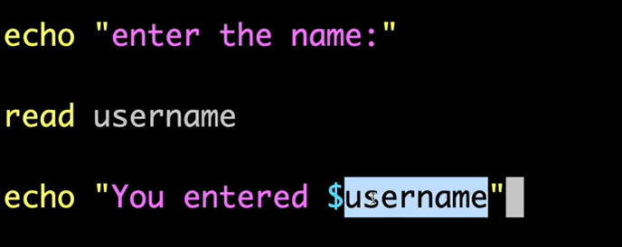
Read variable from user as prompt:
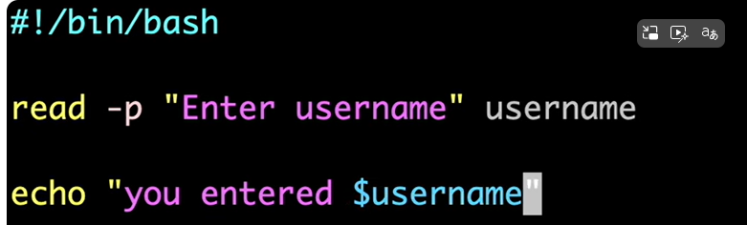

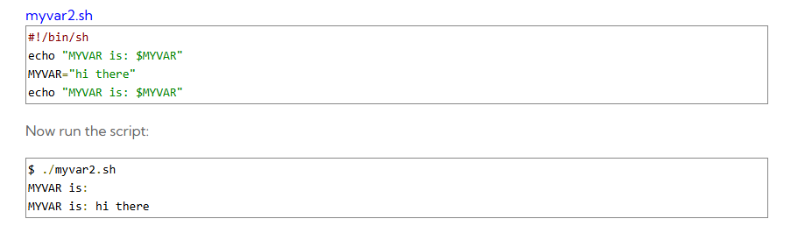
MYVAR hasn't been set to any value, so it's blank. Then we give it a value, and it has the expected result.
Now run:
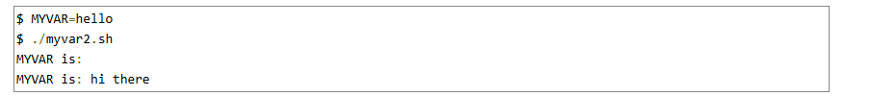
It's still not been set! What's going on?!
When you call myvar2.sh from your interactive shell, a new shell is spawned to run the script. This is partly because of the #!/bin/sh line at the start of the script.
We need to export the variable for it to be inherited by another program - including a shell script.
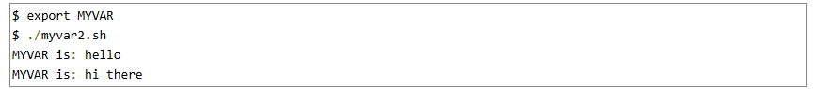
Once the shell script exits, its environment is destroyed. But MYVAR keeps its value of hello within your interactive shell. In order to keep the changes of the script without destroying its environment even after the script ends, we must source the script
To effectively run the script within our own interactive shell, instead of spawning another shell to run it, We can source a script via the "." (dot) command:
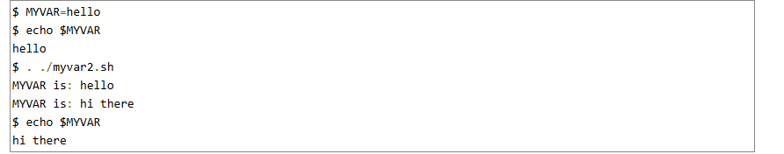
Note that in this case, we don't need to export MYVAR.

- ARGUMENTS:
“./myvar.sh hi hello”

$0 $1 $2

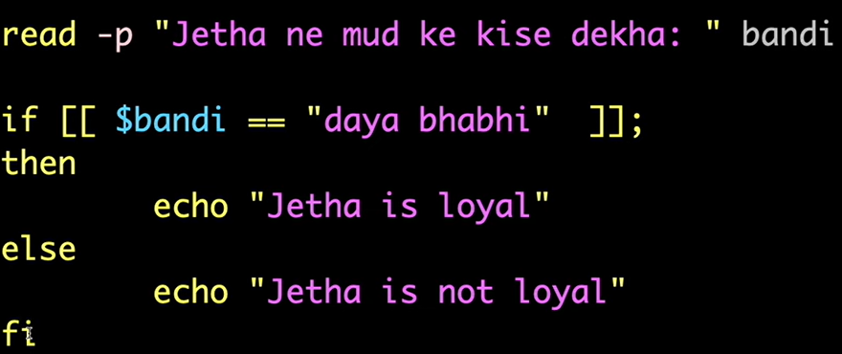

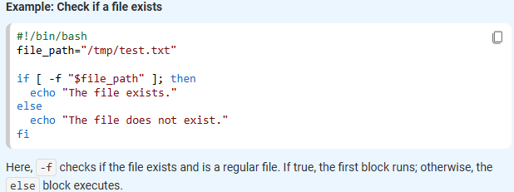

Note :Use [[ ... ]] for advanced pattern matching and regex.

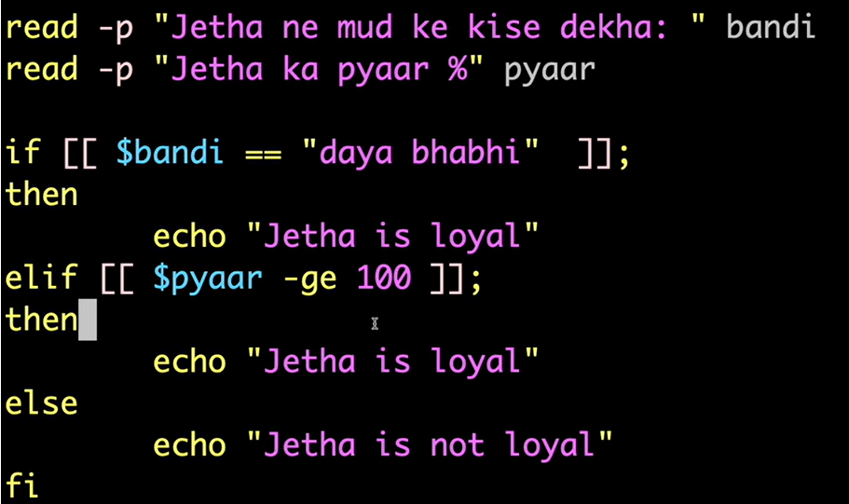
- Escape Characters:
Certain characters are significant to the shell; we have seen, for example, that the use of double quotes (") characters affect how spaces and TAB characters are treated, for example:
$ echo Hello World
Hello World
$ echo "Hello World"
Hello World

So how do we display: Hello "World" ?
$ echo "Hello \"World\""
The backslash (\) character is used to mark these special characters so that they are not interpreted by the shell

An example using the asterisk (*) goes:
$ echo *
case.shtml escape.shtml first.shtml functions.shtml hints.shtml index.shtml ip-primer.txt raid1+0.txt

$ echo *txt
ip-primer.txt raid1+0.txt

$ echo "*"
*
$ echo "*txt"
*txt

- LOOPS:

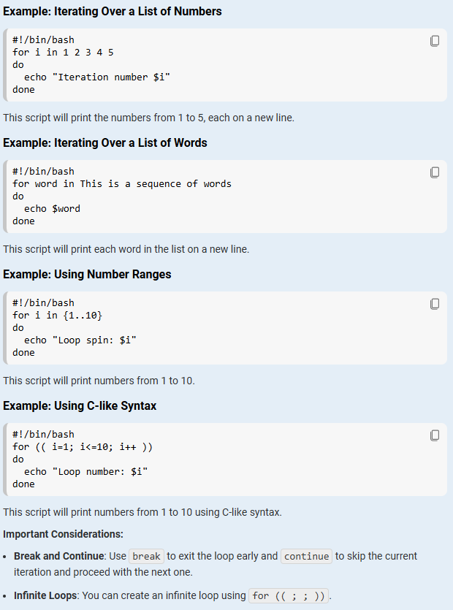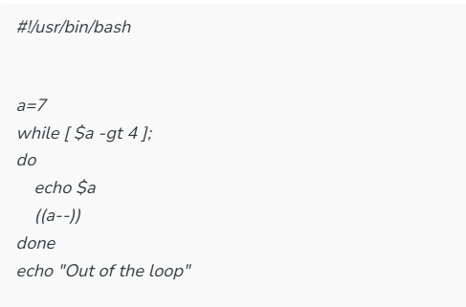
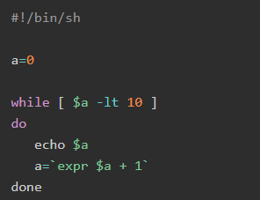

- Function:
#!/bin/bash
function is_loyal() {
read -p "$1 ne mud ke kise dekha: " bandi
read -p "$1 ka pyaar %" pyaar

if [[ $bandi == "daya bhabhi" ]];
then
echo "$1 is loyal"
elif [[ $pyaar -ge 100 ]];
then
echo "$1 is loyal"
else
echo "$1 is not loyal"
fi
}

# This is function call
is_loyal "tom"

- Error Handling:

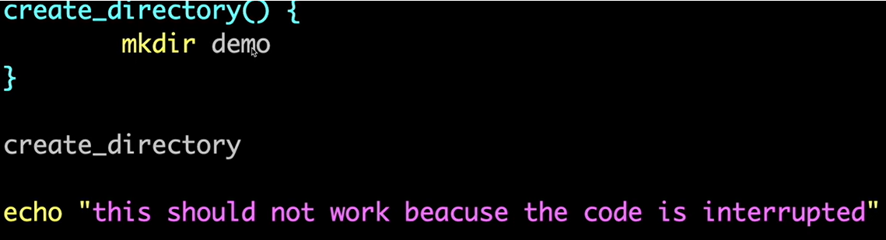

The above script will run only once and after that it will throw error because already ‘demo’ repo is present. To handle this:
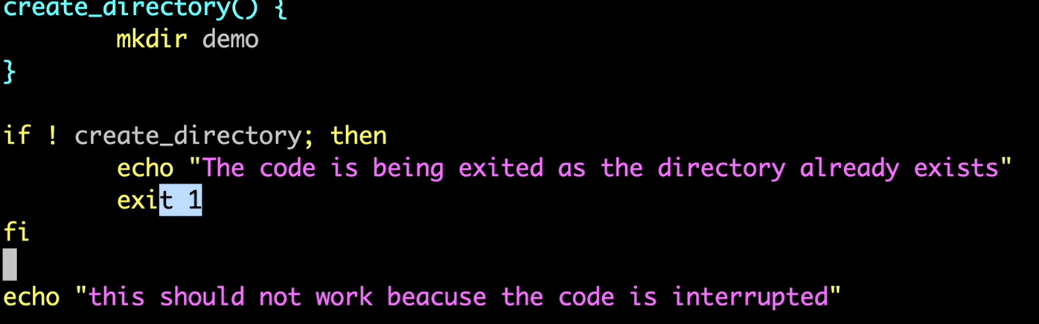

Lets try with an application:

