Assignment-2

TarakRam Nunna

10/11/2021

# Setting working directory

getwd()

## [1] "C:/Users/TARAKRAM/OneDrive/Desktop/Business Analytics/Assignment-2"

setwd("C:/Users/TARAKRAM/OneDrive/Desktop/Business Analytics/Assignment-2")

### 1) Run the following code in R-studio to create two variables X and Y.

set.seed(2017)   
X=runif(100)*10   
Y=X*4+3.45   
Y=rnorm(100)*0.29*Y+Y

## a) Plot Y against X. Include a screenshot of the plot in your submission. Using the File menu you can save the graph as a picture on your computer. Based on the plot do you think we can fit a linear model to explain Y based on X? (5 Marks)

plot(X,Y, xlab = "X (units)", ylab = "Y (units)", main = "Plot of Y vs X for Question 1.a", col = "red")

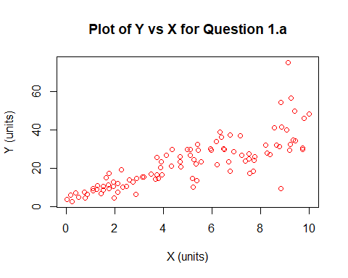 From the graph shown above you can see a positive linear trend between X and Y,

## b) Construct a simple linear model of Y based on X. Write the equation that explains Y based on X. What is the accuracy of this model? (5 Marks)

Model <- lm(Y~X)  
Model$coefficients

## (Intercept) X   
## 4.465490 3.610759

The formula to explain Y based on X from our linear model is: Y = 3.6108*X + 4.4655.

## c) How the Coefficient of Determination, R2, of the model above is related to the correlation coefficient of X and Y? (5 marks)

summary(Model)

##   
## Call:  
## lm(formula = Y ~ X)  
##   
## Residuals:  
## Min 1Q Median 3Q Max   
## -26.755 -3.846 -0.387 4.318 37.503   
##   
## Coefficients:  
## Estimate Std. Error t value Pr(>|t|)   
## (Intercept) 4.4655 1.5537 2.874 0.00497 **   
## X 3.6108 0.2666 13.542 < 2e-16 ***  
## ---  
## Signif. codes: 0 '***' 0.001 '**' 0.01 '*' 0.05 '.' 0.1 ' ' 1  
##   
## Residual standard error: 7.756 on 98 degrees of freedom  
## Multiple R-squared: 0.6517, Adjusted R-squared: 0.6482   
## F-statistic: 183.4 on 1 and 98 DF, p-value: < 2.2e-16

The R2 is 0.6517, that means 65% of the variability of Y is captured by X.

### 2) We will use the ‘mtcars’ dataset for this question. The dataset is already included in your R distribution. The dataset shows some of the characteristics of different cars. The following shows few samples (i.e. the first 6 rows) of the dataset.

# shows first 6 rows.  
head(mtcars)

## mpg cyl disp hp drat wt qsec vs am gear carb  
## Mazda RX4 21.0 6 160 110 3.90 2.620 16.46 0 1 4 4  
## Mazda RX4 Wag 21.0 6 160 110 3.90 2.875 17.02 0 1 4 4  
## Datsun 710 22.8 4 108 93 3.85 2.320 18.61 1 1 4 1  
## Hornet 4 Drive 21.4 6 258 110 3.08 3.215 19.44 1 0 3 1  
## Hornet Sportabout 18.7 8 360 175 3.15 3.440 17.02 0 0 3 2  
## Valiant 18.1 6 225 105 2.76 3.460 20.22 1 0 3 1

## a) James wants to buy a car. He and his friend, Chris, have different opinions about the Horse Power (hp) of cars. James think the weight of a car (wt) can be used to estimate the Horse Power of the car while Chris thinks the fuel consumption expressed in Mile Per Gallon (mpg), is a better estimator of the (hp). Who do you think is right? Construct simple linear models using mtcars data to answer the question. (10 marks)

# Creates a linear model for weight vs horsepower and displays a plot of the points  
Model2 = lm(hp~wt, data = mtcars)  
summary(Model2)

##   
## Call:  
## lm(formula = hp ~ wt, data = mtcars)  
##   
## Residuals:  
## Min 1Q Median 3Q Max   
## -83.430 -33.596 -13.587 7.913 172.030   
##   
## Coefficients:  
## Estimate Std. Error t value Pr(>|t|)   
## (Intercept) -1.821 32.325 -0.056 0.955   
## wt 46.160 9.625 4.796 4.15e-05 ***  
## ---  
## Signif. codes: 0 '***' 0.001 '**' 0.01 '*' 0.05 '.' 0.1 ' ' 1  
##   
## Residual standard error: 52.44 on 30 degrees of freedom  
## Multiple R-squared: 0.4339, Adjusted R-squared: 0.4151   
## F-statistic: 23 on 1 and 30 DF, p-value: 4.146e-05

plot(mtcars$wt,mtcars$hp, xlab = "Weight (wt)", ylab = "Horsepower (hp)", main = "Plot of Weight vs Horsepower for Question 2.a", col = "blue")

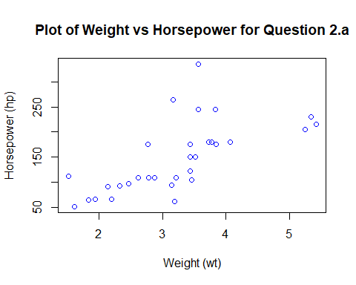 From this linear model we can see that weight results in a model that accounts for 43.39% of the variation in horsepower.

# Creates a linear model for mpg vs horsepower and displays a plot of the points  
Model3 = lm(hp~mpg, data = mtcars)  
summary(Model3)

##   
## Call:  
## lm(formula = hp ~ mpg, data = mtcars)  
##   
## Residuals:  
## Min 1Q Median 3Q Max   
## -59.26 -28.93 -13.45 25.65 143.36   
##   
## Coefficients:  
## Estimate Std. Error t value Pr(>|t|)   
## (Intercept) 324.08 27.43 11.813 8.25e-13 ***  
## mpg -8.83 1.31 -6.742 1.79e-07 ***  
## ---  
## Signif. codes: 0 '***' 0.001 '**' 0.01 '*' 0.05 '.' 0.1 ' ' 1  
##   
## Residual standard error: 43.95 on 30 degrees of freedom  
## Multiple R-squared: 0.6024, Adjusted R-squared: 0.5892   
## F-statistic: 45.46 on 1 and 30 DF, p-value: 1.788e-07

plot(mtcars$mpg,mtcars$hp, xlab = "Miles per Gallon (mpg)", ylab = "Horsepower (hp)", main = "Plot of Miles Per Gallon vs Horsepower for Question 2.a", col = "blue")

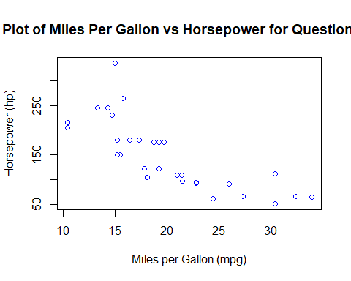 From this linear model we can see that fuel efficiency results in a model that accounts for 60.24% of the variation in horsepower. Therefore, fuel efficiency (mpg) is considered statistically significant in this model.

## b) Build a model that uses the number of cylinders (cyl) and the mile per gallon (mpg) values of a car to predict the car Horse Power (hp). Using this model, what is the estimated Horse Power of a car with 4 calendar and mpg of 22? (10 mark)

# Shows which variables are factor or numeric  
str(mtcars)

## 'data.frame': 32 obs. of 11 variables:  
## $ mpg : num 21 21 22.8 21.4 18.7 18.1 14.3 24.4 22.8 19.2 ...  
## $ cyl : num 6 6 4 6 8 6 8 4 4 6 ...  
## $ disp: num 160 160 108 258 360 ...  
## $ hp : num 110 110 93 110 175 105 245 62 95 123 ...  
## $ drat: num 3.9 3.9 3.85 3.08 3.15 2.76 3.21 3.69 3.92 3.92 ...  
## $ wt : num 2.62 2.88 2.32 3.21 3.44 ...  
## $ qsec: num 16.5 17 18.6 19.4 17 ...  
## $ vs : num 0 0 1 1 0 1 0 1 1 1 ...  
## $ am : num 1 1 1 0 0 0 0 0 0 0 ...  
## $ gear: num 4 4 4 3 3 3 3 4 4 4 ...  
## $ carb: num 4 4 1 1 2 1 4 2 2 4 ...

# Convert cylinder into a factor.  
mtcars$cyl = as.factor(mtcars$cyl)  
str(mtcars)

## 'data.frame': 32 obs. of 11 variables:  
## $ mpg : num 21 21 22.8 21.4 18.7 18.1 14.3 24.4 22.8 19.2 ...  
## $ cyl : Factor w/ 3 levels "4","6","8": 2 2 1 2 3 2 3 1 1 2 ...  
## $ disp: num 160 160 108 258 360 ...  
## $ hp : num 110 110 93 110 175 105 245 62 95 123 ...  
## $ drat: num 3.9 3.9 3.85 3.08 3.15 2.76 3.21 3.69 3.92 3.92 ...  
## $ wt : num 2.62 2.88 2.32 3.21 3.44 ...  
## $ qsec: num 16.5 17 18.6 19.4 17 ...  
## $ vs : num 0 0 1 1 0 1 0 1 1 1 ...  
## $ am : num 1 1 1 0 0 0 0 0 0 0 ...  
## $ gear: num 4 4 4 3 3 3 3 4 4 4 ...  
## $ carb: num 4 4 1 1 2 1 4 2 2 4 ...

# A multiple regression model is utilized in this case to build a model that represents horsepower as a result of cylinders and miles per gallon.

Model5 = lm(hp~cyl+mpg, data = mtcars)  
summary(Model5)

##   
## Call:  
## lm(formula = hp ~ cyl + mpg, data = mtcars)  
##   
## Residuals:  
## Min 1Q Median 3Q Max   
## -58.882 -20.904 -6.261 7.043 125.453   
##   
## Coefficients:  
## Estimate Std. Error t value Pr(>|t|)   
## (Intercept) 171.349 57.946 2.957 0.00625 **  
## cyl6 16.623 23.197 0.717 0.47955   
## cyl8 88.105 28.819 3.057 0.00487 **  
## mpg -3.327 2.133 -1.560 0.12995   
## ---  
## Signif. codes: 0 '***' 0.001 '**' 0.01 '*' 0.05 '.' 0.1 ' ' 1  
##   
## Residual standard error: 37.01 on 28 degrees of freedom  
## Multiple R-squared: 0.7368, Adjusted R-squared: 0.7086   
## F-statistic: 26.12 on 3 and 28 DF, p-value: 2.888e-08

# Predict the estimated horse power of a car with 4 cylinders and 22 mpg  
predict(Model5, data.frame(mpg = c(22), cyl = c("4")))

## 1   
## 98.15275

The estimated Horse Power of a car with 4 calendar and mpg of 22 is 98.15%

### 3) For this question, we are going to use BostonHousing dataset. The dataset is in ‘mlbench’ package, so we first need to instal the package, call the library and the load the dataset using the following commands

library(mlbench)  
data(BostonHousing)

## a) Build a model to estimate the median value of owner-occupied homes (medv)based on the following variables: crime crate (crim), proportion of residential land zoned for lots over 25,000 sq.ft (zn), the local pupil-teacher ratio (ptratio) and weather the whether the tract bounds Chas River(chas). Is this an accurate model? (Hint check R2 )

# Check the dataset to see which variable are considered numeric and which are factors.  
str(BostonHousing)

## 'data.frame': 506 obs. of 14 variables:  
## $ crim : num 0.00632 0.02731 0.02729 0.03237 0.06905 ...  
## $ zn : num 18 0 0 0 0 0 12.5 12.5 12.5 12.5 ...  
## $ indus : num 2.31 7.07 7.07 2.18 2.18 2.18 7.87 7.87 7.87 7.87 ...  
## $ chas : Factor w/ 2 levels "0","1": 1 1 1 1 1 1 1 1 1 1 ...  
## $ nox : num 0.538 0.469 0.469 0.458 0.458 0.458 0.524 0.524 0.524 0.524 ...  
## $ rm : num 6.58 6.42 7.18 7 7.15 ...  
## $ age : num 65.2 78.9 61.1 45.8 54.2 58.7 66.6 96.1 100 85.9 ...  
## $ dis : num 4.09 4.97 4.97 6.06 6.06 ...  
## $ rad : num 1 2 2 3 3 3 5 5 5 5 ...  
## $ tax : num 296 242 242 222 222 222 311 311 311 311 ...  
## $ ptratio: num 15.3 17.8 17.8 18.7 18.7 18.7 15.2 15.2 15.2 15.2 ...  
## $ b : num 397 397 393 395 397 ...  
## $ lstat : num 4.98 9.14 4.03 2.94 5.33 ...  
## $ medv : num 24 21.6 34.7 33.4 36.2 28.7 22.9 27.1 16.5 18.9 ...

# Create a linear model for median value based on crim, zn, ptratio, and chas.  
Model6 = lm(medv~crim+zn+ptratio+chas, data = BostonHousing)  
summary(Model6)

##   
## Call:  
## lm(formula = medv ~ crim + zn + ptratio + chas, data = BostonHousing)  
##   
## Residuals:  
## Min 1Q Median 3Q Max   
## -18.282 -4.505 -0.986 2.650 32.656   
##   
## Coefficients:  
## Estimate Std. Error t value Pr(>|t|)   
## (Intercept) 49.91868 3.23497 15.431 < 2e-16 ***  
## crim -0.26018 0.04015 -6.480 2.20e-10 ***  
## zn 0.07073 0.01548 4.570 6.14e-06 ***  
## ptratio -1.49367 0.17144 -8.712 < 2e-16 ***  
## chas1 4.58393 1.31108 3.496 0.000514 ***  
## ---  
## Signif. codes: 0 '***' 0.001 '**' 0.01 '*' 0.05 '.' 0.1 ' ' 1  
##   
## Residual standard error: 7.388 on 501 degrees of freedom  
## Multiple R-squared: 0.3599, Adjusted R-squared: 0.3547   
## F-statistic: 70.41 on 4 and 501 DF, p-value: < 2.2e-16

The R2 value in this model (crim, zn, ptratio, and chas) captured is 35.99% of the variability in median home value. This is a weak model in terms of accuracy and can be improved by adding more variables into the model.

## b) Use the estimated coefficient to answer these questions?

1. Imagine two houses that are identical in all aspects but one bounds the Chas River and the other does not. Which one is more expensive and by how much?

Based on the coefficients, the resulting formula from our model is:

medv = 49.91868 - 0.26018*crim + 0.07073*zn - 1.49367*ptratio + 4.58393*chas1

Therefore, if the only difference between two houses is that one borders the Chas River, then we would only focus on the chas variable coefficient. The house that borders the river would be $4,583.93 more than the one that does not.

4.58393 (coeff of chas) * 1 (value of chas) * 1000 (medv in $1,000 units) = $4,583.93

1. Imagine two houses that are identical in all aspects but in the neighborhood of one of them the pupil-teacher ratio is 15 and in the other one is 18. Which one is more expensive and by how much? (Golden Question: 10 extra marks if you answer)

Based on the coefficients, the resulting formula from our model is:

medv = 49.91868 - 0.26018*crim + 0.07073*zn - 1.49367*ptratio + 4.58393*chas1

Therefore, if the only difference between two houses is the pupil-teacher ratio, then we would only focus on the ptratio variable coefficient. As a result, the house with the smaller pupil-teacher ratio value would be more expensive, because the coefficient is found to be negative in our model. The difference in values between the houses would be:

-1.49367 (coeff of ptratio) * 0.03 (difference between ptratio values) * 1000 (medv in $1,000 units) = $44.81

Therefore, the house with the lower pupil-teacher ratio would be $44.81 more expensive based on our model.

# c) Which of the variables are statistically important (i.e. related to the house price)? Hint: use the p-values of the coefficients to answer.

Based on the model constructed from these variables, all of the variables (crim, zn, ptratio, and chas) were found to be statistically significant. This is true because all of the p-values calculated from our model at below the 0.05 threshold value for significance.

# d) Use the anova analysis and determine the order of importance of these four variables.

# Returns the ANOVA results for the model used in this problem  
anova(Model6)

## Analysis of Variance Table  
##   
## Response: medv  
## Df Sum Sq Mean Sq F value Pr(>F)   
## crim 1 6440.8 6440.8 118.007 < 2.2e-16 ***  
## zn 1 3554.3 3554.3 65.122 5.253e-15 ***  
## ptratio 1 4709.5 4709.5 86.287 < 2.2e-16 ***  
## chas 1 667.2 667.2 12.224 0.0005137 ***  
## Residuals 501 27344.5 54.6   
## ---  
## Signif. codes: 0 '***' 0.001 '**' 0.01 '*' 0.05 '.' 0.1 ' ' 1

Based on the ANOVA values returned, the order of importance of these variables are:

1. “crim” - accounts for 15.08% of variability in the model
2. “ptratio” - accounts for 11.02% of variability in the model
3. “zn” - accounts for 8.32% of variability in the model
4. “chas” - accounts for 1.56% of variability in the model

Additionally, the residuals in this model still account for 64.01% of variability in the model, so there is still a lot of room for improvement in the accuracy of this model.