1) Based on the following table, design the three stages of reproducible workflow, includes the work you can do and the folder structure in each stage (reference study case in chapter 3).  (5 points)

|  |  |  |  |  |
| --- | --- | --- | --- | --- |
| Height (Inches) | Weight (Pounds) | Age | Grip strength | Frailty |
| 65.8 | 112 | 30 | 30 | N |
| 71.5 | 136 | 19 | 31 | N |
| 69.4 | 153 | 45 | 29 | N |
| 68.2 | 142 | 22 | 28 | Y |
| 67.8 | 144 | 29 | 24 | Y |
| 68.7 | 123 | 50 | 26 | N |
| 69.8 | 141 | 51 | 22 | Y |
| 70.1 | 136 | 23 | 20 | Y |
| 67.9 | 112 | 17 | 19 | N |
| 66.8 | 120 | 39 | 31 | N |

# Stage 1: Data Collection

Below is the initial folder structure.

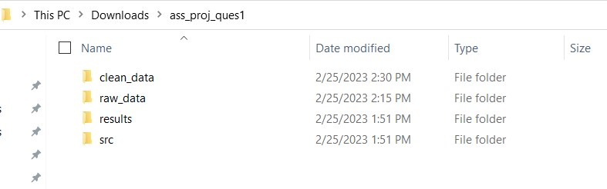

Below are the only files stored in ass_proj_ques1 and in raw_data.

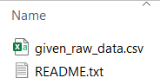

Below is the data in README.txt

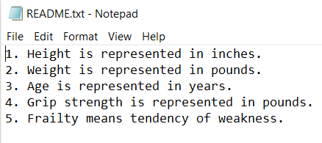

# Stage 2: Data Processing

Below files are added to clean_data folder

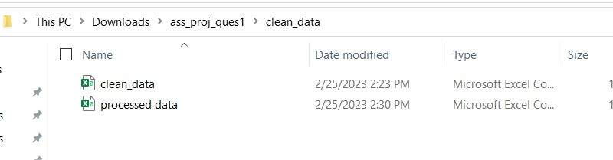

Below are the scripts and respective code used to create above csv files

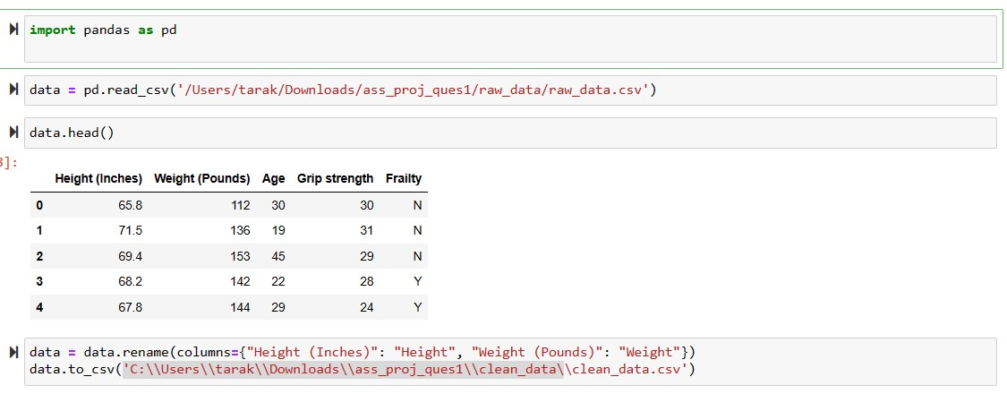

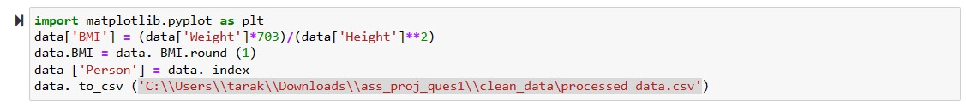

Above .py files are stored in src folder

**Folder structure:**

-ass_proj_ques1

-clean_data

clean_data.csv processed_data.csv

-raw_data

given_raw_data.csv README.txt

-results

-src

data_cleaning.py pre_process.py

# Stage 3: Data Analysis

Below are the two-analysis drawn from the pre proceed data.

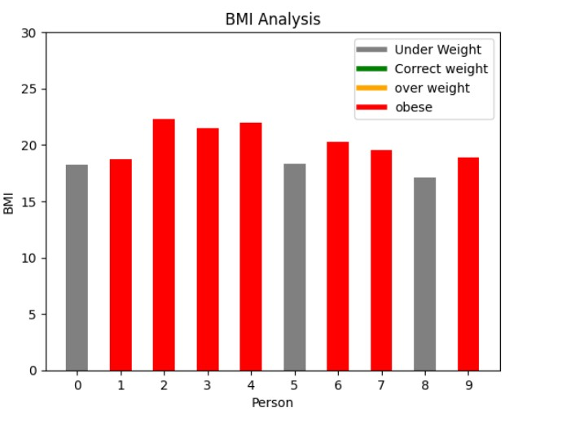

Below are the respective scripts to generate above visuals. These scripts are stored in src folder.

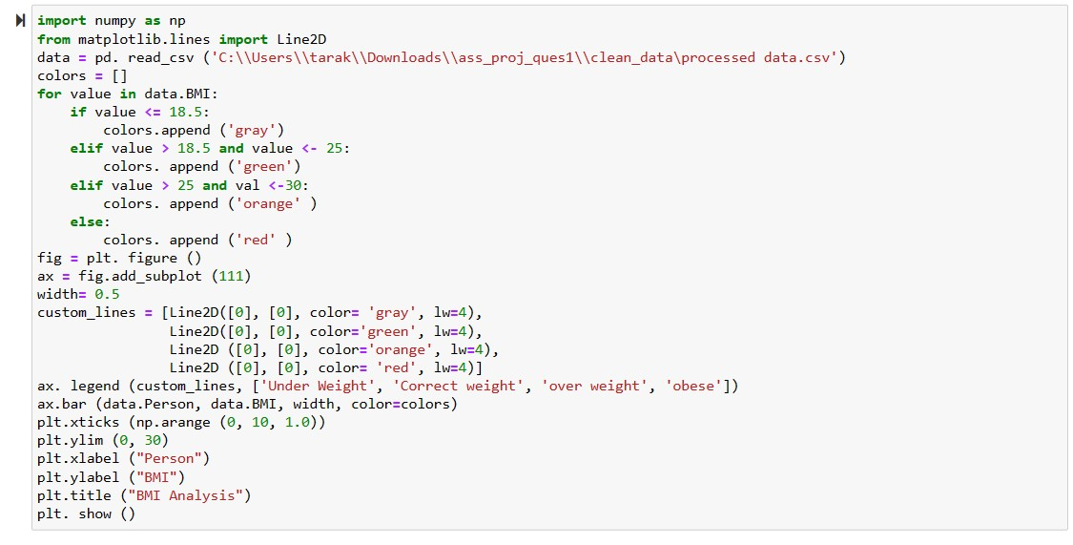

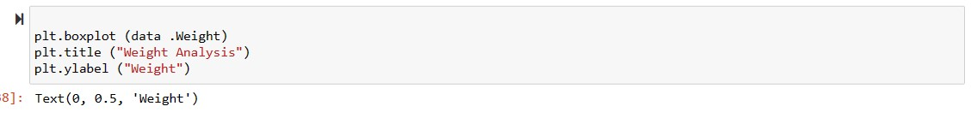

Folder structure:

-ass_proj_ques1

-clean_data

cleaned_data.csv processed_data.csv

-raw_data

given_raw_data.csv README.txt

-results

-src

2) Perform 5 data visualization tasks on the student performance dataset given in the link below (create 5 different visualizations). Explain what kind analysis has become easier with each of the visualizations. Create the folder structure for this question similar to question 1. (15 points).

Data link: <https://app.box.com/s/ji910ez3ycw137rw07xnhielxey7ww41>

Submission:

Create a public GitHub repo and upload the folders for both the questions on the GitHub and submit the link to Canvas.

# Stage 1: Data Collection

# 

# Stage 2: Data Processing

Below files are added to clean_data folder

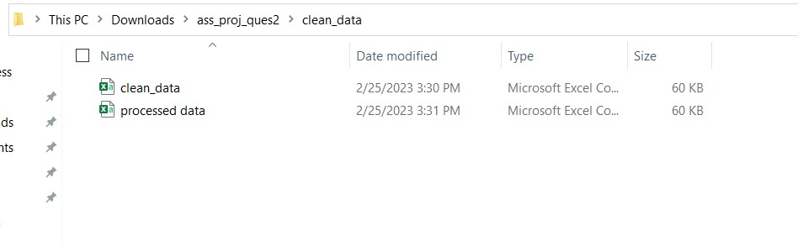

Below are the scripts and respective code used to create above csv files.

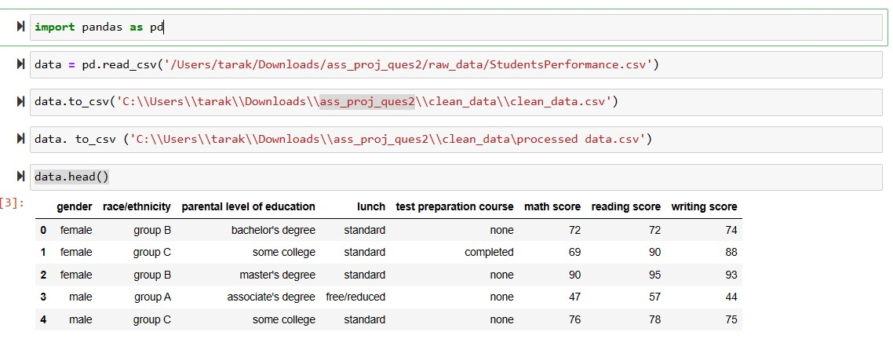

# Stage 3: Data Analysis

1. data visualization tasks are:

1) Bar plot for gender distribution.

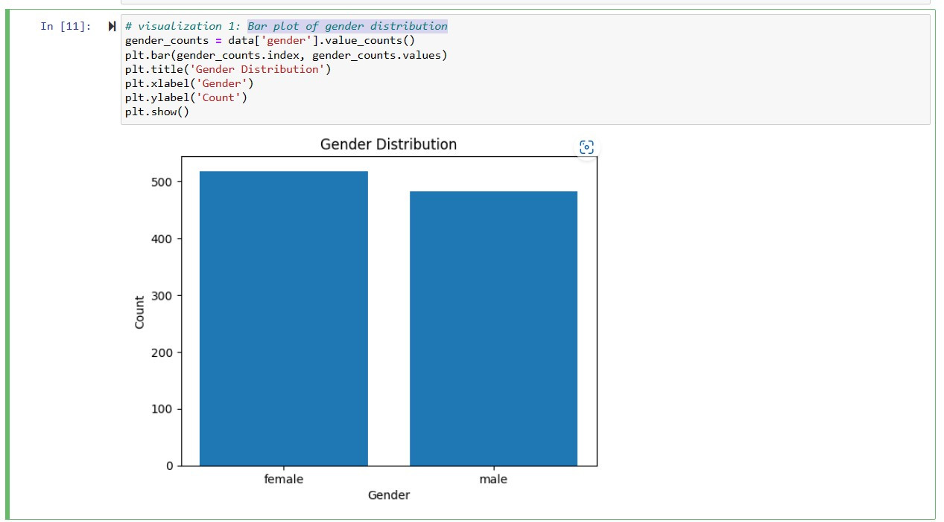

2) Box plot of math scores by gender.

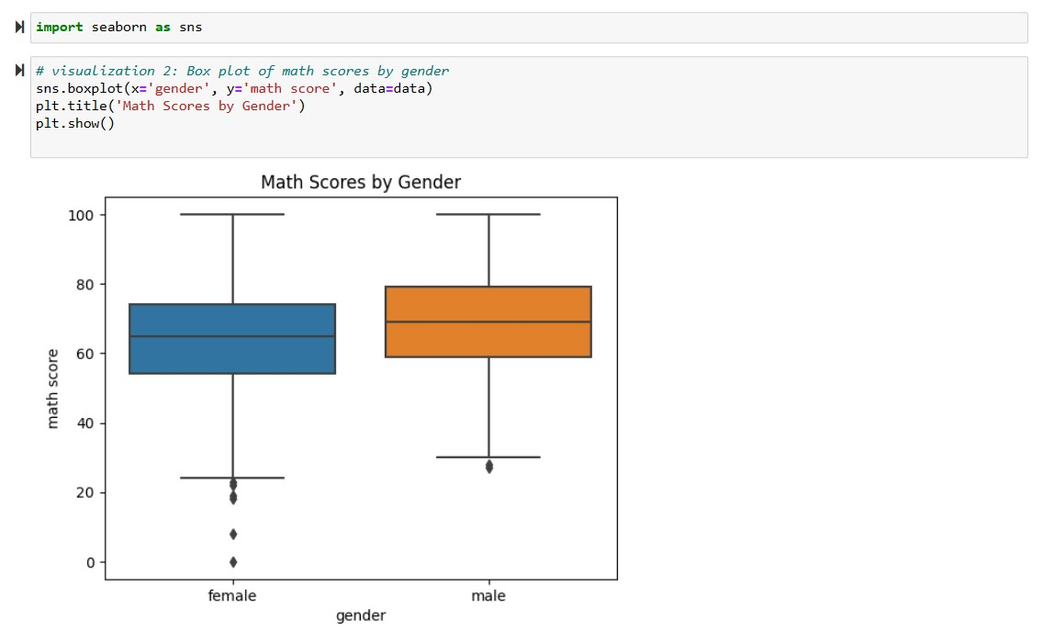

3) Scatter plot of math scores vs

reading scores.

4) Density plot of writing scores by lunch type.

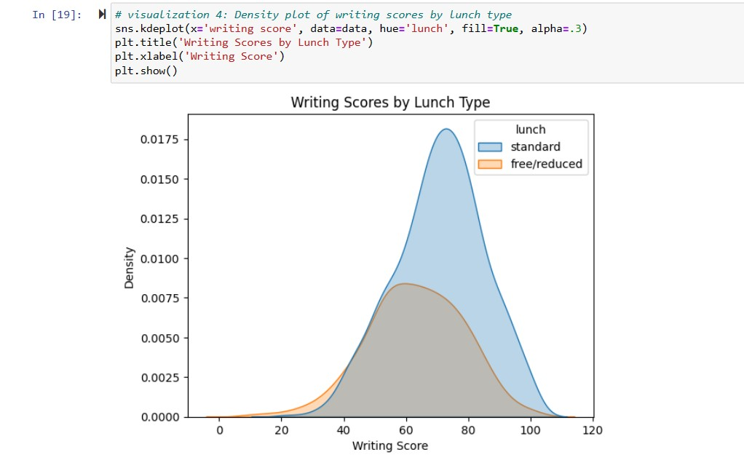

5) Heatmap of correlation matrix.

