Case Study

**P. Taraka Lakshmi**

**Introduction**

**Zomato** is an Indian [multinational](https://en.wikipedia.org/wiki/Multinational_corporation) restaurant aggregator and [food delivery](https://en.wikipedia.org/wiki/Food_delivery) company. It was founded by Deepinder Goyal and Pankaj Chaddah in 2008. Zomato provides information, menus and user-reviews of restaurants as well as food delivery options from partner restaurants in more than 1,000 Indian cities and towns, as of 2022–23. Zomato is one of the most-used apps to find food and restaurants in and around one locality to order and check reviews. Zomato has not only solved the problem of ordering food sitting at your home but also has provided a single platform to know more details about each restaurant.

I really get fascinated by good quality food being served in the restaurants and would like to help community find the best cuisines around the area in Bangalore. like,

* Finding the cuisines that are famous in Bangalore cities.

And also, some of the tasks with the datasets I am going to perform are;

* Figuring out, was the people interested to go to restaurants or very Interested to order food from home.
* While booking a table the people should pay some amount, let’s find the average cost for booking table by finding the costs in all restaurants in Bangalore.
* Figuring out the number of restaurants which are delivering the food.
* Their might have some votes for each restaurant.
* Ratings by the customers is also important. let’s find.

These are the some of the Insights that I am going to perform with the Dataset. To overall the aim is to help the restaurants by these insights.

About the Dataset

This tabular dataset consists of all restaurants in Bangalore. Bangalore is one of the metro countries of India and is also one of the favorite spots for foodies with a variety of cuisines and street food available. The city of students, working professionals, and youth filling up every space, Bangalore is the location to be a foodie, and Zomato taking the highest orders in the country also comes from Bangalore. This data has ratings and review details, the cuisines available, the approximate price for two persons, etc.

Here is the link for the original Dataset:

-----------------------------------

**Process**

In this data the data need to cleaned. For the cleaning process I used two tools which help me to have the accurate data.

* Excel
* Python

Excel:

* I used excel to delete the bad data that is very gibberish and unwanted rows.
* To clean data in excel I used some of the functions like Filtering, Sorting.

Python:

* The data is imported to python for the additional cleaning
* To find the data shape and filling the nulls. And also used to change some columns names.

With this cleaned data we can move to further analysis process

**Analyze**

With the cleaned data it is so easy to analyze the data. By analyzing the data, we can find the keys to solve the business problems.

* Here the cuisines are like tea, Tibetan, Turkish and Vietnamese are famous in cities in Bangalore. Where It is helpful for the down going restaurants to come back with these cuisines where helpful to get profit.
* The data saying that the people who are booking table in restaurant are of 640, as the people not booking are 4,359 people.
* The people ordering food in online are much higher, means the count is 3,590 whereas not ordering via online are 1,490 people. This gives a understanding that most of the people preferring to order food online.
* While booking a table the people should pay some amount, the average cost for booking table by finding the costs in all restaurants in Bangalore is taking average with the costs, 568.7 amount we got as a average amount.
* The restaurants that deliver food are more in Bangalore where I found that 2,861 restaurants were delivering food. I also found that 1,881 restaurants serving food to people within restaurants.
* Here In the data, I found a relationship with the votes and ratings were the restaurant named ‘Empire Restaurant’ which has a greater number of votes (33,613), whereas the rating (4.1) is also high to this restaurant. Here the customers who are satisfying with food, delivering, service, hospitality etc. The people giving the best ratings and more votes to the restaurants.

To present this data to the stakeholders I used visualization tool. That is: **Tableau**

I felt it helps to present my data in a visual form and also it will helpful to understand the business problem and solution and helpful to have a better understanding of the data.

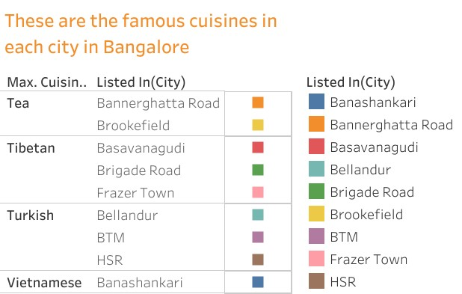**Sheet-1**

Here the cuisines are like tea, Tibetan, Turkish and Vietnamese are famous in cities in Bangalore. Where it is helpful for the down going restaurants to come back with these cuisines to get more profit.

**Sheet-2**

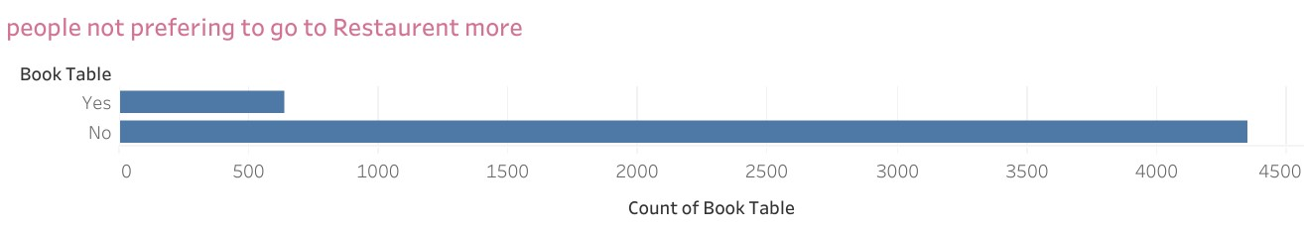

The data saying that the people who are booking table in restaurant are of 640, as the people not booking are 4,359 people.

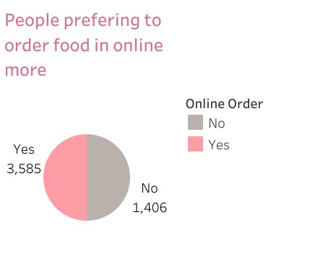**sheet-3**

The people ordering food in online are much higher, means the count is 3,590 whereas not ordering via online are 1,490 people. This gives an understanding that most of the people preferring to order food online.

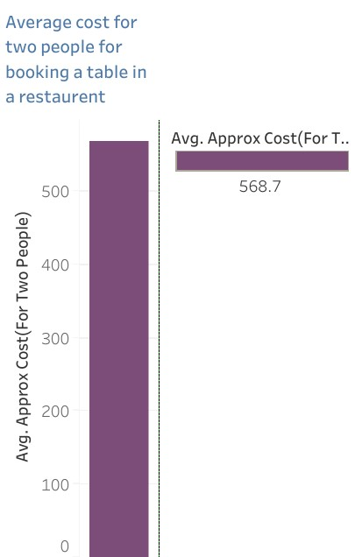**Sheet-4**

While booking a table the people should pay some amount, the average cost for booking table by finding the costs in all restaurants in Bangalore is taking average with the costs, 568.7 amount we got as a average amount.

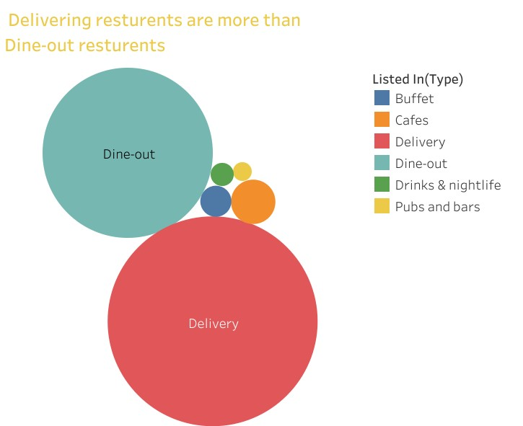**Sheet-5**

The restaurants that deliver food are more in Bangalore where I found that 2,861 restaurants were delivering food. I also found that 1,881 restaurants serving food to people within restaurants.

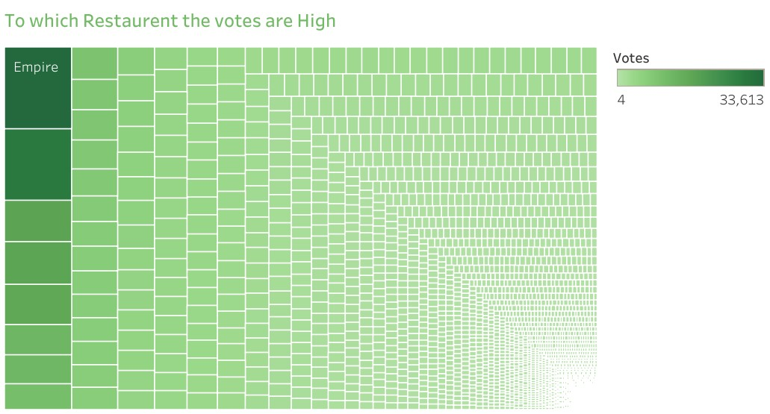**Sheet-6**

Here In the data, I found a relationship with the votes and ratings were the restaurant named ‘Empire Restaurant’ which has a greater number of votes (33,613), whereas the rating (4.1) is also high to this restaurant. Here the customers who are satisfying with food, delivering, service, hospitality etc. The people giving the best ratings and more votes to the restaurants.

**Conclusion:**

This analysis of the Bangalore city restaurant dataset has provided valuable insights into the food preferences and dining habits of the city’s resident. Additionally, it has shed light on several key aspects of the restaurant landscape in Bangalore. Finally, the city is mostly filled with students and working professionals, this might be the reason for the greater number of orders and because of employers and hostelers, so they are not showing interest to go to restaurant. I also found that there is a must visit restaurant to visit in Bangalore city is “Empire Restaurant”.

**Extra Reference:**

**Code:**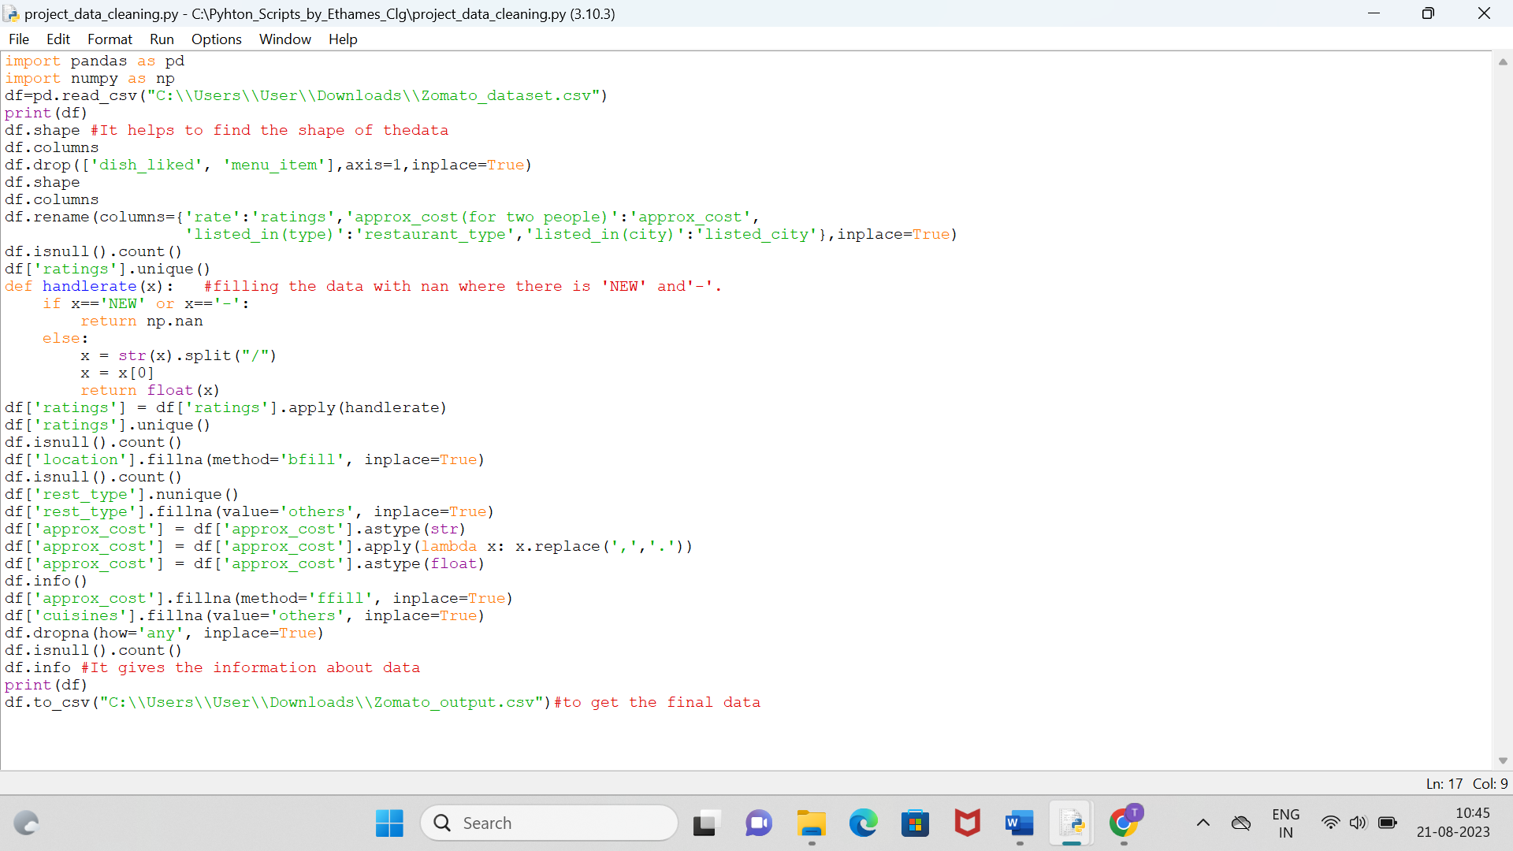

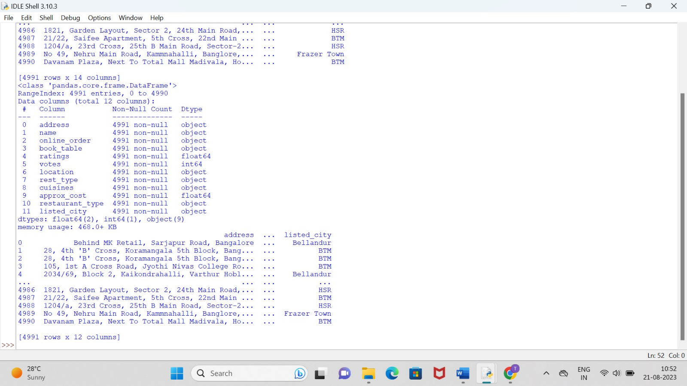**Output:(final output after all the data cleaned)**