**ABSTRACT**

Energy area is as of now dealing with two significant issues of future energy emergency and ecological corruption. To battle the previously mentioned hardships, utilization of hydrogen as an energy transporter might be an essential arrangement in not-so-distant future. Specialists are dealing with this issue all through the world in the mission of fuelling two-and three-wheelers just as traveller vehicles and transports) to diminish neighbourhood contamination at a reasonable expense. This paper offers a extensive outline of the basics of hydrogen ignition, devoted hydrogen motor highlights, the impact of blending hydrogen in with different hydrocarbons and the related execution and outflows. The super charged number and the low lean-combustibility cut-off of hydrogen give the essential components to achieve high warm efficiencies in a motor. The brake warm proficiency and the majority of the discharges are further developed when hydrogen mixes are utilized as energizes in IC motor. In view of the flash start tries, the primary end is that hydrogen added to gas, impacts the fire engendering speed. At consistent overabundance air proportion, the fire speed of hydrogen/fuel/air blends are more noteworthy than the fuel/air blends. With hydrogen supplement to gas, sparkle ignited (SI) motors can run lean bringing about a huge decrease in nitrogen oxides (NOx) discharges comparative with stoichiometric ignition without hydrogen. It was noticed that the warmth discharge rate increments when hydrogen blends in fuel. By adding hydrogen, the burning builds which is not just by the fire proliferation speed of the hydrogen blend yet in addition the auto start of the charge at various areas all the while. Certain solutions for conquer the explosion marvels are endeavoured in this examination. This paper presents consequences of tests for a solitary chamber four stroke variable speed hydrogen helped inside burning motor. In general, excellent understanding among forecasts and trial results was acquired in the whole trial range

**CONTENTS**

DISCRIPTION

Page no.

Abstract

1. **INTRODUCTION**

1.1. History

1.2. Emission Characteristics

1.3. Effect of global warming

1. **SUMMARY**

**LIST OF IMAGES**

**Table no. Title Page no.**

1.2(a) HC Emissions 2

1.2((b) CO and CO2 Emissions 3

1.2(c) NOx Emissions 4

1.3(a) Effect of global warming 6

**Chapter 1**

**INTRODUCTION**

**1.1. History of hydrogen gas:**

A hydrogen vehicle is a sort of elective fuel vehicle that utilizes hydrogen fuel for thought process power. Hydrogen vehicles incorporate hydrogen-powered space rockets, just as autos and other transportation vehicles. Force is produced by changing the synthetic energy of hydrogen over to mechanical energy, either by responding hydrogen with oxygen in a power device to control electric engines or, less normally, by consuming hydrogen in an inner burning engine.

Starting at 2019, there are three models of hydrogen vehicles freely accessible in select business sectors: the Toyota Mirai (2014), which is the world's first mass created devoted energy component electric vehicle (FCEV), the Honda Clarity (2016), and the Hyundai Nexo (2018). A couple of different organizations, as BMW, are as yet investigating hydrogen vehicles, while Volkswagen has communicated that the innovation has no future in the auto space, principally in light of the fact that a power module electric vehicle devours around multiple times more energy than a battery electric vehicle for every mile driven. As of December 2020, there were 31,225 traveller FCEVs fuelled with hydrogen on the world's roads.

Starting at 2019, 98% of hydrogen is created by steam methane improving, which radiates carbon dioxide. It can be created by thermochemical or pyrolytic means utilizing sustainable feedstocks, yet the cycles are at present expensive. Various advances are being fostered that plan to convey costs adequately low, and amounts sufficiently incredible, to contend with hydrogen creation utilizing regular gas.

The advantages of hydrogen innovation are quick refuelling time (equivalent to gas) and long driving reach on a solitary tank. The downsides of hydrogen use are high fossil fuel by-products when hydrogen is created from flammable gas, capital expense trouble, low energy content per unit volume at surrounding conditions, creation and pressure of hydrogen, the speculation needed in filling stations to administer hydrogen, transportation of hydrogen to filling stations, and absence of capacity to deliver or apportion hydrogen at home.

**1**

**1.2. Emission Characteristics:**

Effects of different emission taking place due to hydrogen is studied under this topic. I have compared HC, CO, CO2 and NOx emissions.

**HC EMISSIONS:**

A ton of exploration work has shown that HC discharges slowly decline with expansion in hydrogen part present in the blend. With expansion in hydrogen expansion the development of Gracious revolutionaries are sped up and this outcomes in diminishing HC discharges with expansion in hydrogen parts. The little extinguishing distance of hydrogen (multiple times less than gas) between the situation of fire extinguishment and the chamber divider assists with diminishing HC emanations with increment in hydrogen divisions. Wang et al. [24] showed that HC outflows are adequately diminished with the expansion of hydrogen mixing proportion, in a flash lighted ethanol motor and arrive at the base worth of 1019 ppm at a H2= 5.49%. The above said truth can be obviously seen from the figure 7 which has been taken from their works. Ji et al. [18] found that for ordinary gas fuel, the HC discharge unexpectedly increments after a specific worth of abundance air proportion [λ = 1.36] which, can be diminished by expanding hydrogen content, as the high combustibility of hydrogen helps in complete ignition of the fuel. Crafted by Demopoulos et al. [5] express that hydrogen expansion in fuel diminishes unburnt hydrocarbons to a degree of 6 to 20% contingent upon fuel thought.

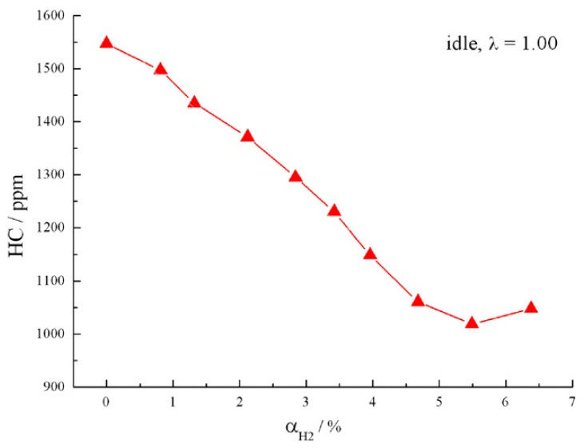

**2**

**CO and CO2 Emissions:**

CO discharge increments with the hydrogen expansion portion at the point when the overabundance air proportion is close to stoichiometric conditions. As hydrogen has higher air-to-fuel proportion than gas, burning of hydrogen in the chamber can cause some lean oxygen region because of the inhomogeneity of the fuel–air blend, which lessens the oxidation rate for CO into CO2. On the off chance that the motor is run under lean conditions, CO discharge is improved by upgrading hydrogen expansion portion as there is

plentiful oxygen accessible for CO to be changed over into CO2. The expanded in-chamber temperature after hydrogen expansion too adds to invigorating the oxidation response of CO into CO2. CO emanation from the gas SI motor increments once more at λ > 1.36 since the

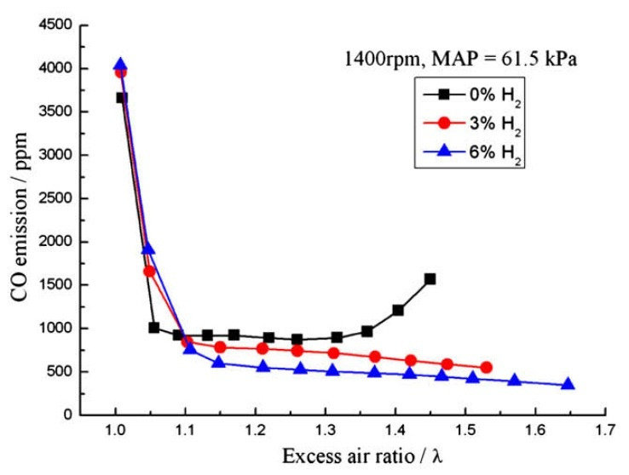

expanded abundance air proportion invigorates the probability of halfway discharge failure,bringing about decreased in-chamber temperature, hindering the response energy of CO oxidation into CO2.The results from crafted by Ji and Wang has been plotted to show the variety in CO outflow with change in hydrogen portions. Nonetheless, Roy et al. has tentatively shown that the greatest CO discharge with flawless H2 activity was more than 99% not exactly different fills and fulfilled a wide range of outflow guidelines. With respect to CO2 outflow is concerned, the CO2 outflow diminishes with expansion in hydrogen content. Hydrogen being carbonless fuel, its burning produces no CO2. At a predefined overabundance air proportion, the carbon content in the gas hydrogen fuel blend is decreased after hydrogen improvement, causing lesser CO2 emanation. CO2 discharge can be additionally decreased in hydrogen–gas blend energized motor by embracing huge overabundance air proportions. **3**

**NOx Emissions:**

NOx outflows are found to increment with expansion in hydrogen divisions in the blend for the most part if there should be an occurrence of a SI motor. NOx discharges rely on conditions like temperature and oxygen fixation present in the chamber. The top in chamber temperature increments with expansion in level of hydrogen for a given overabundance air proportion and consistent oxygen fixation, subsequently expanding NOx focus. Ji et al showed that with expansion in hydrogen content, the important abundance air proportion for the most extreme NOx emanations marginally increment similarly as with higher hydrogen expansion part, more air is required completely consuming hydrogen to create higher in-chamber temperature. Albeit the hydrogen-advanced motor discharges more NOx emanations when the overabundance air proportion is near stoichiometric conditions, NOx emanations for all hydrogen advancement levels drop to a satisfactory worth when the motor runs under very lean conditions, [λ > 1.5]. Demopoulos et al. showed that hydrogen expansion in the fuel brings about additional ideal productivity crude NOx compromise. Stebar found that, the motor lean consume limit was stretched out after hydrogen improvement and NOx emanations were diminished. Another work of Ji and Wang showed that for a half and half hydrogengasoline motor at lean consumes limits, NOx emanations are found to diminish with expansion of hydrogen at lean consume limit as overabundance air proportion increments on improving hydrogen portion. In this manner, the absolute fuel energy stream rate at the lean consume limit diminishes with the expansion of hydrogen expansion part, causing diminished in-chamber temperature and in this way NOx development is obliged. The outcomes from the above work has been shown graphically in Fig and it shows drop in NOx emanations from 52 ppm at the first motor to a generally lower esteem at 4.5% of the hydrogen improved fuel motor. The possibility to extend the force band while keeping up with almost zero NOx discharges is conceivable by working on lean force thickness with pressure boosting.

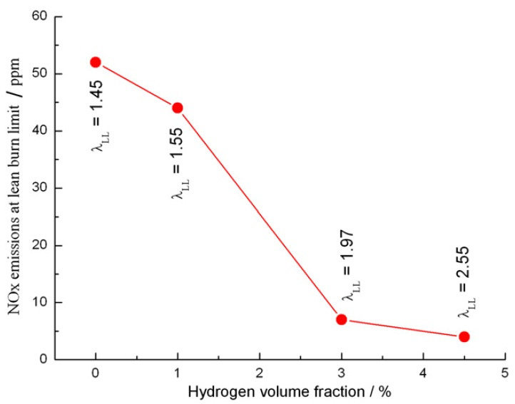

**4**

**1.3. Effect of global warming:**

There is expanding interest in the job that hydrogen-based energy frameworks may play later on, particularly in the vehicle area. They give off an impression of being an appealing option in contrast to current petroleum derivative-based energy frameworks later on, since these have been demonstrated to influence environment because of nursery gasses discharges. In any case, any future hydrogen-based economy would have to survey the conceivable worldwide ecological effects of such elective energy creation. English researchers have as of late audited ebb and flow comprehension of the destiny and conduct of hydrogen in the environment and portrayed its significant sources and sinks. They show that, as opposed to most assumptions, hydrogen is an aberrant ozone depleting substance with an expected a dangerous atmospheric deviation impact. They then, at that point measured a dangerous atmospheric deviation capability of hydrogen in contrast with CO2 and an Earth-wide temperature boost outcomes of supplanting the current non-renewable energy source put together economy with one based with respect to hydrogen. The outcomes propose that since hydrogen responds in the environment with tropospheric OH revolutionaries, the outflow of hydrogen into the environment would disturb the dissemination of methane and ozone, the second and third most significant nursery gasses. Emanations of hydrogen lead to expanded weights of methane and ozone and subsequently to an expansion in an Earth-wide temperature boost. Thusly, hydrogen can be considered as a backhanded ozone harming substance with the possibility to increment a dangerous atmospheric deviation. The researchers have assessed that the possible impacts on environment from hydrogen-based energy frameworks would be a lot of lower than those from petroleum product-based energy frameworks. Be that as it may, such effects will rely upon the pace of hydrogen spillage during its combination, stockpiling and use. The analysts have determined that a worldwide hydrogen economy with a spillage pace of 1% of the created hydrogen would create an environment effect of 0.6% of the petroleum product framework it replaces. On the off chance that the spillage rate was 10%, then, at that point the environment effect would be 6% of that of the petroleum product framework. The current investigation proposes that a future hydrogen-based economy would not be liberated from environment unsettling influence, albeit this might be significantly less articulated that that brought about by the current fossil fuel energy frameworks. Cautious consideration would need to be paid to decreasing hydrogen spillage to a least if the potential environment advantages of a future worldwide hydrogen economy are to be figured it out.

**5**

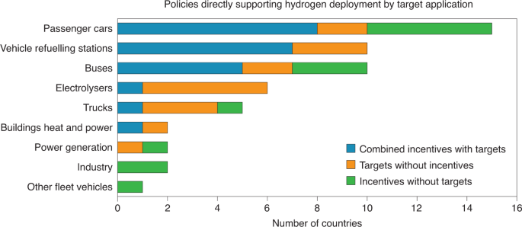

**Summery:**

Hydrogen is by all accounts a practical answer for future transportation. All together for hydrogen vehicles to turn into industrially doable, testing errands in hydrogen creation, dispersion and capacity must be tended to appropriately. The wide combustibility limits, low start energy furthermore, high fire rates can bring about unwanted burning irregularities, including surface start and blowing up just as auto start. Notwithstanding, the works so far revealed in the writing show empowering results from the exhibition and outflow perspectives. It is seen that warm proficiency is improved with hydrogen expansion to gas as fuel. For the blended fuel, HC and CO2 outflow are found to diminish. CO outflow is noted to be all the more especially close stoichiometric air fuel proportion conditions.

**6**