1.Write a c++ program for to find addition of 2 numbers.

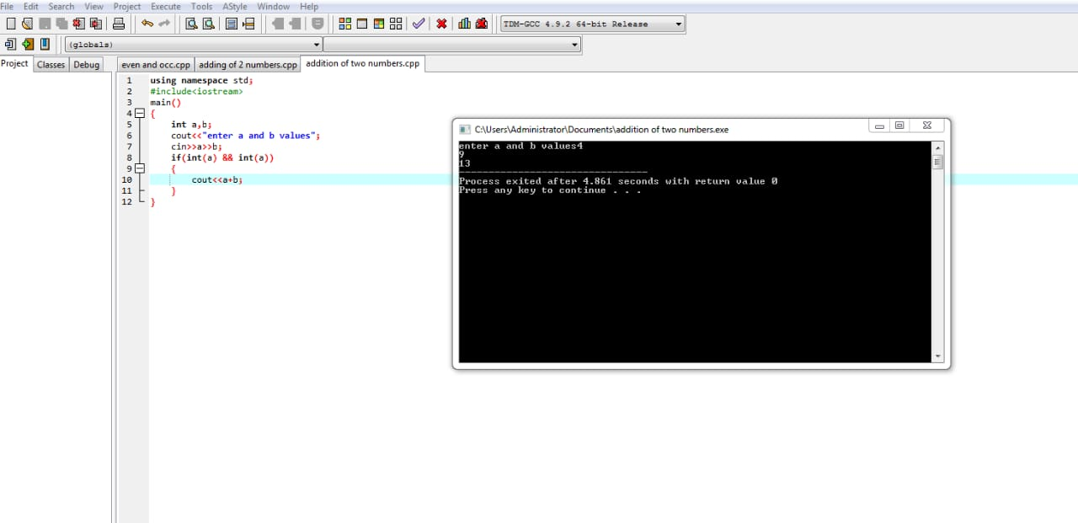

2. Write a c++ program for to find subtraction of 2 numbers.

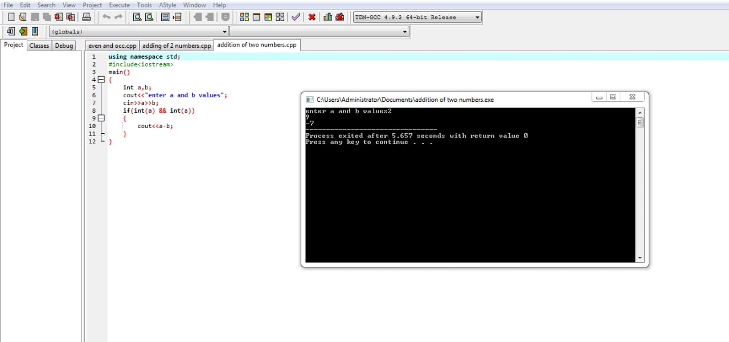

3. Write a c++ program for to find multliplication of 2 numbers.

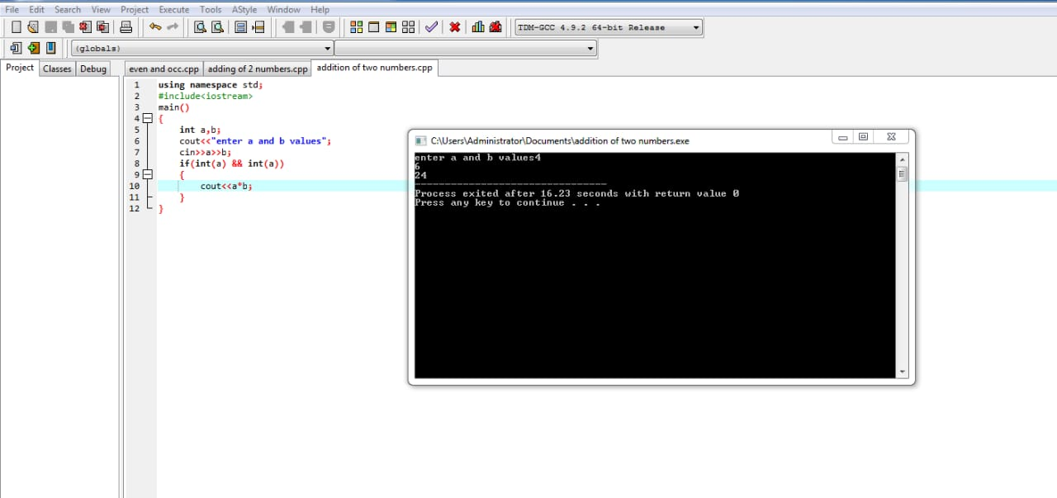

4.write a c++ program for to find the division of two numbers.

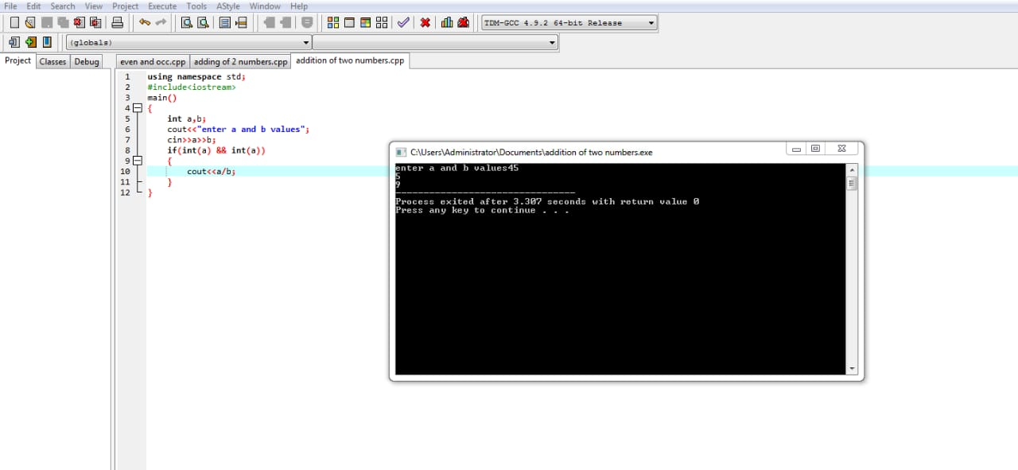

5.write a c++ program for to find the modulus of the 2 numbers

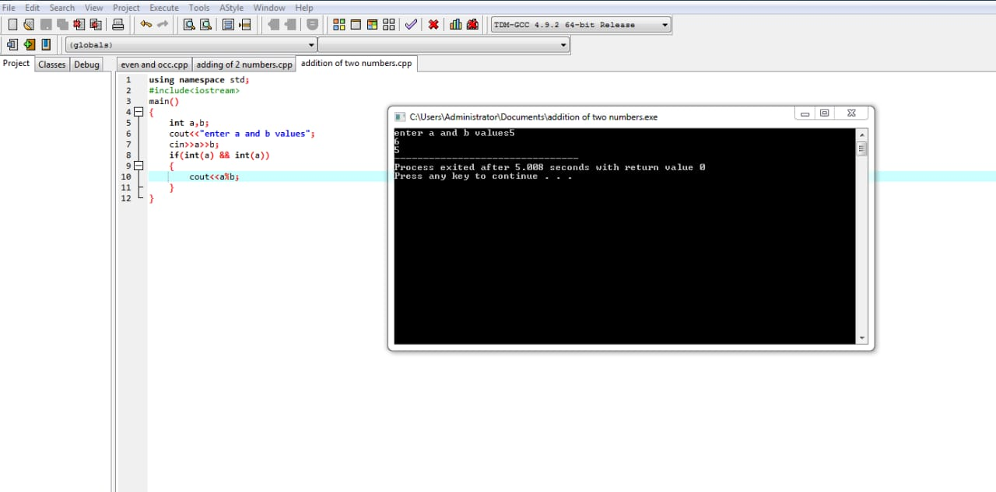

6.write a c++ program for to find the biggest of 2 numbers.

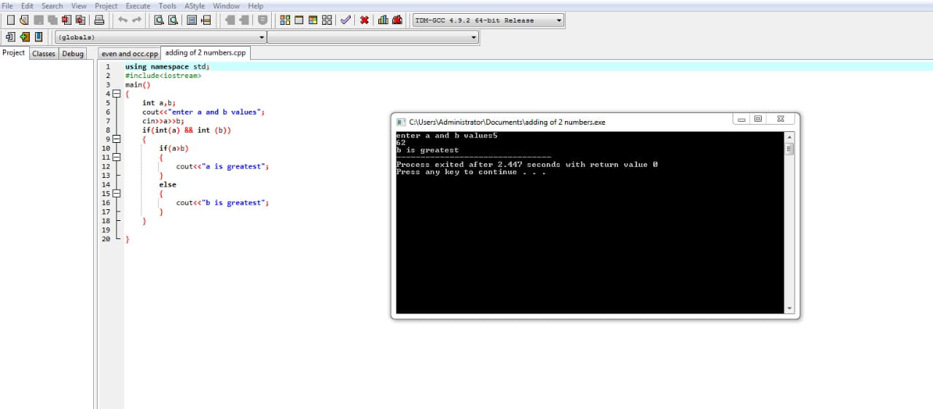

7.write a c++ program for to find the given number odd or even.

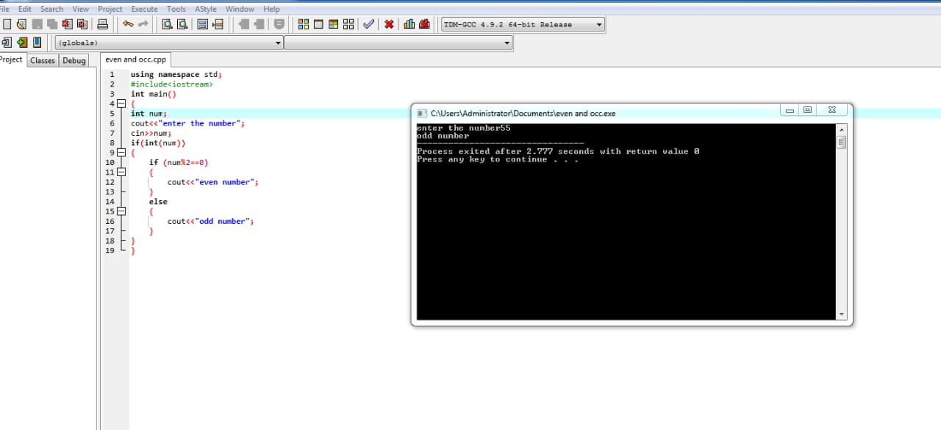

8.Write a c++ program to find the person is eligible for vote or not.

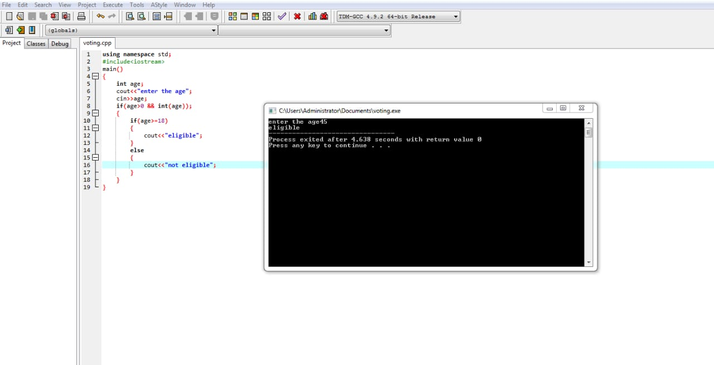

9.Write a c++ program to find the given is int or float.

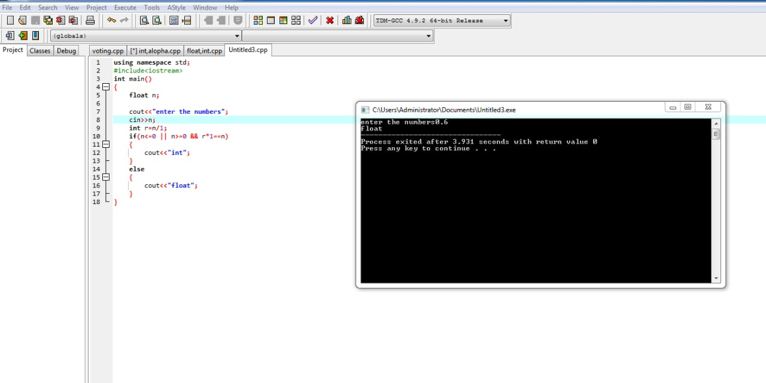

10.Write a c++ program to find the the student marks aggregation.

