1.WRITE A C++ PROGRAM TO DERIVE A CLASS FROM BASE CLASS

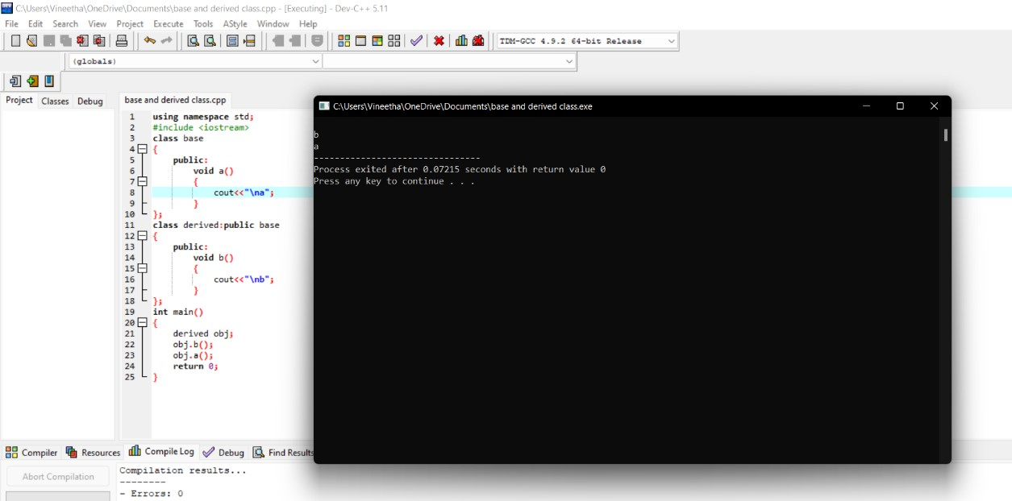

2.WRITE APROGRAM TO CALCULATE THE BONUS OF THE EMPLOYEE,THE CLASS MASTER DERIVE

THE INFORMATION FROM BOTH ADMIN AND ACCOUNT CLASS WHICH DERIVE INFORMATION

FROM THE CLASS PERSON.CREATE A BASE AND ALL DERIVED CLASS WITH NECESSARY FUNCTIONS

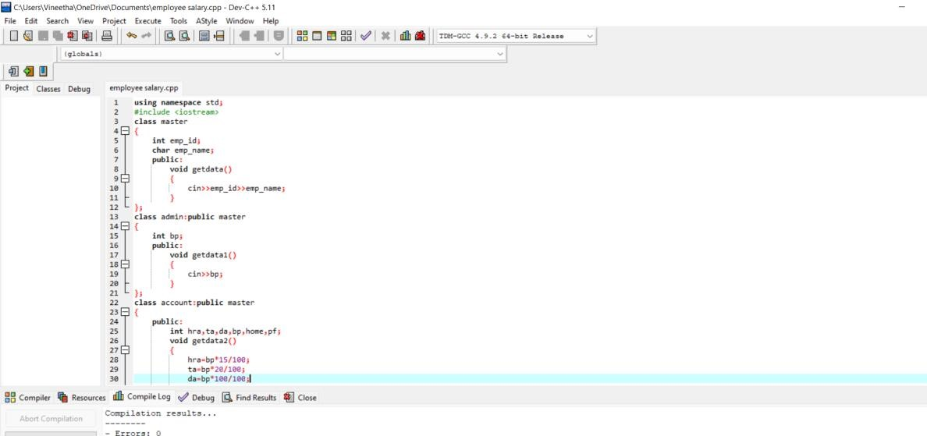

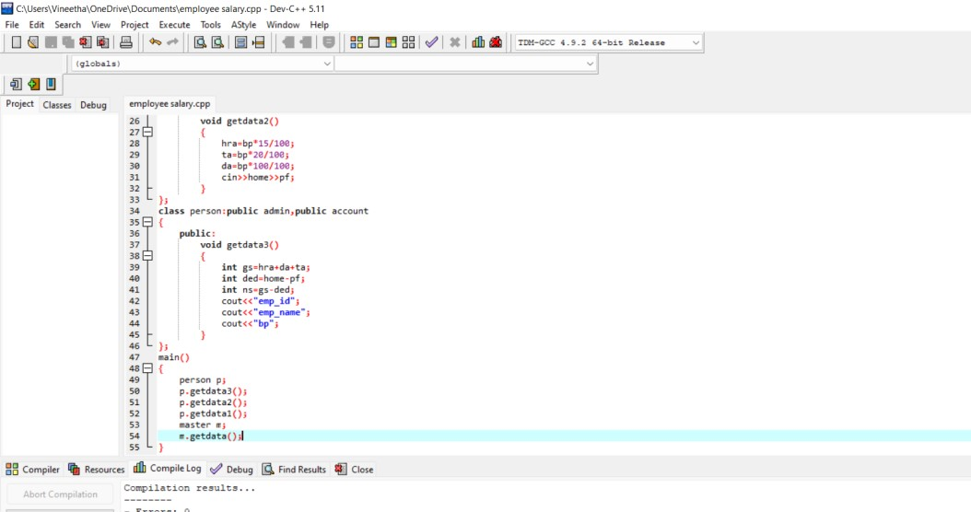

3.DEVELOP A C++ PROGRAM TO FIND THE SUM AND PRODUCT OF TWO NUMBER USING SINGLE INHERITANCE

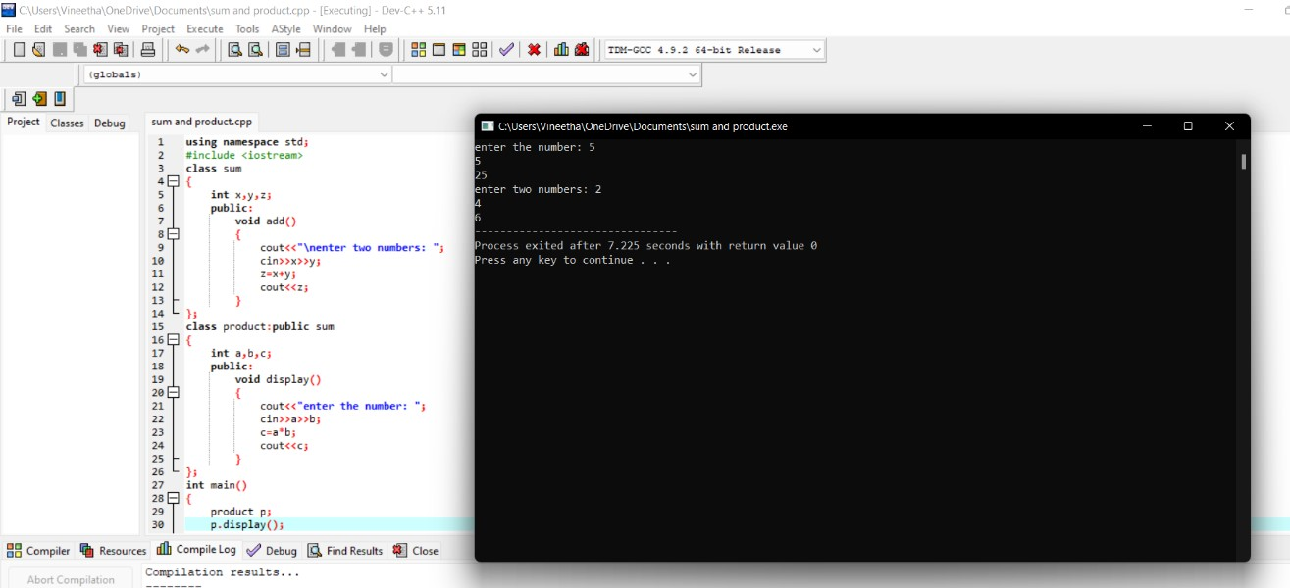

4.ASSUME THAT TEST RESULT OF BATCH OF STUDENTS STORED IN THREE CLASSES.CLASS STUDENT STORES THE ROLL NO,CLASS TEST STORES MARKS OBTAINED FOR 3 SUBJECTS AND CLASS RESULTS CONTAINS TOTAL MARKS FOR THE TESTS.THE CLASS RESULT INHERIT THE DETAILS OF THE MARKS OBTAINED IN THE TEST AND ROLL NUMBER OF THE STUDENTS THROUGH THE DERIVED CLASS

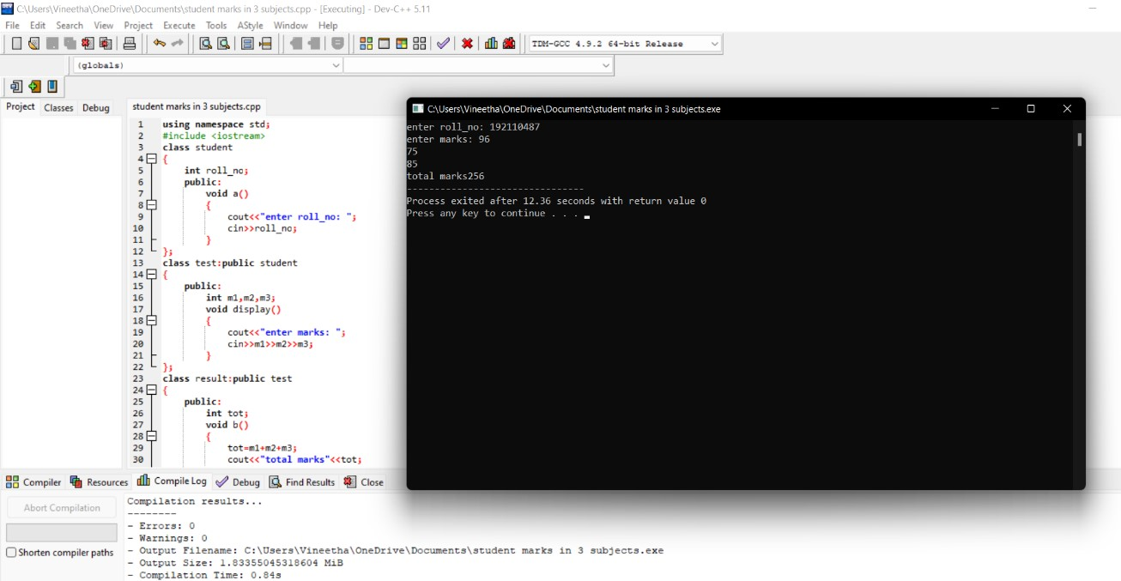

5.MAKE A CLASS NAME FRUIT WITH THE DATA MEMBER TO CALCULATE THE NUMBER OF

FRUITS.CREATE OTHER TWO CLASSES NAMES APPLE AND MANGO,TO CALCULATE THE NUMBER OF

APPLES AND MANGOES IN THE BASKET.PRINT THE NUMBER OF FRUITS IN EACH TYPE AND TOTAL NUMBER FRUITS IN THE BASKET

